Professional Career Development

Table of Contents
Introduction 1
1. Required Employability Skills 2
2. Personal SWOT Analysis 3
3. Current Skills and Learning Styles 4
4. Self-Managed Learning and Lifelong Learning 6
5. Holistic Planning and PDP 7
6. Monitoring Progress and Reflection 8
7. Effectiveness of Development Plan 10
8. Areas for Development and Current Need 12
9. Work Based Solution 13
10. Time Management Strategies 13
Conclusion 15
References 16

Introduction
Professional career development means to increase knowledge and expertise by acquiring transferrable skills and gathering knowledge so that he/she can increase employability in the job market (Bard, 2017). Business organizations in this modern world need to face a greater level of competition in the market to survive than they were to face in the previous ages (Benson, 2015). Employers now search for the employees who have some employability skills that are required to make the organization successful (Bolton and Delderfield, 2015). Currently I am working as a sales executive in KFC. I have greater plan with my career and I have thought that I will join in the marketing department of the organization as an assistant marketing manager, after completing my study. I have conducted a reflective analysis on my current skills and competencies that are needed to become to enter into my desired job. I have conducted a persona SWOT analysis and have identified my strengths and weaknesses in relative employability skills. I also have developed my professional development plan which can lead me in achieving my desired goal.

1. Required Employability Skills
Employability skills are the skills that are needed to be developed by an individual to increase his/her employability to the employers (Estrella, 2010). Every profession requires some specific employability skills. I have plans to build my career as an assistant marketing manager. I need to develop some skills so that I can successfully establish my career in this profession and become successful in future. Required employability skills for working in marketing sector are as followed.
Communication Skill
Communication skill is considered as one of the most vital employability skills that make an employee able to cope with the working environment and to perform his/her activities successfully (Gibbs and Maguire, 2016). Communication skill is much important for the employees who want to develop their career in the field of marketing. An employee with greater communication skill can establish a good relationship with customers, colleagues, superiors and all other parties within the workplace.
Analytical Skill
Most of the employers search for the employees who have a good level of analytical skills. An employee with good analytical skill is able to make right decisions for the organization when any critical condition arises (Haasler, 2013). This skill is much important for the employees working in the managerial level. Employees with greater analytical skill can make the organization able to achieve their targeted success by taking the right decisions at the right time.
Leadership Skill
Leadership is considered as one of the most important employability skills to the employers. Being a good leader is a prerequisite of becoming a successful manager. Good leadership skill makes a manager able to lead the employees work toward the targeted success (Keyte, 2018). As I want to develop my career as an assistant marketing manager in KFC, I need to develop my leadership skills to increase my employability to the employers of the organization.
Technological Skill
Modern business organizations are craven by the inventions of science and technology. New inventions in the business field have made it possible for the organizations to serve the customers with more efficiency (Luther, 2011). Almost all the organizations in the world are now depended on technology. And employers search for the employees who have a certain level of technological skills. Good technological skills will help me to build my career asn assistant marketing manager in KFC.
Creativity
To survive in the competitive business world, organizations need employees who can come up with creative ideas for the organization and make the organization efficient in the market (O’Brien and Jones, 2014). Creativity is much important in the field of marketing. A marketing manager with greater creativity can help KFC in finding creative ways of marketing and in having attention of the customers.
Educational Requirements
Most of the organizations search for the employees who have educational background in the related fiend (Rouse, 2010). Having a bachelor degree is the minimum requirement for building career at managerial level. Post-graduation or other professional are also required in some cases.

2. Personal SWOT Analysis
As I want to develop my professional skills, I need to conduct a personal SOT analysis before that. SO that I can understand my strengths and weaknesses and can find the skills which are needed to be developed to get my targeted job. Table 1 shows my personal SWOT analysis.
Table 1: SWOT Analysis
Strengths  Education  Creativity  Technological skill  Interpersonal skills  Analytical skill  Personal characteristics | Weaknesses  Weak communication skill  Weak Leadership skill  Lack of work experience  Lack of practical knowledge in the related field
Opportunities  Positive trends in the field of business  Utilizing existing skills  Enhancing knowledge  Pursuing professional development | Threats  Strong competition in the job market  Obstacles in training and education  Limitation of time

I have the required level of education which I need to become an assistant marketing manager. My creativity, technological skills, analytical skills, interpersonal skills and personal characteristics will make me more compatible to the employers. On the other hand, my communication skill is not so good. My leadership skill and experience of working in the field of marketing is also dissatisfactory. I need to reduce these weaknesses with a view to getting my targeted job. I have enough opportunities to improve my professional skills. My existing skills will also help me in developing other skills. There are enough scope for gathering knowledge, education and training to improve my expertise in the field of marketing. Although I will have to face a huge competition and I have a very limited period of time for my skills development, my hard work and determination will make it possible to fulfil my dreams.

3. Current Skills and Learning Styles
As I currently work as an assistant sales manager and I have targeted to build my career as an assistant marketing manage, I already have developed some skills to increase my employability. My current skills have been discussed in this section.
Education
Currently I am pursuing to achieve my bachelor degree which will make me able to apply for the job. I am willing to achieve other professional degrees in the related field so that I can become more expert and compatible for the job.
Analytical Skill
Having good analytical skill is must for the employees working in the managerial level (Scott et al., 2015). I have good level of analytical skills. Employees with good analytical skill can make the right decisions and keep the organization on the right track. My developed analytical skill will make me more compatible to the employers.
Leadership Skill
I have tried to develop my leadership skill so that I can become a successful manager. Although I need to develop this skill more, the existing level of skill will help me to understanding leadership skill and becoming a good leader within my workplace. I will drive the other employees and make them devoted towards their work with my good leadership skill.
Technological Skill
Organizations in this modern world are greatly dominated by the inventions of science and technology. Internet and social media sites have a great contribution on marketing activities (Seabrooke and Nilsson, 2014). I can use technological skills for better and developed marketing activities of the organization. My current employability skills have been evaluated on the following table.
Table 2: Current Skills
Required Professional Skills | Current level | Expected Level
Professional knowledge | 4 | 5
Leadership skill | 3 | 5
Experience | 2 | 5
Communication skill | 3 | 5
Technological skill | 4 | 5
Analytical skill | 4 | 5

The above table shows that my communication and leadership skills are not satisfactory. I also do not have any experience of working on marketing department of any other organization. To achieve targeted success in my career, I need to develop these skills. I need to follow a continuous learning process so that I can ensure my continuous success within my workplace. I can follow Kolb’s learning model in this case. The model will help me to continuously evaluate my skills and development of skills according to the needs of the employers.
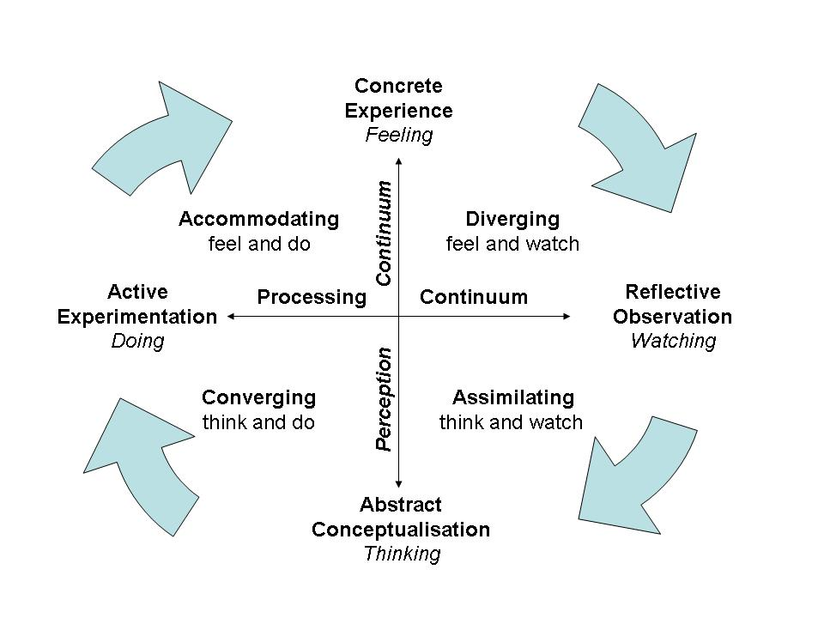
Figure 1: Kolb's Learning Style
Source: (Bard, 2017)
According to the model, learners engage themselves in activities and learn from experience. This is a reflective observation method of learning where learners observe, review and learn for experience of self and others (Benson, 2015). This is a continuous process of experiencing, evaluating and learning. I can follow this model in developing my professional skills so that I can cope with the employability skills required by the employers.

4. Self-Managed Learning and Lifelong Learning
Self-managed learning is the way of learning in which the learners make their own strategy of learning and learn at their own effort (Bolton and Delderfield, 2015). And lifelong learning is the process when the learners continue their learning process so that they can cope up with the advancing world (Estrella, 2010). I need to do follow the self-managed learning process to develop my professional skills. Kolb’s learning approach can be followed in my self-managed learning process.
Divergent
The divergent process of learning encourages the learner to think from different perspective. There can be number of solutions of a single problem (Gibbs and Maguire, 2016). Divergent learning process will make me able to find out the best solution of any problem and make important decisions while performing my job.
Assimilating
Assimilating process suggests thinking about a task before performing it. The learner thinks in divergent ways and finds probable solutions of the problem and then can find the best solution by thinking about the effects after applying the solution (Haasler, 2013). I can select the best way of developing my professional skills by applying assimilating process.
Converging
While going through the self-managed learning process I may face some situations when two different solutions may seem perfect. In this case, I need to find the best solution by the assimilating process and then take the right step for my professional development.
Accommodating
The accommodation process comes at the last stage of self-managed learning process (Keyte, 2018). In this stage, I will adopt the most appropriate way of developing my professional skills. To ensure my continuous career development, I need to evaluate my skills regularly and continue my self-managed learning process.

5. Holistic Planning and PDP
A proper planning is necessary for a successful development process. Holistic planning means the process of achieving the targeted success by using available resources (Luther, 2011). Holistic planning process helps an individual to make the best use of available resources and make plan successful. It is said that a perfect planning makes a work half done (O’Brien and Jones, 2014). So, if I want to develop my professional skills and want to increase my employability in the job market I need to make a holistic plan. I need to know about my available resources and opportunities before making a holistic plan. I have conducted a personal SWOT analysis in the previous section in this regard. The SOWT analysis shows my strengths and opportunities which a can use for developing my professional skills. It also shows my weaknesses and showed the areas I need to develop. I have made professional development plan according to the result of my reflective analysis. I have developed my own holistic planning for my professional skills development. It will take about 90 days to complete my professional skills development plan. Table 3 shows my skills development plan.
Table 3: Professional Development Plan
Skills | Objectives | Skills to improve | To be done by | To be completed within | Current Level | Expected Level
Professional Knowledge | Acquiring more knowledge related to the job | Gathering more knowledge on the related field to become an expert by advanced knowledge in the related field. | Attending professional courses, reading more and gathering more knowledge about the sector. | 90 days (1st February – 30th April) | 4 | 5
Experience | Gathering experience | Gathering practical knowledge about marketing activities of an organization. | Attending internship programmes and taking suggestions of experts about marketing activities. | 60 days (1st February – 30th March) | 2 | 5
Leadership skill | Becoming a successful leader | Gathering knowledge about leadership and becoming a successful manager. | Practicing leadership skills on current workplace and reading more about increasing leadership skills. | 60 days (1st February – 30th March) | 3 | 5
Communication skill | Developing communication skill | Increasing communication skills and being able to communicate with people with more confident. | Practising of listening, thinking and speaking confidently with people. | 30 days (1st February – 1st March) | 3 | 5

6. Monitoring Progress and Reflection
An effective planning can in vain if the plan is not being regularly monitored after implementation of it. After implementation of development plan, it is crucial to monitor the progress of plan on a regular basis (Rouse, 2010). Regular monitoring shows the level of progress and help in finding out the loop holes of the plan. Regular monitoring indicates the areas where the learner where there is needs to put more attention by the learner (Scott et al., 2015). I have developed my own professional development plan which has been showed in table 4. My plan will take about 90 days to be completed. I have monitored my progress after 30 days of implementation of plan. The following table shows my progress after 0 days of implementation of plan.
Table 4: Monitored Progress
Skills | Description of activity | By when to be completed | Current Level | Expected Level | Status
Professional knowledge | Gathering job specific knowledge by attending professional courses, reading books, articles, journals, online courses, case study and interview of the experts in this sector. | 60 days (1st March 2019-30th April 2019) | 4 | 5 | Not fully achieved. Further development can be gained by studying more.
Experience | Gathering experience by attending internship programmes and taking suggestions of experts about marketing activities. | 30 days  (1st March 2019 – 30th March 2019) | 4 | 5 | Not fully achieved. More time is needed to gather practical knowledge on the related field.
Leadership skill | Practicing leadership skills on current workplace and reading more about increasing leadership skills. | 30 days  (1st March 2019 – 30th March 2019) | 4 | 5 | Not fully achieved. More development needed to be done.
Communication Skill | Developing communication skills by practising of listening, thinking and speaking confidently with people | 30 days  (19th August – 18th September 2018) | 5 | 5 | Not fully Achieved, More development is needed.

By monitoring my development and evaluating my progress, I think that I am on the right track of achieving my professional skills. After 30 days of implementation of development plan, I have developed my communication skills. I can now talk to people with more confident that was absence on me previously. Better communication skills will help me in developing my other professional skills. I had no experience before implementation of the plan. Now I have experience of working on the related field. I will be able to gather more practical knowledge after completion of the whole plan. My developed communication plan is putting a positive impact on my leadership skill. My leadership skill has been developed by practicing and learning about leadership. I need to continue my learning process to increase my employability and to become successful in my professional life.

7. Effectiveness of Development Plan
It is necessary to understand effectiveness of the plan after implementation of development plan (Seabrooke and Nilsson, 2014). I have monitored my implemented plan in the previous section. I have measured effectiveness of my career development plan in this section which has been described below.
Objectives
Objectives needed to be SMART which means to be specific, measurable, attainable, relevant and timely. I have also set SMART objectives for my professional development which are as followed.
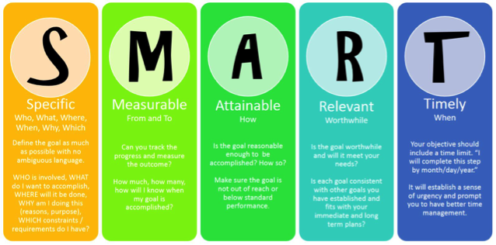
Figure 2: SMART Objectives
Source: (Bard, 2017)
- To establish a successful career in the marketing sector.
- To develop my skills evaluating themselves with selected benchmark.
- To achieve my desired level of employability skills through hard work and practice.
- To become a successful marketing manager by developing the selected employability skills.
- My development plan will be achieved within 90 days.
Efficiency
As per my reflective analysis, I need to develop my professional knowledge, experience, leadership skill and communication skill to achieve my targeted professional goal. Monitoring of my development plan indicates that all of my employability skills are developing by following the plan. My development plan is efficiently working on developing my employability skills.
Quality
My professional development plan is working on developing quality of my skills. I can now communicate with people more confidently and efficiently that I could not do previously. Leadership skill, team working and other skills has also been improved by implementation of the development plan.
Accuracy
Monitoring and evaluation of my development plan shows that I am going on the right track of my development process. This means that I am following the accurate plan for developing my employability skills. I have already developed my communication skill. Other skills will also be achieved within the targeted period of time.

8. Areas for Development and Current Need
After evaluating my skills and after monitoring my development, I think that I have potentialities to become a marketing manager. I evaluated my own skill and competencies to understand my job readiness. I have conducted personal SWOT analysis in this assignment and have found out my strengths and weaknesses. Then I decided to utilize my available skills and to develop the skills which I am lack in. I analysed the skills which I must have to possess to make me a successful professional. I need to develop some areas to achieve my career goal. My required areas for development and current needs are as followed.
Knowledge
A certain level of knowledge to the related field is necessary for becoming a successful professional. Education increases analytical ability and knowledge in the related field (Benson, 2015). As I want to develop my career as an assistant marketing manager, I need to have proper knowledge to the related field. Currently I am pursuing my bachelor degree; this will make me compatible for the job. I will increase my knowledge by self-managed learning process and will try to increase my practical knowledge of working in the field. I need to develop my knowledge more to ensure success in my career.
Skills
After evaluating my skills and competencies, I have found that I have some skills which will help me in developing my career as a successful marketing manager. I have good analytical and problem solving skills which will help me in taking intellectual decisions while performing as a marketing manager. I have a good level of technological skill and I can apply these skills for betterment of marketing activities of the organizations. Still there are some skills that I need to develop more. I need to develop my communication, leadership skills; I need to develop my experience and professional knowledge.
Confidence
Confidence is one of the most important qualifications that an employee needs to grow (Bolton and Delderfield, 2015). I evaluated hat my communication skill is not so good and I have lacking in experience of working on the related field. These things may influence on my lack of confidence. For increasing my employability, I am working on developing my skills and I need to increase my confidence as well.

9. Work Based Solution
Currently I am working in the sales department of KFC. A few months ago, the manager of sales department asked to do an analysis on how the sales of the organization can be increased. I started to collect information about sales of the organization. I took an overview of the sales trend of the organization and tried to find out the possible factors that can effect on the selling trend of the organization. I was in need of information about customers and market. I took interview of some customers and tried to understand their needs and demands from the company. An organization can increase its sales by meeting the needs of the customers. So, customer’s feedback about the organization and its products and services were an important factor to be considered. I also talked to the employees and staffs of the organization so that I can understand their ability to satisfy the customers. I analysed all the information after collecting them. I found that the customers of the organization are satisfied with the products offered. But they are not satisfied with some of the employees working in the organization. The manager also asked me to suggest some possible suggestions for increasing sales. After the analysis, I suggested about training the employees so that they can treat the customers more professionally. I also suggested implementing innovative ideas for marketing so that more customers get attracted to the products offered by the organization and sales volume increase. My analytical ability helped the organization in increasing their sales.

10. Time Management Strategies
Time management means to use available time efficiently while performing a task. Time management means not to finish the task in time; the task must be completed properly and efficiently (Estrella, 2010). Better time management helps employees to increase their productivity. Time management is an important thing to be considered while planning my professional development. I have selected a time frame for developing my professional skills. I have targeted to develop my skills within the selected period of time and increase my employability so that I can achieve my targeted job as soon as possible I can. I will follow the below mentioned strategies while performing my skills development process.
Setting Priorities and Goals
Before making a plan, it is necessary to select the tasks which are most important. Urgent tasks should give much priority that the other tasks which are comparatively less urgent (Gibbs and Maguire, 2016). I can follow Eisenhower time management matrix to find out my priorities. The following figure shows the Eisenhower matrix of time management.
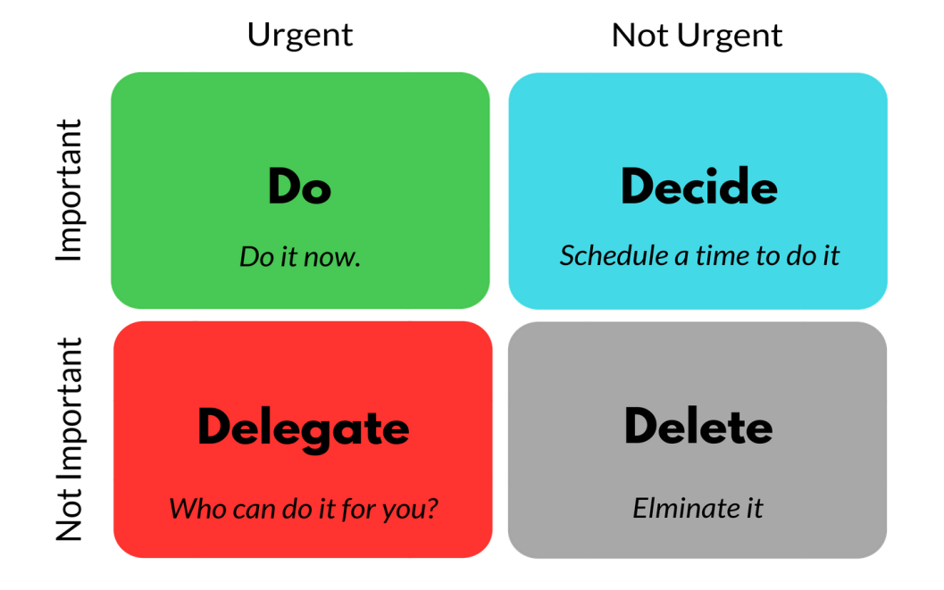
Figure 3: Eisenhower Matrix of Time Management
Source: (Haasler, 2013)
Elimination of Non-priorities
All the tasks in a plan are not equally important. Time management will be easy when the less important tasks are eliminated (Keyte, 2018). Technological skill is an important employability skill. But my technological skill is great. So I have eliminated the plan for developing these skills from my skills development plan.
Making a To-do List
I need to perform a lot of tasks while going through my professional development process. A to-do list will help me ensure my performance of the entire required task. I have make a daily routine for me which has made it possible for me continue my development process without missing any important task.
Creating an Effective Environment
Human being is greatly influenced by the environment (Luther, 2011). I think that I need to build a positive environment around me so that I can feel motivated and encouraged to do hard work for developing my employability skills and make me ready for the job. I have eliminated my bad time habits and become more organized than before which is helping me lot in my development process.

Conclusion
Proper planning and proper implementation of plans is the most important factor in achieving success of any activity. An appropriate planning can make a learner keep on the right track in the development process (O’Brien and Jones, 2014). Professional career development means to increase knowledge and expertise by acquiring transferrable skills and gathering knowledge so that he/she can increase employability in the job market (Rouse, 2010). Business organizations in this modern world need to face a greater level of competition in the market to survive than they were to face in the previous ages. Employers now search for the employees who have some employability skills that are required to make the organization successful (Scott et al., 2015). I have developed my own professional development plan in this assignment. For ensuring success of my development plan, I need to follow my development plan properly. I also need to regularly monitor my development process so that I can understand need of further skills development.

References
Bard, R. (2017). The Trainer's professional development handbook. San Francisco: Jossey-Bass.
Benson, C. (2015). Professional Development.
Bolton, G. and Delderfield, R. (2015). Reflective practice.
Estrella, M. (2010). The Vital Importance of Personal Development. Museum International, 62(3), pp.26-30.
Gibbs, P. and Maguire, K. (2016). The professional and personal values and their revelation through professional doctorates. Higher Education, Skills and Work-Based Learning, 6(3), pp.237-248.
Haasler, S. (2013). Employability skills and the notion of ‘self’. International Journal of Training and Development, 17(3), pp.233-243.
Keyte, P. (2018). Personal development. Oxford: Oxford University Press.
Luther, W. (2011). Development plan. New York: AMACOM.
O’Brien, J. and Jones, K. (2014). Professional learning or professional development? Or continuing professional learning and development? Changing terminology, policy and practice. Professional Development in Education, 40(5), pp.683-687.
Rouse, K. (2010). Personal development. South Melbourne: Oxford University Press.
Scott, Whiddon, Brown and Weeks (2015). The Journey to Authenticity: An Analysis of Undergraduate Personal Development. Journal of Leadership Education, 14(2).
Seabrooke, L. and Nilsson, E. (2014). Professional Skills in International Financial Surveillance: Assessing Change in IMF Policy Teams. Governance, 28(2), pp.237-254.

