Jac Cullen 2400132

TASK A.
Part 1:
A production area in a factory measures 60 metres x 24 metres x 8 metres in height. The factory’s work benches are set at a height of 1m above the floor level. The area’s reflectance's are 0.3 for the ceiling and 0.5 for the walls. The Lighting design specifies fluorescent lamps in recessed louvre with DLOR of 50%.
A Lighting Design Lumen (LDL) output of 18,000 lumens is required.
The illumination required for the factory area is 200 lux at the working plane.
Light Loss Factor = 0.75
Calculate:
1) The Room Index
2) The Utilisation Factor (from tables)
3) The Number of lamps required
4) A suitable layout (value of S) for the lamp fittings
SHOW ALL YOUR WORKINGS AND UNITS AND INCLUDE THE UF SHEET WITH INTERSECTIONS CLEARLY MARKED.
Part 2:
Draw the plan layout on a scale drawing of the factory floor indicating your ‘best fit’ design for the luminaire installation.
Points on the row layout should indicate the position of the lamp centres.
NOTE: You may use a software design package to generate your lighting layout or draft this layout neatly by hand. All drawings must be to scale. Photographs of sketches of the lamp layout will NOT be accepted.
(65 marks)
TASK B:
Part 1:
With the support of academic references, Define frequency and the wavelength of a sound, and discuss the implication of dealing with these two parameters in:
(a) A building’s internal design and services support
(b) A partition wall’s construction technique
(c) The choice of Insulation types available.
(600 words in total for all parts a, b and c above) (20 marks)

Part 2:
(a) Define Thermal Transmittance and Thermal Resistance and explain the relationship between these two parameters when calculating heat loss through the building’s fabric.
(b) Illustrate, by means of your own supporting diagram, how Thermal Conductivity is measured, and explain why ‘material type’ and ‘distance’ are contributary factors in this calculation.

ANSWERS
Task A
Part 1
1)
Room index = (L x W) / (H_{m} (L + W)
Room index = (60 x 24) / 7 (60 + 24)
Room index= 2.4489
Room index=2.45
2)
0.44
3)
N=E x A / F x UF x LLF
N=200 x (60 x 24) / 18000 x 2.45 x 0.75
N=29.4
N=30 Lamps required
4)
S_{max}=1.5 x 7
S_{max}=10.5
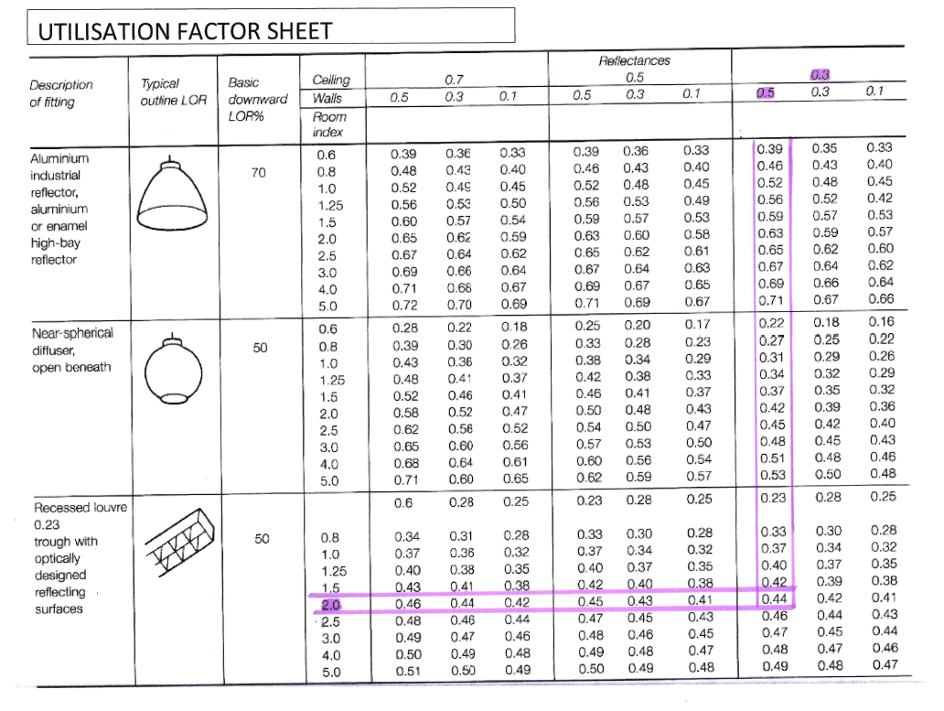

Part 2
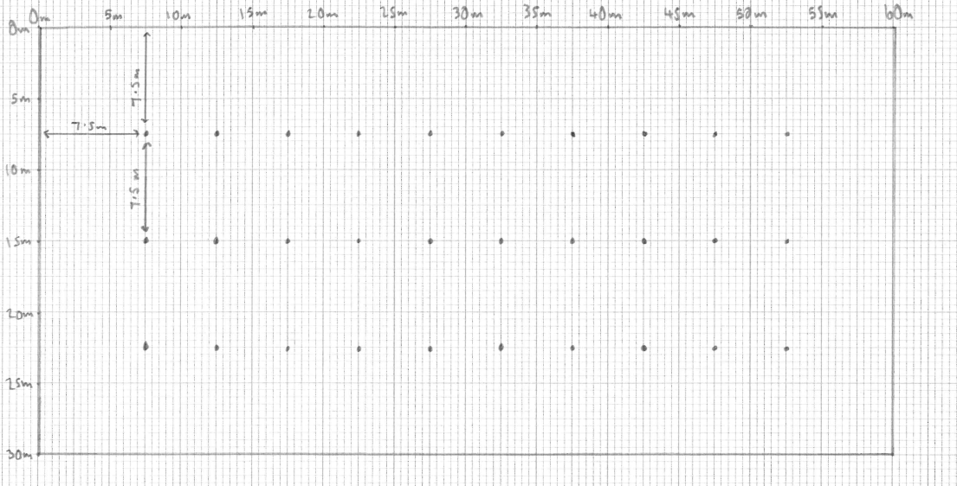

Task B
Part 1
Frequency –
Frequency is the amount of times a sound wave repeats itself per second
Wavelength-
Wavelength is the distance between a peak of a sound wave and the next peak
Buildings internal design and services support-
Internal design is crucial to how much sound will be absorbed etc in a building. As we know there are multiple types of sound but I would assume that the most common noises that would effect the internal design would be impact sound which would be a low frequency and long wavelength and airborne which would also be low frequency long wavelength . For example if you were to design a block of flats, you would need to heavily consider the fact that people will be effected by the impact sound of people walking etc and airborne would be general speech etc. To combat this I would suggest the possible addition on more insulation between floors and possibly adding a acoustic board to the ceilings in order to keep any sound created in the room.
Partition Walls-
Partition walls have the benefit of absorbing sound. As partition walls are not very thick the best noise for them to absorb would be high frequency short wavelength sounds, because it would not take that much for the wall to absorb the noise. Also if the sound was a low frequency and long wavelength the partition wall would have a slight effect on it making it slightly quieter as it passes through.
Choice of insulation types available-
Insulations main purpose is to keep heat in the building and the cold out. It also has the benefit of absorbing sound. If you were to use standard insulation then the best at absorbing sound would be the thicker it is. A possible different type of insulation would mineral wool/ rock wool as it is dense and therefore very effective in both aspects.

Part 2-
A
Thermal Resistance-
Thermal resistance is a measure of the opposition of heat transfer offered by a particular component in a building element and is measure as an “R-Value”
Thermal Transmittance-
Thermal transmittance is essentially the opposite of resistance and is an indication on how quickly heat can pass through the material, this is measure as a “U-value”

Part 2
B
Thermal Conductivity is measure of the rate at which heat is conducted through a particular material. Material type is very important in thermal conductivity because it will change how quick heat can be passed through the material. For example metals such as copper have a high thermal conductivity meaning heat passes through quickly where as plastics have a low thermal conductivity. Distance for example a cavity wall will also have an effect on thermal conductivity because the air filled gap between the internal and external walls acts as a barrier to heat transfer, air is a poor conductor of heat so having an air gap slows down the transfer of heat.
Internal wall
External wall

Air gap being a poor conductor leaves the cold air away from transferring with the warm air
Cold air

