Charlie Williams (2235685)
Computing (Networks and Cyber Security)
Changemakers: Creativity and Value Creation- ACCA5033

Project Management and Innovation

Table of Contents
- Introduction
- Task 1: Project Management
  - Project Management and Planning
  - Product Design
- Task 2: Innovation
- Task 3: Project Reflection
- Conclusion
- Reference List
- Appendix

- Introduction
This document is an essay on my project regarding a SIEM solution designed for home/small office use, utilising a SIEM, log forwarder, and log collector. Herein I will detail the management, considerations I must take during my project along with an analysis of a tech company that is related to the project itself.

2. Task 1: Project Management

- Project Management and Planning

The first step towards effectively managing my SIEM project is to define the scope of the project. The scope of the project will be small- it is only ever intended to be used on small scales, in home or small business environments. The problem is said small environments (particularly home environments) often have low levels of cyber resilience. Everyone knows about the obvious- antivirus and such. But SIEMs can be implemented at low cost and relatively low effort. My solution is to create an approachable configuration that can be deployed by anyone and instantly see a return on enhanced cyber security.
To achieve this, I will be using:
- Logscale community edition will the actual SIEM part, used to parse and look through logs.
- LogRhythm will be my collector for client machines.
- VMs for testing will be using Oracle VirtualBox.
- Filebeat for log forwarding

The timeline for the project will be as follows:
During week 1, I will begin my initial research into the requirements for the solution itself (likely via quantitative analysis) and begin the initial configuration for the virtual machine needed for testing.
During the second week, I will review the documentation available for Logscale, LogRhythm and Filebeat. This will help me highlight what steps are needed for the initial configuration of those systems- after which, I will implement them into the aforementioned virtual environment.
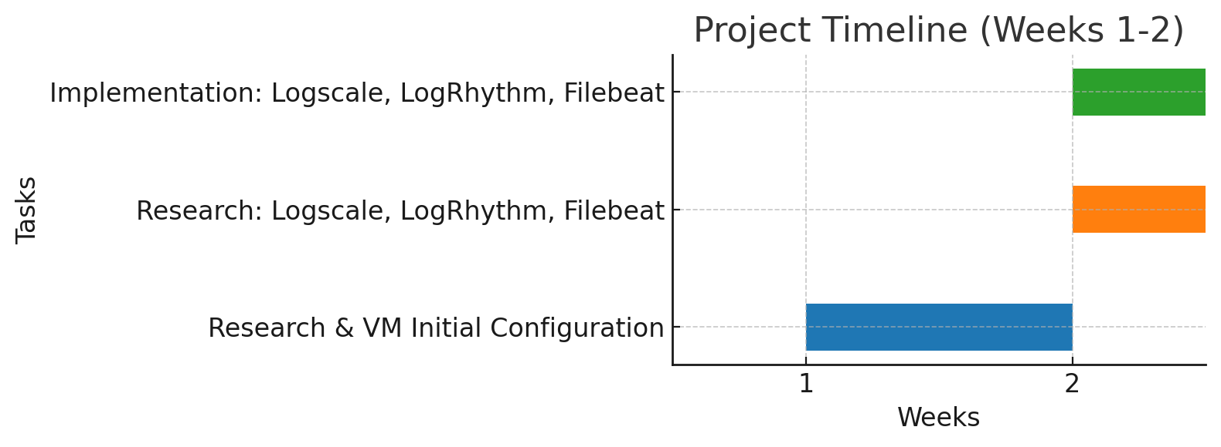
[1] Image generated using ChatGPT
The schedule for my project will be based around my work life. I will typically be working on it from 6pm - 8pm on weekdays where I am able to and on weekends.
This is how I expect the project to progress, represented in a Gantt chart:
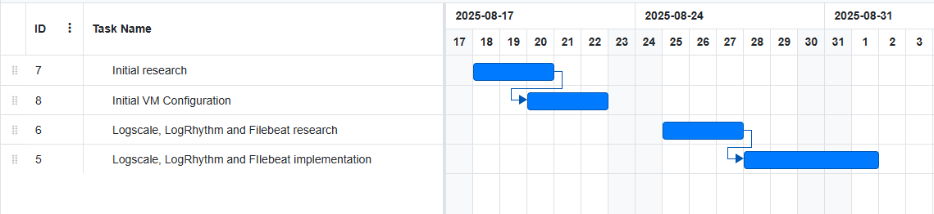
[2] created using https://www.onlinegantt.com/

I believe agile is likely the correct choice of development methodology for this project. There are a few key principles behind my reasoning for this:
- Working software over comprehensive documentation- this project is primarily aimed towards people who are not IT professionals and may not have the time or patience to spend time going through intensive documentation. The setup for this solution needs to be as a simple as possible. [3]
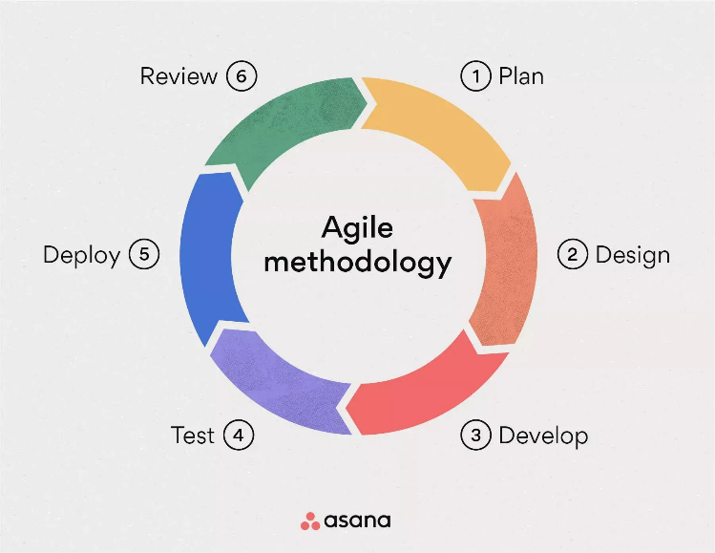
- The iterative process that agile represents is a good match for my project. I intend to do plenty of testing for this project which I will build the foundation of my solution on.
- Adaptability – adaptability is a core aspect of agile methodologies and enables the project to easily pivot from one direction to another without disrupting the flow of work [4].

[4] https://asana.com/resources/agile-methodology

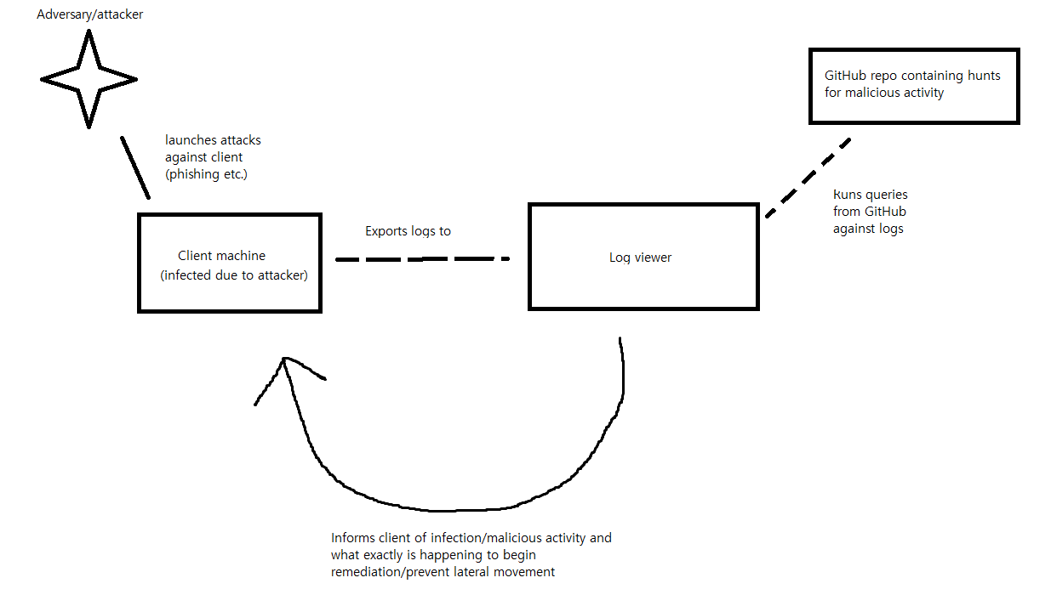
Here’s a simple diagram I created to explain how the system works. It will never work 100% of the time but will prevent lots of malicious activity. I think after creating this and reflecting, it’s probably worth including a service to automatically preform actions on a device following an alert. This could be things like file quarantine, isolating the device from the network, kicking off antivirus scans etc.

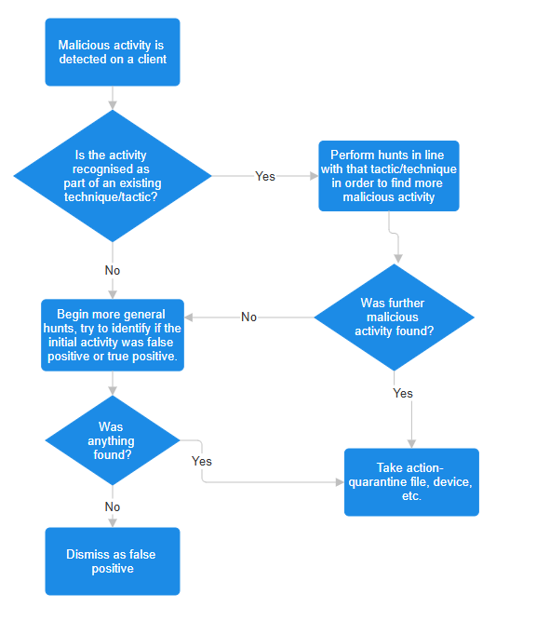
This is a flowchart I created using smartdraw.com [5]. It details the process in which one would respond to an incident after being highlighted by the SIEM in the previous graphic. The SIEM and corresponding repository of hunts for the SIEM would enable most people to complete incident response. I believe this is an improvement over what most people would currently do- delete the file the hope for the best, if they notice it at all.

- Task 2: Innovation
In this section, I will document a PEST/SWOT analysis taken of a tech company, along with what key considerations can be gleaned from that analysis. My tech company of choice is Crowdstrike.
First, PEST analysis. PEST (sometimes known as PESTLE, with the LE being legal and environmental) is a process in which the external environment for a company is evaluated [6]. This consists of considerations for the following:
- Political- this is related to the effect that global politics will have on the company. One form this frequently takes in my experience is regulations for organisations regarding cyber security and the various data protection laws. The specific regulations companies need to follow varies per industry but would almost certainly need to adhere to the GDPR.
- Economic- the obvious consideration for economics is the supply and demand for the products/services offered by the company, though there are other economic events that may affect the company, such as currency fluctuations [7].
- Social- Increasing numbers of remote workers paired with a growing expectation for companies to provide for staff accessibility needs mean increased costs, be it licenses for software, hardware, or increased training costs.
- Technological – currently, expectations for new features (especially AI features) will likely dominate/continue to dominate the market for tech companies [8]. AI integration into products and into the company’s own internal services are necessary to stay competitive in a rapidly evolving industry.
CrowdStrike currently does comply with GDPR and NIS2, which are necessary for them to continue business within the EU. As part of their services, they also assist other companies in becoming compliant with these. The demand for CrowdStrike’s services is certain to continue rising. They did suffer a setback due to a mistake in mid-2024 [9][10], but the excellent quality of their service makes them a serious competitor in the industry. CrowdStrike is one of many companies that benefits from increased remote working, as endpoints have an increasing demand for endpoint security. CrowdStrike makes excellent use of AI with their in-house AI, Charlotte [11][12].
Next, SWOT analysis. SWOT (or strengths, weaknesses, opportunities and threats) is the inverse of PEST in that it examines a company’s internal capabilities [6].
- Strengths – CrowdStrike is one of the leading EDR (endpoint detection and response) solutions available on the market. This is clear upon seeing their massive portfolio of customers, which was further highlighted during the aforementioned mistake in 2024 [9]. Many big companies utilised their services, including Microsoft, another market leader who possess their own in house EDR solution.
- Weaknesses – the products offered by CrowdStrike tend to be expensive. They are high quality, and the price is competitive for what is offered, but nonetheless some companies who wish to invest less into cyber security will opt for a cheaper EDR option. They did also take a big hit to their reputation- most non IT professionals likely only learnt their name during the outage, and this was the main thing they retained since then.
- Opportunities - As a market leader, CrowdStrike works with governments and country critical infrastructure [1][11], providing them with usually long-term and lucrative contracts. CrowdStrike offers excellent benefits for its staff, including upskilling among other things. This means that a variety of some of the brightest minds in the industry will want to work for CrowdStrike and reap those benefits.
- Threats- the main threat for CrowdStrike will likely always be Microsoft, specifically with their product, Microsoft Defender. The two products are distinct, and have different strengths, but neither is strictly better than the other. Other competitors include Sophos, Trend Micro, and Palo Alto Networks.

Finally, I want to mention the legal and ethical considerations for the company. CrowdStrike intakes unbelievably vast amounts of information and telemetry from clients (one example of this is their Falcon Overwatch service). They have both legal and ethical obligations to ensure that data is protected both from overzealous employees and external threats, in the form of limited access controls and encryption as necessary (or compliant with regulations like GDPR). Due to their size and the nature of their services, they hold a responsibility to ensure their own cyber security (and cyber security awareness) is incredibly robust. A supply chain attack from CrowdStrike could be absolutely devastating on customers and would damage their damage their reputation and customer base severely.

- Task 3: Project Reflection
My project idea is solid. Although basic, I think both the concept itself, and its execution, are vitally important for the continued efforts to train people on good cyber security standards. I think we ought to continue pushing people to enforce some cyber security methods on their home devices in the same way we enforce the use of strong passwords.
- I have a good amount of experience working within SIEMs- parsing, hunting, all things operations sided. I am not experienced with the initial setup and further configuration of SIEMs, so, to build out my skillset and earn my salt as a security professional, I want to learn things like this. This project is my way of working towards that goal.
- I believe strong cyber security for all will be a standard eventually. As has been proven repeatedly with massive cyber attacks on the public, such as with WannaCry ransomware attack of 2017 [14] or the Yahoo data breaches in 2013-2014 [15], we are all very much vulnerable to those intelligent or creative enough with negative intentions. Raising awareness for everyone and encouraging positive change is a step towards a more secure future and away from potentially life ruining attacks.
- The main issue with this project is likely the process of trying to make SIEMs and SIEM management “user friendly”. These kinds of software are designed by IT professionals, for IT professionals, and so rely on existing knowledge during their setup and use. Trying to make these things intuitive for most people will be difficult- especially initial configuration. I need to also ensure that all data is handled responsibly between the client machine and the SIEM.

- Conclusion
The tech industry as a whole is one of the fastest evolving industries in the world. This is due to the immense impact and number of scientific advancements made each year. Cyber security is a subcategory of the field that is moving at an especially accelerated pace- it is a constant arms race. The need for cyber security will likely exist for a long, long time, and in line with that, are advancements in cyber security both for organisations and for the people.
This project exists to prove that small scale cyber security operations are possible for anyone. Accessibility is one of the primary concerns for the project.
Careful considerations must be taken throughout the project to ensure responsibilities regarding the security of clients and their data, as was highlighted during the analysis on CrowdStrike using SWOT and PEST.

Reference List
[1] https://chatgpt.com/
[2] https://www.onlinegantt.com/
[3] https://www.atlassian.com/agile/manifesto
[4] https://asana.com/resources/agile-methodology
[5] smartdraw.com
[6] https://library.cityu.edu/researchguides/business/swot
[7] https://www.investopedia.com/articles/forex/080613/effects-currency-fluctuations-economy.asp#:~:text=Currency%20fluctuations%20are%20caused%20by,will%20fall%20relative%20to%20others
[8] https://www.mckinsey.com/capabilities/quantumblack/our-insights/the-state-of-ai
[9] https://en.wikipedia.org/wiki/2024_CrowdStrike-related_IT_outages
[10] My own anecdotal evidence- I was there when this happened and worked with Crowdstrike on it.
[11] Again, anecdotal- I work with this constantly among other platforms and can say it is excellent.
[12] https://www.peerspot.com/products/comparisons/charlotte-ai_vs_robust-intelligence
[13] www.crowdstrike.com/en-gb/platform/threat-intelligence/adversary-overwatch
[14] https://en.wikipedia.org/wiki/WannaCry_ransomware_attack
[15] https://en.wikipedia.org/wiki/Yahoo_data_breaches

