

Euan Kelly

Analysis of Electromagnetic Wave Propagation

University of Wales Trinity Saint David (UWTSD)
Ordnance Munitions and Explosives – Electromagnetic Radiation

BEng
Academic Year: 2023 - 2028

Supervisor: Stalin Jacob
Associate Supervisor: Jenifer Prince
April 2025

Academic Integrity Declaration
I declare that:
- The thesis submitted has been written by me alone.
- The thesis submitted has not been previously submitted to this university or any other.
- that all content, including primary and/or secondary data, is true to the best of my knowledge.
- that all quotations and references have been duly acknowledged according to the requirements of academic research.
I understand that knowingly submitting work in violation of the above statement will be considered by examiners as academic misconduct.

Abstract
This report uses high-frequency electromagnetic simulation software to detail the design, simulation, and analysis of a rectangular wave guide using a Vacuum and Teflon, as well as a half-wave dipole antenna.
In task 1a, a rectangular waveguide with Perfect Electric Conductor (PEC) walls and vacuum as the dielectric medium, with a relative permittivity of εr =1, was modelled on Ansys. A frequency sweep from 2 GHz to 30 GHz was executed to analyse the three propagating transverse electric (TE) modes. After reviewing the results, it was evident that the dominant mode was TE₁₀ due to the conclusion of its lower cutoff frequency shown through simulation and calculated theoretically.
In task 1b, the waveguide was filled with Teflon, with a relative permittivity of εr =2.1, resulting in a reduction of the cutoff frequency values due to the decreased phase velocity. The field patterns remained consistent with the Vacuum waveguide, but modal excitation occurred at a lower frequency due to the high permittivity of Teflon.
Task 2 focused on the design of a half-wave dipole antenna with a PEC structure and excitation through a lumped port with a port impedance of 50 Ohms. The calculated operating frequency was 1.29 GHz, which aligns with the graphs provided through the simulations. Equally, the radiation pattern produced by the half-wave antenna was as expected and formed 2 parallel lobes with minimal radiation along its length.

Table of Contents
Academic Integrity Declaration i
Abstract ii
List of Tables v
List of Equations vi
List of Abbreviations vii
1 Introduction 1
1.1 Background 1
1.2 Objectives 1
2 Methodology 2
2.1 Task 1: Rectangular Waveguide Simulation 2
2.2 Task 2: Half-wave Dipole Antenna 3
3 Results 5
3.1 Task 1: Waveguide Results 5
3.1.1 Vacuum Filled Waveguide Results 5
3.1.2 Teflon Filled Waveguide Results 6
3.2 Task 2: Antenna Results 7
4 Discussion 9
4.1 Waveguide Mode Behaviour 9
4.2 Antenna Performance 9
5 Conclusion 10
6 References 11
7 Appendices 12

Table of Figures
Figure 1 - Radiation Boundary of Dipole Antenna 4
Figure 2 - Mode 1 of a Vacuum-filled Waveguide 5
Figure 3 - Mode 2 of a Vacuum-filled Waveguide 5
Figure 4 - Mode 3 of a Vacuum-filled Waveguide 6
Figure 5 - Mode 1 of a Teflon-filled Waveguide 6
Figure 6 - Mode 2 of a Teflon-filled Waveguide 7
Figure 7 - Mode 3 of a Teflon-filled Waveguide 7

List of Tables
Table 1-1 A table caption 2

List of Equations
Equation 1 - Cutoff Frequency of a Rectangular Waveguide 3
Equation 2 - Operating Frequency 3
Equation 3 - Speed of Light 16

List of Abbreviations
PEC | Perfect Electric Conductor
TE  TM | Transverse Electric  Transverse Magnetic

Introduction

Background
High-frequency electromagnetic systems are crucial components in modern communication methods and radars. This requires efficient transmission pathways.
Waveguides allow for this to happen. A waveguide is a specialised structure designed to direct and control the propagation of electromagnetic waves. The purpose of a waveguide is to ensure electromagnetic waves travel from one point to another with minimal interference or noise. [1]
Dipole antennas also contribute to the efficient transmission and reception of electromagnetic waves. A dipole antenna serves two purposes: converting electrical signals and transmitting them into radio waves, and vice versa, by receiving and converting incoming radio waves into electrical signals. [2]

Objectives
This report analyses electromagnetic wave behaviour in a rectangular waveguide using different dielectric materials and a half-wave dipole antenna. By running these simulations through Ansys, it will allow comparison to existing theoretical theories, such as how changing the dielectric materials of a rectangular waveguide can influence the cut-off frequency.
Task 1a and 1b will consist of a simulation of a vacuum-filled and Teflon-filled rectangular waveguide to display its propagating modes and determine their cutoff frequencies, as well as their dominant mode.
Task 2 will demonstrate the operating frequency, return loss and whether the antenna demonstrates resonance at the expected values in relation to its wavelength.

Methodology

Task 1: Rectangular Waveguide Simulation
The waveguide dimensions consist of width (a), height (b) and length (50mm) along the x-axis. To calculate the a and b values, my student ID number was required (231344).
a= first 2 numbers of the student ID = 23
b= $\frac{3rd and 4th number of the student ID}{2}$ (rounded to the nearest integer) = 7
Consistent simulation parameters were used to facilitate a fair comparison between dielectric materials. These included a common frequency sweep of 2 GHz—30 GHz and maintaining the same waveguide dimensions. This ensured that the different behaviours analysed could be confidently compared against the varying dielectric materials.
2 dielectric materials were used to compare, as they have different Relative Permittivity (εr) values and therefore will influence the propagation of waves through the waveguide due to a lower cutoff frequency. [3]
Vacuum εr = 1
Teflon εr = 2.1
The waveguide was modelled with Perfect Electric Conductor (PEC) walls and a vacuum-filled medium to simulate the required propagation conditions. Wave ports were then applied to either end of the waveguide, designated as port 1 and port 2, to allow excitation of the electromagnetic waves. To gain an effective sample of results, the first three TE modes were propagated through the waveguide to demonstrate the field patterns.
Once these modes have been simulated, a gamma plot can be produced to display the cut-off frequencies for their respective modes. The values of the graph will then be compared against the cut-off frequency calculated theoretically using the following cut-off frequency equation:
$$f_{c}=\frac{c}{2\sqrt{εr}}\sqrt{{\left(\frac{m}{a}\right)}^{2}+{\left(\frac{n}{b}\right)}^{2}}$$
Equation 1 - Cutoff Frequency of a Rectangular Waveguide
Where:
m = number of half-wave length variations of the electric or magnetic field in the width of the waveguide.
n = number of half-wavelength variations in the height of the waveguide.
a = width of the rectangular waveguide
b = height of the rectangular waveguide
c = velocity of light in selected dielectric material

Task 2: Half-wave Dipole Antenna
Task 2 featured a half-wave dipole antenna using a PEC material. The dimensions were derived from the student ID 2313449, using the first 3 numbers to gain the wavelength (λ), giving 231. As the λ=231, an operating frequency of 1.29GHz was expected based on the equation:
$$f=\frac{c}{λ}$$
Equation 2 - Operating Frequency
Where:
f = operating frequency
λ = wavelength
c = speed of light
$$= \frac{3x{10}^{8}}{231}=1.29GHz \left(2dp\right)$$
As this dipole antenna is half-wave, its length is calculated by halving the wavelength, giving a length of 115.5.
The antenna was modelled within a symmetrical cylinder with a 1mm radius, where excitations were formed through lumped ports set at an impedance of 50 Ohms (Ω). A radiation boundary box was placed around the antenna to simulate a free-space area to allow analysis of the antenna's radiating waves, this can be seen in Figure 1.
$​$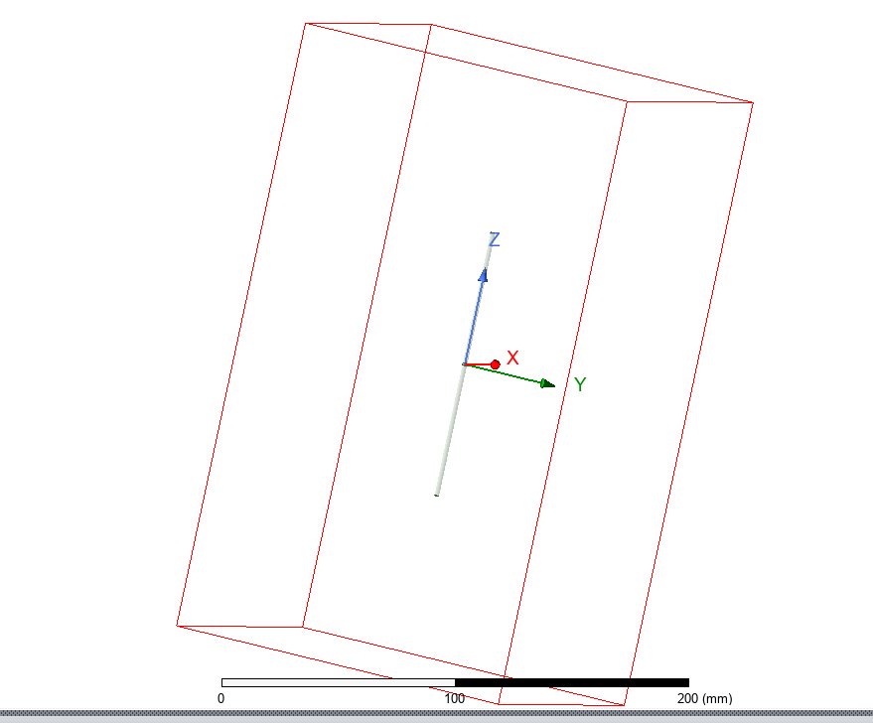
Figure 1 - Radiation Boundary of Dipole Antenna

A frequency sweep was then established between 2 GHz - 30 GHz to ensure the expected resonance frequency of 1.29 GHz was captured, as well as any other unexpected results could be analysed.

Results

Task 1: Waveguide Results

Vacuum Filled Waveguide Results
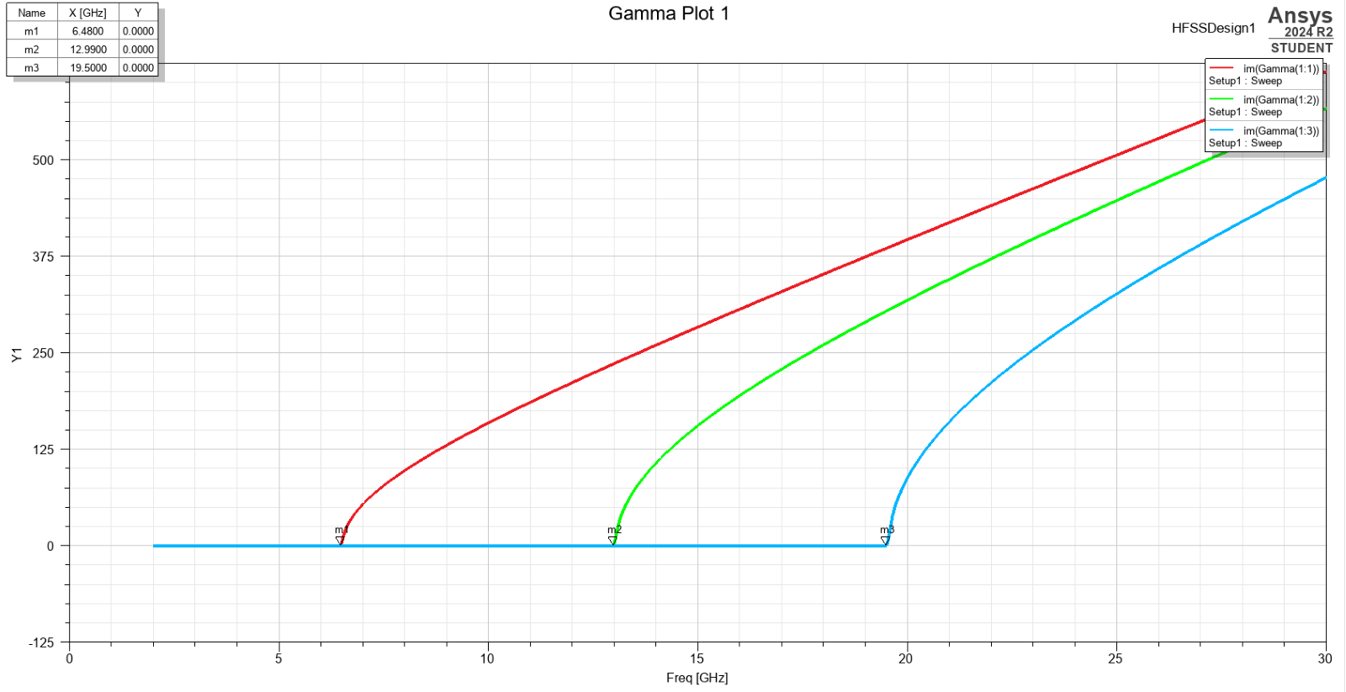
Figure 2 - Gamma Plot of Cut-off Frequency in Vacuum-filled Waveguide
Gamma plot results from Figure 2 display a comparison of the three TE modes for the vacuum-filled waveguide. It is identifiable that Mode 1 is the dominant mode here due to its lower cut-off frequency, 6.48 GHz, compared to Mode 3 at 19.5 GHz. This makes it the dominant mode as it allows Electromagnetic waves to propagate at a lower frequency through the waveguide, increasing the efficiency of waves passing at low frequencies. [3]
The three TE modes for Vacuum can be identified propagating along the waveguide in Figures 3,4, and 5. Mode 1 displays TE₁₀, Mode 2 TE₂₀ and Mode 3 TE₃₀. Mode 1, the dominant mode, only features 1 halfwave along its x-axis and none along the y-axis. In comparison, Mode 2 has 2 along the x-axis and none along the y-axis. This further supports the evidence through simulation that Mode 1 is the dominant mode with a lower frequency, as increased quantities of half-wavelength variations across the waveguide increase the cut-off frequency. [4]
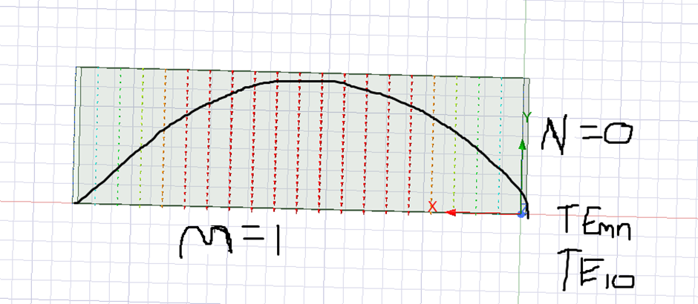
Figure 3 - Mode 1 of a Vacuum-filled Waveguide
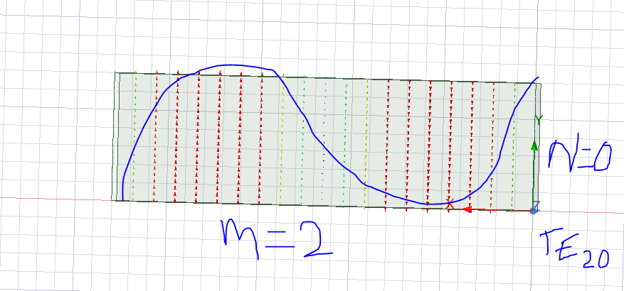
Figure 4 - Mode 2 of a Vacuum-filled Waveguide

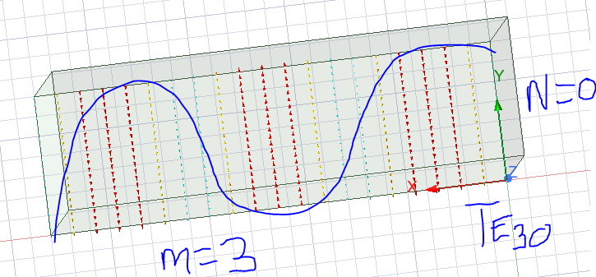
Figure 5 - Mode 3 of a Vacuum-filled Waveguide
Using Equation 1, it is now possible to find the cutoff frequency ($f_{c})$.
Vacuum has a Relative permittivity εr of 1 and a Relative permeability μr of 1.
$$f_{c}=\frac{c}{2\sqrt{εr}}\sqrt{{\left(\frac{m}{a}\right)}^{2}+{\left(\frac{n}{b}\right)}^{2}}$$
$$f_{c}=\frac{c}{2}\sqrt{{\left(\frac{m}{a}\right)}^{2}+{\left(\frac{n}{b}\right)}^{2}}$$
$$f_{c}=\frac{{3x10}^{8}}{2}\sqrt{{\left(\frac{1}{0.023}\right)}^{2}+{\left(\frac{0}{0.007}\right)}^{2}}$$
$$f_{c}={1.5x10}^{8}\sqrt{{\left(\frac{1}{0.023}\right)}^{2}}$$
$$f_{c}={1.5x10}^{9}$$
$$f_{c}=6.52 GHz$$

Figures 6,7, and 8 display the magnitude of the electric field within the vacuum-filled waveguide. The image shows the electric field stronger at either end of the waveguide due to electric fields propagating horizontally along the waveguide because the signals are transverse electric, as seen in Figures 3,4, and 5.
It would be expected that Mode 1 would have the highest Electric field value, 7526.057v/m, as its lower cut-off frequency means it requires lower frequencies to be activated. However, in this case, Mode 2 is slightly larger, 7770.206 v/m, with an expected drop off to Mode 3, 6162.038 v/m. This could be due to the concentration of fields on the waveguide, which focuses the fields into a more compact region.
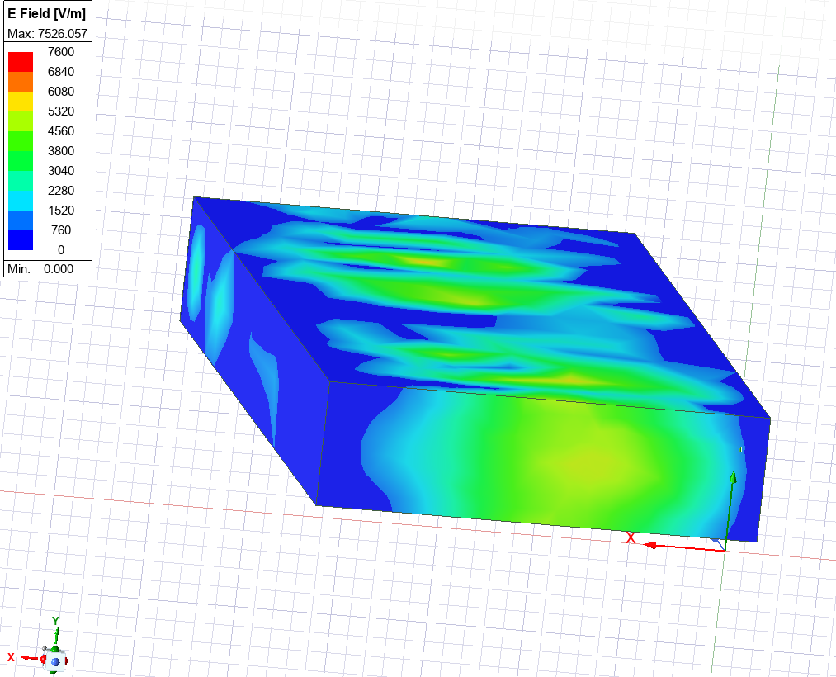
Figure 6 - Mode 1 Vacuum-filled Waveguide Displaying Magnitude of Electric Field
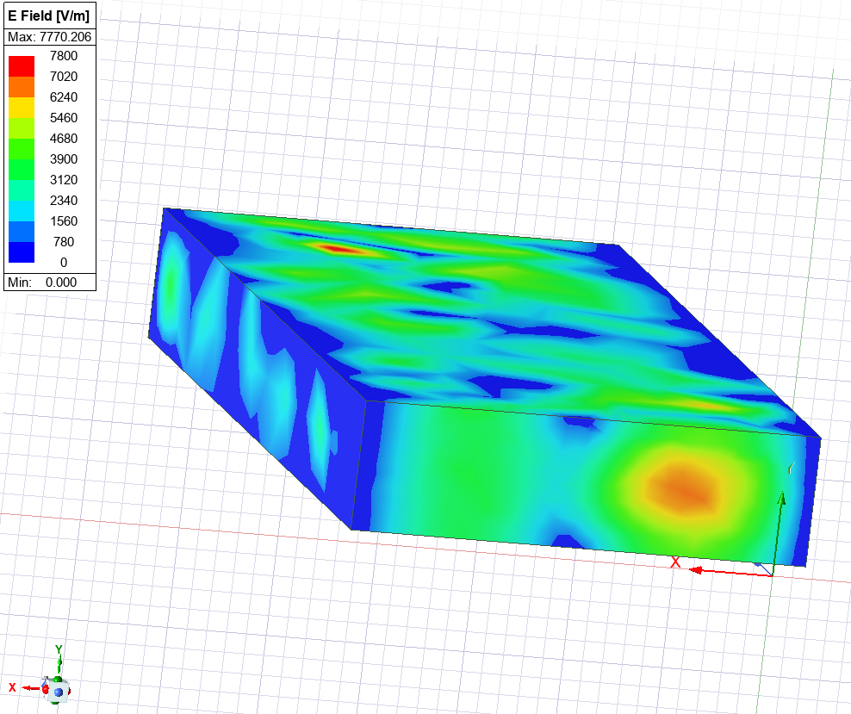
Figure 7 - Mode 2 Vacuum-filled Waveguide Displaying Magnitude of Electric Field
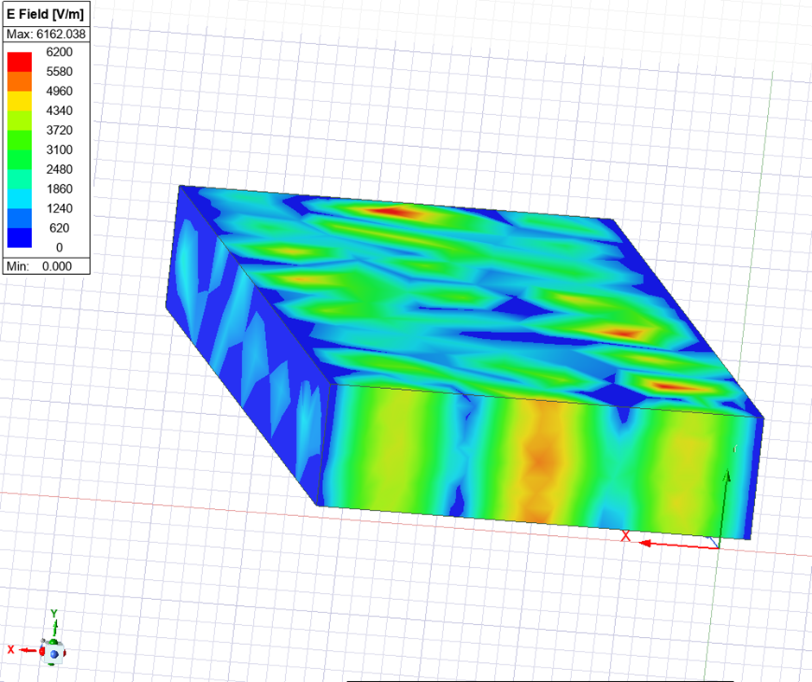
Figure 8 - Mode 3 Vacuum-filled Waveguide Displaying Magnitude of Electric Field

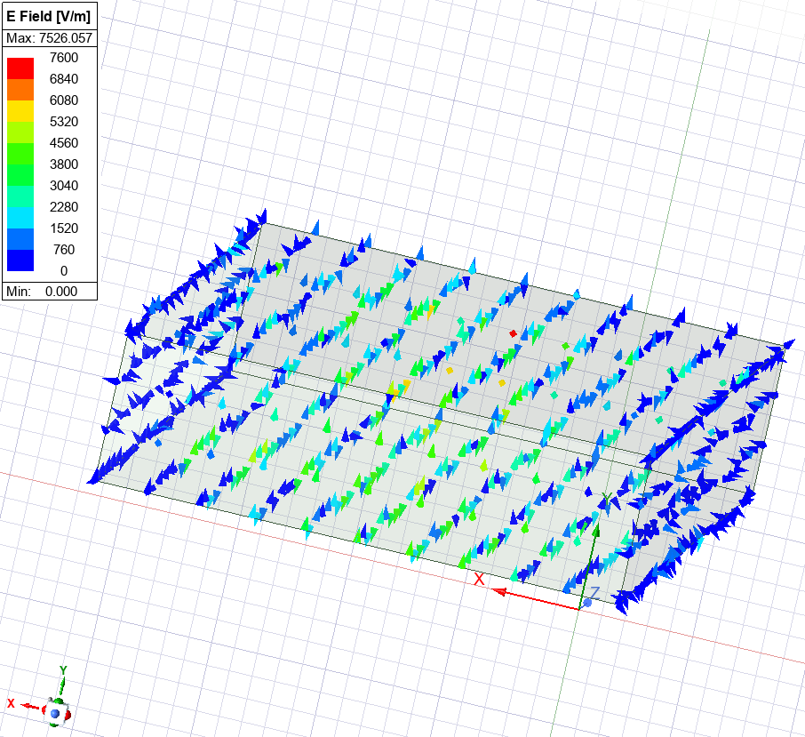
Figure 9 - Mode 1 Vacuum-filled Waveguide Displaying Vectors of Electric Field
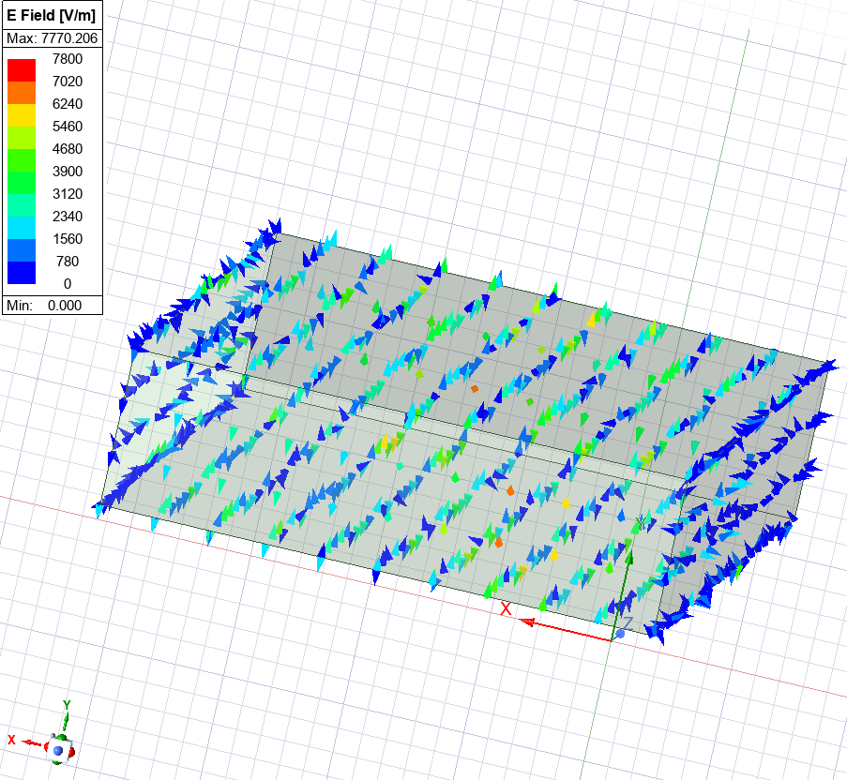
Figure 10 - Mode 2 Vacuum-filled Waveguide Displaying Vectors of Electric Field
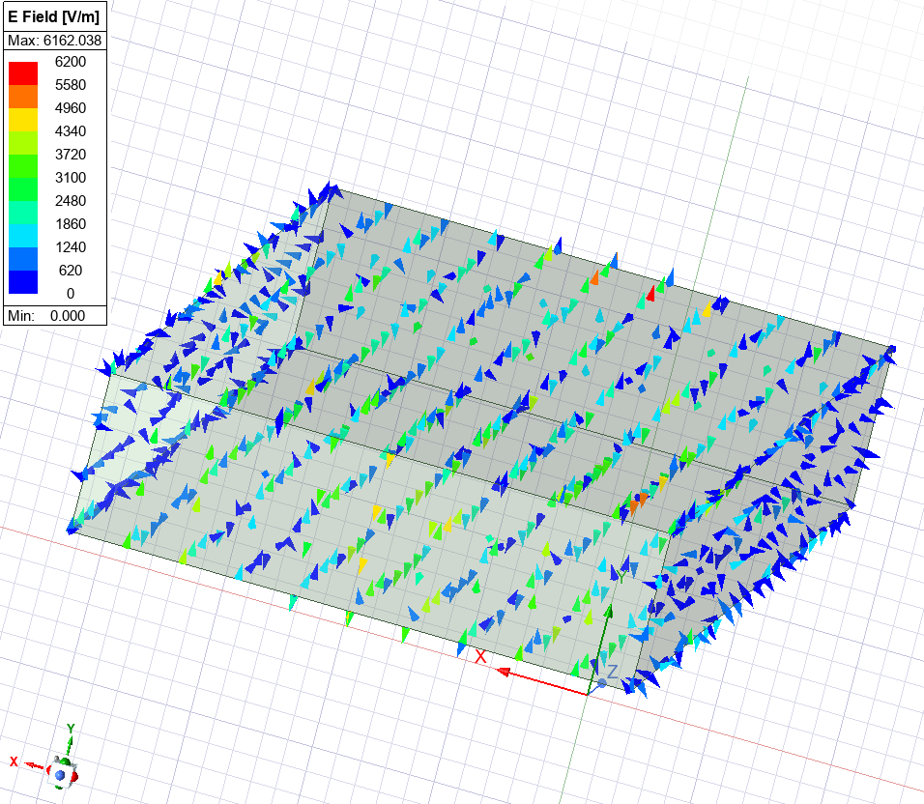
Figure 11 - Mode 3 Vacuum-filled Waveguide Displaying Vectors of Electric Field
In figures 12, 13, and 14, it is visible that the magnitude of the magnetic field is stronger in mode 1, as expected; this is due to the first mode to propagate typically carrying the majority of input power when no other modes are active. [5]. This can be seen as the max A/m in Mode 1 is 17.728 and decreases across modes until Mode 3 its max reaches 10.000.
The figures display a stronger force along the alternate axis of the electric field as the magnetic field propagates in a circular motion around the electric field, as per Ampere's Law [6].

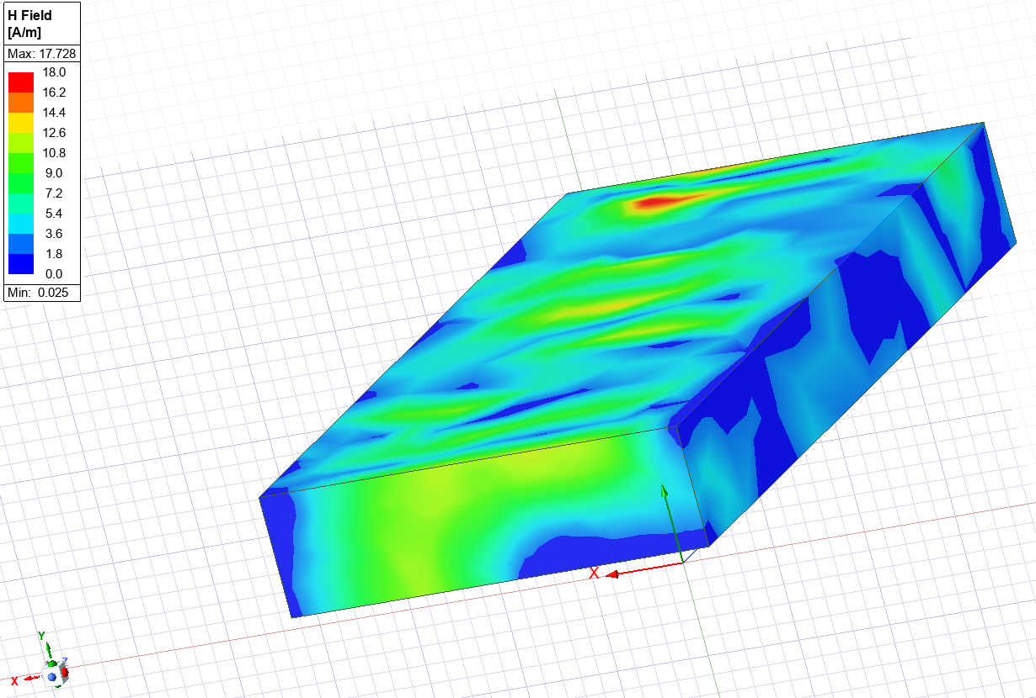
Figure 12 - Mode 1 Vacuum-filled Waveguide Displaying Magnitude of Magnetic Field
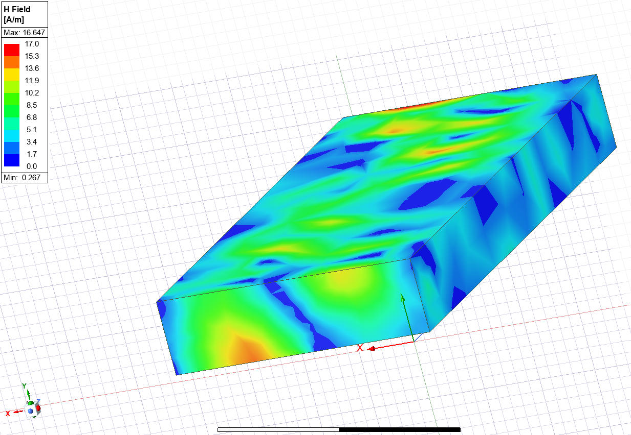
Figure 13 - Mode 2 Vacuum-filled Waveguide Displaying Magnitude of Magnetic Field
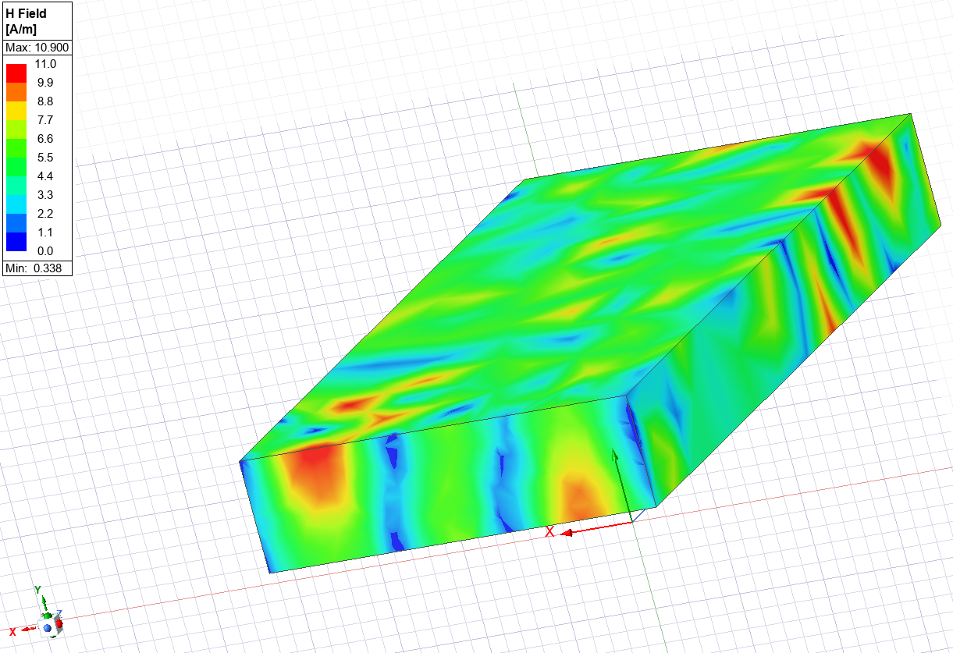
Figure 14 - Mode 3 Vacuum-filled Waveguide Displaying Magnitude of Magnetic Field
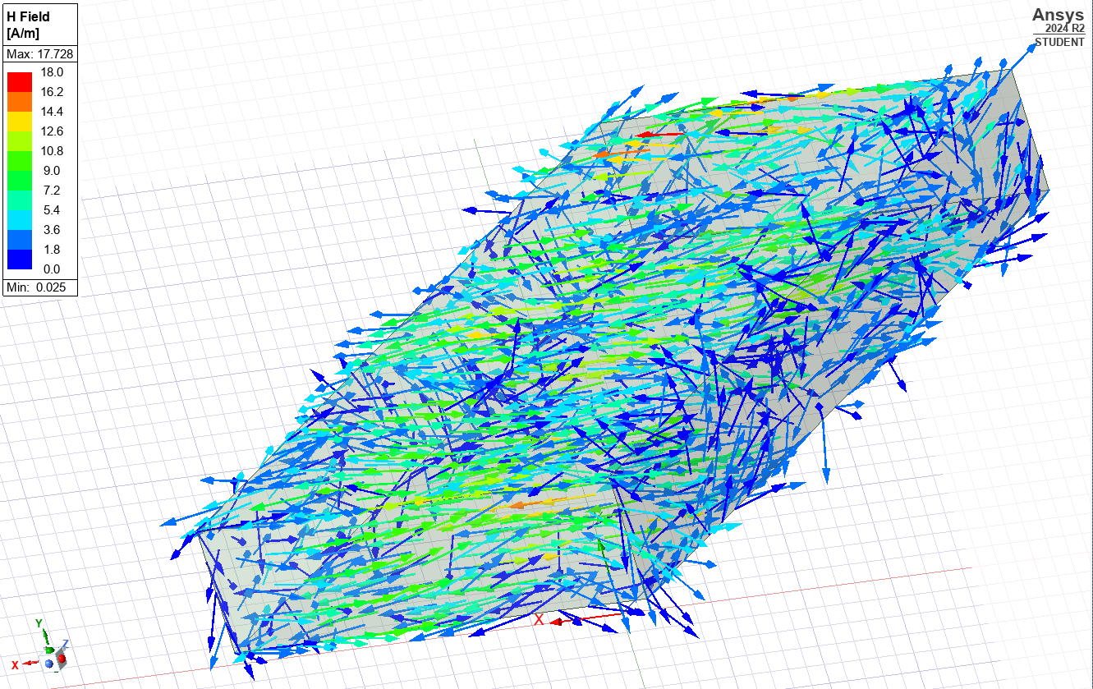
Figure 15 - Mode 1 Vacuum-filled Waveguide Displaying Vectors of Magnetic Field
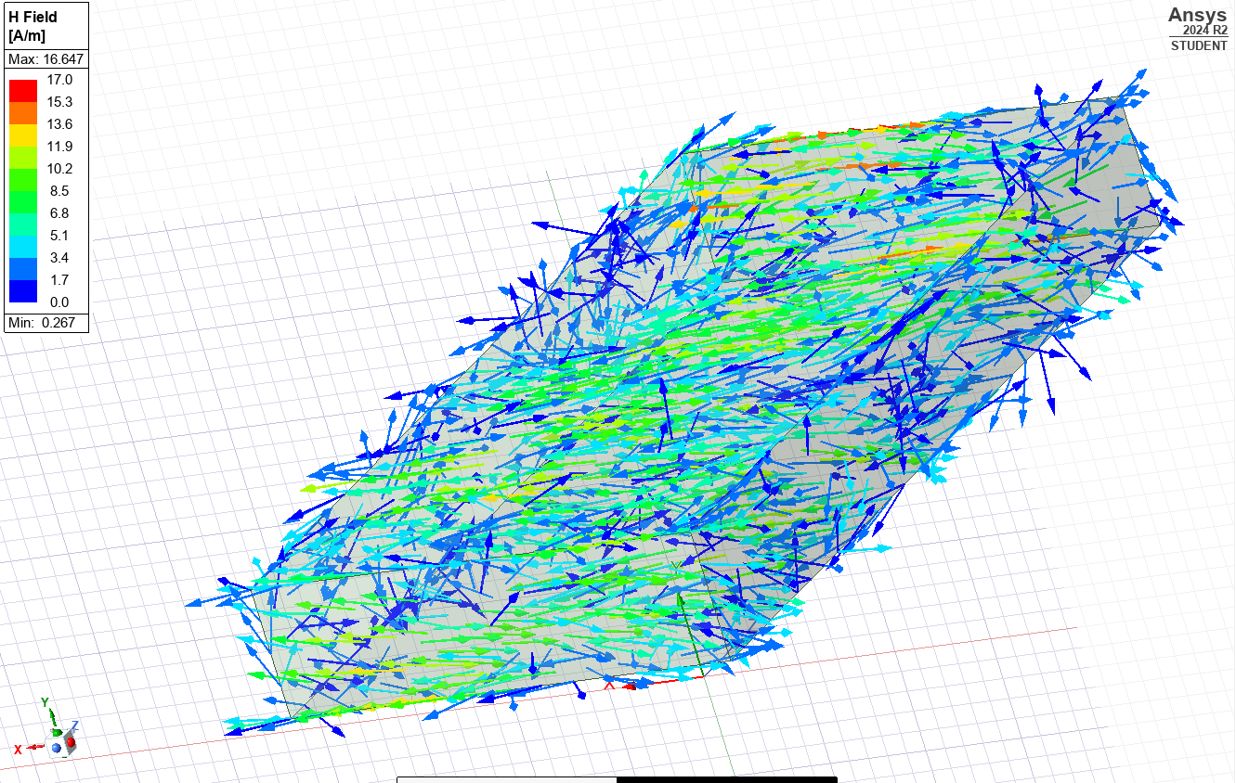
Figure 16 - Mode 2 Vacuum-filled Waveguide Displaying Vectors of Magnetic Field
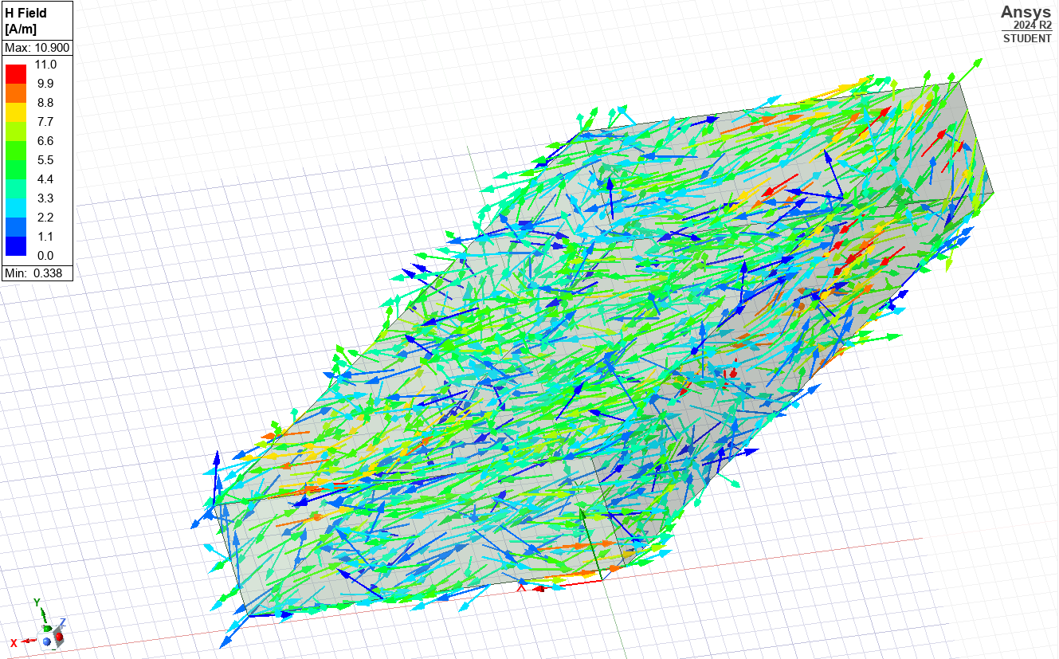
Figure 17 - Mode 3 Vacuum-filled Waveguide Displaying Vectors of Magnetic Field

Teflon Filled Waveguide Results
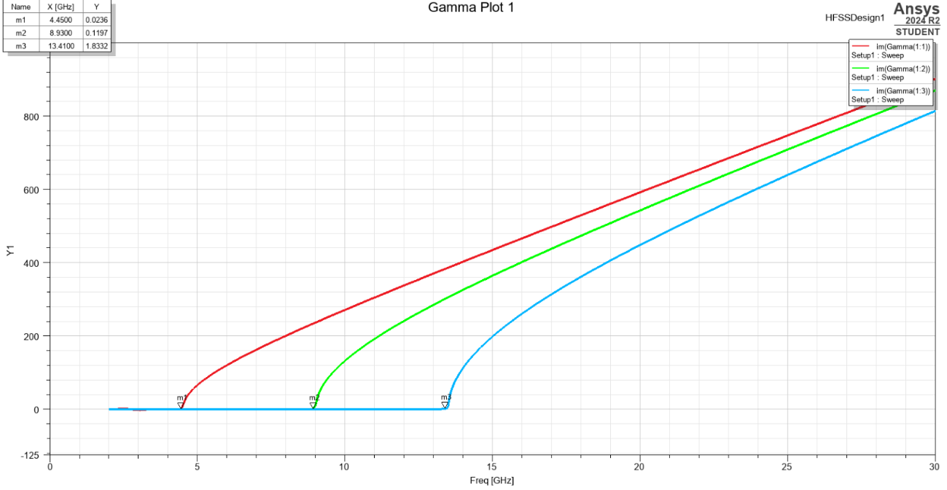
Figure 18 - Gamma Plot of Cut-off Frequency in Teflon-filled Waveguide
Identical to Figure 2, Mode 1 remains the dominant mode in Figure 18, with a lower frequency when using an alternate dielectric material. The Mode 1 cut-off frequency is 4.4500 GHz, with Mode 3 displaying 13.4100 GHz.
The three TE modes for Teflon can be identified through Figures 19,20, and 21. Mode 1 displays TE₁₀, Mode 2 TE₂₀ and Mode 3 TE₃₀. Just like Vacuum, the modes show an increase in one halfwave along the x-axis as the modes increase; no modes were ever identified along the y-axis.
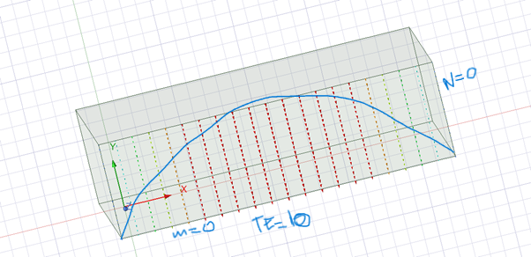
Figure 19 - Mode 1 of a Teflon-filled Waveguide
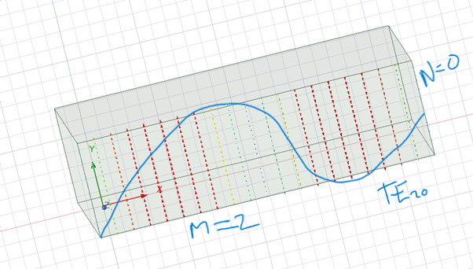
Figure 20 - Mode 2 of a Teflon-filled Waveguide
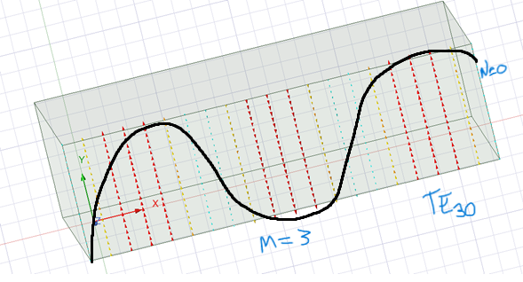
Figure 21 - Mode 3 of a Teflon-filled Waveguide

Using Equation 1 to calculate the cut-off frequency is now possible:
Firstly, the speed of light must be calculated through Equation 3:
$$C=\frac{1}{\sqrt{εμ}}$$
Equation 3 - Speed of Light
$$ε=ε_{0}ε_{r}$$
$$μ= μ_{0}μ_{r}$$
$${permitivity of free space (ε}_{0})=8.854 x {10}^{-12} f/m$$
$$relative permitivity {(ε}_{r})=2.1$$
$${permability of free space (μ}_{0})=4π x {10}^{-7}H/m$$
$$μ_{r}=relative permability=1$$
$$C= \frac{1}{\sqrt{ε_{0}ε_{r}μ_{0}μ_{r}}}$$
C $= \frac{1}{\sqrt{8.854 x {10}^{-12}x2.1x4π x {10}^{-7}x1}}$
$$C= 2.07x{10}^{8} m/s$$
$$f_{c}=\frac{c}{2\sqrt{εr}}\sqrt{{\left(\frac{m}{a}\right)}^{2}+{\left(\frac{n}{b}\right)}^{2}}$$
$$f_{c}=\frac{2.07x{10}^{8}}{2\sqrt{1}}\sqrt{{\left(\frac{1}{0.023}\right)}^{2}+{\left(\frac{0}{0.007}\right)}^{2}}$$
$$f_{c}=\frac{2.07x{10}^{8}}{2}\sqrt{{\left(\frac{1}{0.023}\right)}^{2}}$$
$$f_{c}=1.035x{10}^{8}\sqrt{{\left(\frac{1}{0.023}\right)}^{2}}$$
$$f_{c}=1.035x{10}^{8}\sqrt{{\left(\frac{1}{0.023}\right)}^{2}}$$
$f_{c}=4.5x{10}^{9}Hz$
$$f_{c}=4.56 GHz$$

Figures 22, 23, and 24 show the magnitude of the electric field within the Teflon waveguide. As expected, the v/m declines as the modes progress, in contrast to the vacuum, where this did not happen.
Just like the vacuum waveguide, the electric field can be seen propagating from each end of the waveguide due to the transverse electric waves.
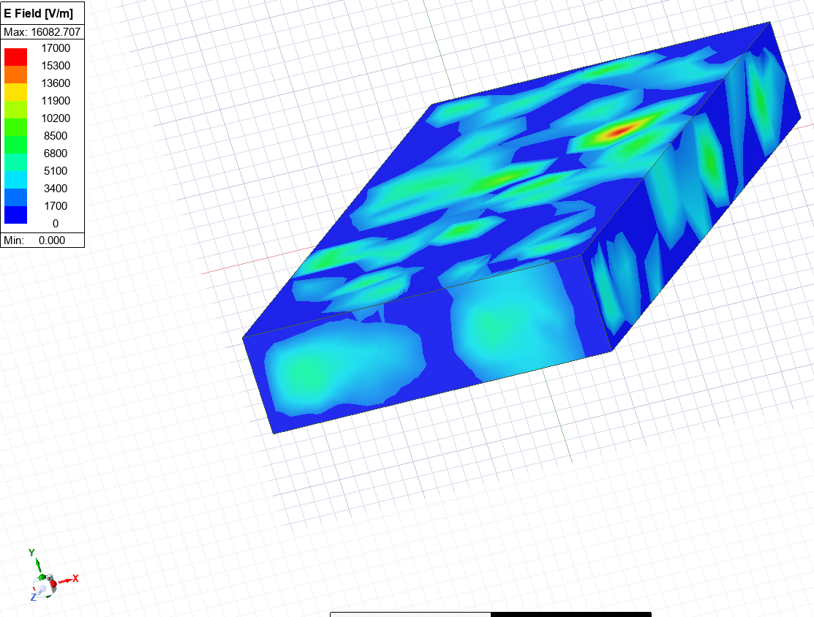
Figure 22 - Mode 1 Teflon-filled Waveguide Displaying Magnitude of Electric Field
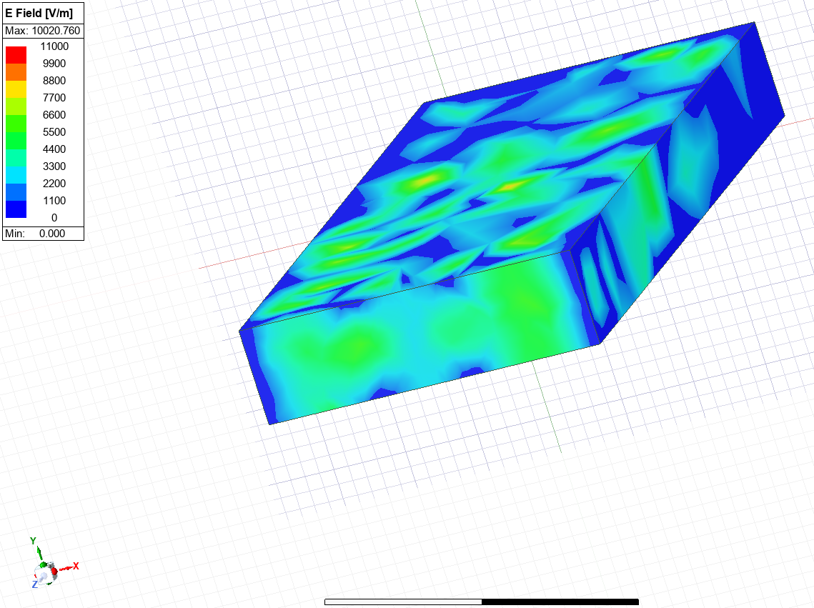
Figure 23 - Mode 2 Teflon-filled Waveguide Displaying Magnitude of Electric Field
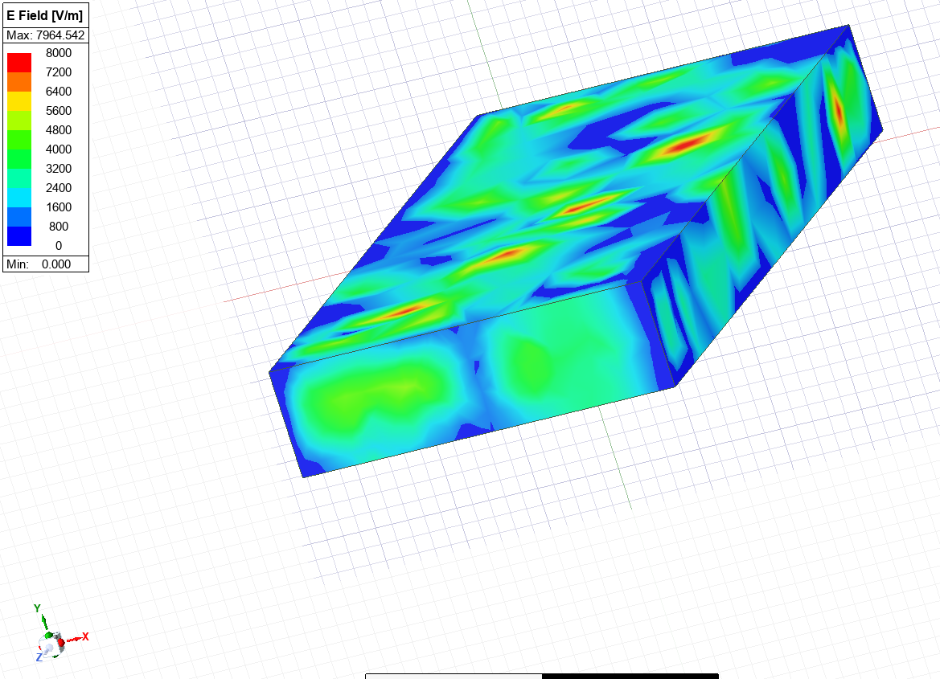
Figure 24 - Mode 3 Teflon-filled Waveguide Displaying Magnitude of Electric Field
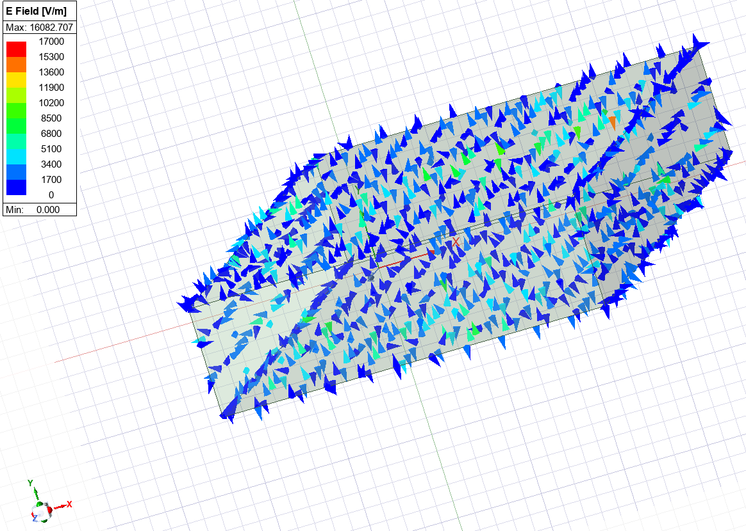
Figure 25 - Mode 1 Teflon-filled Waveguide Displaying Vector of Electric Field
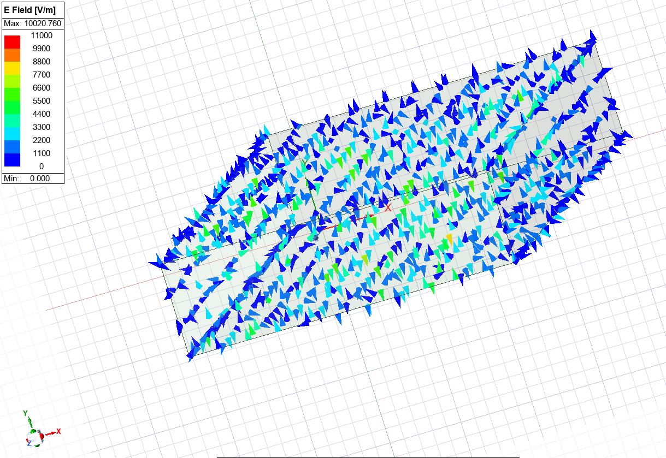
Figure 26 - Mode 2 Teflon-filled Waveguide Displaying Vector of Electric Field
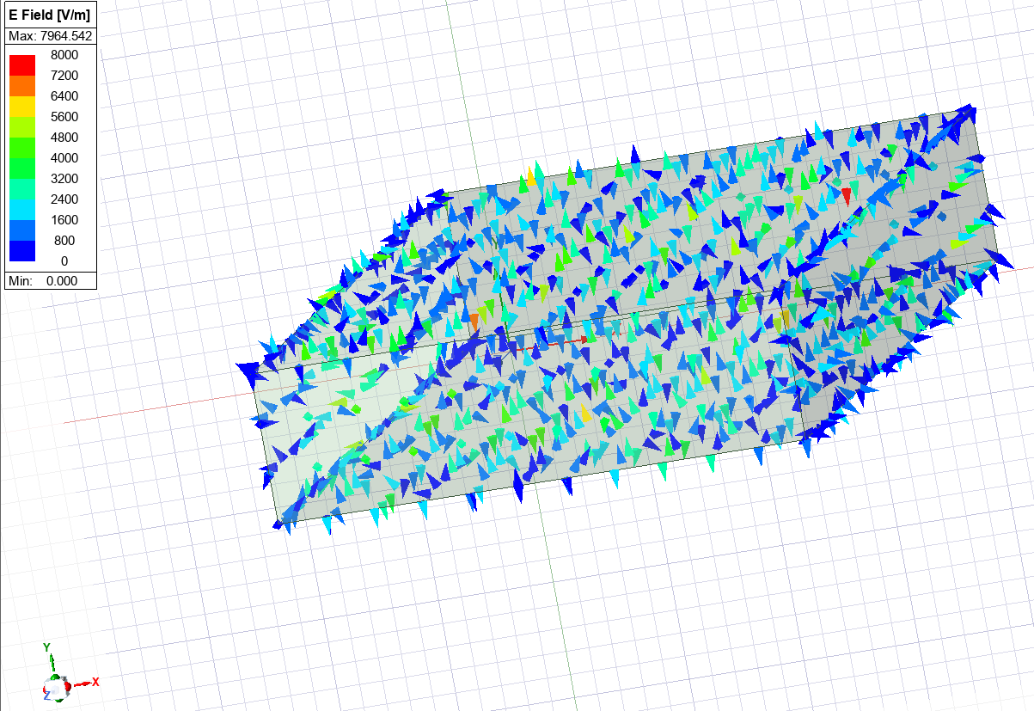
Figure 27 - Mode 3 Teflon-filled Waveguide Displaying Vector of Electric Field
Figures 28,29, and 30 describe the magnitude of the magnetic field. Similarly to vacuum, the A/m increases as the modes increase. This can be due to higher frequency waves propagating through the waveguide, as there is a larger cut-off frequency.
Another similarity to be noted is that the magnetic field circulates the electric field as the wave propagates through the waveguide, matching the theory of Ampere's Law [6].
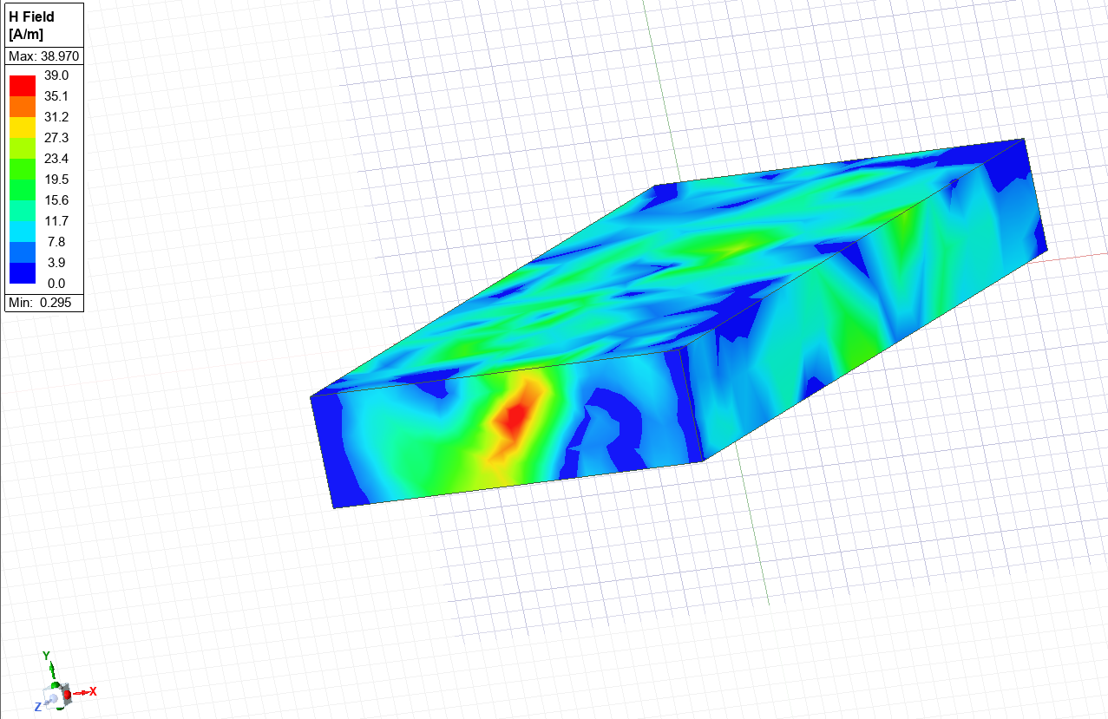
Figure 28 - Mode 1 Teflon-filled Waveguide Displaying Magnitude of Magnetic Field
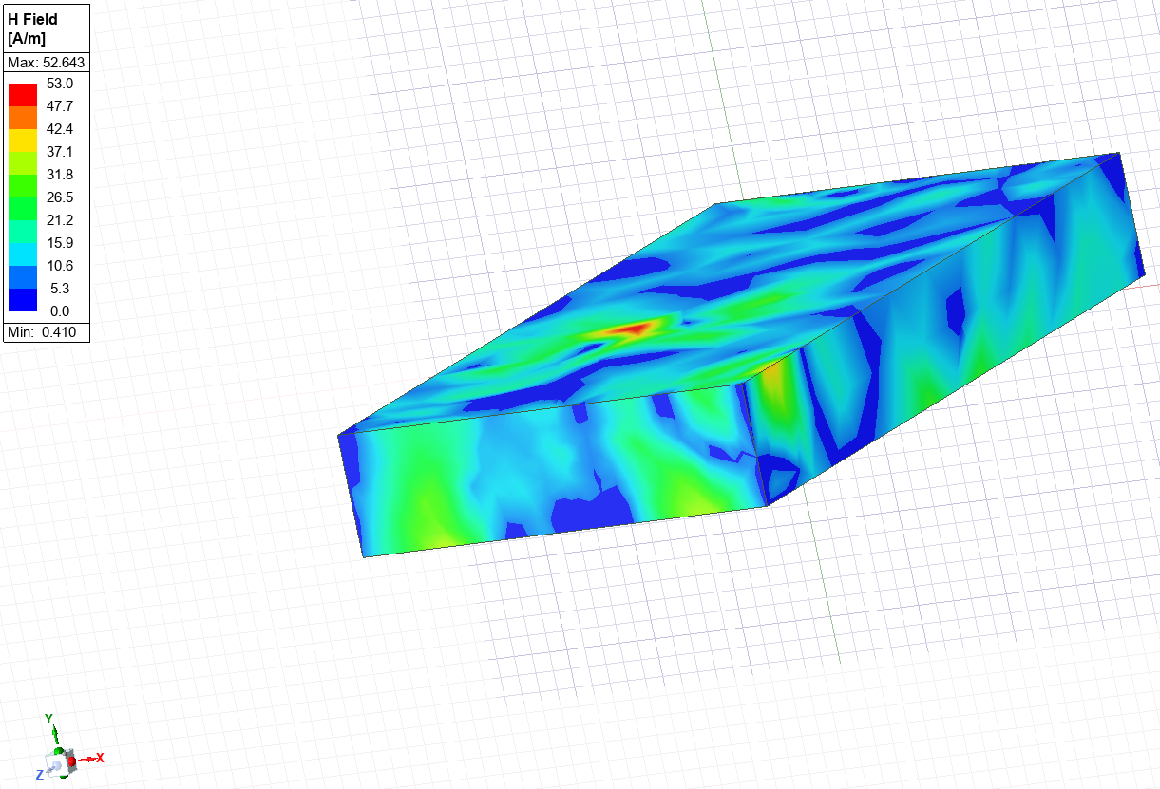
Figure 29 - Mode 2 Teflon-filled Waveguide Displaying Magnitude of Magnetic Field
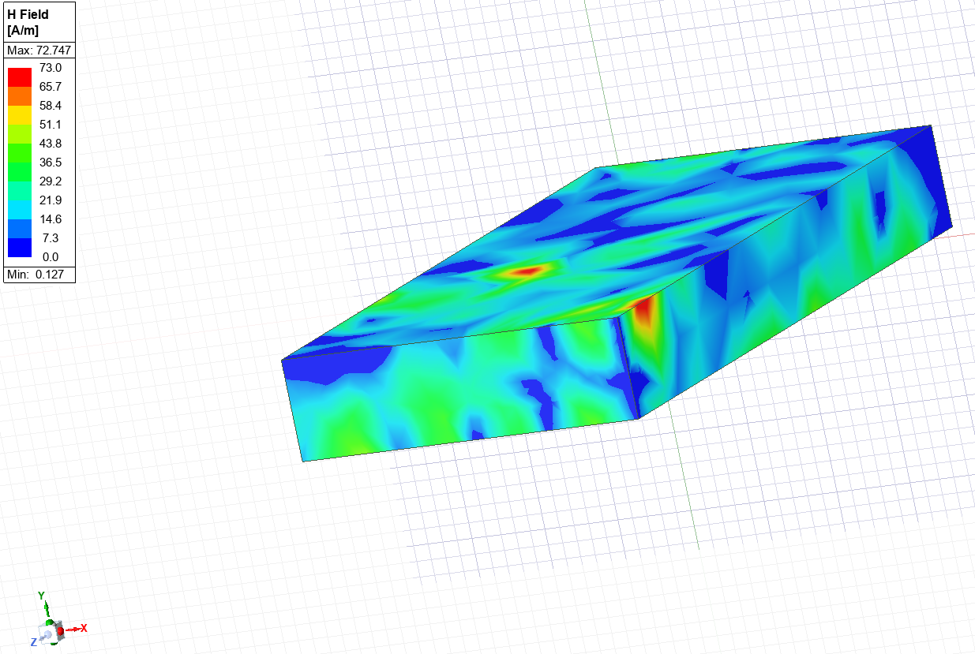
Figure 30 - Mode 3 Teflon-filled Waveguide Displaying Magnitude of Magnetic Field

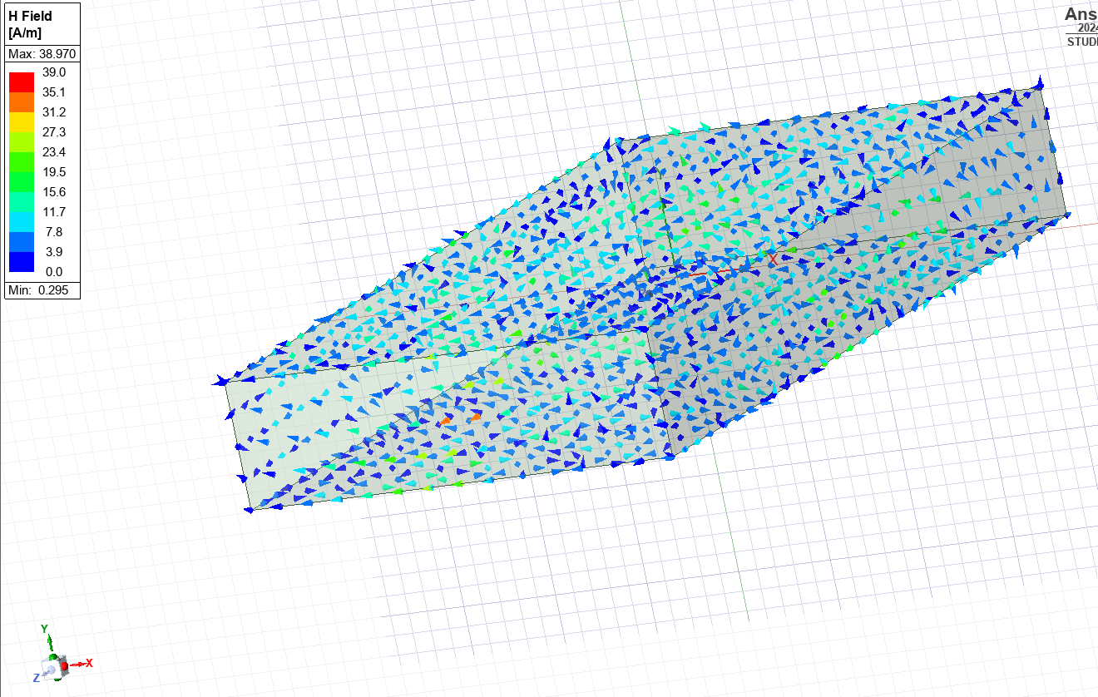
Figure 31 - Mode 1 Teflon-filled Waveguide Displaying Vectors of Magnetic Field
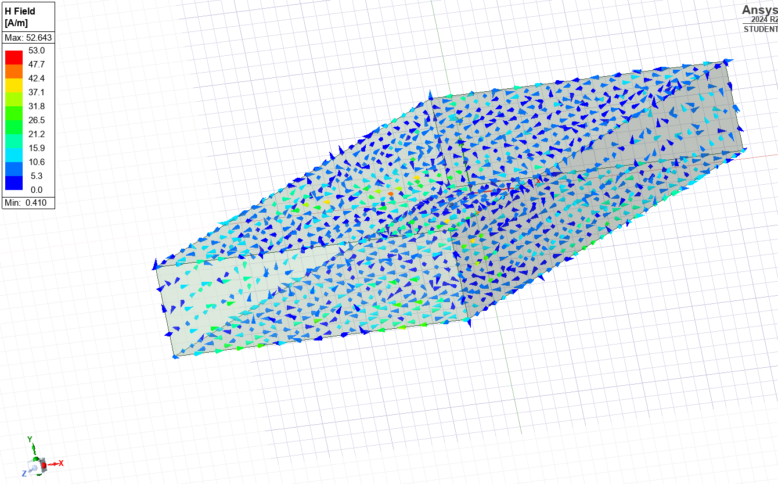
Figure 32 - Mode 2 Teflon-filled Waveguide Displaying Vectors of Magnetic Field
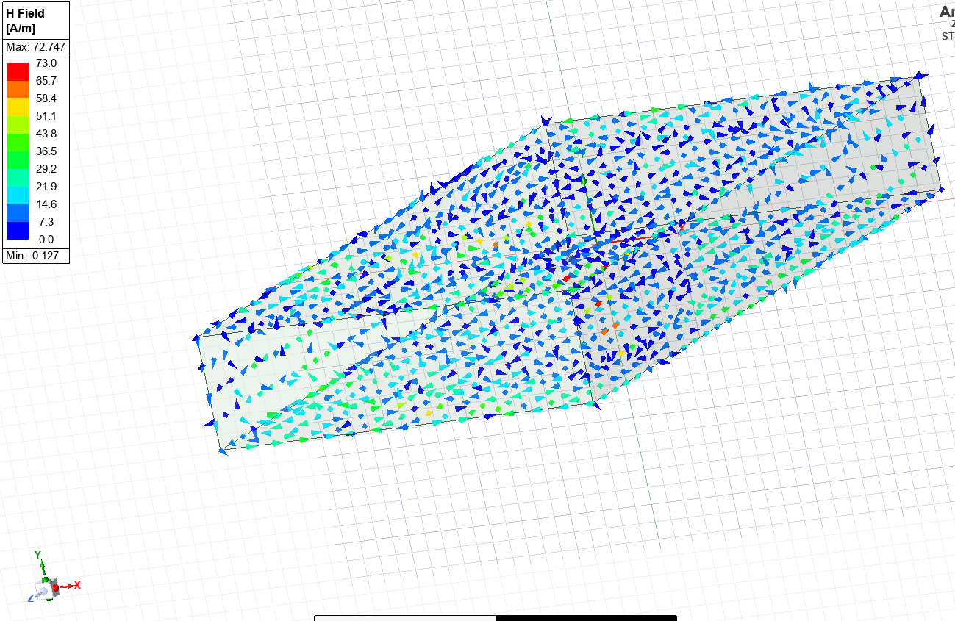
Figure 33 - Mode 3 Teflon-filled Waveguide Displaying Vectors of Magnetic Field

Task 2: Antenna Results
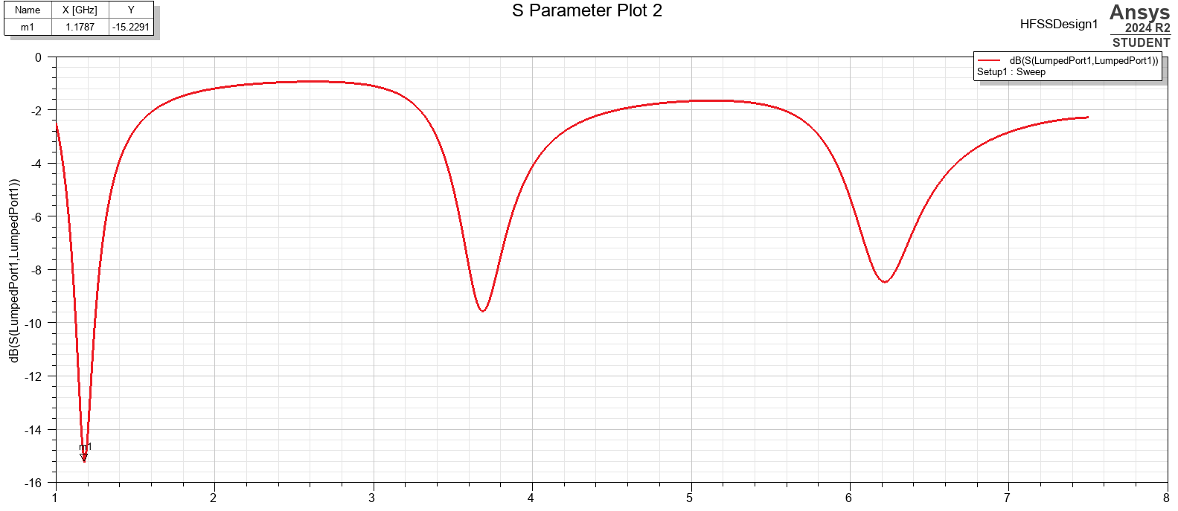
Figure 34 - S11-Parameter Plot for Halfwave Dipole Antenna
Figure 34 presents the reflections from the antenna at various frequency sweep levels. The operating frequency can be spotted at the initial dip and shows 1.1787GHz along the x-axis. The y-axis refers to decibel gain and is -15.2291 at the operating frequency. This suggests high levels of impedance and minimal reflection, implying the antenna is operating efficiently.
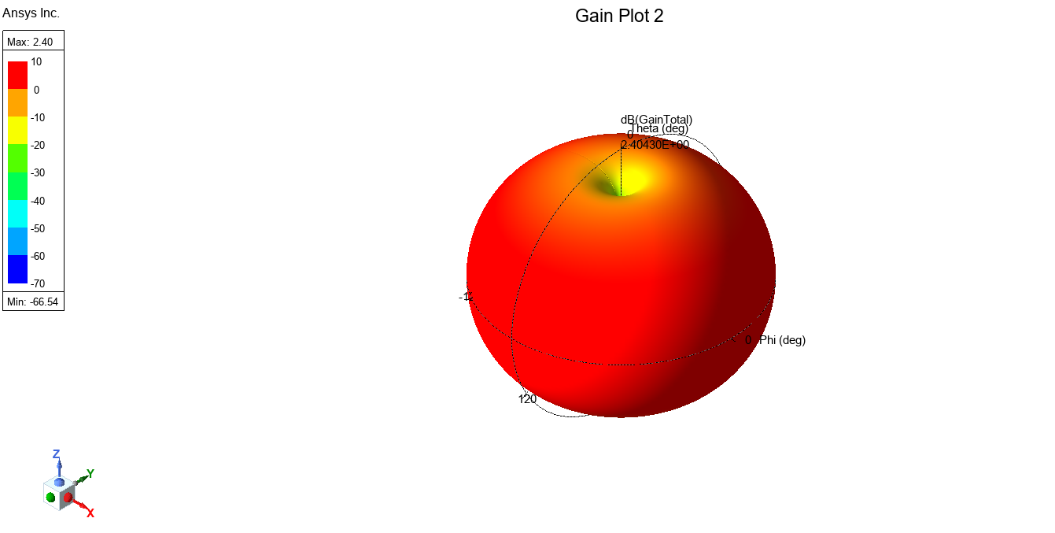
Figure 35 - Plot of Antenna Radiation
Figure 35 demonstrates the antenna in a near-spherical shape, which is expected of a dipole antenna. It also shows the maximum signal radiation away from the centre of the antenna and outwards along the x and y-axis, suggesting signals propagate horizontally from the antenna and minimal travel vertically along the length of the antenna, which matches the standard dipole antenna theory. [7]

Discussion

Waveguide Mode Analysis
After running simulations using both a Vacuum-filled waveguide and a Teflon-filled waveguide, the cut-off frequencies have been presented. The cut-off frequencies display the effectiveness of the waveguides at propagating waves through their medium. Teflon displayed a lower cut-off frequency through simulations, of 4.45 GHz, which was similar to the calculated theoretical expected cut-off frequency, at 4.56 GHz. Similarly, the simulated vacuum cut-off frequency was 6.48 GHz, and the prior calculated value was 6.52 GHz. Due to the Teflon having a lower cut-off frequency, the Teflon waveguide can accept lower frequency waves and therefore is likely to transmit signals more efficiently. It features a lower cut-off frequency as the dielectric material has a greater relative permittivity and therefore decreases the speed of light for the propagation of the waves, as seen in Equation 3 [8].
Mode 1, TE₁₀, was the dominant mode across both waveguides due to its ability to accept lower-frequency electromagnetic waves as a result of its lower cut-off frequency.
It is important to note discrepancies throughout the simulation results, such as the magnitude of magnetic field values in Teflon displaying an unexpected pattern. This may be due to a formatting issue of the waveguide or, as stated, higher-frequency waves propagating with increased modes. This, however, should not influence the results as the calculated cut-off frequency was still a near-perfect match to the simulation figure.

Antenna Performance Analysis
The dipole antenna results of the simulation were as expected when compared to existing studies. Using Equation 2, the expected operating frequency was 1.29 GHz; the simulation showed 1.18 GHz. Although the figures are slightly different, they are still within a tolerable acceptance region, it is likely the larger difference is down to a small error in the antenna model configuration through Ansys.
Figure 34 supports that the designed antenna operates efficiently, as the return loss is below -10dB in this case. Figure 34 shows a value of -15.23dB. This shows that more than 90% of the input power to the antenna is either being radiated or absorbed, with less than 10 % being reflected [9].
There are 2 additional visible peaks in Figure 34, suggesting the antenna can operate at multiple other frequencies. However, it best operates at the lowest valuable decibel, and therefore the second peak which reads approximately 9.5dB and the third peak reading at 8.1dB would not absorb or radiate as much of the input power therefore become less effective.
Figure 35 exhibits a hoop-like shape replicating the radiation pattern from the antenna, with maximum gain along the x and y-axis, reaching as high as 2.46 dB. Sources show that this aligns with the theoretical gain of an effective dipole antenna, which is 2.15dB [10]. The shape of the antenna shows it is capable of transmitting and receiving signals from a variety of directions and is suitable for situations such as Electronic Warfare (EW) jamming to disrupt enemy GPS, as well as radars within weapons tracking to their target [11].

Conclusion
This report concludes that dielectric materials with a higher relative permittivity allow a reduced cut-off frequency, causing waveguides to accept lower frequency waves and propagate a larger quantity of waves. This was seen through the reduction of cut-off frequency in Vacuum at 6.48 GHz to Teflon at 4.45 GHz. These findings are especially useful when operating with lower frequency waves, as it ensures a similar dielectric material waveguide to that of the Teflon is used so that lower frequency waves can be processed through the waveguide and not become susceptible to interference from noise external to the waveguide.
TE₁₀ was discovered as the dominant mode due to it featuring the lowest cut-off frequency in both dielectric modes under evaluation, which is supported by existing theories researched through this project.
The dipole antenna demonstrated an impedance value near the calculated operating frequency, suggesting there is a strong power transfer through the antenna, and it is able to transmit and receive signals effectively.
The shape and radiation pattern of the antenna match existing theoretical theories of dipole antennas. This shows that the antenna could operate in environments involving Ordnance, Munitions, and Explosives (OME), both within weapons tracking to a target as well as targets seeking protection from incoming missiles using EW jamming due to its ability to distribute signals in multiple directions at an efficient rate. Figure 34 further supports this when analysed, as it shows a dB well below the -10 value, which suggests it operates at over 90% efficiency.
Although the resonant frequency was slightly lower than expected, it was still within a tolerable region and is likely down to minor errors within the simulation software, and the values still support a strong example of an efficient antenna.

References

[1] | K. Okamoto, Fundamentals of Optical Waveguides (Second Edition), Academic press, 2006.
[2] | El Pro Cus, [Online]. Available: https://www.elprocus.com/dipole-antenna/. [Accessed 12 April 2025].
[3] | D. M. Pozar, Microwave Engineering, Wiley John Wiley & Sons, Inc, 2012.
[4] | C. Balanis, Advanced Engineering Electromagnetics 2nd Edition, Wiley, 2012.
[5] | R. Colin, Foundations for microwave Engineering, John Wiley & Sons, Inc, 2001.
[6] | “Amperes-law,” [Online]. Available: https://byjus.com/physics/amperes-law/. [Accessed 16 April 2025].
[7] | A. C. Caputo, Digital Video Surveillance and Security, 2010.
[8] | C. S. Analysis, “Understanding Modal Propagation in Rectangular Waveguides,” [Online]. Available: https://resources.system-analysis.cadence.com/blog/msa2021-understanding-modal-propagation-in-rectangular-waveguides. [Accessed 16 April 2025].
[9] | C. P. Solutions, “S-Parameters and the Reflection Coefficient,” [Online]. Available: https://resources.pcb.cadence.com/blog/2023-s-parameters-and-the-reflection-coefficient. [Accessed 20 April 2025].
[10] | “The Half-Wave Dipole Antenna,” [Online]. Available: https://www.antenna-theory.com/antennas/halfwave.php. [Accessed 20 April 2025].
[11] | A. Experts, “Types of Military Antennas,” 20 July 2023. [Online]. Available: https://www.antennaexperts.co/blog/types-of-military-antennas. [Accessed 22 April 2025].

Appendices


Figure 36 - Dipole Antenna Structure
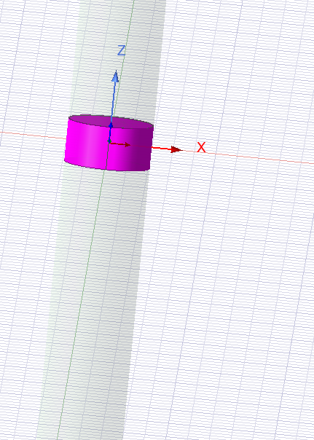
Figure 37 - Antenna Excitation Gap

