

Analyzing Environmental Impact ACMA5012 – Environmental Engineering and Sustainable Energy
HADDEN Joshua
Purflux Filtration ltd Crown Ave, Tredegar, NP22 4EF
Table of Contents
Table of Figures 1
Introduction 2
Discussion of Motor and Industrial Problem 4
Environmental Assessment of DC Motor 8
Environmental Assessment of Servo Motor 10
Lessons Learned and Corrective Actions 12
Conclusion 14
Bibliography 15

Table of Figures
Figure 1 - Lead Acid Cells Casted to Battery Terminals 4
Figure 2 - Battery Terminal with Flash Defect 5
Figure 3 - 5 Why Analysis of The Flash on Terminal Defect 5
Figure 4 - DC vs Servo Motor Acceleration Comparison 6
Figure 5 - Material in A Cell Compared to 138,000 Cells 8
Figure 6 - Comparison of Environmental Factors of DC and Servo Motor on Cell Production Process 13

Introduction
Modern manufacturing organizations are under increasing pressure to balance productivity, quality and cost whilst simultaneously reducing their environmental footprint. As industrial activities continue to contribute to resource depletion, greenhouse gas emissions and waste generation, engineers are expected to consider sustainability alongside traditional operational requirements when designing, maintaining and improving manufacturing processes. Consequently, environmental assessment techniques have become an important tool in engineering decision making, enabling organisations to understand the full impact of a product or process throughout its entire lifecycle.
(ISO 14040:2006, 2006)
Electric motors are among the most widely used forms of industrial equipment and are estimated to be responsible for a significant proportion of electricity consumption within manufacturing environments. They are used to power countless applications including conveyors, pumps, robotics, lifting equipment and precision assembly systems. Whilst electric motors are often associated with energy efficiency during operation, their environmental impact extends far beyond energy consumption alone. The extraction of raw materials, manufacturing processes, transportation, maintenance activities and eventual disposal all contribute to the total environmental burden associated with a motor throughout its service life.
(Zeng & Bo, 2024)
One recognised method of evaluating these impacts is the Life Cycle Assessment (LCA) methodology. Life Cycle Assessment examines the environmental impacts associated with every stage of a product’s life, from raw material extraction through manufacture, transportation, operational use, maintenance and end-of-life disposal or recycling. This approach is commonly referred to as a “Cradle-to-Grave” assessment because it considers the complete journey of the product from creation to retirement. By applying this methodology, organisations can identify opportunities to improve sustainability, reduce waste generation and optimise resource utilisation throughout the entire lifecycle of a product.
(ISO 14040:2006, 2006)
This report focuses on the replacement of a legacy Direct Current (DC) motor with a modern servo motor used within a lead-acid battery terminal casting process. The original DC motor was responsible for controlling the movement of an assembly jig used to lower and remove battery cell packs into and from a molten lead casting operation. Although the motor demonstrated exceptional durability and reliability over an estimated service life of approximately thirty years, limitations in its control capability contributed to a recurring flash defect during production. Investigation using root cause analysis techniques, including Ishikawa and 5 Why methodologies, identified aggressive jig movement as a significant contributing factor to waste generation (Ciecińska, 2023) .
To address this issue, the existing DC motor was replaced with a servo motor capable of providing precise positional control and smooth acceleration profiles. This improvement significantly reduced the occurrence of flash defects and improved product quality. However, the environmental implications of this engineering change extend beyond quality improvements alone. The reduction of manufacturing waste, increased process control and lessons learned from the disposal of the thirty-year-old DC motor have created an opportunity to evaluate the environmental benefits and challenges associated with both technologies.
The aim of this report is therefore to conduct a comparative cradle-to-grave assessment of the existing DC motor and the replacement servo motor, considering environmental impacts associated with material extraction, manufacturing, operation, maintenance and end-of-life management. Furthermore, the report evaluates how engineering decisions can influence sustainability outcomes and identifies lessons learned that can be applied to future equipment lifecycle management strategies.

Discussion of Motor and Industrial Problem
An electric motor is an electromechanical devise that utilises electromagnetic principles to convert electric energy into mechanical energy. The electric energy can be “Direct Current” DC – such as from batteries or rectifiers, or “Alternating Current” AC – such as from power grids or inverters.
(Slemon, 2026)
There are various types of electrical motors, such as:
- DC
- AC
- Servo
- Stepper
- Linear Induction
Each type of motor has their own applications; however, the main focus of this report will be the servo motor, due to its precision and non-linear displacement activities in the manufacturing environment.
(Vyas, 2025)
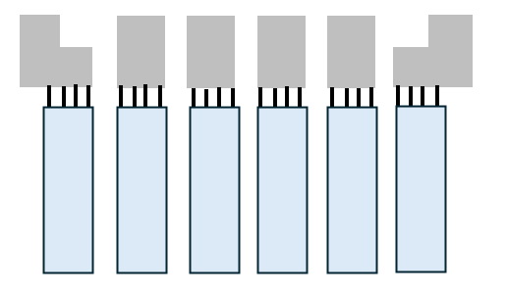
Figure 1 - Lead Acid Cells Casted to Battery Terminals
Figure 1 shows a diagram of 6X lead acid thin plate, pure lead cells, joined to terminals via metal conductive tabs. The manufacturing process to attach the paper packs to the terminals it to load the paper packs to a jig, then lower the jig into a mould casting which is subsequently filled with molten pure lead. The lead then solidifies in the form of the terminals, and the jig is displaced upwards with the paper packs now attached to the castings and thus creating the assembled battery cell.
This process however was susceptible to flash, a manufacturing defect in which the molten material travels to a location outside the defined parameters of the mould creating a non-uniform finish.

Figure 2 - Battery Terminal with Flash Defect
The flash defect is highlighted in the red circle located in figure 2, after using tools such as an Ishikawa and 5 Why analysis, it was determined the flash was caused by aggressively displacing the assembly jig at a rate of 50cm per second using a DC motor, before the lead had finished drying. See Figure 3 for an example of the 5 Why analysis used to identify the root cause of this problem.
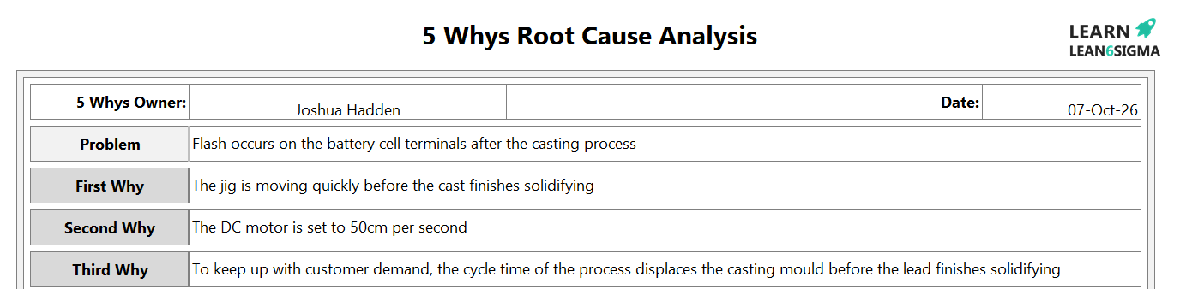
Figure 3 - 5 Why Analysis of The Flash on Terminal Defect
When looking further into the root cause, it was observed the DC motor can only be “on” or “off”, the motor is simplistic and only offers continuous rotation with simple speed controls. The DC motor is low cost but limited in application. A servo motor, however, offers a precise and controlled angular positioning application, it utilises a three-wire system and has an internal control circuit with a position sensor, widening the potential applications.

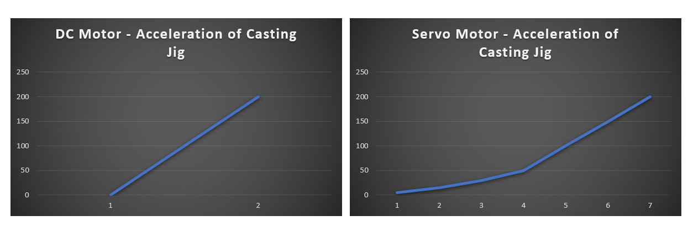
Figure 4 - DC vs Servo Motor Acceleration Comparison
Figure 4 demonstrated the difference between acceleration for a DC motors compared to a servo motor, in which the X axis demonstrated the number of potential steps and the Y axis demonstrates the displacement in (mm). The DC motor having a continuous 2 wire power configuration means the motor is either on or off, however the servo motors 3 wire, sensors and control circuit enables a smooth transition to the same displacement of 200mm. The cycle time is marginally affected with no direct impact on customer demand, and the casting is enabled a smoother transition to limit the occurrence of flash on the terminals, thus rectifying the concern.
Whilst the implementation of a servo motor provided significant quality improvements to the casting production process, it also opened a platitude of opportunities to improve the environmental impact of this process, and it is essential in engineering to consider linking real industry applications to the journey of improving sustainability. With this considered, a “life cycle assessment” (LCA) has bee conducted with the “Cradle-to-Grave” approach to understand the end of life process for the DC motor that was already fitted to the production process, and the full lifecycle and end of life strategy for the new servo motor considering lessons learn from the discarding of the 30 year old DC motor being replaced.
The purpose of a “Cradle-To-Grave” assessment is to consider each individual stage of a products lifecycle, see below for an example:
- Extraction of Raw Material
- Logistics and Transportation
- Operational Use
- Servicing, Maintenance and Repairs
- Disposal or Recycling
The Cradle-To-Grave assessment will be completed on the existing 30-year-old DC motor, and the replacement motor using lessons learned and planning the most effective end-of-life for its eventual retirement from the process.
It is worth noting as this point, the motors are on a constant production line operating 24 hours a day, 5 days a week, and regular weekend overtime.

Environmental Assessment of DC Motor
The DC motor on the production line was typical of a thirty-year-old motor, and was constructed of the following materials:
- Steel Housing
- Copper Windings
- Permanent Magnets
- Carbon Brushes
- Electrical Insulation (Rubber)
As a product of its time, the DC motor was manufactured before many of the energy efficiency standards and sustainability considerations that influence modern motor design and selection practices were widely adopted.
(Accelerating replacement of old and inefficient electric motors in industry and the service sector, 2025) .
The steel and copper would have been mined and refined which are extensively polluting and energy intensive processes. This process would have had a great effect on greenhouse gases, and the contribution would have only multiplied during processing and manufacturing of the motor itself, stacked with the final assembly and logistic implications.
Evolving from the procurement of the DC motor itself, the battery casting process must also be considered in this analysis. 2 million batteries are manufactured a year on this process, and there has been a consistent scrap rate of 0.69% for the past 30 years; which is around 138,000 battery cells. To consider the impact of this, refer to figure 5:
Material | Single Cell | 138,000 Cells
Lead | 300g | 41,400KG
Sulfuric Acid | 90g | 12,420KG
Other Materials | 70g | 9,660KG
Total |  | 63,480KG
Figure 5 - Material in A Cell Compared to 138,000 Cells
Around 50% of this material could be reworked, but 50% of the material was not recoverable. Even considering the material that was reworkable, the additional processing and energy consumption of generating these parts had additional contributions to greenhouse gasses.
After switching from a DC motor to a servo motor, the flashing reject decreased to 0.06%. functionally eliminating the defect entirely and only seeing re-occurrences when paired with an additional factor, such as an operator error setting the lead bath temperatures too high thus increasing the time for the lead to solidify.
Unfortunately, due to poor logging from the maintenance department, there is poor service history on the casting process extending 14 years so it is impossible to know the exact age of the motor, however serial markings would suggest the motor is likely the original component manufactured with the production line in 1997. The DC motor being used for this length of time is certainly a credit to its robustness, and energy and materials have ultimately been saved by not replacing this component frequently. This said, there is a log of servicing and refurbishing on this component on average every 8 months for the past 5 years, and annually 9 years beyond that, for a total of 16 interventions in the past 14 years. The main fault during this time was wiring issues in which led would drip onto the wiring burning through the insulation; in addition to a weld completed on the metal housing at least twice.
Due to the condition of the motor after refurbishment, there was no way to recover the material such as the copper windings and steel frame, due to oil contamination and various materials welded to the surface, there was no option but to discard of the welder via landfill. It was identified that protection over similar mechanical components with valuable materials should be better controlled in preparation for end of life, as discussed further in this report.

Environmental Assessment of Servo Motor
The replacement servo motor is a modern design, constructed of the following:
- Steel
- Copper
- Aluminium
- Electronics
- Position Sensors
- Printed Circuit Boards
Although there are clear benefits to the servo motor in reduction of flash, there are clear issues that must first be addressed. Firstly, the servo motor is a more complex device, made with more different materials including sensors and printed circuit boards. These devices along require complex manufacturing processes, and when stacked together the overall greenhouse emissions generated to manufacture this product is far greater than a simple two-phase DC motor.
(Negi et al., 2026)
Additionally, while in production the addition of a position feedback system and the necessity of PLC control compared to the previous relay circuit increases the overall energy consumed in life. Finally, the overall production cycle time has been, although marginally, increased to thus produce 20 less batteries per month.
There are some counterbalances to the increased energy used in manufacturing, however. Firstly, the sensor input can be used to isolate power to the motor and a portion of the casting process during downtime. The PLC was further optimised to monitor input further down the conveyor belt, if a product was not within 3 seconds of the motor, non-critical devices such as the servo itself was placed in a rest state, compared to the DC motor which constantly power even during downtime. As a rough calculation, an operator has 45 minutes of break per shift which is 135 minutes across the three shifts. Additionally, there is an average of 150 minutes per week spent completing change overs, and an average of 100 minutes per week completing servicing and unplanned breakdowns across the entire manufacturing process. This means, there is now nearly 15.5 hours per week of downtime in which multiple components are in a rest condition rather than fully powered.
Additionally, to the above, the defect rate of flash has been reduced on the casting process from 0.69% to 0.06%. Based on an annual output of 2,000,000 batteries, this a reduction of rejected parts from 138,000 batteries, to just 1,200. As discussed above, 50% of the material was non-recoverable, this therefore also saves 31,740KG of material per year. In addition to the time and labour saved with rework, sorting, downtime, customer complaints and administration activities related to the high failure mode.

Lessons Learned and Corrective Actions
There were multiple lessons learned in this activity, not just from an environmental perspective but also from the perspective of production, quality, health and safety and engineering.
Prior to 14 years ago, there is virtually no log or documentation for servicing and maintenance activities within the legacy technologies within the business. This gap and vagueness in the admin made the history of the component being handles very lacking, thus hindering the end-of-life decision making. For example, it was not clear exactly how old the component was, what the materials were without a visual analysis, and what level of retrofitting had been completed.
Visually assessing the motor, it was clear it has been welded, however the materials used were unclear thus making it difficult to assess the purity of the steel used in the DC motors housing. Additionally, the motor was covered in various oils and fluids which made the motors contamination difficult to repurpose of further repair, leaving no choice but for the part to end up in landfill.
Various recommendations were adopted to improve this process, such as:
- More detailed and precise log keeping of all maintenance activities with digital backups.
- More frequent inspection of all mechanical processes to check for signs of wear and tear.
- Regular analysis of the frequency of repairs. If repeat faults occur, actions to understand the understand and eliminate the root cause are required rather than mending the symptoms.
- Welding can only be complete if using the same material, to avoid additional processing during end of life.
- Horizontal deployment to improve all similar processes.
An online logging platform called “eMaint” has been adopted to log regular servicing of all processes, to ensure a better history of mechanical components in the future. Additionally, the frequency of servicing has been increased while adding to the scope of these audits to look for signs of wear and tear.
The wiring was very frequently damaged on this motor which could have had an impact on the process become more volatile and aggressive during its movements thus exacerbating the flash defect over time. Had the root cause to the wiring faults been considered, it would have been noted the mould was very slightly unlevel and the molten lead was dripping down the side of the mould and onto the wiring, an easy fix once the root cause it known.
The most important part of implementing a corrective action is horizontal deployment, the practice of considering similar processes or product in a business and ensuring corrective actions are applied to all process becoming a business that prevents issues, as opposed to reacting to issues.
Factor | DC Motor (Calculated) | Servo Motor (Forcasted) | Improvement (Forcasted)
Lifetime (Years) | 30 | 20 Years | -10 Years
Scrapped (Cells) | 138,000 | 1,200 | -136,800
Lead Waste (KG) | 41,400 | 360 | -41,040
Material Waste (KG) | 63,480 | 552 | -67,928
Reworked (Cells) | 69,000 | 600 | -68,400
Figure 6 - Comparison of Environmental Factors of DC and Servo Motor on Cell Production Process
Figure 6 shows the clear environmental and sustainability improvements switching from this DC motor to Servo motor has had on the business. Although the motor is predicted to last 10 years less in comparison to the DC motor, the components will have a higher likelihood of being successfully reworked due to improved maintenance practices, and the weight of lead and other materials not ending in landfill has been significantly improved as a result of this engineering improvement.

Conclusion
This report has utilised a cradle-to-grave Life Cycle Assessment methodology to compare the environmental impacts of a legacy DC motor and its replacement servo motor within a lead-acid battery casting process. Whilst the original DC motor demonstrated exceptional durability by remaining operational for approximately thirty years, the assessment identified several environmental challenges associated with the process it supported, particularly the generation of flash defects which contributed to significant levels of material waste, rework and additional energy consumption.
Although the servo motor possesses a more complex construction involving additional electronics, sensors and control systems, the environmental assessment demonstrates that these disadvantages are substantially outweighed by the improvements achieved during operation. The implementation of precise positional control reduced flash defects from 0.69% to 0.06%, resulting in a dramatic reduction in rejected products and preventing tens of thousands of kilograms of valuable material from being unnecessarily processed, reworked or disposed of each year. Furthermore, the introduction of intelligent controls and standby functionality has created additional opportunities to reduce energy consumption during periods of downtime.
The retirement of the existing DC motor also highlighted the importance of effective lifecycle management. Incomplete maintenance records, contamination, repairs and material modifications significantly reduced opportunities for recycling and material recovery at end of life. As a result, valuable lessons were identified regarding maintenance documentation, contamination control, preventative maintenance and standardisation of repair methods.
Overall, the findings demonstrate that sustainable engineering extends beyond selecting environmentally friendly materials or equipment. By considering the complete lifecycle of assets and understanding the wider impact of engineering decisions on quality, waste generation, energy consumption and end-of-life recovery, organisations can achieve significant environmental improvements. The replacement of the DC motor with a servo motor therefore represents not only a process improvement initiative, but also a positive step towards more sustainable manufacturing practices and long-term environmental responsibility.

Bibliography
Accelerating Replacement of Old and Inefficient Electric Motors in Industry and the Service Sector (2025). https://eu-more.eu/wp-content/uploads/2025/04/EU-MORE_Brochure_EN_FINAL_09042025_OK_v3.pdf
Ciecińska, B. (2023). Identification of Defects Causes: Ishikawa Diagram and 5 Whys in Theoretical and Practical Terms. https://www.intechopen.com/chapters/88810
ISO 14040:2006 (2006). https://www.iso.org/standard/37456.html
Negi, S., Rani, A., & Pan, S.-Y. (2026). Strategies for decarbonizing printed circuit board supply chain. https://pmc.ncbi.nlm.nih.gov/articles/PMC13141769/
Slemon, G. R. (2026, August 17). Electric Motor. Britannica. https://www.britannica.com/technology/electric-motor
Vyas, S. (2025, October 10). Different Types of Electric Motors and Their Applications. Electrical Volt. https://www.electricalvolt.com/types-of-electric-motors/
Zeng, L., & Bo, H. (2024). Electric motor systems: why are they important? https://www.iea-4e.org/wp-content/uploads/2025/12/4E-Policy-Brief-EMSA-9-20251218.pdf

