University of Wales
Trinity Saint David

Student Name: Semen Aliona
Student Number: 1814631
Module No: BMSK4003_LON
Module Title: Digital Skills and Research Methods
Lecture: Balendran Kandasamy

Contents
INTRODUCTION 3
EVALUATING MODERN TECHNOLOGIES 4
Web conferencing. 4
SOCIAL MEDIA 5
• Marketing 5
EVIDENCE OF MY ONLINE PRESENCE 9
• LinkedIn 9
• Twitter 10
• Facebook 11
REFERENCES 12

INTRODUCTION
The way people communicate and get information has really changed due the technological advancements. In work places technology has influenced both the work and the work place structures. This advancement have been taken up by business people as well as consumers where various machines and systems are being used to process goods as well for communication. Use instant messages-mails for communication, unlike in earlier days where marketing and branding of goods and services was mainly through advertisements in paper prints for example pamphlets and also in TVs which to some extent was not cost effective (Belch, et al, 2004). The use of manual labour is what was used in earlier days but due to technological innovations work has become easy (Law, .et al 2014). The World Wide Web has enabled public access to information and knowledge which was not previously there. In line with this social media is one of the network platforms that is being used currently. Social media helps create bridges between people of different regions all over the world to share services, information as well as skills in various fields of interest making it a site for socialization and work.
Social marketing networks are created by people who have access to communication technology. Through this customers and producers can read, communicate, exchange information, make reviews of products and also make purchases. Social media marketers use it for building networks because it has become a go to place for many people as you can get current trends in the market as well as references through likes on either of the platforms. In general people are highly informed due to the electronic communication and the online branding practices. The reason being use of internet that can be accessed by anyone in need of anything everywhere across the globe,unlike traditionally where the word of mouth has been the most important marketing strategy (Andreasen, A.R., 2002.). This paper evaluates the effectiveness of the use modern technology within workplaces and explores social media as tool for marketing information gathering and communication in work places.

EVALUATING MODERN TECHNOLOGIES

The world of information communication technology has advanced in many fields including educational institutions, government offices at home and even in work places. Information and communication is actually made easier because most people can easily afford ICT products including: tablets, mobile phones, iPad, digital TVs and personal organizers, personal computers and World Wide Web. Information communication technology has become more accessible since skills required in order to use technology are no longer limited to technology experts (Martin, L.M. et al., 2003).. Of particular interest is the use of tablets. Many households in the U.S own a tablet which is a tool for modern communication .Due to the design of the device it would replace a computer as it’s more portable and has more added features compared to smartphones. However, whatever device used should be easily customized so as to target the right audience and in the right context. In work places ICT is very basic in all organizations, it has various benefits, the major two including communication and data processing.

Web conferencing.
It’s a real time online communication channel where people can communicate simultaneously using multiple computer screens or phones. It’s of major interest as people can communicate, conduct meetings and interviews from various places without access to actual conference rooms. With this, information from the higher authorities and managers can efficiently be accessed and used as needed .Data sharing and information processing is made efficient and quick decision making. Transfer of data and information between people also becomes fast (Kear, et al (2012).A comparison between two forms of web conferencing is discussed below;
Skype-it’s a form of web conferencing that provides video chats and video calls between laptops, tablet, mobile devices and smart watches.
Google hangouts-it allows for communication between two or more users and can be accessed through Gmail, Google +websites or as mobile apps.
SKYPE | GOOGLE HANGOUTS
Bandwidth issues may arise and it does not provide a slider that may help resolve any issues that may arise during the collaboration. | Does not have any bandwidth problems when used by multiple users, and offers sliders in cases of arising issues.
Services and calls are paid for per minute | Offers free calls for longer duration
Screen sharing for personal and small scale business. | Screen sharing for medium and large scale business.
(Xu, et al. (2012, November).
My recommendation in work place settings is use of Google hangouts. Skype is not without its advantages, but the disadvantages out way the advantages. If working on international set up it would lead to delays.

SOCIAL MEDIA

Marketing
Social media marketing is used as a marketing platforms. It uses various social media plat forms including Facebook and LinkedIn for marketing and branding of products and services. It mainly entails the use of videos, articles and images for branding and marketing of products and services. (Andreasen, A.R., 2002). They provide a platform for people to either like or dislike various products and services and hence one is able to distinguish their target customers. Various social media marketing techniques are applied that include e.g. Consumer’s online brand related activities such as uploading pictures in the social media platforms, electronic word of mouth where one customer makes recommendations of your products to other customers and customer targeting where you try to focus on people who through research or their line duty would most probably be interested with your products or services. Some of the advantages of social media include; increased exposure in the business or at work. Partnership, after periods of social media marketing and communication. Market insights and development of loyal fans. Innovations at work places where people are able to make technological advancements in their places of work as they can create new ideas that help in growing and expansion of various business and work place organization structure, work force.
Again use of social media comes along with some challenges, it’s difficult to keep an account safe as there may be breaches, distinction between serious customers and those not serious i.e. knowing when to take action, difficulty in maintaining your product brands as there may be imitations of your work which may affect the quality of your services putting of customers, actualization of information gathered from the social media platforms e.g. geographical boundaries limiting customers access to your supplies. (Michaelidou, N.et al, 2011)
Majority of the people using technology agree that the use of technology in workplaces is fast and easy way to get things done. They are actually sure that through the use social media to communicate and market products their sales increase. Technology is the major enabler of mobility in work places however it’s challenging to manage integration of technology in work places because technological advancement happen more often. The organization has to have some insights on work place designs, opportunities for various technological aspects as well us keeping up with the pace of technological evolutions. Some of the recommendations that would probably be good include e.g. Use of social media is still a new tradition to a certain population percentage, this being the case awareness and transparency should be emphasized.
Opening a business website on Facebook
A business website is an account that is purposely meant for buying and selling goods and services online. The first step is to sign up with Facebook. At the top right corner there is a tab that states ‘sign up’. Once you sign up, there are many types of business options including the brand, product and place. Select the kind of business you plan to market through Facebook. Sometimes a business can be classified into two or more categories so it is important to pick a category that interests the business. Once that is done, a drop box pears and there are other more specific details that are supposed to be filled in such as the exact position.
The other step is to add a profile picture and cover images. The company logo sells out more as a profile picture. For example a clothing line will sell more if there are many pictures that customers can choose from. After that explore the page and make sure to include a short description of the business. The description should be precise and yet compelling to your customers. The next step is to create a user name aligned to your business and complete on the about section to write more about the company. Once that is done, your account is all set and you can create your first post and then begin to engage with customers. The other step is to get verified because the customers want to know that your page is legitimate so it creates public trust.
Why Facebook?
Facebook is popular and many people visit the site every day. Opening a Facebook business page means that your business page will be viewed by more people and this increases your chances of selling. Another reason is that Facebook is growing fast because people of all ages use it. People spend more time of Facebook and this means that your business will grow in the process. Advertising and promoting your business is easy because they are affordable and this means that the products or services reach the target population.
Advertising
Advertising creates more traffic on your page because more people are able to view your products. To do this, then you have to choose your objective and set up your advertising account on Facebook. When creating this account, there are details like the target population that need to be included. the other step is to set up your budget because every type of ad has a designated population depending on the package. The last step is to create your ad and more people will be able to view your page.
When creating an online business, good customer relations is key. Creating a platform of feedback and understanding the needs of the customers will go a long way in increasing productivity and profits. It is also necessary to have delivery services to the customers and create a platform where they can access your products easily. Large businesses such as Apple can ship mobile phones and tablets to their customers worldwide. The business has grown because they have maintained quality all through which prompts more people to buy their products.

EVIDENCE OF MY ONLINE PRESENCE

LinkedIn
It’s a marketing tool targeted for business purposes and for professional interactions. It’s a good platform where one can expand their business and employ people based on their competences. Being active and posting often in LinkedIn sites helps one build their brand personality.
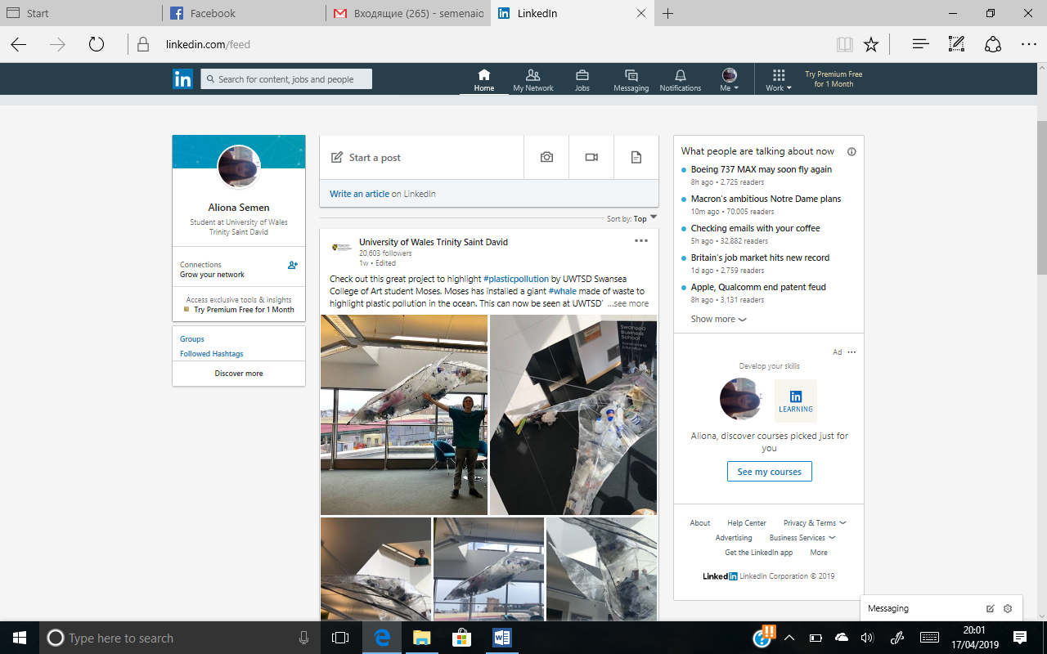

source; https://www.linkedin.com/in/aliona-semen-48b325181/

Twitter
Twitter is a powerful platform for many people across the globe. It allows people to connect with their customers by sending personal messages .You get to spy on your competitors. Customers may comment or complain on issues that other services provider have but you lack. From this aspect one is able to make advancements. Tweets being in texted by Google makes it very easy to use search engines.
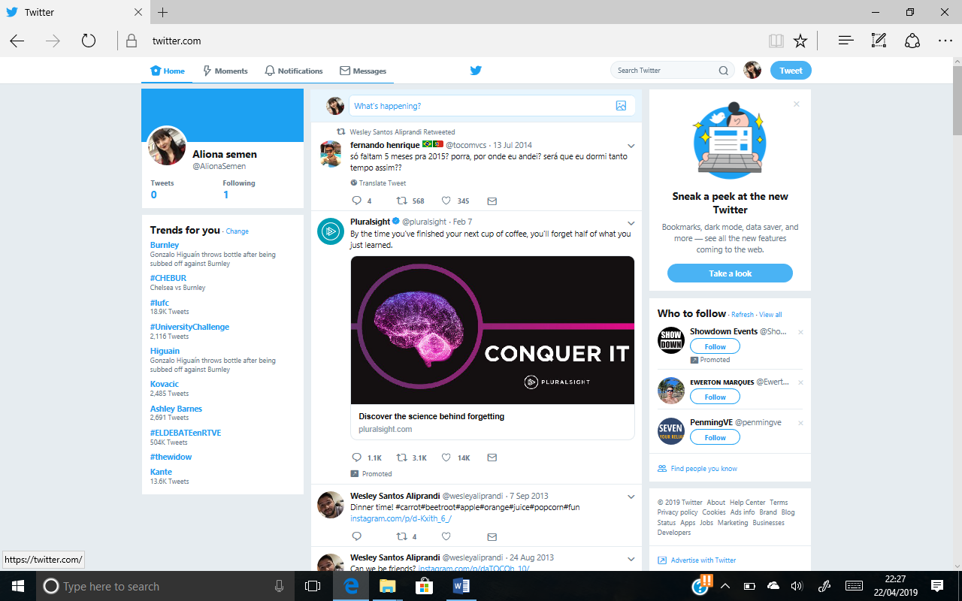
source; https://twitter.com/AlionaSemen/following

Facebook
Using Facebook as a digital marketing platform offers marketers a chance to target worldwide audiences. Marketer share on their face book pages images links videos as well as other materials of interest to consumers. From this sites people are able to like, enquire as well as order goods and services that they are interest in. For me this site is very important as it helps me keep in touch with my former colleagues, friends and people who know me, sharing thoughts, videos and activities.
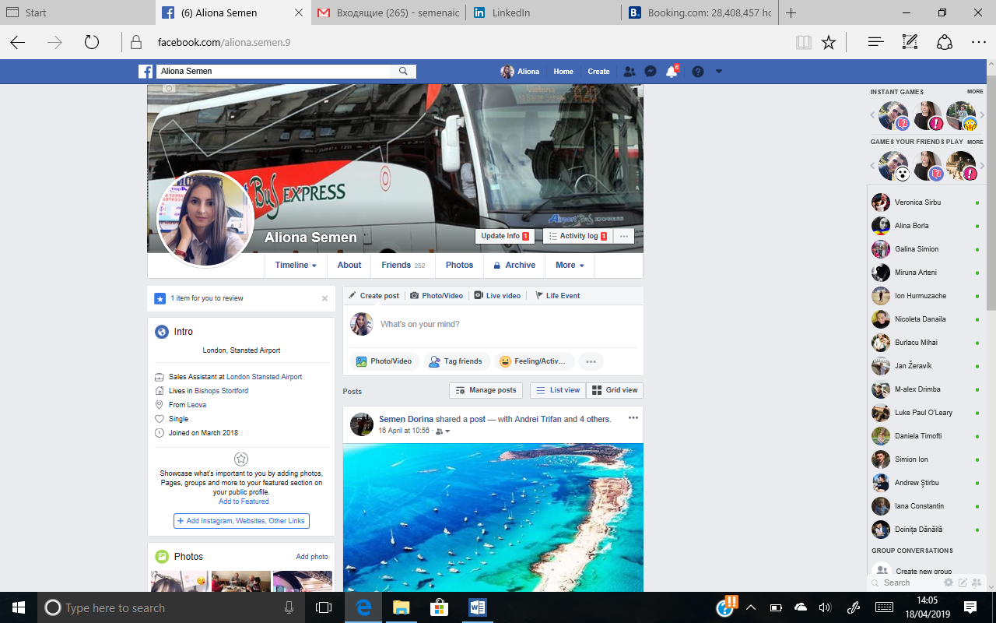
Source; https://www.facebook.com/aliona.semen.9

REFERENCES

Law, R., et al., 2014. Progress on information and communication technologies in hospitality and tourism. International Journal of Contemporary Hospitality Management, 26(5), pp.727-750.).
Andreasen, A.R., 2002. Marketing social marketing in the social change marketplace. Journal of Public Policy & Marketing, 21(1), pp.3-13.
Belch, G.E. et al., 2004. Advertising and Promotion: An Integrated Marketing Communications Perspective 6th. New York: NY: McGraw-Hill.
Michaelidou et al., 2011. Usage, barriers and measurement of social media marketing: An exploratory investigation of small and medium B2B brands. Industrial marketing management, 40(7), pp.1153-1159.)
Kear, K., Chetwynd, F., Williams, J., & Donelan, H. (2012). Web conferencing for synchronous online tutorials: Perspectives of tutors using a new medium. Computers & Education, 58(3), 953-963.
Xu, Y., Yu, C., Li, J., & Liu, Y. (2012, November). Video telephony for end-consumers: measurement study of Google+, iChat, and Skype. In Proceedings of the 2012 Internet Measurement Conference (pp. 371-384). ACM.

