Ransomware
Lowrie Proctor

June 2019

Contents
1. Introduction 1
2. Viruses 1
2.1 General Overview 1
2.2 How a Virus infects a system and the consequences 2
3. Ransomware 2
3.1 General Overview 2
3.2 How ransomware infects a system and the consequences 2
4. Cryptowall 3
4.1 General Overview 3
4.2 How CryptoWall infects a system and the consequences 3
4.3 Steps to take 4
5. Conclusion 4
6. References 5

Introduction

This brief report gives a general overview of viruses, Ransomware and in particular the Crypto Wall; providing details on how these infect systems and the consequences.

Viruses

2.1 General Overview

Cisco [1] describes a computer virus as a “type of malware that propagates by inserting a copy of itself into and becoming part of another program. It spreads form one computer to another, leaving infections as it travels.”

2.2 How a Virus infects a system and the consequences

Cisco [1] depicts the many ways a malware can infect systems. Malware can infect by:
- being bundled with programs
- attached to files
- Through a network device
- Through software
“The vast majority, however, are installed by some action from a user, such as clicking an email attachment or downloading a file from the Internet.”
The consequences of a malware varies. These include browser popups, theft and/or loss of information and entirely disabling systems and networks. Malware has also evolved to being able to damage the hardware of systems [1].

Ransomware

3.1 General Overview

[2] Malwarebytes describes ransomware as a “type of malware that prevents users from accessing their personal files and demands ransom payment in order to gain access.”

3.2 How ransomware infects a system and the consequences

There are a number of ways a ransomware can infect a system. [2] Malwarebytes considers the most common method currently being through malicious spam. This malicious spam uses methods to deceive users into opening various attachments or clicking on links through making them appear legitimate.
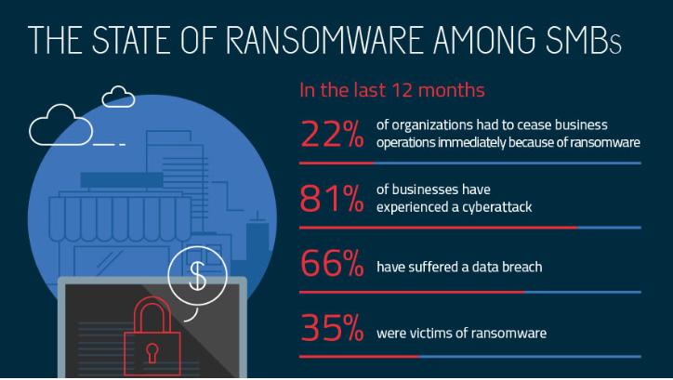
The infographic below [3] W Zamora presents findings, cited from the Osterman Research report, on ransomware from more than 1,000 small and medium-sized businesses, surveyed in June 2017 , which illustrates some of the consequences of a ransomware attack to a SMB.

Cryptowall

General Overview


A CryptoWall is a type of Ransomware. Where a general Ransomware will encrypt files and request payment, in addition to this a Cryptowall will attempt to connect to its command and control server and will start the encryption phase. The Cryptowall will then create an encryption key and start searching for file extensions to encrypt [4]. The below image illustrates the file types that are vulnerable to Cryptowall encryption [5]

CryptoWall is considered one of the most lucrative ransomware currently witnessed [6, p. 4].

How CryptoWall infects a system and the consequences

There are various ways in which CryptoWall infects. O’Brien and Morparia [7] express that it is mainly thought to be distributed through spam campaigns, compromised websites or malicious ads.
Unfortunately there is no current method to retrieve the key used to decrypt the files, without having to pay the requested ransom. Bleepingcompuer [8] states the “only methods you have of restoring your files is from a backup, file recovery tools, or if your lucky from Shadow Volume Copies.”

Steps to take

Should an individual/organisation find themselves infected with a type of ransomware, advice endorsed by the FBI, states never to pay the ransom, due to encouraging cybercriminals [2].
It must be considered that it is unlikely to be able to retrieve files infected by a Crypto Wall, consequently appropriate measures for prevention should be implemented [5].
There are some steps that can be taken to attempt to prevent potential ransomware attacks. The below figure shows some potential prevention considerations [5]
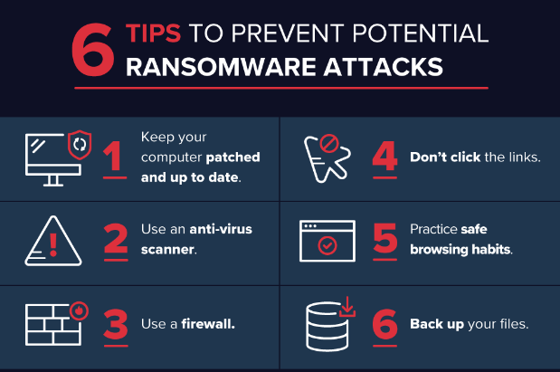

The Cyber Threat Alliance considers “The first and best way to defend against CryptoWall is to ensure that users are trained in common best practices to avoid the malware infecting their systems” [6, p. 52]
O’Brien and Morparia urges users to “be aware of attackers’ social engineering techniques and avoid opening attachments or links in emails that were sent by unknown recipients” [7].

Conclusion

Reflection must be made to the negative and destructive consequences that could occur as a result of a ransomware attack; these include a possible loss of data, breach of data and loss of productivity which all could incur associated costs.
The precautions available and recommended to prevent an attack should be proactively implemented to best safeguard systems and the data held within.

References

[1] | “What is the difference:Viruses, Worms, Trojans, and Bots?,” 14 June 2018. [Online]. Available: https://www.cisco.com/c/en/us/about/security-center/virus-differences.html. [Accessed 12 June 2019].
[2] | “All about ransomware,” [Online]. Available: https://www.malwarebytes.com/ransomware/. [Accessed 12 June 2019].
[3] | W. Zamora, “The state of ransomeware among SMBs,” 27 July 2017. [Online]. Available: https://blog.malwarebytes.com/101/2017/07/the-state-of-ransomware-among-smbs/. [Accessed 12 June 2019].
[4] | “McAfee Labs Threat Advisory,” 22 June 2018. [Online]. Available: https://kc.mcafee.com/resources/sites/MCAFEE/content/live/PRODUCT_DOCUMENTATION/25000/PD25480/en_US/McAfee_Labs_Threat_Advisory-Ransom_Cryptowall.pdf. [Accessed 12 June 2019].
[5] | J. Petters, “The State of Cryptowall in 2018,” [Online]. Available: https://www.varonis.com/blog/cryptowall/. [Accessed 12 June 2019].
[6] | Cyber Threat Alliance, “Analysis of The Cryptowall Version 3 threat”.
[7] | J. M. Laura O'Brien, “Ransom.Cryptowall,” [Online]. Available: https://www.symantec.com/security-center/writeup/2014-061923-2824-99. [Accessed 12 June 2019].
[8] | “Ransomware Informaion Guide and FAQ,” [Online]. Available: https://www.bleepingcomputer.com/virus-removal/cryptowall-ransomware-information#decrypt. [Accessed 12 June 2019].

