
NAME: AURITA CRISTOVAO
STUDENT NUMBER: 2430409
GROUP: 4
Digital Skills LCLM4002
How to create a chart in Excel
Rejwan Bin Sulaiman
Step 1. Open a Blank document in Microsoft Excel
To start Making Chart you will need to open Microsoft Excel by double clicking on its icon or from Menu. Then Click on “Blank Document” to start a new and Enter your data in rows or columns

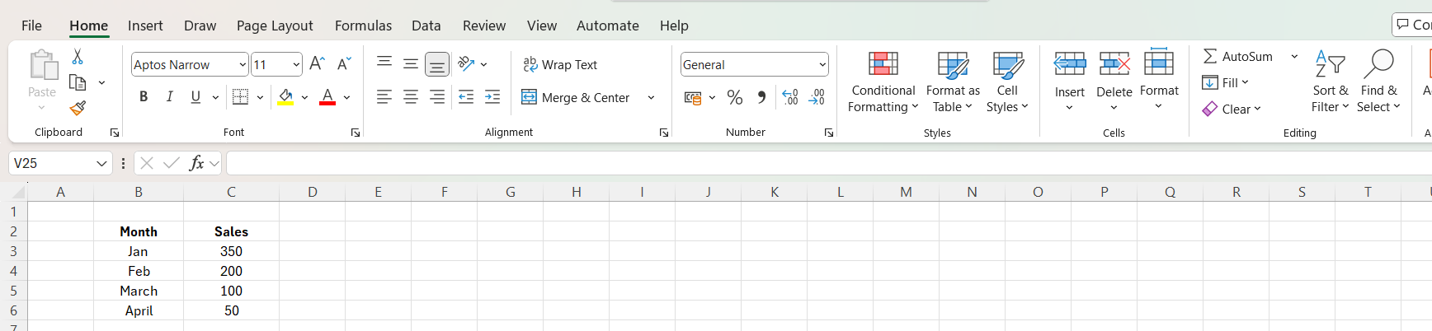
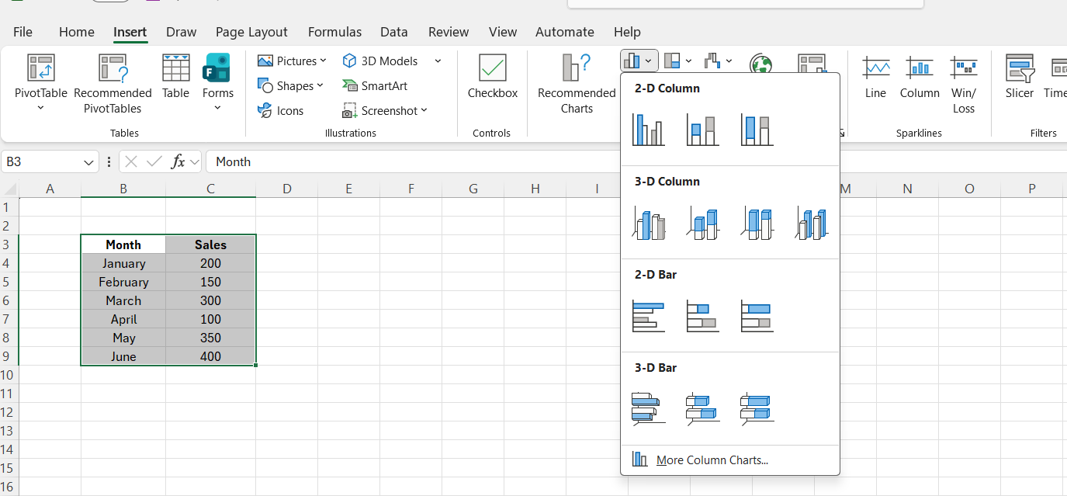
Step 2. Select the Data
- Click and drag to select all the data, including headings.
- I click Insert and click Chart
- Then I selected the data and inserted a column Chart and I used clustered Column.
- mk

Step 3. Choose the Column Chart.
- I labelled the chart “Sales”
- I formatted the Month labels so they so clearly on the bottom.



