Student : MARYAM ANWAR
(2015318)

Lecturer : RACHAEL RIVERS
INTRODUCTION TO PHYSIOLOGY
(BMHP5003_BIRM)
Task 1 : ACADEMIC POSTER
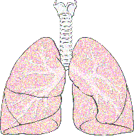 | The act of breathing is respiration. Lungs take in oxygen from the atmosphere and release carbon dioxide into the atmosphere. (Ionescu,2013)

Pharynx
Delivers air to lyranx and food to esophagus
(Robinson and Furlow,2007)

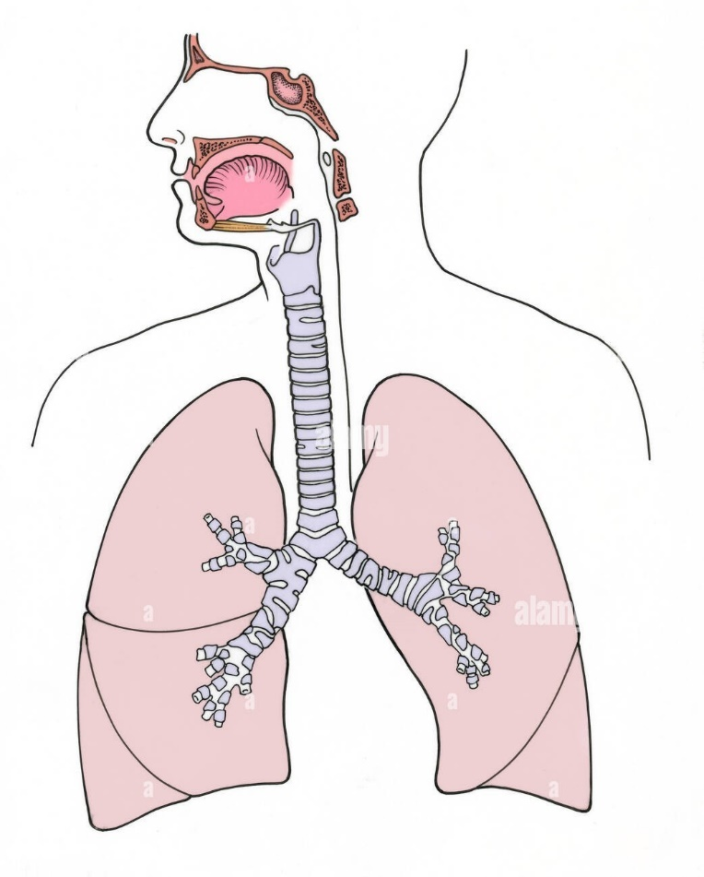
Diaphragm
Dome-shaped muscle
(Ward and Leach,2010)

Lower
Respiratory Tract
(Patwa and Shah,2015)

Bronchioles

Alveoli(Air Sacs)
Bronchi

Left Lung

Right Lung

Larynx
It acts as a sphincter, allowing air to pass from the pharynx to the trachea.(Patwa and Shah,2015)

Trachea
(windpipe)

Upper Respiratory Tract
(Patwa and Shah,2015)

Epiglottis

Nose and Mouth

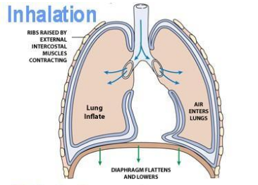 | 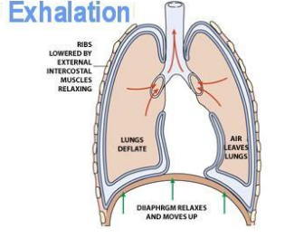  (brainly.in)
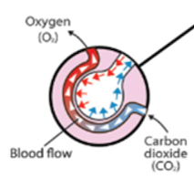
The journey of a breath

A blood cell only passes by an alveolus for about a third of a second, with in that brief period, it takes in hundreds of millions of oxygen molecules.(Medcom,Inc.,2013)

LUNG DISEASES
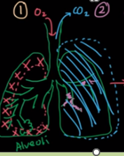
1.RESTRICTIVE :

When you struggle to breathe in oxygen. The lung does not expand at the normal rate. Also called “reduced total lung capacity (TLC)”(Sabbula, et al.,2020)

2.OBSTRUCTIVE :

When you struggle to breath out carbon dioxide.
The name indicates that it is happen where there is “obstructive airflow”(Osadnik and Singh, 2019).

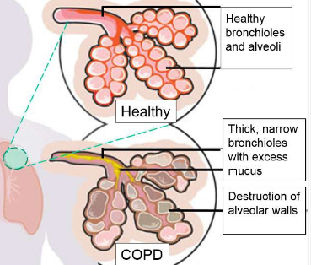
While Chronic Obstructive Pulmonary Disease(COPD) has historically been referred to as a "disease,"it would probably be more accurate to refer to it as a "syndrome" instead.(Agusti,et al.,2010).

- Emphysema;
Over inflation of the lung(Therlbeck and Muller,1994).
- Chronic Bronchitis;
A lot of mucus inside bronchioles

COPD is mainly irreversible!!!
SYMPTOMS
Shortness of breath
Cough
Wheezing
Sputum production



Just Breathe

The majority of us breathe without much thinking. But what if, one day, you found that breathing wasn't as effortless for you and that it became a challenge on a daily basis? To reduce your chance of difficulties, it is crucial that you take care of your lung health.


Lung condition symptoms
Knowing the symptoms will help you decide when to get more help:
Chronic cough, chronic wheezing, shortness of breath, ongoing exhaustion, coughing up blood, and stiffness or pain in the chest

See your doctor if any of these symptoms cause you concern.

The average adult breathes around 12-20 times a minute when resting, and this can reach up to 60 times a minute during vigorous exercise.

Keeping your lungs healthy

- To keep your lungs healthy, you should focus on the following:
- Give up smoking - Smoking is the major cause of mortality and is responsible for about 84% of lung cancer deaths. E-cigarettes are less dangerous, but research on their long-term impact on lung health is still ongoing.
- Protect your lungs from pollutants by avoiding areas with high air pollution, such as congested roadways, whenever you can, especially during rush hours and on days with high pollution levels (check air pollution levels at UK Air). Use precautions if your job involves a lot of dangerous or noxious dust or fumes.
- Prevent respiratory ailments by practicing good hand hygiene. This can help you stay healthy and prevent respiratory illnesses like the flu and the common cold. Seasonal flu vaccinations are also offered to protect people.
- Regular exercise helps to expand your lung capacity and improves lung performance.
- Practice deep breathing; normal breathing typically only utilizes half of your lung capacity. Deep breathing strengthens your respiratory muscles and helps to fill your lungs. Also, it can make you feel calmer and enhance your general well-being.
(Allhealthmatters)

