Ashleigh Roberts – 1810091
Earth Science Exam – 18.05.2020

- Explain the ocean circulation currents and describe their impact(s) on global climate.

Ocean currents are located at the ocean surface and in deep water below 300 meters (984 feet). (National Geographic, 2013). Ocean circulation currents act like a conveyor belt, conveying warm water and precipitation from the equator towards the poles and cold water from the poles back to the tropics. Moving the water horizontally and vertically and it is located on both local and global scales. The ocean has a consistent current powered by wind, tides, the Earth’s rotation, the sun (solar energy), and water density differences. Resulting in the oceans currents regulating global climate, helping to counteract the uneven distribution of solar radiation reaching earth’s surface. Circulation is significant to different species too as it circulates food to organisms who live in one specific place in the ocean.
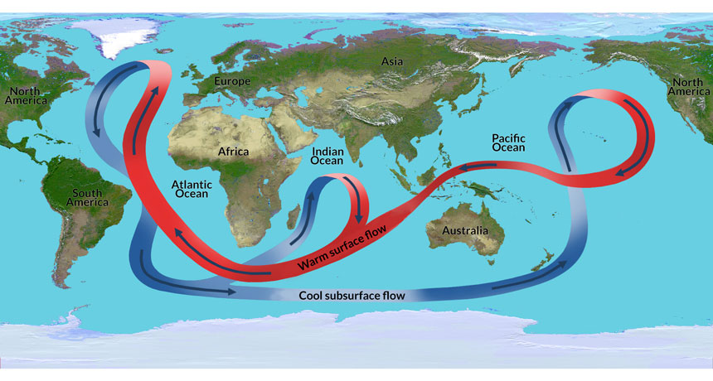 (Sumner, 2017)
The above image clearly shows the direction and movement of the oceanic current to and from the poles. Without these currents the global climate would experience a huge impact. “Without this moving water, wintertime temperatures could plummet in parts of Europe by 7 degrees Celsius (13 degrees Fahrenheit). A stalling of this ocean current also could change rainfall patterns across the globe.” (Sumner, 2017)
The slowing of the oceanic current has many effects on the climate (globally). If it slows down it will cause colder winters and hotter summers in Europe, it will change the rainfall patterns in the tropics, and it can cause warmer water to build up along the U.S coast which can cause the sea level to rise resulting in storms.
A change in the North Atlantic specifically can also increase streams of ice burgs into shipping lanes therefore causing issues in navigation. Unfortunately, there are already signs that the decrease is having an effect due to the decrease in commercially imported cod. “In 2015, scientists traced the imminent collapse of the commercially important cod fishery in the region to rapidly warming water in the Gulf of Maine, which fits the pattern of slowing Atlantic circulation” (Berwyn, 2018)
According to NASA, warm water off the East Coast has helped instigate 2011’s damaging hurricane Irene and storm sandy which followed just a year later. This point supports the idea of the oceanic currents slowing down.
An invasion of cold, fresh water from melting ice is more than likely disrupting the ocean’s circulation, where the cold water from the melting glaciers, ice sheets starts to sink making the water less saline, and less dense than saltwater. This makes it harder to sink and move the current towards the south.
If the oceanic circulation continues to slow down, it will result in the weather conditions changing meaning hotter summers and colder winters which will affect habitats on land and underwater, farming industries, fishing industries etc. If it continues to slow down, the increase and severity of winter storms will increase causing global devastation and severe drought in the summer season in turn causing produce issues and lack of drinking water in some countries.
According to Landscape News “Reaching a tipping point could have drastic consequences for the whole planet, Caesar explained. Model studies suggest that a strong weakening of the AMOC would reduce the absorption of atmospheric carbon dioxide by the ocean in that area, which would increase the concentration of carbon dioxide in the atmosphere more rapidly and thus increase the greenhouse effect and global warming.” (Kusters, 2018)
Greenhouse gases have extreme environmental and health effects. They also cause climate change by trapping heat for example. Smog and air pollution are the result of this. Extreme weather, produce disruptions, and bigger wildfires are other effects of climate change caused by greenhouse gases.
Oceanic circulation and greenhouse gases hold hands in the effect and results of climate change which is why oceanic current slowing down is such a large issue in climate change.

However, according to Scientific American, the oceanic currents have been accelerating since the 1900’s. “A study published yesterday in Sciences Advances find that global ocean circulation has been accelerating since 1900’s. the study examined decades of observations form instruments that monitor the seas’ kinetic energy – a measurements of how fast the water is moving. A closer look, region by region, suggests that much of the acceleration is happening in the tropics. And circulation also appears to be speeding up in other swaths of the Atlantic, Indian, and Pacific oceans.” (Harvey, 2020)
There are still some areas of the ocean that are slowing down but overall this case study explains that the ocean is accelerating due to increase in wind speed. Which in this instance is a positive but can also be a negative due to the size of the waves increasing, making it difficult for navigation and also causes coastline issues.
Some researchers have suggested that the oceanic circulation goes through phases of accelerating and decelerating. This could be due to changes in weather patterns, the speed of the wind during certain points in time could have an impact on the speed on the current not the actual process itself.

References

Berwyn, B. (2018, May 7). Scientists Say Ocean Circulation Is Slowing. Here’s Why You Should Care. Retrieved from Inside climate news: https://insideclimatenews.org/news/07052018/atlantic-ocean-circulation-slowing-climate-change-heat-temperature-rainfall-fish-why-you-should-care
Harvey, C. (2020, February 6). Ocean Currents Are Speeding Up, Driven by Faster Winds. Retrieved from Scientific American: https://www.scientificamerican.com/article/ocean-currents-are-speeding-up-driven-by-faster-winds/
Kusters, K. (2018, June 8). Ocean currents are slowing down, and that’s bad news. Retrieved from The Landscape News: https://news.globallandscapesforum.org/27742/ocean-currents-are-slowing-down-and-thats-bad-news/
National Geographic. (2013, March 21). Ocean Currents and Climate . Retrieved from National Geographic: https://www.nationalgeographic.org/media/ocean-currents-and-climate/
Sumner, T. (2017, January 27). Climate change could stall Atlantic ocean current. Retrieved from Science News for Students. : https://www.sciencenewsforstudents.org/article/climate-change-could-stall-atlantic-ocean-current

- As the Holocene began there was a wave of megafaunal extinctions. Discuss the possible causes of these events.
The sixth mass extinction (Holocene) is an ongoing extinction of species at present due to human activity which began 0.01 million years ago. Overharvesting, pollution, habitat destruction, introduction of invasive species, overhunting etc. are the main causes of the mass extinctions. It is important that we understand how human activity impacts the environment around us and to understand the survival and expansion of prehistoric humans.
When humans came along the decrease in megafauna was imminent. The cause of megafaunal extinctions was through direct killing by humans.
“It doesn’t take a lot to make a species go extinct,” says Advait Jukar from George Mason University. “Humans didn’t need to go out and kill every last individual; all you need is a stressed population and just enough hunting pressure to keep the fertility rate [below replacement levels]. Eventually, the population will collapse.” (Young, 2018)
As stated above it doesn’t take a great deal of effort to put pressure on a specific species.
According to The Guardian, Human activity has:
- Pushed extinction rates of animals and plants far above the long-term average. The Earth is on course to see 75% of species become extinct in the next few centuries if current trends continue.
- Increased levels of climate-warming CO2 in the atmosphere at the fastest rate for 66m years, with fossil-fuel burning pushing levels from 280 parts per million before the industrial revolution to 400ppm and rising today.
- Put so much plastic in our waterways and oceans that microplastic particles are now virtually ubiquitous, and plastics will likely leave identifiable fossil records for future generations to discover.
- Doubled the nitrogen and phosphorous in our soils in the past century with fertilizer use. This is likely to be the largest impact on the nitrogen cycle in 2.5bn years.
- Left a permanent layer of airborne particulates in sediment and glacial ice such as black carbon from fossil fuel burning.
(The Guardian, 2016)
The modern-day human activity is creating major issues in relation to the environment causing global warming. For example, this has a huge influence on Polar Bears. According to National Geographic, “Climate change is heating up the Arctic faster than anywhere else, and sea ice is shrinking 14 percent per decade.” (Leahy, 2018). Meaning that the ice is melting sooner in the year and building back up later in the year, leaving a longer period of time in-between seasons, making them walk/swim longer distances to get to any outstanding ice. Polar bears live of the thick amounts of fat they hold/build up in the winter and the fact they have to walk/swim means that they have to burn massive amounts of energy, in turn if they stay on land and fast throughout the summer they will still be burning their fat.
Leahy explained that Pagano’s study involved holding nine female bears in the Beaufort Sea off Alaska in the month of April (when there are generally more seals around.) he fitted the bears with GPS collars that had cameras along with blood and urine samples. Around eight to 11 days later they were all re-gathered and these were the results found. “One bear had moved 155 miles away by that time. Blood and urine samples were taken again, and the video and other data were downloaded. The data showed the bears were active about 35 percent of the time and resting for the remainder, yet they burned through 12,325 calories a day, much of it from their body reserves. That’s about 60 percent more than previous studies had estimated. The videos revealed that four of the females weren’t able to catch a single seal. Measurements showed those animals lost 10 percent or more of their body mass. One bear lost close to 44 pounds, including her lean muscle, in 10 days. This bear even leapt into the sea in a failed attempt to catch a seal swimming by. “She might have been desperate,” Pagano speculated” (Leahy, 2018)
Leahy stated that he thought that this study was very strong as it demonstrated that polar bears are more “like the big cats—lions and tigers— predatory carnivores with high energy metabolisms” (Leahy, 2018)
However, it is mentioned that humans are not to be at total blame. “it’s not a slam dunk that humans are responsible for the entire [megafaunal] extinction,” says Jessica Theodor from the University of Calgary. As other studies have shown, it can be hard to parse out the effects of human hunting, climate change, and the big changes that ecosystems undergo when big mammals start to disappear. All of these things often occurred simultaneously and compounded each other. Still, as Kaitlin Maguire from the Orma a J. Smith Museum of Natural History puts it, “while it’s thought that the megafaunal extinctions were a result of a one-two punch from shifting climate and human influences, this work demonstrates that the human punch was strong.” (Young, 2018)
As stated above, climate change can also have a detrimental effect on different species. At present the melting of glaciers in Antarctica have caused polar bears to become vulnerable to extinction. The Polar bear populations is decreasing due to loss of sea ice habitat prompted from climate change, “polar bears were listed as a threatened species in the US under the Endangered Species Act in May 2008.” (World Wildlife , 2020)
Deglaciation has a huge impact on habitat. It is an unsteady process and takes a long time to process. This mainly happened in the Pleistocene prelude stage 10,000 years ago (the initial stages of a new species – Homo sapiens). It involved the interstadial phase which mainly concerned insects and when they became apparent. Later came plants and shrubs as the soil became thicker and more hospitable. Following this the temperature on Earth increased and large mammals and humans became apparent.
A huge number of large mammals went extinct at the early stages on the Holocene. Due to the earth’s temperature rising it made it difficult for the large hairy animals to cope and they became unable to adapt to this. Additionally, the human impact on these populations considered hunting. As mentioned above, the population of large animals decreased as they were hunted for food.

References

Leahy, S. (2018, February 1). Polar Bears Really Are Starving Because of Global Warming, Study Shows. Retrieved from National Geographic : https://www.nationalgeographic.com/news/2018/02/polar-bears-starve-melting-sea-ice-global-warming-study-beaufort-sea-environment/
The Guardian. (2016, August 29). The Anthropocene epoch: scientists declare dawn of human-influenced age. Retrieved from The Guardian: https://www.theguardian.com/environment/2016/aug/29/declare-anthropocene-epoch-experts-urge-geological-congress-human-impact-earth
World Wildlife . (2020). FACTS. Retrieved from World Wildlife : https://www.worldwildlife.org/species/polar-bear
Young, E. (2018, April 19). In a Few Centuries, Cows Could Be the Largest Land Animals Left . Retrieved from The Atlantic: https://www.theatlantic.com/science/archive/2018/04/in-a-few-centuries-cows-could-be-the-largest-land-animals-left/558323/

