

Postgraduate/Distance Learning
Assignment coversheet & feedback form

THIS SHEET MUST BE THE FIRST PAGE OF THE ASSIGNMENT YOU ARE SUBMITTING (DO NOT SEND AS A SEPARATE FILE)

For completion by the student:
Student Name: Kim Harrer

Student University Email: 1814398@student.uwtsd.ac.uk
Module code: HPCA7003  Module title: History of Astrology | Student ID number: 1814398 |  |  | Educational support needs:  No
Assignment title: Did medieval astrology (1100-1400) assume that the future was negotiable or fixed?

Assignment due date: 20/04/2020
This assignment is for the 1st 2nd 3rd 4th 5th 6th module of the degree
I confirm that this is my original work and that I have adhered to the University policy on plagiarism.
Signed,
Kimberley M. Harrer
Email submission:if you are submitting this form via email, please tick this box □
(as a substitute for your signature) to confirm that you agree to the above declaration.
Assignment Mark
1st Marker’s Provisional mark
2nd Marker’s/Moderator’s provisional mark
External Examiner’s mark (if relevant)
Final Mark

NB. All marks are provisional until confirmed by the Final Examination Board.

For completion by Marker 1 :
Comments:

Marker’s signature: |  |  | Date:
For completion by Marker 2/Moderator:

Comments:

Marker’s Signature: |  | Date:
External Examiner’s comments (if relevant)

External Examiner’s Signature: |  | Date:

Did medieval astrology (1100-1400) assume that the future was negotiable or fixed?
Word Count: 3,571
Introduction
The medieval period was an exceptional time when ideas were forged, approved, retracted, condemned, and re-approached continually. Astrology and its utility were no exceptions. Medieval philosophy drew on both modern and classical thought, merging ideas that reached back to the likes of Ptolemy with modern Christian theology developed by Albertus Magnus and St. Augustine. According to Charles Mosely, “the oculocentricity of medieval culture is beyond question…religion had been precisely about…looking for what lay beyond language”, and instead thought “in terms of images, of icons, in terms of music, or action” in order to grasp information and make sense of the world around them. The use of a visual medium, specifically iconography, made it possible to disseminate the tenets of faith in a way that could be absorbed by the community at large and present the interpenetrative relationship between astrology, free will, and divine providence as coexistent and cooperative.
Claudius Ptolemy
Although he was a member of the Classical category of philosophy, a major influence on medieval philosophy was Claudius Ptolemy (100 – 170 AD). Along with being a mathematician, astronomer, and geographer, Ptolemy was also well-known for his astrological acumen. Ptolemy extolled the benefits of astrology in predicting weather, natural phenomena such as the tides, and the seasons for agricultural purposes. In his ‘Tetrabiblos’, Ptolemy laid out what he believed to be the ultimate structure of the cosmos, saying “a certain power emanating from the eternal ethereal substance is dispersed through and permeates the whole region about the earth” as well as every celestial body in between the ethereal and the earthly realms. As everything was connected in his model by the “eternal substance”, or divinity, any motion produced within that substance triggered a natural chain-reaction of changes throughout the cosmos, ultimately influencing life on earth. Because weather changes and natural phenomena could be predicted with close attention to the heavens, why then, Ptolemy asked, could we not for an individual “perceive the general quality of his temperament from the ambient at the time of his birth…and predict occasional events” in his life based on the positions of the planets at his birth? How could those positions have no effect on human behavior or individual outcomes?
St. Augustine
When taken up by medieval thinkers, the main concern was not so much whether predictions could be made as it was what the presence of predictions indicated about God’s supremacy. Specifically, medieval philosophers were concerned with whether the use of astrology could refute or uphold the Christian tenets of free will and divine providence. In his ‘On the Free Will’, for example, St. Augustine (354 – 480 AD) expressed his belief that free will was a logical truth of existence, for “if man did not have free will, both punishment and reward would be unjust”. Free will and divine providence coexist, but, he warned, “it is not to be believed that, because sin is committed by it…God gave free will for sin”. According to Augustine, man has a choice to use his free will for good purposes or for sin. The man who chooses to do good with his free will is rewarded while the man who sins is punished and asked “why have you not used your free will for the purpose for which I gave it to you, that is, for doing rightly?”. Augustine’s interpretation of free will as a catalyst for good or a use for evil implies that humans have some control over their individual outcomes.
Augustine applied more stirring rhetoric directly to astrology in his ‘Confessions’. Employing a literary style reminiscent of Plato’s Republic, Augustine, in this work, uses the literary technique of dialogue to convey his (and, by extension, Christianity’s) arguments against divination of any kind – astrology in particular. The story describes a more personal journey with astrology in which he was a believer in the predictive power of astronomy who then came to understand that it left no space for humans’ God-granted free will. When speaking with another character, he asked why some predictions by astrologers come to fruition. Augustine was told the practice of prediction by astrologers was “a complete sham” and that “the force of chance, all-pervasive in the universe, brought this about”. Here, choice is replaced, and ostensibly made synonymous, with chance. Chance is embedded into the cosmos itself in this concept and makes the reading of an individual’s horoscopic future unreliable. Although celestial objects align and can be interpreted based on those alignments, within the cosmos lay the element of chance, within humans lay the element of choice. These elements cooperate to ensure God’s promise of free will. To be clear, it is not that Augustine entirely disavowed astrology and its uses. In fact, he expressed hesitancy in relinquishing his belief in astrological predictions. Augustine wanted to find “absolute proof…to assure me beyond doubt that the things people said they had predicted…were only predicted by luck or blind chance, and not through their skill in astrology”, but his ultimate directive was to find the role of free will in its predictive capacity.
Albertus Magnus
This directive dominated theological debate throughout the medieval period and was eventually taken up by Albertus Magnus (1193 – 1280 AD). Albertus charged himself with reconciling Aristotelian cosmology with Christian theology – which he saw as having a very simple solution. As the Aristotelian cosmological model asserted that “planets, like people…are animated by soul”, which he felt was in harmony with his own beliefs in a Christian cosmos organized, orchestrated, and overseen by God. His model, much like Ptolemy’s, assumed that the planets’ motion was directed by the Prime Mover and lacked agency in terms of divining human life. As was Augustine, Albertus was aware of astrology’s practical uses in agriculture. Going beyond Augustine, he also felt that celestial events could be taken as signs or omens. However, according to Nicholas Campion, although “his attitude to astrology was strongly favourable – he regarded it as demonstrably true”, he would not accept any idea which suggested a lack of free will, opting for a more natural astrology rather than divinatory.
Medieval Iconography
With a diverse audience of varying levels of literacy, religious leaders of the medieval period needed a medium other than written language to clearly convey their ideological messages as well as the morals of the Bible. In his ‘Iconography and Ideology: Uncovering Social Meanings in Western Medieval Christian Art’, Johnathan J.G. Alexander says that medieval art, much like advertising, functioned as “a representational system that is directly aimed by its makers at us and that both reflects our social organisations, our life styles and values, and also manipulates them’. Art was a way of accessing the masses, and cognitive theory of the time posited that “memory stored the ‘intention’ of an image, not simply the image itself”. Consequently, the style and method of the work was deliberate. The simplicity, repetition, and apparent “lack of creativity” commonly seen in works of art from then were purposeful and part of a deliberate practice of religious communication. Rather than attempting verisimilitude in their works, medieval artists utilized icons which were a “sophisticated symbolic system” which requires the viewer to engage with higher-order thinking, moving beyond the canvas “toward the archetype” for a deeper understanding of abstract concepts such as morality and duty as well as free will and divine providence.
The Heavenly Ladder
As discussed earlier, astrology, free will, and divine providence were viewed as interwoven during the medieval period. Religious leaders and thinkers regularly attempted to use each to prove the other (the practice of astrology proves the presence of free will, etc) and rectify any apparent disproof of God’s ultimate power. In fact, astrology was so intrinsic to the concepts (and proof) of free will and divine providence that its relationship to religion was implicitly represented in art of which it was not the explicit topic. The image below, for example, is a depiction of the Scala Paradisi or Divine Ladder from the 12thcentury. This painting is based on the book ‘The Heavenly Ladder’ written by St. John Climacus. The purpose of this book was to be a “spiritual guide” which was structured to reflect the rungs of a ladder. It described a process of steps one must take dedicatedly with focus and integrity in order to reach the realm of God. As with many medieval texts, the targeted audience was largely illiterate, so “paintings and sculpture [were] the books of the unlearned”. In this way, the use of images was essential to adhere to the moral imperative in Christianity to spread the word of God.
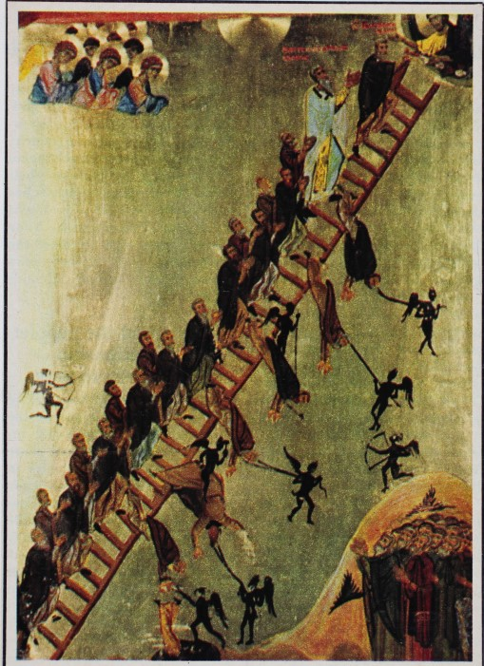
In this piece, a steady stream of men ascends a ladder leading to an opening in the heavens in which waits Jesus Christ. Although the ascent appears chaotic, clamoring even, with men being pulled down by fallen angels with ropes along the way, the men’s gazes are undistracted and remain lovingly and desperately fixed upward toward Jesus. Regarding the function of Christian images in the medieval period, Alexander says that images afforded “visual role models” and “served as markers with resonances within the social practices of medieval society”. Viewers of this piece would understand the message of precarity in the journey to Heaven as translated by this image. This precarity stems from the presence of those dark, winged figures who seem to display a certain indifference about their work as though it was a monotonous day-job. The figures carrying bows and arrows can be interpreted as Augustine’s concept of chance while the figures with ropes can be seen as his concept of consequence of choice. As one metaphorically climbs the ladder to heaven (walks a righteous path, chooses good over sin, etc), there are moments of faltering. When an individual chooses to wield his free will for the purposes of sin, no matter how momentary the weakness, the consequences fell his soul swiftly. The arrows being launched at the men on the ladder can be seen as an external force. A force which chooses when to strike, stealing agency from any individual attempting to live a life over which he has control. Those arrows, however, and the figures carrying them, can also be seen as lying in wait to swoop in at the moment of misstep – at the moment when free will is used by someone for sin. Once the choice to sin is made, the ropes pull those souls mercilessly into the unknown hole of darkness.

Figure 1 Anonymous-Byzantine, Depiction of Divine Ascent as described in the work of the same name by St. John Climacus, c. late 12th century, St. Catherine’s Monastery, South Sinai Governorate, Egypt. Image: The Warburg Institute Iconographic Database.

Jesus’ presence at the top of the ladder, beckoning the climbers, is reminiscent of Magnus. It is as though he is overseeing and orchestrating the journey, but the responsibility for the outcomes of actions is placed squarely on the shoulders of men and their free will. Their position on the ladder in relation to the divine and the structure and direction of the ladder itself contain no prognosticatory power. This interpretation parallels, and even serves as a microcosm of, Magnus’ astrology. The positions and motions of the planets – much like the positions of the ladder’s rungs – cannot determine the future of an individual’s journey. It is the choices one makes on his way which changes the course of the future.
The Wheel of Fortune
Still popular today, a common icon of the medieval period was the Wheel of Fortune. The main image in fortune’s depiction is Lady Fortune. From serving as “an instrument of divine justice” to becoming “the embodiment of chance”, this Lady has been depicted in many roles with many different capacities and capabilities. As an icon, these many different roles can be extended to the broader relationship between free will, divine providence, and astrology. What is remarkable about this particular icon is the deliberate changes in its aesthetic over time to reflect the socio-political-theological shifts “in the balance of interpretation” in terms of the plausibility of free will and divine providence’s cooperation, and the attempts to reconcile the two.
The two images below are roughly from the same time period (mid-15th century), and although they ultimately display the same theological stance, the role of Lady Fortune and those positioned on her wheel in them differs greatly. The first image (Figure 2) is from the frontispiece of Boethius’ ‘On the consolation of Philosophy’. On the left we see Boethius listening to the teachings of Lady Philosophy. On the right, Lady Fortune spins her wheel while eyeing Boethius from a distance. The figures on Lady Fortune’s wheel are clearly at the mercy of her turning rather than wielding their own will. Even though the work itself is still, the motion of the wheel is more than evident in the helpless positions of those seated there – the ascending figure looking expectantly upward toward the king sitting stoically upright and erect at the top, then the downward-facing and submissive figure plummeting toward the bottom of the wheel where there sits a deeply pathetic and traumatized figure who has succumbed, crown and all, to the cycle of fortune. According to Samuel C. Chew, this particular depiction of Lady Fortune does not show her actions as “whimsical and incalculable” but as “the agent of God’s justice”. It is in this sense that the wheel echoes Augustine’s argument for the relevance of astrology, that the presence of divine providence proves the existence of free will and vice versa. At first glance it seems, as mentioned before, that the figures seated on Lady Fortune’s wheel have no agency and are locked in its spinning motion. However, if divine justice is working through Lady Fortune, free will, according to Augustine, is also present and involved in the wheel’s motion regardless of its momentum just as it influences the outcome of someone’s fate regardless of sidereal positioning.
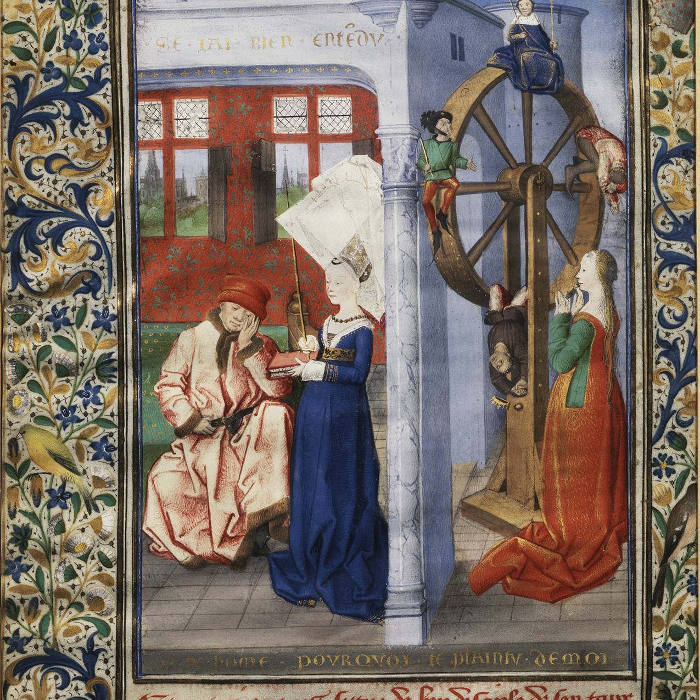
Figure 2. M320, Maître de Coëtivy (Active 1450-1500), Frontispiece of Book II of Boethius’ ‘De Consolatione Philosophiae, c. 1460 – 1470, Gouache, ink, and gold on vellum, 241 mm x 165 mm, The Wallace Collection Sixteenth Century Gallery, London, England. Image: Wallace Collection.
The next image (Figure 3) is from the manuscript of John Lydgate’s ‘Siege of Troy’. In it we again see Lady Fortune and her wheel. This time, though, the manuscript’s illuminator depicted “people mounting the wheel”, making a “conscious choice to open oneself up to Fortune’s whims” in hopes of making an effective enough appeal to her to gain her sympathy. Although these people employ their free will and mount the wheel by choice, the results for each of them are the same. Each one, in his or 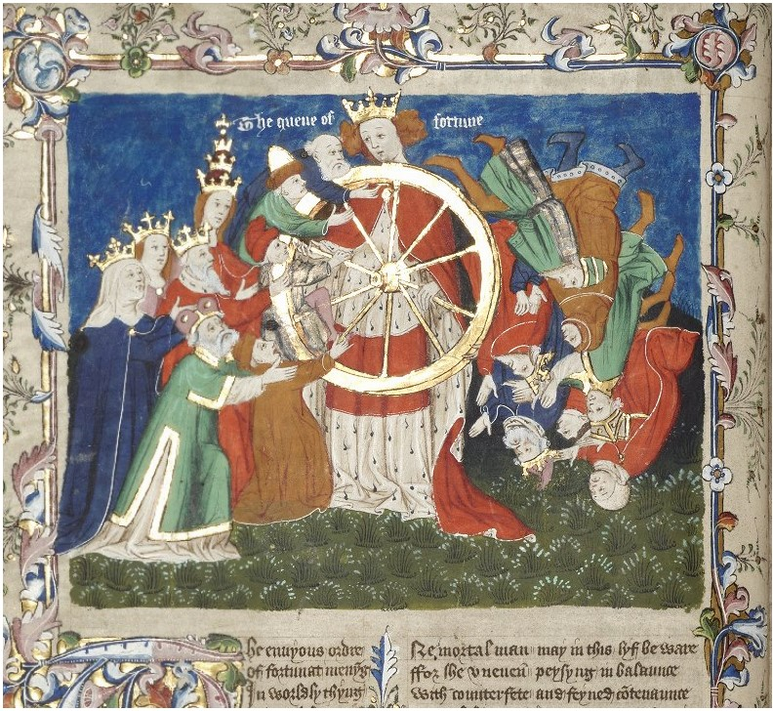
Figure 3 English MS 1, Anonymous, Wheel of Fortune, c. mid-15th century, ink on vellum, 451 mm x 326 mm, The University of Manchester Library, U.K. Image: The University of Manchester Medieval Collection.
her hubris, plunges to the bottom of the wheel. In this way, divine providence, through Lady Fortune, and free will work in tandem to rectify any imbalance in the existence of the two and to ensure their continued cooperation. This image resonates with the astrological proofs put forward by Ptolemy, Augustine, and Albertus. As in Ptolemy and Augustine, the motion of all is directed by a Prime Mover, i.e. the work of Lady Fortune as God’s instrument of justice. In terms of Augustine’s ideas, the free choice depicted in this image of each person to mount the wheel does not preclude God’s providence over the results of his or her decisions. Concomitantly, god’s providence does not preclude the use of free will to make choices for one’s self.
Conclusion
Pulling from classical philosophers and astronomers such as Ptolemy, medieval thinkers and religious leaders tried to explain their observations of the world through the lens of their faith. As such, free will, divine providence, and astrology for the medieval period, were interlocked in a cooperative and meaningful relationship. In addition, their moral imperative was to bestow that faith onto as many others as possible. Manuscript illuminators and artists alike made it possible for the messages of faith to reach an audience with diverse levels of education through the use of iconography. Tacitly present within these icons, astrology was a major part of proving and legitimizing the tenets of Christianity, conforming to them in order to form a cohesive bond with free will and divine providence.

Bibliography
Primary Sources
Augustine, St., Confessions, Volume I: Books 1-8, translated by Carolyn J.-B. Hammond, Loeb Classical Library 26, Cambridge, MA: Harvard University Press (2014).
Augustine, St., ‘On the Free Will Book II’, Selections from Medieval Philosophers: Augustine to Albert the Great, translated by Richard McKeon (ed), Charles Scribner’s Sons (1929), p. 11-64.
Ptolemy, Claudius, Tetrabiblos, translated by F. E. Robbins, Loeb Classical Library 435, Cambridge, MA: Harvard University Press (1940).
Secondary Sources
Alexander, Johnathan J.G., ‘Iconography and Ideology: Uncovering Social Meanings in Western Medieval Christian Art’, Studies in Iconography, Vol. 15 (1993) p. 1-44.

Brown, Alex, ‘Turn, Turn, Turn’, History Today (Jan. 2018), p. 26-35.
Campion, Nicholas, ‘The Thirteenth Century: The Aristotelian Revolution’, A History of Western Astrology Volume II: The Medieval and Modern Worlds, Bloomsbury (2009), p 43-52.
Chew, Samuel C., ‘Time and Fortune’, ELH, Vol 6 No. 2 (Jun. 1939), p. 83-113.
Conty, Arianne Francoise ‘Bending Heaven Down to Earth: The Medieval Icon’, Religion and the Arts, Vol. 19 (2015), p. 1-30.

Duffy, John, ‘Embellishing the Steps: Elements of Presentation and Style in “The Heavenly Ladder” of John Climacus’, Dumbarton Oaks Papers, Vol. 53 (1999), p. 1-17.
Mosely, Charles, ‘Speaking Pictures: Medieval Religious Art and Its Viewers’, The Edinburgh Companion to the Bible and the Arts, Edinburgh University Press (2014), p. 175-194.
Radding, Charles M., ‘Fortune and her Wheel: The Meaning of a Medieval Symbol’, Mediavistik, Vol. 5 (1992), p. 127-138.

Images
Figure 1 Anonymous-Byzantine, Depiction of Divine Ascent as described in the work of the same name by St. John Climacus, c. late 12th century, St. Catherine’s Monastery, South Sinai Governorate, Egypt. Image: The Warburg Institute Iconographic Database, https://www.wallacecollection.org/collection/frontispiece-of-book-ii-of-boethius-de-consolatione-philosophiae/
Figure 2. M320, Maître de Coëtivy (Active 1450-1500), Frontispiece of Book II of Boethius’ ‘De Consolatione Philosophiae, c. 1460 – 1470, Gouache, ink, and gold on vellum, 241 mm x 165 mm, The Wallace Collection Sixteenth Century Gallery, London, England. Image: Wallace Collection, https://wallacelive.wallacecollection.org/eMP/eMuseumPlus?service=ExternalInterface&module=collection&objectId=64507&viewType=detailView
Figure 3 English MS 1, Anonymous, Wheel of Fortune, c. mid-15th century, ink on vellum, 451 mm x 326 mm, The University of Manchester Library, U.K. Image: The University of Manchester Medieval Collection, https://luna.manchester.ac.uk/luna/servlet/detail/Man4MedievalVC~4~4~254893~107255:Wheel-of-Fortune?qvq=q:john%20lydgate%20the%20siege%20of%20troy%20fortune&mi=7&trs=14

Mosely, Charles, ‘Speaking Pictures: Medieval Religious Art and Its Viewers’, The Edinburgh Companion to the Bible and the Arts, Edinburgh University Press (2014), p. 184.
Ptolemy, Claudius, Tetrabiblos, translated by F. E. Robbins, Loeb Classical Library 435, Cambridge, MA: Harvard University Press (1940), p. 7.
Ptolemy, Tetrabiblos, p. 11.
Augustine, St., ‘On the Free Will Book II’, Selections from Medieval Philosophers: Augustine to Albert the Great, trans Richard McKeon (ed), Charles Scribner’s Sons (1929), p. 13.
Augustine, Free Will, p 13
Augustine, Free Will, p 13
Augustine, St., Confessions, Volume I: Books 1-8, translated by Carolyn J.-B. Hammond, Loeb Classical Library 26, Cambridge, MA: Harvard University Press (2014), p. 141.
Augustine ‘Confessions’ p. 141.
Campion, Nicholas, ‘The Thirteenth Century: The Aristotelian Revolution’, A History of Western Astrology Volume II: The Medieval and Modern Worlds, Bloomsbury (2009), p. 48.
Campion, Western Astrology p 48
Johnathan J.G. Alexander, ‘Iconography and Ideology: Uncovering Social Meanings in Western Medieval Christian Art’, Studies in Iconography, Vol. 15 (1993), p. 1.
Mosely, Charles, Speaking Pictures, p. 176.
Alexander, Jonathan J.G., Iconography, p. 1.
Conty, Arianne Francoise ‘Bending Heaven Down to Earth: The Medieval Icon’, Religion and the Arts, Vol. 19 (2015), p. 1.
Duffy, John, Embellishing the Steps: Elements of Presentation and Style in “The Heavenly Ladder” of John Climacus’, Dumbarton Oaks Papers, Vol. 53 (1999), p. 2.
Mosely, Charles, Speaking Pictures, p. 181.
Alexander, Jonathan J.G., Iconography, pg. 1.
Brown, Alex, Turn, p. 28.
Radding, Charles M., ‘Fortune and her Wheel: The Meaning of a Medieval Symbol’, Mediavistik, Vol. 5 (1992), p. 128.
Chew, Samuel C., ‘Time and Fortune’, ELH, Vol 6 No. 2 (Jun. 1939), p. 94.
Brown, Alex, Turn, p. 28.

