INTRODUCTION
The aim of this report is to understand the concept of employee engagement and its link to other concepts like motivation or organisational commitment. I will be explaining the elements which are present in organisations with high levels of employee engagement, expanding on why employee engagement is vital when formulating HR strategies and practices.
But to be able to analyse the level of engagement in organisation, we need to have a knowledge of the data sources. I will be emphasising on the findings of recent studies to study the factors which influence the levels of engagement, to conclude with a summary of the future of employee engagement.

DEFINE EMPLOYEE ENGAGEMENT
Employee engagement is a very broad concept. According to the CIPD (2021a), the MacLeod Review from 2009 observed over 50 different definitions.
Engage for Success (2021), defines employee engagement as a series of appropriate working conditions for all members of an organisation which results in employees who are committed to its values and goals, who are motivated to participate in the organisation’s success and whose well-being feels enhanced. Employee engagement is built on trust, two-way communication and commitment between the employee and the organisation.
In more detail, engaged employees understand their role in the organisation and how it fits in the organisation’s objectives. They are also aware of how the organisation is accomplishing their goals and purpose, and what is being done to achieve them in the best way possible. The organisation allows employees to have a voice to express their views and offer ideas when decisions are made (Engage for Success, 2021). Employees receive regular and constructive feedback, are recognised for their accomplishments and are provided with opportunities to develop their skills.
There is another approach by Kahn from 1990, which states that people who are engaged ‘employ and express themselves physically, cognitively and emotionally’ (Johns and Ellis, 2016):
- Physical: High levels of energy and mental strength, inclined to make an effort.
- Cognitive: Fully concentrated and immersed in their work but find it difficult to detach from it.
- Emotional: Strongly involved in their work with a feeling of significance, inspiration, enthusiasm and gratification.
Johns and Ellis (2016) also establish that the CIPD explains employee engagement as combining the commitment to the organisation and its values along with the disposition to help colleagues, or ‘organisational citizenship’. But also, engagement must be offered by the employer, cannot be part of the employment contract and it is discretionary, as employees will not be engaged automatically.
According to the CIPD research from 2012, employees can be engaged emotionally, when they are devoted to one or more sides of their work in an emotional way, but can also be transactionally engaged, when they are showing their engagement as a behaviour but are not showing any commitment to the job itself or the organisation and would leave when they find a better opportunity (Johns and Ellis, 2016).

COMPARE AND CONTRAST EMPLOYEE ENGAGEMENT WITH OTHER RELATED CONCEPTS.
Employee engagement is related to other concepts, such as organisational commitment and motivation.
- Organisational commitment

It is considered as the individual’s psychological attachment to the organisation (Johns and Ellis 2016), and we can differentiate between three approaches:

- Affective, when an employee identifies with the business’ goals and wants to be a part of them.
- Continuance, related to the costs caused by departure and loss, such pension rights or fears due to unemployment. These employees stay in the organisation because they ‘must’.
- Normative, linked to a feeling of indebtedness and obligation. An example would be when the employer has invested in training and developing an employee, and this feels that ought to stay until the ‘debt is settled up’.
Johns and Ellis (2016) go on explaining how engaged employees show low levels of burnout, low neuroticism and are highly extrovert, enjoying good mental and physical health. But also, we must remember that engagement is about performance and results. When employees go the extra mile, teams and organisations will be more effective, customer service will be better, and efficiency will grow.

- Motivation

In 1963, John Adams developed his Equity Theory, related to motivation, which establishes that there should be a fair balance between the employee’s inputs (skills, enthusiasm, hard work) and outputs (salary, benefits, recognition). When reaching this balance, a productive and strong relationship is achieved with the employee, resulting in contented and motivated employees (Mindtools, 2021).

Adams believed that employees become demotivated if they feel their inputs are superior to their outputs. The employee’s reactions may vary from asking for more recognition or compensation, to seeking for other employment opportunities.

DESCRIBE THE TYPICAL HR, LEADERSHIP AND CULTURAL ELEMENTS LIKELY TO BE FOUND IN AN ORGANISATION CHARACTERISED BY HIGH LEVELS OF EMPLOYEE ENGAGEMENT.
In 2010, Purcell analysed the factors most strongly associated with commitment in the organisations through the 2004 WERS data, which are known as the building blocks of engagement (Robinson and Gifford, 2014). These are:
- Employee trust in management
- Fulfilment with work and the job
- Involvement in decision-making at work
- Atmosphere of relationships between management and employees
- Satisfaction with pay
- Job challenge
- Feeling of accomplishment from work
As we can see, trust in management is the most important factor, where line managers are providing trust-worthy leadership, support employee voice and involve the employees in the job and team decisions. As Robinson and Gifford (2014) explain, through different communication systems, such as briefing groups, social media and work force meetings, line managers reach over four fifths of their employees.
However, it seems that senior managers are still an issue, as most of the workforce in the EU admit that their organisations do not provide them with opportunities to be involved in the decision making, according to the Fifth European Working Conditions Survey (Eurofound, 2012). Other studies in staff councils show that when employees are involved in making decisions it is usually on how to implement the policies, not on the decision making itself (Robinson and Gifford, 2014).
Summarising Purcell’s findings, where line managers promote voice and involvement and the top-level members involve senior managers in the consultative procedure, connecting them both effectively, there will be better outcomes in relation to commitment and engagement (Robinson and Gifford, 2014).
In 2009, MacLeod and Clarke published a report where they established four enablers of engagement. These are:
- Strategic narrative: Explaining the purpose of the organisation, the reasons why it has adopted its vision and how employees may contribute to the purpose. Employees will understand where their work corresponds.

- Engaging managers: They appreciate the employees’ effort and contribution, creating a feeling of support to do their job and rewarding their capabilities.

- Employee voice: It is key to listen to the employee’s opinions and show them they can contribute to have an effect.

- Integrity: Employees are confident that the behavioural values are consistent within the organisation, which produces trust and integrity.

EVALUATE THE NEED FOR ALIGNMENT BETWEEN EMPLOYEE ENGAGEMENT AND OTHER ORGANISATIONAL FACTORS.
When discussing the link between organisational alignment and employee engagement, there must be a psychological agreement between individual and organisational goals (Alagaraja and Shuck, 2015). This originates from the promotion of a positive organisational culture and from continuously observing each element of the organisation’s strategy, both execution and experience.
Behaviourally engaged employees ensure that their efforts are aligned towards organisational objectives to support a move in a positive direction. They usually work harder and experience higher levels of overall well-being. Relating to the dimensions of employee engagement identified by Rich et al in 2010, Alagaraja and Shuck (2015) establish that cognitively engaged employees are willing to invest personally in the organisation, as they understand and share its common purpose. Emotionally engaged employees associate their personal values and rules with the organisation’s and will be very productive. Behaviourally engaged employees will use incentive and reward structures to achieve organisation’s vision and mission.
In an organisation, if we optimise business processes and internally align the organisational structure, strategy and culture, connecting it to the external market, we can inspire the employee’s cognitive and psychological assessment and interpretation of the work setting. A positive interpretation will lead to a supportive employee performance. On the other hand, a negative perception of the work conditions will produce poor performance. This way, employee engagement is considered as the link that clarifies how alignment may support or hinder the effect on the employee’s performance (Alagaraja and Shuck, 2015).

EXPLAIN WHY EMPLOYEE ENGAGEMENT IS AN INCREASINGLY VITAL DIMENSION OF HR STRATEGY AND PRACTICE.
According to research by Gallup (2022b), engaged employees have a higher autonomy and ownership for the organisation, which leads to them putting in a more discretionary effort. In times of recession, engagement is even a stronger predictor of performance. Employees who are engaged are more resilient and keep the organisation going at a high level at difficult times, but they also thrive faster than competitors during the good times.
Nowadays, we can find a lot of positive and negative information about organisations on social media, that is why having an authentic employment brand with an engaging work environment is key, where employees feel like they are performing and developing, and they belong in the organisation’s culture which is making a difference (Gallup, 2022b).
To improve employee engagement, some companies use the Gallup’s Q12 questionnaire, but ultimately, employee engagement is one of the manager’s primary responsibilities. To be able to succeed, they need to have the tools to have coaching conversations with the employees, but the majority do not know how. Gallup (2022a) has found that the role of a manager is a prevailing factor in the employee experience, from the onboarding to the exit, and how they interact with the employees has an impact in positive results. Managers should be set up to success in every aspect of the employee experience below:
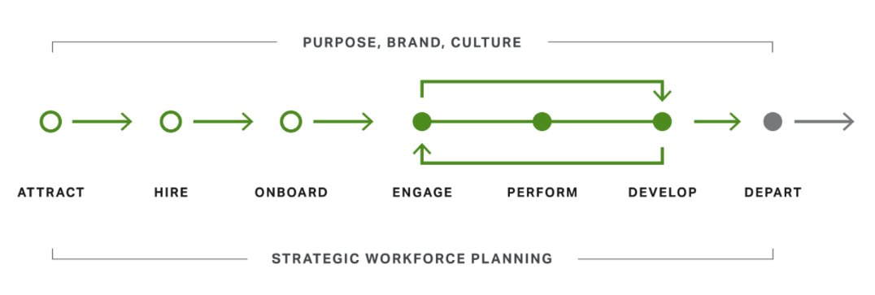
Gallup, 2021a

Gallup (2021a) states that there are different ways of supporting the managers, such as:
- Ensuring that the managers are experiencing and promoting the organisation’s purpose, brand and culture, by communicating it to them clearly. This way the managers will understand how their performance influences the company’s success, how their goals are aligned to the organisation’s and how their salary and incentives are connected to their position in the organisation’s success. This way they will be more effective when leading their teams.

- Redefining the role of a manager as a coach. This way, managers are expected to develop a team, apart from delegating tasks. They will be setting goals with them, providing coaching orientated to the future and accountability oriented through achievement.

- Designing learning and development opportunities that are relevant and strengths based, blending influential in-person experiences with on-the-job training and resources for regular challenges and conversations. This would include training with activities like role-play.

- Requiring that managers receive strengths-based feedback and recognition from their superiors. This way they will identify further developing needs and will be encouraged to find solutions to issues using their strengths.

- Designing a successful planning system, starting with objective performance measures and assessments to define who could be potentially promoted to a people leader role.

EVALUATE THE POTENTIAL BENEFITS, FOR DIFFERENT PARTIES, OF HIGH EMPLOYEE ENGAGEMENT.
As MacLeod and Clarke established in their report from 2009, ‘engagement can be a triple win: for the individual at work, the enterprise or service, and for the country as a whole’.
According to Johns and Ellis (2016), there has been different research studies about how beneficial employee engagement is for the organisations. One of the most important ones is the Towers Perrin 2007/2008 Global Workforce Study (2009), which explains the link between high engagement and high performance. It was found that after observing 50 global organisations for a period of one year, the organisation with a high employee engagement level increased their operating income by 19% and a growth of earnings per share of 28%. However, organisations with low levels of employee engagement dropped their operating income by 32% and their earnings per share was reduced by 11%.
Another research from Saks admitted that high levels of employee engagement are positively related to organisational commitment, employee loyalty, customer satisfaction, productivity, profitability and safety.
Johns and Ellis (2016) carry on showing that on a different research from Gallup, based on nearly 8,000 business units, the ones in the top 25% on ‘work engagement’ had 1% to 4% higher profits and between $80,000 and $120,000 higher monthly revenues than the units on the bottom 25%. Gallup studies have also demonstrated that when employee engagement and customer engagement are practiced jointly, the organisations can achieve better profit margins.
Looking at this evidence might make us accept that employee engagement generates greater outcomes in an organisation, but there can be other factors that might influence high profits in organisations and that are not necessarily related to high levels of employee engagement, such as family businesses with employees on low salaries (Johns and Ellis, 2016).

IDENTIFY KEY SOURCES OF EMPLOYEE ENGAGEMENT RELATED DATA.
When measuring the levels of employee engagement in an organisation, it is important to differentiate between the different types of data. The CIPD (2021b) finds four different concepts:
- Qualitative data: It is subjective and describes qualities observed by someone. It helps us understand the ‘why’, ‘what’ and ‘how’ of something. An example used in employee engagement could be the exit interviews or performance review meetings.

- Quantitative data: It can be described in numbers. It is measurable and objective. Examples can be turnover rates and absenteeism.

- Correlation: When two or more situations happen at the same time, they might be associated with each other.

- Causation: When something occurs, it instigates something else to happen.

Organisations rely on qualitative and quantitative data to predict something else. If it happens, we can admit there is a correlation and define its strength with a number. However, this correlation does not mean causation (CIPD, 2021b).
The UNESCO Institute for Information Technologies in Education (2012) expands on learning analytics, dividing them on Macro, Meso and Micro.
- Macro-level analytics: They are used to support cross-institutional analytics, through methods like ‘maturity’ surveys of current institutional systems. These macro-analytics will become gradually real-time, integrating data from meso and micro levels. They might also profit from data incorporation and benchmarking methods from other sectors.

- Meso-level analytics: They function at institutional level. They can also be perceived as the new Business Intelligence market sector, taking tools to boost workflows, produce dashboards or extract unstructured data, among other things.

- Micro-level analytics: They assist with the tracking and interpretation of data for individuals at process-level. It is very important for the learners and those accountable for their success, as they can provide optimum details as promptly as possible.

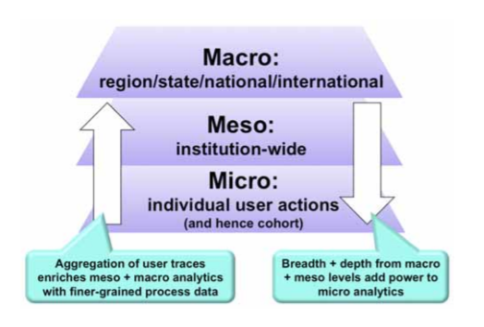UNESCO (2012)
The figure above shows how the different layers are integrated and are enriched between themselves. The depth and breadth at the macro and meso levels add strength to micro analytics. This way better predictive models can be developed, and we might be more confident predicting behaviours when they have been contrasted against a national database.

DESCRIBE KEY TRENDS IN EMPLOYEE ENGAGEMENT AND DIFFERENCES LINKED TO GENDER, DEMOGRAPHIC AND OTHER FACTORS.
The CIPD Employee Outlook survey from 2017 measured employee engagement focusing in four areas: influence over job, use of skills, motivation and effort.
- Influence over job: Employee satisfaction regarding the amount of influence they have over their job in general sits at +35, while satisfaction related the opportunity for using their own initiative within their job is higher, at +55. Both figures increased compared to the previous year. Employees within the public sector are more likely to be satisfied for using their own initiative in their job than the ones working in the private sector (see table below).
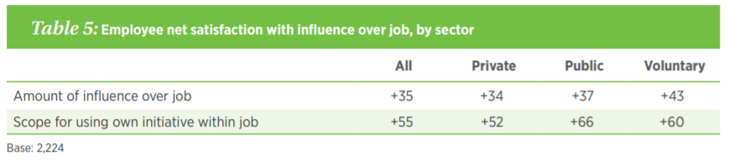
Employee Outlook Survey (CIPD, 2017)

- Use of skills: No substantial differences were found between sectors, with a satisfaction score of +49, increasing from the previous year.
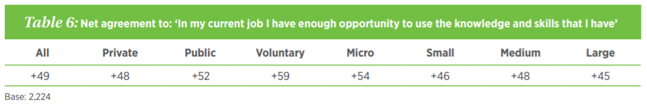
Employee Outlook Survey (CIPD, 2017)

- Motivation: Overall, the score for this area is very low, +12, but it increased from the previous report, as we can see in the table below.

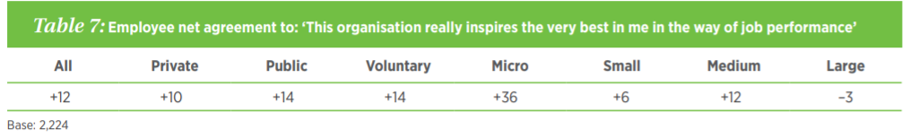
Employee Outlook Survey (CIPD, 2017)

- Effort: This was measured in three different aspects. Whereas the results from employees willing to help others by taking more workload and willing to work harder to help their organisation thrive has produced great results, they also showed that they would leave their company if they found a different job with a higher salary.
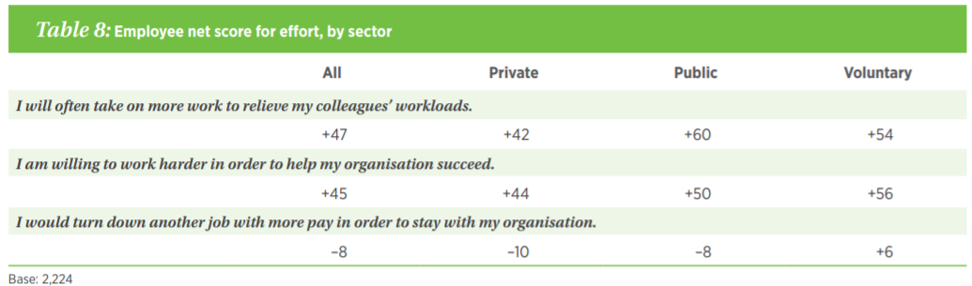
Employee Outlook Survey (CIPD, 2017)

According to Miller and Adkins (2016), in the United States, women are more engaged than men, with a 35% of women against a 29% of men. This also corresponds in terms on management, where only 32% of men are compared to 41% of women.
In terms of age, a study by Gallup (2017) states that the millennials (born 1980-2006) is the group with the lowest percentage on engaged employees (31%). On the other hand, the baby boomers (born 1946-1964) are the most engaged group (35%). Gallup also reported that the millennials value career growth and development opportunities as a key feature for them in a job, although the figures estimate that they are not supported to do so.

EVALUATE THE FUTURE FOR EMPLOYEE ENGAGEMENT, BASED ON CURRENT TRENDS.
The trends report by HRzone (2020), which was published just before the Covid pandemic began, established the following three predictions: graft, autonomy and energy. Even if there were talks of automation in the workplaces, people would be expected to carry on working long hours. In terms of autonomy, the report predicted empowerment, liberation and autonomous ways of working to avoid micro-management, but also to allow growth, diversity and innovation. This way, people will be responsible for their own problem solving, developing adaptive working practices. Also, when talking about energy, the report considers it very important to a balanced performance, having a good relationship with colleagues and customers, but also for our well-being.
The report also agrees there should be a shift in the HR strategy, making a transition to a people-centric style, which can be summarised as below (HR Trends, 2020):
- Human-centred designed.
- Employee experience.
- Digital workplace.
- Workplace design.
- Group performance.
- Agility.
- Self-organisation.
- Importance of purpose and meaning.
- Several stakeholders.
- Humanocracy not bureaucracy.
However, 2020 turned out to be a year of changes and adaptations due to Covid. According to the report by Quantum Workplace (2022), employee engagement showed its highest levels in 2020, with a figure of 77%, which was unexpected as Covid affected the lives of employees and the way businesses work. Organisations improved their communication, implemented more flexible working environments and supported their employees with more well-being initiatives. These changes increased the employees’ trust in management, their work-life balance, and resulted in them being more engaged with their work.
Conversely, in 2021, these engagement levels decreased; by summer 2021 the percentage had declined from 81 to 74. The main reasons for this were (Quantum Workplace, 2022):
- Lack of communication and transparency about changes in the organisation.
- Decline of trust in leadership.
- Work-life balance has dropped.
- Absence of Health and Well-being initiatives.
- Decrease of employee recognition.
- Less clear career growth opportunities.
To overcome this situation, Quantum Workplace (2022) has determined five focus areas for HR, which are:
- Employer brand, to retain those employees who drive the business.
- Learning and development.
- Flexibility and mental well-being.
- Feedback from employees.
- Predictive analytics.

