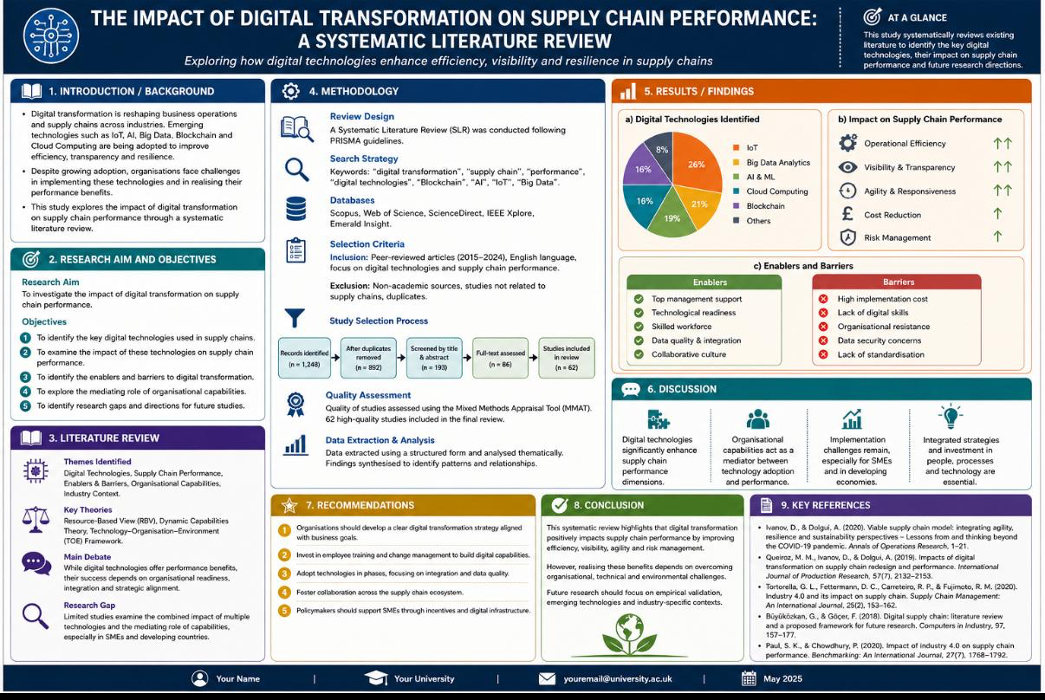
Student name: Monica Iordan Student id: 2130804

