
Student Name: Kavya Raghuraman

Student ID: 2519354

Module Name: International Business Concepts

Module Code: LCMB7034

Lecturer’s Name: Gladius Kulothungan

Work Count: 5923

Table of Contents
Section 1: 3
Introduction 3
Organisational Classification and Global Strategy 3
Macro-Environmental Appraisal and Market Attractiveness 6
Market Entry Strategy 11
Entry Mode Strategy and Strategic Synthesis 13
Historical Pattern Recognition 13
Strategic Fit & Justification 15
Recommendations 16
Conclusion 17
References 18
Section 2: 22
Gibbs reflective framework 22
References 25

Section 1:

Introduction
Company Overview
JD Sports is a well-known sports fashion retail company which was founded by John Wardle and David Makin in 1981, and its headquarters are situated in Greater Manchester, UK (borngroup.com, 2026). The business organisation operates in over 51 countries, which demonstrates its strong market presence. On an additional note, the company has been expanding its operations rapidly, with over 4,800 stores across prime regions such as Europe, the Asia Pacific region, the UK and so on. Also, the firm is known for offering a high-quality and diverse range of products such as sneakers, sportswear, clothing, and so on, which enables it to attract customers, resulting in superior revenue generation.
Report structure
The report will offer an in-depth evaluation of the expansion of JD sports in Bolivia where different aspects will be thoroughly discussed. The initial portion of the report will provide information regarding the international strategy choice of the business organisation followed by its geographic footprint and the impact of international operations on its competitive edge. Also, the macro-environment and market attractiveness of both the home and host countries will be stated. In addition, entry mode strategy and effective recommendations will be offered which will make it easier for the firm to expand its operations into Bolivia.

Organisational Classification and Global Strategy
Strategic Categorisation: Critically analyse the international strategy choice of JD Sports using Bartlett and Ghoshal
The Bartlett & Ghoshal Model is a strategic management framework for global business operations. Multinational corporations (MNCs) use this to determine the best configuration for their global operations. The framework categorises international strategies. It considers global integration and local responsiveness required by a multinational enterprise (Mehra et al. 2026). The model includes four strategic options for this. These are international, global, multidomestic and transnational (Politikova, 2026).
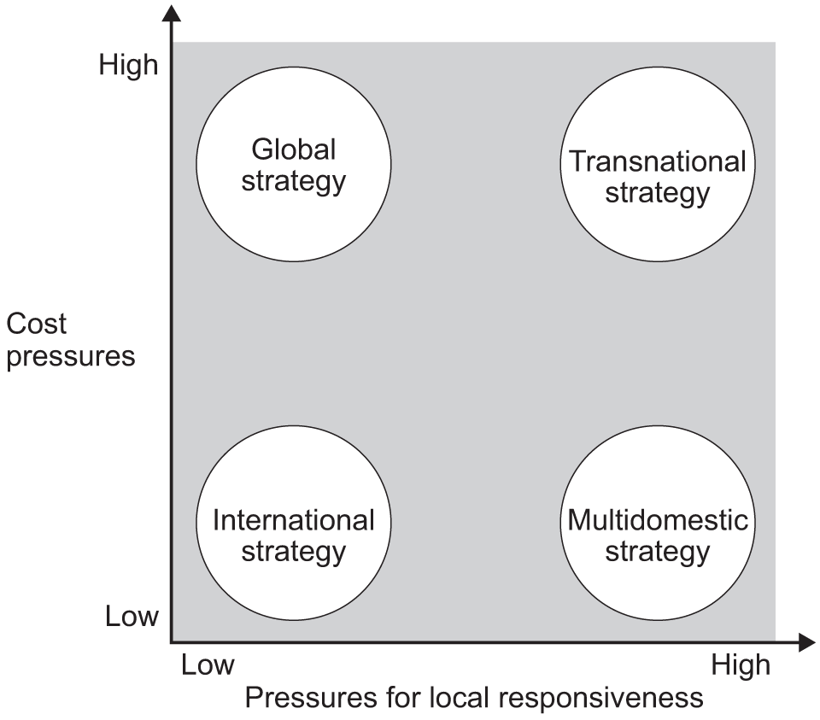
Figure 1: Bartlett Ghoshal Model
(Source: aqa, 2026)
In this section, the suitable international strategy for JD Sports will be explored. JD Sports may undertake the transnational strategy. This is a suitable option for the brand. This approach allows local flexibility despite maintaining global standards. With this, JD Sports will be able to combine global consistency in its brand image. Standardisation in product quality will be maintained. Besides, adaptation to local consumer preferences will also be prioritised. JD Sports' vision is to Connect globally, Inspire locally (jdplc.com, 2026). The transnational approach aligns with this. A transnational strategy will allow JD Sports to maintain its core competitive capabilities. Alongside this, JD Sports will adapt merchandising, promotions, store formats and digital communication to the Bolivian market. Global integration is important for the company. It will sustain technology, supply-chain capabilities and a recognisable retail identity. However, a standardised UK model would be insufficient. Bolivian consumers differ in purchasing power, fashion preferences, sporting interests and shopping behaviour. Hence, high global integration will be combined with meaningful local responsiveness.
Global Configuration: Critically appraise the firm’s current geographic footprint, analysing how its international operations contribute to its overall competitive advantage and value creation
- Current Geographic Footprint
JD Sports is a UK-based sports-fashion retailer. The company has a strong foothold in the UK market. With this, it has expanded its business globally. It manufactures fashion items, sportswear, and streetwear. Company reports reveal its presence in 36 countries with 4,811 stores (jdplc.com, 2026). Alongside this, 68 franchise operations span 15 countries (londonstockexchange.com, 2026). Its international footprint spans major regions. Around 75% of revenue is generated from North America, Europe, and Asia Pacific (jdplc.com, 2026). North America is its largest international market. It accounts for 38% of Group sales (globenewswire.com, 2026). It operates with wholly controlled operations, acquisitions, stores and franchising. This enables the company to balance control and risk. Its acquisition of Hibbett has been beneficial. This has strengthened its North American presence.
- Value Proposition
The value proposition of JD Sports is based on its offering because the company operates in multiple countries and is more likely to produce products focusing on the trends and preferences of the customers. besides it retail experience and omnichannel convenience also quite apple into the customers since the company provides a blind of sports were and fashion. The main target of the company is young consumers who preferred force were widely as lifestyle and fashion apparel. The business organisation creates high-energy visuals along with a hint of sustainability to grab the attention of mass consumers.
- Contribution to competitive advantage
The international operations of the mentioned company contribute to the competitive advantage because the organisation has high brand equity due to its diversification approach. The company has a stronger appeal in the marketplace by offering customer knowledge, which supports a better international footprint and leads to significant financial performance. The Group is also investing in high-end technologies. This supports its competitive advantage in the market. Automation has been integrated in 2026 (jdplc.com, 2026). E-commerce infrastructure and supply-chain optimisation are also beneficial to competitiveness. This improves availability, fulfilment and customer experience across its network. It operates across 36 countries. This provides access to diverse clientele and markets. This enables JD to understand varying consumer trends across different regions. These insights influence marketing and product decisions. The international footprint is also strong. This reduces reliance on only the UK market. North America’s contribution is significant. It accounts for 38% of sales. This demonstrates the strategic importance of geographic diversification for JD Sports.

Macro-Environmental Appraisal and Market Attractiveness

Host Country Analysis
- Political
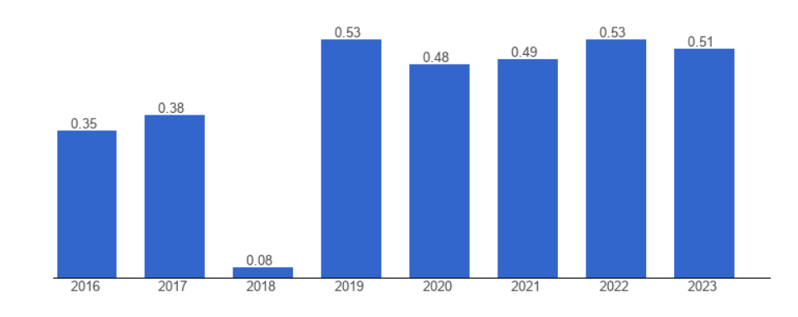
Figure 2: UK Political Stability Index.
(Source: theglobaleconomy, 2023)
The above graph demonstrates the political stability index of the UK from 2016 to 2023. As per the evaluation, it has been evidenced that the political stability index of the UK is 0.51 as of the financial year 2023. This is considered to be highly stable, which makes it easier for business organisations to function smoothly in this region. Taking this into consideration, it has been stated that the country has undergone transformation shifts where the Government has introduced growth-centric policies which have been beneficial for companies to function smoothly. JD Sports focuses on aligning the government initiatives with its potential requirements, which allows it to operate efficiently, resulting in strengthening its competitive advantage. Also, the infrastructure investment initiatives enable the company to lower operational costs as well as enhance overall productivity. On an additional note, the UK commercial setting consists of several investment opportunities due to superior interest and market confidence of investors, which further allows the sports fashion retail company to carry out its operations smoothly. This helps the firm to ensure superior long-term planning and make investments in crucial aspects, as well as manage potential financial risks (Grishunin et al. 2022).
On the other hand, the political stability index of Bolivia is substantially low, which indicates high political uncertainty. However, JD Sports will be able to manage its operations in this region due to its strong infrastructure and financial stability, which will make it easier for it to expand smoothly. Also, the strong risk management approach of the business organisation will further make it potentially easier to deal with the unstable political scenario of this country, resulting in enhanced effectiveness and superior advancement (Pomaza et al. 2023). Based on this, it can be implied that this is due to long-term effective planning as well as the credibility of the sports fashion retailer, which will enable it to expand its functions swiftly in Bolivia.
- Economic
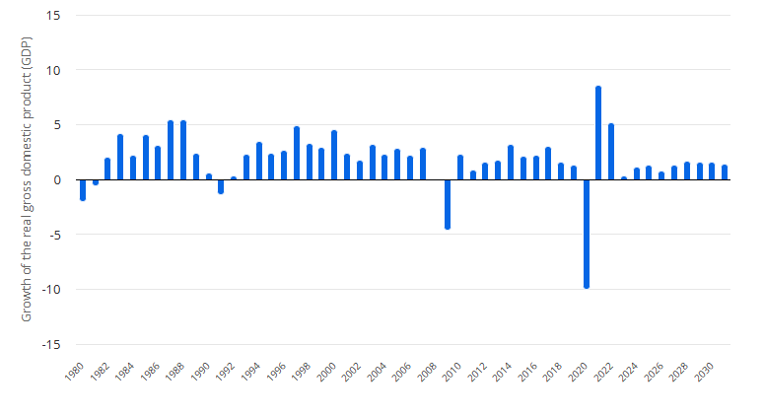
Figure 3: UK GDP Rate.
(Source: statista, 2026)
The above graph underlines the Gross Domestic Product Rate of the UK from the fiscal year 1980 to 2030. Based on the analysis, it can be inferred that the GDP rate of the country is fluctuating substantially, as evidenced in the above graph, which indicates an unstable economic scenario. The GDP of the country is recorded to be 1.32% in 2025, which is anticipated to decline to 0.8% in the financial year 2026 (statista.com, 2026). Taking this into account, it has been stated that a drop in GDP indicates low income among consumers, which potentially lowers their ability to make purchases. However, the inflation rate of the UK is potentially dropping, which was recorded to be 2.8% in May 2026 and 2.6% in June 2026 (tradingeconomics.com, 2026). This is highly beneficial as it allows JD Sports to generate revenue due to strong customer purchasing power, ensuring smooth revenue generation.
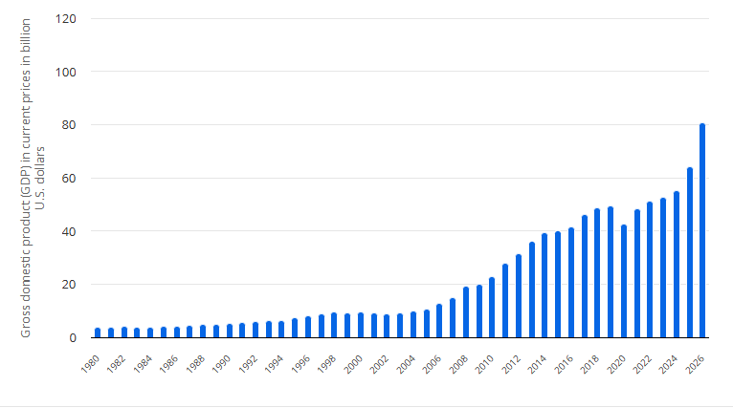
Figure 4: GDP of Bolivia.
(Source: statista, 2026)
The GDP of Bolivia from 1980 to 2026 has been highlighted in the above graph. Considering the evaluation, it is implied that the GDP of the country was valued at $64.25 billion in the financial year 2025, which is projected to increase to $80.74 billion in 2026 (statista.com, 2026). This demonstrates significant growth of the economy, which is highly beneficial for companies to generate profits, resulting in enhanced monetary standing. On an additional note, the inflation rate of this country has potentially decreased, which was recorded to be 12.51% in May 2026 and 9.23% in June 2026 (tradingeconomics.com, 2026). This further indicates a stable economic scenario, which will make it significantly easier for the sports fashion retail business organisation to expand its operations and generate revenue in this region. Based on this, it can be stated that this is due to the superior spending power of consumers, which will increase the demand for the products of JD Sports, consequently ensuring repeated purchases.
- Socio-Cultural
The growing inclination of consumers towards high-quality and unique designs of sportswear and footwear in the UK has significantly increased. Also, the increasing focus of UK customers towards health and fitness has significantly enhanced the demand for the company’s products (Lienher, 2022). Taking this into consideration, it has been evidenced that the focus of the business organisation towards gaining insights about the latest preferences and requirements of consumers enables it to meet their demand, consequently ensuring smooth revenue generation in the constantly evolving UK sports fashion retail industry. On an additional note, the purchasing decisions of consumers are potentially transformed through cultural preferences and the rise of digital culture, which underlines the emphasis of the business organisation towards meeting these requirements (Rajagopal et al. 2022). Taking this into consideration, it has been evidenced that JD Sports implements engaging and superior quality promotional approaches to underline the significance of its offerings, which enables it to capture the attention of UK customers, consequently ensuring superior profit generation.
In addition, the growing demand for fitness-related products is significantly increasing in Bolivia, which can make it easier for the business organisation to generate revenue. This is due to urbanisation and increasing concern of customers towards health consciousness, which will be highly beneficial for the sports fashion retail company to attract and encourage them to make repeated purchases, resulting in smooth expansion into this region. Based on this, it can be stated that it is important for the company to conduct detailed industry research, which will allow it to obtain information about the latest market patterns and customer requirements, as well as cultural preferences (Azimi and Saleh, 2025). Also, the firm will be able to understand the shopping habits of customers, which will further enable it to meet their preferences by offering relevant products, leading to boosting their engagement and ensuring smooth profit generation in Bolivia.
- Legal
JD Sports complies with several rules and regulations, which allows it to function smoothly in the UK. Taking this into consideration, it has been evidenced that the business organisation adheres to consumer protection laws, where it ensures that high-quality products are offered and transparency is maintained, which makes it easier for it to capture the attention of customers and encourage them to stay engaged. This includes offering detailed information about product quality standards, warranties, return policies, adequate marketing, and so on, which allows the sports fashion retail company to enhance customer engagement (Widiarty and Tehupeiory, 2024). On an additional note, the firm complies with employment laws and labour standards in the UK, where it ensures employee rights, which include wage standards, anti-discrimination laws, safety regulations and others, are met. Also, the company complies with intellectual property laws, taxation regulations, data privacy and security laws, environmental laws, and so on, which enables it to function smoothly in the UK. However, the regulatory framework of Bolivia is considered to be highly stringent, which makes it important for the company to adhere to various laws to ensure smooth operations and avoid legal constraints. This includes tax laws, labour laws, commercial code of conduct and others.
Market trends and opportunities
From the above evaluation, it can be implied that JD Sports will acquire several growth prospects while operating internationally due to various aspects. Based on this, it can be stated that the rising interest as well as inclination of consumers towards health consciousness is increasing their inclination towards purchasing sports-related products such as footwear, apparel, and others. This will be highly beneficial for the sports fashion retail company, as it will increase the demand for its products, consequently enabling it to generate revenue and maintain its financial stability internationally.
On an additional note, the strong financial standing of the business organisation due to diverse investors will further make it easier for it to maintain its operational effectiveness due to the availability of funds (Farida and Setiawan, 2022). Also, the emphasis of the company towards complying with different rules and regulations has significantly enhanced its brand reputation as well as boosted investor and consumer trust. This will be highly beneficial as it will help in attracting both customers and investors while functioning internationally, resulting in smooth operations and strengthening its competitive advantage.

Market Entry Strategy
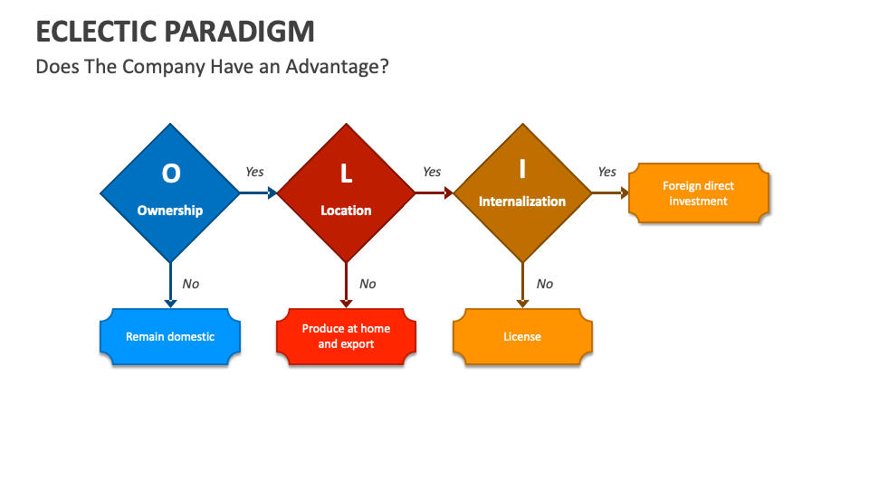
Figure 5: OLI Model
(Source: collidu, 2026)
JD Sports is planning to expand its business operations to Bolivia. The country indeed demonstrates growth potential. In this section, the market entry strategy will be defined using the OLI framework. This model is also referred to as the Eclectic paradigm. The model was introduced by John Dunning in 1979. The model explains the benefits of business expansion in international locations. The model includes three dimensions. These are ownership, location, and internationalisation. In this section, the model will be used for market entry strategy formulation for JD Sports.
Ownership in the OLI framework refers to firms' specific resources (Batschauer da Cruz et al. 2022). This underpins the idea that every firm owns certain unique assets. Similarly, JD Sports also possesses substantial ownership advantages. This will support its entry into Bolivia. The strongest advantage is its established international brand identity. JD Sports is a well-known company in sports fashion. It maintains a global omnichannel presence. It is noted above that it operates with 4,811 stores across 36 countries. Alongside this, a franchise presence is evident in a further 15 countries. Its scale provides experience in managing international retail operations. Besides, its vision supports adapting its proposition to different markets. Another key advantage is JD Sports' established relationships with leading sportswear and athleisure brands. The company includes both established brands and emerging brands. It also has its own-brand portfolio. This enables it to offer footwear, apparel and streetwear aligned with contemporary consumer trends. Technology and omnichannel capabilities also offer an advantage. The company generated approximately 21% of Group sales through online channels in 2026 (jdplc.com, 2026). This demonstrates substantial digital retail capability. Hence, it is evident that its strong online presence also acts as a beneficial aspect. Its physical retail presence is also prominent. Its stores offer high-energy visuals with JD Theatre. This is also beneficial in appealing to a younger population.
The location aspect in the OLI framework refers to the benefits of the foreign market. Bolivia demonstrates a developing retail and digital environment. This underpins opportunities for JD Sports. Venturing into this market will enable JD Sports to establish an early presence in the sports-fashion segment. However, Bolivia's e-commerce market remains relatively small in comparison to JD Sports' major markets. The country is categorised as an emerging market. Hence, prospects are evident. Reports show that in 2024, Bolivia reported approximately 9.14 million internet users (datareportal.com, 2026). This represents 73.3% penetration. Alongside this, 7.55 million social media users were also reported (trade.gov, 2026). This data reveals opportunities for JD's omnichannel business model. JD Sports may concentrate its commercial activity in Santa Cruz, La Paz and Cochabamba. These cities have established distribution channels. Also, these represent important centres of population and business activity. JD may initially concentrate on establishing its physical presence in these locations. From this, it may develop digital reach across the country. However, Bolivia also has certain disadvantages. Its e-commerce market is not vast. This limits opportunities for online retail operations. Besides, the purchasing power of buyers is also limited. Economic volatility may deter customers from purchasing sportswear.
The internalisation advantage concerns whether the company creates value by controlling important activities itself. Or rather, it transfers them to independent companies. Internalisation will allow JD to protect its brand identity. It will be able to standardise its product quality, customer experience, and proprietary knowledge. This is an important factor. But Bolivia poses operational and financial risks. The market is new. It has distinct rules and regulations. Hence, in the initial stage, it may implement a franchise-based internalisation approach. It has previously operated with a franchising model. Hence, this will be beneficial.

Entry Mode Strategy and Strategic Synthesis

Historical Pattern Recognition
JD Sports has leveraged several different market entry strategies for different countries depending on their market maturity, competitive intensity, and regulatory competition. Rather than relying on a single expansion model, the company adopted strategies like acquisitions, joint ventures, franchising, and wholly-owned subsidiaries to accelerate its growth across international markets while maintaining its premium brand positioning. Acquisitions have been one of JD Sports’ most effective market entry strategies. In Europe, JD Sports strengthened its presence by acquiring established sports retailers like Sprinter in Spain and Sport Zone in Portugal, which allowed the company to benefit from their retail networks, experienced employees, supplier relationships, and established customer base (Oliveira, 2025). Acquisition provides major advantages like instant market penetration, reduced entry barriers, and stronger bargaining power with global brands like Nike and Adidas. However, high investment cost, integration issues, cultural differences, and misvaluation of target firms remain some concerns. In the North American market also, JD Sports utilised acquisitions for expansion, as seen in the purchase of Finish Line in the United States and Shoe Palace, which helped it to access one of the world’s largest sportswear markets. However, despite having significant market share and revenue growth, JD Sports encountered integration challenges, operational restructuring and intense competitive pressure from retailers like Foot Locker and Dick’s Sporting Goods (Ayub, 2025).

Figure: Market Entry Strategies
(Source: theinvestorsbook, 2026)
For the Asian and Middle Eastern markets, JD Sports relied on franchising and strategic partnerships. Franchising enabled the company to expand in culturally diverse markets with lower financial risks while having advantages from the local partner’s market knowledge, regulatory expertise, and distribution networks (Cheng, 2026). This approach lowers operational risks and promotes market penetration but sometimes lower managerial control leads to disruption in service quality, customer experience, and brand consistency compared to wholly-owned operations. Furthermore, in developed markets like the UK and Ireland, JD Sports operates via wholly-owned subsidiaries. This particular strategic approach provides complete strategic as well as operational control over the organisation’s pricing approach as well as decision-making process; however, it is high capital expensive which can be difficult for the company to cope with in this fluctuating economy (Pesonen, 2025). The company operates in more than 50 Nations across the globe through various market entry modes; however, it can be identified that the organisation prefers partnerships as well as franchising to a certain extent for emerging economies, while the behaviour and preferences of local customers can be understood quite easily.

Strategic Fit & Justification
Recommended market entry strategy for Bolivia
To enter the Bolivian market, a joint venture approach can be taken into consideration by the business organisation because this market has been an emerging economy characterised by tight and complex regulations as well as lower purchasing power. (Diaz Cuellar, 2026). Hence, by partnering with a local Bolivian retail company, JD Sports can gain valuable market knowledge, understand customer preferences, establish supplier relationships, and become aware of the legal and administrative procedures. A JV approach will balance JD Sports’ global brand consistency with local responsiveness. This will help the company maintain its premium international brand image while adjusting product preferences, pricing strategies, and promotional campaigns. Additionally, compared to a wholly-owned subsidiary, a JV needs lower capital investment and distributes the financial risks among the partners (Hakala, 2025). Unlike franchising, it will provide JD Sports with greater flexibility to control its strategic and operational decisions. Moreover, a partnership will provide future operational expansion into neighbouring South American markets after brand awareness has been generated and operations scaled up. Overall, a JV approach will strike a balance between JD Sports’ market access, operational control, financial commitment, and long-term sustainable growth in Bolivia.
Risk analysis
JD Sports will face several risks while entering the Bolivian market. From a political angle, although Bolivia supports foreign investment in selected sectors, newly entered companies may face challenges regarding policy changes, bureaucratic procedures, and regulatory uncertainties (Hausmann et al. 2026). These factors can delay investment approvals and affect supply chain continuity. By partnering with local retailers, a JV approach can reduce these political and regulatory risks by providing improved stakeholder relationships and local market knowledge. Financial risks are related to exchange rate volatility, inflationary pressures, import duties, and comparatively lower consumer purchasing power in the Bolivian market, which can primarily reduce JD Sports' profit margin. Sharing investment costs via a JV can minimise these risks. Moreover, there will be operational risks such as limited logistical infrastructure, distribution challenges across difficult geographical regions, different consumer preferences, and dependence on imported merchandise (Riby, 2026). As local partners possess knowledge of the transportation network, supplier relationships, and retail operations, operational risks can be reduced in a JV.
From the lens of resource commitment, a JV of JD Sports needs a moderate level of financial and managerial investment, which makes a JV less resource-intensive compared to franchising and wholly-owned subsidiaries. Moreover, regarding control versus flexibility, a JV offers a perfect balance. Since strategic decisions are shared between partners in a joint venture, JD Sports can gain greater flexibility in controlling its merchandising standards, pricing and marketing strategies, and customer experience in changing market conditions (Platania et al. 2026). Overall, for long-term strategic advantage, the joint venture entry mode will support JD Sports’ sustainable international growth while increasing its ownership, operational capability, brand recognition and customer loyalty in the Bolivian market. This will provide an optimal balance between risk management, resource efficiency, operational control, and long-term strategic advantage.

Recommendations
Franchising is recommended for JD Sports to venture into Bolivia. JD Sports is operating with franchising in 15 countries. This shows its extensive hold on aspects associated with this approach. Franchising is a market entry method. In this, an owner (the franchisor) licenses their brand name, logo, and business system to an independent operator (the franchisee) (Yongmei, 2025). This is carried out in exchange for initial fees and ongoing royalties (Rajaratne, 2024). Following this, JD Sports will partner with a local firm. The local firm will have extensive knowledge of the Bolivian market. This will enable the company to understand local consumer preferences, retail locations, regulations, suppliers and distribution networks. However, the company will be able to avoid risks associated with wholly owned operations. It may also implement a transnational approach. This will facilitate a balance between globalisation and localisation. The company will be able to standardise product quality and customer experience. But style, marketing, price, and others will be aligned to local preferences. The digital infrastructure is not very good in the country. Hence, initial emphasis will be on physical stores. Focus will be given to key markets like Santa Cruz, La Paz and Cochabamba. These cities have stronger distribution networks and commercial infrastructure than others.

Conclusion
This report provides market entry planning for JD Sports to a new region. JD Sports is a well-known UK-based sports retail company. It is planning to expand its business to Bolivia. This report examines Bolivian market opportunities and threats. Political uncertainty, economic volatility, lower purchasing power and regulatory complexities are evident in Bolivia. This may create significant challenges. The Bartlett and Ghoshal analysis indicates that a transnational strategy will be beneficial. The OLI framework further highlights the company’s strong ownership advantages. However, it implies selective location opportunities. Hence, a franchise is proposed for market entry.

References
aqa.org.uk, (2026), Bartlett-Ghoshal Model. [Available at: https://www.aqa.org.uk/resources/business/as-and-a-level/business-7131-7132/teach/teaching-guide-bartlett-and-ghoshals-international-multi-domestic-transnational-and-global-strategies] [Accessed on: 05.08.2026]
Ayub, F., (2025). Key Trends in the Market Entry Strategies of the USA Footwear MNEs, encompassing Brand Localization, Digital Engagement and Dynamic Capabilities. Research Journal for Social Affairs, 3(5), pp.423-456. [Available at: https://rjsaonline.com/journals/index.php/rjsa/article/download/340/457]
Azimi, H. and Saleh, M.Y., (2025). Cultural contexts in consumer behavior: a qualitative case study review of market research. International Journal of Management Research and Economics, 3(2), pp.157-165. [Available at: http://jurnal.itbsemarang.ac.id/index.php/Ijmre/article/view/3158]
Batschauer da Cruz, C.B., Eliete Floriani, D. and Amal, M., (2022). The OLI Paradigm as a comprehensive model of FDI determinants: a sub-national approach. International Journal of Emerging Markets, 17(1), pp.145-176. [Available at: https://www.emerald.com/ijoem/article/17/1/145/510750]
borngroup.com, (2026), about JD Sports. [Available at: https://www.borngroup.com/work/jd-sports/]. [Accessed on: 03.08.2026]
Cheng, C., (2026). The Opportunities, Challenges, and Strategies in Adopting the Franchising Business Model: A Literature Review. Jurnal Ilmiah Bisnis dan Ekonomi Asia, 20(1), pp.1-17. [Available at: https://jibeka.asia.ac.id/index.php/jibeka/article/download/2372/661]
collidu.com, (2026), OLI Model. [Available at: https://www.collidu.com/presentation-eclectic-paradigm] [Accessed on: 05.08.2026]
datareportal.com, (2026), digital-2024-bolivia. [Available at: https://datareportal.com/reports/digital-2024-bolivia] [Accessed on: 05.08.2026]
Diaz Cuellar, V.D., (2026). The Capitalist Metabolism: Capitalism, Fossil Energy and Greenhouse Gas Emissions in Bolivia (Doctoral dissertation, Carleton University). [Available at: https://carleton.scholaris.ca/bitstreams/3a72b65d-ff52-4d15-ad4d-0b1515b5cdc4/download]
Farida, I. and Setiawan, D., (2022). Business strategies and competitive advantage: the role of performance and innovation. Journal of open innovation: Technology, market, and complexity, 8(3), p.163. [Available at: https://www.sciencedirect.com/science/article/pii/S2199853122007648]
globenewswire.com, (2026), global-retailer-jd-sports-fashion-plc-begins-trading-on-otcqx-best-market. [Available at: https://www.globenewswire.com/news-release/2026/06/24/3316706/0/en/global-retailer-jd-sports-fashion-plc-begins-trading-on-otcqx-best-market.html] [Accessed on: 05.08.2026]
Grishunin, S., Suloeva, S. and Burova, E., (2022). Development of risk management mechanism and the system of risk metrics to evaluate and enhance the long-term orientation of the strategies of non-financial companies. Risks, 10(9), p.182. [Available at: https://www.mdpi.com/2227-9091/10/9/182]
Hakala, H., (2025). From Institutional Voids to Entry Mode Strategy: Managing Political Risk in Emerging Markets. [Available at: https://osuva.uwasa.fi/bitstreams/ca4ac9bf-3f1b-4573-91e1-d6b63397ce73/download]
Hausmann, R., Venturi Grosso, L., Brenot, C., Abad, A., Lamby, L., Arcay Finlay, G., Garcia, F., Freeman, T. and Shah, T., (2026). Bolivia’s Economic Pivot: Main Findings and Reform Priorities. [Available at: https://dash.harvard.edu/bitstreams/683389ba-1391-449b-84ff-a9fbd030fedc/download]
jdplc.com, (2026), about-jd-group. [Available at: https://www.jdplc.com/about-jd-group/] [Accessed on: 05.08.2026]
jdplc.com, (2026), about-jd-group/business-model. [Available at: https://www.jdplc.com/about-jd-group/business-model/] [Accessed on: 05.08.2026]
jdplc.com, (2026), beyond-physical-retail. [Available at: https://www.jdplc.com/about-jd-group/strategy/beyond-physical-retail/] [Accessed on: 05.08.2026]
jdplc.com, (2026), investment-case. [Available at: https://www.jdplc.com/investors/investment-case/] [Accessed on: 05.08.2026]
jdplc.com, (2026), jd-group-publishes-2026-global-impact-report. [Available at: https://www.jdplc.com/jd-group-publishes-2026-global-impact-report/] [Accessed on: 05.08.2026]
Lienher, S., (2022). Understanding the customers’ needs of Generation Y & Z in the fitness industry. [Available at: https://sonar.ch/hesso/documents/321966].
londonstockexchange.com,. (2026), interim-results-2025-26. [Available at: https://www.londonstockexchange.com/news-article/JD./interim-results-2025-26/17245594] [Accessed on: 05.08.2026]
Mehra, A., Loonkar, S. and Desai, K., (2026), April. Determinants of Local Responsiveness Strategy: Impact of Host Countries Culture on Global Integration. In Global Innovation and Technology Summit “AAROHAN 3.0” _HSS track (GITS-HSS 2025) (pp. 260-270). Atlantis Press. UK.
Oliveira, J.N.F., (2025). Equity research: JD sports fashion PLC. [Available at: https://repositorio.ulisboa.pt/bitstreams/a7613526-303e-4149-bba3-5e0e00c96e25/download]
Pesonen, E., (2025). The Role of Business Intelligence in FDI Entry Mode Choice Between Joint Ventures and Wholly Owned Subsidiaries. [Available at: https://www.utupub.fi/bitstream/handle/10024/180559/The%20Role%20of%20Business%20Intelligence%20in%20FDI%20Entry%20Mode%20Choice%20Between%20Joint%20Ventures%20and%20Wholly%20Owned%20Subsidiaries.pdf?sequence=1]
Platania, F., Toscano Hernandez, C. and Appio, F.P., (2026). Beyond the game: Leveraging athlete celebrities for value creation in sportswear brands in the digital era. European Management Review. [Available at: https://onlinelibrary.wiley.com/doi/abs/10.1111/emre.70064]
Politikova, M.C.H., (2026). тhe transnational strategy as the best alternative for the international development of the automotive companies. International Journal of Professional Business Review: Int. J. Prof. Bus. Rev., 11(2), p.4. [Available at: https://agora.edu.es/servlet/articulo?codigo=10733241]
Pomaza-Ponomarenko, A., Kryvova, S., Hordieiev, A., Hanzyuk, A. and Halunko, O., (2023). Innovative risk management: identification, assessment and management of risks in the context of innovative project management. Economic Affairs, 68(4), pp.2263-2275. [Available at: https://indianjournals.com/article/eaj-68-4-034]
Rajagopal, N.K., Qureshi, N.I., Durga, S., Ramirez Asis, E.H., Huerta Soto, R.M., Gupta, S.K. and Deepak, S., (2022). Future of business culture: An artificial intelligence‐driven digital framework for organization decision‐making process. Complexity, 2022(1), p.7796507. [Available at: https://onlinelibrary.wiley.com/doi/abs/10.1155/2022/7796507]
Rajaratne, M., (2024). Acquisition and Merger, Franchising and Licensing. In Concepts, Processes and Practice of Entrepreneurship: A Primer on Innovation and Venture Creation (pp. 335-362). Singapore: Springer Nature Singapore. Singapore.
Riby, N., (2026). Access, Power and Market Space in Bolivia Understanding: Market Participation and Structural Barriers for Small-Scale Producers. [Available at: https://lup.lub.lu.se/luur/download?func=downloadFile&recordOId=9226358&fileOId=9226359]
statista.com, (2026), Bolivia GDP. [Available at: https://www.statista.com/statistics/440118/gross-domestic-product-gdp-in-bolivia/?srsltid=AfmBOop2v5fovW35SWxB8w_HX_cHZr67XblemVFcRSelcBvj4ypVfFts]. [Accessed on: 03.08.2026]
statista.com, (2026), UK GDP. [Available at: https://www.statista.com/statistics/263613/gross-domestic-product-gdp-growth-rate-in-the-united-kingdom/?srsltid=AfmBOooomPCSjz-6qUqm_VTmp35NEq6Fg1MgBgd9vEWDdoUS_Z9aaI3k]. [Accessed on: 03.08.2026]
theglobaleconomy.com, (2023), political stability index of the UK. [Available at: https://www.theglobaleconomy.com/United-Kingdom/wb_political_stability/]. [Accessed on: 04.08.2026]
theinvestorsbook.com, (2026), market-entry-strategies [Available at: https://theinvestorsbook.com/market-entry-strategies.html] [Accessed on: 03.08.2026]
trade.gov, (2026), bolivia-ecommerce. [Available at: https://www.trade.gov/country-commercial-guides/bolivia-ecommerce] [Accessed on: 05.08.2026]
tradingeconomics.com, (2026), UK Inflation rate. [Available at: https://tradingeconomics.com/united-kingdom/inflation-cpi]. [Accessed on: 04.08.2026]
Widiarty, W.S. and Tehupeiory, A., (2024). The role of business law in improving consumer protection in the digital age. Journal of Law and Sustainable Development, 12(2), pp.1-12. [Available at: http://repository.uki.ac.id/13892/]
Yongmei, L., (2025). Franchise and Franchising. In Dictionary of Contemporary Chinese Economics (pp. 1285-1286). Singapore: Springer Nature Singapore. Singapore.

Section 2:

Gibbs reflective framework
Introduction
In this section, with the help of Gibbs Reflective Framework, the experiential learnings structured in six-stage cycles will be depicted in this project.
Gibbs reflective framework
Description
During the completion of this assignment dealing with JD Sports entering Bolivia, I have excavated how a dominant UK athleisure retailer tailors their premium frameworks to an emerging South American market. I have evaluated the organisational classifications that has made me realise that JD Sports is a transitional corporation balancing strong global brand stagnancy along with regionalised product offerings (Oliveira, 2025). In one way, the macro-environmental appraisal of Bolivia with the help of PESTLE has outlined some critical aspects encountered by the brand while exploring the high economic informality, complicated labour laws and extremely low disposable incomes compared to Europe. However, the analysis of intense market attractiveness has displayed a booming youth demographic and increasing urban demand for Western sportswear. Finally, I also perceived how to eliminate financial risk along with the joint venture and franchising entry mode models, which are far more effective than wholly owned subsidiary local partner networks that increase bureaucratic friction.
Feelings
During the initial stages of starting this assignment of evaluating the expansion of JD Sports from the UK into Bolivia felt overwhelming as I found the layers of internal business theory extremely complicated. However, as I kept on analysing the retail overview of the company along with its identification as a multinational enterprise that provides a clear foundation, I slowly kept on mitigating my doubts. The contribution of macro environmental appraisal with the help of PESTLE analysis underscored the critical economic and political threats that can arise in Bolivia, whereas the aspect of market attractiveness has contextualised the demand of local consumers for sportswear (Alsayyed et al. 2026). Through the evaluation of the entry mode strategies, I have felt that joint ventures versus franchising has outlined how to resist financial downturns and control the overall situation effectively. Finally, I have also noticed that the development of the final strategic synthesis has helped to tie up certain frameworks illustrated inside the project to build up a reinforcing actionable plan.
Evaluation
While completing the assignment on the market expansion of JD Sports from the UK to Bolivia, I encountered critical analytical challenges based on different aspects. The primary challenge was navigating the intense lack of secondary data based on the potential market viability of JD Sports in Bolivia. The discussion on the apprehensive company details and their organisational classification as a multinational corporation seemed to be extremely straightforward due to the absence of UK corporate filings. Moreover, the execution of an enhanced macro-environmental appraisal with the help of PESTLE for Bolivia has been seen to bring critical friction. I also faced problems reconciling JD Sports' premium approaches with the complex economic hurdles inside Bolivia, which comprises high informal markets, abstruse currency controls and unique consumer purchasing power. At times, the issues stemming from data scarcity have deeply affected the assessment of market attractiveness, thereby making it extremely complicated to estimate demand metrics and anticipate the size of the market. Furthermore, the inspection of a practical entry mode approach has been extremely complex and time taking, I have encountered serious analytical confusion in balancing risk and control. The part during achieving a cohesive strategic synthesis seemed to be the most difficult as it required critical cognitive efforts to align with the centralised UK corporate strength of JD Sports necessary in the Bolivian market (Chen and Sun, 2026).
Analysis
I have gained a comprehensive understanding of the complexities hidden behind the expansion of a major UK multinational retailer into a rising South American market like Bolivia while executing the international business project on JD Sports. The analysis of the company’s organisational classification as a global-standardised yet locally responsible firm has helped me to improve my skills in mastering the application of macro-environmental appraisal tools. The utilisation of the PESTLE approach has helped me to analyse the challenging political landscape, high-inflation risks and growing youth demographics inside Bolivia. This has helped me to enhance my analytical skills to reduce disparities between market attractiveness and operational threats. I have increased my abilities to synthesise strategic data by excavating that Bolivia has a growing, untapped demand for athletic fashion, along with economic volatility that demands a more effective market entry mode. I have also structured a strategic synthesis that suggests that a low-risk joint business or licensing agreement is more efficient than a direct capital-intensive expansion. The assignment has also made me realise how the models that have been illustrated secure the brand equity of JD Sports while capitalising on local partner expertise, thereby sharpening my skills in global strategic planning, cross-border risk evaluation and market selection.
Conclusion
The significance of Gibbs Reflective Framework and how it has helped me to gain certain critical knowledge has been covered in this section. During the completion of this assignment, I have learnt and perceived the key aspects outlined in this International Business Concepts dealing with the market expansion of JD Sports from the UK to Bolivia. Further, I have also stated my feelings that I had prior to starting the project and after the project has been finished. Further, I have outlined the various challenges encountered while completing the coursework. I have finally discussed the skill sets gained that I have learnt during the evaluation of this assignment.
Action Plan
After completing the assignment on International Business Concepts dealing with the expansion of the market of JD Sports from the UK to Bolivia, I will improve my knowledge by reading various resources, including books, academic articles, authentic websites, research papers and so on, so that I can include that information in my future projects. Finally, I will develop my research skills by attending different mentors’ and tutors’ sessions. I am also planning to do more analytical projects so that I can improve my critical thinking capabilities.
Overall Conclusion
The section has covered the significance of Gibbs Reflective Framework and its contribution towards analysing the core experiences has been covered in this assignment.

References
Alsayyed, N.M., Allan, B., Sweis, R. and Sweis, G., (2026). Key enablers affecting blockchain technology adoption in construction industry: a bibliometric analysis and PESTLE framework approach. Journal of European Real Estate Research, 19(1), pp.90-115. [Available at: https://www.emerald.com/jerer/article/19/1/90/1271321]
Chen, C.Q. and Sun, S.L., (2026). Competing in the Global Sports Footwear Industry. Asian Case Research Journal, pp.1-14. [Available at: https://www.worldscientific.com/doi/abs/10.1142/S0218927526500070]
Oliveira, J.N.F., (2025). Equity research: JD sports fashion PLC. [Available at: https://repositorio.ulisboa.pt/entities/publication/0b3e11b5-3165-46df-9948-f6e61565b788]

