Study Skills Report – Academic Writing

Contents

Study Skills Report – Academic Writing 1
1. Introduction 2
2. Skills Evaluation 2
3. Self-Evaluation of Academic and Personal/Professional skills 3
4. Application 4
5. Back-up strategy 5
6. Group Presentation 5
7. Conclusion & Evaluation 6
8. Appendices 6
9. Table of figures 12
10. References 12

Introduction

In this report, the topic of Academic writing will be discussed, detailing the basic outlines of higher education learning and how to successfully format reports/essays and the differences between each. There are certain skills required for higher education learning and being able to self-evaluate your own academic and personal/professional skills can enhance your work for the better. Elements such as data back up can be just as important to being successful and being vigilant to avoid any issues arising from loss of work is vital.

Skills Evaluation

To be successful in higher education there are certain skills/criteria that need to be carefully thought through before commencing any study or piece of work. Whether you are studying for pleasure or to enhance your career the main skills required a very similar. Developing and improving skills is a gradual long-term process and can be very individually scoped. [1]
Some of the issues that can worry people starting at undergraduate level can consist of; managing your time and developing learning strategies; reading academic texts critically and effectively; having the skills to take notes in lectures and from hard or electronic copies; planning and writing reports and essays; constructing and presenting bibliographies and references; revising and sitting exams; improving spelling and grammar and preparing and delivering presentations. [1]
To expand on these skills, managing your own time can be the most critical, making sure you allocate enough time for each report of piece or work you have, can enable you to be more prepared and not have the last-minute rush to complete work to a deadline. Setting yourself a timetable in which details the deadline of the piece of work can be very helpful. You can break it down into more specific goals throughout the piece of work to make it more manageable. Being fully aware of the choices you make about how you use your time is vital and learning from experiences and adapting how you manage your time when coming to revising and studying for exams.
Having the skills to take notes during lectures and from hard or electronic copies can make a big difference to helping when writing up reports of journals. Notes must be clear and concise in order to be able to reference them at a later date when finishing your piece of work. Universities will offer assistance in the best ways/methods to take notes during lectures. [1, 2]
Using the software and infrastructure the university has installed will be helpful. There will be online libraries available to access online journals and reports that can be used to assist with the topic your undertaking. Using published journals and reports can give your body of work more credibility when coming to marking. Websites can be used to reference from in your work, but having varying viewpoints from published documents can show a better understanding of the topic.
Improving grammar and spelling is something that will come with time from writing more and more reports. For those new to higher education can find it daunting to write reports and format them correctly. Most computer software can assist with spelling and grammar to a sense but re-reading your work several times can make the difference. Most universities will offer a study skills course, to assist students with understanding and utilising the skills they learn to make an impact on their workload.
When it comes to taking exams, getting yourself prepared is important. Exams have a certain time frame in which you must be able to complete the given task. Being successful in exams is down to good management and not good luck. Before taking an exam, understanding the syllabus can tell you what the aims of the course are and what you are being assessed on, making it easier to tailor your answer to the requirements. [2]
Reading through the exam paper before you start writing any answer can highlight the points which you feel more comfortable on, that will take less time, and gain you easy points. Looking through how the paper is marked will show you which questions will gain the most points and can indicate the level of knowledge needed to be displayed in your answer. A key point to note is that quality over quantity is always the best approach. [1]
Being able to self-evaluate your own personal skills and your learning progress is a valuable tool to enhance your ability to undertake demanding tasks. Self-evaluating can help identify their own skills weakness/gaps and where their knowledge is weak; see where to focus their attention in learning; set realistic goals; revise their work; track their own progress and if taking an online course, when to move onto the next level of the course. This process can help keep self-motivated and encourage reflection and responsibility for their learning and where it is leading. [1]

Self-Evaluation of Academic and Personal/Professional skills

Students are encouraged to self-evaluate their own work and learning process to enable them to show positive attributes and where they need to focus more attention. I am currently undertaking a part-time under-graduate apprenticeship degree course at the University of Trinity St David in Ordnance, Munitions and Explosives whilst still undertaking my full-time job role. I will use the tools discussed earlier to perform a self-evaluation on myself and track my current progress.
Academic progress has been minimal so far as I am currently in my first year of my degree but have handed in several pieces of work in which I can gauge my progress. I am currently undertaking 4 modules as part of my first year, these include; Mathematics; Physics (OME); Electronics and Electrical Principles and Study Skills. From feedback gathered from lecturers on work handed in, I can gauge a level of knowledge within that certain topic. A written report was produced for Electronic Principals in which I achieved a score of 62%, this shows more than a basic understanding of the topic and due to a few formatting errors, I could have achieved a higher mark.
I have currently sat two formulative maths exams and this is where my subject knowledge is weak and could do with improving. I have failed both tests so far with a score of 37% and 36% with the pass mark being 40%. I can see what topics in maths are weak from looking back at the exam paper and analysing the marks given. This is an indicator of where I need to focus my attention when revising for the resist.
From discussing the skills required for higher education above, I believe I am very good at working to a deadline and can set myself certain little goals within a big piece of work to make it more manageable. I have found this useful when writing scientific reports for certain modules. Having the time to work through each section periodically without cramming it all down at once has helped make the topic more understandable and makes the flow of the work much easier to read. I find that my note taking has helped me tremendously when coming to revising or writing reports. I make them ledge able in a way in which I can reproduce what’s been taken down.
From results in mathematics so far, I can see that more revision is required for me to pass this subject. I took the same approach with all the modules not understanding my knowledge base amongst each topic. From recent results I can now see that I should have focused more of my time on this subject to of achieved a higher mark and pass the exams. I now have the opportunity to rectify the failed mark and will put extra time in revising the topic.
From the survey taken from Viacharacter, which is a website aiming to bring the science of character strengths to the world supporting research, creating and validating surveys of characters and developing practical tools for individuals and practitioners. [3]
We can see my top 4 character strengths are Love, Humour, Team Work and Social Intelligence. This information can be interpreted into understanding how you work with others and your opinions on certain behaviours which can be effective in higher education. Team work is vital not only in my professional career but also while studying for my degree. It shows I can work well amongst a team of people to produce a piece of work; this has been shown from the group presentation delivered in the study skills module.

Application

I have applied these skills in all modules in higher education and I feel these skills have helped me achieved the position I am in, in my professional career. Not only are these skills applicable in the education sector but for report writing in the professional field, they have been incredibly helpful.
I have used the skills above to gain the marks I have achieved so far across the modules on my course, ranging from time management, understanding when a report needs to be submitted and not leaving it to the last minute. Taking on feedback from previously submitted reports has helped me change my style of writing in order to gain a higher score. Using the grading criteria, you can break down when your picking up your most points and where your attention needs to be focused on future work to gain those vital extra points.
I can see from self-evaluating my own work and attitude towards learning, I can see some gaps of knowledge and areas of improvement in which I need to focus my attention. Having failed both maths exams, I have now set out a revision time table, breaking down all the topics which are covered in the test in a manageable format and not all a week before the exam. From starting this revision, I can see areas of knowledge improving when sitting past exam papers. I hope this new style of revision technique will achieve me a pass mark when re-sitting the exam.
I have had feedback from reports that my references need to be broader and not just websites, so I have taken this feedback on board and will now use the infrastructure at the university to search for more published journals and specific documentation to cite in my reports. This can be the difference between a pass and a fail and the lecturer understand your breadth of knowledge.

Back-up strategy

It is vital to understand the importance on data back up when taking on work which requires a lot of time and effort. Loss of work can be extremely detrimental and can impact hugely when coming to handing in work to a desired deadline.
There are several ways in which you can backup data/work in this modern era of technology and it is worth taking advantage of as many as possible. The options that I have chosen through my study period is using several memory sticks and making sure that one remains in a separate place from your laptop, in case you lose your laptop bag which contains both your laptop and memory stick.
I also have chosen to email my work to several of my own email accounts so there is a digital copy available if I access my emails. Dropbox/Cloud are very useful tools for storing your work, they can also be a free service depending on the size of the files you wish to store. Accessing your work once it is uploaded is very easy and can be done from any device.
Periodically saving your work can be key, I make sure I save any progress I have made to any piece of work, in case of power loss or a complete system failure. Most software programs like Microsoft have the ability to retain lost information if your laptop was to run out of power, it might not catch every last bit of work that has been lost so using other methods is wise.

Group Presentation

We had to produce a group presentation as part of the study skills module on my degree. In my group I had, myself with the topic of referencing, Lawrence Groom covering the topic of valid sources and Scott Ling covering the topic of Plagiarism and cheating. We did have a forth member of the group but he went of paternity leave before we could deliver the presentation.
I feel the group had a good understanding of the topic we delivered and we discussed amongst ourselves to break it down into separate areas for each individual to focus on. We were chosen to work together due to being in the same place of professional employment, this helped the group when working together to practice our presentation and to help each other with different viewpoints in the topics.
Due to a member of the team not being present in the presentation, I feel the group to on the responsibility to deliver the work produced by the member of the team who couldn’t be there. We had only previously practiced the presentation with the full cohort. I took on the delivery of the slides about essays vs reports and the other 2 members of the group then presented the conclusion and answered any questions asked during the q & a. We worked well as a group to deliver the slides and not only read from the screen but to use notes taken when practising the delivery to show the audience a more advanced level of knowledge.
I feel more visual aides could have been used in all of our slides and it was very text heavy. Taking more notes and having some a visual aide on screen can sometimes be a better way of using PowerPoint, as the audience is not required to read large volumes of text off the screen. This was the audience in more focused on what you have to say.
Having the opportunity to discuss our work as a group in our place of work was key to delivering a good presentation. We met up on several occasions to check on progress and to practice the delivery of the presentation.

Conclusion & Evaluation

From self-evaluating my own skills, I can establish a few areas of improvement to take into the future and areas in which I feel I am achieving the desired result. From feedback from lecturers I can see where I need to improve my work, albeit from extra referencing in my reports or to extra study time to revise for exams.
Taking all the skills evaluated I can feel more comfortable when taking on several pieces of work at a given time. Allowing myself time to focus on the piece of work that requires the most attention and then doing the slightly easier piece of work. I feel this has been successful so far from the feedback I have had from work handed in.
I need to focus more attention when revising for exams, currently I have only written reports for 3 modules and taken only maths exams. I have further exams coming up in the module and have produced a revision time table with my main areas of study to focus on my knowledge gaps, I hope this will assist me in future exams to gain a pass mark.

Appendices

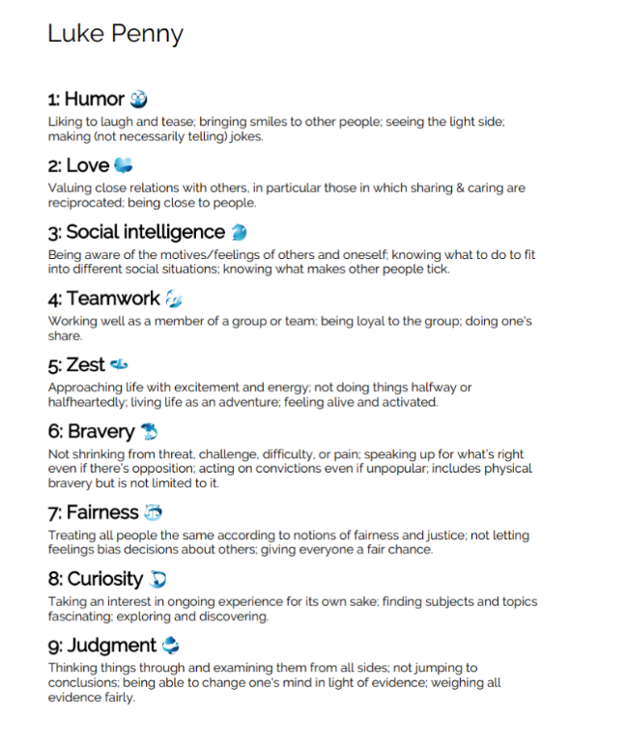
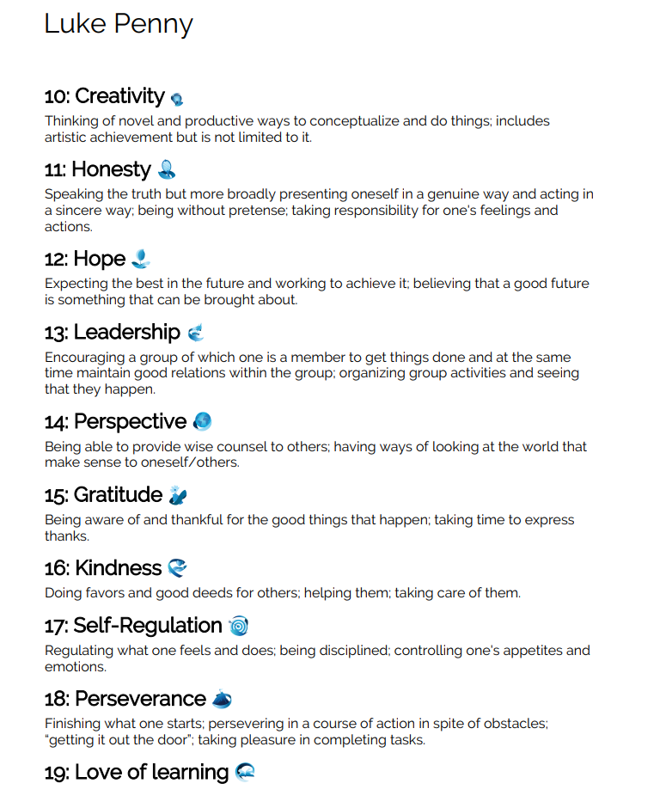
Figure 1 – Viacharacter Survey

Figure 2 – Viacharacter Survey

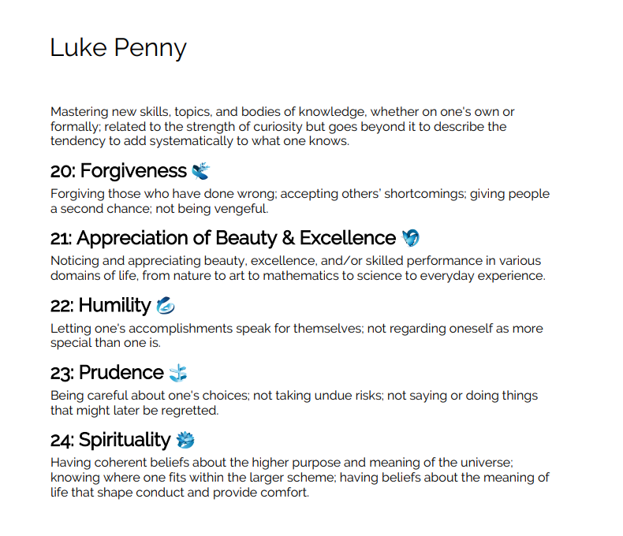

Figure 3 - Viacharacter Survey

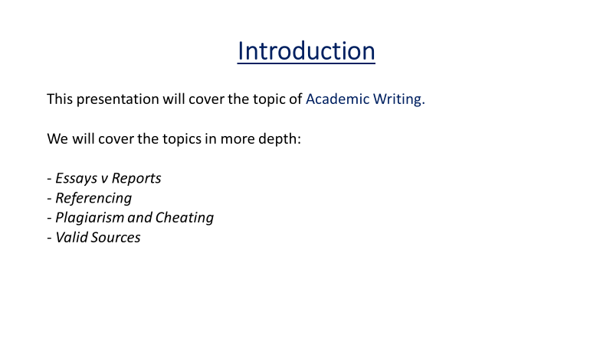
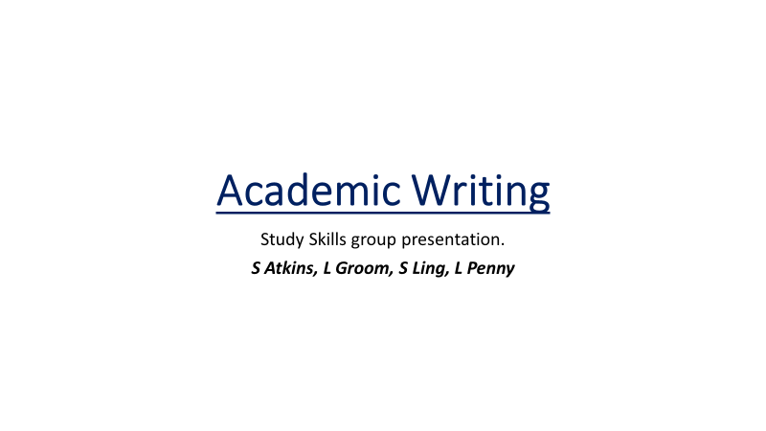
Figure 5 - Group Presentation - Introduction
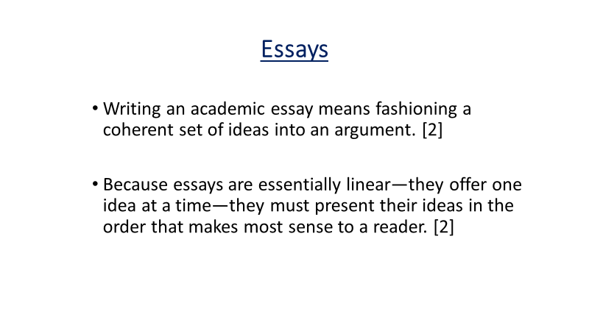
Figure 4 - Group Presentation, Title Slide
Figure 7 - Group Presentation, Essays vs Reports
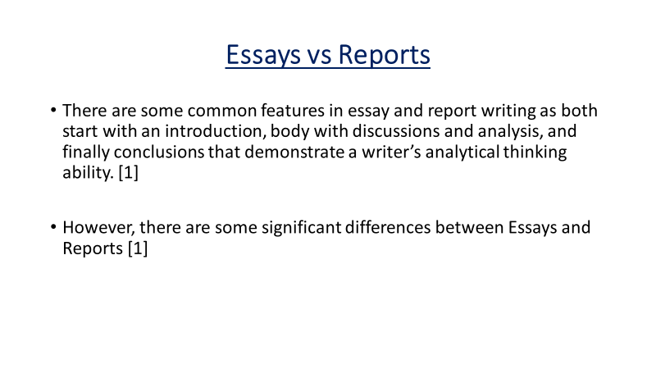
Figure 6 - Group Presentation, Essays vs Reports

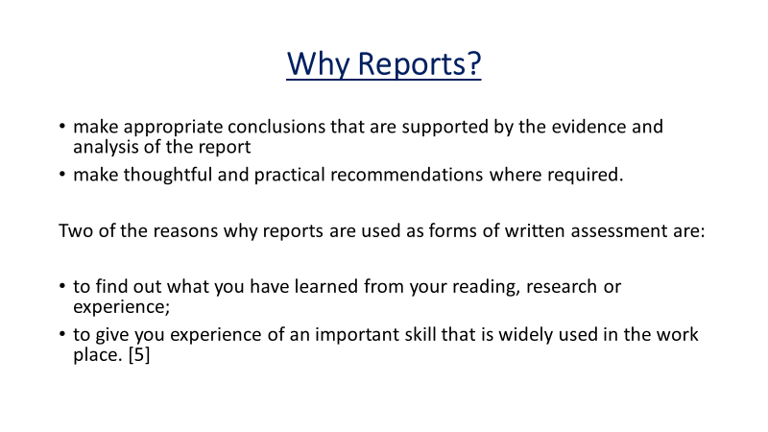
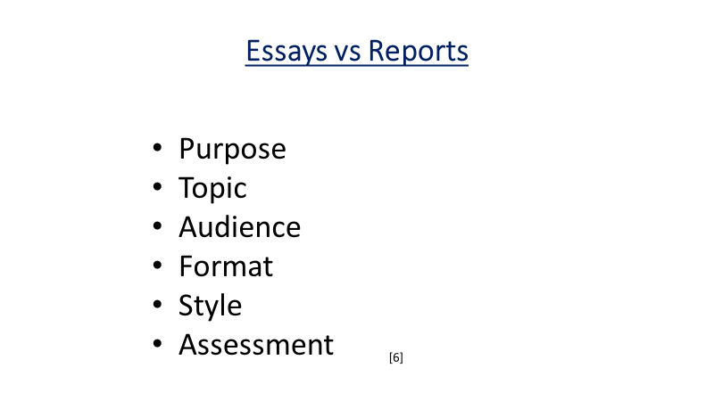
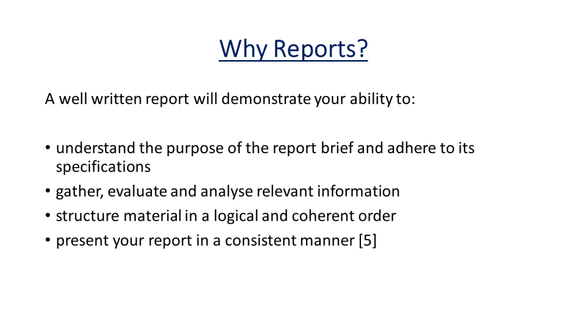
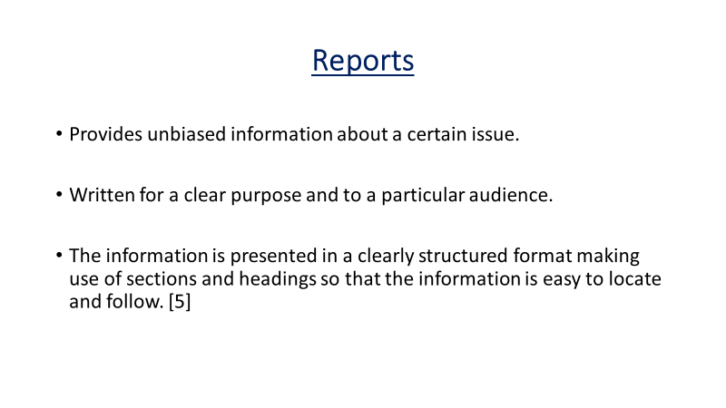
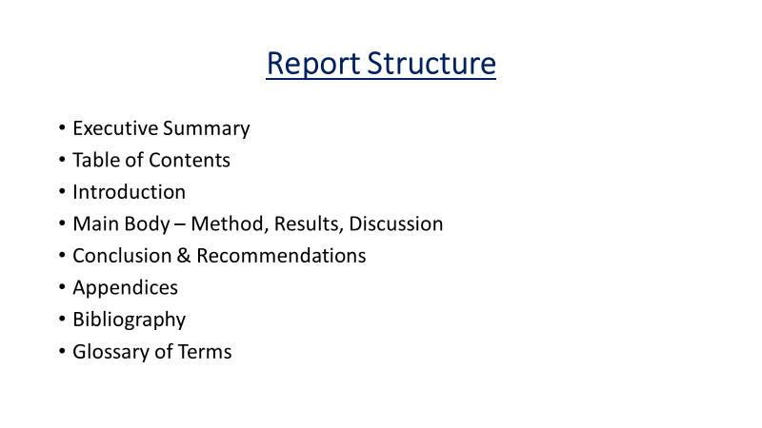
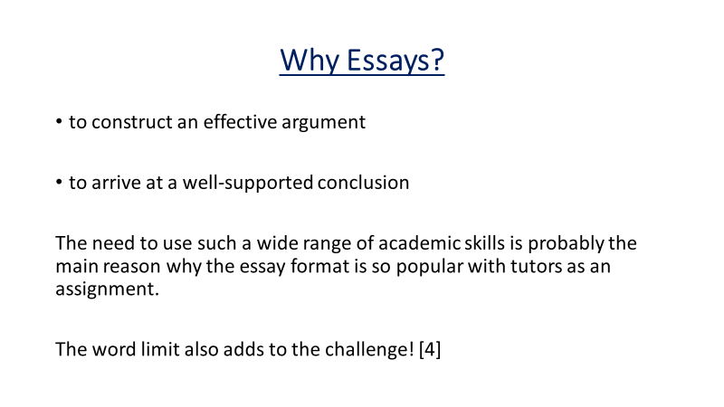
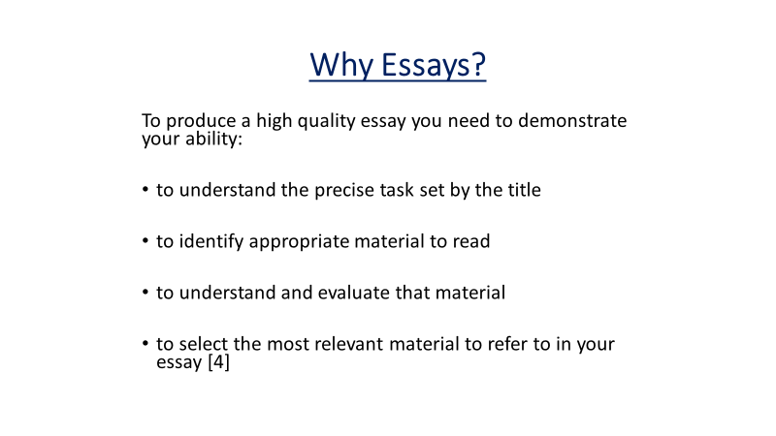
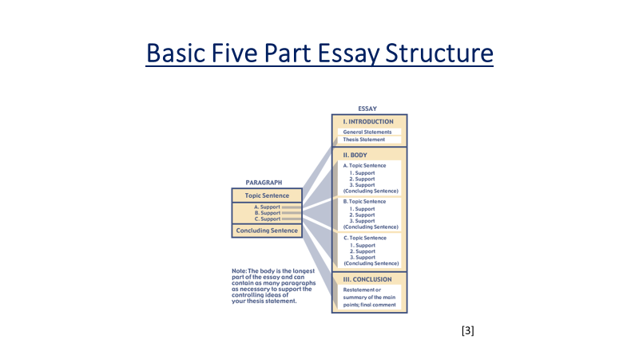
Figure 14 – Group Presentation, Essays vs Reports
Figure 15 – Group Presentation, Essays vs Reports
Figure 13 – Group Presentation, Essays vs Reports
Figure 12 – Group Presentation, Essays vs Reports
Figure 11 – Group Presentation, Essays vs Reports
Figure 10 - Group Presentation, Essays vs Reports
Figure 9 - Group Presentation, Essays vs Reports
Figure 8 - Group Presentation, Essays vs Reports

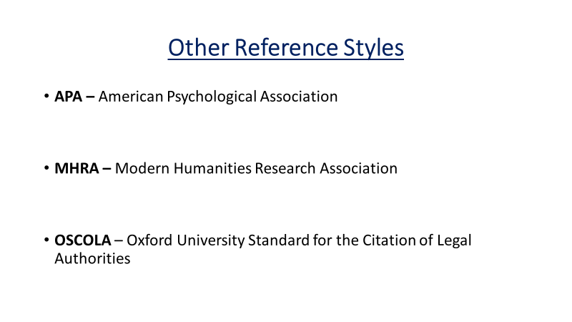
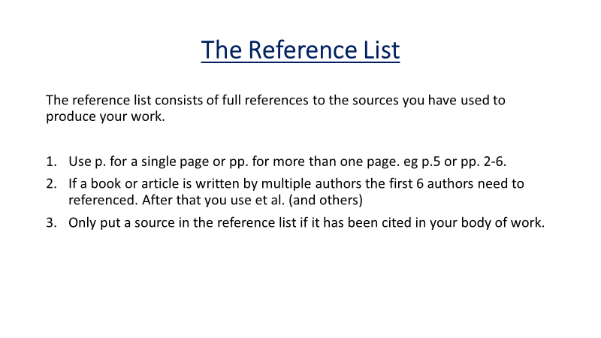
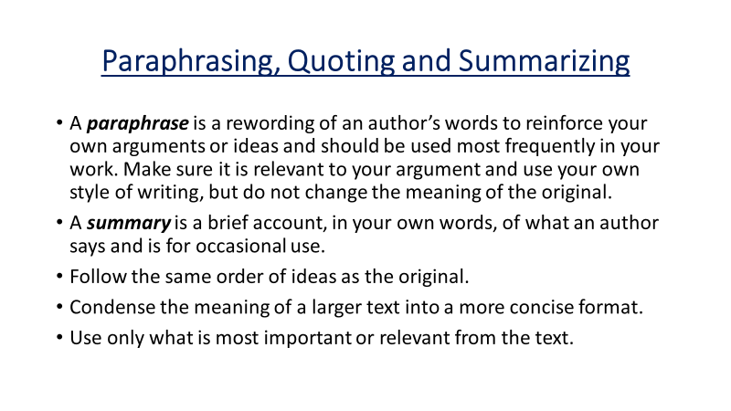
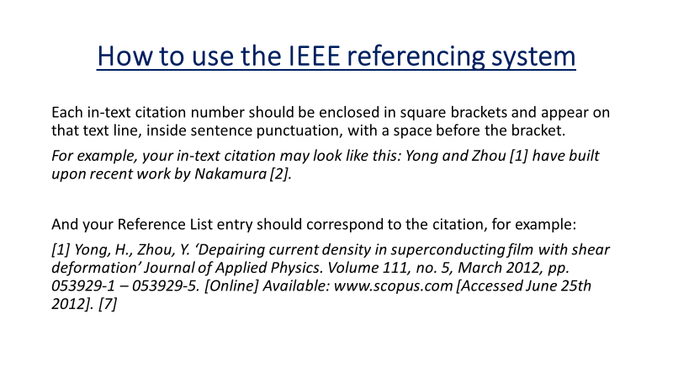
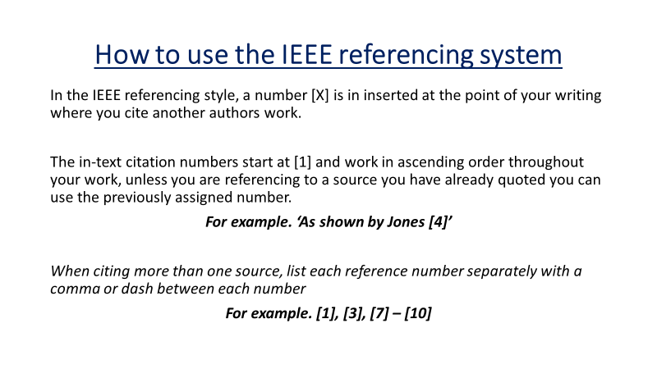
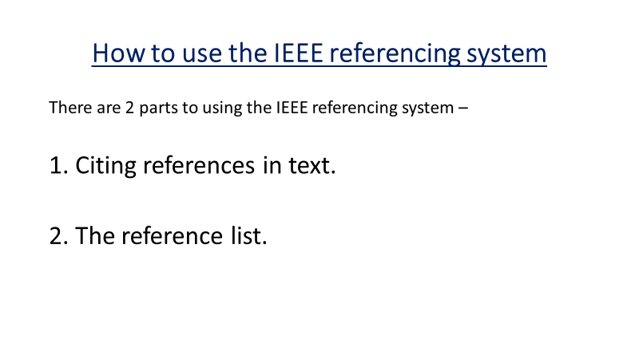
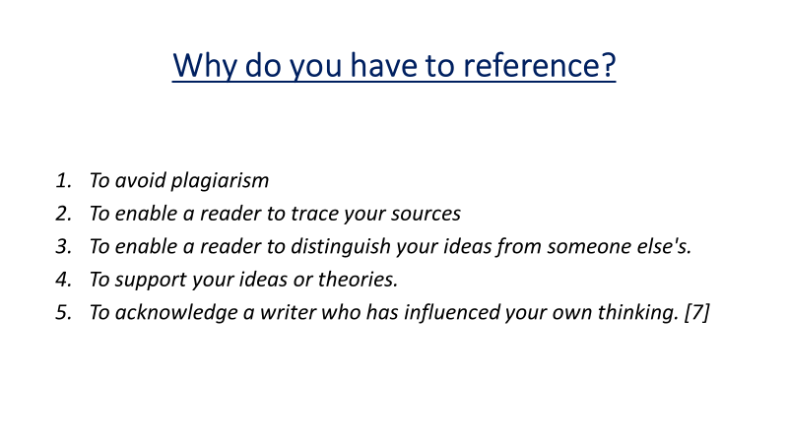
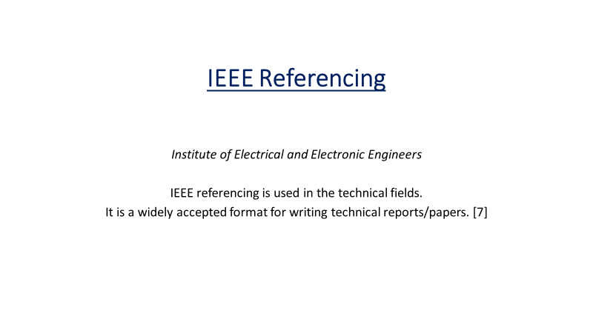
Figure 23 – Group Presentation, Referencing
Figure 22 – Group Presentation, Referencing
Figure 21 – Group Presentation, Referencing
Figure 20 – Group Presentation, Referencing
Figure 19 – Group Presentation, Referencing
Figure 18 – Group Presentation, Referencing
Figure 17 – Group Presentation, Referencing
Figure 16 – Group Presentation, Referencing

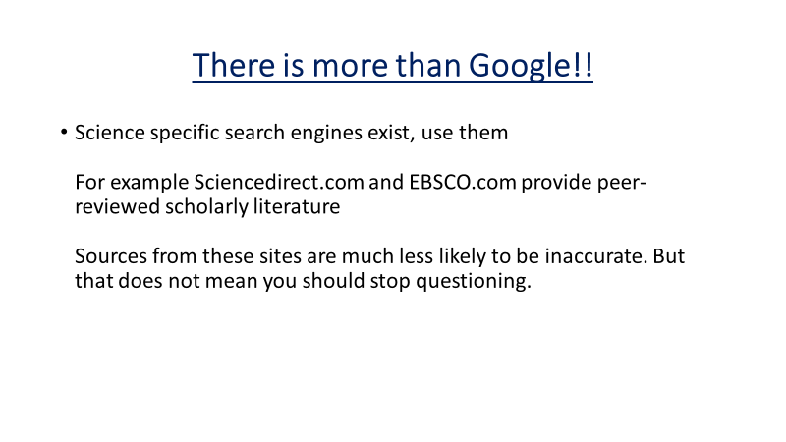
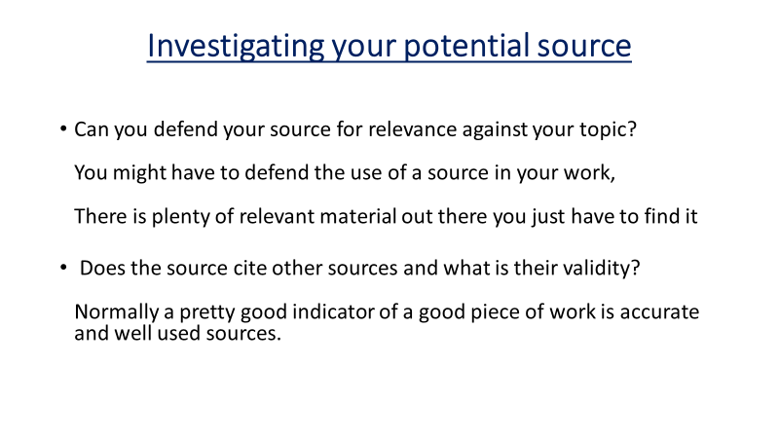
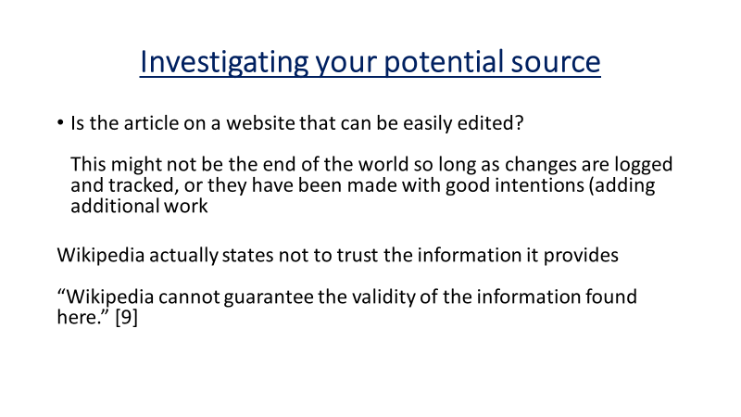
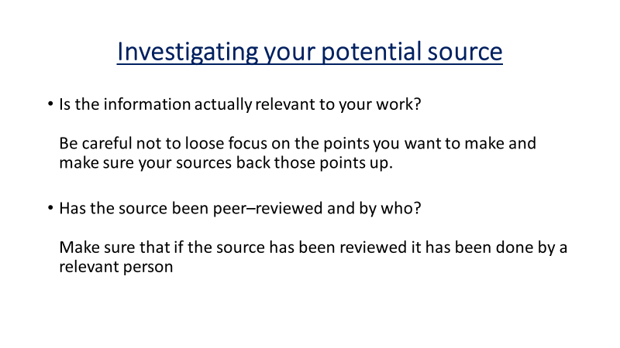
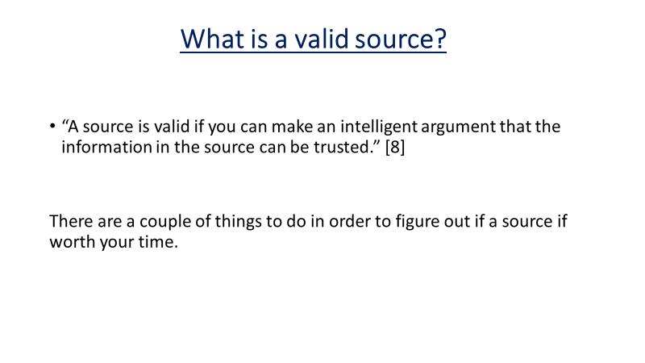
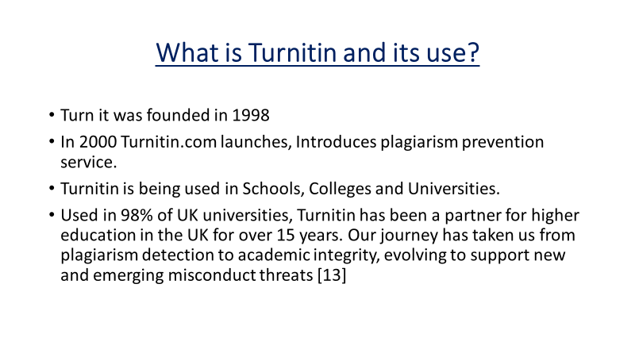
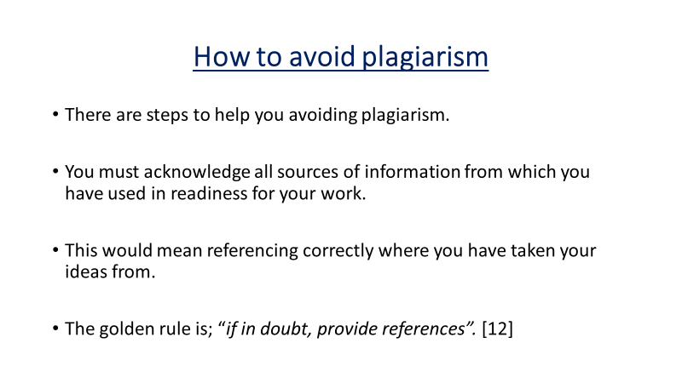
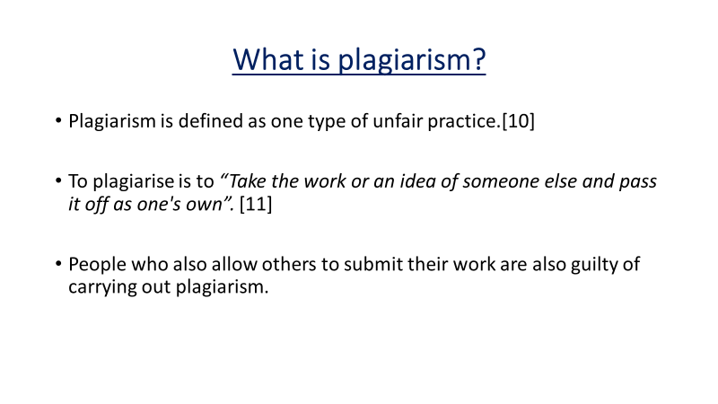
Figure 31 – Group Presentation, Valid Sources
Figure 30 – Group Presentation, Valid Sources
Figure 29 – Group Presentation, Valid Sources
Figure 28 – Group Presentation, Valid Sources
Figure 27 – Group Presentation, Valid Sources
Figure 26 – Group Presentation, Plagiarism
Figure 25 – Group Presentation, Plagiarism
Figure 24 – Group Presentation, Plagiarism

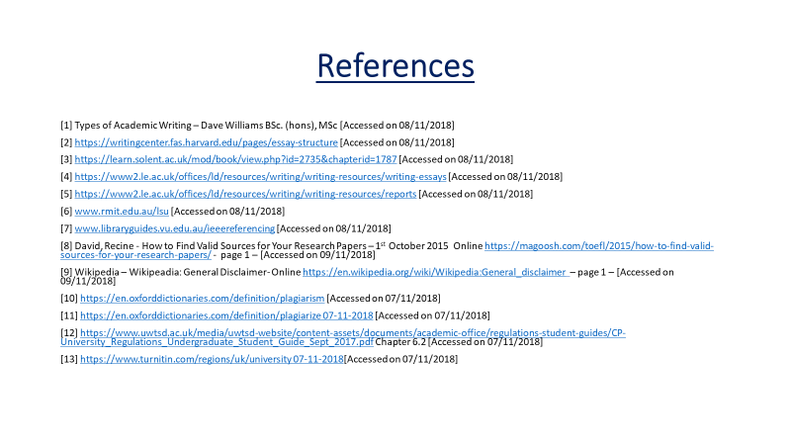
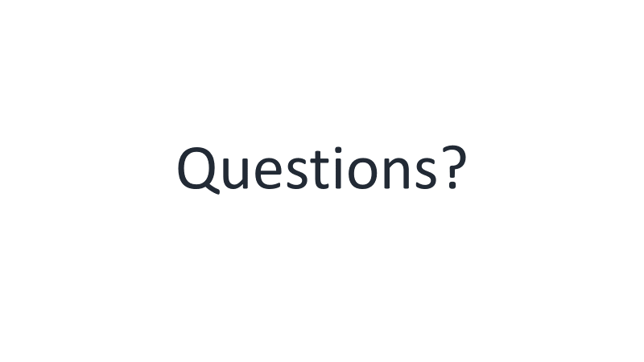
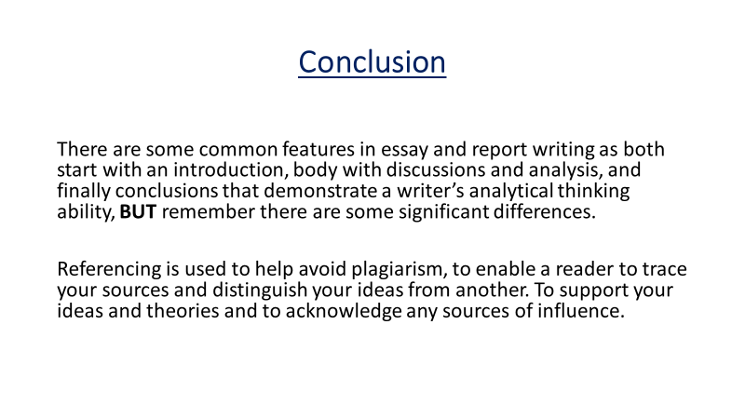
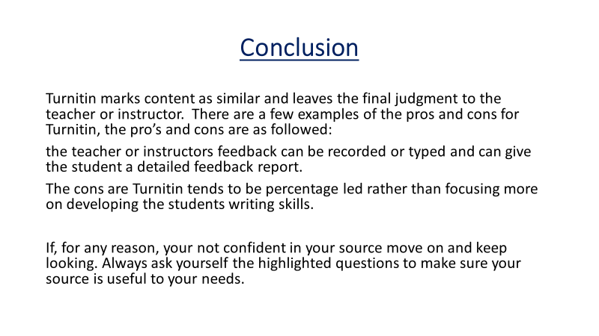
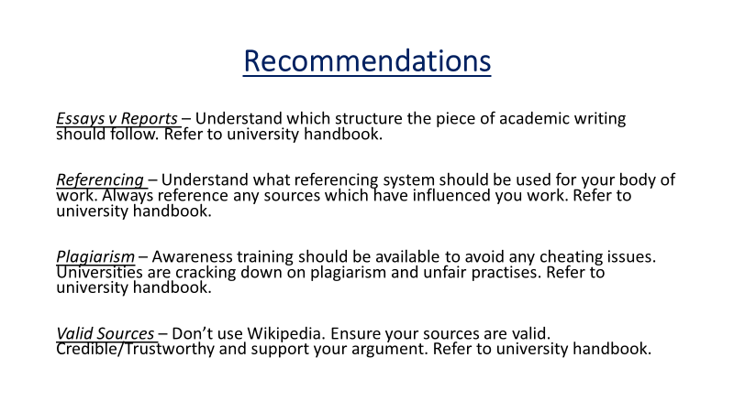
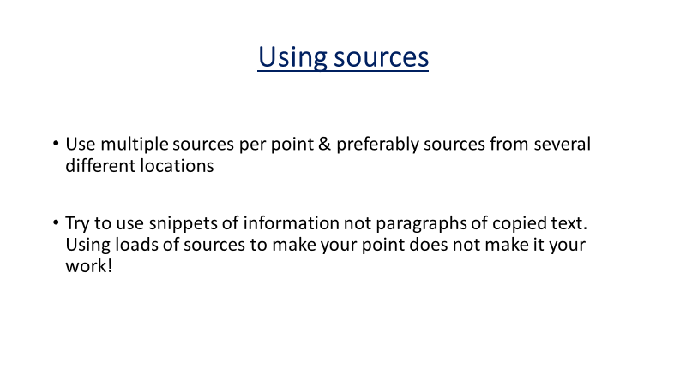
Figure 36 – Group Presentation, References
Figure 37 – Group Presentation, Questions
Figure 34 – Group Presentation, Conclusion
Figure 35 – Group Presentation, Conclusion
Figure 33 – Group Presentation, Recommendations
Figure 32 – Group Presentation, Valid Sources

Table of figures

Figure 1 – 3. Via Character Survey
Figure 4 – 5. Group Presentation, Group Input
Figure 6 – 15. Group Presentation, Essays vs Reports. (Stuart Atkins)
Figure 16 – 23. Group Presentation, Referencing. (Luke Penny)
Figure 24 – 26. Group Presentation, Plagiarism. (Scott Ling)
Figure 27 – 32, Group Presentation, Valid Sources. (Lawrence Groom)
Figure 33 – 37, Group Presentation, Group Input

References

[1] Study Skills Guides. (2019). Retrieved from UCAS: www.ucas.com/undergraduate/student-life/study-skills-guides
[2] Student Self Assessment. (2019). Retrieved from Standford University: www.teachingcommons.stanford.edu/resources/teaching/evaluating-students/assessing-student-learning/student-self-assessment
[3] Viacharacter. (2019). Retrieved from https://www.viacharacter.org/www/Character

