

Finance for Business Managers
BMMB7005

LEVEL 7

SCHOOL OF BUSINESS
FACULTY OF BUSINESS AND MANAGEMENT

Semester 1 – 2025-2026
Executive Summary
This report (Part 1) analyses the financial performance of Aldi as well as the investment opportunities of Westward Plc. The initial section of the analysis will be based on the 2023 and 2024 financial statements of Aldi with reference to essential financial ratios to assess profitability, liquidity, efficiency and gearing. As the findings show, Aldi slightly lost its profitability over the period, but the performance remains stable and is typical of the supermarket industry where low margins and large volumes of sales are typical. The current liquidity ratios do not look very good in contrast to the conventional standards, but this is because of the operational nature of the retail industry where the high rate of the turnover of inventory and a good supplier credit makes high levels of liquid assets unnecessary. Efficiency ratios indicate that Aldi is still operating its working capital and operating resources efficiently, although gearing ratios indicate a conservative capital structure and financial risk that is manageable.
The report (Part 2) also analysed three investment projects that are proposed to be undertaken by Westward Plc through investment appraisal methods in the second section of the report. According to the Net Present Value analysis, none of the projects are not viable financially, but the project that creates the highest NPV is Project B, thus being the most appealing individual project. In the case of limited capital to 2.5 million, the best investment policy is to invest all the capital in Projects A and B and part of the capital in Project C to obtain a total NPV of around 1.85 million. The results emphasize the significance of the use of a formal financial analysis as a tool to facilitate successful managerial decision-making.
TABLE OF CONTENTS
1. Introduction 5
2. Findings and Analysis 6
2.1 PART 1 – BUSINESS REPORT ON ALDI STORES LTD 6
2.1.1 Purpose of Ratio Analysis 6
2.1.2 Profitability Ratios 7
2.1.3 Liquidity Ratios 8
2.1.4 Efficiency Ratios 9
2.1.5 Gearing Ratios 11
2.1.6 Limitations of Ratio Analysis 12
2.1.7 Financial Management recommendations 12
2.2 PART 2 – BUSINESS REPORT ON PROJECT APPRAISAL FOR WESTWARD PLC 14
2.2.1 Investment appraisal – NPV approach 14
2.2.2 Internal Rate of Return (IRR) for Project B 17
2.2.3 Results Interpretation for the Management 19
2.2.4 Capital Rationing and Optimum investment policy 21
2.2.5 Investment Programme Funding 23
3. Conclusion 25
Reference List 26
Appendices 33
Appendix 1: Financial Statements of Aldi Stores 33
Appendix 2: Ratio calculation 35
Appendix 3: Investment appraisal calculations 36

List of Figures
Figure 1: Profitability Ratios of Aldi 7
Figure 2: Liquidity ratios of Aldi 9
Figure 3: Efficiency ratios 10
Figure 4: Gearing ratios 11
Figure 5: Cash flow analysis prior to NPV evaluation 14
Figure 6: PV calculations with 6% cost of capital 14
Figure 7: NPV evaluation by project 15
Figure 8: NPV comparison for all three projects 16
Figure 9: PBP evaluation by project 16
Figure 10: PBP comparison for all three projects 17
Figure 11: NPV comparison with 25% (NPV1) and 35% (NPV2) cost of capital 18
Figure 12: IRR calculations 19
Figure 13: Profitability index (PI) calulation by project 21
Figure 14: Investment breakdown calulation by project 22
Figure 15: NPV contribution calulation by project 22
Figure 16: Investment policy and NPV contribution by project 23

1. Introduction
Aldi belongs to Aldi Süd Group, one of the largest international chains of the discount supermarkets. The firm was established in Germany in the year 1946, and has since spread to many international markets. Aldi in the United Kingdom exists in a market that is very competitive which is in the retail of groceries and has become a nationwide competitor to the old style supermarket stores like Tesco, Sainsbury and Lidl. A low-cost strategy, a high focus on own-label products, and very efficient supply chain operations are the pillars of the business model of the company.
The financial performance and operational performance of a company can only be assessed by analysing the financial statements and ratios. Financial ratios convert accounting information into a format that can be interpreted by the stakeholders by evaluating profitability, liquidity, efficiency and financial risk. This analysis aids the management in determining the trends of performance, the areas of possible weakness, and assists in making strategic decisions. It also allows benchmarking of both competitors that are in the same industry. Investor ratios cannot be applied in this analysis because Aldi is privately owned, and it does not issue publicly traded shares. Alternatively, the analysis is based on profitability, liquidity, efficiency and gearing ratios in order to evaluate the financial situation of the company.
Capital investment decisions are also vital to the business development because they dictate the way firms allocate resources to long-term projects. Net Present Value (NPV), Internal Rate of Return (IRR) and Payback Period are some of the techniques used to assess financial feasibility of an investment opportunity by organisations. Here, Westward Plc will be evaluating three expansion strategies with each having varying investment assets and resulting in different projective cash flows in the span of four years.

2. Findings and Analysis

2.1 PART 1 – BUSINESS REPORT ON ALDI STORES LTD

2.1.1 Purpose of Ratio Analysis
Financial ratio analysis is a significant instrument in terms of assessing the status and financial performance of a company through available financial statements data. The ratios help to make complex financial reporting simple by converting them into quantifiable signs that would enable the stakeholders to determine the trend in profitability, liquidity, efficiency and financial risk (Trejo-Pech and White, 2024). Ratio analysis, according to (Atrill, 2019), helps managers and analysts to define the strengths and weaknesses in the operation as well as make comparisons within time frame and among the competitors in the industry.
In the case of the companies in UK grocery retail industry (as is the case with Aldi), ratio analysis is especially relevant since the industry is supported by large sales volumes and low profit margins (Sesa and Hasnawati, 2023). Financial performance in such an environment is also highly sensitive to even minor fluctuations in the cost structures or efficiency of operations within the environment. Ratio analysis can thus assist the management to determine the success of the pricing policies, cost management policies and asset management.
Ratio analysis can also enable firms to make comparisons with competitors in the industry on the basis of financial performance. Tesco, Sainsbury’s and Lidl are the competitors in the UK supermarket market that struggle fiercely on the price and their efficiency (Clark, Hood and Birkin, 2022). Consequently, the analysis of ratios can assist in identifying whether the financial performance of Aldi is in line with the industry or the company may need to improve its financial management.
Nevertheless, ratio analysis is not devoid of limitations as well. Ratios are based on past accounts of accounting data and the may not represent the impending business environment (Le, 2021). Moreover, the qualitative factors like customer loyalty, brand value or management capacity are not reflected in financial ratios. As a result, ratios might be helpful in understanding the financial performance, but they have to be viewed through the prism of overarching strategic and industry factors (Brigham and Ehrhardt, 2019).

2.1.2 Profitability Ratios
Profitability ratios are used to determine the proficiency of a company to earn profit in the context of revenue or capital injected in the business (Bekaert, 2017). These ratios will help to understand the effectiveness of cost management and efficiency of the operational strategies.
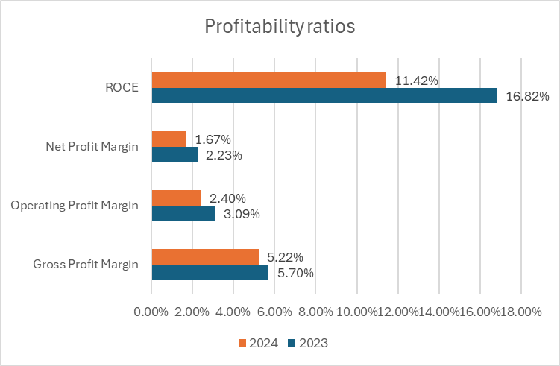

Figure 1: Profitability Ratios of Aldi
(Source: calculated with data from company reports, Gov.uk, 2025)
The gross profit margin of Aldi decreased by a small percentage in 2024, 5.22, compared to 5.70 in the year 2023 meaning that the cost of sales went higher than that of the revenue. Margins in the supermarket industry are generally less than in most other industries due to the fact that price is the major point of competition between the retailers (UK Parliament, 2025). The Aldi business model is founded on the low-cost products meaning that the margins are kept low purposely to keep the prices competitive. The fall however could also be associated with inflationary forces or an increase in supplier prices over the period (Fan et al., 2023; Drury, 2020).
The operating profit margin reduced to 2.40 percent as compared to 3.09 percent indicating that the operating costs also went up in relation to revenue. This can be associated with the increase in labour and energy costs, investment into logistics and the running of the stores. Within a very competitive retail market, companies might not be willing to transfer all the cost increment to consumers and this can pose strain on the profitability of operating.
In the same manner, the net profit margin has dropped to 1.67% in 2024 as compared to 2.23% in 2023, which shows a decrease in overall profitability when taxation and the cost of finance are considered. Though the downward trend indicates rising cost pressures, the ratio is widely in line with the industry average, as the net margins of supermarkets are normally 1-3% (Bennett, 2026).
The ROCE also declined to 11.42 percent as compared to 16.82 percent meaning that the company did not yield commensurate returns on the capital invested in the business. This fall can be due to the higher investment in assets like stores, logistical infrastructure or distribution channels that have yet to deliver proportional rises in operating profit. Although decreasing ROCE can be a sign of low efficiency in the short-run, it can also be a sign of strategic expansion to support future growth (Xue, 2025).
The profitability ratios, in general, indicate that there is a decline in profitability ratios between the 2023 and 2024, indicating that the increasing cost rate and competition might have resulted in a decrease in the profitability of Aldi within the duration (Drury, 2020).

2.1.3 Liquidity Ratios
Liquidity ratios determine how a firm can cover its short-term liabilities with its current assets (Mazur et al., 2021). Maintaining adequate liquidity is critical in ensuring that a business does not suffer a financial setback in terms of its operations.
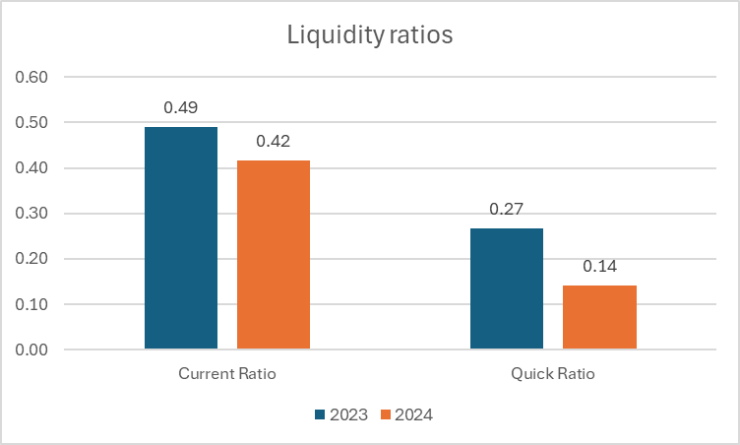

Figure 2: Liquidity ratios of Aldi
(Source: calculated with data from company reports, Gov.uk, 2025)
The current ratio has gone down to 0.42 as of 2024, as compared to 0.49 as of 2023, and that is far below the conventional range of 1.2 to 2.0. On the face of it this might imply a rather weak short-term financial standing (Zintego, 2026). Nonetheless, such an interpretation should take into account the character of the supermarket industry. The quick ratio fell too, as it was 0.27 and it was 0.14 at the end, which shows that liquid assets without inventory fell as compared to the current liabilities.
Regardless of these characteristics in the industry, the negative growth of both ratios indicates that Aldi might be increasingly using the short-term liabilities as a source of funding its operations (Shou, 2022). Although this will be beneficial in the working capital efficiency, over reliance on the short term financing may heighten financial risk in case operating conditions are unfavourable.

2.1.4 Efficiency Ratios
Efficiency ratios review the efficiency of the company in terms of utilising its assets and working capital in generating income (Tadayonrad and Ndiaye, 2023). In retail business, one needs to be good in the management of inventory and a good working capital to ensure that the business is profitable.
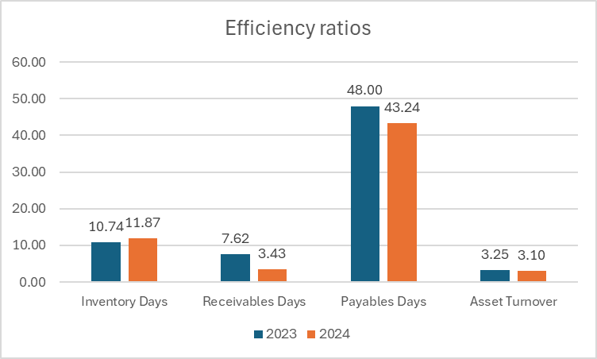

Figure 3: Efficiency ratios
(Source: calculated with data from company reports, Gov.uk, 2025)
The inventory days ratio went up to 10.74 days (2023) and further to 11.87 days (2024) indicating that stocks are held in store longer before sale. The growth is not very significant but can reflect on lower turnover of stocks or an increase in inventory stocks (Arjunan, 2022). Nevertheless, inventory days at Aldi are comparatively poor, which illustrates the effective supply chain and the small number of products offered by the company (Liu, 2022).
The ratio of days receivables enhanced tremendously as the ratio of 7.62 was changed to 3.43 days, which shows that the customers were paying faster. This enhancement also helps to improve cash flow management and limit the risk of unpaid receivables.
Payables days ratio was reduced to 43.24 days, which indicated that the company paid the suppliers faster in 2024. It is true that more rapid payments are likely to enhance relationships with suppliers, but are also likely to minimise the working capital returns that are generally realized when using longer credit terms.
Lastly, there was a slight decrease in asset turnover ratio of 3.25 to 3.10 to indicate that the revenue generated per unit of assets reduced slightly. This can be an indication of new investments in the stores or infrastructure that added to total assets without generating more sales.
On the whole, the efficiency ratios indicate that Aldi still has a high level of operational efficiency but minor shifts in working capital management and asset utilisation would be tracked down.

2.1.5 Gearing Ratios
Gearing ratios analyse the degree of reliance of a company on borrowed finances as opposed to the equity of shareholders (Challoumis, 2024). These ratios play a major role in evaluating the long term financial risk and the stability of the capital structure of a firm.
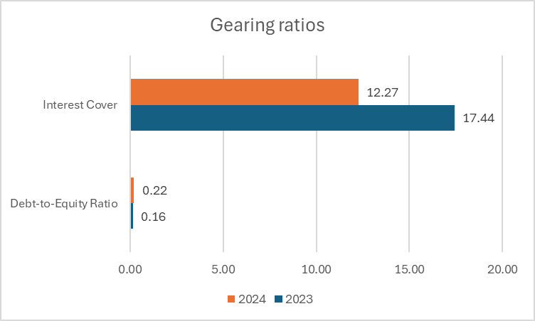

Figure 4: Gearing ratios
(Source: calculated with data from company reports, Gov.uk, 2025)
Debt-to-equity ratio rose in 2023 to 0.16, and then in 2024, it rose to 0.22, which shows that Aldi slightly increased its utilisation of long-term debt as compared to equity. Although this has increased, the total amount of gearing is fairly low. A debt to equity ratio of less than 0.5 is usually regarded as conservative in most industries and it would appear that Aldi has a conservative financing structure (Investopedia, 2024). The growth could be as a result of more borrowing to fund growth initiatives.
The interest coverage ratio is also another significant indicator of financial health, and the ratio dropped to a level of 12.27 in 2024 compared to 17.44 in 2023. This ratio is used to determine the ease at which a company can cover its interest commitments with the help of operating profit. The ratio has decreased but it is still much higher than the generally accepted level of safety at approximately 3 to 5 times, which means that Aldi still has a very high ability to cover its finance expense. The interest coverage ratio is dropping significantly because of a fall in operating profit and not high borrowing growth.
All in all, the gearing ratios indicate that Aldi can be characterised by a rather conservative capital structure and reduced financial risk. Although the fact that the debt levels have been slightly increased should be tracked, the fact that the company boasts of good interest coverage shows that it is in good position to meet its financial commitments (Huang et al., 2022).

2.1.6 Limitations of Ratio Analysis
Despite the fact that ratio analysis gives quite useful information on financial performance, it has a number of limitations that should be taken into account when interpreting the findings. The first weakness is that ratios are founded on past financial statements implying that they indicate the past performance and not the future (Maheshwari et al., 2024).
The other limitation is associated with accounting policies and differences in measurements. The companies can use various accounting procedures to value their assets, depreciation or inventory measurement that can influence the financial ratios and complicate the comparison (Ridwan et al., 2025). The nature of the industry also has some effect on the interpretation of ratios. Performance standards used in one industry may not fit in another. The liquidity ratios tend to be lower than the conventional standards in the retail sector, e.g., in the retail industry, due to the heavy dependence of retailers on inventory turnover and supplier credit (Olayinka, 2022).
Lastly, ratios are mostly quantitative and fail to reflect qualitative attributes like brand strength, customer satisfaction, market positioning and quality of management. Ratio analysis therefore, should be employed in combination with the larger financial and strategic analysis and not as a body of decision making per se.

2.1.7 Financial Management recommendations
Firstly, falling profitability ratios indicate that the company ought to aim at enhancing the cost management and operational efficiency (Ogbulu et al., 2025). An increase in the operating costs might be impacting profit margins and additional investments in supply chain optimisation, logistics efficiency and energy management can be used to control the costs (Le, 2021).
Second, despite the normal character of low liquidity ratios in the retail industry, Aldi must keep a keen eye on its working capital management (Almansour et al., 2023). A balance between the suppliers credit as well as cash reserves must be maintained to allow the necessary financial flexibility especially when there is uncertainty in the economy (Abdul Kareem et al., 2023).
Third, the positive changes in the receivables management are indicative of good cash management. The payables days decreased, however, indicate that the company might be paying its suppliers in a shorter time than otherwise (Jámbor and Zanócz, 2023; Akcigit et al., 2022). As much as good supplier relationship is a plus, Aldi should make sure that payment policies do not compromise efficient utilisation of working capital (Bon and Hartoko, 2022; Cooper, 2023).
Lastly, the rise in the level of borrowings shows that the company might be financing expansion by using more debt (Adil et al., 2022). Although the current gearing is not significantly elevated, the management ought to carry a balanced capital structure to enter into an unnecessary financial risk as the business keeps expanding (Barman et al., 2021).

2.2 PART 2 – BUSINESS REPORT ON PROJECT APPRAISAL FOR WESTWARD PLC

2.2.1 Investment appraisal – NPV approach
Westward Plc has three strategic expansion options within a period of four years. All the options have varying initial investment requirements and projected annual inflows of cash. In order to establish the most viable option in terms of finance, the investment opportunities are considered based on the discounted cash flow methods with the effects of taxation and capital allowance taken into consideration (Nasution and Yusleny, 2023). The corporation tax is held to 25% and capital allowances are availed at 20 per cent of the initial investment in a year, which generates yearly tax shelters on every project.
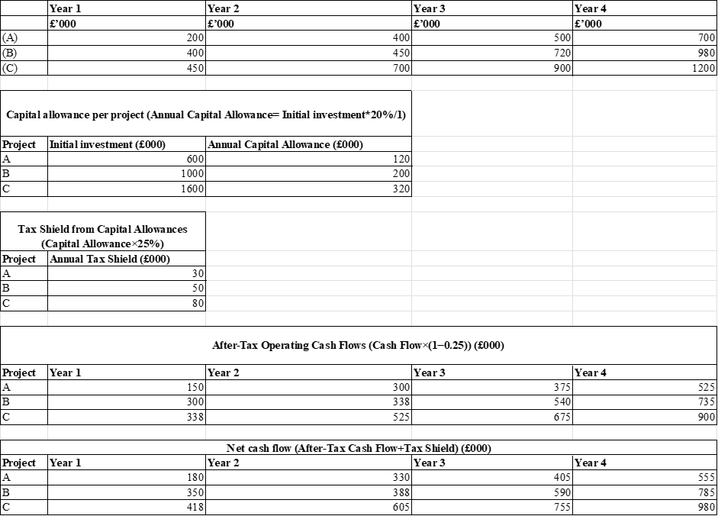

Figure 5: Cash flow analysis prior to NPV evaluation
Projecting the capital allowance rule on the three projects will yield an annual allowance of £120,000 on Project A, £200,000 on Project B and £320,000 on Project C that give rise to annual tax shields of £30,000, £50,000 and £80,000 respectively. The operating cash flows are after-taxed to get the after-tax operating cash flows. The net annual cash flows are obtained when capital allowances tax shield is added. Such net cash flows underlie the assessment of every project by the use of discounted cash flow.
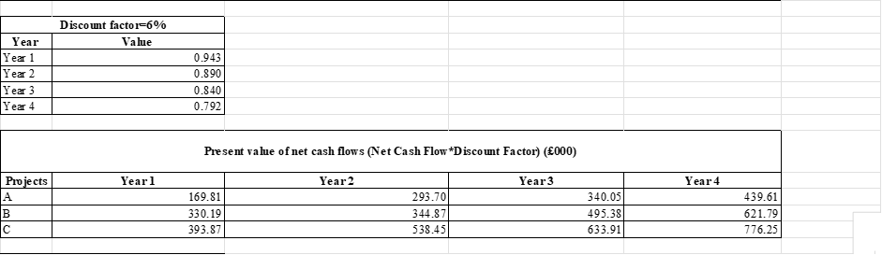

Figure 6: PV calculations with 6% cost of capital
The discounting factor (df) of 0.943, 0.890, 0.840 and 0.792 is used to discount the future cash flows to the years one to four respectively with the cost of capital set at 6% (df = 1/(1+cost of capital)^n). By applying the discount factors to the calculated net cash flows the present value of the future inflows of each project is obtained. In case of Project A the discounted values are; in the first year, there will be values of £169.81 thousand, in the second year, there will be values of 293.70 thousand, in the third year, there will be values of 340.05 thousand, and in the fourth year, there will be values of 439.61 thousand. In Project B, the present values will be £330.19 thousand, 344.87 thousand, 495.38 thousand and 621.79 thousand and Project C will have present values of 393.87 thousand, 538.45 thousand, 633.91 thousand and 776.25 thousand during the four years.

Figure 7: NPV evaluation by project
The Present value of inflows of a particular project is added to the net cash inflows of a project and the initial investment is subtracted to arrive at the net present value (NPV) of the project. Using the calculations, it means that Project A will have an NPV of 643.17 thousand, Project B will have an NPV of 792.23 thousand and Project C will have an NPV of 742.48 thousand. As a positive NPV can be interpreted to mean that a project will bring a higher profit than the cost of capital to the firm, all the three alternatives can be considered as being financial (Nasution and Yusleny, 2023). But in the case of mutually exclusive projects the one with the highest NPV is normally preferred as it offers the maximum value to the shareholders.
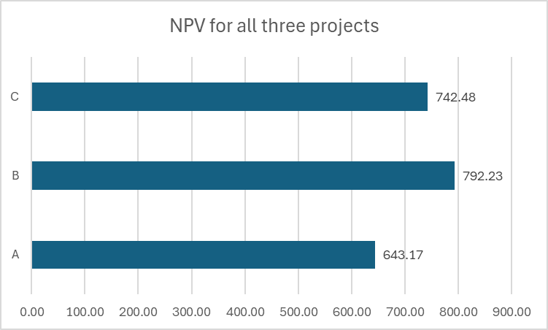

Figure 8: NPV comparison for all three projects
According to the NPV estimates, Project B is the most appealing investment project, since it yields the highest net present value of about £792 thousand. It means that, when the initial investment is recovered and the cost of capital is taken into consideration, Project B should bring the biggest net financial benefit to the company (Prekazi et al., 2023). It is true that although Project C is generating more total inflow of cash, the large initial investment makes it of lower value than Project B, which has less initial investment. Thus, in terms of value maximisation, Project B is the best balance between the cost of investment and the future returns.

Figure 9: PBP evaluation by project
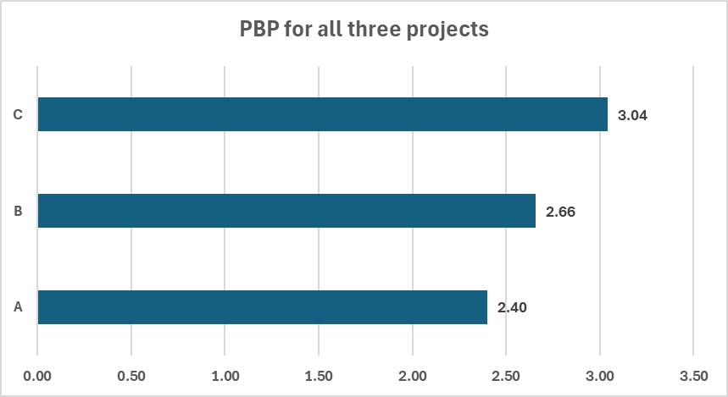

Figure 10: PBP comparison for all three projects
Further information as to the financial appeal of the projects may be gained by analysing the payback period that quantifies the time taken before the initial investment has been recovered due to the cumulative cash flows. The calculations show that Project A will take approximately 2.40 years to break even, Project B will take almost 2.66 years to break even, and Project C will take about 3.04 years to break even. As a result, the payback period is not as effective as discounted cash flow methods (such as NPV) in assessing the overall profitability of long-term projects despite offering useful information on liquidity and the risk of investing in the project (Rahayu and Wardana, 2021).

2.2.2 Internal Rate of Return (IRR) for Project B
In order to further estimate the appeal of the recommended option, the internal rate of return of Project B is estimated. IRR is the discount rate at which the net present value of the project will be equal to zero (Rashid, 2021). In order to estimate this value, the net cash flow of the project is discounted with two alternative discount rates. The standard IRR interpolation formula was used:
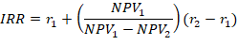
Using a discount of 25 percent, the present value of the inflows will be obtained as 1,151.62 thousand pounds, and the NPV will be positive (151.62 thousand). With the choice of discount rate to 35, the total present value of the inflows reduces to be -948.02 thousand to give NPV of -51.98 thousand.
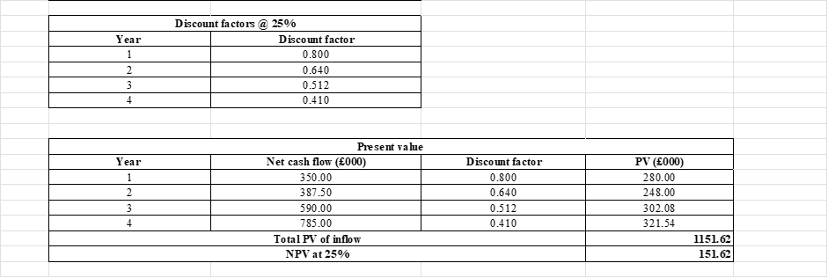
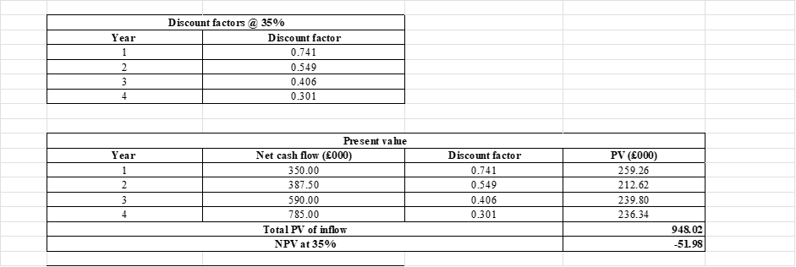

Figure 11: NPV comparison with 25% (NPV1) and 35% (NPV2) cost of capital
The internal rate of return is between 25 percent and 35 percent since the NPV will become negative at these two discount rates. When linear interpolation of calculated NPVs is done, an approximate IRR of project B is 32.45%. This is a very high rate of return compared to the cost of capital assumed by the company to be 6, which means that this project would bring returns that are much higher than the minimum required by the investors.

Figure 12: IRR calculations
The result of the IRR supports that of the NPV analysis. The general criterion that must be used to accept a project is that the IRR of the project must be greater than the cost of capital of the firm since it would mean that the investment would add value to the business (Lubis, 2023). Project B with its estimated IRR of about 32.45 has a great margin over the required IRR and thus it seems to be financially appealing.
In general, the investment appraisal shows that each of the three projects can be used to produce positive returns, but Project B offers the best financial performance when it is assessed through the application of discounted cash flow methods (Koundouri et al., 2022). It produces the largest net present value and rate of return which is substantially better than the cost of capital of the company (Mazur et al., 2021).

2.2.3 Results Interpretation for the Management
The financial analysis shows that the three investment options all give positive net present values, which implies that each of the three projects can be used to create value to the business. Nevertheless, the findings demonstrate the distinct variations in financial attractiveness. Project B has a Net Present Value (NPV) of the greatest value of £792.23 thousand whereas Project C and A have NPVs of 742.48 thousand and 643.17 thousand respectively. As the NPV method is used to determine the addition to firm value caused by an investment, the findings indicate that Project B would bring the most financial value to the Westward Plc (Wijayanti et al., 2024).
Moreover, the Internal rate of Return (IRR) of the Project B is estimated to be about 32.45 with discount rates ranging between 25 and 35 percent. This rate of return is very high compared to the cost of capital that is assumed to be 6 percent meaning that the project will provide returns that are way higher than what the investors would need. This finding also indicates the financial appeal of Project B.
Theoretical evaluation of Net Present Value (NPV):
In terms of theoretical aspects, Net Present Value method is basically considered to be the most suitable method of analysing investment projects. This is because one of its primary reasons is the fact that it uses the time value of money, which acknowledges that cash obtained today has greater value than cash obtained in future. The NPV approach captures the opportunity cost of investing in a given project because it discounts the future cash flows of the project based on the cost of capital of the company (Rashid, 2021). Moreover, the NPV measures directly the value added to the firm in terms of money (Akash et al., 2024). A positive NPV means that the project will expect to generate wealth to the shareholders which is the major aim of the majority of companies (Citterio and King, 2023).
Owing to these attributes, the NPV technique offers a valid foundation to evaluate mutually exclusive investment opportunities and the project which will generate the highest financial value.
Popularity of non-discounting investment appraisal methods:
Even though the theoretical benefits of a discounted cash flow techniques are immense, non-discounted methods like the payback period are still widely used among decision makers (Abdul Kareem et al., 2023). This is because of one reason, their simplicity. Payback period is simple to compute and gives a rough estimate of the period within which the original investment will be recovered.
Payback period is also important to managers since it brings to focus the liquidity and risk nature of a project. The shorter the payback period, the faster the firms recoup their capital and this lowers risk to unknown and market dynamics (Arjunan, 2022). This is specifically so in the industries where the future cash flows might be influenced by technological advances or competitive conditions (Lusardi and Messy, 2023).
Non-discounting methods are however limited in certain ways. The payback period fails to take into account the time value of money and fails to take into consideration cash flows that are beyond the payback point (Osarenmwinda, 2024). Consequently, it can offer valuable additional data but cannot be employed as the foundation of investment decisions.
Additional aspects of investment decisions:
Financial appraisal methods are useful in offering quantitative information but there are wider strategic and operational considerations which should be incorporated in making decisions on investments (Citterio and King, 2023). To illustrate, the management ought to evaluate the fact that the proposed investment is in tandem with the long term strategic goals and positioning of the company in the market.
Risk and uncertainty are to be considered as well. The future cash flows of the project might be affected by shift in consumer demand, the cost of production or change in the competition. The viability of undertaking a specific investment could also be influenced by such operational aspects as production capacity, access to skilled labour, and supply chain capabilities (Lusardi and Messy, 2023).
Besides this, the management ought to take into account external factors like regulatory factors, environmental factors and the possible changes in technology. An analysis of these factors together with financial analysis will ensure the investment decisions made are in support of the financial performance and the long-term business sustainability (Settembre-Blundo et al., 2021).

2.2.4 Capital Rationing and Optimum investment policy
Investment funds are scarce, and the companies have to spend the capital in a manner that maximises the value. Westward Plc in this case has an amount of 2,500,000 to invest in and this is not enough to finance all the three projects entirely. The profitability index (PI) is applied to establish the most optimum investment policy because the projects can be subdivided (Osarenmwinda, 2024).
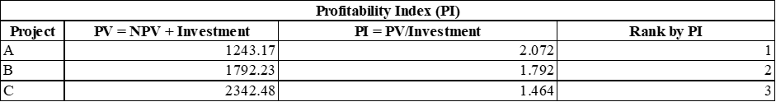

Figure 13: Profitability index (PI) calulation by project
The calculations indicate that Project A has PI of 2.072, Project B has PI of 1.792 and Project C has PI of 1.464. The ranking of projects is then A, B and C i.e. the investment is planned to start with the highest ranking.

Figure 14: Investment breakdown calulation by project
Project A will need an investment of £600,000 and Project B will need an investment of 1,000,000, which makes the total investment amount to 1,600,000. Once these two projects are financed, there is still 900,000 pounds left of the total investment budget. Project C will need an amount of £1,600,000 and this means that only 56.25 of the funds available will allow the project to be implemented.

Figure 15: NPV contribution calulation by project
The NPV contributions that have been obtained are 643.17 thousand, 792.23 thousand, and 417.65 thousand of Project A, Project B, and the partial investment in Project C respectively. This makes the total NPV around to be 1,853.04 thousand pounds, which is the best investment policy within the capital constraint presented.
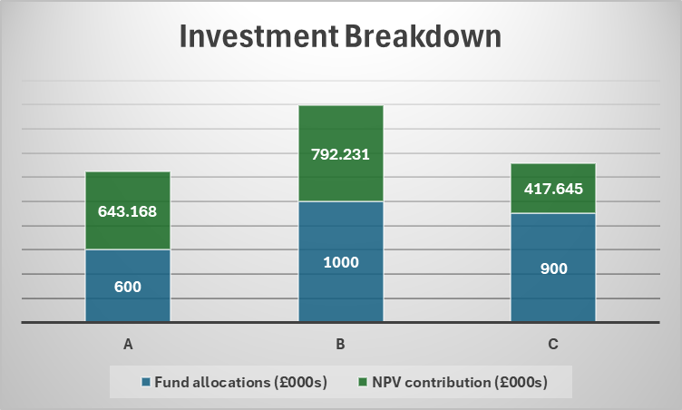

Figure 16: Investment policy and NPV contribution by project

2.2.5 Investment Programme Funding
Westwood Plc can explore a number of sources of finance to finance the proposed investment programme. Retained earnings are one of the options and this represents profits that are reinvested in the business. This source would prove to be most preferred since there are no interest charges and ownership dilution. Nevertheless, inside sources can be restricted and the possibility of using retained earnings can limit the finances.
Debt finance, including bank loans is the other alternative. Debt enables the companies to raise a large amount of money without having to relinquish the rights of ownership and interest charges are often deducted. However, excessive borrowing raises the risk of finances and provides obligatory payments. Equity finance (the issuance of new shares to investors) is another type of financing that the company will consider. Equity finance is a long-term funding source with no periodic repayment requirements.
The analysis conducted offers important information on the financial performance of Aldi as well as the investment decision made by Westward Plc. The ratio analysis of Aldi financial statements of 2023 and 2024 shows that the company is functioning in the normal conditions of the supermarket sector, where the volumes of sales are high, but the profits are not so high, and the profit margin is rather low. Even though the profitability ratios indicate a minor decline in the period, the outcomes are more or less in line with industry expectations. Liquidity ratios seem low in comparison with the conventional standards, but this has been a common feature in the retail industry as a result of high inventory movement as well as good supplier credit facilities.
Investment appraisal of the expansion projects by Westward Plc reveals that each of the three projects is financially viable as they all have positive net present values. Nevertheless, Project B offers the greatest NPV and high estimated internal rate of return, and therefore it is the most financially appealing among the three considered on their own. In capital-rationing conditions, the optimal investment plan is to carry out Projects A and B to the full with the rest of the funds invested in a ratio of Project C with a total NPV of about £1.85 million.
The general results of the results indicate that financial ratio analysis, when used alongside investment appraisal methods, are significant in making strategic financial decisions. Through an acute evaluation of financial performance, and the ability to choose opportunities in investors that will help organisations maximise the value of their investments, organisations can be able to sustain the growth process and remain economically stable.

3. Conclusion
The analysis conducted offers important information on the financial performance of Aldi as well as the investment decision made by Westward Plc. The ratio analysis of Aldi financial statements of 2023 and 2024 shows that the company is functioning in the normal conditions of the supermarket sector, where the volumes of sales are high, but the profits are not so high, and the profit margin is rather low. Even though the profitability ratios indicate a minor decline in the period, the outcomes are more or less in line with industry expectations. Liquidity ratios seem low in comparison with the conventional standards, but this has been a common feature in the retail industry as a result of high inventory movement as well as good supplier credit facilities. Efficiency ratios show that Aldi has an efficient operation management whereas gearing ratios reveal that the capital structure is relatively conservative with manageable financial risks.
Investment appraisal by Westward Plc reveals that each of the three projects is financially viable as they all have positive net present values. Nevertheless, Project B offers the greatest NPV and high estimated internal rate of return, and therefore it is the most financially appealing among the three considered on their own. In capital-rationing conditions, the optimal investment plan is to carry out Projects A and B to the full with the rest of the funds invested in a ratio of Project C with a total NPV of about £1.85 million.

Reference List
Abdul Kareem, A.A., Fayed, Z.T., Rady, S., Amin El-Regaily, S. and Nema, B.M., (2023). Factors influencing investment decisions in financial investment companies. Systems, 11(3), p.146. https://www.mdpi.com/2079-8954/11/3/146
Adil, M., Singh, Y. and Ansari, M.S., (2022). How financial literacy moderate the association between behaviour biases and investment decision?. Asian Journal of Accounting Research, 7(1), pp.17-30. https://www.emerald.com/insight/content/doi/10.1108/ajar-09-2020-0086/full/html
Akash, T.R., Reza, J. and Alam, M.A., (2024). Evaluating financial risk management in corporation financial security systems. World Journal of Advanced Research and Reviews, 23(1), pp.2203-2213. https://www.researchgate.net/profile/Tanvir-Rahman-Akash/publication/382680751_Evaluating_financial_risk_management_in_corporation_financial_security_systems/links/6734882968de5e5a307503f8/Evaluating-financial-risk-management-in-corporation-financial-security-systems.pdf
Akcigit, U., Hanley, D. and Stantcheva, S., (2022). Optimal taxation and R&D policies. Econometrica, 90(2), pp.645-684. https://onlinelibrary.wiley.com/doi/abs/10.3982/ECTA15445
Almansour, B.Y., Elkrghli, S. and Almansour, A.Y., (2023). Behavioral finance factors and investment decisions: A mediating role of risk perception. Cogent Economics & Finance, 11(2), p.2239032. https://www.tandfonline.com/doi/abs/10.1080/23322039.2023.2239032
Arjunan, K., (2022). A new method to estimate NPV and IRR from the capital amortization schedule and the advantages of the new method. Australasian Accounting, Business and Finance Journal, 16(6). https://www.uowoajournals.org/aabfj/article/id/941/
Atrill, P. (2019). Financial Management for Decision Makers. 9th edn. Pearson.
Barman, A., Das, R., De, P.K. and Sana, S.S., (2021). Optimal pricing and greening strategy in a competitive green supply chain: Impact of government subsidy and tax policy. Sustainability, 13(16), p.9178. https://www.mdpi.com/2071-1050/13/16/9178
Bekaert, G. (2017). International Finance Management. 3rd edn. Cambridge University Press.
Bennett, N. (2026). Industry Benchmarks of Gross, Net and Operating Profit Margins. Vena Solutions. 19 Feb 2026. Available at: https://www.venasolutions.com/blog/average-profit-margin-by-industry
Bhimani, A. (2022) Financial Management for technology Start-ups: A Handbook for Growth. 2nd Edition Kogan Page.
Bon, S.F. and Hartoko, S., (2022). The effect of dividend policy, investment decision, leverage, profitability, and firm size on firm value. European Journal of Business and Management Research, 7(3), pp.7-13. https://ejbmr.org/index.php/ejbmr/article/view/1405
Challoumis, C., (2024). Integrating money cycle dynamics and economocracy for optimal resource allocation and economic stability. Journal of Risk and Financial Management, 17(9), p.422. https://www.mdpi.com/1911-8074/17/9/422
Citterio, A. and King, T., (2023). The role of Environmental, Social, and Governance (ESG) in predicting bank financial distress. Finance Research Letters, 51, p.103411. https://www.sciencedirect.com/science/article/pii/S1544612322005888
Clark, S., Hood, N., and Birkin, M. (2022). Identifying the effect of retail brands on private residential rental prices in Great Britain. Journal of Housing and the Built Environment, 37(3), 1489-1509. https://link.springer.com/content/pdf/10.1007/s10901-021-09904-2.pdf
Cooper, R.G., (2023). Expected commercial value for new-product project valuation when high uncertainty exists. IEEE Engineering Management Review, 51(2), pp.75-87. https://ieeexplore.ieee.org/abstract/document/10103160/
Drury, C. (2020) Management and Cost Accounting. 11th edn. Cengage.
Fan, X., Chen, K. and Chen, Y.J., (2023). Is price commitment a better solution to control carbon emissions and promote technology investment?. Management Science, 69(1), pp.325-341. https://pubsonline.informs.org/doi/abs/10.1287/mnsc.2022.4365
Gov.uk (2025). Find and update company information – Aldi Stores Ltd. Available at: https://find-and-update.company-information.service.gov.uk/company/02321869/filing-history
Huang, J., Tong, J., Wang, P. and Zheng, X., (2022, March). Application and comparison of NPV and IRR methods in the company investment decision. In 2022 7th International Conference on Financial Innovation and Economic Development (ICFIED 2022) (pp. 71-78). Atlantis Press. https://www.atlantis-press.com/proceedings/icfied-22/125971679
Investopedia (2024). What Is a Good Debt-to-Equity Ratio and Why It Matters. 15 Nov 2024. Available at: https://www.investopedia.com/ask/answers/040915/what-considered-good-net-debttoequity-ratio.asp#:~:text=The%20optimal%20debt%2Dto%2Dequity,exception%20rather%20than%20the%20rule.
Jámbor, A. and Zanócz, A., (2023). The diversity of environmental, social, and governance aspects in sustainability: A systematic literature review. Sustainability, 15(18), p.13958. https://www.mdpi.com/2071-1050/15/18/13958
Kersten, R. et al (2017) Small Firms, large Impact? A systematic review of the SME Finance Literature, World Development. September 2017, (97), pp. 330-348
Koundouri, P., Pittis, N. and Plataniotis, A., (2022). The impact of ESG performance on the financial performance of European area companies: An empirical examination. Environmental Sciences Proceedings, 15(1), p.13. https://www.mdpi.com/2673-4931/15/1/13
Le, S., (2021, December). The applications of NPV in different types of markets. In 2021 3rd International Conference on Economic Management and Cultural Industry (ICEMCI 2021) (pp. 1054-1059). Atlantis Press. https://www.atlantis-press.com/proceedings/icemci-21/125966042
Le, S., (2021, December). The applications of NPV in different types of markets. In 2021 3rd International Conference on Economic Management and Cultural Industry (ICEMCI 2021) (pp. 1054-1059). Atlantis Press. https://www.atlantis-press.com/proceedings/icemci-21/125966042
Liu, Y., (2022, July). Evaluation method based on NPV and IRR. In 2022 2nd International Conference on Enterprise Management and Economic Development (ICEMED 2022) (pp. 816-820). Atlantis Press. https://www.atlantis-press.com/proceedings/icemed-22/125975479
Lubis, S.S., (2023). Identify Financial Ratios to Measure The Company's Financial Performance. Journal of Economics Business Industry, 1(1), pp.1-9. https://jurnaljepip.com/index.php/Jebin/article/view/7
Lusardi, A. and Messy, F.A., (2023). The importance of financial literacy and its impact on financial wellbeing. Journal of Financial Literacy and Wellbeing, 1(1), pp.1-11. https://www.cambridge.org/core/journals/journal-of-financial-literacy-and-wellbeing/article/importance-of-financial-literacy-and-its-impact-on-financial-wellbeing/A5DBBF9D6F0696E5FD3733241EE28E66
Maheshwari, S. N., Maheshwari, S. K., and Maheshwari, S. K. (2024). Management Accounting and Financial Control. Sultan Chand & Sons. https://books.google.com/books?hl=en&lr=&id=o3wpEQAAQBAJ&oi=fnd&pg=PP1&dq=limitations+of+financial+ratio+analysis&ots=pFYRJpzWvj&sig=vJS_931qcVqFy-hp_LBfulFTSG4
Mazur, N., Khrystenko, L., Pásztorová, J., Zos-Kior, M., Hnatenko, I., Puzyrova, P. and Rubezhanska, V., (2021). Improvement of controlling in the financial management of enterprises. TEM Journal-Technology, Education, Management, Informatics. https://www.ceeol.com/search/article-detail?id=997864
Mazur, N., Khrystenko, L., Pásztorová, J., Zos-Kior, M., Hnatenko, I., Puzyrova, P. and Rubezhanska, V., (2021). Improvement of controlling in the financial management of enterprises. TEM Journal-Technology, Education, Management, Informatics. https://www.ceeol.com/search/article-detail?id=997864
Nasution, Y.A. and Yusleny, Y., (2023, February). Financial Performance Measurement Using Profitability Ratios And Liquidity Ratios. In Proceeding Medan International Conference on Economic and Business (Vol. 1, pp. 1730-1741). https://proceeding.umsu.ac.id/index.php/Miceb/article/view/282
Ogbulu, O.M., Udensi, C.E., Okanta, S.U., Uruakpa, P.C. and Ndubuisi, P., (2025). Appraisal Techniques and Socio-Economic Factors in Real Assets Investment: Critical Study of Micro, Small and Medium Scale Enterprises in Nigeria. IIARD Journals. Available here. https://www.researchgate.net/profile/John-Onoh/publication/393122271/links/685feadd39c3583512054ccb/Appraisal-Techniques-and-Socio-Economic-Factors-in-Real-Assets-Investment-Critical-Study-of-Micro-Small-and-Medium-Scale-Enterprises-in-Nigeria.pdf
Olayinka, A. A. (2022). Financial statement analysis as a tool for investment decisions and assessment of companies’ performance. International Journal of Financial, Accounting, and Management, 4(1), 49-66. https://www.researchgate.net/profile/Aminu-Olayinka/publication/361292771_Financial_statement_analysis_as_a_tool_for_investment_decisions_and_assessment_of_companies'_performance/links/62a90366a3fe3e3df8778ac8/Financial-statement-analysis-as-a-tool-for-investment-decisions-and-assessment-of-companies-performance.pdf
Osarenmwinda, S., (2024). Journal of Accounting, Finance and Management Discovery. Journal of Accounting, 7(2). https://www.researchgate.net/profile/Irabor-Uyimwen-Kurtis/publication/382743182/links/66ab5bd175fcd863e5ed674d/Management-Discovery-Subsidy-Removal-and-Consumer-Behavioral-Pattern-in-Nigeria-a-Study-of-Benin-City-Metropolis-Edo-State.pdf
Prekazi, Y., Bajrami, R. and Hoxha, A., (2023). The impact of capital structure on financial performance. International Journal of Applied Economics, Finance and Accounting, 17(1), pp.1-6. https://www.academia.edu/download/115142774/758.pdf
Rahayu, Y.S. and Wardana, G.K., (2021). The Effect of financial performance and dividend policy on cumulative abnormal return. EL DINAR: Jurnal Keuangan Dan Perbankan Syariah, 9(1), pp.62-76. http://repository.uin-malang.ac.id/8235/
Rashid, C.A., (2021). The efficiency of financial ratios analysis to evaluate company’s profitability. Journal of Global Economics and Business, 2(4), pp.119-132. https://www.researchgate.net/profile/Chnar-Rashid/publication/348686551/links/600ad9df92851c13fe2b24ba/THE-EFFICIENCY-OF-FINANCIAL-RATIOS-ANALYSIS-TO-EVALUATE-COMPANYS-PROFITABILITY.pdf
Rashid, C.A., (2021). The efficiency of financial ratios analysis to evaluate company’s profitability. Journal of Global Economics and Business, 2(4), pp.119-132. https://www.researchgate.net/profile/Chnar-Rashid/publication/348686551_THE_EFFICIENCY_OF_FINANCIAL_RATIOS_ANALYSIS_TO_EVALUATE_COMPANY'S_PROFITABILITY/links/600ad9df92851c13fe2b24ba/THE-EFFICIENCY-OF-FINANCIAL-RATIOS-ANALYSIS-TO-EVALUATE-COMPANYS-PROFITABILITY.pdf
Ridwan, S., Syah, T.Y.R., Kustiawan, U. and Nofierni, N., (2025). Financial planning and investment feasibility analysis based on five-year projections using ROI, NPV, IRR, and financial ratios. Journal La Bisecoman, 6(2), pp.489-506. https://mail.newinera.com/index.php/JournalLaBisecoman/article/view/1970
Sesa, P. G. E., and Hasnawati, H. (2023). Analysis Of Financial And Non-Financial Performance Of The 3 Largest Companies In The United Kingdom’s Apparel Retail Industry For 2018-2022. Enrichment: Journal of Multidisciplinary Research and Development, 1(9), 610-629. http://journalenrichment.com/index.php/jr/article/download/49/70
Settembre-Blundo, D., González-Sánchez, R., Medina-Salgado, S. and García-Muiña, F.E., (2021). Flexibility and resilience in corporate decision making: a new sustainability-based risk management system in uncertain times. Global Journal of Flexible Systems Management, 22(Suppl 2), pp.107-132. https://link.springer.com/article/10.1007/s40171-021-00277-7
Shou, T., (2022, July). A literature review on the net present value (NPV) valuation method. In 2022 2nd International Conference on Enterprise Management and Economic Development (ICEMED 2022) (pp. 826-830). Atlantis Press. https://www.atlantis-press.com/proceedings/icemed-22/125975449
Tadayonrad, Y. and Ndiaye, A.B., (2023). A new key performance indicator model for demand forecasting in inventory management considering supply chain reliability and seasonality. Supply Chain Analytics, 3, p.100026. https://www.sciencedirect.com/science/article/pii/S2949863523000250
Trejo-Pech, C. J., and White, S. (2024). Financial ratios of the US grocery sector in a changing industry landscape. Applied Economics Teaching Resources (AETR), 6(2), 63-80. https://ageconsearch.umn.edu/record/343483/files/AETR_2023_018RR%20Proof%20Final.pdf
UK Parliament (2025). Retail sector in the UK. 19 Dec 2025. Available at: https://researchbriefings.files.parliament.uk/documents/SN06186/SN06186.pdf
Wijayanti, T.C., Naim, S., Hendayani, N., Alfiana, A. and Hanum, F., (2024). Identify the use of economics for family financial management in digital days. Indonesian Interdisciplinary Journal of Sharia Economics (IIJSE), 7(1), pp.325-345. https://e-journal.uac.ac.id/index.php/iijse/article/view/3754
Xue, H., (2025). ESG disclosure, market forces, and investment efficiency. The Accounting Review, 100(5), pp.439-467. https://publications.aaahq.org/accounting-review/article-abstract/100/5/439/13601
Zintego (2026). Understanding the Ideal Current Ratio: A Key Metric for Business Liquidity. Available at: https://www.zintego.com/blog/understanding-the-ideal-current-ratio-a-key-metric-for-business-liquidity/#:~:text=To%20better%20understand%20the%20relevance%20of%20industry%2Dspecific,cash%20inflow%20at%20the%20point%20of%20sale

Appendices

Appendix 1: Financial Statements of Aldi Stores
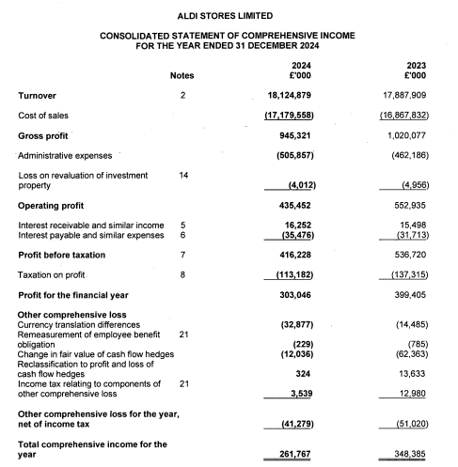
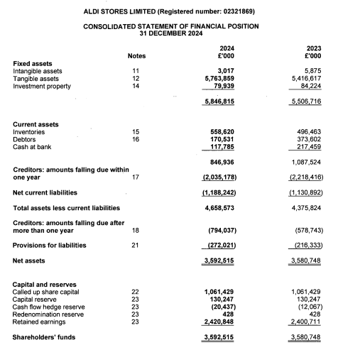
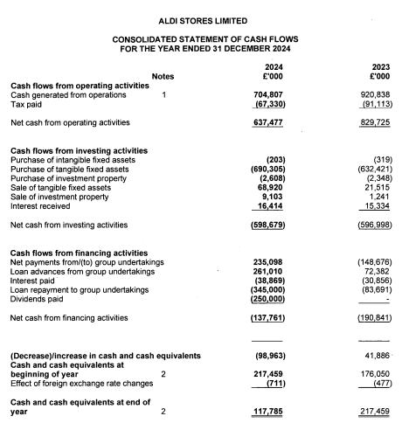

Appendix 2: Ratio calculation
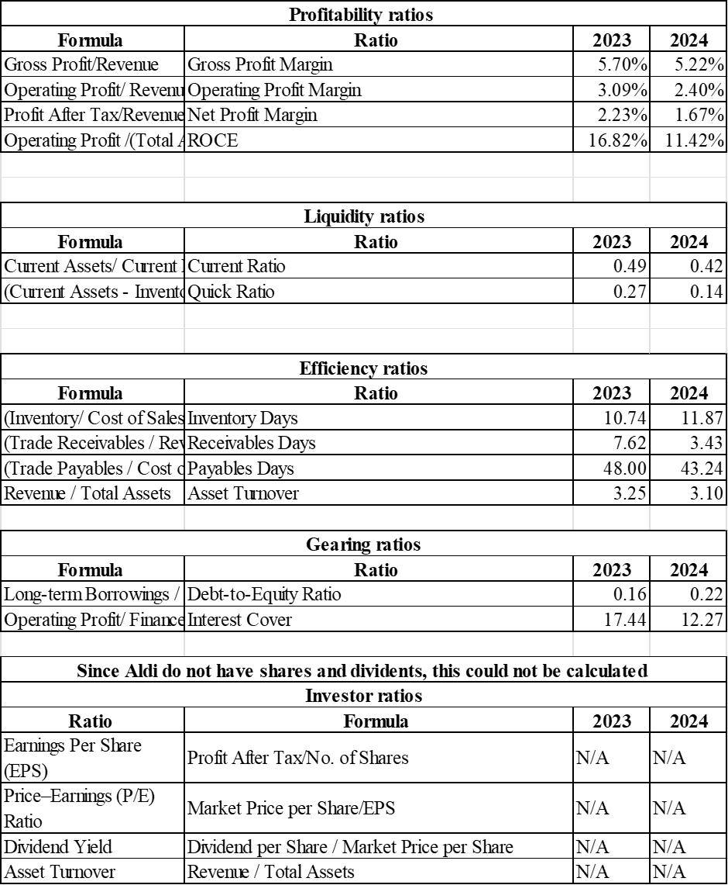

Appendix 3: Investment appraisal calculations


