Design, conduct and critically evaluate a close-to-practice research project focusing on the model of the transformative teacher in developing practice that has a positive impact on the learner.
What are the perceptions of year 2 learners on the use of homework?

Aim, focus and purpose of the research / Research Context
The aim of this research project is to conduct a close-to-practice research project focusing on the model of the transformative teacher in developing practice that has a positive impact on the learner. This research project focuses on understanding and discussing the perceptions of year two learners on the use of homework. From previous experience in my first placement, I noticed that homework was not a crucial element of the school's learning design and was not of regular use in the majority of the classrooms. In addition, it was interpreted that homework was perceived as negative through discussions with the class mentor. However, through observation in my second placement, it has been noticed that in the year two placement class, homework is sent out to the pupils through Google Classrooms every Friday and expected to be completed by the following Monday. Placement 2 is based in the Carmarthenshire Local Authority, totalling 431 pupils, with a two-form entry where the year two placement class occupies 53 pupils (Welsh Government, 2023). These homework assignments vary from a mathematics task, language task or project task. An interest was taken in this topic as the learning throughout the week is consolidated within the homework; where an issue may arise in the homework, further work can be carried out during the following week. In relation to this, when the first observed homework was being handed out the overall opinion of the whole class was positive.

Overview of relevant literature.
Corno (1996) defines the term Homework as the schoolwork brought home. Yildiz and Kiliç (2020) conducted a study on the various viewpoints held by students, teachers, and parents about homework in primary schools. A closer examination of their answers to various interview questions revealed that while all of the participant groups had some unfavourable thoughts about homework in primary schools, all of the participant pupils, teachers, and parents believed that homework promoted academic progress (Yildiz and Kiliç, 2020). The majority of the homework, according to the pupils, was problem-solving; the least amount involved practising musical instruments. Most students said that they received an adequate quantity of homework each day. It was also discovered that among the students who took part, maths was the most popular subject, and music was the least popular (Yildiz and Kiliç, 2020). Therefore, it can be interpreted that the more homework given to a particular topic, the more beneficial and enjoyable the pupils find it. The less amount of homework given towards a subject, the less pupils will find it less enjoyable; the pupils will therefore not want to learn and find the topic irrelevant to their learning. The process of education involves a number of intricately linked factors. Generating successful results is one of this process's primary goals (Yildiz and Kiliç, 2020). These results could be behavioural, emotional, or cognitive in nature. The primary goal of educational curriculum, however, is to attain specific academic goals that are supposed to be represented in students' work (Yildiz and Kiliç, 2020). Consequently, educators often employ a variety of strategies to enhance student achievement, such as assigning homework. According to Farrow, Tymms, and Henderson (1999), assigning homework for each fundamental course once a month in primary schools enhances homework performance. Additionally, research has shown that, as long as it is completed within reasonable time constraints, homework can effectively boost achievement. According to Valle et al. (2016), there is a positive correlation between academic achievement and the amount of homework completed; additionally, there is a relationship between homework time management and the amount of completed homework, homework time management and the approach to homework, and the approach to homework and the student's academic motivation.
According to recommendations published by Ofsted in 1999, all schools were required to have a homework policy and to assign an hour's worth of homework each week to children aged five to seven and half an hour a night to those aged seven to eleven. In response to complaints that homework can disrupt family life and unjustly advantage students from wealthier households, this instruction was abandoned in 2012 and headteachers were instructed to establish their own practices. In relation to Medwell and Wrays’ (2019) study, "homework" refers to assignments that teachers provide to their pupils to complete outside of class (Bembenutty, 2011). In the context of English, this has included reading to or with parents (Brooks et al., 2008). Homework has a 21% chance of affecting students' learning in both primary and secondary schooling, according to Hattie's (2008) meta-analysis, and its impact is significantly stronger in secondary education than in primary (Hattie 2008, cited in Medwell and Wray, 2019). Whatever goals students and teachers set for themselves through homework will determine its possible influence.

Explanation of Case Study
A case study, as viewed by Simons (2009: p.21), delves deeply into the details and distinctiveness of a “specific project, policy, organisation, programme, or system within a ‘real life’ setting”, examining it from several angles. Therefore suggesting that the main goal of a case study is to deliver an accurate understanding of a particular subject. Where Robson (1993) agrees through stating that a case study is a research methodology that combines multiple sources of evidence with an empirical investigation of a specific focus area relating to a real-life context. Thus arguing that a case study must be in relation to a practical application of a situation. Thomas (2017) then suggests that a case study is a comprehensive investigation using one or more methodologies that examine individuals, events, or decisions. Therefore, recognising that a case study must include more than one form of data collection. Yin (1994, p.13) confirms this matter through stating that this form of inquiry draws on evidence from a variety of sources. Heale and Twycross (2018) state that a case study can be simply described as an intensive study about a person or a group of people to then be generalized over several topics. Heale and Twycross (2018) reason that a case study method of research permits the researcher to distil a complicated and wide-ranging phenomenon or issue into a digestible research question, meaning that rather than discussing a large topic in a small-time frame to form focused questions in relation to the area for a focused study. Whether gathering data through quantitative or qualitative means of data collection, a more comprehensive understanding of the topic is gained by the researcher than would be possible with a single form of data (Heale and Twycross, 2018). Heale and Twycross (2018) discuss similarities and differences through contrasting between their selected cases within their article. They reflect on the individual cases, a multiple-case research study which facilitates a deeper comprehension of the cases collectively. Their research was derived from several case studies, which typically yield stronger and more trustworthy evidence than single case studies. Heale and Twycross (2018) further suggest that While case studies offer advantages, they also frequently have disadvantages. Organising the data can be difficult due to its vast quantity. Techniques for data integration and analysis must, therefore, be carefully chosen. Moreover, there is sometimes a tendency to deviate from the investigation's primary subject.
Participants
Within the placement school, the researcher worked alongside a year two class. A sample of pupils was selected based on ability grouping. Across the whole of year two, the two classes are seen as one class, and the two classes will work together as one. In total, there are six ability groups, and one boy and one girl were chosen from each group to have a gender-equal and ability-balanced sample, resulting in twelve participants. These participants were then selected randomly. Through this, in total, five participants agreed to participate in this research.

Research Methods
Having considered the proposed aims of this research project the perceptions of year 2 learners on homework, A mixed methods strategy was determined to be the best way to gather data for this inquiry. This is because, according to Fontana and Frey (2005), qualitative methods provide insight into people's social worlds, the underlying causes of their decisions, and the ways in which they understand the dynamics of the relationships that exist between individuals and their environment at different points in time. There are numerous ways to determine the significance of subjective experiences in qualitative research, whereas quantitative techniques research is more focused on obvious, measurable, quantifiable proof. In order to achieve this, for instance, structured, semi-structured, and unstructured interviews may be used as techniques. Certain techniques turned out to be more effective than others. Semi-structured interviews have a loose structure that facilitates focused, conversational back-and-forth dialogue. Data can be sent and received with it (Fontana & Frey, 2005). The freedom to determine the direction of the inquiry and seize opportunities to opportunistically lead the interview into relevant paths enables investigators to conduct interviews with greater depth. Likewise, contributors could also assume some control over the course of the discussion. Furthermore, unstructured interviews can be employed for in-depth interviews and provide the investigator the leeway to steer the conversation in any direction. No questions are asked during these interviews, thus the respondent is free to express their feelings, ideas, and experiences related to the topic (Fontana & Frey, 2005). There is a chance that the inherent independence in this situation could lead to a lack of coherence throughout interviews, but it also gives researchers the opportunity to travel the field. Formal settings are typically used for structured interviews, and all questions should be open-ended to allow the interviewee to give their best response. In the simplest form of a structured interview, two people ask each other a series of predetermined questions about a carefully selected topic (Fontana & Frey, 2005). Because of this, being careful while choosing the lines of investigation proves crucial in enabling the exploration, or blocking, of novel and unexpected directions.
As per Gaskell (2002), semi-structured interviews offer an abundance of beneficial information that can be integrated with other discoveries to generate a particular understanding of significant data that can be employed to construct or bolster theories. Flick (2002) asserts that interviews are meant to draw forth and make explicit the participant's latent knowledge and opinions. This, in accordance with Gibbs (2007), enables the researcher to support and legitimise the voicing of unsung voices as well as illustrate and investigate complex linkages that would otherwise go concealed within the workplace. Thus, semi-structured interviews are effective because they enable the interviewee and the researcher to take an active role in gathering data and support two-way communication while upholding guidelines to guarantee overall coherence. The researcher will employ quantitative research in addition to the qualitative approach mentioned above. Quantitative approaches, like their qualitative counterparts, come in a variety of forms and include questionnaires, quasi-experiments, and experiments. "Useful for describing trends and explaining the relationship among variables found in the literature," these methodologies are a relevant approach to inquiry (Creswell, 2014:10). Therefore, in order to conduct this inquiry, the researcher developed particular questions, used instruments to gather information to answer the question about general classroom provision, and employed statistics to evaluate the information gathered from the instruments (Creswell, 2014). The researcher examined the data based on the results of these analyses, drawing on prior theories and research projects. The approaches were chosen over more variable approaches that were thought to be unfeasible, such as experiments and quasi-experiments (Creswell, 2014). Experiments investigate hypotheses by testing them in controlled environments and concentrating on the connections between independent and dependent variables. Nonetheless, this type of research has numerous drawbacks (Creswell, 2014). For instance, a lot of these trials are not practically feasible in real-world settings. As a result, experiments are not always a good fit for educational research because neither students nor educators in settings can be allocated to specific, unform conditions. However, we still don't have complete control over the subject's broader influences, and quasi-experiments necessitate the creation of control and influenced groups. Nevertheless, they offer a potential for education research (Creswell, 2014). Based on that, the best quantitative approach to use—or at least a reasonable one—is to use surveys. In addition to the previously mentioned significance of their work, surveys appear to be simple to create and distribute (Cresswell,2014). Furthermore, the participants assume responsibility for the study's completion and return to the researcher with marked answers to questions and basic, personal, or demographic information about themselves, along with some expanded responses. This enables the researcher to efficiently use their time in parallel but complementary directions (Cresswell, 2024).

Ethical Considerations
In accordance with the British Education Research Association (BERA) (2018), participants must be shown respect, dignity and politeness at all time throughout the research, if this is not achieved the participants may wish to withdraw from all research. All research participants, including practitioners and educators, need to be informed about their roles in the study and the possible effects of their contributions. In this instance, it is to express opinions in the questionnaire and interviews and to go about your daily business while being observed (BERA, 2018). When conducting a study which involves children less than sixteen, parents' consent should be sought (UWTSD, 2022). As stated by the EWC (2024), it is our responsibility as practitioners to safeguard and protect the rights of students, young people, parents, and the general public, as well as to uphold public confidence in the workforce in education. In consideration of the child UNICEF (no date) suggests that children have the right to partake in any research with the consent of an adult, “Article 12 says that every child has the right to express their views, feelings and wishes in all matters affecting them, and to have their views considered and taken seriously. This principle recognises children and young people as actors in their own lives and applies at all times throughout a child’s life”.
Within the ethics form, it was stated that all individuals and organisations would be removed from the research. All names of all individuals and organisations have, therefore, been removed from the work. This includes participants, research sites and people and places mentioned in the data. The names of teachers and the school name will not be included on any form of document and will be changed for all reports; for example, replace the name with letters (i.e. Teacher A, Pupil A school 1). When referring to the school, I will use a numbered system and refer only to the district in which it is located, for example, Primary School 1 in Carmarthenshire local authority (BERA, 2018). To track information provided by the pupils at the beginning of the questionnaires, I asked the pupils to provide their names; once the data is analysed, the names will be removed from any documentation. The participants in the research (year 2 pupils) were all made aware of their role in the research. As well as this, the participants understood what was intended to be found out from the questionnaires and interviews. This was conveyed through participant information sheets. In the case of face-to-face interaction, this was verbally reiterated at the beginning of all interactions. I have, therefore, gained the written consent and assent of all participants to take part in the research. All individuals had been offered the opportunity to contact myself to clarify any aspect. Parents were contacted via Google Classroom/paper copy to complete a form explaining what the research project involves and why I would like their child to participate.

Results / Analysis of results / Discussion
Through my questionnaire, the data has shown me that, on average, the small sample base does enjoy homework. However, through the interview, it was suggested that sometimes the homework is repetitive and boring, where they wish they could be doing other family-oriented things.
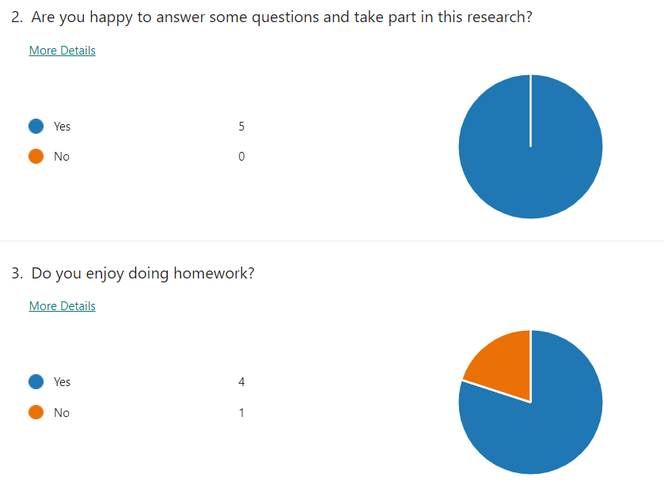

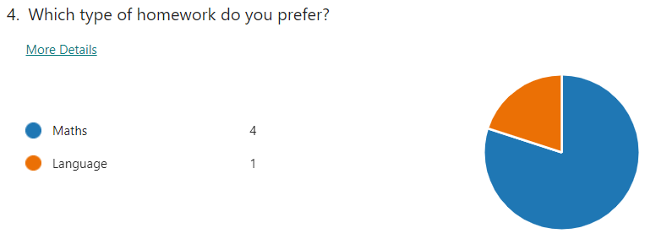

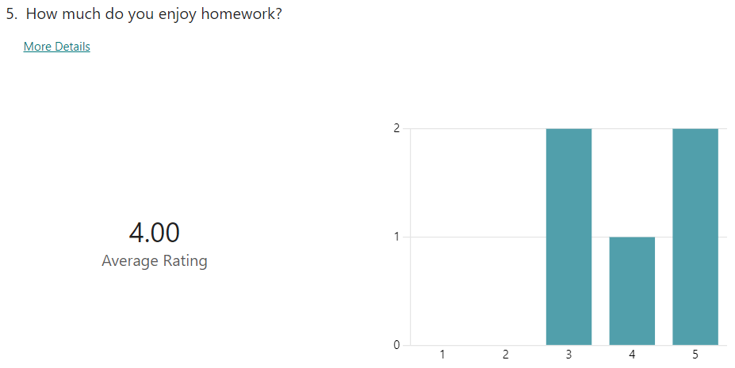

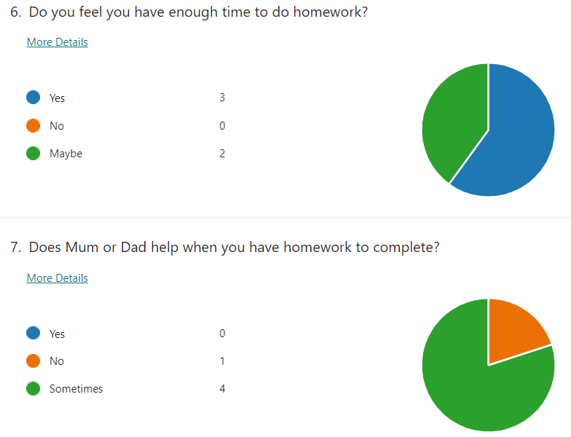

Do you enjoy doing homework?
P1 Yes, I enjoy doing homework because I like using the computer to do my homework.
P2 Yes, I enjoy doing my homework because some of the homework is fun.
P3 Yes, I do enjoy doing my homework because it's lots of different things every week.
P4 Yes, I do enjoy doing my homework because it helps me learn better.
P5 No, I do not enjoy my homework because it's boring.

Do you have enough time to do your homework and does anyone help you with it?
P1 - Yes, I do have enough time because I do it as soon as I get home from school.
P2 – my mummy helps me over the weekend.
P3 – maybe I want to do other things. And sometimes my brother helps me.
P4 – sometimes, I do have enough time if I remember my homework, and sometimes I do get help from mummy.
P5 – yes, I do, but sometimes the homework is too easy, and I don’t usually get help, but sometimes I do.

Conclusions and Recommendations
In conclusion, the results from the questionnaires and interviews have a positive impact on the perceptions of year 2 learners. Where one participant suggested that they do not enjoy homework, it can be perceived that this is due to the homework being set over a weekend. Perhaps as an area for improvement, the class homework could possibly be set on a Monday to be returned by the Friday; thus, the pupils benefit from the weekend to spend quality time with family to improve their social and mental health, therefore not overly focusing on class.

Reference list
Bembenutty, H. (2011). “The Last Word: An Interview with Harris Cooper–Research, Policies, Tips, and Current Perspectives on Homework.” Journal of Advanced Academics Vol, 22. 342–351
British Educational Research Association (BERA). (2018). Ethical guidelines for educational research. (fourth edition). London.
Brooks, G., K. Pahl, A. Pollard, and F. Rees. (2008). Effective and Inclusive Practices in Family Literacy, Language and Numeracy: A Review of Programmes and Practice in the UK and Internationally. Reading: CfBT Education Trust.
Corno, L. (1996). ‘Homework is a complicated thing’. Educational Researcher, 25(8), 27-30.
Creswell, J. (2014). Educational research planning, conducting, and evaluating quantitative and qualitative research. Harlow, Essex : Pearson
Education Workforce Council (EWC). (2024). Code of Professional Conduct and Practice for registrants with the Education Workforce Council.
Farrow, S., Tymms, P., & Henderson, B. (1999). ‘Homework and attainment in primary schools’. British Educational Research Journal, 25(3), 323-341.
Flick, U. (2002). An introduction to qualitative research. London: SAGE
Fontana, A. and Frey, J. (2005). The Interview: From Structured Questions to Negotiated Text. [online]. Available at: http://www.iot.ntnu.no/innovation/norsi-common-courses/Lincoln/Fontana%20&%20Frey%20(2000)%20Interview.pdf [Accessed 01/05/2024 ]
Gaskell, G. (2002). Individual and group interviewing. London: SAGE
Gibbs, G. (2007). Analyzing Qualitative Data. London: SAGE
Hattie, J. A. (2008). Visible Learning: A Synthesis of Over 800 Meta-Analyses Relating to Achievement. London: Routledge.
Heale, R. and Twycross, A. (2018). ‘What is a case study?’ Research made simple. Vol 21, number 1 pp 7-8
Medwell, J. and Wray, D. (2019). ‘Primary Homework in England: the beliefs and practices of teachers in primary schools’. Education 3-13. VOL. 47, NO. 2, 191–204
Ofsted. (1999). Homework: Learning from Practice. London: HMSO.
Robson, C. (1993). ‘A Resource for Social Scientists and Practitioner Researchers’. Real World Research Blackwell Publishers Inc., Oxford.
Simons, H. (2009). Case Study Research in Practice. London: Sage.
Thomas, G. (2017). How to do your research project: A guide for students (3rd ed). Sage Publications
UNICEF (no date). The Right to Participation is one of the most important principles in becoming a Rights Respecting School. Available at: https://www.unicef.org.uk/rights-respecting-schools/the-right-to-participation/#:~:text=One%20of%20the%20relevant%20articles,views%20considered%20and%20taken%20seriously. (Accessed 01/05/2024).
UWTSD. (2022). Research Ethics & Integrity Code of Practice.
Valle, A., Regueiro, B., Núñez, J. C., Rodríguez, S., Piñeiro, I., & Rosário, P. (2016). ‘Academic goals, student homework engagement, and academic achievement in elementary school’. Frontiers in Psychology, 7, 463.
Welsh Government. (2023). My Local School. Available at: https://www.gov.wales/my-local-school-guide (Accessed 3rd May 2024)
Yildiz, Vahit Aga ; Kiliç, Durmus (2020). An Investigation on the Viewpoints of Students, Teachers, and Parents about Homework in Primary Schools. ‘International online journal of education & teaching’. Vol.7, No.4), p.1572-1583
Yin, R. K. (1994). Case study research: Design and methods. London: Sage.

