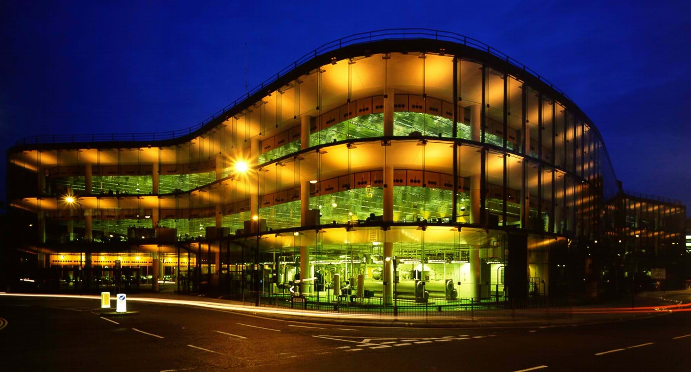

Construction Materials – Concrete Frame

By Ellis Morgan, 2518653
  - Willis Building, London

Contents Page

Introduction 2
Selected Concrete Framed Building 2
Analysis of the Material 3
The Impact on Environment 5
Prevention Method 5
Conclusion 6
References 6
Sieve Analysis 7
Texture Analysis Graph 7

Introduction
The structure of the reliability, durability, and adaptability of concrete-framed buildings make them popular for modern construction. A concrete frame is constructed from slabs, beams and columns made of reinforced concrete that act together to safely transfer the weight of the structure to the foundation. ‘Engineers constructed the Willis Building from a grid of concrete pillars, supporting cantilevered concrete floors’ (1, “How the work was done”, paragraph 1 line 1).
Since steel reinforcement strengthens the material's capacity to withstand pressure while concrete takes compressive strain, reinforced concrete has become particularly useful. ‘The concrete is reinforced with steel cable, allowing the structure to stretch in response to forces such as wind’ (1, “How the tower was built”, paragraph 2 line 1).
However, there are also environmental issues with concrete's common usage. ‘The production of concrete accounts for 8% of global carbon dioxide emissions’ (2, Paragraph 2 line 1). The design, construction process, and concrete's performance to serve as framing material are all going to be considered in this report's analysis of a particular concrete-framed building.

Selected Concrete Framed Building
Description of the Willis Building
In London's financial area, at 51 Lime Street, is a large commercial office complex called the Willis Building. It was constructed as the UK offices for the insurance company Willis Group and was created by the British construction firm Foster & Partners. ‘The Willis Building is a commercial skyscraper in London, located on Lime Street in the City of London financial district’ (3, Paragraph 1 line 1) The structure is an outstanding feature in the city skyline. ‘The building was designed by Sir Norman Foster and is 125 metres tall with 26 storeys’ (3, Paragraph 2 line 2).
The complex was built from 2004 to 2008 under Mace's construction management. ‘The Willis Building was constructed between 2004 and 2008 under the management of Mace’ (3, Paragraph 4 line 1). The building features large transparent façades that reflect the surrounding structures and a unique tiered architectural form designed to resemble a shell. This structural approach enables the structure to be built into the crowded urban setting while providing plenty of office floor area.
The Structure
The Willis Building uses current composite structural technology to maintain flexible interior floor designs while always strengthening the high office. ‘Concrete core, steel frame and metal decking’ (4, Structure, line 1). The building's maintenance shafts, stairwells and major lifts are all located in its central area. For the support of the office floors and transfer the loads to the central concrete frame and foundations, steel framing is employed throughout the perimeter. Large open plan workspaces with few columns inside are made possible by the large structural space made possible by the combination of materials. Through distribution of stresses at various heights across the frame, the building's stepped design further enhances structural performance.
In London, where hybrid buildings are built, the design reflects current high-rise construction methods. Therefore, the structural approach produces an efficient yet stable tall building through integrating the flexibility and decreased weight of steel framing with the compressive durability of the concrete.
Construction Method
The Willis Building was built using a stepped high-rise construction technique, which is usual for major central London office buildings. Building strong foundations and building the reinforced concrete core, which serves as the building's major structural spine, this was during the first phases in the project. ‘The core was topped out in July 2006 and the steelwork completed in September that year.’ (3, Paragraph 6, line 2) The steel frame and floor technologies were progressively constructed on each level after the core structure had reached its maximum height.
The building's structural floors were completed through laying concrete floor slabs and metal decking over the steel beams. With this technique, construction may move forward quickly without negatively impacting structural stability. As the frame raised, exterior cladding and glazing had been installed simultaneously. ‘Cladding began in July 2006, and the structure was externally completed by June 2007’ (3, Paragraph 6, line 4).

Analysis of the Material
Strength & Durability
Due to its great compressive strength as well as its resistance to environmental exposure, concrete is frequently utilised in structural framing. In the UK, where buildings must withstand wind, rain, shifts in temperature, and cold temperatures which are intermittent. ‘Concrete withstands harsh climate conditions including freezing temperatures, extreme heat and heavy rain without degrading’ (5, Weather resistance section, bullet 1 line 1).
When in comparison to other structural materials, reinforced concrete's ability to stand up against fire and insect damage is another factor that contributes to its longevity. ‘Concrete maintains structural integrity far longer than steel or wood during fire’ (5, Fire protection section, bullet 3 line 1). However, if reinforced concrete is not correctly built, being exposed to the environment might still have a significant effect. When moisture enters through the concrete cover, the corrosion of the reinforcement becomes a major issue. ‘Reinforced concrete corrosion costs the UK billions of pounds per year’ (6, Paragraph 3 line 2). Therefore, to guarantee long-term durability in exposed situations, proper mixture design, protective coatings, and sufficient concrete cover are crucial.
The Labour & Cost
The choice there is from steel and concrete construction is affected by the project's cost total, labour requirements, and building time. Reinforced concrete frames often require the installation of concrete formwork, the application of reinforcing, and curing time can support loads. This could prolong the construction in contrast to prefabricated steel systems that can be swiftly placed on site. Concrete continues to be cost-effective since it is easily accessible and requires not much upkeep over the course a building's lifetime. ‘Concrete structures require minimal maintenance compared to alternatives’ (5, Maintenance benefits section, paragraph 2 line 1).
The cost-effectiveness of reinforced concrete in structural applications is another benefit, since that it is capable of being developed locally and shaped into structural materials directly on site, which helps reduce transportation costs when in comparison to prefabricated steel elements. ‘Reinforced concrete remains a cost-effective solution for structural projects’ (7, Cost-effectiveness section, paragraph 1 line 1). However, the requirement for skilled workers in formwork production and reinforcement installation may increase labour costs.
Adaptability
There is a significant amount of design and construction freedom with reinforced concrete frames. Compared to certain structural materials, concrete is capable of being formed using formwork techniques into any shape, enabling engineers and architects to create complex building forms. ‘Reinforced concrete can be moulded into virtually any shape’ (7, Versatility in Design section, paragraph 1 line 1). Large open floor plans with fewer columns were made possible by concrete framing, which improves a structure's adaptability over the years. In commercial buildings, where typical interior layouts are likely to be modified in time.
The increased durability of reinforced concrete buildings is a further advantage. ‘The long-life span and adaptability of reinforced concrete structures save money by delaying replacement’ (8, Long Service Life section, paragraph 2 line 2). However, because structural components are cast in place, it can be challenging to modify existing concrete structures after they have been designed.
Challenges
It might be difficult to recycle reinforced concrete structures when the time arrives for them to be demolished. As concrete frames are so massive, mechanical demolition equipment is usually used to break the building down into smaller parts. The steel reinforcing installed in the concrete affects the demolition process.
As demolishing reinforced concrete structures can be difficult, the material is capable to be able to be recycled efficiently. However, because it is difficult to dismantle sustainably, the steel reinforcement in the concrete in recycling may increase production time and increase prices. To reduce its negative effects on the environment, modern architecture increasingly takes deconstruction planning and better recycling methods. (8, Durability section paragraph 1–2).

The Impact on Environment
Producing cement & CO2 Emissions
The high-energy methods used for producing concrete have a negative impact on the environment. This is part of the production process, so limestone and clay must be burnt to high temperatures in furnaces, this requires lots of fuel and gives out carbon dioxide. This highlights that when producing cement, it is the main cause of emissions during the concrete lifecycle. (9, Paragraph 2 line 1).
Emissions are developed during the manufacturing of clinker by chemical processes in addition to the consumption of fuel. ‘Clinker production is the main source of CO₂ emissions… from chemical reactions’ (10, Page 5, paragraph 2 line 1). This suggests that without recent technologies, emissions cannot be completely reduced, even with the usage of renewable energy. ‘Concrete accounts for around 1.5% of all emissions in the UK’ (9, Paragraph 3 line 2).
Environment
Adding on to carbon emissions, impacts of concrete manufacturing include exploitation of resources and high energy usage. Reduction of Natural resource and landscape destruction may result from requirements for large number of raw materials like aggregates and limestone. ‘Concrete is the most used material on the planet… the constituents are abundant’ (9, Paragraph 3 line 2). Since cement kilns need high temperatures to work properly, energy consumption is a further major problem. Increased use of fossil fuels and related pollutants in the air result from this. (9)
How Communities are Impacted
The manufacturing of cement and concrete can have a significant impact on local communities, particularly the ones close to quarries and industrial areas. Because of, noise, dust, and poorer living standards around the area of quarrying operations which required to get raw materials. Additionally, these activities may lead to loss of habitat and altered local landscapes. (9, Paragraph 3 line 2).

Prevention Method
Innovation in technology and further modifications to industry operations are needed to reduce the environmental consequences of concrete production in local communities. One possible effective strategy is to decrease the amount of cement in concrete replacing other elements like fly ash or slag. This could maintain performance while significantly lowering carbon emissions. ‘Options for reducing cement content… include alternative materials’ (9, Recommendations section, bullet 2 line 1).

Conclusion
In conclusion, concrete-framed structures like London's Willis Building shows off durability, strength, and adaptability with concrete with reinforcement in modern building. The structure serves as a valid demonstration of how adaptable interior areas and stable structure can be achieved using a steel frame and concrete foundation. As concrete is durable and suitable for the UK environment in an urban setting, although it needs to be manufactured effectively to prevent issues like corrosion of the reinforcing. However, due to increased carbon emissions, impacts of cement production on the environment continues as a major issue. While methods for mitigation are being developed, improvement in sustainability is crucial. Concrete is still and continues to be an essential yet evolving material in the building industry.

References
(1) Institution of Civil Engineers, 17 SEP 2024 https://www.ice.org.uk/what-is-civil-engineering/infrastructure-projects/willis-building
(2) Institution of Civil Engineers, 17 SEP 2024 https://www.ice.org.uk/news-views-insights/latest-news/ice-bsi-refresh-standard-on-lower-carbon-concrete
(3) Paul Piazza (2017) – Willis Building Architecture https://paulpiazzaarchitect.com/home/2017/01/29/willis-building/
(4) David Basulto (2008) Arch Daily: Willis Headquarters https://www.archdaily.com/1026/willis-headquarters-at-lime-street-foster-partners
(5) Pro-Mix Concrete (2023) – Why is Concrete a Popular Building Material https://www.pro-mixconcrete.co.uk/why-is-concrete-a-popular-building-material/
(6) Dr Ana Bras, Institution of Civil Engineers (2020), Infrastructure Resilience & Climate Action https://www.ice.org.uk/events/recorded-lectures/infrastructure-resilience-and-climate-action-concrete
(7) Southeast Formwork Ltd (2024) – Advantages of Reinforced Concrete, Structural Projects https://southeastformwork.co.uk/top-5-advantages-of-using-reinforced-concrete-in-structural-projects/
(8) Concrete Reinforcing Steel Institute (2023), Durability & Resilience of Reinforced Concrete https://www.crsi.org/reinforced-concrete-benefits/durability-resilience/
(9) Institution of Civil Engineers (27 April 2022) https://www.ice.org.uk/news-views-insights/media-centre/press-releases-list/construction-sector-could-more-than-halve-emissions-from-concrete-by-2035
(10) Mineral Products Association (2025) https://cement.mineralproducts.org/MPACement/media/Cement/Publications/2025/CC_Roadmap_to_Beyond_Net_Zero_Progress_Report_2025.pdf

Sieve Analysis

Sieve Size (mm) | Mass (g) | % on Sieve | % Passing
125 | 0 | 0 | 100
75 | 0 | 0 | 100
63 | 0 | 0 | 100
37.5 | 120 | 9.6 | 90.4
20 | 137 | 10.96 | 79.44
10 | 143 | 11.44 | 68
6.3 | 105 | 8.4 | 59.6
3.35 | 45 | 3.6 | 56
2 | 130 | 10.4 | 45.6
1.18 | 63 | 5.04 | 40.56
0.6 | 105 | 8.4 | 32.16
0.3 | 102 | 8.16 | 24
0.212 | 109 | 8.72 | 15.28
0.15 | 98 | 7.84 | 7.44
0.063 | 55 | 4.4 | 3.04

Fine & Coarse Aggregate Percentage Calculations
Fine aggregate - 59.60%
Coarse aggregate - 40.40%

Texture Analysis Graph
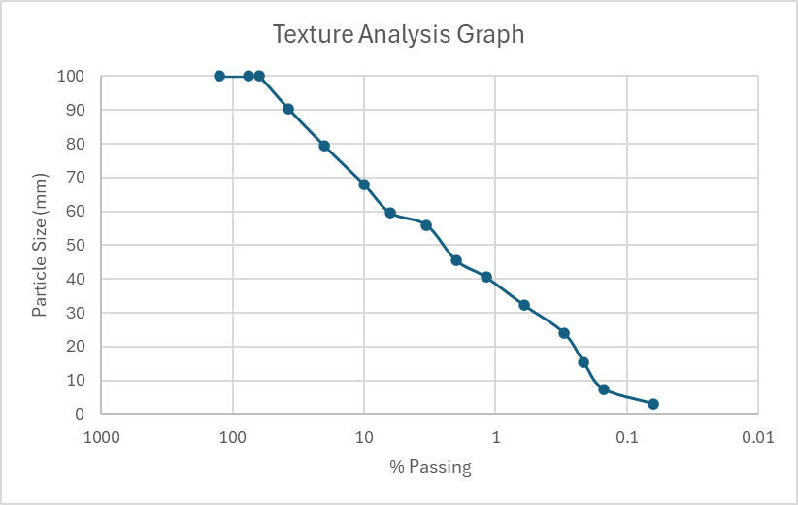
Evaluation
A solid aggregate with a broad variety of particle sizes can be seen by the curve. Both fine and coarse particles are distributed well in the scatter smooth curve, which enhances compaction and decreases voids. The high fine percentage of 59.60% indicates good workability but higher water demand. The lack of large gaps in the curve shows that it is not graded poorly. Changes may be required based on a specific application; the aggregate is suitable for use in regular construction.

