Report

Developing Innovation & Creativity
for
Business Advantage.

2,730 words
Submitted on 17/03/2023
Module BMSW6102_SWAN

Executive Summary

This research on organisational innovation and creativity analyses differences and correlations between these notions and how they can help the organisation stay relevant.
The research unveiled that today's organisations can achieve competitiveness by cultivating and supporting a curiosity culture where employees will be empowered to be creative. Hence, they will pose the right questions to find innovative and add values ways of dealing with volatile business realities while providing new products and services to their customers. Moreover, supportive leadership can use fast learning opportunities to make employees comfortable with ambiguity and able to run innovation experiments.
Additionally, the investigated success of the Toyota Industry Corporation revealed that the company uses an incremental process innovation methodology renowned as Kaizen, created by Masaaki Imai.
As a continuous improvement philosophy and systematic management methodology, Kaizen received worldwide recognition and started to be exercised in many organisations across many industries, from financial services and healthcare to the public sector and car manufacturers (Patwary, 2015).
Masaaki Imai identified the product potential of Kaizen as a corporate strategy and business system and promoted this methodology worldwide via Kaizen Institute (Kaizen Institute, 2023).
The Kaizen corporate strategy methodology's high effectiveness, availability, and clear deployment structure made it one of the most effective innovation tools to drive organisational change (Kaizen Institute Online, 2019). However, it was discovered that Kaizen deployment effectiveness could be tangibly diminished if the corporate culture and leadership commitment are poor.
The report concluded that despite Kaizen's merits and demerits, the continuous improvement philosophy helps drive organisational change to adapt to the internal and external context to stay agile and future-proof.

Table of Contents

Executive Summary
List of Figures
1.0 Introduction 1
2.0 Main Findings 2
2.1 Overview of the Innovation Opportunity 3
2.2 Type of Innovation 4
2.3 The Creative Thinking Process 5
2.4 Models of Innovation 5
2.4.1 Open and Closed Innovation 5
2.4.2 The Innovation Process 6
2.4.3 The 4P's to innovation 7
2.5 Assessment of the Effectiveness 8
2.6 Leadership and Management 9
3.0 Conclusions 10
Reference list 11

List of Figures

- Figure 1: Innovation Matrix …………………………………………………... 4
- Figure 2: Open and Closed Innovation Model ……………………………….. 5
- Figure 3: Innovation Process ………………………………………………….. 6
- Figure 4: The 4P's to innovation ……………………………………………… 7
- Figure 5: Force Field Analysis ………………………………………………… 8

1.0 Introduction

This individual academic report was requested by the principal module tutor Davina Evans, as a part of Pavlo Gladkyi's assignment. Per requirements, the author will submit this report in person on 17/03/2023 via Turnitin.
This report aims to demonstrate acquired knowledge from the Developing Innovation and Creativity for Business Advantage module and provide evidence of expertise through the business case study and the critical evaluation of the gathered information.
The innovation concept that Toyota Industry Corporation (TIC) uses to achieve its objectives is the subject of this report. Additionally, the research identifies that the Toyota Product System (TPS) and Kaizen methodology supports the TIC innovation strategy and cultivate creativity and innovation within the company.
Within this report, the investigation will be conducted arround the practicality of Kaizen as a continuous improvement process and its influence on the companies' competitiveness and resilience. Furthermore, the research explores different types of innovation, the creative thinking process, closed and open innovation concepts, and suitable leadership and management styles as critical organisational change drivers.
Given the required academic format, this report comprises all the module-related tools and methods, such as the Innovation Matrix, Open and Closed innovation models, Innovation process Force Field Analysis and the 4P's to innovation. Moreover, the report's findings were supported by various credible information sources, including books, articles, academic journals, official organisational websites and media content to provide a ground for critical discussion.
As a result, the report reveals why innovative and creative organisational capacity is a critical success factor for an agile organisation.

2.0 Main Findings

Hawkins and Smith (2013) state that incontrovertible forces of The Great Disruption driven by technological progress lead organisations to new ways of generating profit. Similarly, Arbib and Seba (2017) confirm that this imminent disruptive transformation through technological convergence would significantly and, in the most consequential way, transform the information, energy, transportation, food and materials sectors by creating new opportunities and radically transforming or even destroying existing products, markets and industries. Hence, organisations must stay relevant by utilising technological convergence to harness these market opportunities, generate creative ideas, and implement them to meet customers' expectations (Seba, 2021). However, to unleash creative capacity when executing new ideas, organisations must start emphasising creative competitiveness (Brown, 2016). Moreover, he assumes that ideation and creative competitiveness can be fostered by management practices and incorporated into the organisational framework.
Franken (2007) explains creativity as the state of mind to generate new ideas through insights and imagination. Moreover, Cunff (2019) affirms that creativity is not innate and can be cultivated. She distinguishes exploratory, transformational and combinational types of creativity. The author argues that originality is overestimated, as people are inspired mainly by existing ideas and use combinational creativity to differentiate themselves from others. In contrast, she believes that real originality exists and is a vertex of creativity due to its rarity.
Puccio, Mance and Murdock (2011) state that well-balanced divergent and convergent thinking are crucial when dealing with unconventional problems or contingency. Therefore, as a problem-solving tool, creativity is a cornerstone of innovation. Additionally, Satell (2017) confirms that innovation is about solving problems. Similarly, Kaizen can identify and solve problems efficiently and cost-effectively as an incremental innovation support framework. As a result, Kaizen creates ground for radical and large-scale innovation (Duffy, 2014).
Gruhl-Bégin (2019) stated that radical innovation through breakthrough improvement is more beneficial and provides immediate results. In contrast, Bent (2012) declares that breakthrough improvements are risky and challenging to sustain without a strong, open-to-change corporate culture supported by leaders' and managers' commitment.
Bolton (2019) describes innovation as the novelty that creates value and improves the existing state of processes, products or services by aligning it with top-notch technologies and providing a competitive advantage. However, Syal (2021) defined innovation as the art of making meaningful changes by implementing existing solutions that help businesses be or remain profitable. The business needs for innovation could differ and depend on the products or services they provide, external or internal context. However, the commonalities are quite apparent and relay to value creation and value-capturing processes for evaluation, reinvestment or further improvements. Similarly, Riley (2019) asserts that the main objective of any innovation deployment is adding value and optimisation to the outcome that the business or organisation is trying to produce, improve or streamline.
Day (2022) talks about the critical difference between creativity and innovation. She states creativity is about conceiving novelty, while innovation is about reaching your goals through novelty implementation.
Indeed, innovation is the product of creativity, where the practical embodiment of creative ideas and thinking leads to a profitable outcome. Moreover, Tidd and Bessant (2018) argue that continuous innovation is economically essential because there is a direct correlation between innovation and organisational growth, as this process exists to identify or create profitable opportunities. Thus, innovation is what distinguishes a company apart from its competitors today.
Drucker (2002) describes seven sources of innovation opportunities such as unexpected occurrences, incongruities, process needs, new knowledge, industry, market, demographic and perception changes. However, due to perceptual and conceptual aspects of innovation, innovators must purposefully and systemically analyse these opportunity sources.

2.1 Overview of the Innovation Opportunity

TIC was the first company that started using Kaizen methodology as a part of the TPS and, with its example of a highly efficient and innovative company, propelled Kaizen's philosophy worldwide. Initially, Kaizen was elaborated by Masaaki Imai after observing the American conveyor line manufacturing process and the Lean concepts (Hessing, 2019). Subsequently, Kaizen was introduced as a separate systematic management methodology in 1986 and since then evolved from the Total Quality Management (TQM) and TPS tool to the Lean transformation mechanism focusing on leadership behaviours, team efficiency and employee empowerment (Kaizen Institute, 2023). Moreover, a Kaizen Institute founded by Masaaki Imai helps organisations to be relevant, efficient and capable of leading change through consulting and training services.
The Forth Industrial Revolution made Kaizen thrive on technological change, wherein organisations sought cost-effective solutions and methods to remain agile, resilient and future-proof (Schwab, 2016). Consequently, Kaizen today utilised as a business system to improve sales, understand market wants and needs, and streamline the ideas generation process (Medinilla, 2016).
Thus, the innovation opportunity of Kaizen is the up-to-date versatility that provides structure to make production processes efficient and freedom to support employees' entrepreneurship mindset (Ross, 2021). In addition, Kaizen will help companies be disruptive through incremental change (Christensen, 2008).
For instance, Kaizen can help boundaryless organisations balance standardisation, performance, and the flow of incoming ideas without compromising ongoing critical processes and activities (Ashkenas et al., 2015).
The apparent benefits of incremental persistent daily improvements are the continuous process of setting a creative mindset and curious culture that will allow employees to recognise valuable opportunities and challenge the status quo by using innovative ideas to achieve them.
As a result, Kaizen continuously develops employee competencies adding long-term value for organisational competitive advantage.
However, an insufficient flow of incoming ideas could potentially lead to a failure of the continuous improvement strategy. Therefore, a Kaizen culture must be created to enable stable ideas flow and ensure employees' dedication and engagement.
Nevertheless, the major Kaizen disadvantage can appear in its implementation in existing systems that distort whole corporate leadership and management. Additionally, resistance to change might occur from the employees if leadership is not persistent while implementing Kaizen. Moreover, staff training and sustaining-change activities consume resources. Thus, failure to adopt and sustain change will negatively impact the return on investments (Maurer, 2013).

2.2 Type of Innovation

The researcher applied the Innovation Matrix to identify the type of examined innovation and revealed that Kaizen is, at its core, Incremental innovation (Davila et al., 2012).
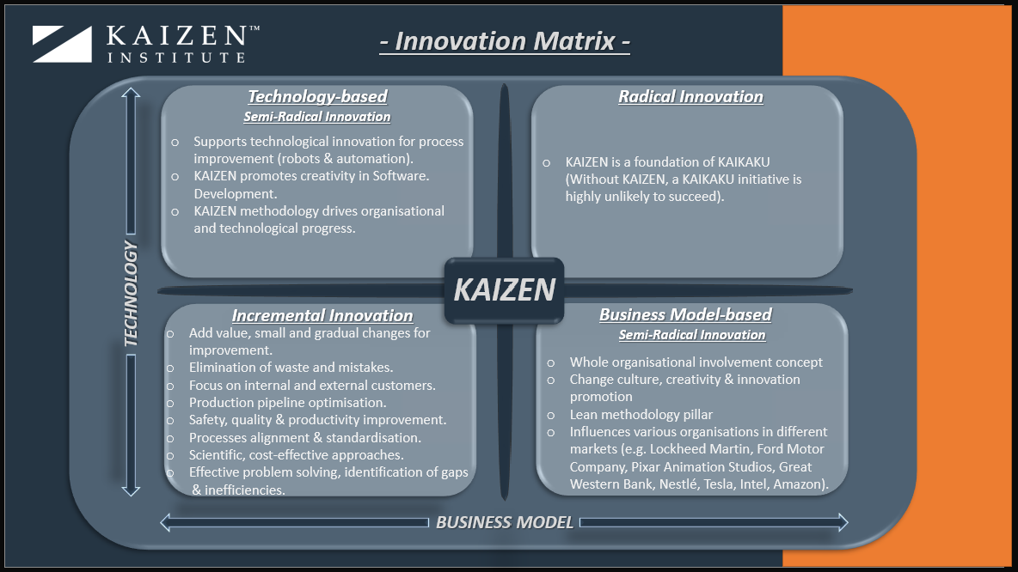
However, as shown in Figure 1, Kaizen substantially affects the other matrix fields, such as Technology-based and Business Model-based innovations. Moreover, despite Kaizen's incremental innovation nature, the continuously applied small improvements have a cumulative effect that results in radical changes. Furthermore, compelling evidence shows that the adaptation of the Kaizen methodology always starts from the Kaikaku. This radical and breakthrough change transforms the organisational business model and uses technologies to achieve and sustain continuous growth and profitability.

Figure 1: Innovation Matrix.

2.3 The Creative Thinking Process

According to Clifford (2014), the Toyota Innovation Fair is a one-day internal event where individuals and teams compete to implement their creative ideas. The award system covers different categories of experiments and ensures recognition of the most innovative ideas to the customers and company.
Additionally, the company uses Toyota Creative Idea and Suggestion System (TCISS) as a highly engaging and comprehensive concept for the collection of improvement ideas from the employees (Miller, 2007). Moreover, following the Kaizen methodology, TIC fosters clear communication channels via complex social networks to facilitate information exchange.
Research confirms that on the organisational level, TIC develops strong cross-functional horizontal links between employees regardless of their locus. Moreover, it provides coaching and mentoring support across vertical hierarchical structures (Takeuchi, Osono and Shimizu, 2008). Therefore, these two strategies incentivise informal ties to simplify sharing of ideas process.
Regarding the industry level, the Kaizen philosophy is broadly integrated into organisational culture and adopted by all TIC subsidiaries, ensuring continuous improvement processes and disruptive innovation experiments (Shingo, 2007).

2.4 Models of Innovation

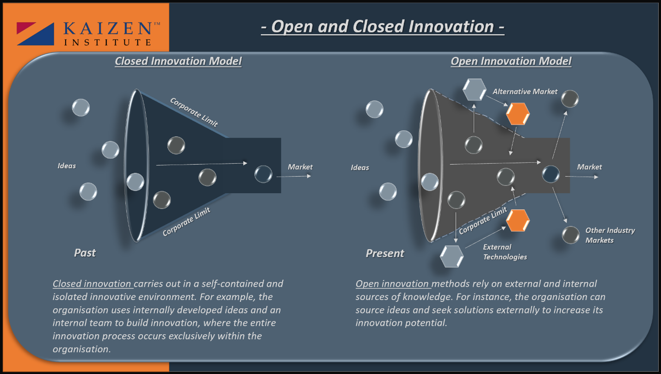
2.4.1 Open and Closed Innovation

Figure 2: Open and Closed Innovation Model.
Figure 2 demonstrates the Open and Closed innovation model (Fried, 2022b). The examination of these modules reveals that apparent advantages of the Open innovation model rely upon the broader sources of expertise, cost-effective research and development, a collaboration of internal and external experts, technological relevancy and potential for fast market expansion with disruptive innovation (Chesbrough, Vanhaverbeke and West, 2006).
However, the complexity of the Open innovation model can negatively affect the innovation process control, risk valuable information exposure and cause a loss of competitive advantage due to intellectual property sharing (Bogers et al., 2016).
On the other hand, Trott (2017) affirms that the Closed innovation model has a more optimised innovative process and intellectual property control but lacks expert diversity, which might cause collateral expenses on research and development and limit market share. However, Kaizen supports both the Open and Closed innovation models and can increase the employees' competency and efficiency of the organisational innovation process with its methodology (Kulkarni, 2020). Hence, both models incorporate continuous improvement techniques to identify and deliver innovation successfully.

2.4.2 The Innovation Process
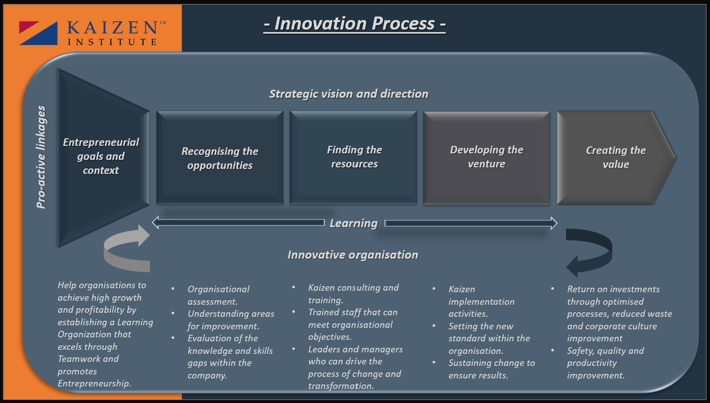

Figure: 3 Innovation Process.
Bolton (2019) claims that the innovation process (IP) implies ingenuity, focus, persistence, knowledge and talent. Thus, this process is about how people work together to create value and find new ways to deliver that. Moreover, Tidd (2014) states that focused thinking must be applied to determine the innovation goals, opportunities and available resources to achieve the needed outcome. Hence, strategic vision in this process is utterly essential, as it will help to structure the innovative funnel.
Notably, depending on the type of innovation, the required steps may vary and must be adjusted accordingly (Zapfl, 2022).
Fried (2022a) ascertains that the IP could be explained in four stages: an idea, a concept, a solution and a market. Moreover, he stated that the IP must be well established where everyone understands the goals, and team members have set responsibilities, skills and levels of expertise in the required subject. Furthermore, chosen innovation strategy and the roles of each stakeholder must be clearly communicated during the process.
Similarly, Bessant (2019) argues that a well-coordinated IP must be supported with relevant and applicable methods.
Intrinsically, the IP within the organisation is akin to the Project management process, and a combination of Scrum and Sage Gate models can manage any complex innovation projects (Hill, 2020). In contrast, the innovation process requires holistic deployment compared to the linear project management approach. Therefore, iterative and flexible methods will support favourable results.
The innovation process depicted in Figure 3 explains the innovation process within the organisation (Tidd and Bessant, 2021). The simplicity of this particular model unequivocally is its most significant advantage, as all stages can be easily distinguished. Nonetheless, this advantage in display simplicity is also a tangible flaw as it does not consider the product, process or service's imminent obsolescence like the Product Life Cycle model (Levitt, 1965). Additionally, Tidd and Bennet's model excludes Kaizen's continuity, where the delivered innovation will be sustained and reviewed for further improvement (Ortiz, 2014). Moreover, unlike the project management tools, this model framework does not have a timeline nor explain the roles and responsibilities of the involved internal and external stakeholders nor the potential risks and control measures to prevent or mitigate them. Furthermore, this model does not specify how innovation value will be captured.

2.4.3 The 4P's to innovation
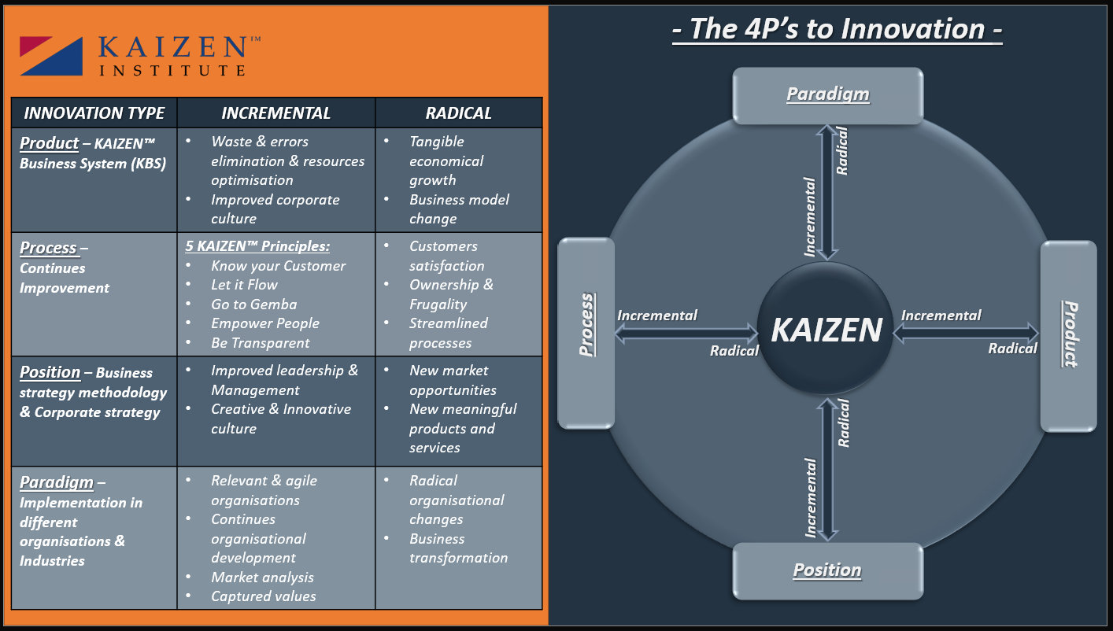

Figure 4: The 4P's to innovation.
As illustrated in Figure 4, the report's author used the 4P's to innovation model to identify how comprehensive Kaizen as a process innovation is and how it can influence the other categories of the diagram (Tidd and Bessant, 2021).
In terms of advantage, the model shows the innovation focus point, the correlation between the four sectors of the diagram and displays the incremental and radical range to understand innovation and the potential consequences of change impact (Zastempowski and Przybylska, 2016). However, the superficial aspect of the model does not consider any further actions that might be taken or the volatility of underdeveloped markets (Agola and Hunter, 2016). Moreover, the blurring transition between incremental and radical change lacks a precise determination if it is one or the other.

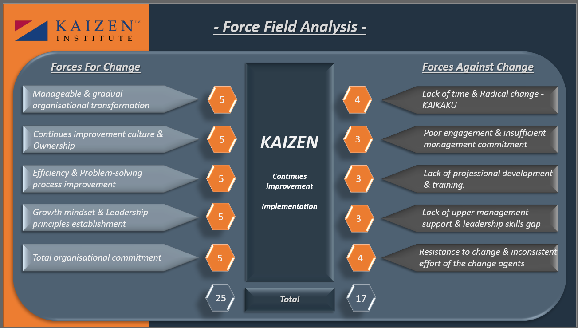
2.5 Assessment of the Effectiveness

Figure 5: Force Field Analysis.
By completing the Force Field analysis illustrated in Figure 5, the report author visually mapped the driving and restraining change forces within the organisation that implements the Kaizen methodology (Covey, 2013).
As a simple but powerful diagnostic and decision-making tool, this analysis is broadly used by change management, project management, and change agents to analyse forces influencing the change inculcation (Blokdyk, 2021).
The results of the Force field analysis show that synergy and total organisational commitment are the key factors that ensure the successful implementation of Kaizen. However, the identified restraining forces could create tangible barriers, especially when resistance to change is significant and the dedication and effort of the leaders are insufficient. As a result, the organisation risk failing Kaizen methodology implementation and sustaining the achievements. Therefore, emphasising the open-to-change organisational culture will provide the foundation for successful Kaizen implementation (Hiatt, 2006).

2.6 Leadership and Management

Imai (2020) argues that leaders play a critical role in building and enabling innovation within the organisation. Moreover, he believes innovation cannot be commanded but can be incentivised. Leaders must show commitment and determination and guide and inspire employees upon working on Kaizen fruition to forestall failure. Hence, Kaizen implementation must start from the top management.
Indeed, Kaizen implementation required consistent commitment, recognition of improvement initiatives, a proactive problem-solving approach and barrier-breaking facilitation (Maurer, 2011). Hence, the participative leadership style is most suitable for Kaizen implementation, as leaders consider feedback and insights from all organisational levels.
Transformational leaders also have appropriate traits for successful Kaizen implementation and can efficiently achieve their innovation objectives through continuous improvement, as they have a deep commitment and a high tenacity (Armstrong, 2016).
Despite their leadership style, innovative leaders and managers should develop ethical models to support and promote the right group norms to encourage overt tacit knowledge sharing between subordinates inside and outside the team. In addition, a high team cohesiveness level can also support this knowledge-sharing relationship and trust, allowing creative ideas to develop and cross-team dissemination. Therefore, everyone can have an equal opportunity to contribute and add value (Al-Tameemi, Alshawi and Ahmed, 2018).

3.0 Conclusions

To recapitulate. The research confirmed that creative thinking and innovation are crucial in today's business reality and are the cornerstone of organisational competitiveness and agility. Moreover, the report's author revealed that Innovation and creativity models and theories could provide valuable knowledge to identify and understand innovation and its opportunities.
Additionally, it was concluded that the Kaizen methodology could support leaders and managers in effectively leveraging available resources and managing the balance between creativity and value capture.
Undoubtedly, continuous improvement as an incremental innovation unleashes organisational innovation potential and increases profitability. However, without total organisational commitment and constant leadership support, the Kaizen implementation will not succeed. Hence, the open-to-change corporate culture and efficient ideas flow are crucial while delivering and sustaining continuous improvement.
The philosophy of continuous improvement and progress cannot exist without innovation. Thus, organisations must innovate to survive.

Reference list

Agola, N.O. and Hunter, A. (2016). Inclusive Innovation for Sustainable Development : Theory and Practice. London: Palgrave Macmillan Uk.
Al-Tameemi, K., Alshawi, M. and Ahmed, V. (2018). Integrating Business Improvement and Innovation Models: a Step Change Approach for Organisational Performance Improvement. International Journal of Engineering & Technology, 7(4.20), p.608. doi:https://doi.org/10.14419/ijet.v7i4.20.27420.
Arbib, J. and Seba, T. (2017). Rethinking Transportation 2020-2030 : the Disruption of Transportation and the Collapse of the internal-combustion Vehicle and Oil Industries. Manchester: Rethinkx.
Armstrong, M. (2016). Armstrong’s handbook of management and leadership for HR : developing effective people skills for better leadership and management. 4th ed. London: Kogan Page.
Ashkenas, R., Ulrich, D., Jick, T. and Kerr, S. (2015). The Boundaryless Organization. John Wiley & Sons.
Bent, D. (2012). Breakthrough innovation: Getting beyond Incremental Improvements. The Guardian. [online] 31 Jul. Available at: https://www.theguardian.com/sustainable-business/breakthrough-innovation-beyond-incremental-improvements [Accessed 7 Feb. 2023].
Bessant, J. (2019). Success and Failure in Innovation. YouTube. Available at: https://www.youtube.com/watch?v=38ZJaIaot1M [Accessed 30 May 2021].
Blokdyk, G. (2021). Force Field Analysis a Complete Guide. 2020th ed. 5STARCooks.
Bogers, M., Zobel, A.-K., Afuah, A., Almirall, E., Brunswicker, S., Dahlander, L., Frederiksen, L., Gawer, A., Gruber, M., Haefliger, S., Hagedoorn, J., Hilgers, D., Laursen, K., Magnusson, M.G., Majchrzak, A., McCarthy, I.P., Moeslein, K.M., Nambisan, S., Piller, F.T. and Radziwon, A. (2016). The Open Innovation Research landscape: Established Perspectives and Emerging Themes across Different Levels of Analysis. Industry and Innovation, 24(1), pp.8–40. doi:https://doi.org/10.1080/13662716.2016.1240068.
Bolton, R. (2019). Council Post: Back to Basics: What Is Innovation? [online] Forbes. Available at: https://www.forbes.com/sites/forbesbusinesscouncil/2019/12/30/back-to-basics-what-is-innovation/?sh=3e907c254ca2 [Accessed 4 Feb. 2023].
Brown, T. (2016). Leaders Can Turn Creativity into a Competitive Advantage. [online] Harvard Business Review. Available at: https://hbr.org/2016/11/leaders-can-turn-creativity-into-a-competitive-advantage [Accessed 4 Feb. 2023].
Chesbrough, H.W., Vanhaverbeke, W. and West, J. (2006). Open Innovation : Researching a New Paradigm. Oxford: Oxford University Press.
Christensen, C.M. (2008). The innovator’s Dilemma : When New Technologies Cause Great Firms to Fail. Boston, Mass.: Harvard Business School Press.
Clifford, J. (2014). Toyota and the Power of Suggestion. [online] Toyota UK Magazine. Available at: https://mag.toyota.co.uk/toyota-and-the-power-of-suggestion/.
Covey, S.R. (2013). 7 Habits of Highly Effective People. Simon & Schuster Ltd.
Cunff, A.-L.L. (2019). Combinational creativity: the Myth of Originality. [online] Ness Labs. Available at: https://nesslabs.com/combinational-creativity [Accessed 4 Feb. 2023].
Davila, A., Epstein, M.J. and Shelton, R. (2012). Making Innovation Work : How to Manage it, Measure it, and Profit from It. Upper Saddle River, N.J.: Wharton School Publ.
Day, J. (2022). What’s the Real Difference between Creativity and Innovation? [online] IdeaScale. Available at: https://ideascale.com/blog/whats-the-real-difference-between-creativity-and-innovation/ [Accessed 4 Feb. 2023].
Drucker, P. (2002). The Discipline of Innovation. [online] Harvard Business Review. Available at: https://hbr.org/2002/08/the-discipline-of-innovation.
Duffy, G.L. (2014). Modular Kaizen : Continuous and Breakthrough Improvement. Milwaukee, Wis.: Asq Quality Press.
Franken, R.E. (2007). Human Motivation. 3rd ed. Australia; Belmont, Calif.: Thomson/Wadsworth.

Fried, B. (2022a). Innovation Management. The 4 Phases of Innovation. Available at: https://www.lead-innovation.com/en/insights/english-blog/the-4-phases-of-innovation [Accessed 6 Feb. 2023].
Fried, B. (2022b). Open Innovation vs. Closed Innovation. [online] www.lead-innovation.com. Available at: https://www.lead-innovation.com/en/insights/english-blog/open-innovation-vs.-closed-innovation [Accessed 8 Feb. 2023].
Gruhl-Bégin, D. (2019). Radical Innovation | Dominique Gruhl-Bégin | TEDxHochschuleLuzern. YouTube. Available at: https://www.youtube.com/watch?v=ArS_2Dgytqo [Accessed 11 Jul. 2021].
Hawkins, P. and Smith, N. (2013). Coaching, Mentoring and Organizational Consultancy : supervision, Skills and Development. Maidenhead: Open University Press.
Hessing, T. (2019). History of Lean | What You Need to Know for Lean Six Sigma certification. [online] Six Sigma Study Guide. Available at: https://sixsigmastudyguide.com/history-of-lean/ [Accessed 8 Feb. 2023].
Hiatt, J.M. (2006). ADKAR: a Model for Change in business, government, and Our Community. 1st ed. Loveland: Prosci Learning Center Publications.
Hill, S. (2020). How to Marry Innovation and Project Management. [online] PM Today. Available at: https://www.pmtoday.co.uk/how-to-marry-innovation-and-project-management/ [Accessed 6 Feb. 2023].
Imai, M. (2020). Strategic Kaizen. S.L.: Mcgraw-Hill Education.
Kaizen Institute (2023). What Is KAIZENTM. [online] Kaizen.com. Available at: https://kaizen.com/what-is-kaizen/.
Kaizen Institute Online (2019). Kaizen Change Model (KCM) Intro. YouTube. Available at: https://www.youtube.com/watch?v=BkcIKaCybR8 [Accessed 3 Aug. 2021].
Kulkarni, A. (2020). Learn to Improve Employee Competency. [online] in.kaizen.com. Available at: https://in.kaizen.com/blog/post/2020/07/30/learn-to-improve-employee-competency--the-kaizen-way.
Levitt, T. (1965). Exploit the Product Life Cycle. Boston, Mass.: Graduate School of Business Administration, Harvard University.
Maurer, R. (2011). Changing for the Good - the Kaizen Way. [online] www.youtube.com. Available at: https://www.youtube.com/watch?v=DmgIgTMqGdU [Accessed 10 Feb. 2023].
Maurer, R. (2013). The Spirit of Kaizen : Creating Lasting excellence, One Small Step at a Time. New York: Mcgraw-Hill.
Medinilla, A. (2016). Agile Kaizen Managing Continuous Improvement Far beyond Retrospectives. Berlin Springer Berlin Springer.
Miller, J. (2007). Toyota’s Suggestion System: 56 Years and Still Going Strong. [online] Gemba Academy. Available at: https://blog.gembaacademy.com/2007/12/09/toyotas_suggestion_system_56_years_and_still_going/#:~:text=Perhaps%20this%20initial%20exclusion%20was [Accessed 5 Feb. 2023].
Ortiz, C.A. (2014). Kaizen and Kaizen Event implementation. Prentice Hall.
Patwary, E.M.Z. (2015). Top Kaizen Applying Companies in the World. [online] Textile Fashion Study. Available at: https://textilefashionstudy.com/top-kaizen-applying-companies-in-the-world/.
Puccio, G.J., Mance, M. and Murdock, M. (2011). Creative Leadership : Skills That Drive Change. Thousand Oaks, Calif.: Sage.
Riley, J. (2019). Innovation (Product and Process). YouTube. Available at: https://www.youtube.com/watch?v=BbUE9Fco5Nc [Accessed 7 Feb. 2023].
Ross, J. (2021). How Toyota Generates New Ideas | MIT Sloan on Driving Innovation. [online] www.youtube.com. Available at: https://www.youtube.com/watch?v=W2nSfhco3vM&t=3s [Accessed 4 Feb. 2023].
Satell, G. (2017). Mapping Innovation : a Playbook for Navigating a Disruptive Age. New York: Mcgraw-Hill Education.

Schwab, K. (2016). The Fourth Industrial Revolution, by Klaus Schwab. [online] World Economic Forum. Available at: https://www.weforum.org/about/the-fourth-industrial-revolution-by-klaus-schwab [Accessed 2 Feb. 2023].
Seba, T. (2021). The Great Disruption - Rethinking Energy, Transportation, Food & Agriculture / August 17th, 2021. [online] www.youtube.com. Available at: https://www.youtube.com/watch?v=Kj96nxtHdTU [Accessed 15 Dec. 2021].
Shingo, S. (2007). Kaizen and the Art of Creative Thinking. Productivity Press.
Syal, D. (2021). The Art of Innovation | 10 Things to Learn from Guy Kawasaki. [online] InnovationManagement. Available at: https://innovationmanagement.se/2021/04/12/the-art-of-innovation-10-things-to-learn-from-guy-kawasaki/ [Accessed 7 Feb. 2023].
Takeuchi, H., Osono, E. and Shimizu, N. (2008). The Contradictions That Drive Toyota’s Success. [online] Harvard Business Review. Available at: https://hbr.org/2008/06/the-contradictions-that-drive-toyotas-success [Accessed 5 Feb. 2023].
Tidd, J. (2014). Developing an Innovation Process. YouTube. Available at: https://www.youtube.com/watch?v=l9sNGnxMEXE [Accessed 6 Feb. 2023].
Tidd, J. and Bessant, J. (2018). Managing Innovation. New Jersey: John Wiley & Sons.
Tidd, J. and Bessant, J. (2021). Managing Innovation : Integrating technological, Market and Organizational change. 7th ed. Hoboken, Nj: Wiley.
Trott, P. (2017). Innovation Management and New Product Development. 6th ed. Harlow, England: Pearson.
Zapfl, D. (2022). Innovation Process. Available at: https://info.lead-innovation.com/en/paper-5-tips-innovation-process?utm_referrer=https%3A%2F%2Fwww.lead-innovation.com%2Fen%2Finsights%2Fenglish-blog%2Fthe-4-phases-of-innovation [Accessed 6 Feb. 2023].
Zastempowski, M. and Przybylska, N. (2016). Cooperation in Creating Innovation in Polish Small and Medium-Sized Enterprises in the Light of Empirical Studies. Journal of Competitiveness, 8(2), pp.42–58. doi:https://doi.org/10.7441/joc.2016.02.04.

