Research Methodology & Planning
Introduction
In this chapter, I will be discussing the methods that I will be using to conduct my research for this dissertation. In the previous chapter, the literature review, I achieved objective 1 of my dissertation, and this chapter aims to achieve objective 2, which is:
To identify the most appropriate research approach required to effectively explore views and opinions on the topic of mental health in policing.
This is a very important area to research as I believe police officers’ mental health often gets overlooked and illnesses such as stress and burnout are just seen as part of the job and there’s not much you can do about it. The literature review chapter of this dissertation identified many topics of discussion in regard to the issue of mental health in policing, and it identified a gap in the current research, which is how police officer’s own mental health is directly affected by responding to mental health incidents. I intend to conduct primary research in order to achieve my objectives and fill this gap.
The Research Onion
As shown in the diagram below, the Research Onion (Saunders et al, 2019) is a proven and efficient concept of how to understand research when deciding to undertake an academic dissertation. When following the layers, it assists the researcher in deciding which method of research to take on and results in the researcher being able to collect and analyse the data.

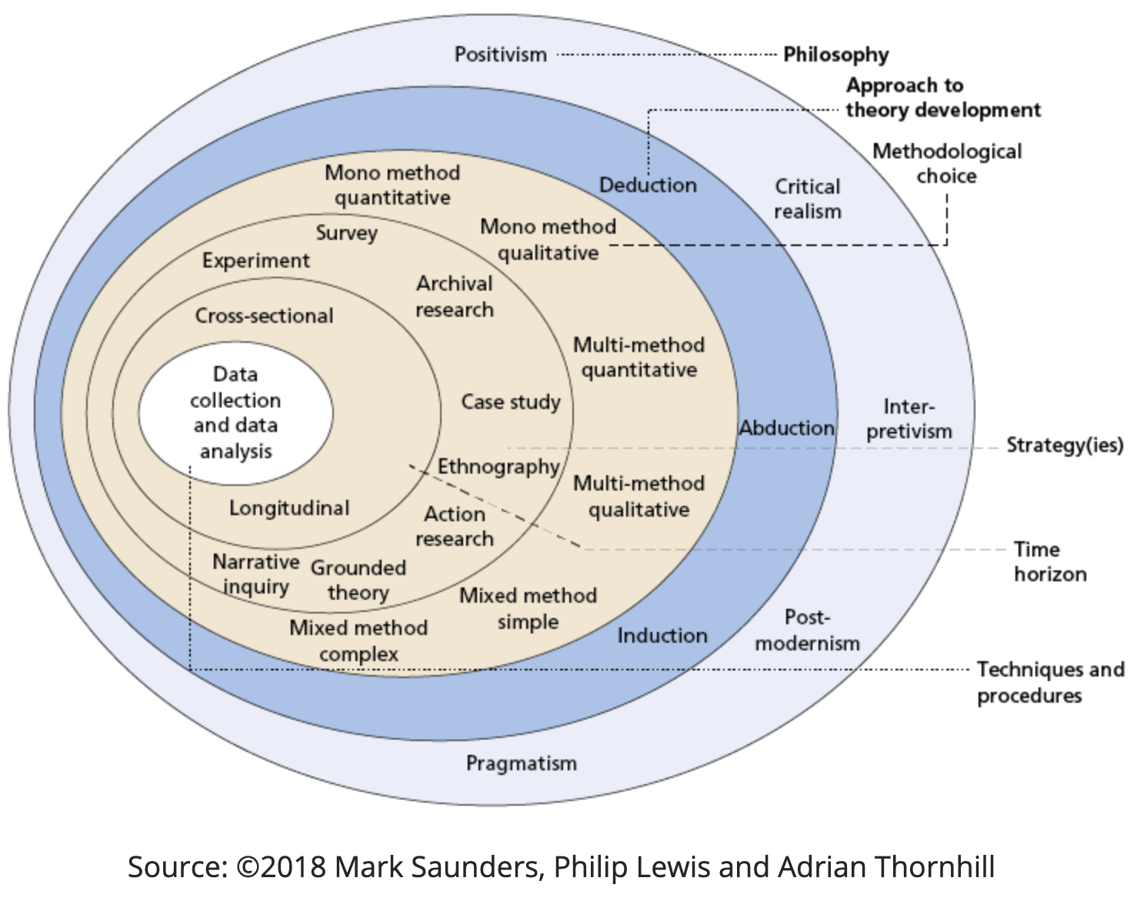

The first layer of the research onion is philosophy, which in other words means the overall approach or style of the research that the researcher wishes to take. In this research, I will be using an interpretive philosophy as I anticipate a wide variety of responses that will fall on all areas of the spectrum on the topic of mental health. An interpretivist research philosophy provides multiple benefits in terms of the results that can be obtained, as it increases accuracy and offers clear understanding of the opinions police officers have on the topic of mental health.
The next layer is the approach of the research. For this dissertation, an inductive research approach will be used. This is because I intend to interpret the data of the responses I receive in order to obtain a better understanding of how police officer’s mental health is affected by attending mental health incidents and develop theories and solutions for the topic, rather than confirming or negating a theory that I already possess.
The third layer of the research onion is the methodological choice. The research that I will be conducting will be of a mixed method design. This means that I will be using both quantitative and qualitative data within the research process of this dissertation. This mixed method design allows the researcher to understand the subject that they are researching more effectively. The quantitative aspect of the research will allow me to convert responses into numerical values such as percentages, in order for me to better understand and compare the views and opinions, and the qualitative aspect will allow me to obtain a variety of viewpoints and provide context behind the numbers in the quantitative data.
The next layer is the research strategy, meaning what tools or methods are going to be used to collect the data. In order to conduct my research, I will be using a questionnaire shared electronically among my colleagues and posted onto the police homepage message board. This will be in order to obtain as many responses from as many police officers as possible. I am choosing a questionnaire as they are the most effective and efficient method of obtaining many different and varied responses. They are also the most effective method when it comes to analysing and comparing the data, as all respondents will have answered the same questions. A questionnaire is also the most appropriate research strategy for a mixed method design, as in the questionnaire will be closed questions, allowing the responses to be converted into a numerical value which will represent the quantitative data, and open questions, allowing the respondents to express their views and opinions with ease, which will represent the qualitative data.
The final layer of the research onion is time horizon, which depicts the amount of time the researcher will spend conducting the research. For this dissertation, I will be conducting cross sectional research as I intend to only do this research once, capturing a snapshot of officers’ views on the subject of mental health at a single point in time.
Limitations & Potential Problems
This research will have a number of limitations in regard to the responses I receive. The main limitation I see arising from this research is that I will be asking police officers for their own views and opinions regarding a highly political, topical, and controversial area of their occupation. This may result in some tempered responses from officers, rather than their genuine beliefs on the subject. This in turn will affect the overall results and produce statistics that are not necessarily reflective of officers’ true beliefs. The questionnaire will also be asking the respondents about their own mental health, which could be another limitation of this research, as from personal experience, many officers do not like to talk about their mental health, so may also provide responses that are not reflective of the true way that they feel. These limitations will be reduced by ensuring that the questionnaire will be anonymous, which will encourage the respondents to express their true views and opinions. A final limitation in the research of this study is the time limit and the need for the dissertation deadlines throughout the year. This affects the length of time that the questionnaire will be available to respond to, and due to the highly unpredictable nature of the police officer role, I may not get as many responses as I hope for in the time frame available.
Conclusion
In this chapter, an appropriate and effective research method has been thoroughly explained and planned in order to collect the relevant research data. This chapter has also achieved the second objective of the proposal, which is -
To identify the most appropriate research approach required to effectively explore views and opinions on the topic of mental health in policing.
The next chapter of the dissertation will organise and analyse the data collected during the primary research phase of the dissertation.

1063 words.

Bibliography
Saunders, M. et al (2019) Research Methods For Business Students. 8th ed. [ebook] London: Pearson. Available at: https://www.researchgate.net/profile/Mark_Saunders4/publication/330760964_Research_Methods_for_Business_Students_Chapter_4_Understanding_research_philosophy_and_approaches_to_theory_development/links/5c53056f299bf12be3f0e2cf/Research-Methods-for-Business-Students-Chapter-4-Understanding-research-philosophy-and-approaches-to-theory-development.pdf (Accessed: 11 June 2024)

