2025
Student name: Ana Petronela Radulea

3/14/2025
Business Plan for VELLOCHIC: A Sustainable Fashion Enterprise
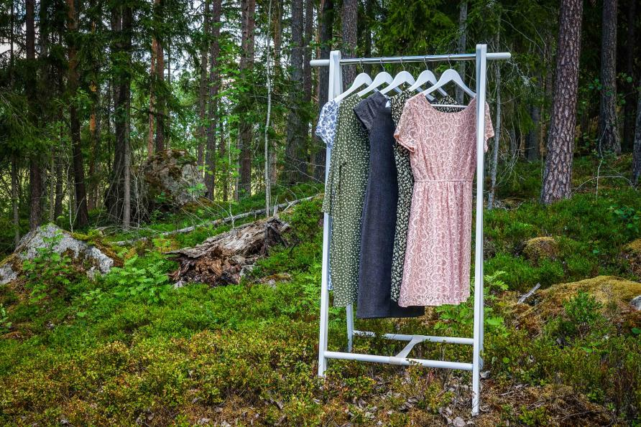
- Executive Summary
VELLOCHIC is an emerging start-up in the fashion sector, founded with the objective of establishing a sustainable enterprise that prioritises environmental stewardship and social fairness. Considering the fashion industry's ongoing criticism regarding its role in pollution and unethical labour methods, VELLOCHIC seeks to provide a sustainable alternative through the production of eco-friendly and ethically created apparel. The company will incorporate sustainable methods throughout its operations, from raw material sourcing to fashion product design, assuring minimal environmental effect and equitable treatment of its personnel. In doing so, VELLOCHIC will establish a new benchmark for ethical fashion, appealing to environmentally concerned customers and investors seeking sustainable business strategies.
Our objective is to establish a brand that resonates with consumers who are progressively aware of the environmental and social issues confronting the fashion industry. The company will primarily concentrate on manufacturing sustainable fashion products, including organic cotton shirts, recycled polyester dresses, and accessories crafted from renewable materials. Our dedication to sustainability will mitigate environmental deterioration often linked to fashion production while promoting social and economic advantages through ethical employment practices and fair-trade collaborations. VELLOCHIC aspires to establish itself as a global leader in the transition to a more sustainable and ethical fashion sector, achieving profitability while positively impacting society and the environment.
- Objectives and Goals
VELLOCHIC seeks to attain defined goals and objectives that correspond with our dedication to sustainability and ethical business practices.
- Short-term Goals
During the first year of operations, the company will focus on laying the groundwork for its sustainability strategy and increasing brand recognition. The primary objectives throughout this timeframe encompass the following:
- Product Development: Our objective is to design and produce a preliminary collection of eco-conscious fashion items, including shirts, trousers, and accessories, with an emphasis on utilising sustainable materials such as organic cotton, hemp, and recycled fabrics. This marks our initial endeavour to position VELLOCHIC as a brand synonymous with excellence and sustainability within the fashion sector.
- Brand Awareness: VELLOCHIC seeks to enhance its brand visibility via a focused digital marketing initiative, utilising channels including Instagram, Facebook, and TikTok. We will emphasise our dedication to sustainability and ethical production practices to distinguish our items from traditional fashion alternatives. In the initial 18 months, we intend to attain an audience of 50,000 followers throughout various social media channels.
- Environmental Impact: By prioritising sustainable material procurement and waste reduction in production, we seek to diminish our carbon footprint by a minimum of 20% within the first year. We will collaborate with manufacturers that employ renewable energy and implement water-efficient techniques, therefore harmonising with our environmental objectives.
- Long-Term Goals
VELLOCHIC aims to broaden its market presence, enhance its product range, and significantly influence the sustainability of the fashion sector in the medium to long term. Our enduring goals encompass:
- Market Expansion: Within five years, we intend to broaden our product range to encompass accessories including bags, shoes, and scarves, while also investigating overseas markets. We intend to augment revenue via global internet sales, concentrating on expansion into Europe and North America, where the demand for sustainable design is escalating.
- Zero-Waste Manufacturing: VELLOCHIC will establish a zero-waste production system within five years. This will entail the integration of closed-loop procedures, wherein every fabric waste is either used or recycled into new items, guaranteeing that our activities are entirely circular.
- Social Impact: Our objective is to collaborate with communities in developing economies and cooperate with local artisans, ensuring equitable compensation and enhanced working conditions. In doing so, we will facilitate socio-economic growth and generate enduring, beneficial effects in the regions where we function.
- Sustainability Framework
VELLOCHIC's sustainability strategy is structured on a framework that encompasses the three pillars of sustainability: environmental, economic, and social responsibility. This comprehensive strategy guarantees the company's dedication to sustainability in all aspects of its operations.

- Environmental Sustainability
VELLOCHIC's dedication to environmental sustainability is vital to our business model. We will:
- Eco-Friendly Materials: The company will prioritise the usage of organic cotton, hemp, recycled polyester, and other eco-friendly fabrics. These materials are responsibly generated and possess a markedly reduced environmental impact relative to traditional fabrics.
- Waste reduction: Our manufacturing processes will focus on diminishing textile waste by employing effective cutting methods and recycling residual materials. We will adopt a circular design strategy that repurposes surplus materials from prior collections into new designs, so minimising waste and generating extra items from the same raw resources.
- Reduction of Carbon Footprint: We will implement sustainable production methods that decrease energy usage and lower CO2 emissions. Additionally, we intend to mitigate our emissions by investing in renewable energy initiatives, like wind and solar energy, to neutralise any residual carbon output.
- Social Sustainability
In addition to our environmental sustainability activities, VELLOCHIC is also committed to attaining social sustainability through the following initiatives:
- Fair Trade Practices: The company will guarantee that all workers engaged in the manufacturing of VELLOCHIC products receive equitable remuneration, operate in safe and humane environments, and are afforded equal treatment irrespective of their gender, race, or background. By collaborating with verified fair trade suppliers, VELLOCHIC will guarantee that the workforce engaged in the production process is handled responsibly.
- Community Engagement: VELLOCHIC will partner with local communities and craftspeople, especially in emerging countries where sustainable job options are limited. Through the provision of skills, equitable remuneration, and access to international markets, we will promote economic progress while advancing social equality.
- Economic Sustainability
VELLOCHIC is dedicated to attaining financial sustainability via prudent company operations. We will:
- Revenue from Direct-to-Consumer Sales: The principal revenue source will be from online transactions via our e-commerce platform. We will serve environmentally concerned clients who are prepared to invest in sustainably manufactured fashion products.
- Strategic Alliances: To enhance our market presence, we will pursue wholesale collaborations with retailers that align with our beliefs. These collaborations will enhance brand visibility while generating a consistent revenue stream.
- Cost-Effective Operations: Although the utilisation of sustainable resources and ethical manufacturing techniques typically incurs elevated expenses, VELLOCHIC will endeavour to enhance production efficiency. This entails negotiating advantageous contracts with suppliers and optimising our supply chain to minimise overhead expenses and enhance profit margins.
- Required Resources
- Physical Resources
- Manufacturing Facility: The company will manage a compact production facility outfitted with energy-efficient gear and technologies aimed at reducing waste. This plant will be situated adjacent to a sustainable textile hub to minimise transportation emissions.
- Sustainable Materials: VELLOCHIC will procure materials from approved vendors offering organic, fair trade, and recycled fabrics. The materials comprise organic cotton, hemp, bamboo, and recycled polyester, guaranteeing that all raw materials adhere to our environmental requirements.
- Distribution Network: Products will be distributed via an online e-commerce platform, utilising sustainable packaging composed of recycled materials. We will investigate collaborations with environmentally responsible logistics firms that provide carbon-neutral shipping solutions.
- Human Resources
- Design Team: A core team of professional designers will oversee designing trendy and sustainable collections that cater to eco-conscious consumers. We will prioritise designers with expertise in sustainable fashion and a thorough understanding of eco-friendly materials and production methods.
- Production Team: VELLOCHIC will hire skilled individuals in the production process, ensuring that they are adequately compensated and work in safe settings. We will engage sustainability specialists to supervise the integration of sustainable practices throughout all phases of production.
- Marketing and Sales Team: A digital marketing team will use social media and other online platforms to increase brand recognition and attract new customers. We will recruit sales professionals specialising in online retail and direct-to-consumer sales, guaranteeing that VELLOCHIC's products attain a global reach.
- Financial Resources
- Initial Investment: To initiate the firm, VELLOCHIC will necessitate seed capital, which will be procured through a blend of personal savings, sustainable investment funds, and crowdfunding. We will additionally seek funding that support eco-business efforts.
- Revenue Streams: The principal source of income will be derived from direct-to-consumer sales of our products. Additional revenue sources will derive from wholesale relationships and collaborations with other sustainable businesses.
- Operating Capital: In the initial years of the business, operating capital will be necessary to cover the costs of production, marketing, and logistics. We will meticulously oversee cash flow and modify tactics as needed to guarantee the business's financial viability.
- Marketing Strategy
VELLOCHIC's marketing strategy aims to establish the brand as a frontrunner in the sustainable fashion sector. We will capitalise on the increasing consumer demand for sustainable and ethically manufactured apparel, utilising digital platforms to enhance brand recognition and interact with consumers.
- Brand Positioning: VELLOCHIC will establish itself as a premium, sustainable fashion brand providing high-quality apparel crafted from eco-friendly materials. We will underscore our dedication to mitigating environmental degradation and advancing social fairness via ethical labour practices.
- Target Market: Our target market comprises environmentally aware customers, specifically millennials and Gen Z, who are progressively seeking sustainable and ethical fashion options. These consumers frequently exhibit a readiness to pay a premium for things that correspond with their ideals.
- Digital Marketing: We will employ social media platforms, such as Instagram, TikTok, and Facebook, to engage with our target demographic. By leveraging influencer collaborations, product introductions, and exclusive content, we will cultivate an engaged community that resonates with VELLOCHIC’s sustainability objectives.
- Storytelling: We will utilise storytelling to communicate the brand's sustainability initiatives, showcasing the process behind each product, from material sourcing to ethical production. By demonstrating our dedication to environmental and social sustainability, we seek to cultivate trust and loyalty among consumers.
- Partnerships & Collaborations: VELLOCHIC will work with other sustainable companies, influencers, and environmental organisations to expand our reach and credibility. These collaborations will facilitate our engagement with new clientele and allow us to access established eco-conscious communities.

- PESTLE Analysis
The PESTLE analyse delineates the external elements that may influence VELLOCHIC's business operations.
- Political: The escalation of government rules regarding sustainability and environmental protection, especially within the European Union, may present both opportunities and challenges. Although these restrictions may bolster VELLOCHIC’s environmental activities, they may also lead to increased compliance expenses for the company.
- Economic: While the fashion industry is seeing an increase in demand for sustainable products, the high cost of eco-friendly clothes may hinder market penetration in some countries. Economic recessions may diminish discretionary expenditure on premium, sustainable fashion products.
- Social: Consumers are becoming more aware of the environmental and social implications of their purchases. The demand for ethical and environmental products has markedly increased, aligning with VELLOCHIC's market positioning.
- Technological: VELLOCHIC will benefit from advancements in sustainable fabric technology and production processes. The advancement of biodegradable textiles and eco-friendly dyeing methods provide avenues for innovation and product distinction.
- Legal: More stringent regulations concerning labour practices and environmental standards may provide obstacles but will be consistent with VELLOCHIC’s sustainability objectives. Adherence to fair trade norms and environmental certifications will be essential for the company to fulfil legal obligations.
- Environmental: While the fashion industry's environmental footprint continues to be a serious concern, it also provides an opportunity for VELLOCHIC to set a good example. By providing sustainable alternatives, the organisation may mitigate pollution and waste within the fashion supply chain.
- SWOT Analysis
The SWOT analysis assesses the strengths, weaknesses, opportunities, and threats confronting VELLOCHIC.
- Strengths: VELLOCHIC's dedication to sustainability and ethical manufacturing distinguishes it from traditional fashion firms. The utilisation of sustainable resources, waste minimisation strategies, and ethical labour practices establishes the brand as a frontrunner in the sustainable fashion industry.
- Weaknesses: A significant hurdle for VELLOCHIC will be the elevated production costs linked to sustainable materials and ethical manufacturing practices. This could constrain the business's scalability during its initial years. Furthermore, as an emerging brand, VELLOCHIC will have the problem of establishing brand recognition in a competitive marketplace.
- Opportunities: The increasing consumer demand for sustainable fashion offers a substantial opportunity for VELLOCHIC to enhance its market share. By focussing on environmentally aware clients and utilising social media platforms, the company may swiftly expand its customer base. Furthermore, collaborations with other sustainable companies and organisations will enhance its outreach.
- Threats: The emergence of fast fashion companies adopting sustainable practices may provide a challenge, as these firms may utilise their scale and brand name to provide affordable eco-friendly products. Economic recessions may adversely affect consumer expenditure on high-priced sustainable goods.
- Financial Cash Flow and Expected Income
VELLOCHIC anticipates revenue generation via direct-to-consumer sales, wholesale collaborations, and exclusive collections. The preliminary capital necessary for initiating the enterprise will amount to £500,000, encompassing expenses related to product research, marketing, and the establishment of the manufacturing facility.
The anticipated revenue from sales is estimated at £600,000 in the inaugural year, with a yearly growth rate of 20%. Wholesale relationships are projected to generate £200,000 in income by the conclusion of year two. By the fifth year, we project an annual revenue of £3 million.
- Contingency Strategy
In the event of unexpected financial difficulties, VELLOCHIC will pursue supplementary finance via venture capital, sustainable business grants, and crowdfunding initiatives. The corporation will concentrate on cost reduction by optimising its supply chain and renegotiating supplier contracts.

References
Dean, T., & McMullen, J. (2007). Toward a theory of sustainable entrepreneurship: Reducing environmental degradation through entrepreneurial action. Journal of Business Venturing, 22(1), 50–76.
Desa, M. (2012). Resource mobilization in international social entrepreneurship: Bricolage as a mechanism of institutional transformation. Entrepreneurship Theory and Practice, 36(4), 727-751. https://doi.org/10.1111/j.1540-6520.2010.00430.x
Edgeman, R., & Eskildsen, J. (2014). Modelling and assessing sustainable enterprise excellence. Business Strategy and the Environment, 23(3), 173–187.
Elkington, J. (1999). Cannibals with forks: The triple bottom line of 21st century business. Capstone.
Emerson, J. (2003). The blended value proposition: Integrating social and financial returns. California Management Review, 45(4), 35-51.
Emerson, J., & Spitzer, J. (2007). From fragmentation to function: Critical concepts and writing on social capital markets' structure, operation and innovation. Retrieved from http://eureka.bodleian.ox.ac.uk/762/
Eurostat. (2009). The environmental goods and services sector: A data collection handbook. Luxembourg: Eurosta.
Febrizal Rahmana, F., & Bawono, A. (2020). Sustainable development toward sustainable enterprise. Management Science Letters, 11(2), 657–668.
Høgevold, N., Svensson, G., & Gårdfeldt, H. (2014). A corporate effort towards a sustainable business model: A case study from the Norwegian furniture industry. European Business Review, 26(4), 342–365.
Lathabhavan, R. (2021). Sustainable business practices and challenges in Asia: A systematic review. International Journal of Organizational Analysis.
Monday, J. U. (2015). Local content policy, human capital development, and sustainable business performance in the Nigerian oil and gas industry. Journal of Management and Sustainability, 5(1).
Nichols, W. (2012, April 3). UK green economy grew £5.4bn in 2011. The Guardian. Retrieved from https://www.theguardian.com/uk-news
Thompson, F. M. M. (2010). Social enterprise: Developing sustainable enterprises. Palgrave Macmillan.
https://www.oxfam.org.uk/oxfam-in-action/oxfam-blog/7-facts-about-sustainable-fashion/#:~:text=Sustainable%20fashion%20is%20a%20term,hand%20to%20extend%20their%20life.
https://immago.com/sustainable-fashion-important/
https://www.harpersbazaar.com/uk/fashion/what-to-wear/g19491797/the-best-and-still-chic-sustainable-brands/
https://www.sustainablefashionweek.uk/

