Electronic Blind Assist Cane Final Report
By Bailey Armin

Table of Contents
Electronic Blind Assist Cane Final Report 1
Table of Contents 2
Table of Figures 3
Introduction 4
Summary of Research Findings 5
Group Roles and Responsibilities 6
Updated Research and Developmental Decisions 7
Final Design Overview 8
Coding Implementation and Logic 9
Testing and Evaluation 10
Cost and Schedule 12
Discussion 14
Recommendations and Future Improvements 15
Conclusion 15
Reflective Journal 16
References 17
Bibliography 18
Appendix 19
Appendix A – Arduino IDE Code 19

Table of Figures
Figure 1: Final Prototype Design with Labels 8
Figure 2: External Setup Testing 10
Figure 3: Validation of Working Sensors 11
Figure 4: Project Gantt Chart 12
Figure 5: In-Person Meeting Diary 13
Figure 6: Online Meeting Diary 13
Figure 7: Code for Motor Driver Board, Sensor Pin Connections, and Sensor Limits 20
Figure 8: Code for Motor Strength Limits and Distance Variables 21
Figure 9: Code for Sensor Activation and Measurement Conversion 21
Figure 10: Code for Motor Strength to Distance Variation 22
Figure 11: Code for Overall Setup and Looping Function 23
Figure 12: Code for Reading Distance Values and Conversion to Motor Strength 24
Figure 13: Code for Testing on Serial Monitor 24

Introduction
This report looks at the final stages of development of the prototype for the electronic blind assist cane, with the focus being the software and electronic logic of said cane. The project was created as a low-cost alternative device for people with visual impairment as the competition began at a significantly higher price point (WeWALK, 2025). The purpose was to produce a working prototype that could improve obstacle awareness without being expensive, complicated or difficult to use. The market gap for the product was shown in the interim report. Vision impairment is a growing issue in the UK, with over two million people affected and future figures expected to increase (RNIB, 2021). Traditional white canes are useful, but they lack the ability to warn of upper-body hazards such as signs, branches or hanging plant pots. This created an opportunity: a cane that still works as a normal mobility aid but also has electronic detection and vibration feedback at a low-price point.
The final prototype uses an Arduino Nano, hard-wired push button, external battery, two ultrasonic sensors, a DRV2605L motor driver and a compact vibrational motor. The working design detects obstacle distance and changes the vibration strength depending on how close the object is.

Summary of Research Findings
The interim report looked at the market need, existing solutions and early design choices. It found that many commercial smart canes are extremely expensive, with examples such as WeWALK and UltraCane costing more than 7 times the target budget. As our prototype is below £100 and uses mass-produced, low-cost, Arduino-compatible parts, our prototype is a solution to that problem. Avoiding unnecessary complexity and keeping our device simple was another key aspect, as high cost, unfamiliar feedback and training requirements can lead to device abandonment (Federici et al., 2016).
The interim research showed that electronic canes can improve obstacle detection, but they introduce issues such as weight, battery life, sensor reliability and user comfort. Sahoo et al. (2019) supports the idea that smart walking aid designs should remain lightweight, simple and cost-effective. Mai et al. (2023) also discuss the use of multiple sensors in smart cane research. For our project, ultrasonic sensors were selected because they are (in this case) waterproof, affordable, widely used with Arduino, and suitable for short to medium obstacle distances. Vibration feedback was kept as the main method of alert because it does not block environmental sound, which is vital for user safety (Kim and Cho, 2013).

Group Roles and Responsibilities
My role in the group was project lead, electronics support and software developer. I was responsible for planning how the electronic parts would work together and creating the Arduino code that made the sensors and vibration motor operate as one system. I also had responsibility for making the code understandable and easy to test, rather than over-complicated as the device may introduce additional parts later down the developmental line.
My role as project lead meant creating timetables for target goals (Gantt chart), as well as organising online and in-person meetings as well as recording said meetings in a meeting diary. However, the key task as my role as project lead was cohesion, my principle task was to ensure that our grouped worked for the single goal of developing the prototype and not getting side-tracked or lose focus.
The other group members focused more on mechanical structure, ergonomics, material selection, procurement and the physical build. Working together with them was essential, because the code depended on where the sensors and motor were placed. For example, the threshold values in the code had to match the real position and angle of the sensors.

Updated Research and Developmental Decisions
The main control system was kept as the Arduino Nano rather than a Raspberry Pi or a more advanced microcontroller as mentioned in the interim report, which was due to the Arduino being was more suitable because the cane only needed to read sensor values and control a motor output. A Raspberry Pi would have given us more processing power, but this would have increased cost and power use which was overkill for the final prototype (Singh et al., 2020). Arduino also made debugging easier because the serial monitor could be used to view live distance readings during testing.
The project used two waterproof ultrasonic sensors so that the cane could check both the forward direction and height. The sensors work like echolocation, by sending a short sound pulse and waiting for the echo to return (Sahoo et al., 2019; Mai et al., 2023). With that said, angled, soft or narrow surfaces can produce less reliable echoes, so the ultrasonic sensors are not perfect, so the prototype needs more testing with different obstacle types, which may determine if the project would need a new type of sensor.
The vibration system was also updated during development. At first, the concept was based around separate directional feedback, but it was discovered that only one driver board controls one vibration output. Full independent left/right motor control would need extra driver boards, so the final prototype used one reliable vibration output based on either sensor.

Final Design Overview
This final design is a low-cost electronic cane that gives haptic warnings when an obstacle is detected. The cane still works as a normal physical cane, but the electronic system adds an extra layer of awareness. The main electronic components are the Arduino Nano, two JSN-SR04T ultrasonic sensors, one DRV2605L driver board, a 3V vibration motor, battery supply and an on/off switch. The Bill of Materials total remained below the original £100 target, with the final presentation showing an actual BOM total of £87.27.
The Arduino Nano is the central controller. It runs a continuous loop where both sensors are checked, distance values are calculated, and vibration strength is updated. Sensor 1 (Forward) uses a 40cm to 80cm range, while Sensor 2 (Upward) uses a 40cm to 120cm range. The forward sensor has a limit of 80cm to stop overly early activation, which may cause confusion as the user may feel that the obstacle is imminent even though the object itself may yet still be a considerable distance.
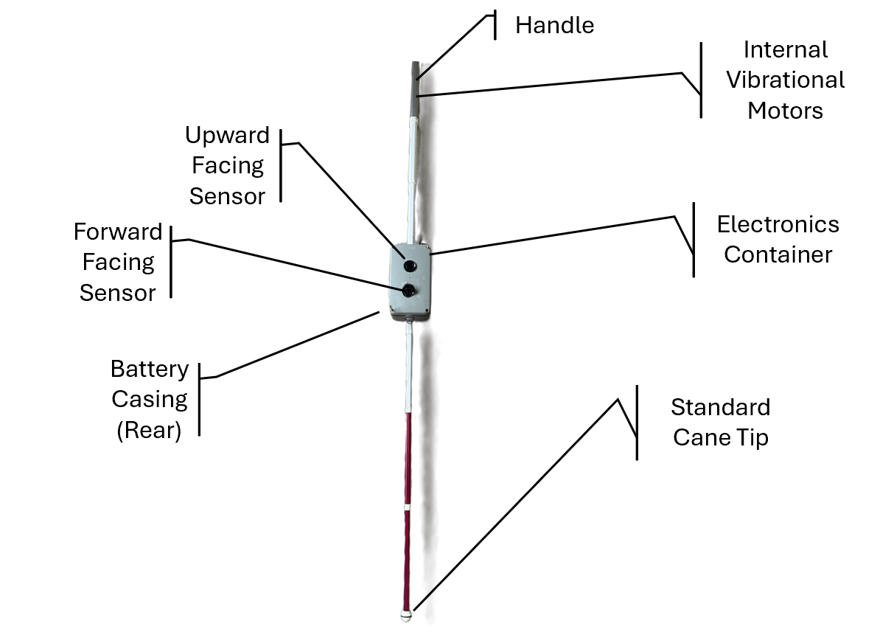
Figure 1: Final Prototype Design with Labels
The physical design and casing still require final improvement. The current prototype proves the function, but the motor and wiring need better fixing inside the handle or casing to avoid wires being pulled loose.

Coding Implementation and Logic
I followed a basic software development process by first deciding what the code needed to do, then building it in sections, testing it, and improving it where needed.
The main software requirement was that the cane needed to read two ultrasonic sensors, check if the values were valid, convert the readings into distance, and then change the vibration strength depending on how close an object was. The first stage was setting up the sensor pins, distance limits and motor driver, as shown in Appendix A, Figure 7. This was needed because the Arduino had to know which pins controlled each part before the rest of the code could work.
The code was split into labelled sections, so it was easier to understand and fault-find. The motor strength limits and distance variables were placed near the start of the code, so they could be changed easily during testing, as shown in Appendix A, Figure 8. This helped when adjusting the vibration strength so it was noticeable but not too harsh.
The distance reading function section sends the pulse, waits for the echo to return, and converts the time into centimetres. One concern was false readings, and the way I overcame that was the trigger pin is set LOW, then HIGH, then LOW again to send one clean pulse. If no echo comes back, the code returns -1, so the Arduino knows the reading is not usable. This process is shown in Appendix A, Figure 9.
The next problem was converting distance into motor strength. Instead of only turning the motor on or off, the code makes the vibration stronger as the object gets closer, as shown in Appendix A, Figure 10. This gives the user more useful feedback because they can feel the warning becoming more urgent.
The setup section prepares the sensors and checks that the DRV2605L motor driver is connected, as shown in Appendix A, Figure 11.
In the main loop, Sensor 1 is read first, followed by a short delay, and then Sensor 2 is read. The code then calculates a motor strength for each sensor and uses the strongest warning from either one, as shown in Appendix A, Figure 12. This is due to the fact that the prototype only uses one driver board, so using the strongest warning was more reliable than trying to create directional feedback without the correct extra hardware.

Testing and Evaluation
Testing was mainly carried out through bench testing and prototype checks. The electronics were first connected outside the cane so I could see the Arduino Nano, sensor boards, wiring and vibration motor while the code was running as seen below in Figure 2. This made early fault-finding easier because loose wires, wrong pins and sensor problems could be seen before the parts were fitted into the cane.
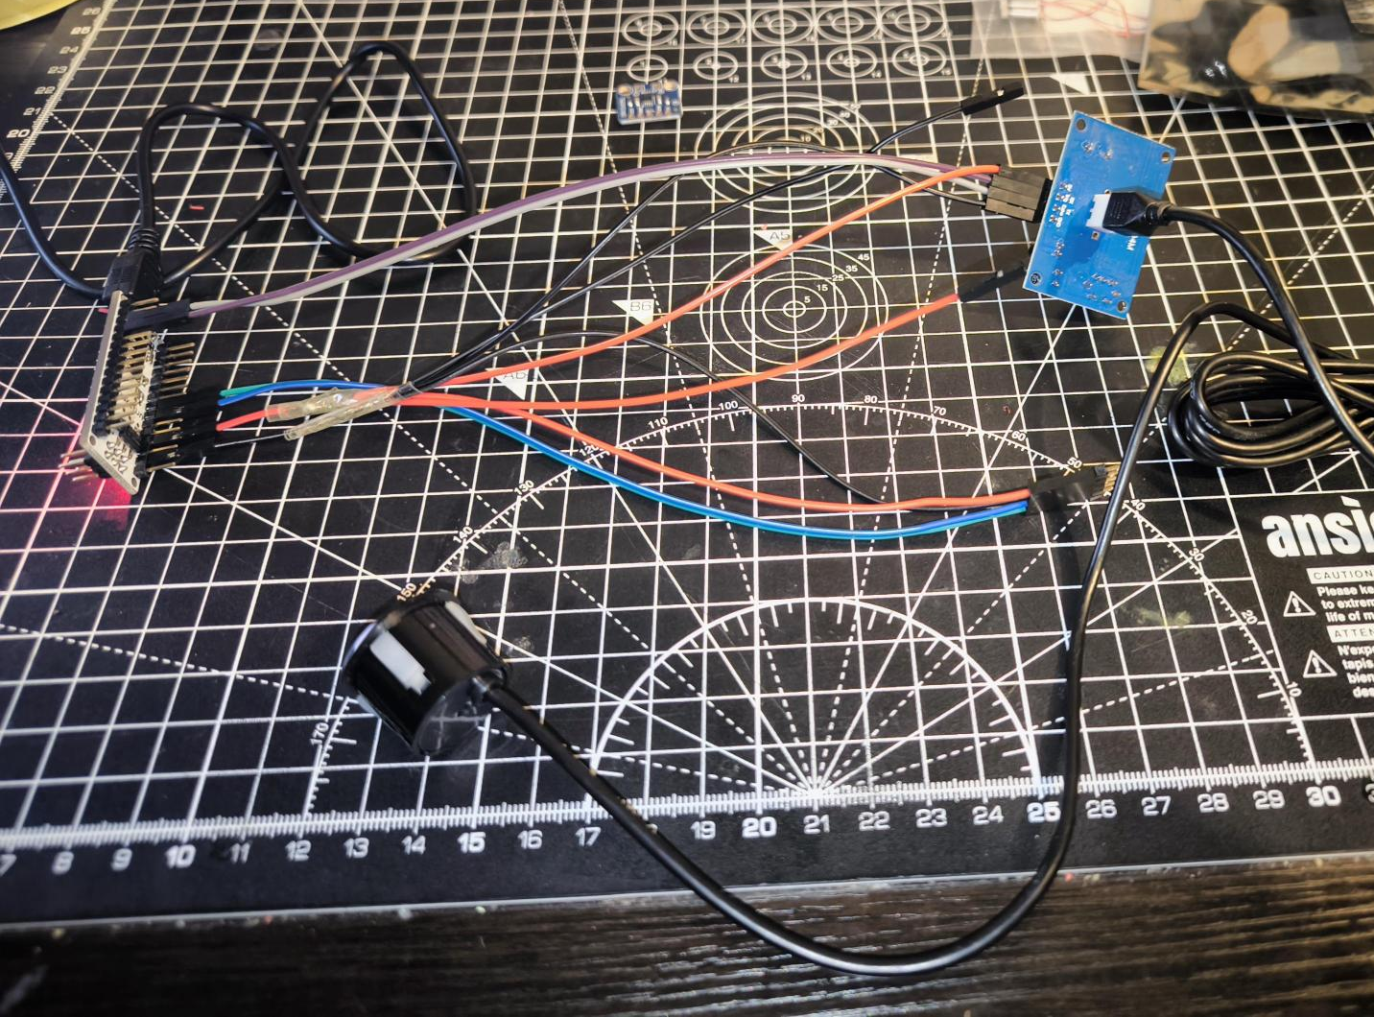
Figure 2: External Setup Testing
I used testing as both verification and validation. Where verification is checking that the system conforms to the specification, and validation checks whether it meets the user need (I Sommerville, 2004). For verification, I checked that both sensors returned centimetre readings, invalid readings were ignored, and the vibration changed when objects moved into the set range, which is shown in Figure 3.
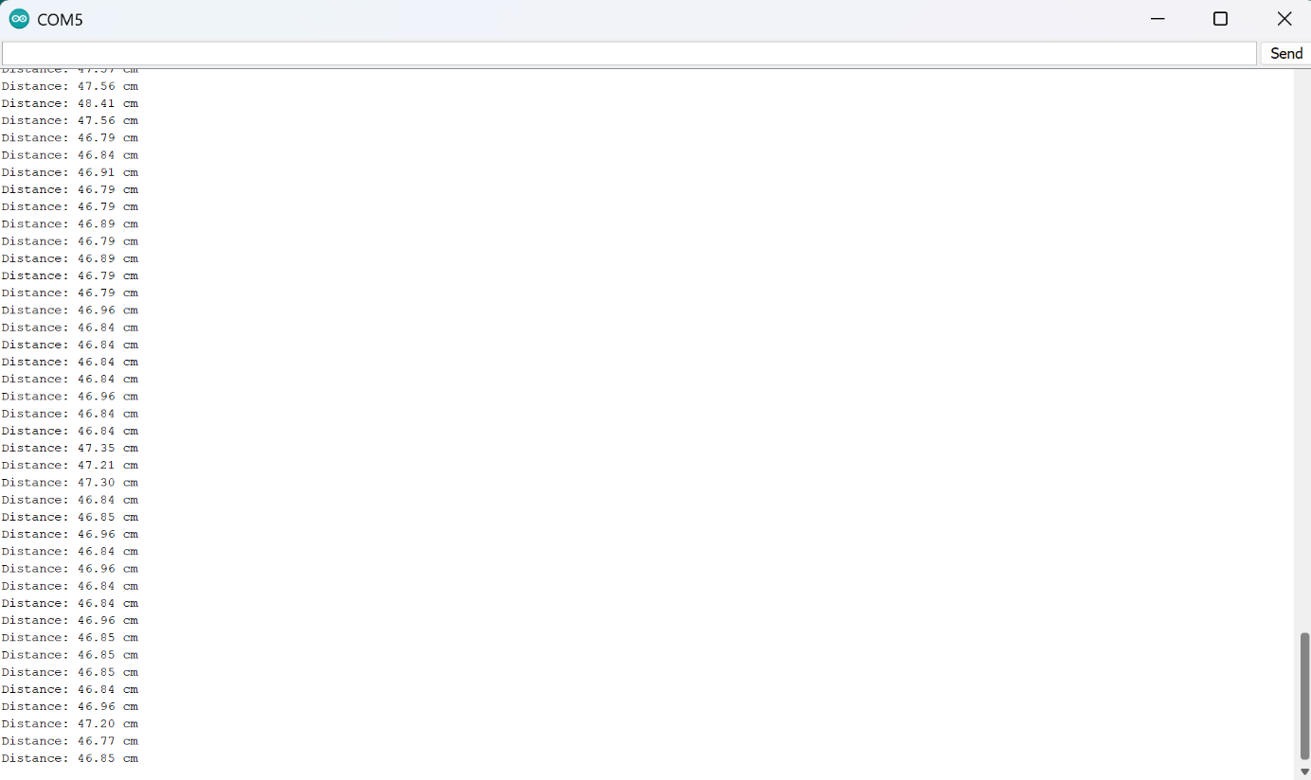
Figure 3: Validation of Working Sensors
Validation was more limited, but the working prototype still showed that the main aim had been achieved at prototype level. The cane could detect an obstacle and give a real-time haptic warning without relying on a phone screen or audio message. However, it still needs outdoor testing, battery-life recording and supervised user trials before it could be judged as fully validated.

Cost and Schedule
The project stayed below the original cost target. The final presentation recorded the actual BOM total as £87.27 against the £100 target shown in the interim report and Appendix B. This supported the low-cost aim of the project and showed that the design could be built with affordable Arduino-compatible parts.
The cost target also affected the coding. A more complex design could have used GPS, Bluetooth, extra sensors or separate motor drivers, but this would have increased wiring and programming complexity. I kept the software focused on the functions needed for the prototype: reading distance and controlling vibration.
The schedule was more difficult than the cost. The biggest pressure came near the final stage, when the electronics had to work together. The Gantt chart and meeting diaries shown below in Figures 4, 5, and 6 were pivotal in keeping the team on track to achieve the final goal of a working prototype in check.
Figure 4: Project Gantt Chart
Figure 5: In-Person Meeting Diary
Figure 6: Online Meeting Diary

Discussion
The main technical idea behind the cane is the sensors being read by the Arduino, and then that sending a signal to the DRV2605L driver board and that to the motors, in this aspect, the code and setup is simple, which is a key aspect as to why this product surpasses the competitors as they are too overly complicated and as mentioned previously, lead to large abandonment rates (Kim and Cho, 2013; Federici et al., 2016). Yet another boon to come from the simplicity is the ease of repair or replacement of parts should anything break, as the competition also likely uses expensive, custom-made parts, which is indicated by the much higher price point.
The lack of a fully implemented fully directional haptic feedback is a takeaway from the product. One driver board limited the final build because fully separate left and right motor control would need extra driver hardware or a different output design. However, this shortcoming can be rectified as the driver board can be bought from the remaining 11% of the budget, and as mentioned, the Arduino code is simple and easily configurable.
The project also showed the difference between verification and validation. I could verify the code using serial monitor values and distance tests, but full validation would need real user trials and realistic environments. This is important because a smart cane can work electronically but still be uncomfortable, confusing or unreliable in daily use.
This is also where the software process material helped. Without the SDLC structure, it would be easy to describe the project only as a finished object (Sommerville, 2011). By using planning, implementation, testing and future maintenance as talking points, I could show that the code was developed through decisions and trade-offs rather than just copied into the Arduino IDE at the end.

Recommendations and Future Improvements
The first improvement would be to secure the vibration motor and wiring properly inside the handle or casing and improve the soldering techniques. At the current prototype stage, when the motor vibrates too strongly for too long, the motor breaks the wire and soldering keeping it attached to the cable. The code works, but the physical packaging needs to protect the electronics better before proper user testing.
A way of reducing sudden unstable readings would be for the code to be improved by averaging several readings before setting the motor value. Another future improvement would be separate directional haptics, but this would need extra driver hardware and careful testing so the vibration patterns do not confuse the user.

Conclusion
By the end of the project timeline, a successful working prototype of the Electronic Blind Assist Cane was created, with my main contribution being the Arduino coding and electronics logic. Thanks to how low-cost, simple and intuitive to use our product is, it creates a perfect opportunity to successfully enter the market gap mentioned in the interim report. It still needs stronger casing, battery-life testing and supervised user trials, but the simple design makes it easy to improve with extra sensors, directional motors or low-battery alerts in future.

Reflective Journal
At the start of the project, I was responsible for choosing the system architecture for the smart cane. I did feel some pressure with this, because whatever was chosen would affect how the sensors, electronics and software could all work together later on. After looking at Raspberry Pi and Arduino, I decided Arduino suited the project better because it was cheaper, lower power and simpler for what we needed. Looking back, I think this was the right decision, as the final prototype worked using a fairly simple Arduino Nano setup. It showed me that early design choices can make the rest of the project easier or harder. It also made me more confident when explaining and defending technical choices to the group.
During the final stage, my role changed from planning the Arduino logic to actually writing, testing and fixing the code. At first, I found it quite overwhelming because I had to get two sensors, a motor driver and vibration feedback working together. Splitting the code into smaller sections helped a lot, especially with the distance reading, motor strength calculation and main loop. This links with UK-SPEC Competency B, as I had to use research and engineering knowledge to solve a practical problem, not just describe it (Engineering Council, 2021). Testing with the serial monitor also helped me understand how the code related to the real hardware.
Explaining the electronics and coding to the group was still sometimes difficult. I did not want to overcomplicate it, but I also needed them to understand why certain decisions were made. Using simple diagrams, examples and live testing made this easier and helped the group discussions. This improved my communication skills and links with UK-SPEC Competency D (Engineering Council, 2021). Overall, the project made me more confident with Arduino coding, testing and explaining technical decisions. In future projects, I would still use early planning, simple code sections and regular testing, as this made the final build much easier to manage.

References
- Federici, S., Meloni, F., Borsci, S., and Mealli, M. (2016) ‘Device abandonment in assistive technology: A self-report survey’. Available at: https://oro.open.ac.uk/87866/1/87866.pdf
- Kim, S.Y. and Cho, K. (2013) ‘Usability and design guidelines of smart canes for users with visual impairments’, International Journal of Design, 7(1), pp. 99–110. Available at: https://www.ijdesign.org/index.php/IJDesign/article/view/1209/559
- Mai, C., Xie, D., Zeng, L., Li, Z., Li, Z., Qiao, Z., Qu, Y., Liu, G. and Li, L. (2023). Laser Sensing and Vision Sensing Smart Blind Cane: A Review. Sensors, [online] 23(2), p.869. doi:https://doi.org/10.3390/s23020869.
- RNIB (Royal National Institute of Blind People) (2021) ‘Key information and statistics on sight loss in the UK’. Available at: https://www.rnib.org.uk/professionals/research-and-data/key-information-and-statistics-on-sight-loss-in-the-uk/
- Sahoo, N., Lin, H.-W. and Chang, Y.-H. (2019) ‘Design and implementation of a walking stick aid for visually challenged people’, Sensors, 19(1), article 130. DOI: 10.3390/s19010130
- Singh, S., Tomar, M. and Mahendra, V.S. (2020) Rapid Review of Assistive Technologies for Persons with Disability in India. New Delhi: Amaltas Consulting Private Limited for the South Asia Research Hub, Department for International Development. Available at: https://assets.publishing.service.gov.uk/media/5ed6321bd3bf7f4606f1e15b/DFID-AT_Report.pdf
- Sommerville, I., (2004). Software Engineering. [online] Boston: Pearson/Addison-Wesley. Available at: https://engineering.futureuniversity.com/BOOKS%20FOR%20IT/Software-Engineering-9th-Edition-by-Ian-Sommerville.pdf.
- WeWalk (2025). WeWalk V2 smart cane. [online] Rnib.org.uk. Available at: https://shop.rnib.org.uk/products/wewalk-v2-smart-cane-copy
- Engineering Council (2021). UK-SPEC. [online] Engc.org.uk. Available at: https://www.engc.org.uk/our-role-as-regulator/setting-standards/professional-engineering-competence-and-commitment.

Bibliography
- GitHub (2023) Smart Cane and Walking Stick Open-Source Projects. Available at: https://github.com/topics/smart-cane.
- Sudharshan, M., & Kaur, K. (2024). Rechargeable Smart Cane using Arduino Nano. In Proc. of ICICC 2024 (Innovative Computing & Communication) . Available at: papers.ssrn.com.
- Yin, S. (2019). Why is creating electronic canes for the blind so hard? [online] WHYY. Available at: https://whyy.org/segments/why-is-creating-electronic-canes-for-the-blind-so-hard/
- Yogeshwaran, P. (2025). Smart Blind Stick (Arduino Ultrasonic Stick) code repository. Available at: github.com.

Appendix

Appendix A – Arduino IDE Code
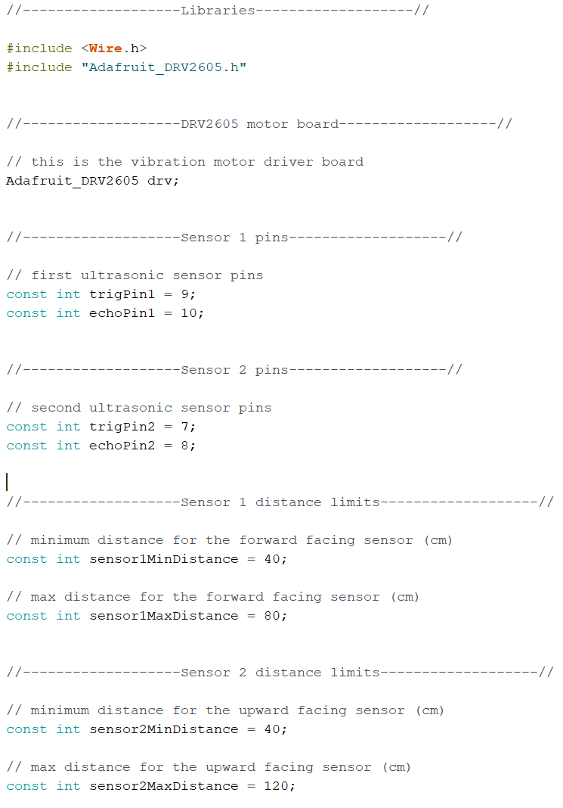
Figure 7: Code for Motor Driver Board, Sensor Pin Connections, and Sensor Limits
This part sets up the libraries, creates the vibration motor driver object, and gives each ultrasonic sensor its trigger and echo pins. It also sets the distance limits for each sensor. These values are fixed at the top of the code, so they are easy to find and change during testing.
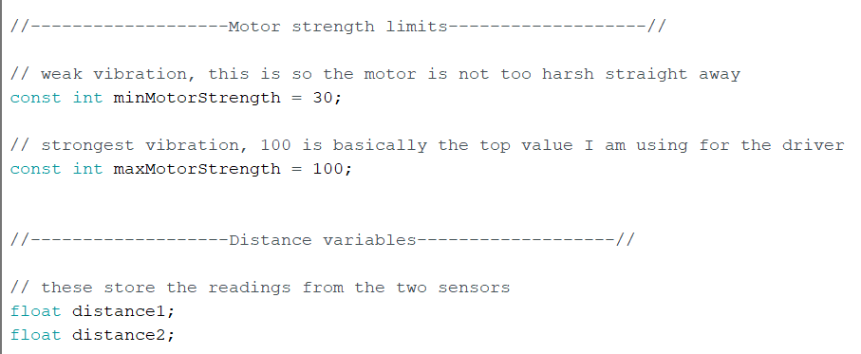
Figure 8: Code for Motor Strength Limits and Distance Variables
This part sets the weakest and strongest motor values used by the vibration driver. It also creates the two distance variables that store the live readings from Sensor 1 and Sensor 2. Using float variables allows the distance values to include decimals.

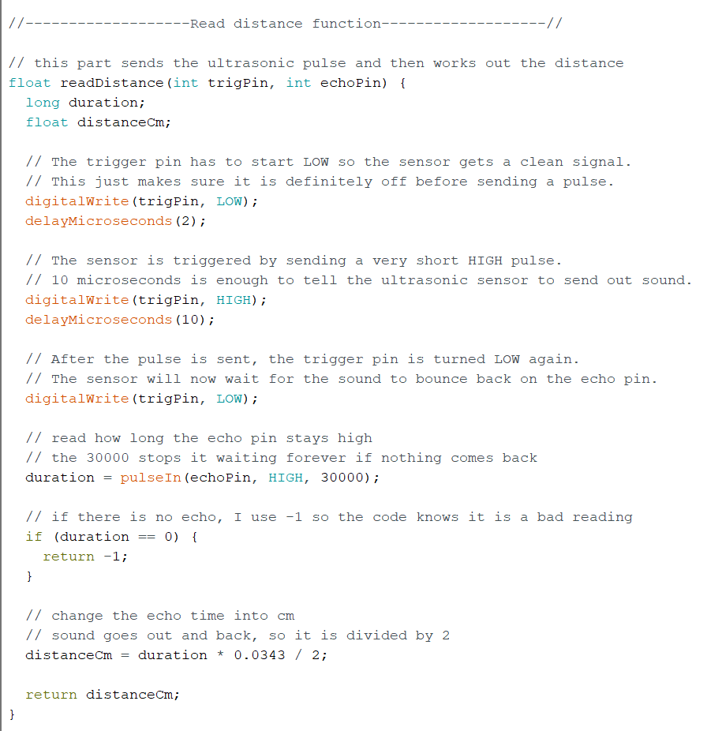
Figure 9: Code for Sensor Activation and Measurement Conversion
This function is what measures distance. The trigger pin is switched LOW-HIGH-LOW to send one clean ultrasonic pulse. The echo pin then measures how long the sound takes to come back. If no echo is found, the function returns -1. If the reading is valid, the time is converted into centimetres using the speed of sound and divided by two because the sound travels out and back.
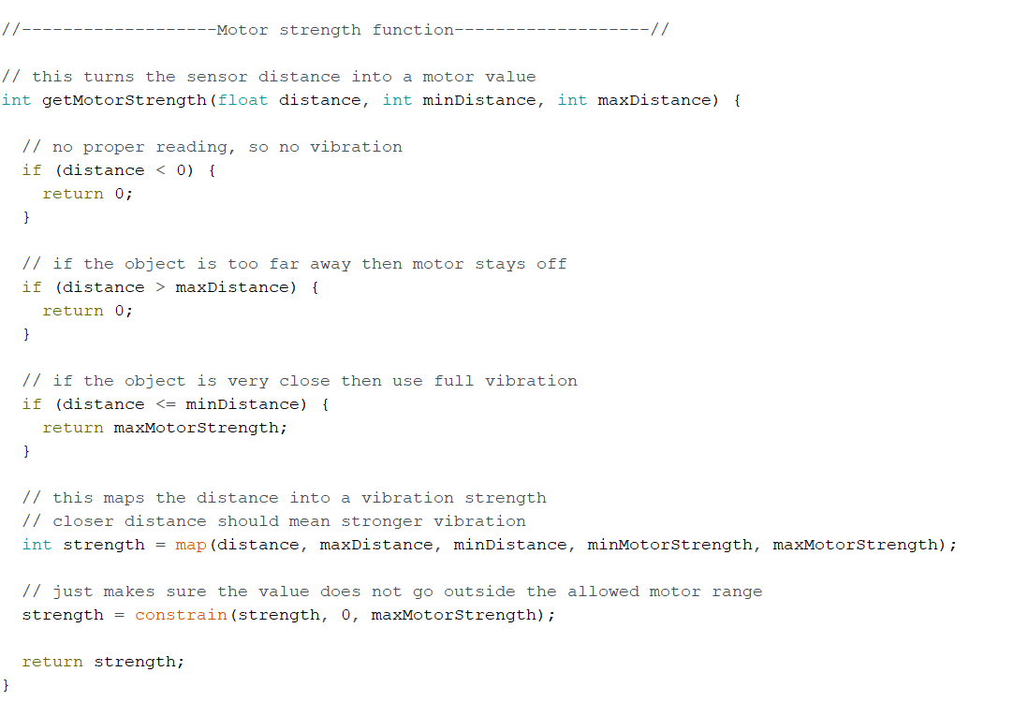
Figure 10: Code for Motor Strength to Distance Variation
This function turns the distance reading into a motor strength value. If the reading is invalid or too far away, the motor stays off. If the object is very close, the motor uses the strongest vibration. For distances between the limits, the motor strength gradually increases as the object gets closer

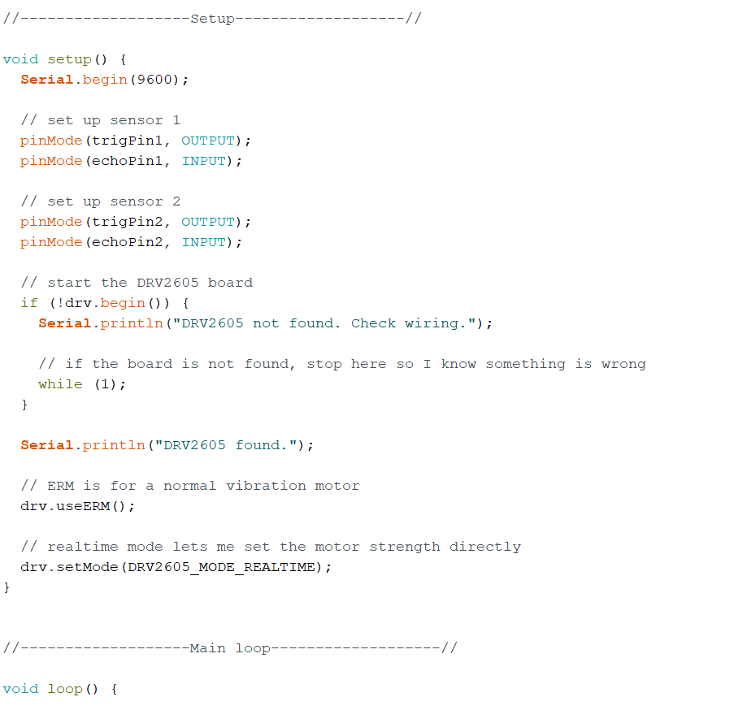
Figure 11: Code for Overall Setup and Looping Function
This setup section starts the serial monitor, sets the sensor pins as inputs or outputs, and checks that the DRV2605L motor driver board is connected. If the board is not found, the code stops so the wiring problem can be fixed before testing continues.
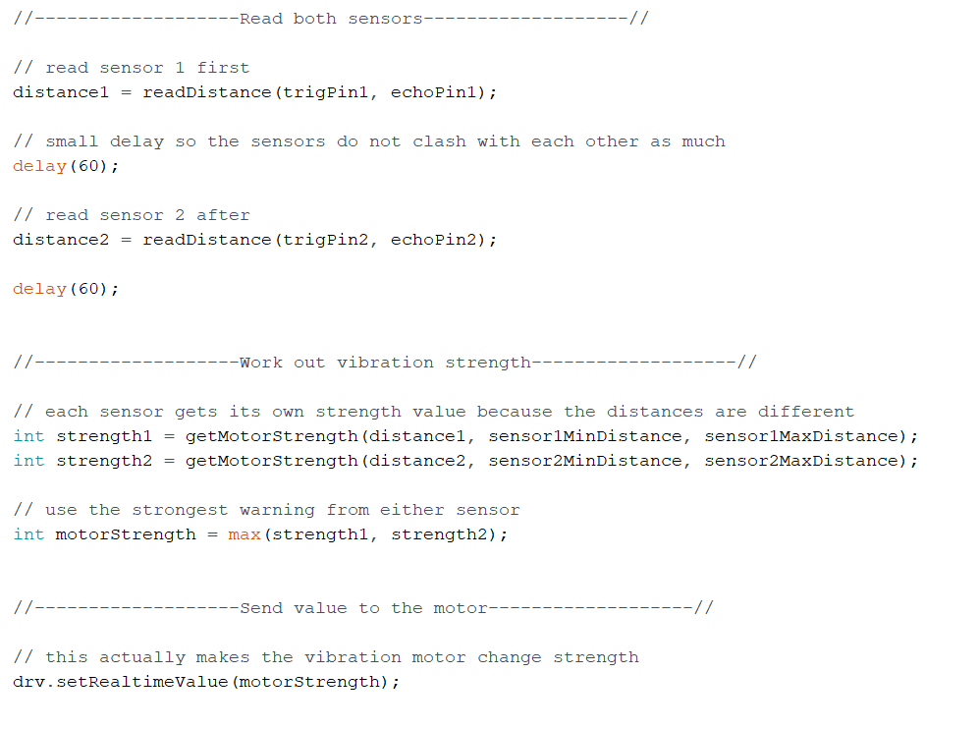
Figure 12: Code for Reading Distance Values and Conversion to Motor Strength
This is the main loop of the code. It reads Sensor 1 first, waits briefly, then reads Sensor 2. The short delay helps stop the sensors interfering with each other. The code then calculates the strength for each sensor and uses the strongest warning to control the vibration motor.

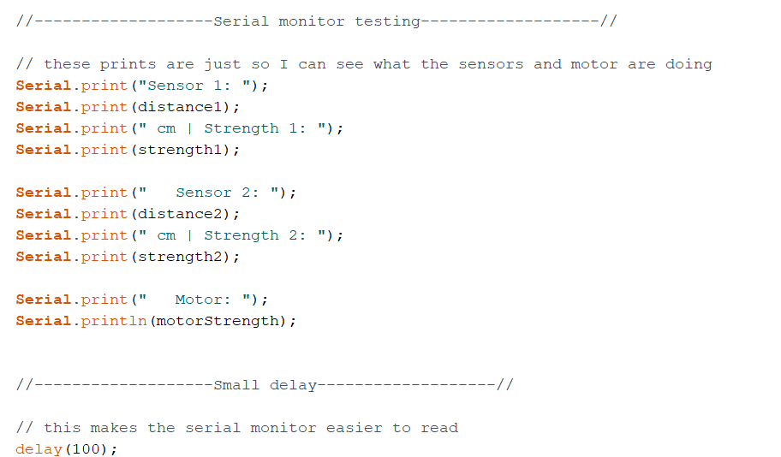
Figure 13: Code for Testing on Serial Monitor
This section prints the sensor distances and motor strength to the serial monitor. I used it to check that the readings and motor output changed when an object moved closer or further away.

Appendix B

Bill of Materials
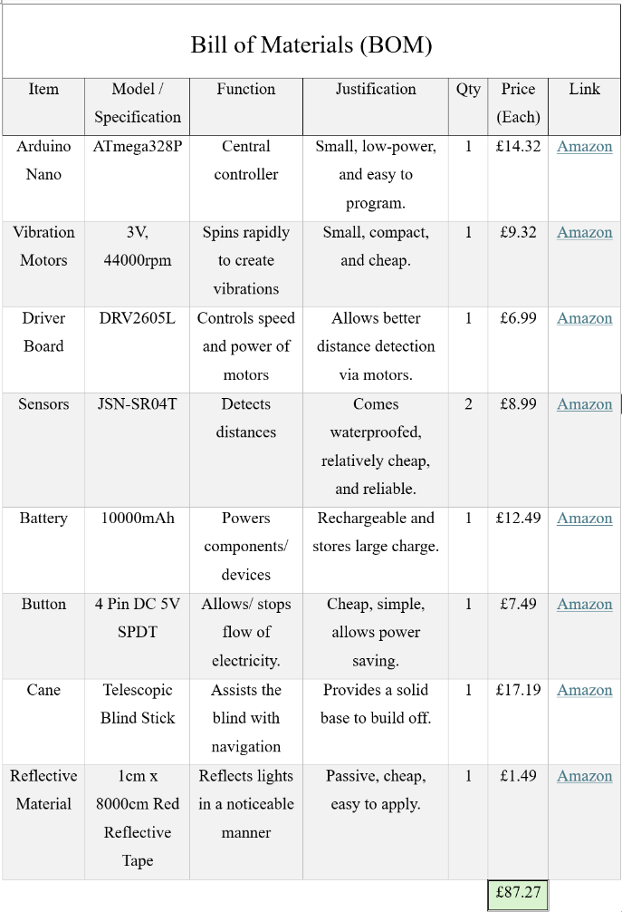
Figure 3: Bill of Materials (BOM)
Appendix A gives the full Bill of Materials (BOM) for the smart cane prototype. It shows every component used, including the Arduino microcontroller, ultrasonic sensor, vibration motors, and rechargeable battery, along with their prices, sources, justification, and intended function in the system. By selecting lightweight and low-power components, the cane remains comfortable to use for long periods while still supporting long battery life. The waterproof ultrasonic sensor allows the system to operate reliably outdoors, even in rain or near puddles. All components are fully compatible with Arduino, which reduces build complexity and helps speed up software development. Keeping the overall cost under £100 is a key design requirement, so the BOM plays an essential role in confirming that the product remains affordable for visually impaired users.

