To place an order please call us on: 01912345678
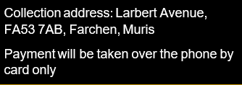
Hotel Trinity

Fish & Meat Course

GRILLED SEAFOOD 290g
Bass fillet, Prawns, Mussels and octopus in a garlic caper and chilli butter 12

PAN SEARED BRANZINI FILLET 240g
Seabass fillet with sliced potatoes, minted pea puree and fresh Pico de Gallo 10

ATLANTIC SALMON FILLET 260g
Fire roasted eggplant and rainbow of vegetables 11

GRILLED TURKEY BREAST 320g
With grilled vegetables and wild rice 9

MAGRET OF DUCK 300g
Seared Duck Breast with sweet parsnip mash, Broccoli, wild berry and red wine sauce 10

ROAST PORK TENDERLOIN 300 g
Baked potato and Pepper mushroom sauce 9

AGED BEEF RIBEYE STEAK 320g
With sautéed mushrooms, french fries and pepper sauce 10

Cold and Hot Starters

ALASKAN SMOKED SALMON 220 g
With cucumber and pepper slaw with honey mustard dressing 10

ANTIPASTO PLATTER 120 g
Coppa, zuchinni, eggplant, olives, bruschetta, salami, artichoke hearts, mozzarella fresca 7

MARINATED FRESH TOFU 220 g
With crunchy Iceberg, Red quinoa, Avocado and a mild ginger dressing 7

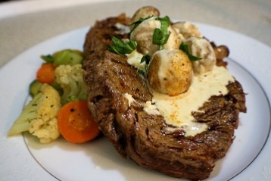

Accompaniments

BASMATI RICE & DRIED FRUITS AND SAFFRON 200g 6

GRILLED OR STEAMED ASPARAGUS 200 g 5

GRILLED SUMMER VEGETABLES 200 g 4

FARMERS SALAD WITH CUCUMBER, TOMATOES, BELL PEPPER AND RED RADISH 200g 5
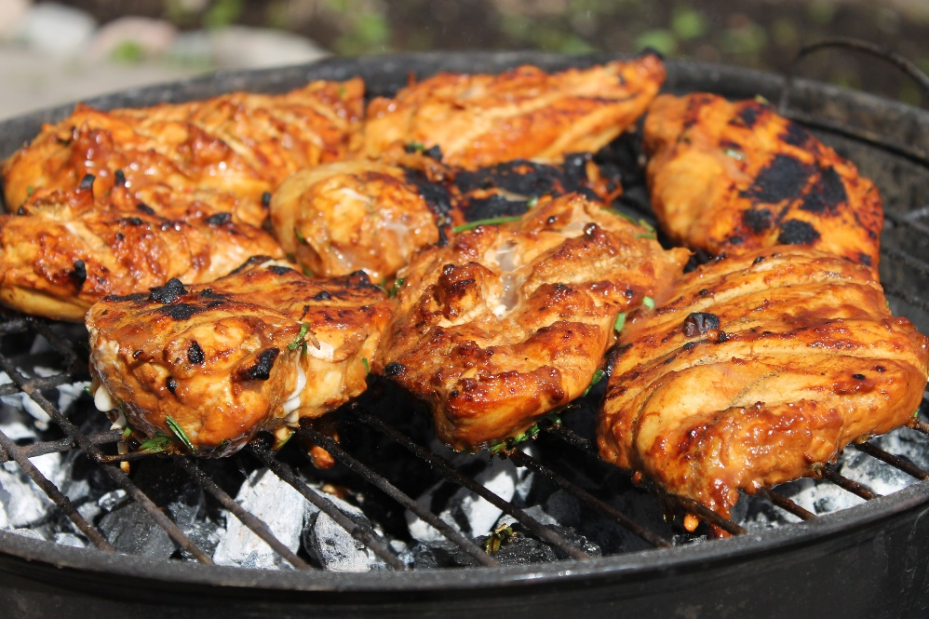

If you suffer from any allergic reactions or intolerances, please contact our staff before placing an order
To place an order or to speak to our staff please call : 01912345678


Desserts
DARK BELGIAN CHOCOLATE TRUFFLE 150g 7
Our chocolate truffle recipe with 72% dark chocolate

MACARON ICE CREAM SANDWICH 150g 8
With a trio of coloured macaron and chocolate sauce

MELTING CHOCOLATE CAKE 150 g 7
Warm centered chocolate cake with a scoop of ice cream

Hotel Trinity



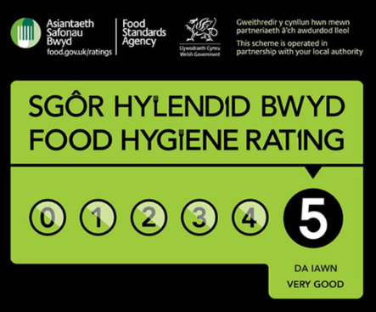
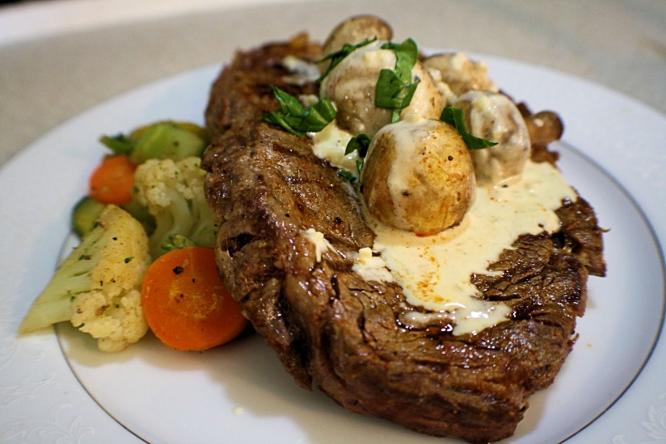

Opening Times:
Monday – 11:00 to 21:00
Tuesday– 11:00 to 21:00
Wednesday– 11:00 to 21:00
Thursday– 11:00 to 21:00
Friday– 11:00 to 21:00
Saturday - Closed
Sunday- Closed

Ewch i food.gov.uk/ratings i ganfod sgôr hylendid bwyd ein busnes neu gofynnwch inni beth yw ein sgôr hylendid bwyd wrth archebu /
Go to food.gov.uk/ratings to find out the food hygiene rating of our business or ask us for our food hygiene rating when you order.

Drinks
Coffee/4
Still/sparkling water/4
Lemonade/5


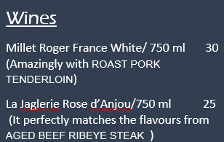

Reference List:
Allergies and intolerances information, available at https://www.knowsleynews.co.uk/allergies-and-intolerances-information-for-businesses/ , Accessed on 18/02/2022


