Legal and contract responsibilities in the Built Environment
ACBA4004
Keaton Davies
2320042



Table of Contents
Introduction 3
What are the essential elements that make a contract valid? 3
How can contracts be misinterpreted? 3
Scenario 1: Ambiguity in Payment Terms 4
Scenario 2: Ambiguity in Project Completion Date 5
Disputes and Delays: 5
Work Stoppage: 5
Financial Implications: 6
Legal Consequences: 6
The impact on a project in relation to any deficiencies 6
Conclusion 7
References 8

Introduction
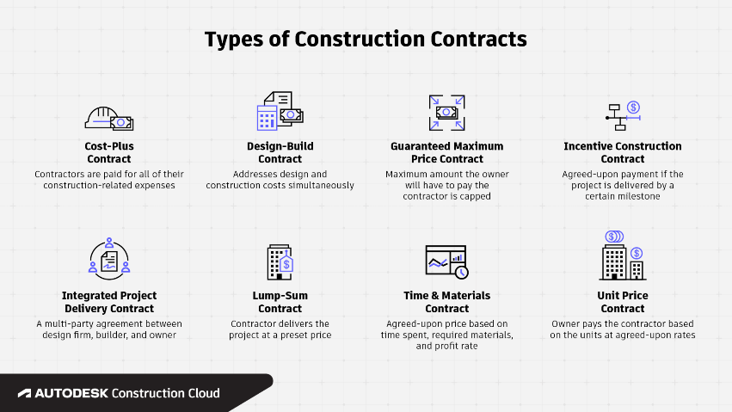
In this assignment, I will be going over what essential elements make a contract valid with regard to the construction industry. I will then look at a scenario where the contract has been misinterpreted. In the construction industry, a clear agreement—that is, an offer made by one party and accepted by the other—makes a contract enforceable. Subsequently, there is a consideration, which refers to the gifts or services that one person provides to the other. Since both parties must be of legal age and sound mind in order to engage in a contract, capacity is also essential. The goal of the contract must be lawful, hence nothing unlawful may be included in the contract. Finally, for a contract to be enforceable, both parties must intend for it to be so.

What are the essential elements that make a contract valid?
In construction, a legitimate contract must have a number of essential components. Firstly, an agreement in which one party represents an offer and the other accepts it is necessary. For instance, offering to build a structure for a specific sum and being accepted to pay that sum. Secondly, each side is contributing consideration, which is essential. In the construction industry, it usually refers to the building service and the associated cost. Thirdly, both parties need to be of legal age and mental ability in order to engage in the contract. Fourthly, a contract for a structure that doesn't adhere to local codes isn't lawful since the contract's goal needs to be legitimate. Furthermore, for a contract to be enforceable, it must be the intention of both parties. Adding to that, all of the contract's terms—including those pertaining to the task, supplies, schedule, and payment terms—must be unambiguous and explicit. Finally, there should be no compulsion or false representations made by any party when they enter into the contract.

How can contracts be misinterpreted?
A construction contract may be misinterpreted for several reasons. The use of vague or confusing language is one frequent reason. Parties may interpret the terms and conditions differently if they aren't stated clearly, which might cause misunderstandings and arguments. Furthermore, if complicated technical language is not sufficiently explained, it might be misunderstood. For instance, not all parties engaged may be aware of certain building techniques or material standards. A typical concern is an assumed lack of understanding. It is possible for parties to believe they understand the provisions of the contract in the same way, but in reality, their interpretations may differ. This may be challenging when it comes to things like project schedules, scope of work, and payment arrangements.

Additionally, the contract may be missing certain crucial information, which might lead to varying interpretations. For instance, if the contract is vague about the kind of materials to be used or the precise nature of the job to be done, parties may have erroneous expectations that might result in miscommunication. Misunderstandings can also result from differences in languages and cultures, particularly in multinational building projects. Confusion may result from disparate interpretations of specific phrases or customs among the involved parties.

Scenario 1: Ambiguity in Payment Terms

Suppose the following conditions of payment are stated in a building contract:

"The contractor shall be paid monthly for work completed. Payments will be made based on the progress of the project."

The definition of "progress of the project" in this instance may be unclear. While the contractor may understand it as the end of particular building phases, the owner may see it as the achievement of particular milestones. Conflicts may also occur when the contractor expects payment after completing particular stages, which may differ from the owner's milestones, and the owner expects payment after the achievement of important project milestones. A precise definition of "progress of the project" should be included in the contract to avoid misunderstandings in this kind of situation. It could outline deadlines, phase completion, or other quantifiable standards. To guarantee that all stakeholders are in agreement, it might also specify how these milestones will be verified and certified as completed.

A construction contract's wording must be exact and clear in order to prevent misunderstandings and disagreements. It is essential that all parties involved thoroughly go over and discuss the conditions in order to guarantee that everyone is aware of their responsibilities and expectations. Before signing the contract, get clarification or legal counsel if necessary to assist avoid any ambiguities later on.

If the uncertainty around the project completion date is not resolved immediately, it may give rise to disagreements and delay the progress of building activities on the site.

Scenario 2: Ambiguity in Project Completion Date
"The contractor agrees to complete the construction of a commercial building by September 1st."
The lack of clarity on whether "complete the construction" means completing all structural work, receiving a certificate of occupancy, or reaching final project acceptance now gives rise to uncertainty. While the contractor might think of it as finishing all structural work by September 1st, the owner may take it as receiving a certificate of occupancy by that date. Conflicts emerge because the contractor thinks they have more time to perform the non-structural finishing touches, but the owner wants to use the building by September 1st.
The contract should state clearly what is meant by "completion of construction" in order to prevent misinterpretations, getting a certificate of occupancy, permission for the final inspection, or any other quantifiable need might be included. Additionally, clauses about possible delays should be included in the contract, precisely defining the conditions that would allow for extensions of the completion date as well as how any extensions should be announced and recorded. The contract can help both parties prevent misunderstandings and potential disagreements over project schedules by using clear definitions and specific wording. Ensuring that all parties are in agreement with project milestones and deadlines may also be achieved by regular updates and communication during the construction phase.

Disputes and Delays:

There might be arguments between the owner and the contractor as a result of the uncertainty around the project completion date. It's possible that the parties vary in their expectations and perceptions of when the project should be finished. This may give rise to disagreements that, if not settled, can slow down the building process.

Work Stoppage:
The likelihood of work stoppage in construction projects can be greatly impacted by uncertainty in the project completion date. Construction contracts depend heavily on the completion date, and any ambiguity in this area can result in a number of problems, including disagreements, unfavourable financial outcomes, and delays. The disagreement might result in a work stoppage if it gets out of hand and cannot be resolved. Until the completion date and related milestones are clear, the contractor may stop working. This can be expensive and cause more delays.

Financial Implications:
Both sides may have financial consequences from work stoppages. Contractors may be entitled to reimbursement for the delay in addition to the expenses of demobilisation and remobilization. On the other side, if the project is delayed and the owners are unable to utilise or lease the finished area as scheduled, they may suffer financial losses.

Legal Consequences:
Legal action may be taken in severe situations if the parties are unable to come to an agreement and the lack of clarity is not addressed. This can cause the project to be further delayed and increase expenses for both parties.
It's critical to resolve any confusion during the contract negotiation process in order to avoid work stoppages and disagreements over the project completion date. Misinterpretations may be reduced by clearly establishing project completion criteria, identifying milestones, and detailing methods for resolving delays. In order to resolve disagreements without stopping construction, it is crucial that the parties speak clearly and, if needed, seek legal or professional help.

The impact on a project in relation to any deficiencies

Deficiencies on a building site have a significant effect on the project, affecting several important aspects of how it is carried out. The interruption of project timetables is one major effect. Defects must be fixed, which means that time and resources must be diverted to look into and fix problems. This can cause delays, which can affect later stages of development. This temporary delay results in higher expenses as more work, supplies, and machinery are needed to address and fix the flaws.
Defects on the building site immediately risk quality assurance and control. Poor craftsmanship, the use of poor materials, or poor installations not only harm the project's structural integrity and longevity in the long run, but they also put the project's construction phase at danger. The effect on quality is not simply a current issue; it may also result in higher maintenance needs and expenses down the road.
Discrepancies on the site have contractual consequences in addition to the immediate construction issues. The project requirements are closely compared to the reported deficiencies and any differences might result in disagreements between the project owners, subcontractors, and contractors. To properly handle these contractual obstacles, cooperation and clear communication are essential.
Deficits on the building site have raised serious worries about safety. Poor safety procedures or structural problems put the health and safety of employees and end users at risk. This puts the project in danger right now, but it also raises the possibility of legal problems down the road and problems with regulatory compliance.
Another victim of low-quality construction is client satisfaction. If problems remain unfixed or are not quickly fixed, clients might not be happy with the outcome. In addition to having negative impact on the ongoing project, the dissatisfaction may damage the reputation of the construction business and make it more difficult for it to get future contracts.

Conclusion

In conclusion, having clear construction contracts is not just a formality. It is an essential requirement for the success of the project. It provides a clear framework for expectations, controls risks, guarantees financial transparency, encourages regulatory compliance, eases communication, and functions as a trustworthy legal instrument. Making the time and effort to draft thorough and unambiguous contracts will pay you in the form of increased project efficiency, stakeholder satisfaction, and the endeavour's overall success in building. It is impossible to exaggerate the significance of contract clarity when it comes to building projects. The basis for a successful project's execution is a clear, transparent contract that offers a path forward that all parties involved are able to adhere to. For a number of factors that eventually contribute to the project's successful completion and smooth development, clarity in construction contracts is essential.

References
Picture 1
Google.com. (2023). Redirect Notice. [online] Available at: https://www.google.com/url?sa=i&url=https%3A%2F%2Fconstructionblog.autodesk.com%2Fconstruction-contracts-types%2F&psig=AOvVaw2dpzvldALOFz9OiGWNuHwJ&ust=1702412845302000&source=images&cd=vfe&opi=89978449&ved=0CBIQjRxqFwoTCND09pmciIMDFQAAAAAdAAAAABAI [Accessed 08 Dec. 2023].

Martin, K. (2023). 7 Essential Elements of A Contract | Akorda - The future of legal contracting. [online] www.akorda.com. Available at: https://www.akorda.com/blog/elements-of-a-contract#:~:text=For%20a%20contract%20to%20be. [Accessed 11 Dec. 2023].
‌
Zaremba, Y. (2022). 7 Essential Contract Elements to Double Your Document’s Credibility. [online] Blog. Available at: https://www.pandadoc.com/blog/contract-elements/. [Accessed 11 Dec. 2023].

gtpac.org. (2016). 5 of the most commonly misinterpreted terms in construction contracts | Georgia Tech Procurement Assistance Center. [online] Available at: https://gtpac.org/2016/10/18/5-of-the-most-commonly-misinterpreted-terms-in-construction-contracts/ [Accessed 12 Dec. 2023].

Harper James. (n.d.). Misrepresentation in Contract Law | Commercial Contract Disputes. [online] Available at: https://harperjames.co.uk/article/contracts-misrepresentation/. [Accessed 12 Dec. 2023].
‌
Construction Lawyer & Building Solicitors Sydney | Contracts Specialist Law Firm. (2023). How to Address Ambiguity in Building Contracts: Tips for Homeowners. [online] Available at: https://www.contractsspecialist.com.au/articles/how-to-address-ambiguity-in-building-contracts/#:~:text=Misunderstandings%20and%20disputes%20between%20parties. [Accessed 12 Dec. 2023].
‌Ullman, J. (2023). Contract Ambiguity: I Know What It Says, but What Does It Mean? [online] Berman Fink Van Horn P.C. Available at: https://www.bfvlaw.com/contract-ambiguity-i-know-what-it-says-but-what-does-it-mean/. [Accessed 12 Dec. 2023].
‌ www.icaew.com. (n.d.). Case law: Court clarifies how it will interpret ambiguous contract clauses. [online] Available at: https://www.icaew.com/library/subject-gateways/law/legal-alert/2017-05/case-law-court-clarifies-how-it-will-interpret-ambiguous-contract-clauses. [Accessed 12 Dec. 2023].

Benarroche, A. (2019). Defects in Construction: The 3 Main Types and How to Avoid Them. [online] Levelset. Available at: https://www.levelset.com/blog/construction-defects/. [Accessed 12 Dec. 2023].
‌

‌

‌

‌

