Housekeeping Department



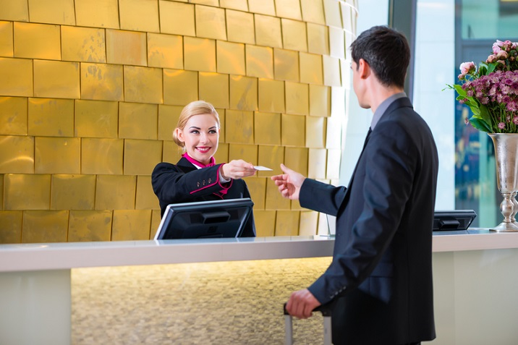
(By Bing,2025)

Student Name: Georgiana Camelia Otesanu
Student ID: 2239363
Module: BMIH6003 – Managing Guest Service Operations
Lecturer name: Daniel Payne

Contents

Introduction 3
Description. 4
Feelings 4
Evaluation 5
Analysis 6
Conclusion 7
Reference List 9

Introduction
During my placement in the Housekeeping department at Ashford International Hotel & Spa, I observed how communication, teamwork and cultural diversity influence daily guest service operations. The team includes staff from different backgrounds, with varying levels of English, which shaped how tasks were coordinated. My direct supervisor was Ioana, and collaborating closely with her allowed me to understand the expectations and challenges within the department.
This reflection focuses on two real incidents that highlight teamwork and communication issues: a room affected by a water leak, which resulted in a wet ceiling, and a recurring mould problem that I had also encountered during my Level 4 placement. Both incidents required a coordinated response and revealed areas where team communication could be improved.
In analysing these experiences, I draw on theories from the Level 5 module Personnel Resourcing and Development, including multicultural teamwork, communication barriers, psychological safety, and team development. I also compare my current approach to similar situations experienced during Level 4, where I felt less confident and less aware of organisational behaviour.

(by Bing, 2025)

Description.
The first incident occurred when a guest reported water leaking from the ceiling. Ioana instructed the team to clear the room, remove linen, and prepare it for maintenance. However, because several attendants were more comfortable communicating in their own language, some instructions were misunderstood. Tasks were duplicated, certain steps were delayed, and the room took longer to prepare for maintenance.
The second incident involved a recurring mould issue in several rooms. This was familiar to me, as the same problem had appeared during my Level 4 placement. Ioana emphasised that the rooms needed immediate attention due to guest impact, but again some staff members were unsure about the urgency or the specific steps required until instructions were clarified. These incidents showed how multilingual environments sometimes lead to delays and reduced efficiency.

Feelings
At first, I felt uncertain and slightly overwhelmed, especially during the water leak incident. I wanted to help the team, but I was worried about misunderstanding tasks or adding to the confusion. These feelings reminded me of my Level 4 experience, when I lacked confidence and often avoided asking questions.
However, this year I noticed significant personal growth. I felt more comfortable approaching Ioana for clarification, assisting in explaining tasks and supporting the team where needed. Although I still felt frustrated when communication issues affected our response time, I also felt more capable and more aware of how teamwork operates in practice. This reflection helped me recognise how my confidence has developed since my earlier placement.
(by Bing,2025)

Evaluation

There were both positive and challenging aspects to the incidents. Ioana provided calm and structured instructions, showing effective supervisory behaviour. Some team members were proactive in helping each other understand the tasks. However, communication gaps caused delays, repeated tasks, and uncertainty.
The strengths included teamwork willingness and the supervisor’s clear directions. The weaknesses centred on inconsistent understanding of instructions and the absence of a shared working language, especially during urgent tasks. Compared to Level 4, my own progress was clear. Previously, I would have remained quiet in confusing situations. This year, I became more proactive and supportive, contributing positively to the team response.
In Level 4 I tended to rely on others to guide me, whereas in this placement I actively supported colleagues and clarified instructions. This shift from passivity to initiative marks a significant step in my development.

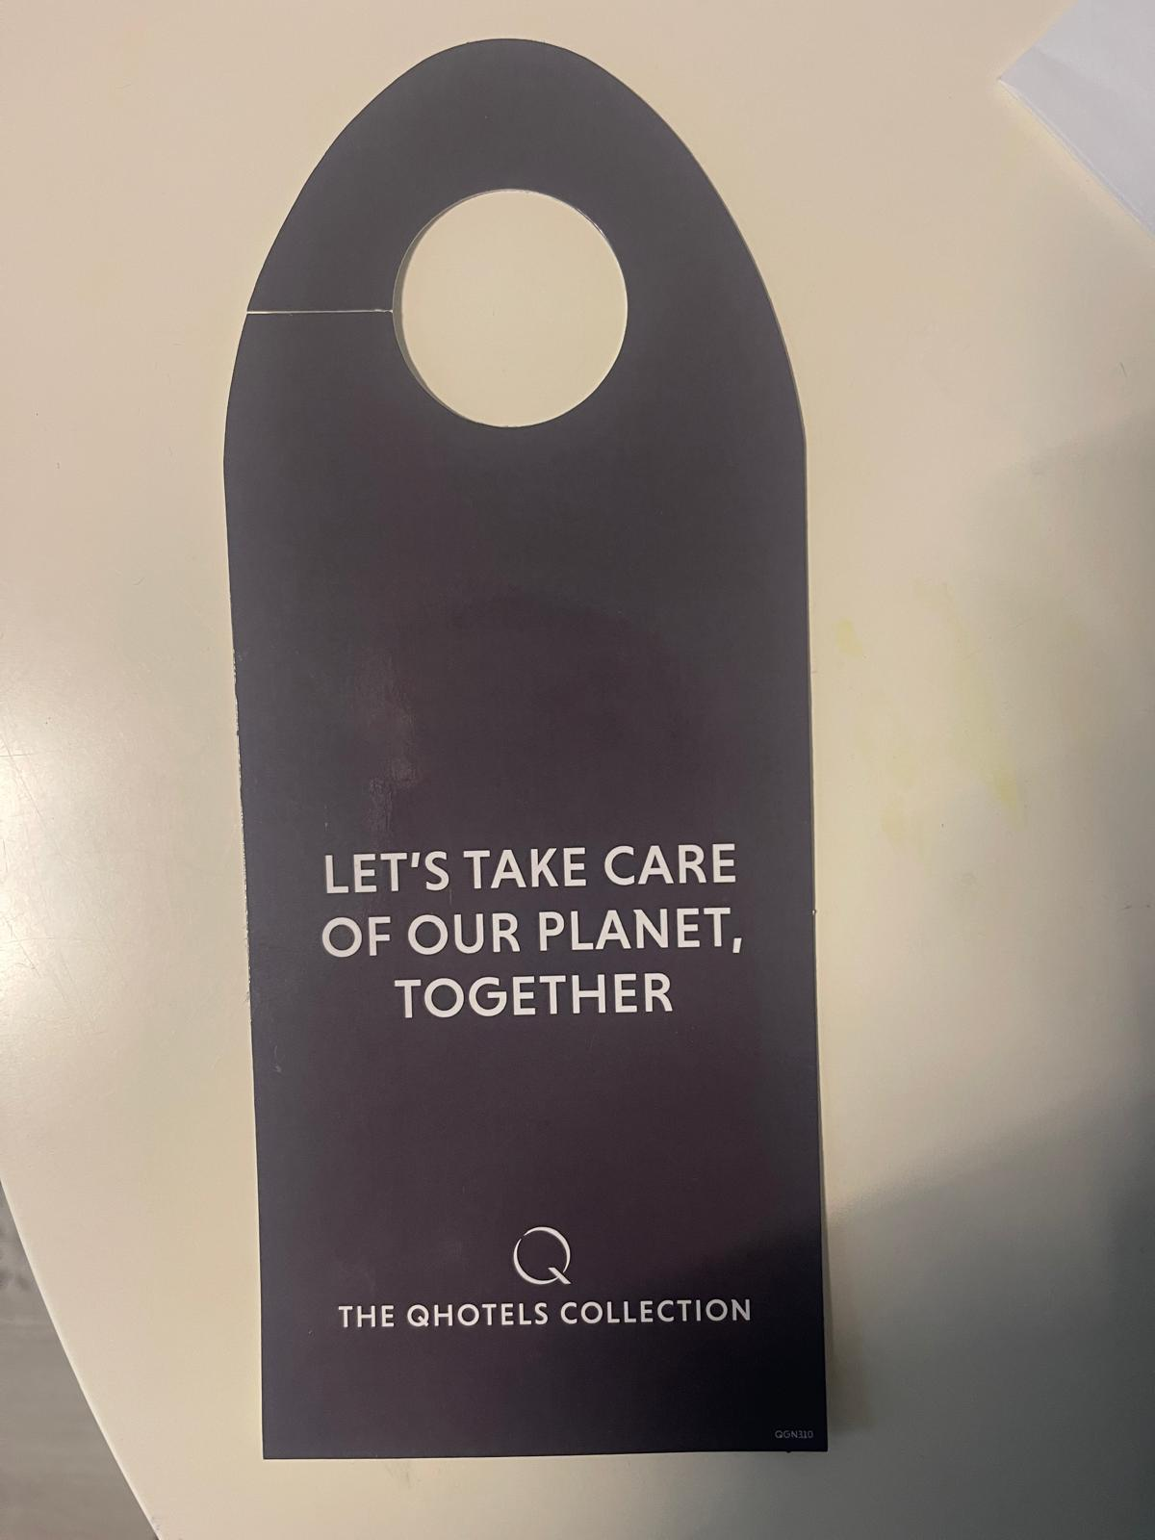
(Source: Autor,2025)

Analysis
The incidents can be understood through theories discussed in Personnel Resourcing and Development. One of the main factors was the multilingual nature of the team. While English is the hotel’s working language, not all staff members have the same level of confidence using it, especially under pressure. According to Lauring (2011), language differences can affect clarity, coordination, and team cohesion. This explains why, during the water leak incident, not all instructions were understood consistently, leading to duplicated tasks and slower response times.

Tuckman’s (1965) model of team development also offers insight. The team seemed to function between the forming and storming stages, where uncertainty and communication breakdowns are common. The transition towards norming, where roles and communication patterns become clearer, appeared incomplete. The confusion observed during both incidents reflects this lack of fully developed coordination routines.

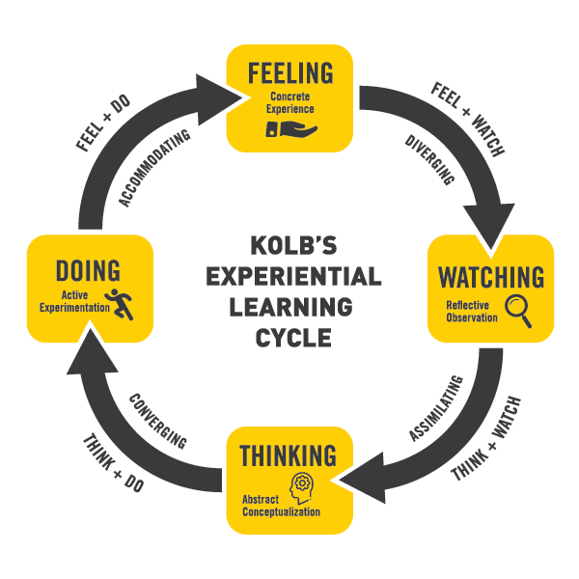(by Bing,2025)
.
Psychological safety (Edmondson, 1999) further influenced team interactions. Some staff members appeared hesitant to ask questions or seek clarification, possibly because they lacked confidence in English or were unsure about how their questions would be perceived. This hesitation limited open dialogue and contributed to slower responses. I recognised this behaviour because, during Level 4, I often felt similarly unsure. This year, however, I found myself more confident in asking questions and supporting communication within the team.
For instance, one attendant repeated a task that had already been completed instead of asking for clarification, which indicated uncertainty and limited psychological safety within the team.
PRD theory also emphasises that effective resourcing involves not only allocating staff but ensuring that employees have the communication tools needed to perform well. The incidents showed that although staffing levels were adequate, the absence of a consistent communication strategy reduced efficiency.

The recurring mould issue demonstrated again how important clear communication is in housekeeping. When instructions were not fully understood, staff underestimated the urgency, delaying the cleaning process and potentially affecting guest satisfaction. PRD theory highlights that strong teamwork requires shared understanding, consistent communication, and a sense of common purpose (Armstrong, 2020).

These incidents showed that while the team works hard and has strong intentions, structured communication methods—such as English-only briefings or standardised verbal instructions—would help the department operate more effectively in a multilingual environment.

Conclusion

Reflecting on these experiences has helped me understand how communication, cultural diversity and teamwork shape the daily operations of housekeeping. Compared to Level 4, I have developed greater confidence, stronger communication skills, and a better understanding of team behaviour. While Ioana demonstrated strong leadership during both incidents, communication challenges remain a key issue for the department.
This reflection emphasised that effective teamwork relies on psychological safety, consistent communication, and clear expectations. These insights will guide my development in future hospitality roles, particularly in multicultural settings where teamwork depends on clarity, confidence, and collaboration.
These insights will support my future development and prepare me for supervisory responsibilities in hospitality.

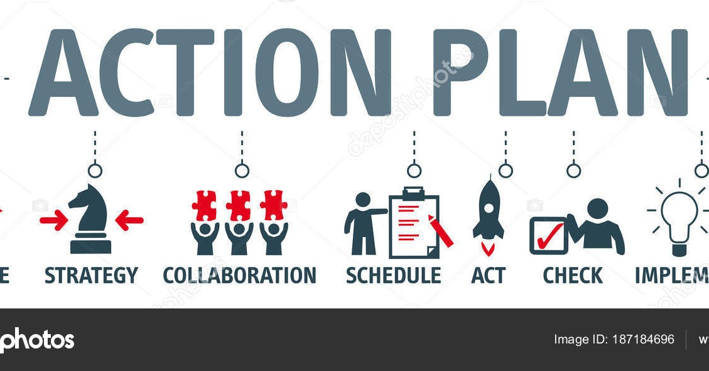
This Photo by Unknown Author is licensed under CC BY

Moving forward, I plan to strengthen my communication and teamwork skills within multicultural environments. I intend to take part in cross-cultural communication training, as this will help me understand how language and cultural background influence workplace interactions. I also aim to support Ioana by helping implement short daily briefings delivered in English, to create greater consistency in how instructions are shared. To improve my confidence further, I plan to develop my assertiveness so that I can communicate more clearly during demanding situations. Learning a few basic phrases used by colleagues may also help reduce misunderstandings and build rapport. Finally, I want to observe Jolanda’s supervisory approach more closely, as her experience leading a multilingual team could offer valuable guidance for my future development.
I aim to complete a short course in cross-cultural communication within the next three months to strengthen my ability to work in multilingual teams.

Reference List

- Gibbs, G. (1988) Learning by doing: A guide to teaching and learning methods. Oxford: Oxford Polytechnic.
- Goleman, D. (2011) Leadership: The power of emotional intelligence. Northampton, MA: More Than Sound.
- Hospitality Institute (2024) Reporting maintenance issues: A guide for housekeeping staff. Avalable at : https://hospitality.institute/bha106/reporting-maintenance-issues-guide-housekeeping-staff/ (Accessed : 27 Octobre 2025).
- Kolb, D.A. (1984) Experiential learning: Experience as the source of learning and development. Englewood Cliffs, NJ: Prentice-Hall.
- Lashley, C. (2018) Hospitality management: A brief introduction. London: Routledge.
- roomMaster (2025) Hotel preventive maintenance checklist. Avalable at : https://www.roommaster.com/blog/hotel-preventive-maintenance-checklist (Accessed : 28 Octobre 2025).
- Schön, D.A. (1983) The reflective practitioner: How professionals think in action. London: Temple Smith.
- Snapfix (2024) Emergency maintenance: The ultimate guide to staying prepared and minimizing risk. Available at: https://snapfix.com/news/emergency-maintenance-the-ultimate-guide-to-staying-prepared-and-minimizing-risk (Accessed: 1 November 2025).
- University of Edinburgh (n.d.) Gibbs’ reflective cycle. Available at: https://reflection.ed.ac.uk/reflectors-toolkit/reflecting-on-experience/gibbs-reflective-cycle (Accessed: 31 October 2025).
- Walker, J.R. (2016) Introduction to hospitality management. 5th end. London: Pearson Education.

I confirm that I have not used any AI tools in the research and creation of this assignment.
I confirm that I have not presented any AI generated materials as my own work.
I confirm I have copies of my drafts, notes, and other resources I used, which I may be asked to provide in evidence.

