

Individual Report

Baciu Severina 2022009
Management accounting
LCBB5002
Lecturer: Dr. Hafiz Rahmani

Table of Contents
Executive summary 2
Introduction 2
Analyses 2
Recommendations 4
Conclusion 5
References: 6
Appendices 7

Executive summary
The objective of this task analysis is to determine whether to close a branch of the business if it is losing money for the overall firm or to keep it open since it is profitable and there is no need to shut it down based on financial analysis.
Another task is to discuss the major areas of performance for the company by doing a ratio analysis and an analytical examination of significant elements, allowing the managing director to focus on closing decision as it will affect all sides of rapid growing business.

Introduction
According to the overview description, the corporation NGPL's Manchester side of business has been losing money for the previous few years, and a new managing director of Manchester branch has recently stepped in to reverse the branch's underpinning business. The managing director of the Company intends to close the Manchester branch because she believes that if Manchester branch has been losing money it will most likely continue to lose money in the future.

Analyses
“A management accounting decision is one of the most complex issues which a manager will have to deal with”. (quarterly report, 2002).
Branch closures have an obvious impact on the clientele of the closed branch, but they also have an impact on other branches and may have ramifications throughout the company and its communities.
The strength and weaknesses in several areas of operating and financial activities are revealed in accounting profit/loss reports. “These identifications are extremely beneficial to management in terms of exerting control and making decisions.” (Jeferson, 2015)
The main reason why a Managing Director may consider closing a branch is poor performance indicators measured by financial information such as balances or income. Before closing a branch for performance concerns, the Company must first examine market potential to discover whether the branch is failing since it operates in a shrinking market, or whether it is underperforming in a viable market area. From overview of the company can be deducted that there is huge market potential for all sides of the business and is left to analyze whether Manchester branch is profitable or not. Profit maximization is the primary goal of any commercial firm.
According to financial accounting data a “decision on business approach has to be made based on financial analysis through ratio analysis, comparative statements, trends, graphs, and diagrams.” (Jeferson, 2015)
“When cash is received, a firm records it as income, and when cash is utilized to pay bills or liabilities, it is recorded as a liability.” (Fernando, 2021)
The cash technique, often known as the cash accounting method, is only employed when money enters and exits a firm.

The latest financial statement for the company NGPL which has operations within 3 branches as shown in Appendix A.
From first look at diagram (Appendix E) and overall sales (Appendix A) can be seen that Manchester branch has been an underperformer in overall sales ratio and were paying more for advertising which added more to their fixed expenses.
Total sales from all 3 branches are calculated according adding each branch sales.(Appendix D).
In Appendix A are shown deducted fixed branch expenses but also company has variable costs of 70% off sales (Appendix B). ‘”Any expenses that alter depending on how much a company produces and sells are known as variable costs.” (Nickolas, 2019)
Knowing that variable costs of the company is 70% of sales, the variable expenses have been deducted for each branch accordingly ( Appendix C).
As per pie chart (Appendix H) can be observed that Manchester branch has less variable costs of 25% of total sales from(Appendix D) compared to London for example which are 46% of total sales(Appendix D)
Fixed branch expenses shown in financial statement are calculated adding all fixed expenses (Appendix F). As a graphical representation (Appendix G) to see which branch has expensive use of money. Manchester branch uses less money for fixed expenses than its peers from London and Ipswich.
The Company has to pay for bookkeeping service firm a sum of £462.000 which is divided to all branches of the company according to their sales ratios.
Each branch has to pay its part of the service and its been calculated as branch sales divided by total sales and multiplying by total amount for payroll services (Appendix I).
Appendix J as a diagram of proportions paid by each branch shows that Manchester branch has less expenses for the service comparing to other two branches.
Finally to decide close or not to, the profit/loss information is deducted as shown in Appendix K.
Take the sale figures and subtract The sum which branch has to pay to bookkeepers service added to variable cost expenses and fixed expenses and the profit or loss is deducted.
As can be observed in Appendix L, the chart clearly show that Manchester branch is actually profitable on second place after Ipswich branch and before London branch which is less profitable.

Recommendations
Having less sale figures and less variable and fixed expenses, Manchester branch has grown, adding profitability to the company overall and become even more profitable than London branch which also was managed in the past by the same manager in Manchester now.
After all information shown above is recommended to keep the Manchester branch open as it become very profitable than London.
IF the manager Director decides to close the branch the losses will be next:
Fixed expenses from Manchester expenses have to be paid, which consist as per Appendix F:£179.000
Plus profit of £49,741.79 which will be lost.
So a total of £228,721.79 will be deducted from Manchester sales.
IF reducing head expenses from £462,000 to £370,000 that’s £92,000 reduced from total loss.
The total loss will be a huge sum of £136,741,79 (Appendix M)
Appendix M shows that total of losses in case of shutting down Manchester business is massive and does not make sense financially as losses shadows profits from other two branches and this case scenario makes company as overall to lose money.
Cash flow positive, reduced expenses and profit, makes the Manchester branch a cash cow for the company.
Embracing the growth which Manchester branch is eyeing at the moment, profits theoretically will be multiplied in the coming years and the branch has the potential to shadow its peers.

Conclusion
The analysis of concrete case scenario of closing a branch of the business has given the next results:
All 3 branches currently are very profitable. Ipswich in the lead with £82.855.50 of profit, followed by Manchester branch with £49,741.70 of profit, and less profit generated by London branch a total of £29,702.41 positive cash flow.
As recommended, the Manchester branch is profitable and thriving in its core business and shall not to be closed. As stated in analysis the results from closing the specific Manchester side of business will result in massive losses for the company -£136,741.79.
The Managing Director should set aside his emotions for the Manchester branch manager and work together to keep all branches growing and prospering in order to maintain financial stability of the Company.

References:
Accounting, P. (2020). Accounting Assignment Sample| Accounting Assignment Solutions [Free Download]. [online] www.myassignmentservices.com. Available at: https://www.myassignmentservices.com/accounting-assignment-sample.html [Accessed 2022].
Bloomenthal, A. (2021). How Ratio Analysis Works. [online] Investopedia. Available at: https://www.investopedia.com/terms/r/ratioanalysis.asp [Accessed 25 Feb. 2022].
Fernando, J. (2021). Profit and Loss Statement (P&L) Definition. [online] Investopedia. Available at: https://www.investopedia.com/terms/p/plstatement.asp [Accessed 25 Feb. 2022].
Jeferson (2015). Tools and techniques of Management Accounting. [online] Accountlearning.com. Available at: https://accountlearning.com/tools-and-techniques-of-management-accounting/ [Accessed 25 Feb. 2022].
Nickolas, S. (2019). Variable Cost vs. Fixed Cost: What’s the Difference? [online] Investopedia. Available at: https://www.investopedia.com/ask/answers/032515/what-difference-between-variable-cost-and-fixed-cost-economics.asp [Accessed 25 Feb. 2022].
quarterly report (2002). Bancography - Branch Planning, Marketing Research, Brand Strategy, Products & Profitability. [online] www.bancography.com. Available at: https://www.bancography.com/ [Accessed 24 Feb. 2022].

Appendices
Appendix A: NGPL latest financial statement
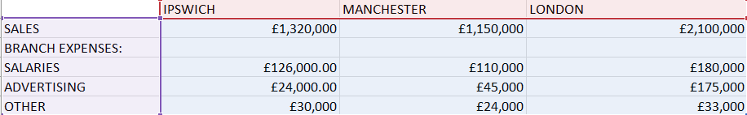
Appendix B: Bookkeping payment and variable costs
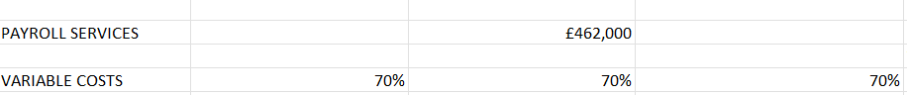
Appendix C: Variable costs
Appendix D: Total sales
Appendix E: Sales vs fixed expenses
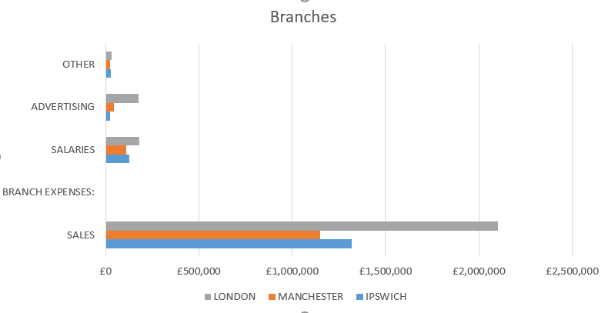
Appendix F: Fixed branch expenses

Appendix G:Graph representation fixed expenses
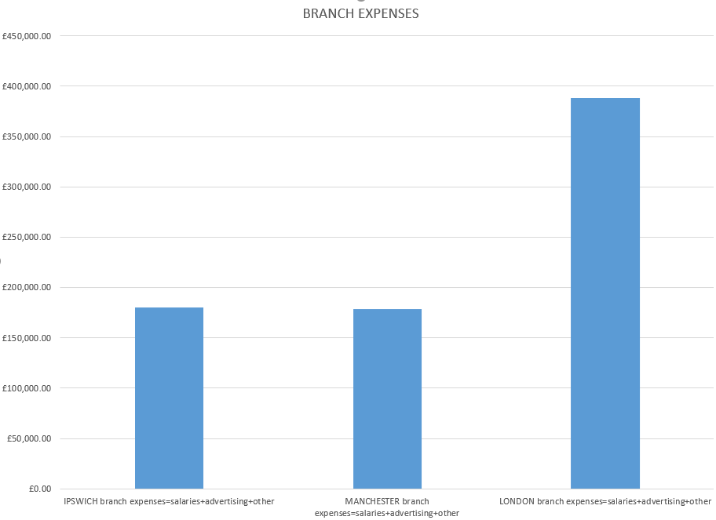
Appendix H: Variable costs pie
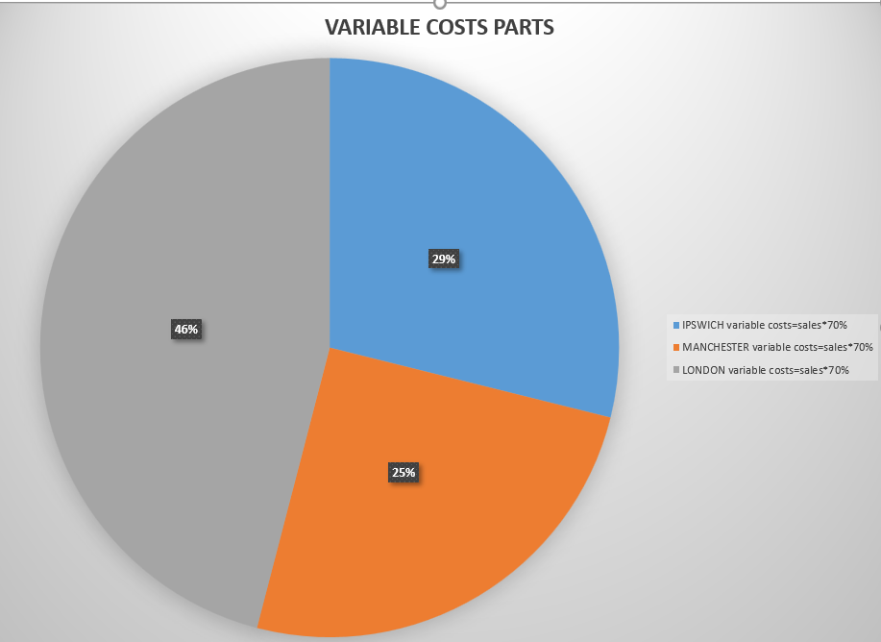
Appendix I:Payroll services
Appendix J: Diagram representation of proportions
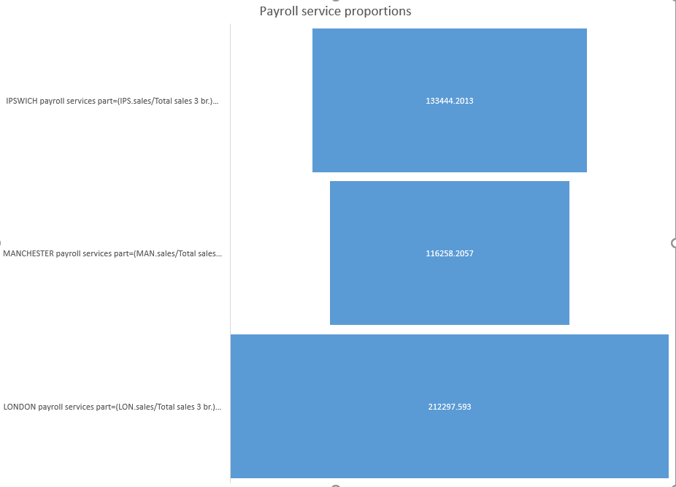
Appendix K:Profit/loss calculations
Appendix L: Profit for each branch
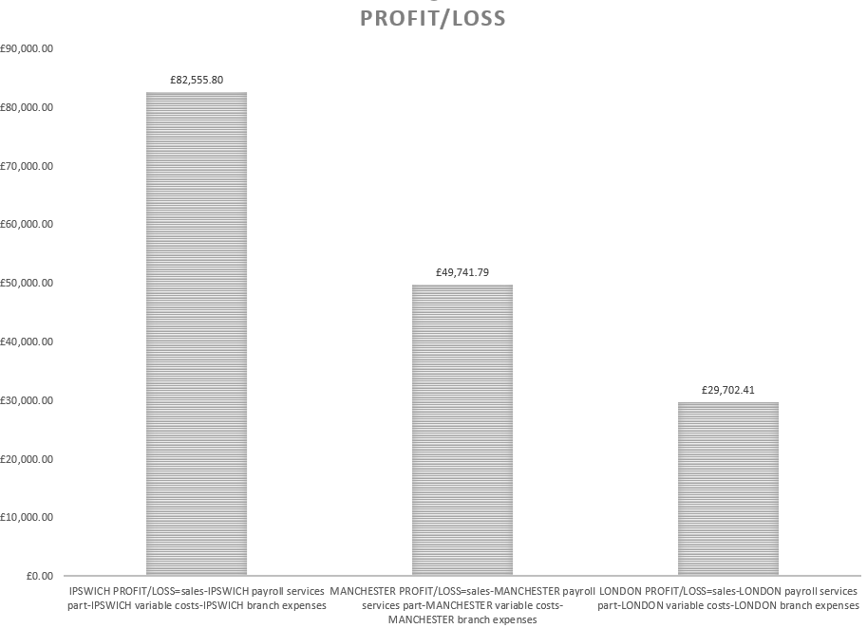
Appendix M: IN case of closure Manchester


