

Assignment Report

DBA

LCDB7007：
Research Principles and Philosophy

Guidance specific to this assessment:

- Considerable information has been provided in the Instructions section above.
- Written in UK English in an appropriate business/academic style.
- Length: 7,500 words (equivalent) +/- 10% (Marks will be taken off for skills for professional practice where the word count is exceeded)
- Document format: Report with a clear title page and each section clearly labelled.

Student Name: Xuefeng Qin Student Number: 2109185

CONTENTS

Abstract 3
1. Research Topic 3
2. Background and Details of Research Activity 3
2.1 Researchers and research fields 5
2.2 The importance of research 5
2.3 Research Purpose 6
3. Literature Review 7
3.1 Introduction of the main literature review 7
3.2 Literature Review about Classification research 8
4. Research questions and assumptions 13
4.1 Quality of the video content 13
4.2 Incentive Mechanism 13
4.3 Online comments  14
4.4 Trust 14
4.5 Value-added content 15
4.6 Cognitive attitude  15
4.7 Personal charm of Internet celebrities 16
5. Research Methodology 17
5.1 introduction 17
5.2 Why The Research Methods Are Important 18
5.3 ontology 18
5.4 Epistemology 19
5.5 Axiology 19
5.6 methodology 19
6. Ethical considerations 19
7. Research Risk Evaluation 20
8. Time Table 21
9. List of references 22

Abstract
The bricks-and-mortar retail industry was hit hard by the COVID-19 pandemic in 2020, and its performance continued to decline. In order to cope with the challenges, physical retailers have changed their thinking and effectively responded to the challenges of the epidemic with the help of short video platforms and online sales methods of "e-commerce + short video". E-commerce short video marketing, as a new way of network marketing in the era of digital economy, has carried out many meaningful explorations in the improvement of customer consumption experience, the satisfaction of differentiated needs of users, and the stickiness of consumer platforms through Internet technology. Short video platform has the characteristics of low threshold, strong participation and strong connection, and pays more attention to user experience and interaction. As a popular video social application, it has attracted more and more people's attention.

E-commerce short videos connect consumers, products and content in a new form, influence consumers' decisions, facilitate the transaction of goods and services, and achieve marketing purposes. However, in the new situation, there are few studies on e-commerce short videos, so it is of great practical significance to study the generation of consumers' purchase decisions under e-commerce short videos. Based on the development status of e-commerce short videos and the research on consumers' purchasing decisions, this paper analyzes the factors that affect consumers' purchasing decisions in the context of e-commerce short videos. In theory, the influencing factors of consumers' purchase decisions in the context of e-commerce short videos are constructed.

In terms of empirical research, consumers of e-commerce short video platforms (TikTok, Amazon, FaceBook, etc.) are selected as objects to study the academic achievements of previous scholars, design a measurement scale and questionnaire, and use the collected effective data to carry out research hypotheses.

Finally, according to the actual research and experimental results in the research process, this paper puts forward some management suggestions from the four aspects of e-commerce short video vloggers, enterprises, consumers and short video platforms. The limitations and prospects of this study are summarized.

Research Topic
《Research on the influence of e-commerce short video on consumers' purchase decisions》

Background and Details of Research Activity
With the advent of e-commerce short video era, consumers are the key. E-commerce short videos connect consumers, products and content in a new form, influence consumers' decisions, promote product transactions and achieve marketing purposes. At present, although e-commerce short videos are developing rapidly, there are few studies on the impact of e-commerce short videos on consumers' purchasing decisions. Based on this, this paper conducts an empirical study on short video platforms, trying to discuss how e-commerce short videos influence consumers' purchasing decisions, and gives guidance on the content and form of short video on short video platforms, so that e-commerce short video, a new online shopping model, can develop better.

Among many short video application platforms, DouYin (China TikTok) is the one with the fastest user growth, ranking first in both the user scale and daily active users in the market. Data from the "2020 China Mobile Internet Annual Report" released by QuestMobile show that the monthly per capita usage time of short video industry still maintains a large growth, and the user scale keeps expanding, increasing 39.07% compared with December 2019. The large number of users and high proportion of time spent on short video platform lay a foundation for innovation and development. With the wide popularization of mobile Internet and the improvement of Internet access speed of mobile terminals, short video industry develops rapidly and has a large scale. Short video applications are more and more accepted, loved and respected by the public.

DouYin is a short video social platform for all ages. On the platform, users can freely choose the music they are interested in, shoot their own creative short videos and share them with other users. According to the 2020 Douyin Data Report released by ByteDance, Douyin has more than 600 million daily active users in China, with the majority of users in their 20s and 30s.

At present, more and more families choose to use short videos to record beautiful moments in life, work and school. With a large number of users, the short video platform carries out commodity marketing in the form of live broadcasting and e-commerce short videos, and the total volume of commodity transaction in 2020 will exceed hundreds of billions of yuan. E-commerce short videos have played an important role in promoting economic recovery, expanding employment forms and enriching social life.

At present, The communication characteristics of short videos are highly consistent with the marketing demands of e-commerce. The scene, interest and amplification effect of multi-level communication of short videos fit with the characteristics of high conversion rate and low risk of social e-commerce, making the combination of the two inevitable. In the first half of 2019, relevant departments put forward constructive suggestions for the short video industry, promoting its integration with e-commerce and other fields. Short video platforms are no longer just entertainment videos for users. Through cooperation with e-commerce, short video platform shortens user transaction process and makes users tend to directly consume in short video, thus connecting consumption links.

E-commerce short videos cover three different scenarios of content consumption, social communication and online shopping, and organically connect users, products and content. As a new form of social practice of "digital economy", e-commerce short videos have played an important role in helping the economy recover from the sluggish state and continue to develop well in the era of COVID-19 after 2020. The popularity of e-commerce short video heralds the arrival of the Internet 3.0 era. In the Internet 1.0 era, product-oriented, people's focus is production and sales, supply is less than demand, the product gets the world; In the Internet 2.0 era, channel sales is the main, people focus on how to sell products, so the sales channel is very important; In the Era of Internet 3.0, with the rapid development of mobile Internet and the wide application of digital technology, the content forms, information channels, service means and marketing methods of consumers have undergone great changes. Consumers begin to pursue personalized needs and attach great importance to experience. At this time, consumers win the world.

2.1 Researchers and research fields
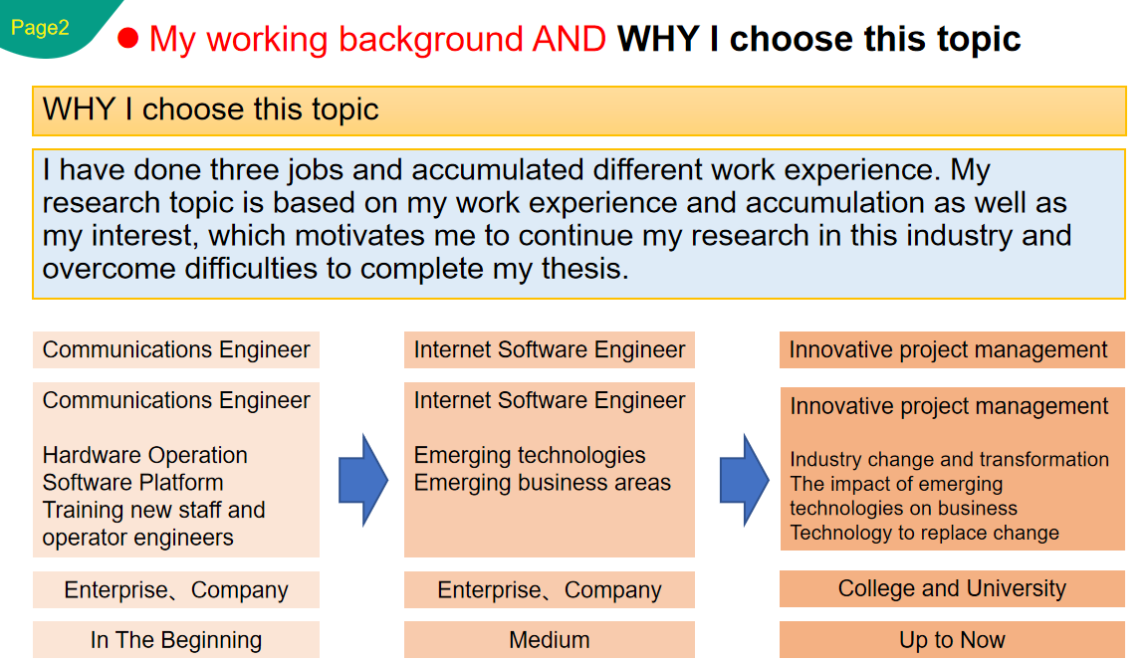

2.2 The importance of research
The birth and gradual maturity of e-commerce has greatly changed the working and living habits of contemporary people. Nowadays, e-commerce platforms have become an indispensable part of contemporary social life. They constantly improve themselves with the huge advantages of the Internet. Up to now, they have developed into an extremely fine and complete industrial chain. With the rise of e-commerce, mobile Internet technology is also developing rapidly. As the most typical representative of the era of information fragmentation, short video has become an extremely important part of people's spiritual life.

2.3 Research Purpose
1.Research purpose
Study the psychological change process of consumers when they make purchase decisions while watching short e-commerce videos, and identify the key factors that affect consumers' decisions. E-commerce short video production teams can deepen their understanding of consumers according to key elements, such as consumer demand points and satisfaction, so as to focus on the focus of video content production, grasp the direction of products, carry out targeted marketing, and bring consumers better purchasing services and experience. This has important guiding value for the business model of "e-commerce + short video". 

2.Research significance
With the rapid development of the Internet, short video platforms continue to explore in the consumer market and gradually integrate with e-commerce. Since 2019, Douyin and Kuaishou have opened up a "new track" outside traditional e-commerce platforms such as Taobao and JD.com with the attributes of "e-commerce+short video". Various types of e-commerce short video platforms continue to emerge and flourish, forming a trend of contention among a hundred schools of thought. 

As an important part of the Internet industry, e-commerce platform and short video platform attract people's attention and have always been the focus of scholars' research, but there are few studies on the combination of the two. In this paper, some classic at home and abroad for reference, the consumer purchase decision model, combined with the management of related research fields, such as Gui results, construction of electricity class short video platform concept of consumer purchase decision model, put forward relevant assumptions, and carries on the empirical research Gui of short video platform, to explore the size of the degree of impact of different factors on the consumer purchase decision, to prove the validity of the model and hypothesis. Therefore, it not only expands the width of consumer purchase decision research, but also promotes the depth of e-commerce short video research. 

Research questions. Therefore, this article is based on electricity class short video consumer purchase decision analysis, the short video platform focus on empirical research, identify the factors that influence consumer purchase decision, influencing factors of the relationship between each other, for the demand of the construction of electricity class short video platform to provide some more detailed and feasible method and targeted, It has very important reference significance for the future development mode and operation mode of e-commerce short video industry. 

Literature Review

3.1 Introduction of the main literature review
Mobile short video first appeared in the United States. Vine, an American video-sharing startup company, officially released short video products in May 2009. Its positioning is to help users instantly capture, quickly create and quickly share life details. Since the launch of Viddy, the first short video platform in the United States on April 11, 2011, YouTube, Facebook, Snapchat and other major short video platforms have emerged one after another, promoting the rapid development of short video industry. Enter the keyword "short video" in Science Direct for retrieval, and the research content related to communication in the obtained articles can be roughly divided into the following three types. It mainly includes the research on the development status of short video communication, the research on the integration development of news media industry and short video platform, and the research on the commercial value of short video.

First of all, the commercial value of short video platform has been studied earlier and in a large number. Sheldon and Kerrin (2012) illustrate the value of mobile short video communication in marketing and the prospect of future development in five aspects based on the development status of short video at home and abroad. Harris Ryan (2013) made a comparative analysis of short video platforms Instagram and Vine, emphasized the role and value of mobile short video in content marketing, and discussed the influence and development of short video in the advertising industry.

In addition to Harris Ryan, scholar Luke Chitwood(2014) also conducted in-depth research on Vine and Instagram, two major mobile short video platforms, and discussed their application value in advertising promotion, brand building and label classification. Foreign scholars have also made many attempts to study the marketing strategy of short video platform. Kenneth Revett (2017) gave a new explanation on advertising marketing, emphasizing that businesses should strengthen the utilization of big data resources and accurately push short video advertisements to consumers who really need them through personalized information push to meet the personalized needs of users.

Ioanid et al. (2017) analyzed the advantages of enterprises using mobile short video platforms such as Twitter and YouTube for marketing communication, and proved that mobile short video has an impact on their business realization activities at least 30%.

In addition, as a new research field, scenario-based marketing of short video platform has been vigorously developed. Hemant C (2016) pointed out in his article that merchants use short video platform Snapchat to create a social scene integrating sweetness, closeness and inclusiveness, so that users become acquaintances with brands, shorten the distance between users and operators, and realize brand marketing through strong interaction.

Secondly, it studies the communication development of news media industry with the help of short video platform. A review of relevant literature shows that foreign scholars often focus on the research on the integration development of short video platform and news industry. Rachel Bartlett(2014) reports on a new project being developed by the BBC in collaboration with Instagram. Use Instagram's short video features, huge fan base and obvious social nature to better engage news organizations and journalists when reporting.

Scholar Caroline O 'Donovwan (2014) analyzed the Washington Post's practice of using short videos to report news, and believed that short video platforms could use mobile short videos as news communication channels. Using Vine To Cover Breaking News by Ungerleidel and Neal (2013) discussed the advantages and functions of mobile short video platform in News reporting.

The research on the communication mechanism of short video platform is also the main part of the current research on short video communication, including the operating mechanism, communication characteristics, existing problems and future development trend of short video platform. Vandersmissen B (2014) studied Vine, the originator of short videos, and found that Vine short videos that were frequently shared on Twitter won more likes after being posted than those that were not shared. Short videos, on the other hand, take on a life of their own after they are published and quickly attract the attention of many users. Over time, it's not as popular as it used to be, but it doesn't stop. Short videos tend to plateau after a few weeks. and scholars Charawee Sangkhum LaddaPreechaveerakul, WiPhada Wettayaprasit (2009) put forward, some mobile short video platform to news video push filtering. The system firstly aggregates the short news videos from multiple sources, and then filters out some unqualified short news videos through the filtering mechanism, so that users can see some better content.

3.2 Literature Review about Classification research

1. Consumer behavior 
Everyone is a consumer because they actively or passively consume a variety of goods or services. Consumption behavior is accompanied by people's production and life to meet people's physiological and psychological needs. According to the early view of consumer behavior, consumers do not take the initiative to consume, and consumers generally have strong autonomy and are easily influenced by things around them. Therefore, under the guidance of various marketing methods, consumers will unconsciously produce consumption behavior. The research on consumer behavior involves many fields. Researchers' definition of consumer behavior is as follows :NICOSIA(1968) believed that consumer behavior is not for secondary sales, but for individuals or families without middlemen. DEMBY(1974) pointed out in his study that evaluating goods, obtaining goods and using goods are three important links of consumer behavior. Fazioand WilliasS(1980) defined all the motivations and decisions related to purchase as consumer behavior. They define consumer behavior as the entire process of making a purchase decision, including all the behaviors consumers take to acquire and use goods or services.

Based on the above summary, this study believes that consumer behavior is a decision-making process in which an independent individual takes actions to meet demands based on his past cognition and experience, in which consumer emotions, feelings and external influences play an important role. Both internal and external factors can affect consumer behavior. Therefore, merchants or vloggers can improve product quality and video content to meet consumers' demands and benefit consumers, thus positively influencing consumers. Consumers can strengthen the management of internal factors such as emotion and experience, and evaluate goods and services rationally and objectively in combination with external factors, and decide whether to buy or not to buy. 

2. Research on consumer attitudes
People have their own attitudes towards everything. Their love for a star, dislike for a brand, and approval for a behavior are all manifestations of their attitudes. Attitude is the unity of emotion and cognition. Consumer attitude is based on the emotional and cognitive impact of products or services, that is, the purchase behavior tendency produced by the influence of attitudes. Attitude is a motivational psychological tendency that can be learned and can make consumers do or stop certain behaviors. Consumers' early impressions of commodities and vloggers will be stored in their memory and extracted when necessary to influence purchase decisions. Consumer attitudes in many situations, have important sense to consumer purchase decisions: attitude can effect on the subjective and objective evaluation of consumers for goods or services, such as some groups boosterism well-known brands abroad, attitude can also function for goods or services to consumers' willingness to learn, such as patience finish see some brand propaganda video, ultimately affect consumers' buying behavior. In some situations, the positive attitude will produce a strong impulse to buy, prompting consumers to make purchase decisions.

At present, ABC attitude model is widely recognized and used in academic circles. The ABC attitude model was discovered by Rosenberg in the 1960s. In the model, attitude is composed of three key elements, among which A represents Affect emotion, B represents behavior, and C represents Cognition. Behavioral attitude refers to the subjective tendency of consumers to take certain actions, that is, consumers' purchase intention. Cognitive attitude refers to consumers' cognition of a commodity or service, namely consumer cognition.

Behavior
Cognition
Affect
ABC Attitude model



ABC attitude model intuitively shows the influence relationship among three elements: emotional attitude, behavioral attitude and cognitive attitude. The three elements are of different importance in the tendency and intention of consumers towards attitude objects. The hierarchy effect is a good example of the interaction between these three elements. In the standard learning hierarchy, cognition affects behavior through affecting emotion. At the low involvement level, cognition affects emotion through behavior. At the experience level, emotion affects cognition through behavior. Consumers' cognitive and emotional attitudes are important factors affecting consumers' purchasing decisions, and this model provides theoretical support for the subsequent research on the relationship between variables in this paper.

3 Consumer purchase decisions
The generation of consumer behavior is made up of a series of steps including demand discovery, information collection, understanding, and finally consideration before making a purchase decision. It is not an industry state that can happen in a short time. First, consumer demand will find himself in life, what you want, want to go to where to buy, and then start looking for the information related to such needs, the Internet is very developed, might search on the Internet, to find and the corresponding products, the demand for details of this commodity again, in the end, people will decide to buy goods, And gain relevant experience after consumption.

- commerce short video as a new thing in the past two or three years, the current domestic and foreign academic research focus on e-commerce platform marketing model, consumer loyalty and other aspects, but the new business model of e-commerce and short video combination and consumer purchase decisions are relatively lacking. E-commerce short video content vivid, diversified forms, easy to get consumers love and goodwill. Lei Wenjing et al. (2011) showed in their research that consumers' attitudes towards mobile video are influenced by the quality of video content, and high-quality video content can more influence purchasing behavior. Liu Fengjun et al. (2020) believe that online commodity promotion has obvious advantages and obvious effects, which can more motivate consumers to purchase. MOON&Kim (2001) believed that consumers could judge the effectiveness and authenticity of marketing content through online comments, sales volume and other contents, and decide whether to purchase. Liu Pingsheng et al. (2020) point out that vloggers are a kind of opinion leaders. In daily communication and interaction, their personal characteristics and charisma are easily loved by consumers, which can deepen the trust between the two parties, thus triggering consumers' purchasing behavior. E-commerce short videos have played a huge role in promoting economic recovery from the impact of COVID-19. Through the review of domestic and foreign scholars' studies on factors affecting consumer purchase decisions in different scenarios, this paper provides a variable basis for the research on consumer purchase decisions under e-commerce short videos.

4 Consumer purchase decision model 

Previous scholars have sorted out four well-known consumer behavior models in the West: Nicosia model, Kotler model, Engel-Kollat-Blackwell model and Howard-Sheth model.

(1) Nicosia Model :Nicosia model was proposed by Nicosia in 1966, which was mainly used to study the relationship between merchants and consumers, and pointed out that both of them jointly affected consumers' decisions. Nicosia model is divided into the following four parts:

Advertising information. Merchants transmit product information to consumers through media and other publicity channels, and consumers form their attitudes towards products or services based on the obtained information. External information and internal demand work together on consumers' cognition, so effective marketing mode affects consumers' cognition of demand.

Purchase motivation. After consumers have a positive attitude, they will be motivated to buy and take the initiative to investigate and study the products they are interested in.

Purchase behavior. After evaluating the collected information (such as product quality and price, etc.), consumers form purchasing decisions and implement purchasing behaviors.

5. Howard-Sheth model
Howard-sheth model was proposed by Howard and Sheth in the 1960s. They believed that consumers' purchase decision was a process of selecting a scheme that was in line with their own interests from a variety of evaluation schemes of internal and external factors, commodity or service information. The model believes that consumer buying behavior will be influenced by four factors: stimulus or input factor, external factor, internal factor, reaction or output.

A stimulus or input factor. Product essence stimulation, product symbol stimulation and social stimulation are all stimulating factors to consumers. Product substantial stimulus by product quality, price, availability, service and other elements. Product symbols stimulate the transmission of product features and other information to consumers through different media and marketing. Social stimulus factors are composed of family, related groups and social class.

External factors. Consumers are influenced by external factors such as culture, personality, time pressure and financial situation when making purchase decisions.
Internal factors. In simple terms, the intrinsic factor is the internal psychological process of consumers after being stimulated, including the perceptual structure and learning structure.
Reaction or output factor. After being stimulated, consumers begin to understand the product, form their attitude towards the product, and then form their purchase intention and complete the purchase.

Based on the above four consumer buying decision theory discussion and the research of the model, to know the following information: each model of consumer purchase decision process is analyzed, has its merit, but as the deepening and development of consumer behavior research Gui, single a model has been difficult to accurately explain the consumer behavior. In fact, consumers' purchasing decisions are affected by many factors at the same time. Therefore, this article research Gui will to combine the four theoretical models, the integrated application of psychology theory, introduction to the study of consumer purchase decision, a more in-depth discussion in such short video watching electricity, consumers' purchase decision by those factors, thus make the research of consumer purchase decisions is more comprehensive, more accurate, more system

4. Research questions and assumptions
According to the previous review of the relevant literature and the constructed conceptual model, the relevant concepts in the model are defined, and the research hypothesis of this paper is proposed.

4.1 Quality of the video content
E-commerce short video content includes text, pictures, videos and other information to display comprehensive, dynamic and diversified content of goods, and high-quality content is easy to win the recognition of consumers. Consumers can have a more in-depth and intuitive understanding of commodities through the appearance, material and usage feelings of commodities displayed by online celebrity anchors in short videos, which makes up for the lack of on-site experience to a certain extent. E-commerce short videos can improve the effect of display content, strengthen consumers' real feeling and cognition of the value of goods or services, and thus promote the growth of sales of goods or services and gain more income. The good and poor quality of e-commerce short videos will affect whether consumers will continue to watch videos, as well as their attitudes towards goods or services and purchasing decisions. Therefore, this is taken as a predictive variable and the following assumptions are proposed.

Assumption 1: When consumers browse e-commerce short videos, good content quality has a positive impact on consumers' cognitive attitude.
Assumption 2: When consumers browse e-commerce short videos, good content quality has a positive impact on consumers' emotional attitude.

4.2 Incentive Mechanism

Incentive mechanism refers to promotional activities, such as low price promotion, large coupon, etc. adopted by vloggers in short videos. Online marketing of products often achieves better sales results than traditional marketing methods. This is because consumers will focus on price factors in the process of making shopping decisions. Activities such as time-limited low prices and gifts directly hit consumers' price pain points, which can increase product sales volume and sales volume. At the same time, the marketing scene of e-commerce short videos is oriented to a large number of consumers, and the stimulus effect generated by price will be more obvious. Under the influence of external environment stimulation and extra incentive, consumers will have the behavior of buying certain goods or services. Vloggers use incentive mechanisms to attract traffic on various platforms, which not only brings real benefits to consumers, but also satisfies consumers' psychological expectations for products and arouses consumers' enthusiasm to buy.

Assumption 3: In e-commerce short videos, the incentive mechanism adopted by Internet celebrities positively affects consumers' cognitive attitudes.
Assumption 4: In e-commerce short videos, the incentive mechanism adopted by Internet celebrities positively affects consumers' emotional attitudes.

4.3 Online comments 
E-commerce short video playing interface includes online comment function. Consumers will make online comments based on their first impression of the product or service or their subjective feelings of using the product or service in real life, which is an important reference for consumers to make purchase decisions. Petty&Cacioppo (1984) pointed out that online comments are profound, authentic, clear and specific, which are regarded as reliable comments and will directly affect consumers' perception. Li Jian (2012) believes that online review information can directly and positively influence consumers' credibility of products and services, thus affecting consumers' final purchase decisions. Zheng Guotao (2012) emphasized that the authenticity and reliability of comments made by consumers who have purchased goods or services will directly affect subsequent consumers' purchase intention of products and services, and consumers are more inclined to believe goods with comments and are more susceptible to positive comments. Therefore, this paper believes that online reviews will have an effect on consumers' cognitive and emotional attitudes, so this is taken as a predictive variable and the following assumptions are made. 

Assumption 5: In short e-commerce videos, online comments positively affect consumers' cognitive attitudes.
Assumption 6: Online comments positively affect consumers' emotional attitudes in e-commerce short videos.

4.4 Trust

In current academic circles, trust has been extensively studied. Trust refers to the degree of consumers' trust in online celebrities and the products or services recommended in e-commerce short videos. It is an attitude of consumers formed under the continuous enhancement of satisfaction. Gabarino&JohnSon (1999) defined trust as an attitude that consumers believe in the content quality of goods or services. Limayem et al. (2003) emphasized that trust is an important factor affecting purchasing attitude when analyzing consumers' online shopping behaviors. Trust takes time to build up. Through years of interaction with fans, Internet celebrities have accumulated trust bit by bit, relying on daily performance and recognition from followers. Consumers' trust in the professionalism and seriousness of online celebrities has a positive effect on consumers' cognitive and emotional attitudes, and increases the possibility of consumers making purchase decisions. Therefore, this paper also takes trust as a predictive variable and puts forward the following assumptions.

Assumption 9: When browsing e-commerce short videos, consumers' trust in Internet celebrities has a positive impact on consumers' cognitive attitude.
Assumption 10: When browsing e-commerce short videos, consumers' trust in Internet celebrities has a positive impact on consumers' emotional attitude. 

4.5 Value-added content

E-commerce short videos not only contain product information for marketing to consumers, but also entertainment, life and other content. Consumers can acquire interesting knowledge content, learn practical life skills, relax their tired bodies and delight themselves in the process of watching e-commerce short videos. These are e-commerce short-sighted band to consumers of value-added content. Under the background that the age structure of Internet users is getting younger, young people are the main force for watching short videos and online consumption. And the young group of e-commerce short video value-added content is more acceptable. Therefore, value-added content is used as a predictive variable in this paper.

Assumption11: In short e-commerce videos, value-added content has a positive impact on consumers' cognitive attitudes.
Assumption12: In short e-commerce videos, value-added content positively affects consumers' emotional attitudes.

4.6 Cognitive attitude 
Cognitive attitude is the subjective cognition formed by processing the information related to commodities or services collected by people. Consumers get the information they need through the e-commerce short video content of Internet celebrities, including self-observation and judgment, detailed and vivid video content, and online comments from other consumers. Under the combined action of these stimuli, consumer's cognitive attitude changes, and then affects consumer's purchase decision.

Hypothesis 13: Consumers' cognitive attitudes have a positive impact on their purchase decisions when browsing e-commerce short videos.
Hypothesis 14: When browsing e-commerce short videos, consumers' emotional attitudes positively affect their purchase decisions.


4.7 Personal charm of Internet celebrities
The personal charm of Internet celebrities refers to the personal style gradually formed by Internet celebrities in the process of releasing video content for a long time, which has certain influence on consumers. Internet celebrities usually export relevant content in a certain field. Therefore, Internet celebrities are more like key opinion leaders with characteristics such as credibility and professionalism.

Song Jingqian (2018) believes that Internet celebrities convey a positive, optimistic and energetic attitude towards life and personal image to their followers on social media. As the information network becomes more and more developed, consumers are more willing to obtain useful information on the Internet. Among them, Internet celebrities are regarded as a channel to obtain information and are sought after and loved by consumers. Therefore, Internet celebrities can influence consumers' values, and thus affect consumers' perception of products or services. In the process of watching e-commerce short videos, consumers will focus on the opinions of Internet celebrities and vloggers, and sometimes even want to try the process of e-commerce short videos. The relaxed and happy emotions generated by consumers will positively affect consumer behavior, thus contributing to the formation of consumers' purchasing decisions. At the same time, consumers' emotional attitude towards online celebrities will also affect their purchase behavior.

Therefore, this paper takes cognitive and emotional attitudes as intermediate variables affecting purchase decisions, and puts forward the following hypotheses. 

Hypothesis 15: Consumers' cognitive attitudes have a positive impact on their purchase decisions when browsing e-commerce short videos.
Hypothesis 16: When browsing e-commerce short videos, consumers' emotional attitudes positively affect their purchase decisions.

5. Research Methodology

5.1 introduction
This chapter mainly discuss the research methods, as well as for the theory and methods of data collection, we in the process of doing research, we need to carry on the questionnaire survey and interview, this kind of thought belongs to the "onion" research, in this way, we can see a potential problem when collecting data, in the process of research, we think of things need layers of strip.

In fact, some writers, such as Guba and Lincoln(1994:105), regard research methods as secondary in importance to the question of which paradigm to apply, pointing out that any research can appropriately use both qualitative and quantitative methodological paradigms. Methodological questions are secondary to paradigm questions, which we define as the fundamental belief system or worldview that guides the investigation, not just in the choice of method, but in an ontological and epistemological fundamental way.
However, TerreBlanche and Durrheim(1999) added another element to the research process, including methodology in addition to ontology and epistemology; This was supported by Lincoln and Guba(1985). They believe that research paradigms are interconnected practices and thought processes that describe the nature of inquiry including the three dimensions mentioned above.

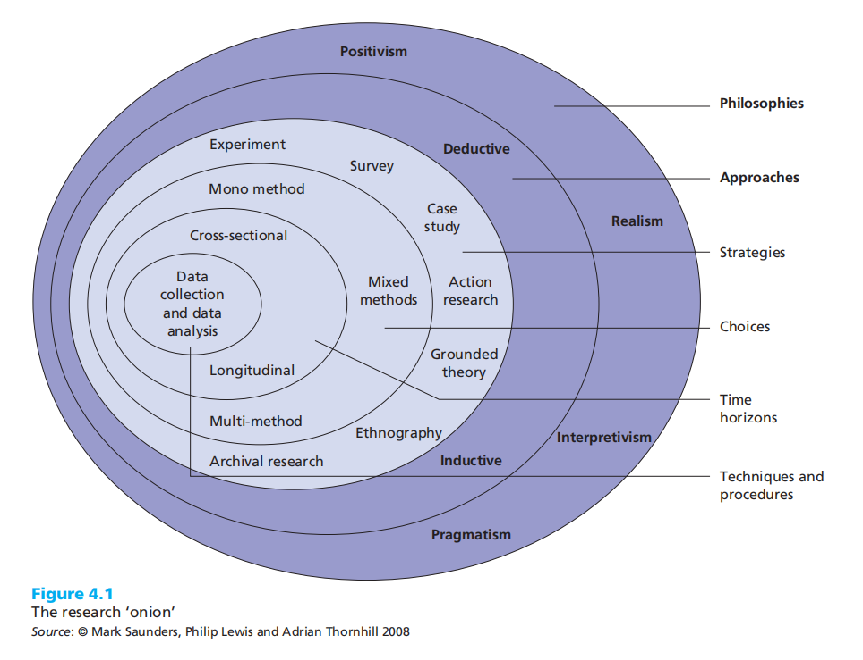

5.2 Why The Research Methods Are Important
We adopt the research methods including our hypothesis, we can see the world, these philosophical views in support of our research theory, as well as our research strategies, as Johnson and clark (2006) pointed out that our philosophy of business and management researchers need to be aware of commitment we through our research strategy choice, Because it has a huge impact not only on what we're doing, but we know what we're investigating. To some extent, the philosophy you adopt will be influenced by practical considerations.

In addition, our philosophical views will also be influenced by practical considerations, mainly the influence of how we put forward the knowledge, for example: our research on the emotional attitude of enterprise managers, for different views, our research method 矼 is also different. Philosophical positions are also very important for researchers, we can have a good understanding of how the world works, and only with that understanding can we be able to test these hypotheses as we see fit, perhaps adjust them, and behave in different ways.

5.3 ontology
Ontology is the branch of philosophy that concerns whether things are true or false when we make assumptions, or the nature or nature of the social phenomena we are investigating when we are doing our doctoral dissertation (Scotland, 2012). It is the philosophical study of being or reality, the nature of being or realization, and the basic categories, the things that exist and the relations between them. It examines your underlying belief system as a researcher about nature, about existence.

Ontology is important to paradigms because it helps provide an understanding of the things that make up the world (Scott & Usher, 2004). It tries to determine the true nature, or basic concepts that make up the themes that we analyze to understand the embedded research data.

It makes you ask questions like: Is there reality in the social world? A building created by one man himself? What is the nature of reality? In other words, is reality an objectively existing nature, or is it the result of individual cognition? What is the nature of the situation being studied? Ontology can serve as a researcher in order to examine your underlying belief systems and philosophical assumptions about the nature of being, being and reality. Philosophical assumptions about the nature of reality are essential to understanding how you make sense of the data you collect. These hypotheses, concepts, or propositions help the mind locate about the research question, what it means, and how you might solve it to answer your research question, understand the question being investigated and contribute to its solution.

5.4 Epistemology
Epistemology comes from the Greek, the word epistemology means knowledge, and simply put, in research, epistemology is used to describe how we know things; How we know the truth or reality; McDonald(2011) said, what is knowledge in the world? It is about knowledge -- its nature, its form and how to acquire it, and how to communicate knowledge creatures to others.

It focuses on the nature of human knowledge and understanding, the knowledge that can be acquired as a researcher or knower in order to be able to expand, expand and deepen understanding in your field of study. Schwandt(1997) defined it as the study of the nature and justification of knowledge. So, in thinking about epistemology about our research, these questions are important because they help researchers position themselves in the research environment so that they can discover new things when they already know.

5.5 Axiology
Axiology is considered to be the study of the values and ethics involved in the process. Axiology is the branch of philosophy that deals with value judgments. This involves how researchers perceive their own values and research objects. Research conducted by Heron(1996) shows that researchers need to demonstrate their skills in relation to axiology in order to express their value as an obstacle to correct judgment and how research is conducted. The data collection techniques chosen by the researchers are considered a reflection of their value

5.6 methodology
Methodology is considered a research design that Outlines the choices of researchers, uses specific methods, and relates them to appropriate results. It provides the results of the methods used in a particular study or study. Methodologies are primarily considered to be a mix of techniques used to investigate specific situations (Easterby-Smith et al., 2004). Induction is mainly used for data outside the literature, and collaborative surveys include the degree of researcher participation

6. Ethical considerations
Ethical issues in research are very important. If a research lacks ethical principles, it cannot produce real, valid and reliable results. Researchers are responsible for maintaining the privacy of information throughout the study. In the course of the research, the survey is required to provide demographic information, such as gender, age, education and education. Before collecting personal information from respondents, researchers need to make sure that personal information is secure during and after the study. Once respondents complete the online survey, the information is automatically updated into a file that only researchers can access, so there is no direct link between researchers and respondents. The reactions collected from this study will be destroyed after a period of time.

7. Research Risk Evaluation
 | Research Risk Evaluation | a. | b. | c.
 | Risk factor. | Likelihood of occurrence. | Degree of harm if factor occurred. | Total  a x b = c
 | Participant extreme emotional disagreement in discussion. Threatening behaviour to other focus group members.. | 1 | 1 | 1
 | Participants naming individuals in the discussion. In extreme cases some disclosures might be illegal. Focus group members would therefore be witnesses. | 2 | 2 | 4
 | Participants lack honesty about behaviour. Lying in this case would be low risk. There is no plan to follow up and verify the truth of statements. | 2 | 1 | 2
 | Participants confess to illegal behaviour. It might cover very antisocial behaviour which researcher might have to report, if proved. | 1 | 1 | 1
 | Insulting attitude to researcher by participants. Threatening behaviour to researcher. | 1 | 1 | 1
 | University reputation issues should its recycling policies be seen to be ineffective. Researcher’s report publication or participants “whistleblowing statements made during focus group discussions. | 2 | 3 | 6
 | Release of confidential participant data from researcher’s files. Anonymisation of transcripts, identities of participants and secure location of recordings, might be accessed with true identities by malicious agents. | 1 | 2 | 2
 | Total |  |  | 17

Time Table

Planned Development (e.g. submission of form, completion of chapter, submission of thesis) | Target Date
Submission of the proposal form | Jan, 2022
Literature review, first draft | July, 2022
Literature review, final version | Oct ,2022
Methodology | Dec ,2022
Data collection | Jan, 2023
Data analysis | July, 2023
Write up Findings and Discussion | Oct, 2023
Write up conclusion | March, 20224
Footnotes and references | April ,2024
Submission of thesis | April, 2024

9. List of references
1、Roche L, Nic Dhonncha E, Murphy M. TikTok™ and dermatology: promises and pearls. Clin Exp Dermatol 2020. https://doi-org.ezproxy.uwtsd.ac.uk/10.1111/ced.14529.
2、Nikookam Y, Guckian J. TikTok™ and dermatology: lessons for medical education. Clin Exp Dermatol 2021. https://doi-org.ezproxy.uwtsd.ac.uk/10.1111/ced.14624.
3、Zheng DX, Ning AY, Levoska MA et al. Acne and social media: a cross-sectional study of content quality on TikTok. Pediatr Dermatol 2021; 38: 336– 8.
4、Zheng DX, Mulligan KM, Scott JF. TikTok and dermatology: an opportunity for public health engagement. J Am Acad Dermatol 2021. S0190-9622: 00412– 6.
5、Zheng DX, Xiang L, Scott JF. The bandwagon effect: a double-edged sword for influencing teenage acne outcomes. Pediatr Dermatol 2021; 38: 336– 8.
6、M. K. Y. Chen, F. Garden, D. F. Sebaratnam, Isotretinoin on TikTok™: misinformation getting under our skin, Clinical and Experimental Dermatology, 10.1111/ced.14810, 46, 8, (1606-1607), (2021).
7、M. Balogun, N. Mathe, J. Yoo, Correspondence on prevailing dermatology‐related topics on the rapidly growing TikTok™ social media platform, Clinical and Experimental Dermatology, 10.1111/ced.14927, (2021).
8、M. K. Y. Chen, F. Garden, D. F. Sebaratnam, Isotretinoin on TikTok™: misinformation getting under our skin, Clinical and Experimental Dermatology, 10.1111/ced.14810, 46, 8, (1606-1607), (2021).
9、Facebook. Number of monthly active Facebook users worldwide as of 2nd quarter 2020 (in millions) [Graph]. 2020.
10、Iglesias-Puzas Á, Conde-Taboada A, Aranegui-Arteaga B, et al. “Fake news” in dermatology. Results from an observational, cross-sectional study. Int J Dermatol 2021; 60: 358– 362.
11、Mueller SM, Jungo P, Cajacob L, et al. The absence of evidence is evidence of non-sense: cross-sectional study on the quality of psoriasis-related videos on YouTube and their reception by health seekers. J Med Internet Res 2019; 21: e11935.
12、Qi J, Trang T, Doong J, et al. Misinformation is prevalent in psoriasis-related YouTube videos. Dermatol Online J 2016; 22.
13、Sierro TJ, Young PM, Kassabian SK, et al. Dermatologists in social media: a study on top influencers, posts, and user engagement. J Am Acad Dermatol 2020; 83: 1452– 1455.
14、Galadari HI. Social media and modern dermatology. Int J Dermatol 2018; 57: 110– 111.
15、Brunk D. ‘Dr. Pimple Popper’ shares her social media tips. 2020.

