Business Plan for FOOD TRUCK

Produced By:

GROUP MEMBERS:
Student Name | Student No.
NATESHA LEWIS-CAMBPELL | 2134545
AMIRUL ISLAM | 2234363
VASILICA CRENGANIS | 2221600
IULIA MARIA LUCA | 2239007

Module Name: Entrepreneurship
Module Code: BMIH5001
Lecturer Name: CHRISTOPHER WILKIN

Word count: 2000 words

CONTENTS
AI Declaration 3
1. EXECUTIVE SUMMARY 4
2. THE BUSINESS IDEA 5
2.1 The Product/Service 5
2.2 SWOT Analysis Summary 5
3. THE TEAM 6
3.1 Key Personnel 6
3.2 Skills Gaps & Key Partners 8
4. MARKET RESEARCH 9
4.1 Market Information, Trends and External Factors 9
4.2 Customer Profiles 9
4.3 Competitor Profiles 10
5. MARKETING PLAN 10
5.1 Price 10
5.2 Product 11
5.3 Placement 11
5.4 Promotion 11
6. KEY RESOURCES 12
6.1 Premises 12
6.2 Equipment 12
6.3 Key Suppliers 12
7. FINANCES AND START-UP SUPPORT 13
7.1 Financial Summary 14
APPENDICES 16
Appendix A – SWOT Analysis 16
Appendix B – PEST Analysis 17
Appendix C – Copy of Pitch Supporting Material 18
Appendix D - Price List 31
Appendix E - Branding mock-up for The Curry Truck 32
REFERENCE LIST: 33

AI Declaration
We acknowledge that this business plan has not relied on any AI assistance throughout the development process, only in the design of the branding mock-up using Microsoft Copilot. All of the research, writing, and analysis were done independently to ensure that the ideas and content presented are individual and personal to the business proposal. The branding mock-up was done solely to provide a visual representation. AI was used to design the logo of the business, with no further AI influences on the content of the plan.

1. EXECUTIVE SUMMARY
Located at Birmingham and Wolverhampton, the Curry Truck was a new innovative food venture offering various curry recipes that were both authentic in their flavour as well as fusion. They positioned at retail parks and football grounds to cater to the emergent market for quick quality, affordable food. The UK food truck sector is expected to reach as high as GBP 6.87 billion by 2029, and with the popularity of curry within The Curry Truck, it's capturing this movement in street food.
What puts our truck at the forefront of food trucks is variety in its menu, an eco-friendly package, and a strong presence in its locality. For the first year, we predict that The Curry Truck to be worth £63,000. While the initial funding at is £18,000 we are expected to make more than 50% in profit. In the near future, some of our objectives would be brand awareness, gaining average weekly sales, and customer loyalty. The Curry Truck will be marketed on social media, especially on the football groups, shop windows and the local metro. With the Curry Truck being at every football stadium when there is a match, we have the potential to make sales from over 4000 people who need to eat.

2. THE BUSINESS IDEA

2.1 The Product/Service
The business idea is a Food Truck. The name of the truck is ‘The Curry Truck’. The location of the truck is in Birmingham/Wolverhampton. It is a hospitality industry serving people a variety of curry dishes, at retail parks and football stadiums. This unique business will offer quick, affordable, and high-quality meals based on authentic and fusion-style curry dishes. Popular locations and busy events will be targeted to serve a range of customers-from families and sports fans to students and professionals seeking convenient, satisfying meals.

2.2 SWOT Analysis Summary
SWOT analysis for The Curry Truck: strengths, focus curry dishes, good food quality, is strategically located in retail parks and football stadiums (Gautam, 2023). Weaknesses include limited seating capacity, reliance on weather, and storage constraints. Opportunities include the growth in demand for diversified, affordable food options and expansion through events and festivals (Alabama, 2024). Some threats would include strong competition from the burger van, another food van, McDonalds, who is likely to be within miles of our preferred location. The Curry Truck will establish a dependable supplier base, keep an eye on costs very closely, and have a solid social media strategy to get the most exposure and engagement of customers in targeted areas (Appendix A).

3. THE TEAM

3.1 Key Personnel
Name and Company Position: Natesha Lewis-Campbell (Waitress)
Skills and Experience: Lewis Family Builders Ltd Project Supervisor and Co-Ordinator Mar 2017 -Present Successful in being proactive in avoiding construction delays and unnecessary expenses.
Lyndels Home Care Assistant June 2013 – Feb 2017 Duties include assisting clients in washing, dressing, maintaining their hygiene, preparing food and drink, maintaining a clean environment, and identifying activities that support the client’s mental and physical well being
Caribana Restaurant Hostess Oct 2011–May 2013 Hostess to greet customers, manage the table waiting list, and direct diners to their seats.

SKILLS:
Multi-tasking, Problem-solving, Strategic thinking, Decision making, Communication

Role and Responsibilities: Waitress (wages will be £2000 a month). Working on the curry truck, I will be serving food to customers, while cleaning the surroundings. My customer service skills will be applied through out the process of working on the truck.

Name and Company Position: Amirul Islam (Driver)
Skills and Experience:
Over 14 years of hospitality industry experience in managerial roles
Strong focus on high standards of customer service and operational efficiency
Experienced in maintaining hygiene and ensuring compliance with health and safety standards
Led a team at Sangri Indian Restaurant, achieving a 7% reduction in overhead costs
Skilled in team management and problem-solving from previous assistant manager role
Adaptable in fast-paced settings, providing seamless customer service.

Skills: Problem-solving, organization, planning, team leadership, customer service

Role and Responsibilities: Driver (Wages will be £3000)

Name and Company Position: Vasilica Crenganis (Chef)

Skills and Experience:
Over six years of experience in high-efficiency roles, demonstrating dedication and adaptability.
Background as a general nurse, emphasizing attention to detail, patient care, and teamwork.
Proven leadership skills, currently overseeing a warehouse team to optimize workflow and productivity.
Strong commitment to maintaining standards, quality, and safety in high-pressure environments.

Skills: Team leadership, attention to detail, safety compliance, multitasking

Role and Responsibilities: Chef (wages will be £4000)

Name and Company Position: Iulia Maria Luca (Manager)
Skills and Experience:
Current Manager at AS3.3 Limited, with experience in team leadership, setting performance targets, and client relations
Expertise in recruitment strategy, client management, and budget forecasting
Skilled in problem-solving, decision-making, and managing team productivity and development
Pursuing a Level 4 certification in International Hotel Management, enhancing industry-specific knowledge

Skills: Time management, communication, recruitment strategy, problem-solving, decision-making

Role and Responsibilities: Manager (Wages will be £6000)

3.2 Skills Gaps & Key Partners
- Accountant: Essential for managing finances, budgeting, and tax compliance (Bella et al., 2023).
- Lawyer: Needed for legal guidance on contracts, liabilities, and employment laws (Pacella, 2020).
- Council Permits: Required for location permissions and food truck licensing. (Sandwell 2024)
3.2.1 Additional Staff Requirements
- Driver/Waiter: Manages food deliveries, customer orders, and serves customers efficiently (Jiang et al., 2021).
- Chef: Specializes in Indian cuisine, skilled in food preparation and maintaining quality standards (Farrer, 2023).
3.2.2 Training and Development
- Food Hygiene & Safety: Training by Food Standards Agency to comply with health regulations, cost £100 (Kamboj et al., 2020).
- Customer Service Skills: Online course, enhancing communication and service quality, cost £50 (Demir et al., 2021).
3.2.3 Outsourced Support / Key Partners
- Food Suppliers: Partner with local suppliers for fresh ingredients, ensuring quality and supporting local businesses (Roy, 2024).
- Social Media Marketing: Hiring a freelance marketer to increase online visibility and customer reach, cost £200 per month (Sweeney, 2022).
- Accounting Services: Outsourcing to a small accounting firm for financial tracking and reporting, cost £150 per month (Cahyaningtyas and Ningtyas, 2020).

4. MARKET RESEARCH (Amirul Islam)

4.1 Market Information, Trends and External Factors
The UK food truck industry will rise from GBP 4.15 billion in 2024 to GBP 6.87 billion by 2029. As of now, the nation is home to over 7,000 operating units that increase at 20% per year. Food Trailer Pro, 2024 (Food Trailer Pro, 2024). Curry has long been a staple throughout the UK, with a popular variety called Balti particularly being associated with Birmingham, 2024 (Plyvine Catering, 2024). Plyvine Catering. Key trends reveal that there is an upward trend in street food based on lifestyle urbanization with busy lifestyles and fusion cuisine becomes highly popular. Such trends reflect the huge business opportunity that exists for The Curry Truck in serving diverse tastes of curry at affordable and high-quality standards in accessible locations.

4.2 Customer Profiles

Gordon Ramsay- Age-58
Gender-Male
Occupation- Entraprenuer
His Story- Gordon is a famous chef worldwide who like to help potential upcoming chef find their way. He’s known for tasting variety of dishes and learning how to cook them.
Goals- his goal is to train as much newly chefs as possible and help others expand their restaurant business. Ramsay is now looking for something new to do (The Famous people)

4.3 Competitor Profiles
McDonalds – Difference from The Curry Truck – Specialise in burgers, chips and not fast food that is not curry based. (McDonalds 2024)
Strength- World wide brand that is well known for their fast food
Weaknesses- Not a healthy option to eat everyday
How to compete- Offer a healthier meal for customers.
Your USP/Competitive Edge- Authentic fusion style curry dishes.

The Burger Van- Difference from The Curry Truck – Specialise in Burgers (Jeevs Burger food truck)
Strengths- Burgers are in demand more than a curry dish
Weaknesses- Not a healthy option
How to compete- offer a different option for customers
Your USP/Competitive Edge- Authentic fusion style curry dishes.

Greggs – Difference from The Curry Truck- Specialise in Quick hot meals, pizzas, cookie and hot drinks. (Greggs 2024)
Strengths- The hot drinks are in demand especially in the cold season.
Weaknesses- no substantial meal available for customers
How to compete- provide a ranges of dishes customers can enjoy
Your USP/ Competitive edge- Substantial curry dishes

5. MARKETING PLAN (Natesha Lewis-Campbell)

5.1 Price
We shall adopt competitive pricing so as to attract a very broad range of customers by giving us dishes priced between £6 and £10, that is, within which price range we can provide our dishes at affordable and at the same time the highest quality ingredients that suits a budget-conscious student as well as the family seeking value as it is indicated by Barringer and Ireland (2018). As a comparative advantage, The Curry Truck offers more varieties as regards curry options as a platform to position our dishes to be affordable yet premium compared to competitors (The cooking foodie 2018). There will also be weekly specials and combination meals; those are perceived values for the regular customers while attracting new ones (Appendix D).

5.2 Product
The Curry Truck design will have bright colours and cultural motifs that are very welcoming and memorable. The food truck will be decorated with bold curry-inspired artwork using bold and attractive typography for attention-grabbing display at events. The packaging will be eco-friendly and made of recyclable material to show the sustainability approach by the brand (Wandosell et al., 2021). Branded packaging will have the logo and a catchy tagline that will give brand presence (Williams, 2021). All dishes will come in durable, leakproof containers that retain heat to ensure food quality. The cohesive branding and design aim to enhance overall customer experience and brand recognition (Appendix E).

5.3 Placement
The Curry Truck will be located at places with high traffic volumes like retail parks and football stadiums. This will maximize the visibility and accessibility of the truck. Placing it at retail parks will help us attract shoppers and families seeking a quick, quality meal (Burns, 2022). On match days, we will set up near stadiums to capture the attention of fans looking for fast and flavourful options. This mobile setup will provide the flexibility to shift between different events and festivals, meeting the season's demands and targeting customers from various segments. At the stadiums, there are over 4000 potential customers that need to eat.

5.4 Promotion
We will use social media platforms such as Instagram, Facebook, and Twitter. On Facebook, we will join football groups, so advertise the truck and also make tik Tok videos to help with some free marketing,. We will target fans of local food and sports enthusiasts. Regular posting of our dishes, preparation in the back, and customer feedback are sure to attract and follow many (Pham, 2024). We will also take advantage of limited offers, such as offering a discount on first orders, and participate with local influencers to increase our reach (Burns, 2022). More exposure through food delivery apps. Customers will find and order online from us.

6. KEY RESOURCES (Vasilica Crenganis)

6.1 Premises
The Curry Truck will be mobile, making use of a food truck as the base, thereby not needing a fixed storefront. The rental costs for it will be significantly lesser than other places. This place can be retail parks or football stadiums where exposure will be maximised (Blackwell, 2011). Administrative work, such as tracking orders and inventory, will be done remotely and with the utmost efficiency. These parking and site fees at such places are expected to average at about £500 per month, depending on the location and the specifics of the event.

6.2 Equipment
To maintain its services efficient, and products fresh, kitchen equipment of high standard has to be maintained by The Curry Truck. Some specific items needed are a commercial stovetop, a refrigerator, a freezer, and an insulated food storage system. Other valuable tools are serving utensils, pots, and the mobile POS for cashless transactions. The possible supplier of kitchen appliances will be Nisbets and Epos Now for POS and their initial cost will vary between £3,000 to £4,000 (Epos Now, 2024). We also look at various website, such as eBay, amazon and Temu.

6.3 Key Suppliers
Reliable suppliers will be the lifeblood of the business for daily operation. The Curry Truck will source spices, vegetables, and meats from local suppliers, including Birmingham Market, to ensure only quality ingredients. Eco-friendly packaging materials will be sourced from Vegware to support our sustainability mission. Estimated monthly supply cost will be £1,200–£1,500 (Vegware, 2021).
7. FINANCES AND START-UP SUPPORT (Iulia Maria Luca)
EXPENDITURE | Year 1 (£)
Company Registration | 200
Rent/Rates | 6,000
Staff Wages | 15,000
Travel/Accommodation | 1,200
Telephone (mobile) | 300
Broadband | 200
Utilities | 500
Marketing and Materials | 2,000
Insurance | 1,000
Capital Expenditure/Equipment | 4,000
Training & Development | 500
Accounting/Legal | 1,200
Outside Services | 800
Stock/Materials Purchases | 12,000
Bank Charges | 150
Office Consumables | 300
Loans Repayments | 2,500
Total Expenditure | 47,850

INCOME | Year 1 (£)
Sales A | 20,000
Sales B | 15,000
Sales C | 10,000
Capital Introduced | 5,000
Funding | 8,000
Loans/Borrowing | 5,000
Total Income | 63,000

YEAR ONE PROFIT/LOSS | £15,150
Total Income | 63,000
Total Expenditure | 47,850
Profit/Loss | 15,150

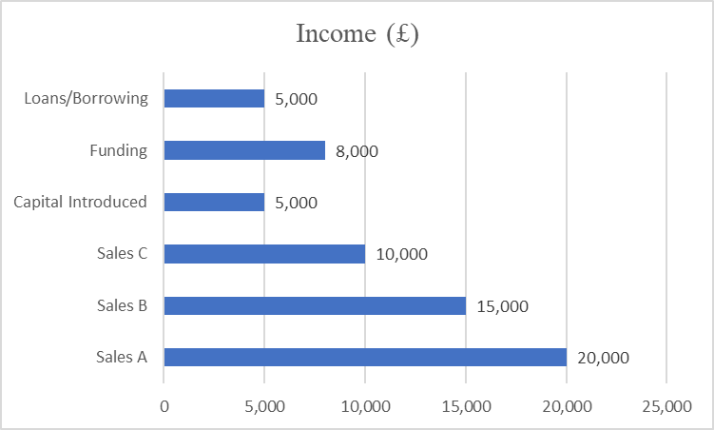
Figure 1: Income statement (Self-made)

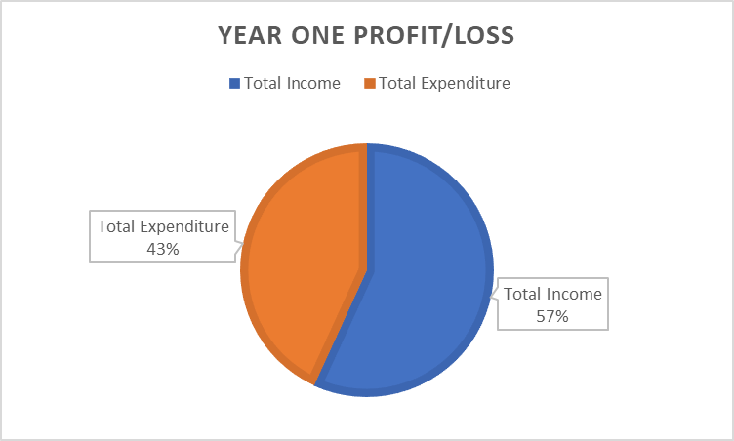
Figure 2: P/L statement (Self-made)

7.1 Financial Summary
For estimating income and expenditure, assumed sales figures, investment from the beginning, and various operational costs needed to setup and maintain The Curry Truck for the first year. Sales A, B, and C have expected sales with moderate success located at retail parks and stadiums, where the sales volumes are £45,000 per year. The addition of capital introduced, finance, and loans brings a further addition of £18,000 to pay for the starter costs.
This would mean the cost of salaries to employees at £15,000, essential machinery worth £4,000 for acquiring and marketing, which would also be valued at £2,000, would help in the formation of a stable brand image and the operational costs of renting the store, utilities, and other insurances account for approximately £10,000. All these have been considered to be important functions as regards 'The Team' or resources such as 'Key Resources', since such aspects have always played an important role in performing any successful function and it can't be stated that maintaining the customer is not the prime concern. This plan will achieve near £15,150 at the year-end profit, still fully viable with growth prospects.

APPENDICES

Appendix A – SWOT Analysis
Strengths | Weaknesses
• Unique concept of a curry-focused food truck | • Limited seating for customers
• High-quality, authentic, and fusion curry dishes | • Reliant on weather conditions, which may affect foot traffic
• Strategic locations at retail parks and football stadiums with high foot traffic | • Limited storage space for ingredients and supplies
• Affordable, quick meal option in busy areas | • Initial high setup and operating costs
• Flexibility to move and serve different customer bases | • Dependent on maintaining consistent ingredient supply
Opportunities | Threats
• Growing demand for diverse and affordable food options in the UK | • Strong competition from other food trucks and nearby quick-service restaurants
• Opportunity to expand to popular events, festivals, and other high-traffic areas | • Economic fluctuations impacting discretionary spending
• Potential for social media marketing to reach broader audiences | • Health and safety regulations that may require strict compliance and additional resources
• Collaborations with local suppliers for fresh ingredients | • Rising costs of ingredients and fuel

Appendix B – PEST Analysis

Factor | Description | Action
Political | Regulations and Licensing: UK food trucks must comply with stringent food safety and hygiene laws (Okumus et al., 2019). | Ensure ongoing compliance with health standards, maintain up-to-date licenses and certifications.
Economic | Market Growth: UK food truck market to grow from GBP 4.15B in 2024 to GBP 6.87B by 2029 (CAGR 6.5%) (Food Trailer Pro, 2024). | Leverage lower startup costs to offer affordable, high-quality meals compared to traditional dining.
Economic | Disposable Income Rise: Increased disposable income supports dining out (ONS, 2023). | Focus marketing on quality ingredients and unique flavors to attract consumers with disposable income.
Social | Urbanization & Busy Lifestyles: High foot traffic in Birmingham/Wolverhampton suits food truck locations. | Position The Curry Truck in high-traffic areas like retail parks and stadiums for maximum exposure.
Social | Curry Popularity: Curry, especially chicken tikka masala, is a UK favourite; Birmingham is famous for Balti curry (Ruggeri, 2022). | Offer traditional and fusion curry dishes to appeal to wide-ranging tastes and preferences.
Technological | Digital Platforms: Online ordering and delivery platforms are on the rise in the food industry. | Integrate with food delivery apps and online ordering to increase convenience and expand reach.
Technological | Innovation in Delivery: Potential use of driverless trucks and advanced tech (Madhumithaa et al., 2024). | Monitor technological advancements for future incorporation into The Curry Truck’s operations.

Appendix C – Copy of Pitch Supporting Material

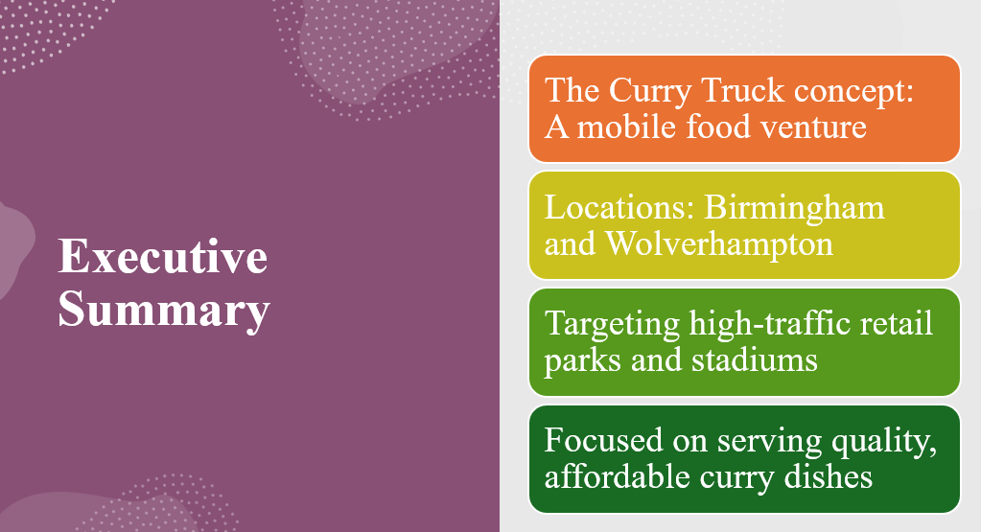
The Curry Truck is a food truck business that launched in Birmingham and Wolverhampton, targeting busy retail parks and football stadiums. The UK food trucks are expected to grow up to GBP 6.87 billion by 2029, with this venture offering curries as a meal variety to satisfy the needs of fast, quality foods in heavy-traffic venues.

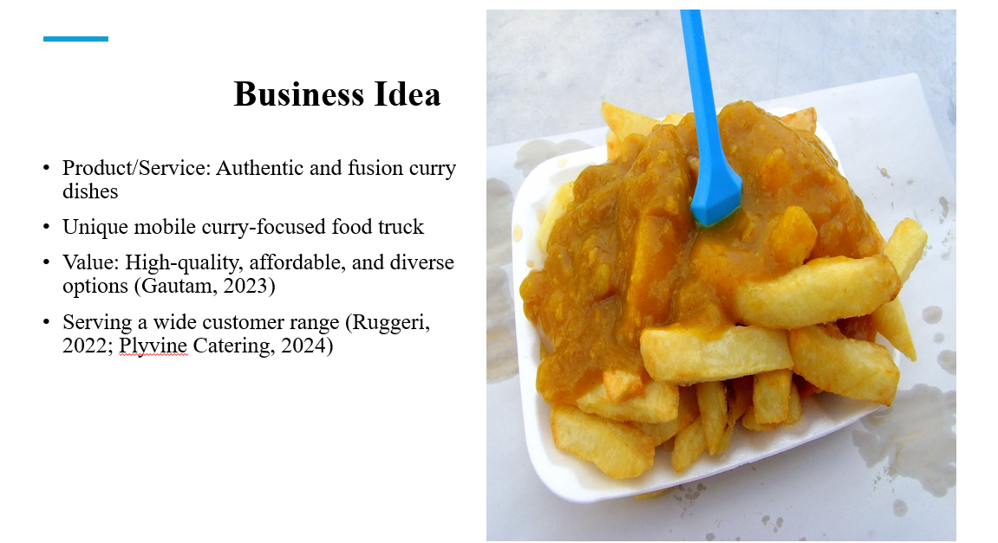
The Curry Truck offers proper curry and fusion-style curry for all tastes, within the hustle of busy urban centers. In a mobile setup, the Curry Truck can easily fulfill customers' demands for convenient variety. Strategically located, it takes advantage of curry's popularity in the UK, especially in Birmingham where Balti dishes are largely adored.
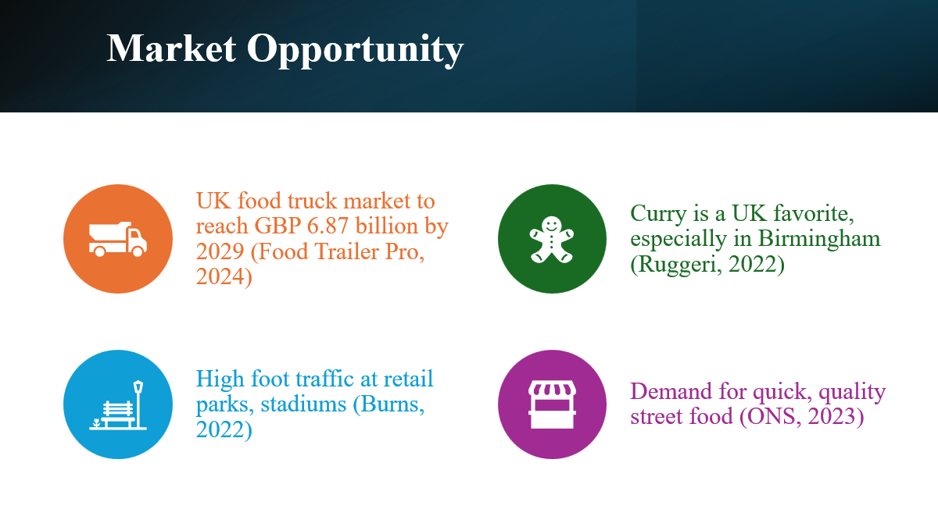
The UK food truck industry is one of high growth value, worth approximately GBP 6.87 billion by 2029. Curry is also a popular cuisine in the UK. Birmingham is one place that is known for its distinct Balti curry culture. Because Curry Truck focuses on busy areas such as retail parks and stadiums, we will be able to capture the demand for quick, high-quality food options in busy places.

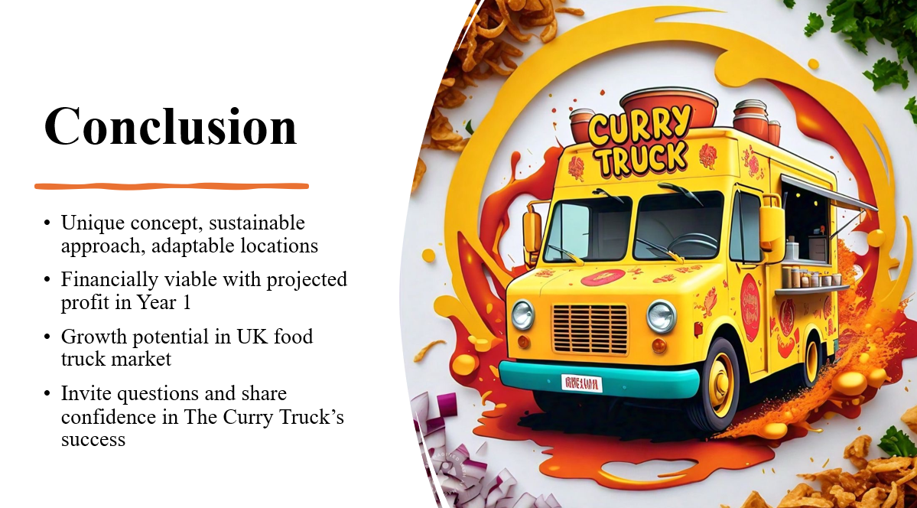

Based on research and calculations, the Curry Truck is expected to make a profit within a year, with the predicted sales and estimates. The location chosen has a great opportunity to expand the sales more than what is predicted because from research, you can see that football games as over 2000 potential customers for one game. The Curry Truck brings a different taste to these environments and with the growing taste for curry, sales are expected to do well. There are few choices for suppliers but the one that provides a good deal for the business because the business needs to make a profit.



Appendix D - Price List

Dish | Price (£)
Classic Chicken Curry | 7.00
Vegetable Tikka Masala | 6.50
Lamb Rogan Josh | 8.50
Paneer Butter Masala | 7.00
Prawn Coconut Curry | 9.00
Chicken Curry Combo (with naan and drink) | 10.00
Kids' Mild Veg Curry | 5.00
Weekly Special | 6.00 - 8.00

Appendix E - Branding mock-up for The Curry Truck
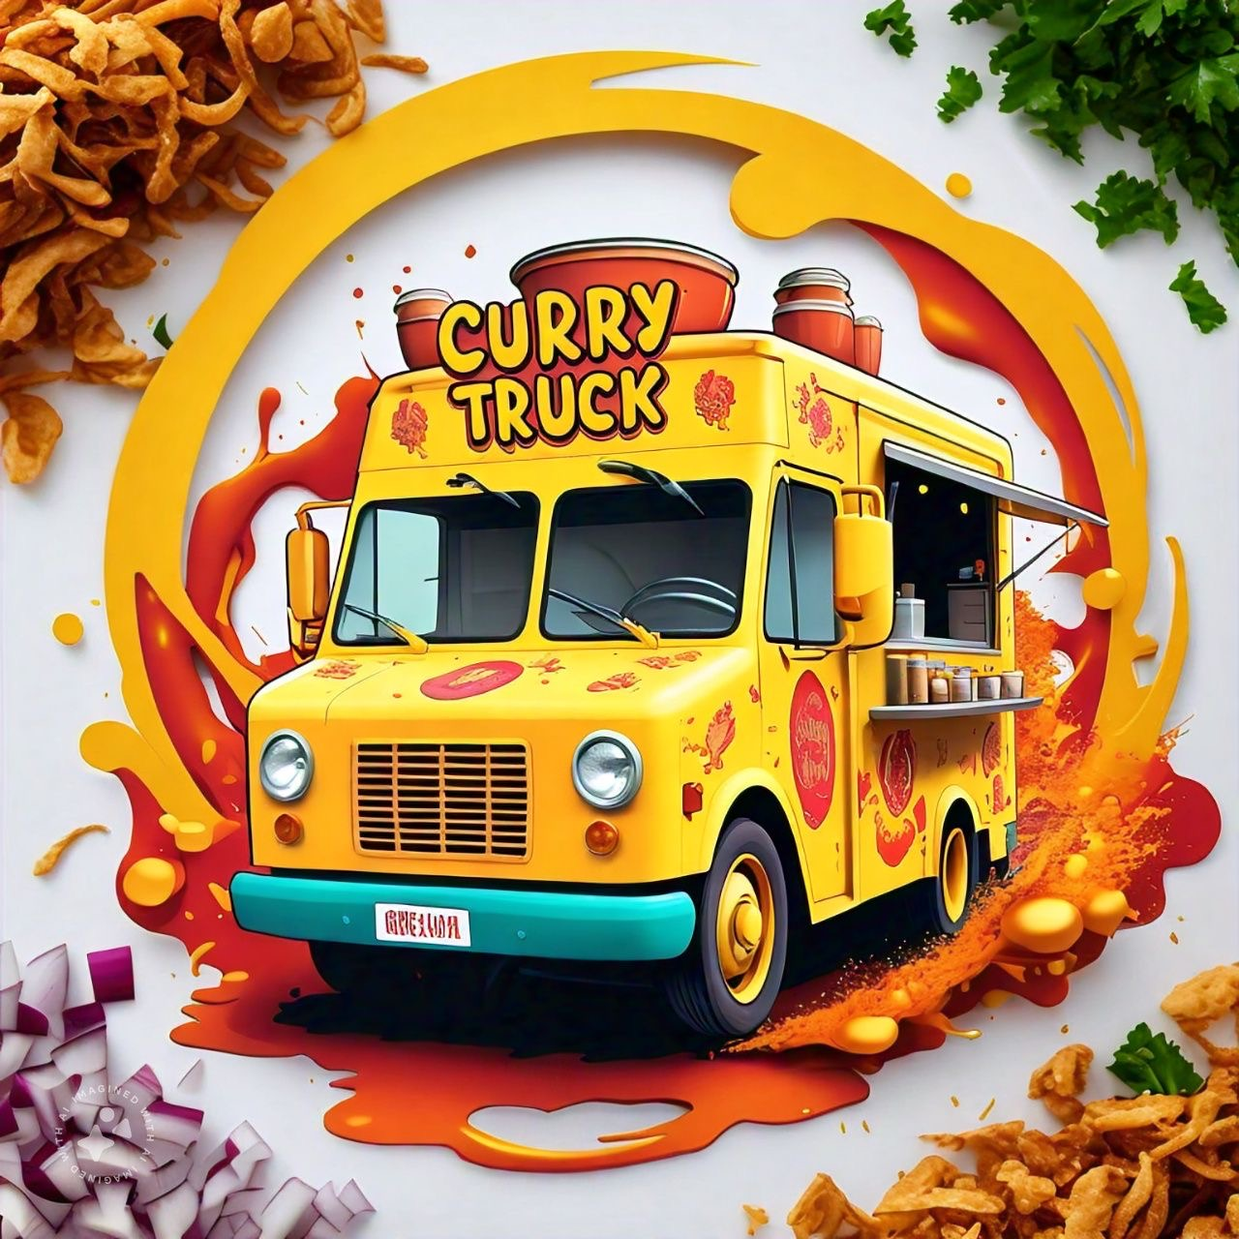

REFERENCE LIST:
Barringer, B. R. and Ireland, R.D. (2018) Entrepreneurship: Successfully Launching New Ventures, 4th Ed., Prentice Hall: New Jersey
Bella, S., Apriyanti, N., and Sriwijayanti, H. (2023). Enhancing financial management and accountant roles: A study on the role of technological advancements. SEIKO: Journal of Management & Business, 6(2), 435-446.
Blackwell, E. (2011), How to Prepare a Business Plan: Planning for Successful Start-up and Expansion, (5th Ed) Sunday Times Business Enterprise Series, Kogan Page.
Burns, P. (2022) Entrepreneurship and Small Business, 5th Ed., Palgrave Macmillan: Basingstoke.
Cahyaningtyas, F., and Ningtyas, M. N. (2020). The use of outsourced accounting service and its impact on SMEs performance. JABE (Journal of Accounting and Business Education), 4(2), 79-97.
Demir, A., Maroof, L., Sabbah Khan, N. U., and Ali, B. J. (2021). The role of E-service quality in shaping online meeting platforms: a case study from higher education sector. Journal of Applied Research in Higher Education, 13(5), 1436-1463.
Epos Now (2024) How much does a POS system cost? Available at: https://www.eposnow.com/us/resources/how-much-does-a-pos-system-cost/ (Accessed: 31 October 2024).
Farrer, J. (2023). From cooks to chefs: Skilled migrants in a globalising culinary field. In The Question of Skill in Cross-Border Labour Mobilities (pp. 123-139). Routledge.
Food Trailer Pro (2024) The food truck revolution: Navigating the 2024 UK market. Available at: https://foodtrailerpro.com/the-food-truck-revolution-navigating-the-2024-uk-market/ (Accessed: 31 October 2024).
Gautam, R. K. (2023). Fundamentals Of Retail Management. Academic Guru Publishing House.
Greggs (2024). Website, available at: Greggs | About us (Accessed on 10 November 2024)
Jeevs burger food truck. Available at: Jeevs Burger Food Truck | London (Accessed on 10 November 2024)
Jiang, Y., Lai, P., Chang, C. H., Yuen, K. F., Li, S., and Wang, X. (2021). Sustainable management for fresh food E-commerce logistics services. Sustainability, 13(6), 3456.
Kamboj, S., Gupta, N., Bandral, J. D., Gandotra, G., and Anjum, N. (2020). Food safety and hygiene: A review. International journal of chemical studies, 8(2), 358-368.
Madhumithaa, N., Elangovan, G., Sridharan, S., Karthick, L., ul Islam, A., and Venkatesh, R. P. (2024). Cutting-Edge AI-Powered Driverless Delivery Solution. In Trends and Applications in Mechanical Engineering, Composite Materials and Smart Manufacturing (pp. 129-145). IGI Global.
McDonalds (2024) website, available at: McDonald’s UK (Accessed on 10 November 2024)
Microsoft Copilot. (2024). AI Companion. Available at: https://www.microsoft.com/en-us/ai/copilot [Accessed 31 Oct. 2024].
Okumus, B., Sönmez, S., Moore, S., Auvil, D. P., and Parks, G. D. (2019). Exploring safety of food truck products in a developed country. International Journal of Hospitality Management, 81, 150-158.
ONS (2023) Household disposable income and inequality: Financial year ending 2023. Available at: https://www.ons.gov.uk/peoplepopulationandcommunity/personalandhouseholdfinances/incomeandwealth/bulletins/householddisposableincomeandinequality/financialyearending2023 (Accessed: 31 October 2024).
Pacella, J. M. (2020). The regulation of lawyers in compliance. Wash. L. Rev., 95, 947.
Pham, T. (2024). The Role of Social Media Marketing in Building Customer Loyalty in Fast Casual and Fast-Food Restaurants in Helsinki.
Plyvine Catering (2024) The UK’s 10 most popular curry dishes. Available at: https://plyvinecatering.co.uk/the-uks-10-most-popular-curry-dishes/ (Accessed: 31 October 2024).
Roy, H. (2024). Connecting farmers’ markets to foodservice businesses: A qualitative exploration of restaurants’ perceived benefits and challenges of purchasing food locally. International Journal of Hospitality & Tourism Administration, 25(3), 602-637.
Ruggeri, A. (2022) In search of a truly British curry. BBC Travel, 25 February. Available at: https://www.bbc.com/travel/article/20160113-in-search-of-a-truly-british-curry (Accessed: 31 October 2024).
Sandwell (2024) Approval of food business establishments. Website, available at: Approval of food business establishments | Sandwell Council (Accessed on 10 November 2024)

The Cooking foodie (2018) Quick and easy chicken curry recipe, video. Available at: https://youtu.be/JYg1UfVCfiw?si=cx-ZkPLFktNB56RC (Accessed on 10 November 2024)
The famous people (no date) ‘Gordon Ramsay Biography’ Article, available at: Gordon Ramsay Biography - Facts, Childhood, Family Life & Achievements (accessed on 10 November 2024)
Vegware (2021) Catalogue Available at: https://www.vegware.com/uk-en/catalogue/?gad_source=1&gclid=Cj0KCQjw1Yy5BhD-ARIsAI0RbXawz52fXIO1qhzYaavXnz_og28RB-B771DE-QGbBYM9oaoCy94pR1QaAqZXEALw_wcB (Accessed: 31 October 2024).
Wandosell, G., Parra-Meroño, M. C., Alcayde, A., and Baños, R. (2021). Green packaging from consumer and business perspectives. Sustainability, 13(3), 1356.
Wikipedia (no date) ‘Prince Harry, duke of Sussex’ biography available at: Prince Harry, Duke of Sussex - Wikipedia (accessed on 11 November 2024)
Williams, S. (2021) FT Guide to Business Start Up: The most comprehensive guide for entrepreneurs, 32nd Ed., Financial Times Press: Harlow.

