Art and Representation: Assessment 2 – A theoretically informed analysis of your chosen representation/art object/image, drawing upon one of the approaches covered in the module
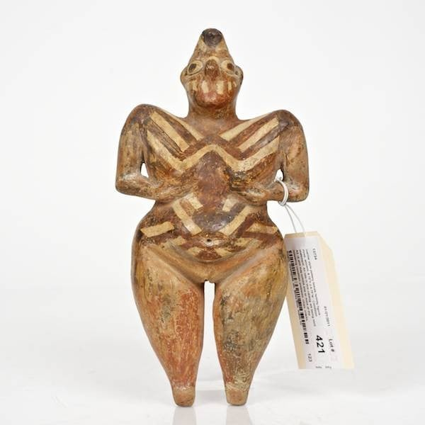
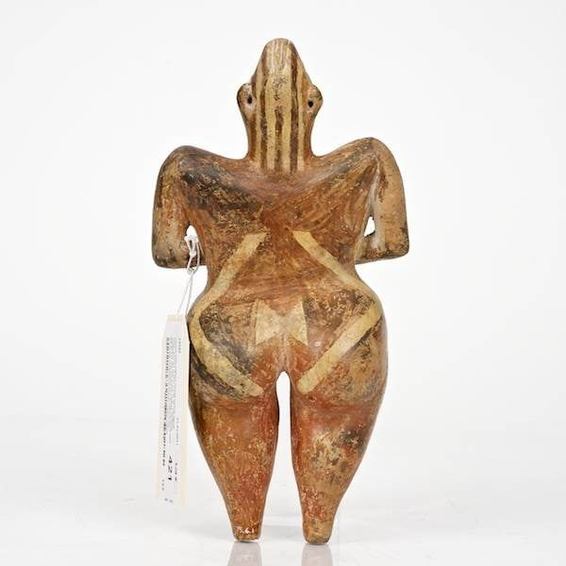
Figure 1. Hacilar style pottery female fertility figure Front Image. From Live Auctioneers. https://www.liveauctioneers.com/en-gb/item/8583810_421-hacilar-style-pottery-female-fertility-figure.
Figure 2. Hacilar style pottery female fertility figure Back Image. From Live Auctioneers. https://www.liveauctioneers.com/en-gb/item/8583810_421-hacilar-style-pottery-female-fertility-figure.

This object (Fig. 1 and 2) is a figurine from the Neolithic site of Hacilar. This figurine was sold on an auctioning site for $29,000 in February 2011. The figurine is the typical representation of an older woman. She has a curvy figure, pointed shoulders and a pointed-cone head. There are white lines painted in a zigzag pattern on the front and back of her body, her feet – which are not defined – are stubbed at the bottom and she has her hands held underneath her breasts. She has large eyes painted on, as well as what could be a mouth. This figurine may be a representation of women from Hacilar.

Because of this object’s journey, there is no scholarship mentioning or examining this specific figurine. To conduct the analysis of this particular figurine, other figurines from the site will be used to infer the object’s possible use and meaning. The figurines found and used are made of clay, and are unbaked. The figurine is red with the white painted on top – White-on-Red Ware –but Mellaart later describes the white colour as ‘orange or creamy’. This painting style is also seen on other pottery pieces from the site.

Mellaart lead the excavation at Hacilar, and he intended to ‘extend the archaeological sequence into the Chalcolithic and Neolithic periods’, and to also record any relations Anatolia had with ‘major geographical regions to both east and west’. Mellaart also achieved his two main purposes of the excavation: ‘to determine the character of the culture to which the painted pottery vessels acquired in December 1956 belonged … and secondly to establish a sequence of occupation levels down to virgin soil’.

The other figurines used have been dated between the Late Neolithic and Chalcolithic Period, and the auctioning website vaguely describes the figurine as ‘ancient’. Mellaart says that this painting style possibly came about during the Chalcolithic period, of which Voigt also works with in her analysis.

The figurine is one of many, and with there being such a variety in postures and possible ages they represent, they can tell us so much about Hacilar and women. These figurines are communicating an aspect of the Hacilar society, and how women were viewed and represented. To help understand communication in art – symbolic or not – Hatcher is used. She discusses the many ways meaning can be conveyed through art, using many examples from different cultures. Hatcher references Schieffelin, who summarises the importance of symbolic communication and what it means.

Ethnographic comparisons can also aid in providing possible examples of their use and importance based on similar scenarios in other cultures; this is something Bolger demonstrates effectively and thoroughly. By examining and analysing these figurines, scholarship can open up new possibilities in what and who they represent, in what context they featured, and how important these women were to the people of Hacilar.

The decorations, modelling and posture of the figurine are intriguing. The figurine is highly decorated, and this is one of the aspects that could be conveying a symbolic message of the Hacilar society. Scholars have previously looked at the use of figurines in a didactic approach, and with Voigt suggesting this briefly in her analysis, it is an interesting and – most definitely – a possible context the figurine could have been used in.

With there being no obvious, practical use known for this figurine, as well as the lack of textual evidence to tell us the use and meaning of it or even simply what it is, an investigation looking at the possible ways the figurine communicates a message, and if any of them are symbolic, will propose possible purposes and contexts of the figurine. By imitating the use of the figurine through an ethnographic comparison, there is a greater chance that scholarship can come up with the possible use and meaning of the figurine.

This figurine, according to Voigt’s report of Mellaart’s grouping, is part of the ‘statuette’ category, and within this, the standing sub-group. Voigt’s attempt to reconsider the grouping of the statuettes took into account the position of hands, where she reported that standing figures frequently had their hands positioned either at the sides or under the breasts.
Her examples include drawings of figures 485, and 531. Figures such as 523 show other figurines that depict the women holding their hands beneath the breasts while in different postures and positions.

The artistic style of the figurine is highly stylised but has some very naturalistic aspects to it in the gentle and suggestive curve of the body and legs. Voigt reports how Mellaart described the varying ages and postures of the women, and how they are associated: ‘standing figures include ‘mature woman with pendulous breasts’, ‘young woman, slim, in briefs’’. This figurine’s breasts are not as “pendulous” as figurine 531, but her breasts are emphasised by the painted lines following the curves of her chest and shoulders, and her hips, waist and thighs are emphasised with their curves. The slim figure of the younger women – which can be seen in Voigt’s drawings of figurines 575 and 486 – tend to be seen with less curve in the waist-hip-thigh area, and their breasts do not attract as much as attention to those listed as “mature”.

The placement of the hands underneath the breasts is particularly interesting; this choice of placement could have been made to bring more attention to the breasts, or simply because the figurine would have lasted longer with the hands being secured to the body like so. The second option seems less likely with the arms being cut away from the body, although it is still an option to be considered.

A third option important to consider is that the arm position is associated with symbolic gesture. The hand position is not a natural resting position, so the posture must have a form of meaning. Posture being associated with communication can be seen in Catholicism. When we look at people who have their hands in prayer, or paintings of saints with their eyes looking up, we understand that this means there is communication with God. Body language plays a large role in communicating messages, with it even communicating messages without us knowing, and studies in body language has allowed us to understand others at another level. It is definitely important to take into account the posture of the figurine, and it might indicate a message.

There are many other figures throughout history of women holding their breasts, and Qasim describes how the Willendorf figure grasps the breast with her fingers spread apart, ‘indicating the grip with which mothers hold the breast in breast feeding’. It is possible that the figurines being naked could be an everyday cultural gesture – like the modern day shaking hands or thumbs up. This figurine could represent a mother, or at least show what it is to be a woman at that stage in her life, and alongside the white lines emphasising the stomach and breasts, this is most definitely an option. The breasts being exposed, held and emphasised like so gives the impression that there is a meaning, and with the non-natural resting position, it could be a significant ritual gesture, like a modern-day blessing or prayer gesture.

The high, pointed shoulders deserve comment as they cannot be missed when one first looks at the figurine. They may be so high and pointed due to the posture and hand placement, and so be part of the ritualist gesture that is possibly being portrayed, and this view is supported by the many other figurines that Voigt has shown. Most of the figurines with high shoulders have their hands placed at breast level, and it is approximately equal numbers when looking at how many are stood up and how many are sat down. There seems to be a considerable correlation, then, between the shoulders being pointed and the hands holding the breasts, and so it is feasible that the shoulders are part of the suggested gesture and has a level of meaning being communicated to whoever is using the figurine.

What seems to be the most captivating part of the figurine is the surface design; the white painted lines on her body – both the front and back – are neat and tidy, carefully painted. They are deliberately placed and bring attention to her stomach area, her breasts, and her buttocks. A simple option of what these lines could be is that they are part of the Hacilar painting style, which can be found on pottery from the same site and time period (Fig. 3). They also may have symbolic significance, and may be intended to communicate cultural information related to ritual, status or a particular cultural activity, but an interesting idea to explore is that the painting may also represent a body art/modification of sorts.

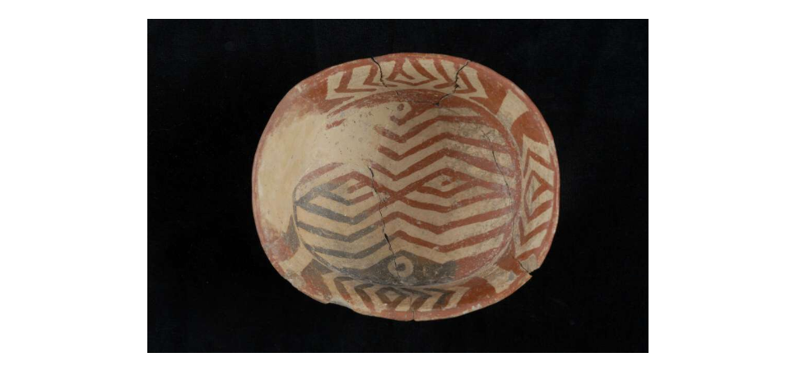
Figure 3. Painted Bowl from Hacilar. From the Trustees of the British Museum. https://www.britishmuseum.org/collection/object/W_1966-0616-2.

Body paint can be found across communities in Australia, Africa and Papau New Guinea, and while the designs help express personal and/or group identity, research has shown there is a possibility that they also ‘serve a function in heat regulation or as camouflage’. A popular modern day design used is to replicate zebra stripes; horseflies are not attracted to these contrasting stripes, and by using this design in their body paintings, people are at less risk of contracting disease from these insects. Akesson et al. also comment that the white paint is also applied to boys and girls ‘to initiate them into society’, showing that the white lines – if they represent body paint – could have a ritualistic meaning. They could represent a pattern that shows a woman entering into an important milestone in her life, such as motherhood or pregnancy.

The white lines painted around her stomach could be used to highlight a pregnancy; today, women are ‘bump painting’, and according to a makeup artist that has been in the body painting industry for 12 years, women do it for three reasons: ‘the bespoke design … the act of being professionally photographed … being pampered and focused on in the late stages of pregnancy’. When having their photographs taken, the women bring more attention to their pregnancy with the design painted on the bump. The white lines on the figurine may be a version of the ‘bump painting’, as it would have brought attention to the woman in an important stage of her life.

Scarification is also seen in other cultures. When looking at this body modification in Ghana, Irving found that scarification was used in medical contexts, protection from spirits, tribe and familial identification, and for decorative use. Irving also found that scarification was used to ‘beautify’ both men and women, but it was more common among women. These white lines could represent scarification. Irving interviewed a man in Gwollu who bore marks on his face. While they had medicinal and decorative purposes, they also had a personal meaning to him, because they ‘served as family marks of bonding, but not by tribe’. These marks were made by his father, and were seen on most of his siblings too.

Markings are also used as a form of spiritual protection; Irving spoke to E. M. Wright, who spoke about how priests would mark wrists or hips as a way of protecting the person from evil. The hips were a private place to have these marks, and any marks made on the wrists would make others suspicious. Wright also says that men are more likely to bear the marks of spiritual protection, because they bore more hardship in their lives. These marks around the outside of her stomach – near her hips – could represent scarification to protect her from evil. Studies about the contexts in which zigzag lines appear have frequently been found to protect from evil, or to guard objects and sites from evil. It is possible that the lines on the figurine represented protection for the owner, or represented a way in protecting the owner’s fertility and ability to breastfeed, although these cannot be known.

These white lines painted on the figurine could show what women looked like; there is a possibility that the lines represent body paint, scarification, or tattooing. Body modification can be seen across the world, across time periods, and so it is not something to dismiss when looking at the patterns on these figurines.

The legs of the figurine seem to be worn down, and it is not possible to tell if they were also painted at all. However, the wearing of these legs is a crucial part of the analysis. It suggests that the figurine was held by the legs, and possibly rubbed, and so it had importance to whoever used it. Bolger’s research of a ritual deposit in Chalcolithic Cyprus led her to suggesting that the figurines found were used in a birthing and fertility context, and she uses ethnographic comparisons to show why this is a respectable and fair proposal. Some figurines did have polished areas, which meant they were held at some point by someone, and with there being localised areas of wear, alongside the variety of postures and positions of pregnancy and birth, Bolger suggests they were ‘used as dolls or dummies to demonstrate aspects of pregnancy and birth’. Bolger further suggests that these were held and squeezed by women while they gave birth. She argues that they were didactic models, to guide women through labour – an extremely dangerous part of their lives.

It is possible that the Hacilar figurine also had a didactic use; they could have been used to explain and show girls and women what the important events and milestones of their lives were, and what to expect.

This figurine was created to convey a meaning of sorts, and it is still a question if any of these messages communicated are symbolic. The posture presents a plethora of possibilities in both ritualistic contexts and everyday life, but the symbolic gestures suggested are particularly intriguing and more likely due to the unnatural resting posture and hand position of the figurine.

The painted lines could also be a ritualistic aspect, as well as their possible use in protection, but they also, simply, highlight parts of the woman’s body that could have been seen as the most important – pregnancy and breast feeding.

I believe this figurine, as well as the others found, could have been used to teach girls and women about what their body goes through, and the important parts of their lives – puberty, marriage, childbirth etc. These figurines could have been a mentor for them, someone for them to talk to – although I do not believe that these figurines were any kind of ‘mother-goddess’ for them.

Bibliography
Akesson, S., Horvath, G., Kriska, G. and Pereszlenyi, A. (2019) ‘Striped bodypainting protects against horseflies’, Royal Society Open Science, 6, pp. 1-13.
Bolger, D. L. (1992) ‘The Archaeology of Fertility and Birth: A Ritual Deposit from Chalcolithic Cyprus’, Journal of Anthropological Research, 48(2), pp. 145-64.
Chesson, M. S. and Kuijt, I. (2005) ‘Lumps of Clay and Pieces of Stone: Ambiguity, Bodies, and Identify as Portrayed in Neolithic Figurines’, in Bembeck, R. and Pollock, S. (ed.). Archaeologies of the Middle East: Critical Perspectives. Oxford: Blackwell Publishing.
Friekman, M. and Garfinkel, Y. (2009) ‘The Zoomorphic Figurines from Sha’ar Hagolan: Hunting Magic Practices in the Neolithic Near East’, Levant, 40(1) pp. 5-17.
Hartley, G. and Karinch, M. (2007) I Can Read You Like a Book: How to Spot the Messages and Emotions People are Really Sending with their Body Language. USA: Career Press.
Hatcher, E. P. (1985) Art as Culture: An Introduction to the Anthropology of Art. London: University Press of America.
Irving, A. (2007) ‘An Ancient Practice: Scarification and Tribal Marking in Ghana’, HCAD, Fall, pp. 1-44.
Ladd, K. L. and McIntosh, D. N. (2008) ‘Meaning, God, and Prayer: Physical and metaphysical aspects of social support’, Mental Health, Religion & Culture, 11(1), pp. 23-38.
Lesure, R. G. (2011) Interpreting Ancient Figurines: Context, Comparison, and Prehistoric Art. New York: Cambridge University Press.
Live Auctioneers (2011) 421: Hacilar style pottery female fertility figure. [MEDIUM] Aavilable at: https://www.liveauctioneers.com/item/8583810_421-hacilar-style-pottery-female-fertility-figure. (Accessed: 22 October 2020).
Mellaart, J. (1958) ‘Excavations at Hacilar: First Preliminary Report’, Anatolian Studies, 8, pp. 127-56.
Mellaart, J. (1959) ‘Excavations at Hacilar: Second Preliminary Report, 1958’, Anatolian Studies, 9, pp. 51-65
Pickard, A. (2012) ‘Bump painting: a pregnancy trend?’, The Guardian, 17th October. Available at: https://www.theguardian.com/lifeandstyle/2012/oct/17/bump-painting-pregnancy-trend. (Accessed: 1 December).
Qasim, E. (2013) ‘Female Figurines: The Milk Squirting-Venus Galaktorainoussa’, Das Altertum, 58(4), pp. 289-306.
Seksel, K. (2014) ‘Fear, Aggression, Communication, Body Language and Social Relationships in Cats’, EJCAP, 24(3), pp. 20-27.
Stringham, S. F. (2011) ‘Aggressive body language of bears and wildlife viewing: a response to Geist (2011)’, Human-Wildlife Interactions, 5(2), pp. 177-91.
Uher, J. (1991) ‘On Zigzag Designs: Three Levels of Meaning’, Current Anthropology, 32(4), pp. 437-39.
Voigt, M. M. (2007) ‘The Splendour of Women: Late Neolithic Images from Central Anatolia’, in Morley, I. and Renfrew, C. (ed.). Image & Imagination: A Global History of Figurative Representation. Cambridge: McDonald Institute for Archaeological Research.

Live Auctioneers 2011.
Voigt 2007, p. 158.
Ibid: These pieces have already gone through an analysis in scholarship.
Ibid, p. 158.
Ibid; p. 160.
Mellaart 1959, p. 60.
Ibid.
Mellart 1959.
Voigt 2007, p.157.
Mellaart 1958, p. 128.
Voigt 2007, p. 158.
Live Auctioneers 2011.
Mellaart 1959, p. 62.
Hatcher 1985, p. 135-166.
1976, cited in Hatcher 1985, p. 165-6: ‘symbolic activity brings objects and concepts into new and different kinds of relationships in a larger system of meaning, formulating and organizing them in new ways according to a few simple procedures’.
Bolger 1992.
Chesson and Kuijt 2005; Freikman and Garfinkel 2009; Lesure 2011.
Voigt 2007, p. 158: statuettes are ‘carefully modelled figures that depict female bodies in some detail’, whereas figurines have an ‘inferred function as ‘ex voto substitutes’ rather than on form’.
Ibid.
Ibid.
Ibid, p. 164.
Ibid, p. 165.
Ibid, p. 168; p. 172: this figure in particular is sat on ‘a double cat chair’.
1970, cited in Voigt 2007, p. 158.
Voigt 2007, p. 165.
Ibid, p. 167; p. 172.
Ibid, p. 166; p. 171.
Ladd and McIntosh 2008, p. 32.
Hartley and Karinch 2007; Seksel 2014; Stringham 2011.
Qasim 2013, p. 293.
Voigt 2007, p. 163-70.
Akesson, et al. 2019, p. 2.
Ibid, p. 1-3.
Ibid, p. 3.
Pickard 2012.
Irving 2007, p. 5.
Ibid, p. 17.
Ibid.
Uher 1991, p. 438.
Bolger 1992, p. 155.
Ibid, p. 160.

