AUDIT CASE STUDY OF HYATT HOTEL GROUP
ASSIGNMENT 2: REPORT
Student Name: Florin Matache
ID: 2126293
Lecture name: Charlotte Joyner
BMIH5004
Management & Organisational Behaviour

Executive Summary
This report provides an in-depth analysis of Hyatt Hotels Corporation, a leading global hospitality company. It examines Hyatt's organizational structure, perceived culture, strategic goals, change initiatives, and current business performance. The report highlights Hyatt's strengths in brand reputation, innovation, and sustainability, while acknowledging weaknesses such as reliance on external factors and high operational costs. Opportunities for growth include expansion into emerging markets and technological advancements, while threats include intense competition and economic fluctuations. Overall, Hyatt's strategic direction emphasizes customer-centricity, employee empowerment, and sustainable practices, positioning the company for continued success in the dynamic hospitality industry.
Table of Contents
Introduction 4
Main body 4
Organizational structure 4
Perceived organizational culture 6
Goals, visions or aims 6
Hotel’s change strategy 6
Hotel group’s current business performance 6
Conclusion 6
References 7

Introduction
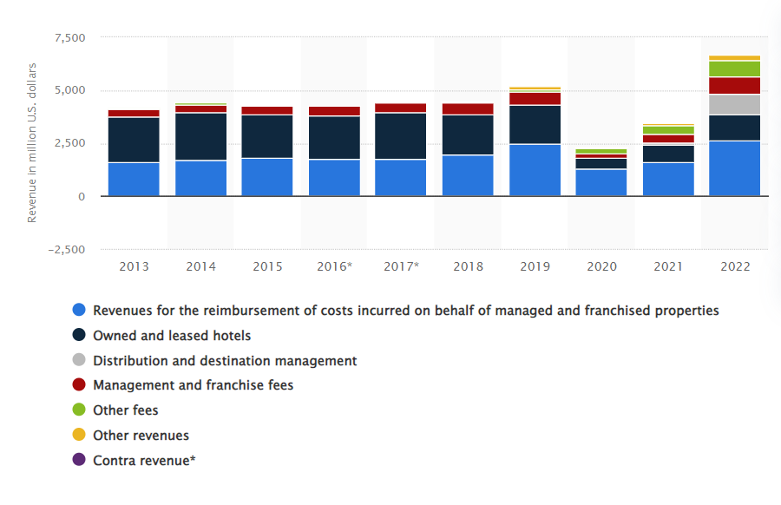
Figure 1: Revenue streams of Hyatt hotel
(Source: Statista, 2023)
Hyatt Hotels Corporation is a leading global hospitality company renowned for its upscale accommodations and exceptional guest experiences. With over 1,000 properties worldwide, Hyatt operates under various brands, including Hyatt Regency, Grand Hyatt, Andaz, and Park Hyatt, catering to diverse traveler preferences. Committed to innovation and sustainability, Hyatt prioritizes guest satisfaction while embracing cultural diversity and community engagement (Hyatt, 2024). Through its distinctive properties and personalized service, Hyatt continues to redefine luxury hospitality, ensuring memorable stays for guests across the globe. Hyatt's commitment to innovation, sustainability, and cultural diversity sets it apart, ensuring memorable stays for guests while contributing positively to the communities it serves.

Main body

Organizational structure
The organizational structure of Hyatt Hotels is characterized by its hierarchical arrangement, functional divisions, and geographic segmentation, reflecting its commitment to operational efficiency, innovation, and customer satisfaction.
At the top of the hierarchy is the Board of Directors, responsible for setting the strategic direction and overseeing the overall performance of the company. Reporting to the Board is the executive leadership team, led by the President and CEO, who holds ultimate responsibility for driving Hyatt's vision, mission, and values across all levels of the organization (Investors.Hyatt, 2024).
Hyatt's organizational structure comprises various functional divisions, each tasked with specific responsibilities to support the company's operations and strategic objectives:
- Operations Division- This division oversees the day-to-day management of Hyatt's properties worldwide, ensuring high standards of service, guest satisfaction, and operational efficiency. It includes departments such as Rooms Division, Food and Beverage, Sales and Marketing, and Guest Services.
- Finance and Administration Division- It is responsible for financial planning, budgeting, accounting, and administrative functions across the organization. This division also manages corporate governance, risk management, and compliance activities (Fitriah, 2022).
- Human Resources Division: Focuses on recruiting, training, and retaining talent, as well as fostering a positive work culture and employee engagement. It plays a crucial role in supporting Hyatt's commitment to diversity, inclusion, and employee development.
- Development and Real Estate Division: This division is responsible for identifying new growth opportunities, negotiating property acquisitions, and managing real estate assets. It oversees the expansion of Hyatt's global footprint through strategic partnerships, franchise agreements, and property developments.
- Technology and Innovation Division: Manages the company's IT infrastructure, digital platforms, and innovation initiatives aimed at enhancing guest experiences, optimizing operational processes, and driving technological advancements within the hospitality industry (Fukuda, 2020).
The company has set up working functional units and it has added the geographical organization to meet different customer needs and various regional norms. The firm works through a worldwide network of offices and regional departments that perform the market analysis, brand positioning and day-to-day operations management. Alignment of centralized control and decentralized decision-making is what characterizes Hyatt’s organizational structure and is aimed at balancing the need for brand-wide consistency, agility, and adaptability to market particulars and dynamics. Such configuration conveys the high focus of the company on the customer's comfort and Hyatt's desire to become the most preferred and valued hotel firm worldwide.

Perceived organizational culture
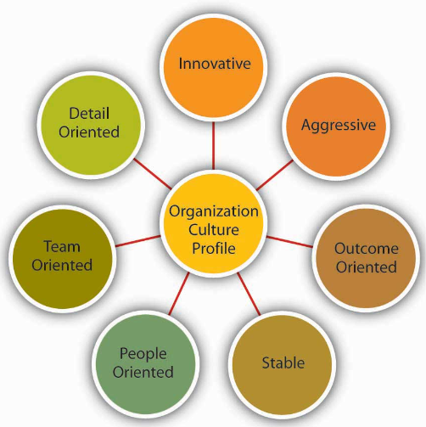
Figure 2: Types of Organisation Culture Profile
(Source: Tortorella et al. 2021)
At the core of the organizational culture at Hyatt Hotels is customer service excellence, employee empowerment, diversity, and sustainability which are perceived to be the most important ones. This culture is much imbedded in company values and practices that determine how employees conduct them and interact with one another across all levels (Isensee et al. 2020).
One of the important components of Hyatt's organizational culture is its unyielding attention to guest satisfaction employees are motivated to adopt a concierge approach in order to provide guests with exceptional experience during their stay. Such customer-centric mindset is demonstrated in Hyatt’s training, where the employees are given the capabilities and the tools to forecast and fulfil guests’ demands. In addition, from the pleasantness, to the attention to details, and all the way to consumer interaction, Hyatt's culture encourages the idea that the guest is one's main priority.
\Furthermore, Hyatt will focus on the staff involvement and engagement as the key factors of organizational growth. The organization recognizes the impact of its workers and creates an alliance environment that is accommodative and inclusive where people are enabled to express themselves, take leadership, and work as a team. With such a culture of empowerment, employees will experience better morale and job satisfaction, which also spurs innovation and constant improvement of the company (Spicer, 2020).
In addition, and to confirm, diversity and inclusion are the basic pillars of the Hyatt organizational culture. Diversity and inclusion are core values of the company, and these can be clearly seen through the workforce that the company have, where it reflects the diversity of the community it serves and celebrates various backgrounds, perspectives, and experience. Through celebrating diversity, Hyatt creates an atmosphere of respect, openness, and understanding, thereby, enriching the employees’ experience and boosting the company’s ability to connect with a wide range of guests.
In this theoretical perspective, Hyatt's organizational culture correlates with theorists' models such as Edgar Schein's model and the Competing Values Framework. Schein's theory around organizational culture is significant because it lays down the basis of the shared values, assumptions, and artefacts that contribute to the cultural setting of this hotel where customer service, empowerment of employees, and diversity are the core elements (Azeem et al. 2021). Similarly, the Competing Values Framework highlights four types of organizational culture: group, project, hierarchy, and market. Hyatt's culture is a mix of clan culture (emphasis on cooperation and employee development) and market culture (results and customer satisfaction being the focus not being neglected) and so the balanced approach.

Goals, visions or aims
The Hyatt Hotels Corporation has developed a strategically oriented guideline that integrates overarching objectives, visions, and ambitions into its operational priorities. The goals include many areas of operation such as sustainability, guest experience, staff welfare, and financial performance.
One of Hyatt's main objectives is to be one the leaders in sustainable hospitality. The company is aiming for lofty goals in terms of reducing environmental impact and making a positive social contribution (Bashir et al. 2020). Likewise, Hyatt aspires to reach net-zero carbon emissions across all its global operating locations by a designated date.
On the aspect of guest experiences, Hyatt focuses on providing consistent excellent service and personalized treatments that go beyond customer expectations. The company attempts to increase guest satisfaction by continuously innovate its offerings, utilizing technology to improve efficiency and convenience, and providing employees with professional development and training pathways that enable them to deliver world class service.
Additionally, Hyatt is committed to creating an environment, where everyone is treated fairly and respectfully, and providing employees with the opportunity to advance. The company set up diversity, equity, and inclusion goals including the inclusion of groups that were underrepresented in leadership positions as well as the implementation of projects helping to raise awareness and create a feeling of belonging among employees (Boulware et al. 2022).
The financial performance as an area of concern is another focus area for Hyatt since they strive for sustainable growth and generation of long-term value for its shareholders. Financial objectives can be highly specific, e.g. increasing revenue per available room (RevPAR), maximizing profitability, and growing market share in a selected key areas and markets.

Hotel’s change strategy
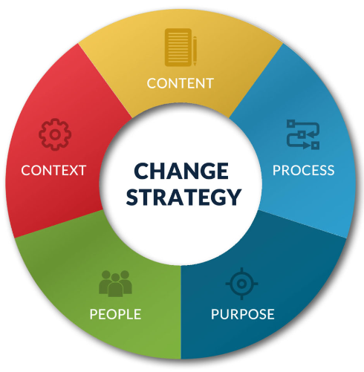
Figure 3: Change strategy
(Source: Hanelt et al. 2021)
Hyatt Hotels Corporation is firmly focused on the implementation of change strategies and initiatives to cope with phenomenal market dynamics improve the guest experience and create sustainable growth. These efforts cover the areas, including technologies adoption, sustainability practices, and organizational development.
Another critical strategy leveraged by Hyatt is the implementation of state-of-the-art technologies for the purpose of service innovations and increasing operation efficiency. The organization has been on a path of investing in digital platforms, mobile applications and artificial intelligence (AI) to create smooth check-in/check-out processes, customize customer experiences and enhance operational performance (Bonina et al. 2021). With the use of technology, Hyatt is aiming at providing more convenience to guests, getting the maximum utilization of resources and keeping up with an ever-changing industry.
Furthermore, Hyatt has included sustainability within its change program and made it a core component. The organization is involved in the actions to diminish its ecological footprint, to lessen the amount of generated waste and to promote the sustainable operations. These attempts are the energy-efficient designing of buildings, water conservation measures, waste reduction programs, and sourcing responsible materials. In addition, Hyatt commits to its social responsibility by adopting sustainability practices and attracts eco-friendly consumers, which in turn increases its brand value.
Moreover, organizational development and cultural transformation are the key forces that change the culture within Hyatt. The company understands the value of developing an innovation-led, collaborative, and continuous learning attitude, which must be flexible to meet the evolving needs of customers and the industry (Shufutinsky, 2020). The Hyatt invests in staff training programs, leadership development courses, and performance management techniques so that the company can empower its workforce and make the organization more successful. Through the development of the culture of agility and adaptability, Hyatt Inc. will stay ahead of the pack and it will be prepared to compete in the dynamic business environment in the end.

Hotel group’s current business performance
Strengths | Weaknesses
Strong brand reputation and global presence | Dependence on external factors like economic conditions
Diverse portfolio of upscale hotel brands | Vulnerability to geopolitical risks and natural disasters
Commitment to innovation and sustainability | Reliance on third-party owners for property management
Emphasis on exceptional guest experiences | High operational costs and overhead expenses

Opportunities | Threats
Expansion into emerging markets and untapped regions | Intense competition from other hotel chains and Airbnb
Growing demand for sustainable and experiential travel | Economic downturns and fluctuations in travel demand
Technological advancements driving digital transformation | Shifts in consumer preferences and travel behaviour
Strategic partnerships and collaborations for growth | Regulatory changes impacting the hospitality industry
Table 1: SWOT analysis
(Source: Self-created)
Hyatt Hotels Corporation's present business execution reveals a result of mixed strengths, weaknesses, opportunities, and threats. The firm does not cease to benefit from its powerful brand reputation, global presence and wide range of upmarket hotel brands which give it competitive edge in this dynamic business environment to serve the preferences of different travellers and market segments (Rust et al. 2021). Innovation and sustainability of the brand, Hyatt, are other factors that improve the competitiveness and appeal to the environmentally conscious consumers.
Although Hyatt has competitors, the key challenge for the company is that it is dependent on external factors, which include the economy and political risks that can affect the company's financial performance and growth prospects Also, the company’s operation through the third-party owners for property management and high operational costs implies that profitability and operational efficiency are not guaranteed.
In spite of these challenges, Hyatt has outlined a few opportunities for growth, which include the presence in untapped markets, application of technological advancements, and capitalizing on the increasing demand for sustainable and experiential travels. Through deliberate growth of reach, improved efficiencies of digital footprint, and establishing strategic alliances, companies like Hyatt has the ability to take advantage of these opportunities in order to achieve sustainable growth (Cacciolatti et al. 2020).The challenge is not yet over. Other hotels and non-traditional accommodation are opportunities that Hyatt must compete against as well as the few concerns like economic downturns and shifts in consumer choices.

Conclusion
To sum up, Hyatt Hotels Corporation is rightfully considered as a leading world hospitality company that is guided by its values, searching for new ideas, being environmentally responsible, and providing outstanding service to the customers. Adopting a robust structure and a culture that empowers and embraces diversity, as well as aligning the strategic initiatives towards the growth and adaptability to meet change in market dynamics, Hyatt shall retain success. Through its leveraging its strengths, addressing weaknesses, taking up opportunities, and neutralizing threats, Hyatt is an excellent brand to maintain its reputation as the preferred choice of travellers worldwide and contributing to the community and environmental sustainability.

References
Fitriah, A., (2022). Analysis of the effect of providing financial and non-financial compensation on employee job satisfaction studies on employees of the division of human resources (HR), administration and finance of PT. Hanazono Engineering Indonesia. Indonesia Auditing Research Journal, 11(3), pp.89-96.
Fukuda, K., (2020). Science, technology and innovation ecosystem transformation toward society 5.0. International journal of production economics, 220, p.107460.
Hyatt, (2024). Home Page [Online], Available at: Hyatt | Search Results [Accessed on 19th Feb, 2024]
Investors.Hyatt, (2024). Executive Management [Online], Available at: Hyatt Hotels Corporation - Governance - Executive Management [Accessed on 19th Feb, 2024]
Statista, (2023). Revenue of the Hyatt Hotels Corporation worldwide from 2013 to 2022, by business segment [Online], Available at: Hyatt Hotels revenue by segment 2022 | Statista [Accessed on 19th Feb, 2024]
Tortorella, G.L., Fettermann, D., Fogliatto, F.S., Kumar, M. and Jurburg, D., 2021. Analysing the influence of organisational culture and leadership styles on the implementation of lean manufacturing. Production planning & control, 32(15), pp.1282-1294.
Hanelt, A., Bohnsack, R., Marz, D. and Antunes Marante, C., 2021. A systematic review of the literature on digital transformation: Insights and implications for strategy and organizational change. Journal of Management Studies, 58(5), pp.1159-1197.
Isensee, C., Teuteberg, F., Griese, K.M. and Topi, C., 2020. The relationship between organizational culture, sustainability, and digitalization in SMEs: A systematic review. Journal of Cleaner Production, 275, p.122944.
Spicer, A., 2020. Organizational culture and COVID-19. Journal of Management Studies, 57(8), pp.1737-1740.
Azeem, M., Ahmed, M., Haider, S. and Sajjad, M., 2021. Expanding competitive advantage through organizational culture, knowledge sharing and organizational innovation. Technology in Society, 66, p.101635.
Bashir, M.F., Ma, B. and Shahzad, L., 2020. A brief review of socio-economic and environmental impact of Covid-19. Air Quality, Atmosphere & Health, 13, pp.1403-1409.
Boulware, L.E., Corbie, G., Aguilar-Gaxiola, S., Wilkins, C.H., Ruiz, R., Vitale, A. and Egede, L.E., 2022. Combating structural inequities—diversity, equity, and inclusion in clinical and translational research. N Engl J Med, 386(3), pp.201-203.
Bonina, C., Koskinen, K., Eaton, B. and Gawer, A., 2021. Digital platforms for development: Foundations and research agenda. Information Systems Journal, 31(6), pp.869-902.
Shufutinsky, A., 2020. Employing use of self for transparency, rigor, trustworthiness, and credibility in qualitative organizational research methods. Organization Development Review, 52(1), pp.50-58.
Rust, R.T., Rand, W., Huang, M.H., Stephen, A.T., Brooks, G. and Chabuk, T., 2021. Real-time brand reputation tracking using social media. Journal of Marketing, 85(4), pp.21-43.
Cacciolatti, L., Rosli, A., Ruiz-Alba, J.L. and Chang, J., 2020. Strategic alliances and firm performance in startups with a social mission. Journal of Business Research, 106, pp.106-117.

