Student name: Kayani Amjad Ghulam
Student ID: 1807441
Module title: Developing innovation and creativity for business advantage
Module code: BMSW6102
Lecturer name: Dr Md Nazmul Hasan

Table of contents:
Introduction: page 3
Unique service proposition: page 3
E-commerce: page 4
Marketing: page 7
Conclusion: page 7
Reference list: page 7

Introduction:
This report is about a unique service that can be provided remotely during the lockdown. The pandemic has had an impact on everyone including customers behaviour. During the lockdown, the demand for online shopping has seen a surge and customers turned to online shopping to acquire certain products. This report consists of a unique service proposition on how to learn to drive during the lockdown’s ban on professional driving tuition. Traditionally, driving lessons are given by a professional driving instructor and extra help is given by family members or friends. But during the lockdown, only people within the bubble can help leaners to learn to drive as long as they meet certain regulations. Initially, the first part of this paper will look at the unique service proposition in details. While, the second part will look at how this service will be accessible to customers. The third part will look at the marketing aspect of this online business. And finally, to complete this report, a conclusion will be given.
Unique service proposition:
During lockdown, professional driving tuitions weren’t allowed and only a household member or a support bubble could help learners gain some practical driving skills (Martin, 2021). As long the household members or a support bubble meets the legal requirements, this is the only way for learners to practise driving during the lockdown. There are many you tube videos regarding driving lessons but there isn’t any unique service that will allow learners to pass their driving test without the help of a professional driving tuitions. According to DVLA, overs 40 hours of professional tuition along with some private practise is required in order to pass the practical driving test (Allan, 2019). This unique service proposition takes into consideration the ban on professional driving lessons during the lockdown as well as the cost involve in learning to drive. This unique service proposition is to combine videos recorded briefings about all the topics needed to pass the driving test as well as an agreed numbers of direct contact through phone or video calls with a professional driving instructor to ask any questions or ask to clarify or explain topics. This service will allow learners to have a direct contact with a qualified driving instructor and practise their skills according to a well-structured way of learning how to drive during the lockdown. Furthermore, this service will allow learners to save money and through this service, learners will be able to pass their driving test going forward. This proposition can benefit all learner drivers as long as they have someone in the household or support bubble that meet the requirements set by DVSA to supervise a learner driver. According to the DVSA, a person can supervise a learner driver as long the driving license is held for three years and the minimum age of the person is twenty-one (gov, 2021). In the UK, during 2019/20, the number of driving test taken was above 1,5 million (Statistica, 2021). This figure highlights the potential for driving lessons and the potential for the unique service proposition.
This service will be available to buy online in the UK and the customers will be able to choose between different options to meet their needs. Upon completion of the payment, the customers will receive an email containing all the information about their purchase including links to the briefings. Due to the nature of this business proposition, everyone in the UK can benefit from this service. The name of this business represents the main idea of the service, it is called Pass your driving test without an instructor. The idea can be considered as a disruptive innovation as it will make learning to drive cheaper, simpler than usual. According to Hopp & el l (2018, p446) “disruption by definition begins in the low-end of the market”. Keeping this idea in mind, this service proposition will challenge all the established driving school businesses and been the first to come up with this unique service will allow this business to be the first to established itself and to maintain a competitive advantage over the rest of the competitors. At this stage, this is a unique type of service and doesn’t directly have any competitors that sell this type of service. However, going forward, other competitors may try to emulate this idea but having the first share of the market should help the business establish itself. Along with the early monopole of the market, regular innovations such as website changes and improving the services would help the business to maintain a competitive advantage above other rivals.
E-commerce:
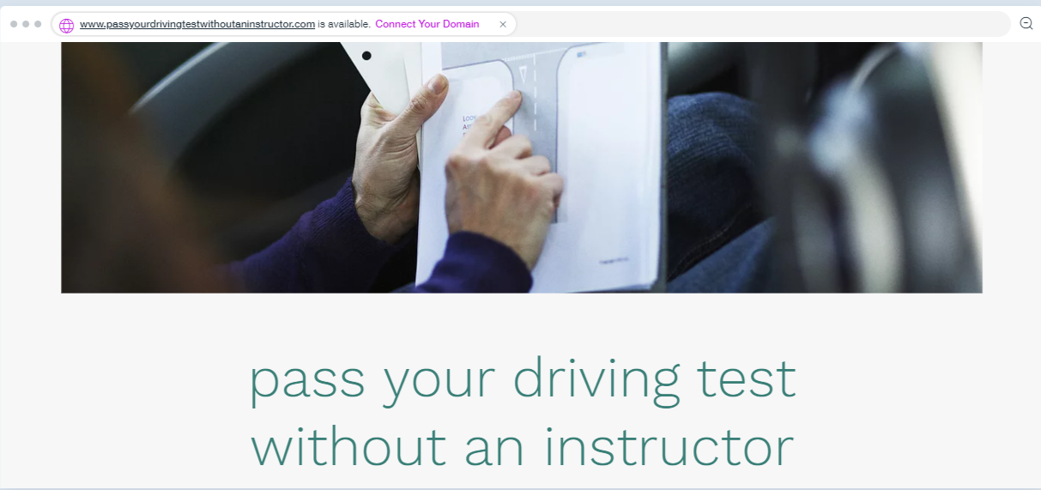

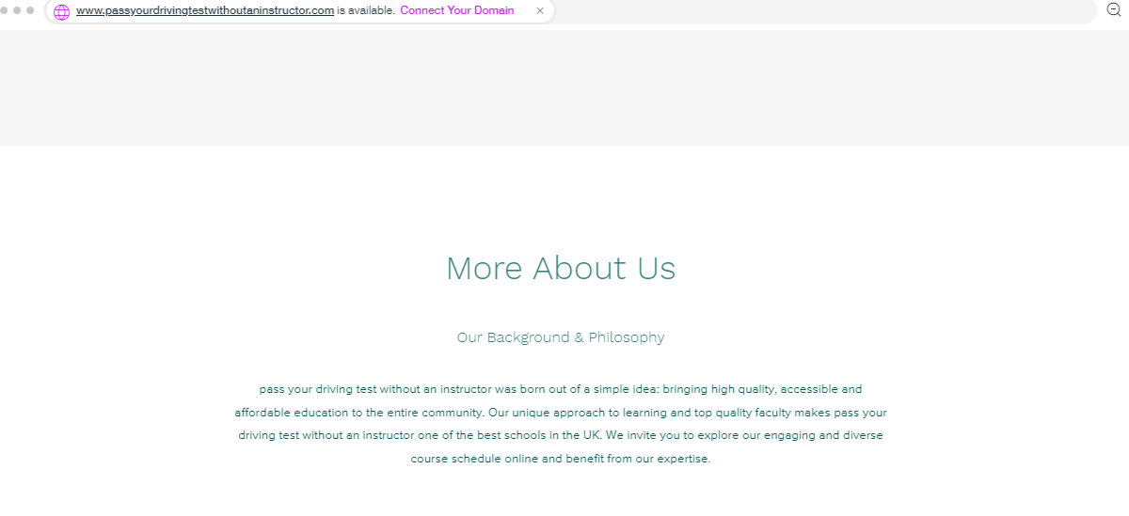

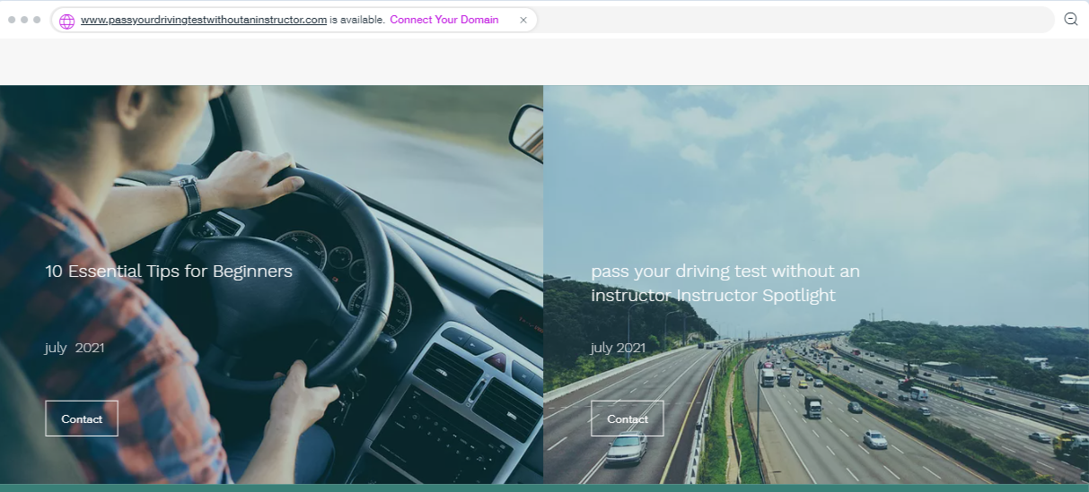
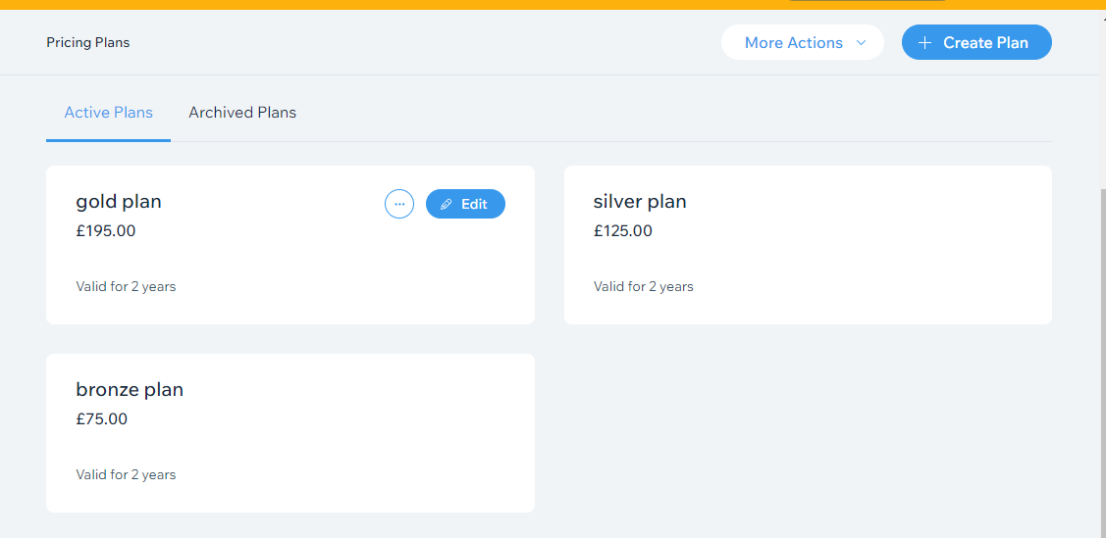
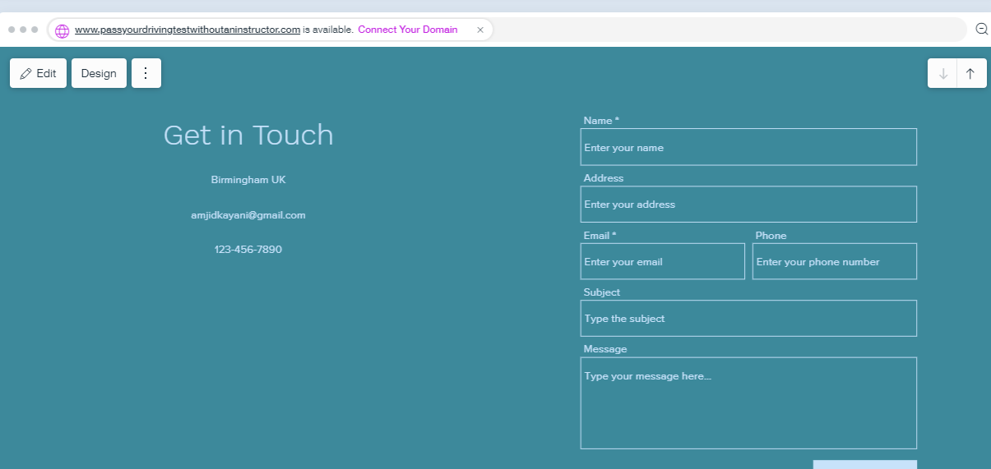
This business proposition will be an online shop where customers will be able to purchase a service that will allow them to practise their driving skills according to a structured way of learning that has been developed over the years by a qualified driving instructor. The website and the website name will represent the key concept of this unique service. Pass your driving test without an instructor highlights the point that learners can benefit from the lockdown rules and learn to get ready to pass their test according to the professional way of learning and with the help of qualified driving instructor that can guide them even if it is done remotely. The main idea about the website is that all customers must be able to navigate easily through in order to find all information and to be able to purchase the service needed. To start up, this online shop must be done professionally to inspire confidence when customers visit the website. According to Zaoui (2008, p3)” many are reluctant to provide sensitive personal information to web sites because they do not trust E-commerce security”. Hence, it is important to have all the security required from an online shop to inspire customers confidence and in order to create trust, it is necessary to allow customers to leave feedback regarding their experience dealing with the online store. The concept of feedback is to give customers a tool that allow them to express their opinions as if they were shopping in a real shop. Furthermore, responding back to the feedback will give the website users a sense that the online shop is taking care of their customers opinions and dealing with any issues that have been highlighted. An online retail shop must build an atmosphere that inspire confidence and create a good perception for the customers (Eroglu et al,2003). Along the similar lines, it is important to inspire trust in customers when it comes to the monetary transaction. Having a payment system that is well known and trusted by consumers is an important part of the online shopping. Risks of online shopping such as hackers and identity theft are a constant treat that cannot be ignored (Savage, 2012). According to Niranjanamurthy (2014, p4) “PSP offer full guarantee against any risks, especially with global transactions, and thus gain confidence of consumers who use them”. having a well-known payment service provider like payment PayPal would inspire customers to shop online and to trust this business. Although, the charges used by this Payment system may be more than a direct bank transaction, it gives customers a sense of security needed to shop online. Furthermore, having this type transaction system compare to card payments reduce risks for the business as the PayPal company is in charge of the security of the customers and guarantees the transactions.
Along with all these necessary steps required to have a successful online business, it is very important a have a very clear message that need to be understood by customers when they visit the online shop. The message for this business adventure is to help learners practise their driving skills during the lockdown and to eventually pass their driving test by themselves without the need or traditional driving lessons. Hence, the name of this business adventure represents the main key concept of the business and this name will be the main attraction for learners that are looking to pass their driving test while still saving money. Furthermore, along with a good name, it is important to explain clearly the services that this company offers and to help customers make the right decision. To have a name for each of these three different services is important to help learners chose the correct one and to help create a clarity between the three different services. Moreover, a good content for a website that explain the different services available to customers helps create a good understanding with the consumers and the company. Furthermore, it also helps the business to be find online as having good variety of content material promote the online presence. Good content can be a well written descriptive information about the business and the services available with some good key words that are in demand when people are looking for some driving lessons. Furthermore, images and videos play an important role in promoting the business and form an important part of the content. However, bad content can also affect the business image and therefore could be detrimental to the success of the business adventure. Hence, it is worth investing in a professional person that can optimize the content on a regular basis and can maximize the potential of the business by creating material that will help promote the business.
Marketing:
To promote your business, it is primordial to understand your potential customers to be able to promote your business. According to Barlow & maul (2000, p9) “building emotionally competent relationships with customers starts with love, caring, and respect”. When it comes to driving lessons or potential learners, the spectrum is waste in term of age and experience. Regardless of age and experience, all customers must feel that they are valued and respected by this organisation but to be able to promote the business efficiently, knowing and understanding customers behaviour is vital to reach them. the young people tend to be more active online and on social media while the older customers may prefer a more traditional way of looking for this type of service through direct marketing or recommendation from friends or family. To be able to reach a maximum of customers, it is important to be active in all fronts and to be visible as much as possible. As a start-up business, it will take time to be reach the first page on the google search as the search engine needs regular traffic to recognize the business and promote it in the search engine. However, to promote this start up, it is vital to invest money in certain key words and a daily maximum budget need to be set with google to promote the website. This form of marketing will allow an online presence and customers will be able to access all the services. However, according to Fox (2012, p14) “fifty-six percent of google queries show no paid ads at all, so if you’re counting on paid search to provide all of your visibility to searchers, you could be missing half of your audience”. To maximize the visibility, it is important to remain active online by regularly optimizing the content by uploading photos or videos. The videos or photos of successful candidates will attract customers and will make the business more visible to potential clients. This type of marketing can be a good way to connect with all type of customers. However, to attract a younger audience, the use of social media is necessary. YouTube, Facebook, Instagram are certain platform that can be useful to attract potential customers. According to Tuten (2020, p4) “most internet users, about 45% of the world’s population, are active on at least one social network”. Hence, a good presence on social media is a must to maximize the business. having a YouTube channel in the name of the company will help promote the brand and by having videos of some successful customers journey will help the business to be recognize by the users. Furthermore, having some tutorial videos on YouTube could create an interest in the services and may generate inquiries. Along with YouTube, Facebook plays a big part in developing brand awareness and by promoting your business on Facebook, you can reach your customers directly by selecting the customers that you are looking for. Advertising of Facebook can be a good way to create interest in the brand and potential customers can like the page and forward it to friends and family. Combining google search and social media will help promote the business to a big part of the customers. However, there are other way to create an interest in the brand and this could be done by some direct marketing such as leaflets, email marketing, putting signs of cars and by joining the brand to some charitable events. The idea is to generate interest in the company and to develop the brand. But one of the most important factors in creating a sustainable business is the quality of the services. Good services will help the business promote itself and generate interest by creating recommendations and developing word of mouth business. The idea in promoting the business is to invest initially and create a sustainable business that can strive with a minimum of investment.
Conclusion:
This report highlights a business opportunity arisen from a difficult situation such as the lockdown. Pass your driving test without an instructor is an online business that can help leaners improve their driving skills during the ban on professional driving tuitions. This business proposition is not only looking at the short-term solutions but also looking to compete with the main stream way of learning to drive going forward. The idea is to develop a business and a brand online that can be sustainable in the future. This report looks at the creation of the online store as well as the way to develop the brand by using different forms of marketing tools.

Reference list:
Allan, M. (2019)’ UK driving test: how many lessons you need to pass, what’s in the theory and practical tests and how much it costs’. I news [online]. 20/11.2019. Available at :UK driving test: how many lessons you need to pass, what's in the theory and practical tests and how much it costs (inews.co.uk). [accessed 17/07/2021]
Barlow, J. and Maul, D., 2000. Emotional value: Creating strong bonds with your customers. Berrett-Koehler Publishers.
Eroglu, S. A., Machleit, K. A., & Davis, L. M. (2003). Empirical testing of a model of online store atmospherics and shopper responses. Psychology & marketing, 20(2), 139- 150.
Fox, V., 2012. Marketing in the Age of Google, Revised and Updated: Your Online Strategy IS Your Business Strategy. John Wiley & Sons.
Gov.uk (2020). Lessons and learning to drive. Available at: Driving lessons and learning to drive: Practising with family or friends - GOV.UK (www.gov.uk). [accessed: 18/07/2021]
Hopp, C., Antons, D., Kaminski, J. and Oliver Salge, T., 2018. Disruptive innovation: Conceptual foundations, empirical evidence, and research opportunities in the digital age.
Martin, G. (2021) ‘when will driving lessons start again and test resume? How England’ s lockdown roadmap affects learner drivers. I news [online].04/03/2021. Available at: When will driving lessons start again and tests resume? How England's lockdown roadmap affects learner drivers (inews.co.uk). [accessed: 17/07/2021]
Niranjanamurthy, M., 2014. E-commerce: Recommended online payment method-Paypal. International journal of computer science and mobile computing, 3(7), pp.669-679.
Savage, M., 2012. The PayPal Official Insider Guide to Internet Security: Spot Scams and Protect Your Online Business. Peachpit Press.
Statistica (2020). Number of practical driving tests taken and passed in the United Kingdom from 2007/08 to 2019/20. Available at: Practical driving tests taken and passed 2020 Statistic | Statista. [accessed: 18/.07/2021]
Tuten, T.L., 2020. Social media marketing. Sage
Zaoui, I., 2008. WHICH" KIND" OF TRUST FOR BUYING ONLINE? AN INTERCULTURAL STUDY. MCIS 2008 Proceedings, p.46.
.

