

Managing Enterprise in the 21st Century

Business Plan

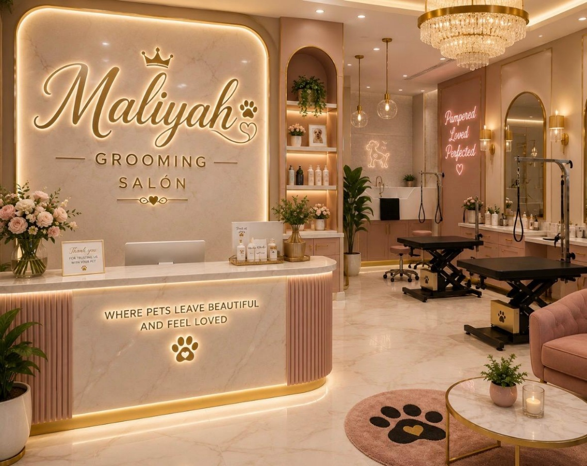

Module Title: Enterprise and Entrepreneurship

Module Code: LCLM4006_LON

Assessment: Maliyah Grooming Salon

Student Name: Jesus Eduardo Alvarado Gomez

Student Number: 2427092

Lecturer’s Name: Richard Ashaye

Table of Contents

- Executive Summary 4
- overview of the bussiness idea 4
- Management structure, Business legal format 5
- Market Research 5
- Market Analysis (Competitors, Customers, Target Groups) 5
- PESTEL Analysis 6
- Marketing communication 8
- Financial Plan (One Year) 8
- conclusion 10
- Reference 11

Executive Summary

Business Name: Maliyah Grooming Salon

Location: 92 Priory Crescent, London, SE19 3PF

Mission:

At Maliyah Grooming Salon, our mission is to provide gentle, professional, and personalized high-quality pet grooming tailored to every breeds and temperaments, from tiny breeds to large long-coated dogs, in a calm and safe environment. Maliyah salon likes treat every pet as if they were our own using gentle modern techniques in a calm, stress – free setting.
We like to owners fully informed throughout the grooming process, building long-term trust with both pets and their owners.

Our services promote long-term coat health help prevent skin issues saving you time and bringing more joy to your time together.

We aim to build a caring community of pet lovers, helping more families to discover the benefits of regular grooming, while continuing to grow and serve even more happy pets and they owners in the coming years.

Goal: Become the most recommended local grooming salon, with steady growth, loyal repeat clients, and strong profitability within 12 months.

Overview of the business idea

Maliyah pet grooming Salon is establishing a dedicate pet grooming studio that provides comprehensive grooming services styles for all necessities related to dogs grooming, our service is including washing, trimming, nail trimming, ear cleaning, and specialized treatments tailored to various coat types. In contrast to typical salons services provided by our competitors around (SE19 POSTCODE), our method is entirely personalized: each service is modified to suit the pet’s personality, health requirements, and coat features. We exclusively use pet-friendly, high-quality products and operate in a calm, low-noise environment designed to minimize stress for anxious animals. Our aim is to transform grooming into a pleasant experience for pets, while offering owners reassurance, saving them time, and assisting them in maintaining their pets' health and happiness. We intend to cater to both walk-in customers and regular visitors, with adaptable appointment options and home visits available for those needing additional assistance.

Maliyah Grooming Salon Services Offered:

- Full Groom: Bath, dry, brush, breed-specific cut, nail trim, ear clean, paw tidy.

- Bath & Tidy only.

- Nail clipping / Ear cleaning / Teeth brushing (add-ons)

- Deshedding treatments / Flea baths

- Puppy introduction sessions

- Senior / nervous dog care

Management Structure and business Legal Format

Legal Status: Maliyah Grooming Salon is going to operate as a Sole Trader, with intentions to transition to a Limited Company as the business grows. Our legal structure is straightforward, cost-efficient, and well-suited for launching a small business in the United Kingdom.

Management: The Salon will be operated and guided by an experienced groomer possessing formal qualifications in animal care and handling. As we expand, we intend to recruit 1–2 trained assistants to facilitate daily operations.

Responsibilities:
- Management of daily operations, grooming services, and ensuring pet safety.
- Communication with clients and management of appointments.
- Sourcing of products, maintaining hygiene standards, and adherence to animal welfare regulations.
- Marketing initiatives and financial tracking

Compliance: We are committed to fulfilling all legal obligations in the UK, including animal welfare standards, insurance, health and safety regulations, and registration with the local council.

Market Research

The pet grooming industry is growing steadily in the united kingdom, particularly in London,
And the South East.
The high demand for professional pet grooming service keep going up as pet ownership rises and awareness of animal health and wellbeing grows.

At the same time, the animal care market industry reports that more than half of Uk households own at least one pet, creating a steady expanding market for pet care services.

According to local council authorities more than 50% of UK households own a pet and increasing awareness of animal health and wellbeing. Since COVID -19 PANDEMIC, more pet owners view grooming as an important part of pet care, not just a luxury.

There is strong demand for services that prioritize gentle handling and stress-free environments, especially for anxious, elderly, or special-needs pets. Local Context In Tendring and nearby towns, there are few dedicated grooming studios that offer fully personalized care. Many owners travel long distances or settle for basic services that do not meet their pets’ specific needs. This creates a clear opportunity for a business that stands out through compassion, quality, and transparency.

Market Analysis

According to the market research conducted in the SE19 post code in London, there is a significant opportunity to fill service gaps that many existing grooming salons fail to provide for clients from diverse backgrounds and nationalities.

Maliyah salon will fill these gaps by offering a new and flexible pick up and drop off services for customers with special needs, as well as local dog owners including busy professionals, families and elderly owners who struggle to groom large breeds themselves.

Our reception team will communicates with clients in different languages supporting those for whom English is not a first language.

Target groups

CONSUMERS | COMPETITORS | CUSTOMERS NEEDS
- Dog owners with high maintenance breeds | - Existing Salons close to 2 miles radius | - Gentle service and stress-free experience
- Dog owners of adult dogs or nervous pets | - Mobile groomers | - Service information and price list
- Families with busy schedules | - Private pet care services | - Convenient booking and reliable appointments
- Local breeders and rescue centres |  | - Health benefits

Pestle Analysis - Location SE19, London

Political
According to Animal Welfare Act 2006: is a law in the united kingdom that protects vertebrate animals and requires owners to provide suitable environment, a proper diet and protection from pain, safe premises and hygiene.
THIS LAW is enforced by Lambeth & Southwark local authorities. (animal welfare-GOV.UK)
Local licensing/planning: Maliyah Grooming Salon Requires animal establishment registration, routine inspections, noise control for residential SE19 neighbourhoods.
Local councils in London is helping small business with a policy that state : GLA and council start-up grants, high street regeneration schemes and inclusive service policies supporting diverse communities.
Equalities legislation: This government law help us to Supports our multilingual, accessible service model for SE19’s mixed population.
Economic
• SE19 population: This area has a high residential density, with strong pet ownership, mix of professionals, families and retirees with disposable income for pet health & wellbeing.
• London operating costs, Higher rent, business rates, utility bills, transport and minimum wage are higher here than in regional areas. Our pick-up/drop-off service adds running costs delivers but premium convenience value for clients.
• Resilient sector: Grooming is viewed as essential health care (prevents pain/infection/matting) rather than luxury; demand holds well through economic shifts.
Social
• Pet-as-family culture: Very high dog/cat ownership across Crystal Palace, Norwood and Gipsy Hill; strong focus on welfare, low-stress handling and ethical businesses.
• Multicultural community: SE19 has high linguistic and ethnic diversity our multilingual staff removes that communication barriers that many competitors ignore.
• Lifestyle needs: The number of professional workers and the increment of elderly populations who struggle with transport or handling large/strong dogs has grown steadily over the past years, helping us to launch our pick-up/drop-off service.
Technological
• High digital service: The local residents expect online booking service as well as WhatsApp updates, digital receipts, Google Business Profiles and reviews.
• Visual social media: Instagram/Facebook WhatsApp is highly effective for local residents who wants to share reviews and pets images before and after grooms, care education and building word-of-mouth.
• Modern grooming & safety: Low-noise dryers, non-slip electric tables, hypoallergenic products improve animal comfort; contactless payments essential.
• Logistics tools: Mapping/routing apps make efficient local pick-ups/drop-offs across hilly, residential SE19; ULEZ-compliant vehicles avoid central London charges.
Environmental
• Local sustainability priorities: Strong demand for biodegradable, cruelty-free, plastic-reduced products and low-waste operations across London boroughs.
• Local regulatory rules: Lambeth/Southwark controls for hair/chemical waste disposal, water drainage, noise and air quality in residential zones.
• Low-emission transport: Electric/hybrid delivery vehicles align with London air quality goals and ULEZ requirements for travel within SE19 and wider London.
Legal
• Animal Welfare Act 2006: Strict standards for care/hygiene; mandatory staff training; penalties for neglect or unsafe practice.
• Business & employment law: Sole trader registration, national minimum wage, employer liability insurance, right-to-work checks and workplace safety.
• Insurance mandate: Public liability and animal care/vet fee indemnity insurance required to operate and build client trust.
• Consumer Rights Act 2015: Requires accurate service descriptions, clear pricing and fair complaint/refund procedures.
• GDPR/Data Protection: Secure storage of client/pet records, contact details and appointment logs.
• COSHH & Health & Safety: Controlled storage of grooming chemicals, fire safety, first aid, slip-resistant flooring and ventilation required for council licensing.

Marketing communication

Marketing & Sales

• Our plan is to use Local shops to advertise Maliyah Salon using Flyers at veterinarian clinics, pet shops, parks public advertising boards; business cards; partner with dog walkers/trainers

• Online: Facebook/Instagram (post before/after photos, tips); Google Business Profile; simple website with prices & booking link

• Promotions: New client discount; referral reward; loyalty card (10 grooms = 1 free nail trim or bath)

• Opening hours: Tue–Sat 9am–5pm; flexible slots for working owners.

Financial Plan (Estimated UK figures)

Startup Costs | Item Estimated Cost (£)
Equipment & tools | 2,500–4,000
Rent deposit / fit-out | 1,500–3,000
Licences, insurance, registration | 300–600
Initial stock & supplies | 200–400
Marketing & website | 150–300
Total | £4,650–£8,300

Pricing Guide

Breed Size | full groom
Small breed | £55
Large / thick coat | £75-£100
Bath only (small breed) | £30
Bath only (large breed) | £45
Nails trim | £15

Pet service per day approximately

• Average 7 grooms per day at £55 average = £385 daily

Weekly £2,310

• Monthly turnover approx £10,010

• Monthly costs: rent £1500, utilities £470, supplies £350, insurance £90 = £2,410

• Net profit target: £7,600/month approx. once established.

Risk Management

• Low bookings: run special offers, build online presence, ask for reviews

• Animal injury/incident: full insurance, proper training, clear consent forms

• Supply shortages: use multiple suppliers

• Illness: build a backup list of trusted groomers to refer clients to.

8. Next Steps

1. Secure funding / savings

2. Complete training if needed; join NDGA

3. Research location; check council licensing

4. Get insurance quotes

5. Buy equipment; set up booking system

6. Launch social media; take pre-bookings before opening.

CONCLUSIONS

Maliyah Grooming Salon is established to fill the gaps identified in the pets grooming market within South-East 19 of London, particularly in West Norwood, Crystal Palace and the surrounding communities.
The business combine professional grooming skills, with compassionate pet care to meet the needs of local pet owners and provide high quality, reliable service.
Our vision is to become to be one of the leading Grooming Salon in the South East region by offering low stress handling technique for hyperactive, nervous and special needs pets. This approach aims to create a safe and comfortable grooming experience while giving owners confidence that their pets are treated with care, love and respect.
Maliyah Salon will provides multilingual customer support, helping to remove language barriers for clients from diverse cultural backgrounds for whom English is not a first Language and is an obstacle for the pet community. In addition to this program the convenient pick up and droop off service will help the community with especial needs to be in control of the pet health, wellbeing, and the human-animal bond for years to come.
By offering a fully transparent and accessible pet grooming prices exceptional customer service and a personalised approach to pet care, Maliyah Grooming Salon is well positioned for sustainable growth and create a loyal long term success. The business aims to create a long lasting relation with the pet community and stablish a reputation as a reliable and professional pet grooming salon for years to come.

REFERENCE

- Hisrich, R.D., Peters, M.P. and Shepherd, D.A. (2020) Entrepreneurship. 11th edn. New York: McGraw-Hill.
- Mullins, J.W. (2023) The New Business Road Test: What Entrepreneurs and Executives Should Do Before Writing a Business Plan. 6th edition. Harlow: Pearson.
- Uk government(2024) animal welfare licensing guidance (https://www.gov.uk)
- Pet industry federation (PIF 2026). Uk pet care industry standards and trends. (https://www.petindustryfederation.co.uk)
- Webb, A. (2020) the Pet business handbook. London: Kogan page.

