
SOCIAL MEDIA and modern technologies in the workplace
Digital Skills and Research Methods

Submitted to: Renuga Jayakumar
12 january 2018
beatriz jesus student no. 1707557 group 8
University Of Wales Trinity Saint David

Table of contents
Introduction 2
Mobile Technology 3
How can tablets and smartphones be used in the workplace? 3
IPAD WIFI 2017 32GB vs SAMSUNG GALAXY TAB S2 9.7 LTE 4
Cloud storage 4
Google Drive vs Dropbox vs One Drive´ 5
Social media in the workplace 5
Conclusion 6
Appendices 6

Introduction

This report aims to analyse modern technologies within the workplace and how social media can influence marketing, information gathering and communication within the workplace.
Technology in the workplace permits industries to grow fast and professionally. Professional technology such as web conferencing and virtual bureau technology has ended with workplace restrictions that beforehand restricted industry development. With business technology, corporations can aim to reach bigger customers and levels. (Scott, 2016)
Substantial workplace changes are the consequence of first-hand and innovative technology. Since the last decades, high-tech creations and developments seem to be presented weekly. The tendency is certain to continue. Technology’s influence on the 21st century place of work will end in fast alterations. (Mayhew, 2016)

Mobile Technology

Mobile technology is crucial in the current place of work. Due to its adaptability, it provides a variety of welfares, on the other hand it also comes with significant threats to the industry. It is vital to think through equally pros and cons of using mobile technology in the workplace. Mobile technology is all of the portable technology such as tablets, smartphones etc. (NiBusiness, 2016)

How can tablets and smartphones be used in the workplace?

Tablets offer industries with improved functionality, while allowing workers to access essential data rapidly. Smart phones are still a foremost element of the on-the-go methodology, but any person who is using a tablet will be capable to take documents to a better screen size. (Bosari, 2012)
According to Dalton (2017), if workers are to carry their own smartphone to work, and owners are enthusiastic about adopting a BYOD (bring your own device) philosophy within the place of work, then this might save managers time which consequently benefits to increase efficiency. When workers are linked to a wireless internet network, they are capable to finish tasks in methods that do not put much boundaries to them such as being in an office all day.
Since tablets do have boundaries, it is doubtful that they will substitute old-style laptops soon, if they ever do. On balance, an Information Technology branch cannot both simply link up hundreds of tablets onto the same server network and share files nor can a user sit down and write down a massive Word file using the touch screen boundary. Even if people are used to typing using a touchscreen (and nowadays we can find keyboards sold in separate to use with tablets), it is not approximately as simple to do so. (Bosari, 2012)
According to Bosari (2012), tablets are good for storing files that have previously been made and for replying to things on the move, but they are not adequate to fulfil the requirements of a worker who occupies most of their time inputting big, information and CPU exhaustive applications. Notwithstanding these disadvantages, the tablets’ comfort of use, user-friendly size and weight make it a computer-generated foregone conclusion that tablets will continue to sculpt out place usage in the workplace.

IPAD WIFI 2017 32GB vs SAMSUNG GALAXY TAB S2 9.7 LTE

There are different brands of mobile technology. In this report I will compare two of the most famous brands in their latest releases: Iphone X (Apple device) to Samsung Galaxy S8 (Samsung Device) and IPad WIFI 2017 32GB to Samsung Galaxy TAB S2 9.7 LTE.

 | IPAD WIFI 2017 32 GB | Samsung Galaxy TAB S2 9.7 LTE
Performance | Dual Core | Octa Core
Display | 9.7’’ | 9.7’’
Camera | 8MP | 8MP
Battery | 8827 mAh | 5870 mAh
Fingerprint Sensor Position | Front | Front
Other Sensors | Light Sensor, Accelerometer, Barometer, Compass, Gyroscope | Light Sensor, rgbw sensor, Accelerometer, Barometer, Compass, Gyroscope

Since the battery is better in the IPAD it will last longer but the Samsung Galaxy has a better performance so it is a better device and more efficient to use in the workplace. It also has mobile data connection and the IPAD does not and it is lighter, has a better front camera and the memory is expandable which helps to store files. (now, 2017)
Using tablets and smartphones help increasing employability because it helps the business to grow due to a better performance of the employees. If a business grows, it will consequently need more staff.

Cloud storage

Cloud storage is a word that states to virtual space that you can utilize to save your data. It can be used to backup files and to avoid the use of usb drivers that may be lost, cloud storage delivers a safe way to distantly store your important information. Virtual storage answers are regularly delivered utilizing a huge network of computer-generated servers that come with utensils for handling documents and shaping virtual storage space. (Harris, 2017)

According to Estrada (2016), cloud storage can provide: accessibility, invisibility, security, automated backup, syncing, sharing and collaboration and recovery.

Google Drive vs Dropbox vs One Drive´

There are different cloud storage providers with different costs and different efficiency. I will analyse which of the 3 following providers has a better service.
 | Google Drive | Dropbox | One Drive
Cost | From 2$ to 300$ per month | 10$ per month | 2$ per month
Storage Plans for free | 15GB | 2GB | 5GB
Access | Through browser | Through browser | Through browser

Even though they are all accessed through browser, Google drive provides more storage for free and it is easier to store files and photos. Anyway, Google Drive is appropriate for Google users, One Drive is more appropriate for Microsoft users and Dropbox is appropriate for everyone in general. (Allan, 2016)

Social media in the workplace

Social media is really common nowadays. It is known that we can use social media for different purposes such as marketing and getting to know what is trending to help the business.
LinkedIn is the best social media when it comes to search for a job since it offers a variety of knowledge about it and it is possible to create a profile which is pretty most a CV.
Disadvantages of using social media are that it is not always safe and security is not always certain so all of our data can be transmitted somewhere else putting ourselves in danger but nowadays most of them can provide minimum security since we can chose if we want to make our profile public or private and we can chose who sees what.
My favourite social media is twitter because we can be updated with real life posts and most of the members of the government use it as well. We can be informed with what is happening in the world and give our opinions through tweets.

Conclusion

Workplace is an evolving place. Every week there are new creations in the technology industry and it helps develop every business. Being updated helps every business to stand out from all of the others avoiding rivalry. It is important that managers always try to introduce new technologies to improve their employees’ performance and consequently grow together.

Appendices

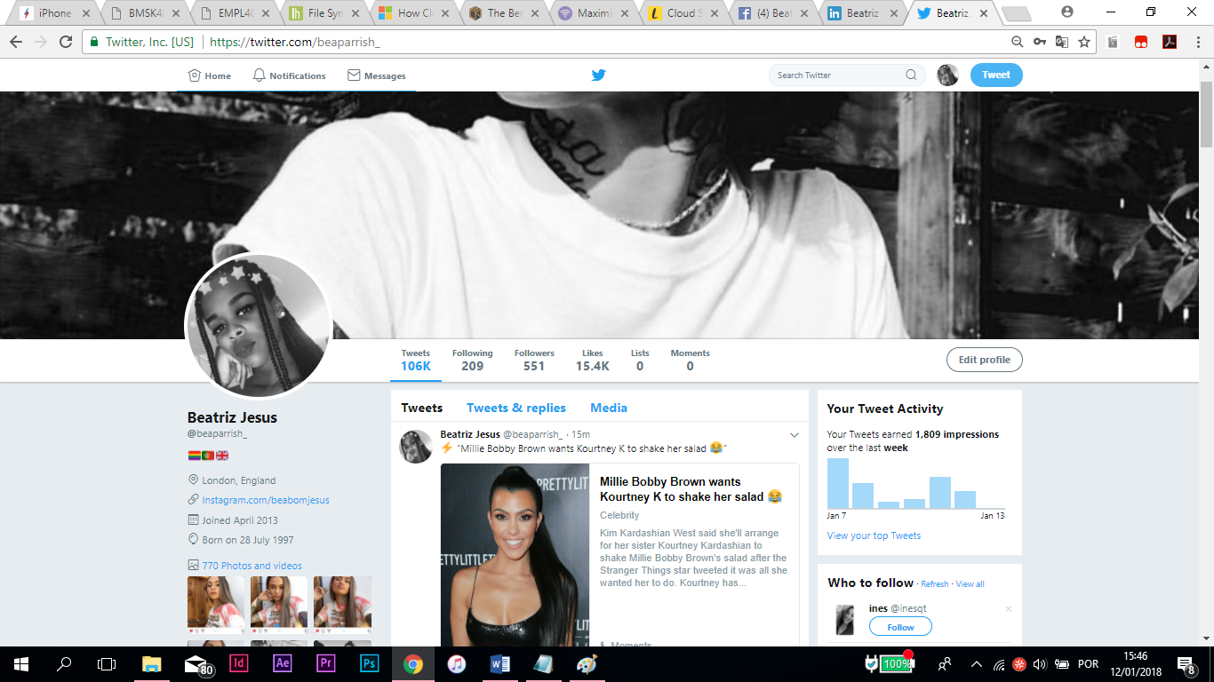

Twitter Page
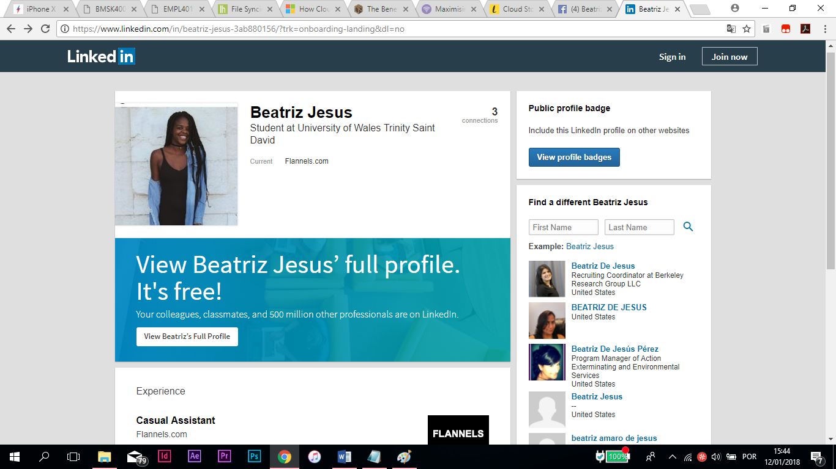

Linkedin Page



Facebook Page

References
Allan, P., 2016. Life Hacker. [Online]
Available at: https://lifehacker.com/file-syncing-showdown-google-drive-vs-dropbox-vs-one-1770094376
[Accessed in 03 January 2018].
Bosari, J., 2012. Forbes. [Online]
Available at: https://www.forbes.com/sites/moneywisewomen/2012/10/10/do-tablets-have-a-role-in-your-workplace/#7b4a636cc1cc
[Accessed in 03 January 2018].
Dalton, A., 2017. insights for professional. [Online]
Available at: https://www.insightsforprofessionals.com/blog/smartphones-in-the-workplace
[Accessed in 03 January 2018].
Estrada, L., 2016. wun. [Online]
Available at: https://www.wunsystems.com/cloud-storage-coworking-software/#
[Accessed in 03 January 2018].
Harris, M., 2017. life wire. [Online]
Available at: https://www.lifewire.com/what-is-cloud-storage-2438541
[Accessed in 03 January 2018].
Mayhew, R., 2016. Chron. [Online]
Available at: http://smallbusiness.chron.com/technology-impacting-changes-21st-century-workplace-3357.html
[Accessed in 03 January 2018].
NiBusiness, 2016. NiBusiness. [Online]
Available at: https://www.nibusinessinfo.co.uk/content/advantages-and-disadvantages-mobile-technology
[Accessed in 03 January 2018].
now, g., 2017. gadgets now. [Online]
Available at: https://www.gadgetsnow.com/compare-tablets/Apple-New-iPad-2017-WiFi-32GB-vs-Samsung-Galaxy-Tab-S2-97-LTE
[Accessed in 03 January 2018].
Scott, S., 2016. Chron. [Online]
Available at: http://smallbusiness.chron.com/importance-technology-workplace-10607.html
[Accessed in 03 January 2018].

