Introduction:
I am currently working on several aspects of the independent project. I am working on still trying to find some credible resources that fit my project which is minorly difficult. I have several, but it is such a niche field of study, and I want to make sure that they aren’t just basic sources. I am working hard on getting my film off the ground, I now have a schedule of how I want to accomplish the film moving forward. I am working on story boarding currently and getting everything scheduled with my actors and friends who are going to help me film. I have been working hard on setting up how my project wants to be so far, I have the whole written part split into different sections and I have some resources, so I am filling in the sections that I have so far.
Where I’ll go next:
So as for where I will go next, I plan during winter break to do some play for my film. I want to get things rolling in terms of filming, but I need myself and my actors to enjoy the process. So, I will have about 4 weeks of spent time going around and having fun filming and trying things out to get the best results. After that I plan on Filming for a week or two and then editing during the rest of the time allotted. For my written portion I am going to start writing and keeping up with the project during winter break I plan on doing a large majority of or finishing my 6,000 words during the break. This will give me enough time to focus on my practical portion of my project which is the film. These are all hopes I won’t be doing much in terms of leaving during the break so I will have plenty of time to focus on all aspects of my project.

Script/Project Synopsis:
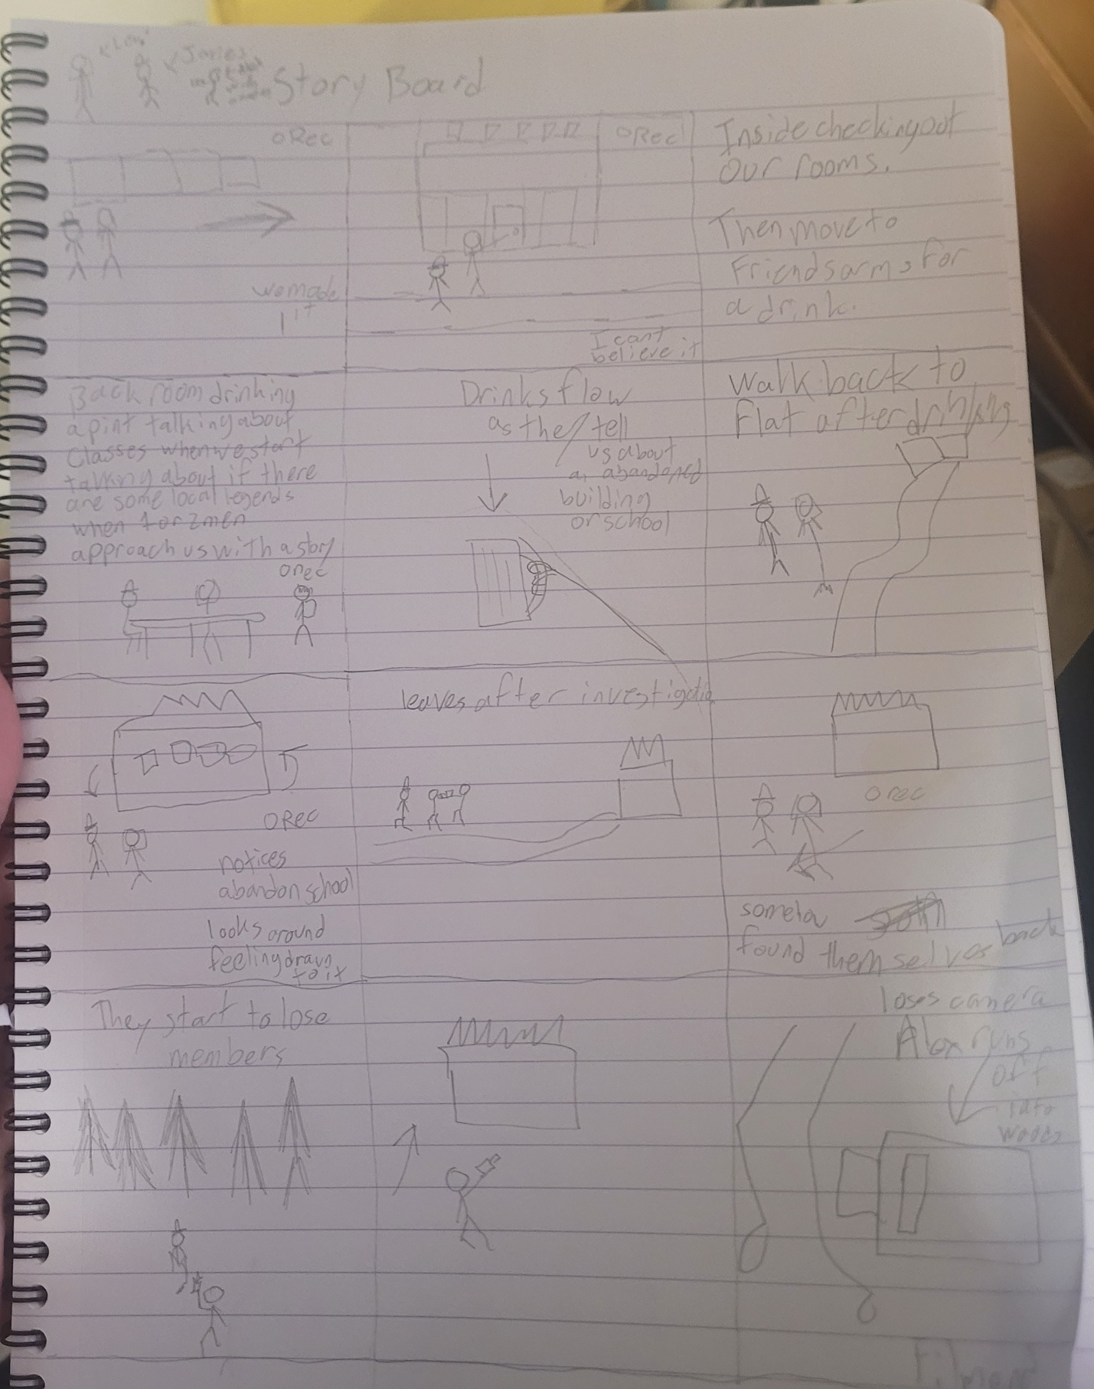
I decided to make a quick story board, it is not fantastic by any means, but it covers each element of the short horror film. I plan on making a much greater version of the story board before filming to cover each angle and what I plan to do. I am currently working on the script with one of my flat mates who is a creative writing major. He has talent in making scripts so I plan once the script is completed I will work hard on drawing up a good figure and communicating with my actors that this is how the base lay out will be. I am by no means a great artist so that was about all I could do. This covers how I want the film to go and it covers the three locations; Outside of the flats when we first arrive, our filming location “The Friends Arms” for the drinking scene, and then finally the abandoned building which will be the focal point of the film. This allowed me to get out what I desperately needed for the film, I needed to make sure what I was making would be an okay film at least and there is still plenty of work that needs to be done.
Collaboration:
For my Collaboration, I am doing a short-found footage horror film. I have already started story boarding which I talked about during my Script/Project Synopsis. I have my schedule laid out for filming and editing and I have my actors ready to go. I am working with James/Levi/Thomas/Chris on this project this may be subject to change due to scheduling, but they know they are needed for filming. I feel like scheduling will be the hardest part of filming, but I will work with my actors to see if we can all work something out, especially for film week. I am also working with one of my flat mates who is a creative writing major to work on the script with me. He has made many scripts before, and he was lovely enough to help me with this project. Working with everyone is a difficult task but I specifically chose these people because I know they can be trusted to help me with this process.
Conclusion summary:
In conclusion, my IP is coming along nicely on all aspects of study. I have everything laid out and I plan on making a great paper and a student film “I can’t tell if it will be good or not.” I will be focusing heavily on all aspects during the break, since I will have plenty of free time to do so. This project is a passion project for me, and I will be putting everything into it to make it something that I will be proud of. Overall, there is a lot more work to be done, but I have no doubts that I will have everything done in time for the turn in date.
Bibliography:
Books
- Clasen, M. (2017) Why Horror Seduces. Oxford: Oxford University Press. OUP Academic
- Iaccino, J. F. (2016) Psychological Reflections on Cinematic Terror: Jungian Archetypes in Horror Films. Santa Barbara, CA: Praeger. Bloomsbury
- Turnock, B. (2019) Studying Horror Cinema. Liverpool: Liverpool University Press. OUP Academic
- Pitillas, C. & Martínez-Biurrun, I. (2025) The Psychodynamics of Trauma and Modern Horror Cinema: I Am What Haunts Me. London: Routledge. Routledge+1
- Wild, M. (2026) Psychoanalysing Horror Cinema. London: Routledge. Routledge
- Avalos, S. (ed.) (2024) Criminological Understandings of Horror Films: Reel Fear. London: Bloomsbury Lexington Books. Bloomsbury+2Bloomsbury+2
- Clover, C. J. (1992) Men, Women, and Chain Saws: Gender in the Modern Horror Film. Princeton, NJ: Princeton University Press. Wikipedia
- Sittel, J. (2025) The Experience of Fear in Horror Films: Methods for Software-Based Analysis and Interpretation of Narrative Suspense. Springer. SpringerLink
- Pirie, D. (1973/2008) A Heritage of Horror: The English Gothic Cinema 1946-1972 (rev. edn A New Heritage of Horror 2008). Manchester: Manchester University Press. Wikipedia
- e.g. Martin, G. N. (2019) (Why) Do You Like Scary Movies? A Review of the Empirical Research on Psychological Responses to Horror Films. Although technically a journal article, it is book-length in review form, and gives strong psychological background. — see web-source list below.

Website/Online Articles
- Groh, F. (2023) ‘“Experiencing Trauma”: Aesthetical, Sensational and Narratological Issues of Traumatic Representations in Slasher Horror Cinema’, Arts, 12(4):132. Available at: https://doi.org/10.3390/arts12040132 (Accessed: 9 November 2025). ‘Psychology of Horror Films’ (2016) PsychologyItBetter. Available at: https://psychologyitbetter.com/horror-films (Accessed: 9 November 2025). PsychologyItBetter
- ‘The Psychology Behind Why People Enjoy Horror Movies’ (2025) MellonPost, 12 September. Available at: https://mellonpost.com/the-psychology-behind-why-people-enjoy-horror-movies/ (Accessed: 9 November 2025). mellonpost.com
- Martin, G. N. (2019) ‘(Why) Do You Like Scary Movies? A Review of the Empirical Research on Psychological Responses to Horror Films’, Frontiers in Psychology, vol.10. Available at: https://www.frontiersin.org/articles/10.3389/fpsyg.2019.02298/full (Accessed: 9 November 2025). Frontiers+1
- ‘Why do we enjoy horror films?’ (2021) Psychology Today UK, 15 October. Available at: https://www.psychologytoday.com/gb/blog/how-to-think-like-a-neandertal/202110/why-we-enjoy-horror-films (Accessed: 9 November 2025). Psychology Today
- Dolan, E. W. (2024) ‘Why do people enjoy horror movies? New study sheds light’, PsyPost, 30 October. Available at: https://www.psypost.org/why-do-people-enjoy-horror-movies-new-study-sheds-light/ (Accessed: 9 November 2025). PsyPost - Psychology News
- ‘The Neuroscience of Thrills: Why Do We Like Horror Movies?’ (2025) The Scientist. Available at: https://www.the-scientist.com/why-do-some-people-enjoy-horror-movies-72181 (Accessed: 9 November 2025). The Scientist
- Park, M. (2018) ‘The Aesthetics and Psychology Behind Horror Films’, Undergraduate Thesis, Long Island University. Available at: https://digitalcommons.liu.edu/post_honors_theses/31/ (Accessed: 9 November 2025). digitalcommons.liu.edu
- Riggio, R. E. (2025) ‘The Psychology of Horror Movies’, Psychology Today US. Available at: https://www.psychologytoday.com/us/blog/cutting-edge-leadership/202510/the-psychology-of-horror-movies (Accessed: 9 November 2025). Psychology Today
- ‘What Happens to Your Body When You Watch a Scary Movie?’ (2023) Verywell Health. Available at: https://www.verywellhealth.com/what-happens-when-you-watch-horror-film-8365111 (Accessed: 9 November 2025).
- Jarrett, C. (2017) ‘Why do some people love horror films?’, BBC Science Focus Magazine, 21 August. Available at: https://www.sciencefocus.com/the-human-body/why-do-some-people-love-horror-films (Accessed: 9 November 2025).

