Contents Page
Contents Page 12
Task 1 13
How the Transmission Control Protocol operates and endeavours to guarantee delivery of data. Refer to the three-way handshake and so-called “Two Generals’ Problem”. 13
The impact of the maximum transmission unit (MTU) size on the transfer of data. You should consider associated factors such as the size of the protocol data unit (PDU), their relative positions in the OSI model and the practicalities of IP fragmentation. 16
Synchronicity and asynchronicity in network protocols. Consider the sorts of applications you might use with each. Consider I/O dispatch models. 17
The meaning of interoperability for networked applications and how it is best achieved. 18
Task 2 19
Design Statement 19
Application Logic Planning 19
Data Requirements 19
Application Flow 20
Interface Wireframe Designs 21
Development 21
References 22

Task 1

How the Transmission Control Protocol operates and endeavours to guarantee delivery of data. Refer to the three-way handshake and so-called “Two Generals’ Problem”.
The transmission control protocol, often referred to as its acronym, TCP, is responsible for data transmission for email, file transfer and web browsing. The transmission control protocol allows a device to send a packet or packets to another device. A packet is data that has been divided to make smaller to transfer and is the unit of communication over the network (1). The packet will then carry the information until it gets to its intended destination. Each packet contains a header and payload. Within the header of the packet is the “IP addresses of the source and destination, plus other fields that help to route the packet” (2). These fields, that can help route the packet, can include the destination port number, the sequence number, the acknowledgement number, the checksum and the window size. This is important so that the transmission control protocol can maintain an established connection between the devices. The payload within the packet is the “actual data” (3). This could include the content of an email message, a file or a web page. The payload can differ in size when being sent using the transmission control protocol. The payload can sometimes be encrypted when sending sensitive data like passwords or payment details in order to try and increase the security of the transmission. When the packets are sent across a network, they are broken up into frames in the data link layer within the OSI model, whereas packets are used within the network layer of the OSI model. The layers within the OSI include the physical layer, the data link layer, the network layer, the transport layer, the session layer, the presentation layer and the application.

OSI Model | TCP/IP Model
Application Layer | Network Access Layer
Presentation Layer | Internet Layer
Session Layer | Transport Layer
Transport Layer | Application Layer
Network Layer
Data Link Layer
Physical Layer

Figure 1- The OSI & TCP/IP Model (4)

The transmission control protocol is also used within the TCP/IP model. There are four layers within the TCP/IP model, which include the application layer, the transport layer, the internet layer and the network access layer, and data is divided into packets at the third layer, the internet layer. This layer is also responsible for the packet having a header where its destination is withheld. When the packet has arrived at its intended destination, the header is taken off, as that information is no longer needed. The packet will then be processed by the transmission control protocol. At this point, the packet could also be processed by UDP. UDP stands for User Datagram Protocol and can be seen as “faster” (5) than the transmission control protocol but less reliable as compared to the transmission control protocol, UDP does not provide error checking. UDP is commonly used for live streaming, online games and VoIP whereas the transmission control protocol can be used for the transfer of files, sending and receiving an email and browsing the web (5).

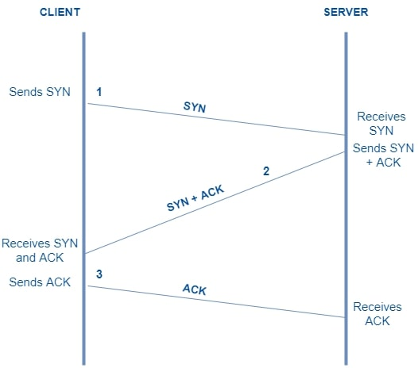
Figure 2 Example of the Three-Way Handshake (6)

In order for a socket connection to be reliable and guarantee a transmit of data between devices, the three-way handshake is used (7). The three-way handshake, is also known as SYN-ACK. The three steps within the handshake include SYN, SYN-ACK and ACK. First, the client sends a SYN, a Synchronize Sequence Number, to a server. Then, once the server has received the SYN, it will respond with a SYN-ACK packet, a Synchronize Acknowledgement. Once the client receives the SYN-ACK from the server the client will reply with an ACK packet, acknowledging that they have received the SYN-ACK from the server (7). This is where a reliable connection would have been established between the client and the server. When the two generals’ problem is applied to data transmission there could be a risk of loss or corruption to the messages that they are sending to and from each other. The transmission control protocol utilises the three-way handshake in order to provide a reliable way of transferring and delivering data. The transmission control protocol also uses retransmissions if there is data loss. If the client does not reply with an ACK packet to the server, then the server will retransmit that packet to the client until they respond with the ACK packet. TCP also utilises flow control and congestion control in order to attempt to limit the amount of error with delivering data. Flow control surrounds the “amount of data sent to the receiver side without receiving any acknowledgment” (8). By doing this it can allow the receiver not to be flooded with an overwhelming amount of data (8). Congestion control will be able to limit “the flow of packets at each node of the network” (8). Congestion slows down response time, so using congestion control will be able to keep the speed of transmission to be the speed expected.

There is also the four-way handshake. This is used when a connection between the client and server is terminated. The termination of the transmission control protocol connection begins with a FIN packet, finish, sent as a request to terminate the connection. If a client wanted to terminate the connection, then an ACK, acknowledgement will be sent back by the server. The server would then have to send its own FIN packet, a finish packet. Followed by the client acknowledging the request, an ACK.

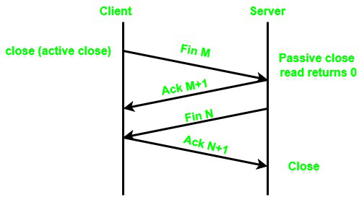
Figure 3 Example of the Four-Way Handshake (9)

The impact of the maximum transmission unit (MTU) size on the transfer of data. You should consider associated factors such as the size of the protocol data unit (PDU), their relative positions in the OSI model and the practicalities of IP fragmentation.

The packet, mentioned and defined in one of the previous section, size is limited by the maximum transmission unit. The maximum transmission unit, sometimes referred to as its acronym MTU, is responsible for providing the maximum amount of data that can be transmitted between client and server. The maximum transmission unit size is something that can be different from network to network. The maximum transmission size can usually be “configured on network devices such as routers and switches” to either increase or decrease the maximum transmission size (10). The Ethernet protocol has a default maximum transmission size of 1500 bytes, meaning that any data payload larger than the 1500 bytes limit will be fragmented into packets and reassembled at the receiving end of the data transfer. However, some network technologies, such as DSL, the Digital Subscriber Line and PPPoE, the Point-to-Point Protocol over Ethernet, have a smaller MTU size.

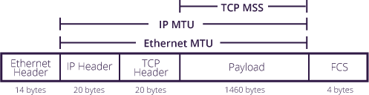
Figure 4 - Anatomy of a Datagram (11)

The larger the maximum transmission unit size could result in more efficiency for the transmission as “each network packet carries more user data while protocol overheads, such as headers or underlying per-packet delays, remain fixed; the resulting higher efficiency means an improvement in bulk protocol throughput” (12). If the packet size is larger than the maximum transmission unit, then this would result in fragmentation. Fragmentation is where the datagram is divided into pieces small enough to be transmitted using the maximum transmission limit. When the resized packets have reached their destination, they will be reassembled into the packet it was before fragmented. However, fragmentation does bring its own drawbacks for the transfer of data. More traffic will be sent because of fragmentation because the packet’s IP header will now be duplicated. This will add “processing overhead on the router that fragments the packets, and on the destination that reassembles them” and if these fragments become corrupted then the packet will have to be resent and undergo fragmentation again (13). This can also result in a slower rate of transmission.

The Protocol Data Unit is a group of information either “added or removed by a layer of the OSI model” (14). The Protocol Data Unit in the physical layer of the Open System Interconnection model are called bits. The Protocol Data Unit within the data link layer of the OSI model are called frames and is made up of the TCP header, the network layer header and the data link header. The Protocol Data Unit within the network layer of the OSI model are called packets. The Protocol Data Unit within the transport layer of the OSI model are called segments or datagram. When using TCP, it is a segment, however, when using UDP, it is a datagram (15). Within the final 3 layers of the OSI model, the session layer, the presentation layer and application layer, the Protocol Data Unit is data.
PDU Name | OSI Model Layers
Data | Application Layer
Data | Presentation Layer
Data | Session Layer
Segments | Transport Layer
Packets | Network Layer
Frames | Data Link Layer
Bits | Physical Layer

Figure 5 - Protocol Data Unit Name per Layer Within the OSI Model (15)

Synchronicity and asynchronicity in network protocols. Consider the sorts of applications you might use with each. Consider I/O dispatch models.

Synchronicity and asynchronicity are two types of network communication and differ in how they operate within the network. Synchronicity can be defined as something “happening or done at the same time or speed” (16). When applied to network communication and protocols, synchronicity is where more than one party is continually listening for incoming data and replying to each other (17). Synchronicity is used when data has to be transferred quickly across multiple networks and is described as the “full-duplex type” of transmission (18). When a network utilises synchronicity, it will be waiting to receive and once it does it will act upon what it receives. An example of this would include an online customer service chat (16). A connection would be made between the customer and that responsible for the customer service chats. When the connection is established, the sending of chats can begin from either person at any time. Once a chat is sent from the customer, the other side is waiting to receive the message and the same can be said for when a chat is sent by the customer service agent/representative, the customer will be waiting to receive the message. Other examples include chat rooms and video conferencing. Russinovich et al state that “Most I/O operations that applications issue are synchronous…the application thread waits while the device performs the data operation and returns a status code when the I/O is complete” (19). Synchronicity within network protocols and communication can ensure that the transmission of data between devices, systems or networks can be done accurately and efficiently. Another advantage of synchronicity is that it can allow for a reliable exchange of data across the networks. This would allow for less errors and less data being corrupted. Security could also be improved by using synchronicity as devices that are synchronised could quickly identify and stop any suspicious traffic which could prevent a number of security threats. A disadvantage of not using synchronicity could lead to data loss of communication error which diminishes the performance and quality of a system. Applying synchronicity within a network could however lead to a lack of scalability within the network which would result in the network being expanded. Another disadvantage of utilising synchronicity could include the cost as with some synchronisation requires specific specialised hardware in order to work efficiently.
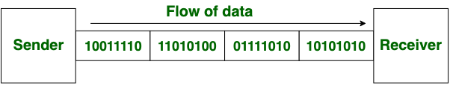
Figure 6 – Data Transmission Through the Use of Synchronous Transmission (18)

Asynchronicty however, is communication where data can be transmitted and received independently without having synchronisation between a device, system or network. One of the advantages of asynchronous communication is that it allows devices to transmit data independently, without waiting for other devices to finish transmitting. This can improve the overall efficiency of the communication system, especially in situations where there are many devices transmitting data simultaneously. This way of transmitting data can be described as the “half-duplex type of transmission” (18). The use of asynchronous communication typically have a delay “between when the sender initiates the message and when the recipient responds” (17). An example of this could be an email. When the email is sent by the customer, they would not expect to receive a reply in real time from the intended recipient. Instead, the message arrives in the business email inbox and the staff have the choice of “when to read or reply to the message” (17). Russinovich et al also elaborate on the use of asynchronous I/O. They state that “Asynchronous I/O allows an application to issue multiple I/O requests and continue executing while the device performs the I/O operation. This type of I/O can improve an application’s throughput because it allows the application thread to continue with other work while an I/O operation is in progress” (19). Utilising asynchronous network communication over synchronous could offer advantages such as lower cost, an increase in potential scalability and an improvement in the reliability data transfer between different systems or networks. However, the use of asynchronous over synchronous could result in lower efficiency in transmission and implementing asynchronous could be more complex than implementing synchronous data transmission.
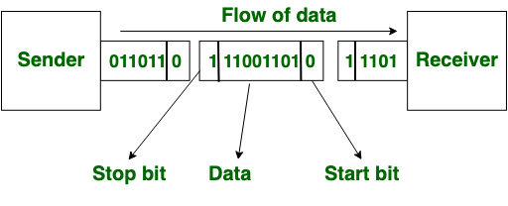
Figure 7 - Data Transmission Through the Use of Asynchronous Transmission (18)

The meaning of interoperability for networked applications and how it is best achieved.

Interoperability can be defined as “the ability of apps, equipment, products, and systems from different companies to seamlessly communicate and process data in a way that does not require any involvement from end-users” (20). Interoperability can be used in systems in many different sectors of work. Interoperability can be seen as essential in fields such as “Healthcare, eGovernment, Public Safety, Military and Flood Risk Management” (21). The use of interoperability within these fields can bring benefits to the sectors that use them. These benefits include adaptability, smoother business operations, data unity, improved protection of sensitive data, fewer errors and lower costs (20). By implementing interoperability within a business are able to operate smoothly as data is available and can be sent to those who need the data.

There are different types of interoperability that can be implemented. These include syntactic interoperability, semantic interoperability and cross-domain. Syntactic interoperability is when multiple systems can communicate and exchange data to each other regardless of the programming language used for each system or their interfaces. It is when different and more than one system can communicate through the same standards. Using syntactic can result in the lack of additional translation or processing. Applying syntactic interoperability can allow data to be transferred reliably and efficiently which would benefit the previous sectors that use interoperability. Semantic interoperability is when the data that has been exchanged is meaningful to the system. Utilising semantic interoperability can allow the different systems to interpret the data in the same way as each other. This can be an important type of interoperability within the health care sector as it can allow accurate data for the patient. Using semantic interoperability can allow more to be done with the data. Data analytics or artificial intelligence could be used once the data has been defined as meaningful to the systems. Whereas cross-domain “refers to the standardization of practices, policies, foundations and requirements of disparate systems. Rather than relating to the mechanisms behind data exchange, this type only focuses on the non-technical aspects of an interoperable organization” (22). This is where data can be transmitted and exchanged over different domains. This type of interoperability can allow different organisations and businesses to send and receive data securely over their networks. Having cross-domain interoperability in place can allow a business to transmit securely and efficiently while ensuring that policies and law are maintained.

There are a number of ways that interoperability can be achieved. Some examples include using standardised protocols and formats, implementing open application programming interfaces (APIs), using middleware, testing for compatibility, utilising collaboration and providing documentation and support. By utilising standardised protocols, it can allow for an easier communication process between the systems. Standardised protocols include “Wi-Fi, the Internet Protocol, and the Hypertext Transfer Protocol (HTTP)” (23). The use of APIs can be integrated across different systems to allow a standardised way for the systems to interact with each other. Middleware could be used as a software which can allow the different systems to share data and communicate with each other. Having documentation and support could aid users and developers by allowing them to understand how different the different systems can work together and communicate with each other. Implementing this could reduce the time and resources needed for custom integrations and improve the user experience. Interoperability can only be achieved once standards have been implemented and testing has been completed. “The specifications of the standardization should properly cover the architecture, requirements and protocols” (23). Conformance testing and interoperability testing are undergone “in order to check that the equipment and network confirm to the standards” (23).

Task 2

Design Statement
The project will be a desktop application game. The game of choice will be blackjack, or twenty-one. The aim of the game is to be the player closest to twenty-one without going over it. The user will be up against a ‘the dealer’. In this instance ‘the dealer’ will be assigned one number until the user decides that they do not want any more cards. Once that has happened, the dealer will then be dealt their cards until they either bust or are happy with the number that they have (if it is closer to twenty-one than the user’s cards). This application will not incorporate other decisions that the user can make whilst playing blackjack at a casino. There, the player would have the choice to hit, stand, double down, split or surrender. In this application the user will only be able to hit and stand. This application will not include face cards or the ability for an ace to be a one or eleven. This application could be used by those who want to try their luck or those who want to gamble without losing any money. This application could be considered as a practice game before placing any money using different applications or in person. It could be used by those who have recently reached the legal age that they would be able to play twenty-one. It could also be used by a seasoned veteran of the card game as practice. The application will be developed using Visual Studio and written in C#. This will be used to create a Windows Forms Application. Development of the application should be relatively easy. However, the inclusion of sockets will need to be understood further in order to develop an application that meets the brief’s needs.

Application Logic Planning
Both the client and the server will communicate based on certain outcomes once the client has connected to the server. The client is responsible for how the game will be played based on whether they hit or stand. This will then be sent to the server.

The server must be responsible for the creation of the integers needed for the game screen. These can be created using the Random class. This will need to be done twice at the start of the game to generate the card number for the client and for the dealer. The server will also need to generate the card number for the user when they decide to hit. The server will generate the next cards for the dealer once the user has decided to stand. These numbers will be sent to the client when they have been generated. The server will also deal with the game logic. The server will understand when either the user or the dealer has won and will convey that to the client.

Data Requirements
The information that the application requires includes the card numbers, the user’s decision and who has won. The card numbers will be generated by the server and sent to the client. The user’s decision is decided from which button has been clicked by the user. Who has won is decided by the server depending on the scores of both the user and the dealer. The card numbers will be stored as an integer as they will only be used as whole numbers. The user’s decision and the winner will be stored in a string.

Application Flow

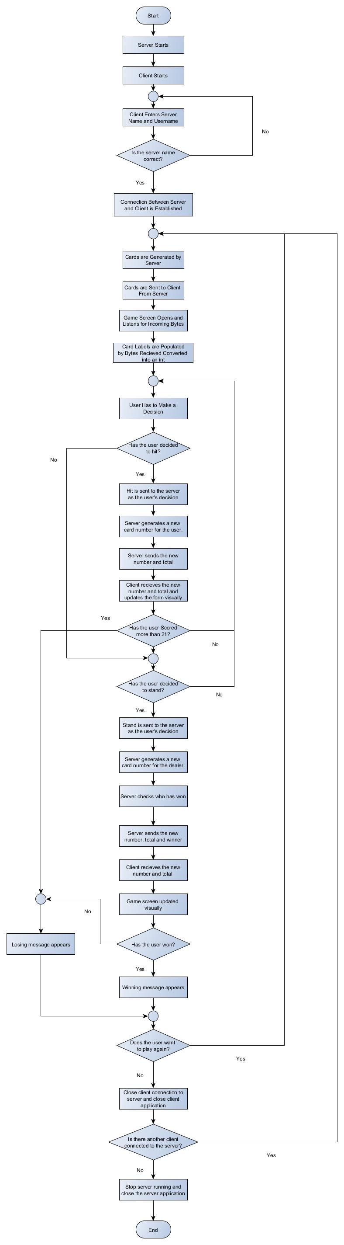

Interface Wireframe Designs
Wireframes were designed using Adobe XD.

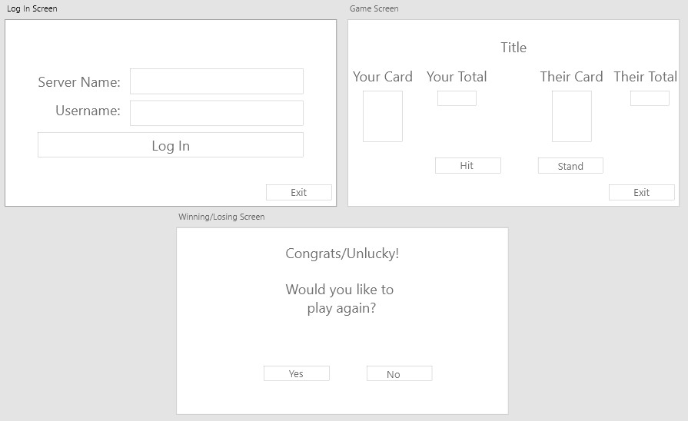

The login screen will consist of two text boxes, two labels and two buttons. The two labels are there to show the user what to enter in the text boxes. The text boxes are there so that the user can enter the server they are trying to connect to and their username that they want to appear within the game. The buttons located on the login screen would allow the user to connect to the server by pressing the ‘Log In’ button. If the user has entered an incorrect server name or the server had not been started, then a message box would appear to make the user aware of the issue. If the user were to enter the correct server’s name, then they would connect to the server. From this the log in form would close and the game screen form would open. The exit button would close the application.

The game screen form will consist of labels, buttons and images. When the form is loaded first the user will be able to see what number they have scored and their total. These will populate the images underneath the ‘Your Card’ and ‘Your Total’. The dealer's cards would also be populated under the ‘Their Card’ and ‘Their Total’ labels. The buttons on this form are for the main aspects of the game, whether the user would like another card or not. If the user were to click the stand button their total would not increase, and the ‘dealer’s’ cards would increase and stop once they have gone above 17. If the dealer has bust, then the user would have won. If the dealer stops at 18 and has a higher total than the user, then the dealer has won. The other button on this form is the ‘Hit’ button. When this is pressed the user will have another card populate the image underneath ‘Your Card’ and the total will increase. If the total exceeds 21 then the user has lost. The numbers will be generated by the server and will be sent to the user using sockets. The button clicks will be sent to the server and there, the server will either send another card total or stop the addition of numbers.

Once the game has ended with either the user winning, the ‘dealer’ winning or the game resulted in a tie, the game screen form will close, and the winning/losing screen form will appear. Here the user will see whether they have won, lost or tied the game. From here they can decide whether they want to play again. If they click the no button, then the application will close and if they were to click the yes button the game would restart.

Development
For development see YouTube video and zipped project folder.
Socket Programming Screencast
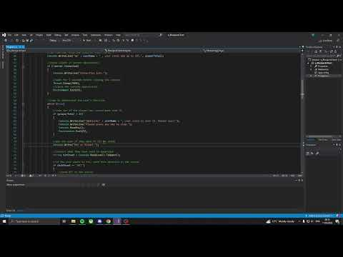

References

[1] Indiana University, “What is a packet?”. [Accessed 30th April 2023] Available at: https://kb.iu.edu/d/anyq

[2] Khan Academy, “IP Packets” 2020. [Accessed 30th April 2023] Available at: https://www.khanacademy.org/computing/computers-and-internet/xcae6f4a7ff015e7d:the-internet/xcae6f4a7ff015e7d:routing-with-redundancy/a/ip-packets

[3] Cloudflare, “What is a packet? | Network Packet Definition”. [Accessed 30th April 2023] Available at: https://www.cloudflare.com/learning/network-layer/what-is-a-packet/#:~:text=Packets%20consist%20of%20two%20portions,payload%20is%20the%20actual%20data.

[4] S. Tawde, “OSI Model vs TCP/IP Model”. [Accessed 30th April 2023] Available at: https://www.educba.com/osi-model-vs-tcp-ip-model/

[5] K. Koshigawa, “TCP vs. UDP — What's the Difference and Which Protocol is Faster?”, 28th June 2021. [Accessed 1st May 2023] Available at: https://www.freecodecamp.org/news/tcp-vs-udp/

[6] U. Abhishek, “TCP 3-Way Handshake | Computer Networks”. [Accessed 1st May 2023] Available at: https://workat.tech/core-cs/tutorial/tcp-three-way-handshake-in-computer-networks-yoo7331910lh

[7] M. Rouse, “Three-Way Handshake”, 10th November 2020. [Accessed 1st May 2023] Available at: https://www.techopedia.com/definition/10339/three-way-handshake

[8] S. Datta, “Flow Control vs. Congestion Control in TCP”, 8th November 2022. [Accessed 1st May 2023] Available at: https://www.baeldung.com/cs/tcp-flow-control-vs-congestion-control

[9] P. Kashayp, “Why TCP Connect Termination Need 4-Way-Handshake”. [Accessed 2nd May 2023] Available at: https://www.geeksforgeeks.org/why-tcp-connect-termination-need-4-way-handshake/

[10] Geeks For Geeks, “What is MTU(Maximum Transmission Unit)?”, 18th April 2023. [Accessed 2nd May 2023] Available at: https://www.geeksforgeeks.org/what-is-mtumaximum-transmission-unit/

[11] Imperva, “MTU and MSS: What You Need to Know”. [Accessed 2nd May 2023] Available at: https://www.imperva.com/learn/application-security/what-is-mtu-mss/

[12] Network Security, “Maximum Transmission Unit”. [Accessed 2nd May 2023] Available at: https://www.networxsecurity.org/members-area/glossary/m/mtu.html

[13] Network Direction, “How MTU and MSS Affect Your Network”. [Accessed 2nd May 2023] Available at: https://networkdirection.net/articles/network-theory/mtu-and-mss/

[14] M. Rouse, “Protocol Data Unit”, 6th November 2014. [Accessed 2nd May 2023] Available at: https://www.techopedia.com/definition/25292/protocol-data-unit-pdu

[15] A. Jaweb, “Protocol Data Unit (PDU)”. [Accessed 2nd May 2023] Available at: https://www.geeksforgeeks.org/protocol-data-unit-pdu/

[16] Cambridge University Press, “Cambridge Business English Dictionary”, 10th November 2011. [Accessed 7th May 2023] Available at: https://dictionary.cambridge.org/dictionary/english/synchronous

[17] P. Gupta & J. Shore, “Synchronous vs. asynchronous communications: The differences”, 18th August 2021. [Accessed 7th May 2023] Available at: https://www.techtarget.com/searchapparchitecture/tip/Synchronous-vs-asynchronous-communication-The-differences

[18] GeeksForGeeks, “Difference between Synchronous and Asynchronous Transmission”. [Accessed 7th May 2023] Available at: https://www.geeksforgeeks.org/difference-between-synchronous-and-asynchronous-transmission/#article-meta-div

[19] M. E. Russinovich et al, “Windows Internals, Part 2”, 15th September 2012. [Accessed 7th May 2023] Available at: https://www.microsoftpressstore.com/articles/article.aspx?p=2201309&seqNum=3

[20] V. Hare, “What is Interoperability and Why is it Important?”, 24th November 2021. [Accessed 7th May 2023] Available at: https://www.tokenex.com/blog/what-is-interoperability-and-why-is-it-important/

[21] Heavy.AI, “Interoperability”. [Accessed 7th May 2023] Available at: https://www.heavy.ai/technical-glossary/interoperability

[22] S. Lewis, “interoperability”. [Accessed 7th May 2023] Available at: https://www.techtarget.com/searchapparchitecture/definition/interoperability

[23] M. Comviva, “All You Need To Know About Network Interoperability”, 23rd May 2023. [Accessed 7th May 2023] Available at: https://www.comviva.com/blog/references/all-you-need-to-know-about-network-interoperability-comviva/

