As a CrossFit instructor, I teach one class per week and sought permission from both the parents and the gym to use this kids' class for my assignment. I faced some challenges, including irregular attendance and a diverse age range, with children ranging from 4 to 8 years old and varying abilities. We have 3 under 7 and 3 above 7 years of age. Our setting is really small and I have to be creative with the space. We have a lot of equipment – all the recommended Skip Cymru equipment to our disposal.
Throughout the session, I reflected on how to best support the children's individual needs, particularly given the wide range of abilities within the group. In our first week, we focused on developing gross motor skills, with the session centring on activities like jumping and balancing. The session was structured to cater to different skill levels among the children. For example, colourful markers were placed at varying distances to create two lanes: one for advanced jumpers with markers spaced farther apart and another for beginners with markers closer together. I added balance into the lanes by having specific places they needed to walk heel to toe and balance on both left and right legs. The activities ranged from complex movements in the advanced lane to simpler, two-footed jumps in the beginner lane. The children interacted positively, often encouraging each other, while supporting adults helped manage the group, providing individual attention as needed. My role was to guide the activities, offering instruction, encouragement, and support to ensure that each child was fully engaged (Newell, 1986).
Moving children between the two lanes allowed me to assess whether they were placed in the appropriate group, but it also highlighted the need for adaptability. The children's struggles and successes significantly influenced these reflections, reinforcing the importance of providing tailored support (Gibbs, 1988).
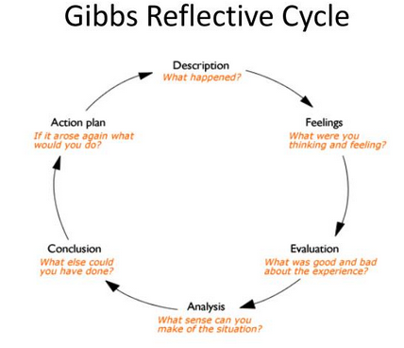
The two-lane approach worked well, particularly in helping children find a level of challenge appropriate to their abilities. The option to switch lanes ensured that children who found one lane too challenging could move to a more suitable one, thus maintaining their confidence and motivation. However, the balance exercises proved more challenging for some, particularly for Eira, William, and Rosie, who struggled significantly in the more difficult lane. This highlighted the need for better differentiation within the balancing tasks and greater flexibility in allowing children to choose their lane, aligning with Tomlinson's principles of differentiated instruction, which emphasize tailoring learning experiences to meet individual needs and allowing students to work at their own pace (Tomlinson, 2001).
These observations align with Kolb's theory of experiential learning, which suggests that children learn best when tasks are tailored to their developmental stage, allowing them to build on existing skills through concrete experiences (Kolb, 1984). Moreover, Haywood and Getchell’s (2019) work on motor development emphasizes that children often require extensive practice with basic tasks to build muscle memory and coordination, which was evident in the struggles of younger children with the more complex tasks. The session also reflected Vygotsky's theory, where the support and scaffolding provided to the children as they navigated their tasks allowed them to operate within their Zone of Proximal Development (ZPD) (Vygotsky, 1978).
Concluding from the session, further differentiation in task difficulty is needed to ensure all children are working within their capabilities while still being challenged. Breaking down activities into smaller, more manageable steps could help those who struggled with the balance tasks. Additionally, incorporating peer modelling might support the development of these skills, as younger or less skilled children can learn by observing their more advanced peers (Wood, Bruner, & Ross, 1976).
Looking ahead, my action plan involves introducing simpler balance exercises for children like Eira, Rosie and William who struggled with the more complex tasks such as heal to toe, I should rather give them a line to walk on. This will be coupled with positive reinforcement for children like Yonas, who are more advanced, to keep them challenged and engaged. I will also increase communication with parents to emphasize the importance of practicing foundational skills at home. By adapting my practice to incorporate these strategies, I aim to provide more personalized support that better meets the needs of each child, thereby fostering a more inclusive and effective learning environment (Tomlinson, 2001).
In the second week of the program, the focus shifted to catching exercises. The session involved activities using balls of different sizes and textures, allowing the children to practice and improve their catching skills. The younger children, such as Eira, Rosie and William, practiced catching with larger, softer balls using a "rainbow" throwing motion, which involved passing the ball to each other from a short distance and then gradually increasing the distance as their confidence and skill improved. In contrast, the older children, like Yonas and Olivia, were challenged with smaller balls and longer distances, which required more refined motor skills. The children's interactions were positive, with many of them helping each other and offering encouragement, particularly when one of their peers struggled with a more challenging task. My role was to guide the children through these activities, provide positive reinforcement, and offer individualized feedback to help each child improve (Vygotsky, 1978; Instructor, 2024).
Throughout this session, I reflected on the balance between using different types of balls to match each child's ability. I experienced a mix of satisfaction and empathy as I navigated the different responses from the children—satisfaction from seeing their successes with the larger balls and empathy to help them when they struggled with the smaller ones. These feelings were largely informed by my observations, particularly noting how the younger children found the smaller balls more challenging, leading to a potential decrease in their confidence if not managed carefully. There for encouraging the kids was essential (Gibbs, 1988).
The use of larger balls for the younger children proved to be particularly effective, as it allowed them to experience success and build confidence before moving on to more challenging tasks. However, I noticed that Teddy, who was more advanced in his catching skills, became overconfident and occasionally disregarded the session's rules, which required setting clearer boundaries and expectations. The importance of these observations reflects Vygotsky’s (1978) theory, where scaffolding must be adjusted based on the learner’s ability, ensuring that tasks remain challenging but achievable.
From a theoretical perspective, this session aligned well with the principles of differentiated instruction, which emphasize the importance of tailoring activities to meet the diverse needs of learners (Tomlinson, 2001). The use of different ball sizes and textures helped scaffold the children’s learning, providing them with the right level of challenge to develop their skills. Additionally, Haywood and Getchell’s (2019) insights on motor development suggest that using appropriately sized and textured equipment can significantly impact a child’s ability to develop these fundamental skills.
In conclusion, the session highlighted the importance of consistently using a variety of equipment to match the children's abilities and the need for clear rules to manage behaviour effectively. The reflection reinforced my understanding of the impact that equipment variety can have on skill acquisition and the necessity of setting clear behavioural expectations to maintain an effective learning environment.
As an immediate action, I plan to continue using a variety of balls, but with clearer guidelines on when to progress to smaller or more challenging equipment. I could use place markers to help the children understand where to stand. Additionally, I will communicate with parents about the importance of practicing these skills at home, using different types of balls to reinforce the learning that occurs during the sessions. By adapting my practice in this way, I aim to provide a more structured and supportive environment that fosters both skill development and positive behaviour (Tomlinson, 2001).
In the third week, the focus of the program shifted to throwing activities, emphasizing both accuracy and distance. The session was designed to challenge the children’s throwing skills, with activities such as aiming at targets placed at various distances. The older children, like Yonas and Teddy, were given more challenging tasks, such as throwing at smaller, more distant targets, while the younger children practiced basic throwing motions. Throughout the session, a competitive spirit emerged, particularly between Teddy and Yonas, which was encouraged as long as it remained healthy and supportive. My role was to instruct on proper throwing techniques, provide individualized feedback, and ensure that the competitive environment remained positive and inclusive.
During the session, I reflected on how to encourage technique and distance while maintaining fairness and motivation among the children. I felt a sense of optimism as I observed the children’s improvement and engagement in the activities, but also recognized the need to address specific challenges, such as Eira’s difficulty with throwing technique. These reflections were informed by the children’s progress and the competitive dynamics within the group, which needed careful management to ensure that all children felt included and supported. (Gibbs, 1988)
Personalized challenges, such as setting individual targets for each child based on their skill level, proved to be particularly effective in this session. This approach not only maintained the children’s motivation but also allowed them to experience success at their own pace. However, it became clear that Eira’s difficulty with throwing required more attention, I put a marker for her to step on before she threw and encouraged an overhand throw by lifting her target slightly higher in the air engaged (Newell, 1986).
In conclusion, this session underscored the value of personalized challenges and the importance of managing competitive dynamics to foster a supportive learning environment.
Moving forward, I will also discuss the importance of individualized practice with parents and suggest at-home activities that can further support their child’s development. By adapting my practice to incorporate these strategies, I aim to provide a learning environment that is both challenging and supportive, helping each child to reach their full potential (Tomlinson, 2001).
In the final week of the program, the focus was on kicking activities, with tasks designed to improve both distance and accuracy. The session involved kicking for distance and aiming at targets, with children at different skill levels given appropriately challenging tasks. The older children, such as Yonas, Teddy and Olivia, demonstrated advanced kicking skills, while the younger children, like Eira Rosie and William, required more foundational support. My role was to guide the children through the activities.
During the session, I reflected on how to balance the challenge level to ensure that all children were both engaged and successful. With the older kids I kept moving the targets further away as well as making them smaller (Newell, 1986). I felt a sense of satisfaction as I observed the children’s progress, but also recognized the need for further differentiation.
Reflecting on the session from a theoretical perspective, the success of differentiated tasks in this session can be linked to the concept of scaffolding, where children are provided with the support they need to achieve tasks just beyond their current abilities (Wood, Bruner, & Ross, 1976). By providing differentiated tasks and additional support where needed, the session ensured that each child could engage with the activities and improve their skills.
In conclusion, the session highlighted the importance of both differentiation and direct teaching in supporting skill development. I have learned that while it is important to provide tasks that match each child’s abilities, it is equally important to ensure that they have the clear direction to apply the activity.
Moving forward, my action plan involves continuing to provide differentiated tasks while also incorporating more helpful instructions such as placing markers for where they should step, particularly for the younger children. I will also discuss with parents the importance of practicing these skills at home, with specific activities that can help reinforce the learning that occurs during the sessions. By adapting my practice in this way, I aim to create a learning environment that is both supportive and challenging, helping each child to develop their skills and confidence (Kolb, 1984; Haywood & Getchell, 2019; Tomlinson, 2001; Vygotsky, 1978; Wood, Bruner, & Ross, 1976).
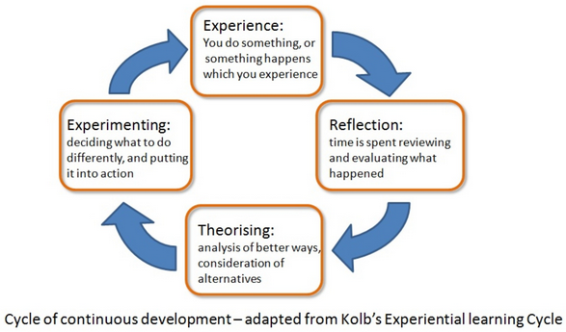

References
- Haywood, K. M., & Getchell, N. (2019). Life span motor development (7th ed.). Human Kinetics.
- Kolb, D. A. (1984). Experiential learning: Experience as the source of learning and development. Prentice-Hall.
- Newell, K. M. (1986). Constraints on the development of coordination. In M. G. Wade & H. T. A. Whiting (Eds.), Motor development in children: Aspects of coordination and control (pp. 341-360). Springer.
- Newell, K. M. (1986). Constraints on the development of coordination. In M.G. Wade & H.T.A. Whiting (Eds.), Motor development in children: Aspects of coordination and control (pp. 341-360). Martinus Nijhoff.
- Gibbs, G., 1988. Learning by Doing: A Guide to Teaching and Learning Methods. Further Education Unit, Oxford Polytechnic, Oxford.
- Tomlinson, C. A. (2001). How to differentiate instruction in mixed-ability classrooms. ASCD.
- Vygotsky, L. S. (1978). Mind in Society: The development of higher psychological processes. Harvard University Press.
- Wood, D., Bruner, J. S., & Ross, G. (1976). The role of tutoring in problem-solving. Journal of Child Psychology and Psychiatry, 17(2), 89-100.

