The Impact of Employee Training and Development on Employee Performance in UK Retail Organisations

Module: BMSW5014 Developing a Research Proposal
Lecturer: Jaliya De Silva
Student Name: Rana Rajjoub
Student ID: 2312015
Word Count: 2,197 words

1. Title and Introduction
The Impact of Employee Training and Development on Employee Performance in UK Retail Organisations
Introduction and Background
Employee performance is a source of competitive advantages. This is particularly true in the UK retail sector, which employs over three million people and is a highly competitive customer facing sector (Armstrong and Taylor, 2023). The retail landscape is in a constant state of flux, with digital disruption, increased customer expectations and the impact of the pandemic on the workforce. Training and development programmes for employees are a strategic tool that can be used by businesses to improve the capabilities of their workforce and to ensure that the organisation continues to perform.

The Human Capital Theory (Becker 1993) provided a first codification of the theoretical basis of this type of investment. The theory posits that conscious investment in education and training boosts the productive capacity of individuals which in turn, results in better organisational outcomes. This perspective views training as a strategic resource rather than an operational cost, a view reflected in contemporary human resource management practice (Garavan, McCarthy and Morley, 2021).
There is a large body of literature supporting a positive link between training and performance . However there is ongoing debate about the circumstances under which training produces meaningful benefits . Contextual characteristics such as managerial support, organisational culture and individual motivation have been shown to moderate the effectiveness of training interventions (Aguinis and Kraiger, 2009). Moreover, there is a lack of empirical research that has investigated this link in the context of UK retailing, creating a justified vacuum for future research.

Aim of the Research
To investigate the impact of Employee Training and Development Programmes on Employee Performance in UK Retail Organisations.

Research Objectives
- To study the effect of employee training and development on the level of employee performance.
- To evaluate the extent to which employees find the training effective and impacting on job performance.
- To test if the number of training sessions and the importance of training are significant predictors of employee success.
- To study organisational characteristics as possible moderators of the training–performance relationship.
- To provide evidence-based recommendations for enhancing training processes in UK retail organisations.

Research Question
What is the impact of training and development of employees on employee performance in UK retail organisations?

Importance of the Study
This study adds to the scarce empirical literature on workforce development in a sector where training practice and its performance outcomes have been under-researched. Indeed, the findings will provide retail managers with practical insights to optimise their return on investment in training, especially in the face of increasing staff diversity and technology integration.

2. Literature Review
Human Capital Theory
Human Capital Theory (HCT) is the foundation to this study, positing that investment in employee education and training enhances productive capacity at the individual and organisational level (Becker, 1993). From this perspective investment in training pays off in terms of better skills, better job performance and competitiveness. Since then, HCT has evolved to encompass the importance of social and relational capital in determining performance outcomes, recognising that human capital does not operate in isolation from organisational context (Garavan, McCarthy and Morley, 2021). However, critics have pointed out that HCT oversimplifies the relationship between training inputs and performance outputs by underestimating the role of environmental and motivational factors (Aguinis and Kraiger, 2009).
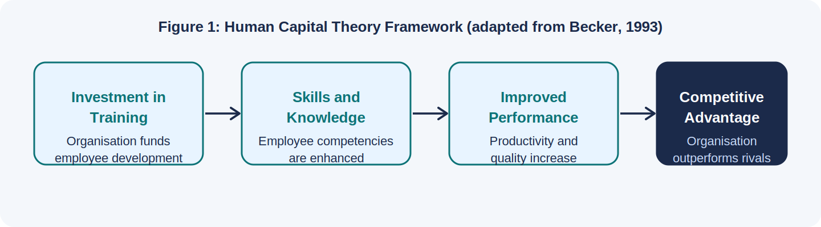
Figure 1: Human Capital Theory framework (Author’s own adaptation, based on Becker, 1993)
An Empirical Study of Employee Performance and Training
There is good evidence from peer-reviewed studies that formal training programmes improve employee performance. Elnaga and Imran (2013) in a frequently cited conceptual paper in the European Journal of Business and Management maintained that training is a key human resource management tool that improves directly the knowledge, skill quality and job-level effectiveness of employees. The authors observed that organisations that do not invest in systematic training are at risk of a decline in workforce productivity and a competitive disadvantage.

More recent empirical research confirms these findings. In The Learning Organization (Emerald Publishing), Andoh et al. (2022) examined how training value, psychological empowerment, and employee engagement affected training transfer. Their structural equation modelling analysis revealed that training value was a significant predictor of motivation to transfer knowledge to the workplace with important implications for performance improvement. The study is especially important because it highlights the mediating role of employee engagement. It suggests that the effectiveness of training depends not only on the design of the training program, but also on the psychological state of employees.

Robert and Mori (2025) further explored explored the moderating effect of training needs assessment on training intensity and employees’ skills and firm performance. They used a dataset of over 400 firms and partial least squares structural equation modelling (PLS-SEM) to show that organisations that have rigorous training needs assessment practices gain significantly greater performance benefits from their training investments than those that do not. The results indicate that the quality of the training design is just as important as the quantity of training.

Similarly, Salas et al. (2012) in Psychological Science in the Public Interest reviewed a large amount of organisational training research and concluded that well-designed training programmes greatly improve knowledge acquisition, skill application and task-level performance. Their analysis pointed to the significance of pre-training conditions like readiness of the learner, and post-training conditions like managerial reinforcement and opportunity for practice, in the effectiveness of training.
Organisational Moderators and Training Transfer
One of the important concepts for understanding training effectiveness is training transfer, or the extent to which skills and knowledge learned in training are applied on the job. Burke and Hutchins (2007) discovered that the most consistent predictors for successful training transfer in Human Resource Development Review were supervisor support, organisational climate and peer encouragement. Their integrative review showed training programmes delivered in isolation from supportive workplace conditions result in significantly lower performance improvements than those embedded in a wider developmental culture.
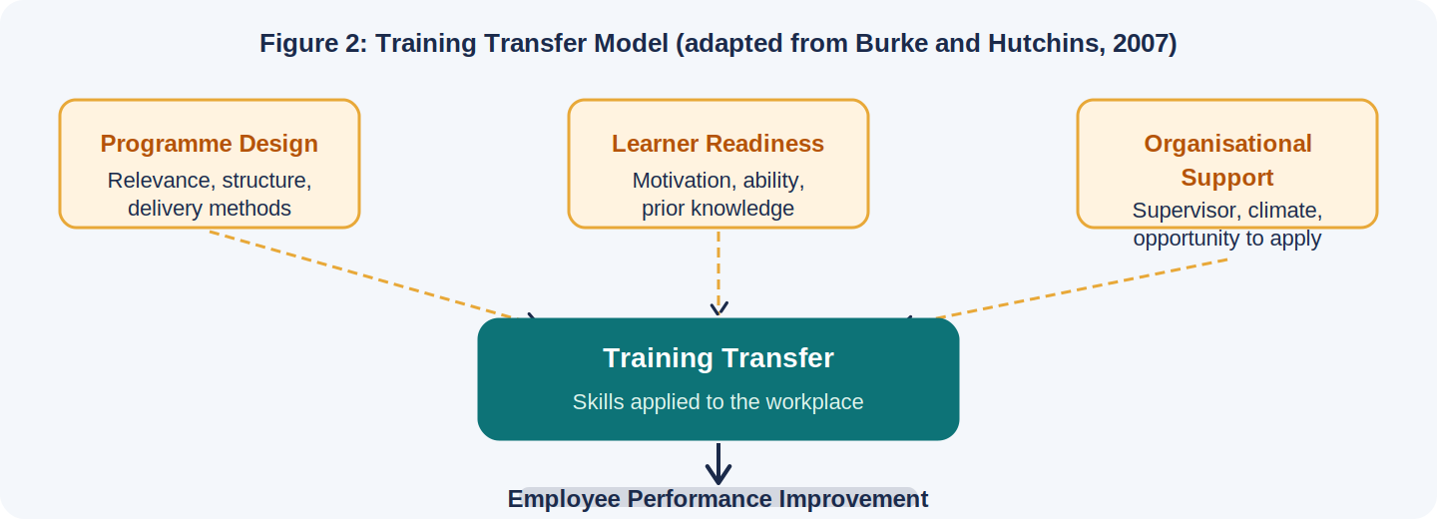
Figure 2: Training Transfer Model (Author’s own adaptation, based on Burke and Hutchins, 2007)
This conclusion was further supported by Aguinis and Kraiger (2009) in a major review published in Annual Review of Psychology. They found that whereas training generally leads to measurable improvements in individual performance, the magnitude of effects is moderated by organisational and motivational variables. This analysis also points to an important limitation of purely quantitative approaches to evaluating training: aggregate data can obscure important individual and contextual variation in training outcomes.
Employee Performance in the Retail Setting
Retail employee performance is a multi-dimensional construct that includes productivity, quality of customer service, teamwork and achievement of sales targets (Armstrong and Taylor, 2023). Robbins and Judge (2022) stated that performance is a complex mix of ability, motivation and opportunity; therefore, training cannot improve performance unless employees are motivated and have the opportunity to use their new skills. These contextual considerations are especially relevant to UK retail organisations where high staff turnover, shift based working patterns and frontline customer contact are defining features.
Research Gap
While the literature broadly confirms a positive relationship between training and performance, most quantitative studies focus on manufacturing, healthcare, or large multinational organisations. Relatively little empirical research has examined this link within UK retail businesses, particularly from the perspective of frontline employees. New empirical research is needed, driven by the fast-changing nature of the retail environment, with digital integration, changes in the employment market post-Brexit and changing customer habits. This study aims to fill this vacuum through the objective study of the effect of training procedures on employee performance in UK retail businesses.
3. Research Methodologies
Research Philosophy
The research philosophy adopted for this work is Positivism. Positivism argues that social reality exists independent of human consciousness and can be measured by observation experimentally (Saunders, Lewis and Thornhill, 2023). This is an appropriate approach to philosophy, since the research is designed to test a hypothesis derived from theory with numerical data and statistical inference compatible with the assumptions of positivist social science. The positivist position is consistent with the Human Capital Theory emphasis on measurable links between training inputs and performance outputs (Creswell and Creswell, 2023).

Research Approach
A deductive research approach will be used. Deduction is the movement from theory to the development of testable hypothesis that are then empirically tested (Bryman and Bell, 2023). The following hypotheses are proposed on the basis of Human Capital Theory:

H0: There is no significant relationship between employee training and development and employee performance in retail organisations of the UK.

H1: There is a significant positive relationship between employee training and development and employee performance in the UK retail organisations.

Research Design and Strategy
The research will be conducted using a quantitative survey method with a cross-sectional research design. Cross-sectional surveys are a method of collecting standardised data from a sample population at one point in time and are often used to investigate statistical relationships between variables (Bryman and Bell, 2023). This design is suitable given the time constraints of an undergraduate project and the aim of the study, which is to find associations between training variables and performance outcomes within a sample of UK retail employees.

Data Collection Method
Primary data will be collected through a structured self-completion online questionnaire. The questionnaire will contain closed-ended items using a five-point Likert scale (i.e., ‘Strongly Disagree’ (1) to ‘Strongly Agree’ (5). This format has been widely applied in training and performance research and offers robust quantitative analysis (Field, 2024). The questionnaire will include four sections: (1) demographic information; (2) training participation and frequency; (3) perceived training effectiveness and relevance; and (4) self-reported employee performance indicators including productivity, customer service quality, and target achievement.
Before distribution on a large scale, a pilot study with ten participants will be conducted to identify ambiguities, assess face validity, and estimate the internal consistency reliability by Cronbach’s Alpha (Pallant, 2020). Items will be adapted from previously validated scales to improve content validity.
Population, sampling design and sample size
The target population are supervisory and front-line employees working in UK retail organisations. A simple random sampling technique based on probability will be adopted to minimise selection bias and to improve the representativeness and generalisability of the findings (Cochran, 1977). The recommended sample size is around 150 participants, which is deemed statistically satisfactory for correlation and regression analysis at the 0.05 significance level (Cochran, 1977; Field, 2024). The survey will be circulated via professional networks and social media channels, targeting retail workers in the UK, and will be distributed via online platforms, including Microsoft Forms.

Variables
The independent variable is employee training and development, operationalised through training frequency, training relevance, perceived training quality, and training transfer to the workplace. The dependent variable is employee performance, operationalised through self-reported measures of productivity, work quality, customer service effectiveness, and achievement of performance targets.

Data Analysis
Data will be analysed using IBM SPSS Statistics. Participant demographics and distributions of relevant variables will be described using descriptive statistics (i.e. frequencies, means and standard deviations). Inferential analysis will be performed to assess the strength and direction of the association between training and performance using Pearson’s correlation coefficient. This will be followed by simple linear regression to explore the predictive relationship estimating the level of variance in employee performance scores explained by the training variables. The level of statistical significance will be set at 0.05. Internal consistency reliability will be assessed using Cronbach’s Alpha and a value of 0.70 or above will be considered reliable (Pallant, 2020).
Ethical Considerations
The study will be carried out following the ethical procedures of the institution and the UK GDPR laws. All participants will receive an information sheet detailing the aims, procedures, voluntariness and data processing policies of the study. Informed consent will be obtained before participation. No personal identifiers will be collected, ensuring participant anonymity. Participants may withdraw at any time without prejudice. Data will be stored in password-protected files accessible only to the researcher. Ethical approval will be sought before data collection commences.

Limitations
Several limitations are acknowledged. First, the cross-sectional study design limits causal inferences and the relationships do not imply that training leads to improved performance. Second, the self-reported data may be subject to social desirability bias, where participants may over-report their training involvement and performance levels. Third, the non-probabilistic nature of the online recruitment may limit the representativeness of the sample to the wider UK retail work force. Despite these limitations, the study is expected to generate meaningful empirical insights within a relatively under-researched sector.

4. Project Plan and Timeline
The research project will be completed over twelve weeks following ethical approval. Weeks one and two will focus on refining the literature review and finalising research objectives. Weeks three and four will involve questionnaire design and submission of the ethics application. Week five will be dedicated to the pilot study and instrument refinement. Data collection will occur during weeks six through eight via the online questionnaire. Week nine will involve data cleaning and coding for analysis. Weeks ten and eleven will focus on statistical analysis using SPSS, including descriptive statistics, correlation and regression. The final week will be devoted to interpreting findings, drawing conclusions, and preparing the dissertation for submission.
A Gantt chart detailing these milestones by week is provided in Appendix A.

References
Aguinis, H. and Kraiger, K. (2009) 'Benefits of training and development for individuals and teams, organisations, and society', Annual Review of Psychology, 60(1), pp. 451–474. Available at: https://doi.org/10.1146/annurev.psych.60.110707.163505

Andoh, R.P.K., Owusu, E.A., Annan-Prah, E.C. and Boampong, G.N. (2022) 'Training value, employee internal states and training transfer: examining the web of relationships', The Learning Organization, 29(6), pp. 674–691. Available at: https://doi.org/10.1108/TLO-09-2022-0100

Armstrong, M. and Taylor, S. (2023) Armstrong's Handbook of Human Resource Management Practice. 16th edn. London: Kogan Page.

Becker, G.S. (1993) Human Capital: A Theoretical and Empirical Analysis. 3rd edn. Chicago: University of Chicago Press.

Bryman, A. and Bell, E. (2023) Business Research Methods. 5th edn. Oxford: Oxford University Press.

Burke, L.A. and Hutchins, H.M. (2007) 'Training transfer: an integrative literature review', Human Resource Development Review, 6(3), pp. 263–296. Available at: https://doi.org/10.1177/1534484307303035

Cochran, W.G. (1977) Sampling Techniques. 3rd edn. New York: Wiley.

Creswell, J.W. and Creswell, J.D. (2023) Research Design: Qualitative, Quantitative and Mixed Methods Approaches. 6th edn. London: Sage.

Elnaga, A. and Imran, A. (2013) 'The effect of training on employee performance', European Journal of Business and Management, 5(4), pp. 137–147. Available at: https://www.iiste.org/Journals/index.php/EJBM/article/view/4475

Field, A. (2024) Discovering Statistics Using IBM SPSS Statistics. 6th edn. London: Sage.
Garavan, T., McCarthy, A. and Morley, M. (2021) Human Resource Development and Organisational Performance. London: Routledge.

Khan, R.A.G., Khan, F.A. and Khan, M.A. (2011) 'Impact of training and development on organisational performance', Global Journal of Management and Business Research, 11(7), pp. 63–68. Available at: https://globaljournals.org/GJMBR_Volume11/8-Impact-of-Training-and-Development-on-Organizational.pdf

Noe, R.A. and Kodwani, A.D. (2018) Employee Training and Development. 7th edn. New York: McGraw-Hill.

Pallant, J. (2020) SPSS Survival Manual. 7th edn. Maidenhead: McGraw-Hill.

Robbins, S.P. and Judge, T.A. (2022) Organisational Behaviour. 19th edn. Harlow: Pearson.
Robert, N. and Mori, N. (2025) 'Effects of training needs assessment in enhancing employees' skills and firm performance', Journal of Work-Applied Management, 17(1), pp. 82–98. Available at: https://doi.org/10.1108/JWAM-05-2023-0046

Salas, E., Tannenbaum, S.I., Kraiger, K. and Smith-Jentsch, K.A. (2012) 'The science of training and development in organisations: what matters in practice', Psychological Science in the Public Interest, 13(2), pp. 74–101. Available at: https://doi.org/10.1177/1529100612436661

Saunders, M., Lewis, P. and Thornhill, A. (2023) Research Methods for Business Students. 9th edn. Harlow: Pearson.

Appendix A: Research Project Timeline (Gantt Chart)

Task | w1 | w2 | w3 | w4 | w5 | w6 | w7 | w8 | w9 | w10 | w11 | w12
Literature review
Questionnaire & ethics
Pilot study
Data collection
Data cleaning
SPSS analysis
Conclusions & submission
Figure 3: Research Project Timeline – Gantt Chart (Author’s own work, created using Microsoft Word, 2026)

Appendix A: Research Project Timeline (Gantt Chart) as PNG
Figure 4: Research Project Timeline – Visual (Author’s own work, created using Canva, 2026)

