

Student name: | Diya Ganguly | Student  ID Number: | 2013048
Programme: | DBA-Doctor of Business Administration
Module: | Visions for the Future: Theoretical Perspectives on Management
Module code: | LCDB7006 | Contribution to Overall Module Assessment (%): | 100%
Lecturer: | Dr. Amare Desta | Internal Verifier: | Stephen Sommerville
Assignment Title: | Assessment 1- Written Report | Word count (or equivalent): | 7500 Words  (-/+ 10%)

Title-Managing Emotional Intelligence in the Workplace in the Post-Covid World
Table of Contents-
Executive Summary
Introduction- Decoding the intricate components of Emotional Intelligence
Understanding why a post-covid-19 world demands leaders or workforces with greater degree of Emotional Intelligence
Theoretical Frameworks or Models for keeping hybrid teams engaged and productive: decoding the power of emotional intelligence at contemporary workplaces for future leaders or management practices
Signs of managers/teams or employees with high emotional intelligence and it’s usefulness in the contemporary work environments
Critical evaluation of the benefits of EI in enhancing the envisioned management practice in the post covid world.
Recommendations: Specific and actionable measures companies can adopt for managing employee emotional intelligence for good organizational citizenship behaviours in the professional work settings
Conclusion
References

The Covid-19 pandemic being a new situation, there is no doubt that leadership/ or the way leaders drive their teams to do business will be one of the most heavily tested skills during and even after this pandemic. From the currently published articles, research publications or virtual business summit’s we all know by now that the future of work is flexible but to facilitate such flexible working systems and cultures, CEO’s or business leaders need to be equipped to deal with the demands this new era of work has imposed on them as people leaders or managers.
The pre-pandemic style of management heavily leaned on transactional and transformational leadership approaches as providing the workforce with right trainings, resources, tools, and incentives was believed to be the integral duty of a good leader for promoting employee engagement, wellbeing, and productive organization cultures. The leaders were expected to have all the answers and be in ‘command and control’ of their workforce, and simultaneously had to be aware of their workforce and customers’ needs and regularly be in touch with their own senior management teams for planning and implementing the top-down strategies for the company. (Guida, D. 2020)
However, with the pandemic, the times have changed, and the way people do business have undergone a fundamental reset following the catastrophic effects of the health pandemic and the resulting economic uncertainties that has affected various businesses, their workforces and for the generations to follow after. The leaders now need to adopt work models that both allows flexibility as well as promotes productivity with great economic returns. Undoubtedly Covid-19 has shunned a harsh light on leadership shortfalls and where leaders need to improve in retaining the newly acquired flexible and autonomous work cultures. Hence leadership needs an update but in real practice, any behavioural change is hard, requires practice and strong determination. (Steinberg, S., 2019)
In this report we aim to find out the benefits of emotional intelligence and why all organizations must strive to build emotionally intelligent workforce who are more productive, better performers and are able to build strong working relationship at work where employees can freely collaborate, share ideas and experience a sense of belongingness. Also, the example of a successful company-Tesla, Inc., will be used to demonstrate how a management within contemporary organization could use emotional intelligence to redress the post-Covid work challenges.
Emotional intelligence is the key ingredient rather the core of being able to make these behavioural shifts and only by doing so, one can progress towards a new stellar leadership style that allows self-sufficiency and flexibility. Decades of research have indicated that nearly ninety percent of employees who are successful in their career’s or are classed as high performers are likely to be more emotionally intelligent than their co-worker’s having similar academic backgrounds and technical skills. It’s the emotional intelligence (EQ) that will either make or break a business trying to thrive in this post-pandemic business world. The businesses adopting to the new covid-19 world, will still need ‘traditional’ people management skillsets, competence, and expertise (that primarily led them to be successful or thrive to the top positions of their companies) but more importantly they got to create a culture where employees feel proud to work, have greater work flexibility and autonomy, and believe that their leaders are sensitive to their changing needs and expectations. To achieve this, an organization would need a leader with greater degree of emotional intelligence who can build trust among their workforce and navigate through these uncertain times while meeting new employee expectations and challenges. (Bechara, A., Tranel, D., & Damasio, R. 2000)
Understanding why a post-covid-19 world demands leaders or workforces with greater degree of Emotional Intelligence- the future of the work is flexible, be it remote or hybrid way of working having an emotionally intelligent workforce must be a business priority
Emotional Intelligence is the soft skills which is predicted to be the one of the top-five most in demand attribute for employers according to LinkedIn (2020). It is the combination of emotional and social attributes that impacts an individual’s overall capability to cope effectively with time pressured situations or demands of life. To put simply, it is all about judiciously and empathetically engaging with others and also in part, having the skill to appreciate and manage one’s own emotions.
As the new realities and challenges of the post-Covid world are presented, the leaders are going to find it more challenging to manage their own intense emotions as well as understand others to stay emotionally connected with their teams. Also, the stressors that is constantly resulting from new Covid virus variants, new social distancing measures, ongoing economic crisis etc are impacting the wellbeing negatively of the both employees and their employers. (Adreatta, B. 2020)
Besides, in such times of change and uncertainty, more than ever workers expect and need to be heard and understood. They crave for feelings of safety and belongingness, seeking deeper connections with their leaders/organizations to find the true purpose of their job roles. Employers with high levels of emotional intelligence, transitioning from office-work to remote working jobs, will have the ability to perceive and understand these employee needs and also reasonably regulate their own emotions to build trust and healthy work relationship with their teams to achieve business goals. For example- the CEO of Facebook, in the early phase of the pandemic realised most of his workforce enjoyed remote working and was willing to retain such flexibility even after the pandemic. Acknowledging these new set of employee expectation, in a personal company newsletter, Mark Zuckerberg wrote to his employees, confirming that remote working will be a permanent work model at Facebook even after the days of pandemic are long gone, not only that but he also mentioned he himself will continue working remotely and heavily invest in software developments or augmented reality tools for boosting employee engagement, wellness and productivity for future remote working generations. This goes onto show that this contemporary tech giant entrepreneur has recognised that for remote work or any future jobs offering flexible work patterns, they need their staff to excel in soft skills and hence making large investments on smart technology or artificial intelligence tools (i.e., as Oculus VR headsets, AR glasses, BibBox VR etc) to keep their staff connected and make them feel supported, when things are changing almost instantaneously in the workplace. Infact very recently this leading social media network have confirmed that they are going to be the next-gen-metaverse company where instead of just streaming/viewing contents on their digital platforms, their teams and users can actually move between different devices and communicate in a virtual environment. (Culliford, E.,2020)
With this global shift in the way office work is done, many such successful business leaders and entrepreneurs are now realising that soft skills like emotional intelligence (EI or EQ) are at the moment most important than ever as teams navigate uncharted waters. Working remotely requires adaptability, creativity, self-awareness of one’s abilities and resilience, and individuals high in emotional intelligence tend to exhibit all these attributes. In a recent article published by Forbes magazine (2021) it has been stated that in this new age of flexible work there will be greater emphasis on people leaders developing ‘soft-skills’ such as empathy and trust in order to meet emerging employee expectations. A similar finding has been published by MIT Sloane Management Review (2021) claiming that; -
- more than 75% of employees expect their managers to adopt and demonstrate a leadership style centred on empathy and a supportive attitude
-almost 73% of workers feel safe and more committed to their work when they know that there is right amount of support available within their company for their mental wellbeing- which is believed to be the most vital to their post-pandemic working life.
-finally, 65% of managers have found to be asserting that they need support in meeting these new set of employee expectations.
Thus, we need leaders with higher emotional intelligence to meet these new expectations of their workforces for building strong team communications, cohesion, assertiveness, higher self-regard, greater employee loyalty and better decision-making competencies. This will also lead to developing workforces better placed for successes as they possess greater resilience, more mental fortitude and better critical thinking and creative problem-solving capacities. (Gerald, C. et.al 2020)
Introducing Tesla, Inc- A contemporary organization with a mission to accelerate our planet Erath’s transition to sustainable energy.
With Tesla, who has decided to convert its significant retail workforce to remote work are up for some challenge ahead but before we highlight those challenges, let’s explore who Tesla is and what it does.
Tesla formerly known as Tesla Moors was founded in 2003 by group of passionate engineers who wanted to reinvent electronic motor driving experience to replace gasoline cars. It’s an American organization and it’s headquarter is based in Palo Alto, United States. Their vision is to produce all electric-vehicles with scalable clean energy generation and storage products for a zero-emission future. For decades now Tesla has been dominating the clean energy, electric motor vehicle industry by producing the safest, quickest and most efficient sport utility vehicle in the history. It’s successful CEO, Elon Musk, a man of extraordinary genius and vision, in 2016 came up with a ‘master plan’ that enabled Tesla to produce low cost and high-volume electric vehicles that enabled the vehicle owners to save at least $200,000 over a million miles based on fuel costs only. Currently the company is working on creating an entire sustainable energy ecosystem for a greener and better future. However, compared to other vehicles and automobile products, ay item from Tesla is still considered to be a luxury purchase. Thus, Tesla is beginning to design and manufacture products that is more affordable and accessible to more people. Their future is all about accelerating the advent of clean transport and clean energy production including electric batteries, cars, storage etc. However, to pull up such hefty company goals, Tesla is solely dependent on their workforce. Tesla has been consistently producing energy efficient electric vehicles that not only provides an amazing thrill to its owners when driving its cars but also is considered to be the safest. It holds 5-stars ratings across every category from different car safety regulators in the world. In achieving this standards, Tesla’s management have been conscious enough to recognise that their workforce would require adequate tanning to produce such high quality and safe electric vehicles apart from their academic backgrounds or technical skillsets. Thus, Tesla has taken a proactive approach to redress this challenge as it provides multi-day training program to its production employees even before setting their foot on the production factory location. Not only that, Tesla also keeps providing on the job-training and track their employee’s performance frequently to help them improve their existing skillsets and thrive in the work they do. (Tesla.com, 2021)
However, covid-19 has posted new challenges to this clean energy manufacturer. First there was a massive supply chain drop including global chip shortages, port disruptions and production issues. Apart from that, between 2019 to the first quarter of 2021, Tesla has incurred 30% more employee injuries than the industry standard, and many industry experts believe it’s due to lack of appropriate training and supervision as many supervisors are social distancing or working remotely due to the global pandemic. While Tesla got to find a solution for this, in the interim their CEO Elon Musk, have already in an email committed to personal accountability to his employees. Musk has also penned an emotional note to his employees mentioning that he is heart broken every time any of his employees are injured while building the cars and he and this management is ready to do anything to fix this as employees safety and wellbeing is a vital priority for their organization.
Also, in a recent interview to Financial Times (2020) Musk stated that at Tesla all managers including him, must be directly notified about every injury so that they can meet with the injured employees personally and attempt to do their best for them. He also confirmed that at Tesla, the goal of the management is to lead from the front line and not form any warm, cosy and jazzy ivory tower office cabins as managers must put their team’s safety above their own. (Inc. 2020)
Thus, this goes onto show Musk and his management is not only emotionally intelligent to be sensitive to their employee needs and expectations but also willing to take steps to respond to employee concerns by encouraging more empathy and communication between their workers and the management. This not only discards the traditional management approach often dictated by “sternness”, “power”, “command” and “control” and even greed to exploit employees for driving profits but rather focuses on valuing employee needs, aspirations and safety for employee empowerment. Thus, this contemporary organization is willing to exploit the power of emotional intelligence to expand their business. (Inc. 2020)
However, with remote work and ongoing Covid-19 challenges, predicting and understanding employee needs is only going to only get tougher and trickier and in the following section some expert solutions will be discussed to redress the Covid-19 challenges.

Theoretical Frameworks or Models for keeping hybrid teams engaged and productive: decoding the power of emotional intelligence to redress post-Covid challenges faced by contemporary organizations like Tesla, Inc.
As the place of work for many organizations have been changing due to Covid-19, hybrid work practices are now becoming the new norm globally. While there are plenty of upsides attached to new remote or hybrid working patterns but there are plenty of downsides too. Historically a ‘physical office’ has been the most fundamental aspect for work life for many individuals but with remote/hybrid work, one is completely separated from so called ‘concrete office space’, which can lead to experience the feelings of isolation, void, disengagement etc. However, office space is not just a physical entity, but it is a place of congregation where individuals gather, brainstorm, share ideas, resolve challenges for meeting the primary goal of their office works. Hence, the place is not only the axis employees are pivoting during Covid-19 pandemic for office work but it’s also the flexibility around time. It’s no more about the traditional 9-5 schedules, it’s about fitting work into personal homes spaces and schedules that might include childcare, caring for elderly parents or family or even finding time to engage in professional upskilling. It’s about providing the flexibility with time or certain level of autonomy in carrying out remote work. To ensure these new set of needs, leaders must build a professional setting that emphasises on productivity and positive wellbeing even when working remotely. For instance, with remote work independent aspects of work can be carried out quite effectively but there some aspects of work that require teamwork, significant coordination with others in the team/relevant stakeholders can be quite challenging. So, the challenge is to remain motivated, productive, and goal-oriented, fluidly aligning with others in the team even when there is limited human interactions. (Adreatta, B. 2020)
This can perpetuate the risk of alienation, burnout, and underperformance. It’s not that the leaders who are disinterested in boosting employee engagement or performance but in fact are not many easy ways to do it the new normal remote or hybrid work era, especially when most companies are trying to provide more flexible working arrangements or trying to implement remote work policies. It’s difficult for any management these days to connect with their employees through a homogenous work culture for boosting the sense of belongingness, productivity and motivation among remote working employees. To address these concerns, organizations or people leaders must navigate these challenges by retaining the social elements of work even when people continue to work from home. Also, every management must have the courage to innovate new ways of working and to let the new culture of work from home/hybrid work evolve. None of us know what the future will bring but if the leaders are emotionally intelligent they will be more willing to adopt wide range of approaches to invent different and new ways of employee engagement strategies without having to see them in person to offer unique hybrid work experiences. Thus, every management, must rely on their own emotional intelligence to understand what works for their employees and what doesn’t and also have the skills to adjust accordingly. To understand the intricate notions of emotional intelligence and how leaders can develop their own emotional quotients we will review a couple of theoretical models and framework’s below. (Salovey, P., & Mayer, J. D. 2012).
The first model to be discussed is Bar-On’s Mixed Model of Emotional Intelligence. The model was originally developed by Reuven Bar-On, which comprises fifteen interconnected emotional and social competencies that determines the ability to understand oneself, interact and associate with others and to cope with everyday demands and challenges. The concept of social intelligence first started emerging in the twentieth century with the work of E.L. Thorndike (Anastasi, A.,1988). Then it was David Wechsler who further explore such concepts and much later contemporary theorists like Peter Salovey and John Mayer originally viewed emotional intelligence as part of social intelligence theory and it was actually their work which suggested that the concepts of social and emotional intelligence are interrelated and, in all possibility, represents interconnected components of the same construct. However, it was Charle’s Darwin’s scholarly work on the significance of emotional expression for adaptation as well as survival that initiated Reuven Bar-On’s study on emotional intelligence. His theory primarily focuses on understanding emotion-social intelligence as a combination of interrelated emotional and social skills, aptitudes and actions that impact one’s own cognitive abilities. Bar-On’s conceptual model include one or more following components-
i)Ability to understand one’s own emotions as well as articulate one’s own feelings
ii)Ability to understand others feeling and empathise with others
iii)Ability to self-manage and control one’s own emotions
iv)Ability to change and resolve problems of interpersonal and interpersonal natures
v)Ability to be optimistic and remain intrinsically motivated. (Anastasi, A.,1988).
These five-meta-factorial components of emotional intelligence led to the emergence of fifteen factors that are now see in the Bar-On’s Model of EI, and the following factors are described below: -

Factors (these dimensions comprise the EQ-I scales of EQ measures) | The EI Skills and Competencies represented under each factor
Dimension 1- Intrapersonal | Self-Awareness-the ability to express oneself:
1-Self-Regard | Observing and understanding one’s situation to accept one-self
2-Emotional Awareness | Being conscious of to understand one’s emotions
3-Assertiveness | Expressing one’s emotion constructively.
4-Independence | Avoid emotional dependency on others and be self-reliant
5-Self Actualization | Striving for personal growth to accomplish one’s highest potential
Dimension II- Interpersonal | Being Socially Aware and To Effectively Manage Interpersonal Relationships
6-Empathy | Understanding and being aware of how others feel
7- Social Responsibility | Identifying one’s social circles to leverage cooperation with others
8-Interpersonal Relationship | Building mutually satisfying relationships and fruitful association with others
Dimension III-Stress Management | Emotional Regulation and Management:
9- Stress Tolerance | Constructive management of one’s own intense emotions
10- Impulse Control | Having control on one’s emotions
Dimension-Adaptability | Coping with Change and uncertainties:
11-Reality Testing | Objectively validating one’s feelings and engaging in logical thinking by analysing real world scenarios.
12-Flexibility | To assimilate and accommodate one’s feelings and thinking to new situations
13- Problem Solving | To effectively resolve interpersonal or existential crises.
Dimension IV-General Mood | Having the ability to be Self-Motivated:
14- Optimism | Having an open mindset to focus on the bright side of life
15- Happiness | To be pleased with oneself, others around to experience satisfaction with life in general.

(Source- R.Bar-On, 2005)
These fifteen factors altogether point to the simple fact that emotional intelligence is key in organizational behaviour management and its usefulness is prevalent in every stage of our life. From managing one’s own mood or feelings to understanding and validating other’s feelings, one need to be competent in picking up subtle emotional cues and tailor their management styles accordingly. (Bar -On, R., 2005)
To evidence the importance of EI additionally Goleman’s Emotional Intelligence (EI) Performance Model will be reviewed. This model can be useful for contemporary organizations like Tesla, who believes in employee empowerment for reaching their mission of a zero-emission future.
Daniel Goleman defined emotional intelligence as a thread of interrelated competencies and aptitudes that can boost managers sensitivity towards others for effective people behaviour management in the workplace. These competencies are grouped into four main categories, including-
1-Self Awareness- (includes self-confidence, emotional awareness and accurate self-assessment competencies)- this is the ability to read and understand one’s own emotion and understand its impact on others. Goleman’s model also indicates that emotional self-awareness occurs in a sequence which is as follows-
-feeling or sensing one’s own emotionsthen acknowledging those emotions then identifying how logical or valid that feeling is followed by acceptance of the feelings reflecting on why one feels that way or what are the emotions present or came before then finally to act to take the appropriate action/s then reflect on usefulness of the action and analyse the lessons learnt from that situation. (Goleman, D.,1998).
This sequence occurs all day long continuously as one encounters different feelings or situations in life and hence it’s important to evaluate how this impacts others mood and behaviours. Also, emotions are contagious, and it can have the ripple effect on group behaviour (Craig, H., 2002)
2-Self Management- (includes the aptitudes of transparency, emotional self-control, adaptability, achievement, initiative, optimism)- this is the ability to self-regulate for managing one’s cognition, affection and actions in flexible ways to get the desired results. The goal of self-regulation is to pick cues from one’s own emotional responses for performing the required actions and for coping effectively in personal and professional relationships. When an individual fails to self-regulate then their brain can be clouded with pessimistic thoughts causing feelings of frustration, anger, anxiety etc causing the brain to get swamped by these overwhelming emotions. This is quoted as the ‘’amygdala hijack’’ by Goleman as the amygdala is the nerve centre of emotions or emotional behaviour in the brain and when one encounters a crisis this area of the brain goes into overdrive causing high activity leading one to continuously worry and obsess over the problem rather than finding a solution for it. It causes a lot of distress as its very difficult to think or focus on other engagements, causing one to miss out on other relevant matters. Thus, it is important to develop self-awareness for authenticity, transparency, and achievement. (C. Ott, 2016)
3-Social Awareness (this includes the aptitudes of empathy, organizational awareness, and service)-the ability to accurately observe and identify other’s emotions and interpret social situations aptly. It’s about perceiving what others are feeling and thinking and taking other’s perspective into consideration using one’s own ability for empathy. It’s all about noticing who’s frustrated in the team performing the work they are doing and then communicating in a manner that prevents further negativism.
4-Relationship Management- (this includes the competencies of inspirational leadership, influence, conflict management, change catalysts, building bonds, developing others and collaborative teamwork)- this category is focused on working in collaboration and performing successful teamwork with others by being mindful of individual emotions as well as acknowledging other’s emotions to manage social interactions and relationships effectively. (Goleman.D.,2002)
Using these skills Goleman (2002) believed that it is possible to steer a group or an entire workforce towards their goals and achieve the objectives and vision of the organisation. (Refer Diagram 3 in Appendix for Golman’s EI Quadrant) Also for Tesla, with a charismatic leader on top, must work on the building these competencies among their workforce for overcoming challenging situations.
Mayer-Salovey-Caruso-Emotional-Intelligence-Model (MSCEIT) is another very popular framework for measuring EI. Around 1990, Professor Peter Salovey, Chris Argyris and John Mayer started working on emotional intelligence and published multiple articles on its importance. Later they were joined by a PhD student named David Caruso and together they developed an ability based emotional intelligence assessment, which is now popularly known as the Mayer-Salovey-Caruso-Emotional-Intelligence-Test (MSCEIT). These four scholars defined emotional intelligence as the ability to conduct sophisticated information processing dealing with one’s own cognitions and emotions to use it as a guide for making decisions and engaging in actions. Bottom line is that individuals high in emotional intelligence can pay greater attention, comprehend and manage emotions better as well as perform adaptive functions that potentially benefit themselves and others. (Cote, S. & Miners, C.T.H., 2006)
The initial model that was published in 2008 comprised four branches as follows-
-having the capacity to perceive one’s and other’s emotions accurately
-having the skill to use emotions to facilitate thinking
-having the capability to comprehend emotions and identify the signs conveyed by those emotions
-finally having the ability to effectively manage one’s own emotions to attain specific goals
Later this model was expanded to include the sub-dimensions of emotional intelligence in each of these four branches. However, the final model was published in 2016 which was a revised version of the earlier four-branch framework of emotional intelligence. This revised model also included the area of reasoning and was published under the title of “The Ability Model of Emotional Intelligence: Principles and Updates”. (John. D, et.al., 2016)
The revised 2016 model is as follows-
Source- (John. D, et.al., 2016)
The above model was later transformed into a gold-standard ability measure known as Mayer-Salovey-Caruso-Emotional-Intelligence-Test (MSCEIT) for assessing an individual’s level of emotional intelligence. It can help leaders as well as an individual working in a team to perceive their emotions accurately and to manage them effectively. It also helps to monitor emotional responses to determine their rationality and to disengage with those emotions if they are unhelpful. The test also suggests highly emotionally intelligent individuals stay open to both pleasant and unwanted feelings as needed and engage accordingly. They also have the capacity to label emotions and determine its antecedents, meanings, and consequences. This also helps with raising awareness of one’s own physical situations, feelings, and cognitions. This self-awareness of one’s own thoughts and feelings can eventually help with leveraging mood swings and prioritizing thinking by directing attention to present emotional state or feelings. Thus, emotions influence our memory, thoughts, behaviours and even our ability to focus, engage or build relationship with others. At work emotions are equally important but it can just be little more complex and complicated to manage. Infact, identifying the power of emotion at work is fundamental to form effective partnership, to good leadership and to minimising conflict for promoting creativity and innovation. Thus, emotional intelligence is not about ignoring emotions or keeping them under control at work instead it’s all about accepting and validating the emotion one feels and relating to them in a healthy and productive way. (Matthews G., et al.,2004)
From these above two theoretical frameworks, any contemporary organization, especially that of Tesla who have their retail outlets and factories across nations, must learn to design strategies that will help their workforce to be more emotionally intelligent, as emotional intelligence is a great skill to have to better how work must be approached, what can be done with the work to make it more meaningful and purposeful and also being self-motivated and resilient to understand not all days at work will be jolly and free from crisis. In fact, management with greater levels of emotional intelligence helps their employees to witness any crisis or conflict situations as constructive and an opportunity to grow. This ensures better team collaboration, productive and even greater profitability for the company.
Genos Workplace Model of Emotional Intelligence- This another contemporary framework for assessing emotional intelligence at work settings. Late in the 1990’s this model was developed by Dr Ben Palmer, CEO of Genos and Prof. Stough from the Swinburne University, Australia.
This model encompasses a few competencies that make one stand out as more emotionally intelligent than others in the workplace. This model includes behaviour competencies that is effective for self-awareness and resilience. This model captures the six behaviour aptitudes that manifest from emotional intelligence abilities and are crucial for a world of ‘do more with less’. Greatest advantage of this framework is that along with the core emotional skills or competencies, it also offers a mix of productive and unproductive states that a leader or employees may encounter when working in fast-paced and dynamic work environments. Developing these emotional behaviours, helps employers to showcase more of the productive states and minimize the non-productive states for effective collaboration and better employee engagement. For example, with Tesla, they have been recording serious employee accident cases in their car manufacturing units, which is reasonably higher than other car manufacturing companies in the US but makes them stand out is there is employee accident benefit policies and the fact that they have invested million dollars in building safe work units and safety trainings for employees with a mission to reduce such accidental deaths. This proactive approach on Tesla’s part shows that they not only care for their employees but are listening and acknowledging their safety needs for preventing workplace accidents for smoother operations. This is actually a win-win solution, as employees get to feel happy with all the on the job safety trainings and also knowing that their employers would do anything to prioritize employee safety. When employees are content, on the other hand, employers can benefit from it as a happy workforce is a productive workforce. (Inc,2020)
The six key emotional intelligence competencies of this model are as follows- (Genos. International, 2020)
1-Emotional Self-Awareness: Present Vs Disconnected – This refers to emotional awareness and the impact this sort of awareness can bring on our decision-making abilities, performances and relationships. Employees who develop self-awareness are ready to acknowledge their emotions to enhance their decision-making skills. Lack of emotional awareness, on the other hand can disconnect one from their immediate feelings and lead to experience feelings of frustration, anger or chaos. Especially in today’s date and time when most teams are working remotely, the leaders must develop greater emotional awareness to remain constantly in touch with their teams and make their employees feel appreciated.
2- Emotional Awareness of Others: Empathetic Vs Insensitive- It encompasses the competency to perceive, understand and appreciate how others feel. This helps to demonstrate empathy, anticipate emotional responses, and modify our behaviours so that it fits well with others. When leaders are able to demonstrate this skill effectively, they are more likely to be perceived as empathetic and when they don’t, they can come across as being insensitive to other’s feelings.
3- Authenticity: Genuine Vs Untrustworthy- It’s the ability to openly express oneself and having the courage to honour commitments and even transfer this positive aptitude in others. It’s about bringing a certain degree of authenticity in communications by genuinely sharing emotions at the right time to right degree and to the right people in the team. Leaders who embrace authenticity often described as genuine whereas leaders low in this skill often come across as untrustworthy leading their employees to feel unwanted, unrecognised, and even insecure fostering a climate of psychological danger in the workplace. (Ovans, A., 2019)
4-Emotional Reasoning: Expansive Vs Limited- It is about integrating information (from oneself and others) in feelings when deciding. Its synthesizing own and other’s feelings with factual and technical information when making decisions. A significant component of emotional reasoning is also about communicating decisions to others and taking accountability for it. Leaders who can integrate feelings and technical information in their decision are perceived as expansive, creative and well though-out with their decision-making skills. Failure to combine feelings with facts, results in decisions that are limited in scope which in turn can negatively impact creativity and productivity.
5-Self Management: Resilient Vs Temperamental-This skill incorporates the importance of mood, emotion, time, and behaviour management. It is also about continuous improvement. The contemporary workplace is both demanding and time pressured, and can generate chaos, conflict, negative emotions, and outcomes. These negative feelings are contagious and can be a powerful force in determining how productive or unproductive are the workplace. Therefore, leaders who are emotionally aware and have a conscious grip over their emotional responses and behaviours are found to be resilient rather than being temperamental and effectively manage high work demands and different stressors at work. (Ovans, A., 2019)
6-Positive Influence: Empowering vs indifferent- This is about creating a positive influence on teams or co-workers via feedback, collaborative team efforts and creative problem-solving tactics. This helps to create productive environment for others and certainly encourages professionals at work to cooperate and effectively work together.
Especially in times of duress like we are in now, every management should at least attempt to positively influence their employee’s moods, feelings and emotions to encourage them to be resilient and foster the can-do attitude. This in turn will empower them to get more engaged with work and also motivate those around them. Lower levels of this competency on the other hand can create indifference which is unhelpful as it does not help in resolving issues that are affecting employee’s performance or team dynamics. (Green, R. 2004)
These six core competencies of Genos Model underlie the usefulness of emotional intelligence in the workplace and its relevance in our contemporary work environments where change is the norm and effective teamwork is critical.
To summarise these theoretical frameworks and models underpin the value of emotions and emotional response management in our lives. Skills like self-awareness, social perception, empathy and resilience are all connected to being an emotionally intelligent leader who is not only aware of one’s own needs and feelings but also has the ability to understand other’s feelings and expectations and the charisma to positively influence or empower others through problem solving, feedback, recognising and supporting others work in the team. (Green, R. 2004)
Signs of managers/teams or employees with high emotional intelligence and its usefulness in the contemporary work environments
Organizations that have managers with high emotional intelligence means that they can understand and regulate their own moods and recognize how others feel and empathize with them to get their needs met and resolve any ongoing crisis. This also allows them to emerge as charismatic leaders creating positive impact on others to boost employee loyalty and good citizenship behaviour within their respective work teams. Just like Elon Musk, who is discarding the traditional control and command leadership tactics and embracing more human tactics filled with core competencies of emotional intelligence behaviour. On the contrary leaders with low emotional intelligence often find it challenging to decipher and manage their own emotional needs and to recognise and honour emotional needs of their teams or employees working for them. These manifestations can impact the people around or teams one is working with and can also make it difficult for leaders to maintain a productive working relationship with their workforce. This can be related to Apple’s current condition, which suffered an exodus of talented employees as they denied offering remote or other flexible working opportunities in this new normal era of flexible work. This has now made Apple to rethink their management strategies as 70% of employees, especially knowledge workers are more willing to compromise salaries over flexible work options these days (Laundry, L. 2019)
Thus, it’s important to notice and regulate the signs of low emotional intelligence which includes trouble recognising what causes certain intense feelings or strong emotions, sudden mood changes or frequent outbursts, difficulty asserting opinions or taking accountability of a crisis situation, having a fixed mindset or little interest in finding new ways of solving problem or accepting constructive criticism etc. Thus, improving on emotional intelligence offers plethora of benefits resulting in with both personal and professional growth. For instance, people with high emotional intelligence, practice self-control, can restrain impulses during conflict or tense situations, are resilient and remain optimistic even when facing setbacks. Emotional intelligence can be learnt and is often associated with improved wellbeing, higher job satisfaction and higher quality of life. (Laundry, L. 2019)
Understanding the usefulness of emotional intelligence and why it is such a big deal in the contemporary work environments- Managing emotions successfully can lead to self-awareness, better relationship management and even the boost the chances of professional success. However high emotional intelligence doesn’t automatically translate to ‘exemplary human being’ but developing emotional intelligence can help one build strong relationships, be more mindful of one’s and other feelings and effectively navigate through unwanted feelings and stressful situations to be resilient in the face of setbacks. The best part of emotional intelligence is that it isn’t fixed and can be learnt to increase emotional awareness, better emotional regulation, and empathy. (Genos. International, 2021)
For instance, just like Elon Musk, another the personalised digital marketing leader and CEO of Jivox, Diaz Nesamoney applied an empathetic approach centred on emotional intelligence to navigate through the Covid-19 crisis. He made a choice right at the beginning if the pandemic to lead his workforce with humanity and empathy at the core of his strategy. This approach seemed unconventional and risk-filled, but it attributed to his company’s success through 2020 and beyond. His strategy was to focus not on results but on people first. Nesamoney believed that leaders should focus on people as when their people at work are happy, customer satisfaction, revenue and product innovation will naturally follow. (Raypole, C., 2021) As for Musk, he to decided to shutter his brick and motor offices right in the beginning of the pandemic to operate virtually keeping their employee’s health and safety in mind. By doing this he not only managed to keep his employees happy but also managed to keep them engaged so much so that the company hit a new record sale during the pandemic. (CNBC, 2021)
Understanding the nuances of emotional intelligence in the workplace can have pragmatic benefits but it’s not natural for everyone to be in tune with their emotions.
In the following section we will discuss why developing emotional intelligence is such a big deal in the contemporary work environments such as that of Tesla.
-Emotionally intelligent mangers foster safe working environments for allowing employees to sense psychological safety in their workplace so that they feel safe, inspired and comfortable to hone their critical thinking skills to take intended risks, explore new ideas and freely express their opinions. In such environments, working collaboratively isn’t just a duty but it’s an integral part of an organizational culture. However, managing people behaviour is not so easy and can be quite a stressful mandate as it requires one to be competent in managing both their own and other’s expectations. Leaders who are low in emotional intelligent tend to be discombobulated in demanding situations as they fail to handle their own emotions. This might then lead them to be verbally offensive to others or being passive aggressive in their reactions to others. (Thomas International Ltd, 2021) Now for Tesla, they already have many safety measures and trainings in place, even before Covid had occurred, but their management have got to realise that those old safety measures needs to be revised as Covid-19 might have impacted their workers both physically and psychologically. The training mustn’t only comprise the aspects of physical safety but also touch upon emotional wellbeing and psychological resilience to cope with any level of pain or loss their employees have suffered during the global pandemic.
- Also if leaders at Tesla possess high level of emotional intelligence will be aware of the authority and responsibility vested in them and also will be able to perceive that the decisions they make will impact the fate of hundreds or even thousands of people working for them. They should understand they have the responsibility of effecting any necessary changes in the organization and if they are aware of the possible emotional reactions of other’s to these changes, they are then able to prepare and chalk out the most optimal ways to make the necessary changes. Hence, they should utilise their emotions productively to drive their workforce and the organization forward. (Petrides, 2019)
-Besides leaders at Tesla can display the power of emotional intelligence by abstaining from engaging in any sorts of personality clashes or taking things personally. If they are aware of how they feel and how their reactions might affect others, they will be able to move forward with their plans without worrying about the impact of their egos. The biggest hindrance to productivity in any workplace is when personal vendettas between leaders and employees are evident. The lesser such issues arise, better will be the team productivity and cohesion. Not being an emotionally intelligent leader can hinder collaboration within the organization and cause disastrous effects on productivity and team cohesion as employees are always bothered by the fear of making mistakes and remains too distracted. This fear can negatively impact employee wellbeing and even their analytical thinking skills. Also lack of emotionally intelligence can also mean lacking the ability to handle situations that could be fraught with intense emotions. Leaders ae supposed to be conflict-ready and the leaders who isn’t clued into theirs or their workforce’s emotions will have a difficult time recognising conflict in the first place along with identifying effective strategies to resolve such conflicts. (Genos. International, 2021)
To put it simply, emotions are present everywhere and when leader’s doesn’t have a grip on their own emotions and reacts inappropriately, most of their teams or employees tend to feel nervous about contributing their suggestions, feedbacks or even honing their own critical thinking skills, as they fear how their leaders will riposte. It’s almost like where employees are walking on eggshells trying to prevent themselves from the inappropriate outburst of their leaders or perhaps even trying to save themselves from being embarrassed in front of their team members. Work environments like these, are not only stressful to work and bond but also unproductive, non-stimulation which ultimately limits the growth and progress of the overall organization. Hence embracing emotional intelligence in the workplace can create a workforce that is more productive, creative, motivated, happier, healthier, and better at collaboration and teamwork. (Raypole, C., 2021)
Critical Evaluation of the benefits of EI in enhancing the envisioned management practice in the post Covid-19 world-
It’s quite clear remote working is to stay even when the Covid-19 pandemic is long gone. While working remotely offers obvious benefits but there are potential downsides attached to it. One of the biggest concerns is that remote working will be unable to offer the strong connection between the co-worker’s and their management team or leaders that a traditional physical work environment naturally offers. Then are issues like employees feeling isolated, left-out and even they are worried about their advancements and promotion opportunities as they do not get to meet or interact with their leaders or management team regularly. These feelings are harmful and can limit employee creativity and productivity. Hence a good leader must adopt some strategies to keep themselves connected with their workforce and prevent from fading into the woodwork just because there is no face-to-face connections or physical workspace to meet their teams. Below are a few examples that can be implemented to keep in touch and motivate, inspire, and empower employees even when working remotely. (Pineiro, J., 2021)
-Embracing ambiguity- To put it simply it’s much about getting comfortable with agility. It’s shifting from the mindset of right vs wrong only decisions. As we are navigating through the crisis of a global pandemic, every management must learn to get comfortable with ambiguity and have the ability employ flexible solutions to be agile in problem-solving during these crisis situations. While impulsive-decision-making is neither a choice nor advisable in such crisis scenarios and fact-finding is critical, emotionally intelligent leaders must be agile too. This will prevent them from analysis-paralysis and give an opportunity to rely on their own decisions, despite possible unknowns. It’s about evaluating the pro’s and con’s and being aware of the worst that can happen and having a backup plan for dealing with it. Embracing ambiguity, also enables a company to broaden their perspectives, allowing them to gather opinions and insights from others as well as staying informed and connected with their employees. This in return helps in creating productive work environments where employees can feel safe, heard and valued for the contribution they are willing to bring onto the company. (Bates, S. 2020)
-Sharpening the skills of self-reliance and empathy- From Bar-On to Goleman, each of these emotional intelligent gurus, have focused on self-reliance as a critical component of EQ, in their respective theories. According to Newman, M. (2016) Self-reliance is pretty much about having the ability to gauge the level of confidence an individual has in controlling their own behaviours and emotions when encountered with major events that can their impact their life. The critical component in that is self-belief. The more confident one feels with their own decisions and judgements, quicker they will be in taking actions to implement those decisions. Even Daniel Goleman, in his latest research has stressed on leader’s mood and how contagious it is. He believes if a leader is low in confidence when making big changes across organizations, this will impact their mood and even negatively impact their judgements. That’s why Goleman says a leader’s mood is contagious. The employees often model behaviour of leaders they admire and even look for emotional support and feedback from their leaders when in crisis. That’s why leaders must be decisive, self-reliant, authentic and embrace an optimistic mindset that conveys a can-do-attitude. This helps in fostering a sense of self-confidence and helps leaders rise to the major challenges and opportunities that the world of trade presents. Also, leader’s must listen carefully and be empathetic towards their workforce. Empathy do not require one to be warm and fuzzy, it’s indeed about having the self-confidence to communicate that as an individual one can acknowledge and appreciate other’s point of view. It’s an integration of cognitive and emotional dimension. For example- as a leader one must have the ability to understanding the tasks in hand and how a person needs to perform them but also can appreciate the humanity of another person before entering into a transaction with them. Such emotional connections ae comforting and allows one to establish strong rapport and common grounds to fulfil company goals done together. (Newman, 2019)
Especially in times of crisis such as now, being empathetic will allow management to listen to their employees with an open mind, to acknowledge their pain points and help them to be aware of how their decisions might impact others working for them. Not many individuals will forget the boss or the organization that was especially empathetic or those who protected their employees during a difficult time and these employees are likely to be more loyal and work harder to perform more productively for those employers in the future. For example- the organization ‘Apple’ published a mandate for all their employees to return to office this summer against their half of their employees wishes and this have now thrown the company into a bit of disarray as many of their top-level executives or super performers of the company have quit their jobs at Apple and joined other conglomerates that have kept remote working as an option for their employees. On the contrary, companies like Facebook, Slack, Netflix, Siemens have acknowledged this work from home employee need and made it a permanent option in their companies for those who can manage working from home, as they believe greater the level of flexibility offered better will be their employee morale and productivity. Besides, these brands have managed to create a fair image that portrays themselves as better leaders, management or organizations who value employee wishes and needs, even during the stress of a pandemic. (Ovans, A., 2019)
-Be calm and hone critical thinking to manage change response- Even we emerge out of this pandemic, things will not necessarily resume back to how it was before the pandemic. This will often lead leaders to experience a range of intense emotions such as worry, confusion, frustrations, resentment, fear as any situation that demands change or is unanticipated is difficult to handle. However, in uncertain, unpredictable situations like these, emotional intelligence can be quite handy as it involves understanding and managing the negative emotions that arise with uncertainty. It allows one to recognise the negative aspects of change but also unravel the opportunities these uncertain situations might present. This in turn promotes critical thinking, as it helps one to avoid thinking there is only one option or method to resolving a crisis. It helps to review a complex situation with little bias and evaluate different options. Particularly when companies are navigating uncertainty, critical thinking is crucial as it allows organizations to reinvent new ways of doing business or launch new products or services to survive and thrive during crisis situations and maybe even beyond them. (Steinberg, S., 2019)
-Adopt an approach that balances optimism with realism to move through disappointments- In unprecedented times like these, our hopes and aspirations are often dashes out. When we are disappointed, we often dwell on what went wrong or how it happened or why it happened to us, rather than accepting what has happened has happened and worrying about it will not resolve or change anything. These thoughts keep us stuck and makes it more difficult to move past the disappointment. We all know that things won’t fall back into its place automatically unless we decide to do something about it to steer past through such situations. Hence, it’s useful if leaders adopt an approach that allows them to look for something positive about the crisis situation and come up with new ways of doing things if the previous methods aren’t working. It’s about designing supports for recovery plans rather than hoping business will automatically bounce back its usual productive pace or revenue earnings. Being optimistic is fine but being realistic about the crisis situation is equally important and a critical component of emotional intelligence. Thus, having a strategy that includes both realism and optimism can help leaders shape a clear vison for future, remain authentic with their workforce by transparently communicating their plans to emerge out the crisis situations, implement realistic goals for business recovery and even brainstorm new ideas or plans for dealing with the long-term or future challenges. (Pineiro, J. 2021)
However, these are easier said than done, as it requires years of practice to master these critical soft skills of emotional intelligence. For instance, embracing self-reliance or reconditioning one’s brain to be empathetic is never going to be easy, as putting others before oneself or focusing on employee progress or wellbeing first over sales, will require some sheer grit and courage on the leaders part, as in the cut-throat world of business the opposite is more commonly witnessed. Moreover, when one encounters crisis, it’s hard to remain calm, optimistic and even find the courage to move through disappointments. Building any business or service, requires time and great deal of perseverance and seeing it crumble into pieces, after years to hard work just because of a health pandemic, might be quite a daunting experience. All one can think in such times is to save themselves first over others no matter how productive or important those others or employees have been in building their businesses. Their minds are clouded with negativity, fear, anxiety etc which makes them incapacitated to think for others benefits or wellbeing. It’s only the visionaries or leaders high in EQ, are able to see the benefits of emotional intelligence on employee morale and overall business performance in advance as they realise to achieve the lofty, ambitious company goals and to solve complex problems, they typically need to build strong relationships at work and assemble more effective where employees can freely collaborate to accomplish shared tasks and resolve any challenges that emerge. (Pineiro, J. 2021)
Recommendations: Specific and actionable measures Tesla can adopt for managing employee emotional intelligence for boosting employee morale, productivity and creativity in the professional work settings
Our life is full of experiencing different emotions and making emotional decisions. These emotional decision making is not only applicable in our personal lives but also have to do with our co-workers and business partners. Hence making good emotional decisions helps both personally and professionally. In this section we will cover a few solutions and poplar techniques that can be adopted by Elon Musk’s management to redress the post covid-19 challenges.
Regret Minimization- This is a technique that can be adopted when making big decisions. Successful business entrepreneur Jeff Bezos have also adopted this framework and found it to be instrumental in helping him make big decisions in core areas of life. He believed when faced with a hard decision, developing a framework to navigate through it crucial. However, most people in such situations procrastinate or avoid making a decision which ironically is a decision in itself. Decision making is a skill and it’s a skill that needs practice and refinement over time. In business, there are moments when we are torn between logical and emotional questions. Logically, we need to comprehend what’s happening around and emotionally we need to decide can we stick to it. In situations such like these, this Regret Minimization technique can be quite handy as it teaches us to keep the emotions out of equation and perceive things more distantly. This allows one to take the opportunity to step into the mental space required to make effective long-term decisions. For instance- for Bezos, the question was whether to leave his highly paid secured job at hedge fund or to build his business idea of Amazon. (Ibrahim, 2020)
To resolve this, he came down to think he could stay in his secured job and do well, but this decision will always make him wonder what the business idea could have been. Thus, he decided to minimise his regrets by quitting his job and stated Amazon. Today his company is valued at two trillion dollars, which simply goes onto show when one seeks to minimize regrets, the answers tend to reveal themselves.
Thus, this framework helps one to minimize doubts, fears or insecurities when faced with a difficult decision or venturing into an unknown territory. It allows one to remain focused to logically perceive the situation and address what needs to be done to move forward effectively. Also, one must remember not all life-changing decisions are binary instead they are multi-faceted. That’s why is important to be aware of one’s own emotions and if needed one must talk to others who have been in similar situations for an outside perspective. Hence regret minimization is not simply about following the instincts and sticking to it but mostly about sensing the risks or benefits attached to those emotional decisions and how it could affect an individual and others around them. (Ibrahim, 2020). For Tesla, they have decided to operate their retail units virtually and they shouldn’t be amending this decision unless they incur a big blow to their revenue earnings or are unsuccessful in managing virtual retail work operations.
-Incorporate the Ikea Effect-The Ikea effect is a cognitive predisposition that helps to explain why people place higher value on things they helped to create or build. It was Earnest Dichter, a psychologist and motivational researcher who originally coined this concept in the 1950’s. This effect suggests that mere ownership of a product or task increase its value to the individuals. However as much as its effect is evident on consumer buying behaviour, it can also be used for enhancing self-worth that results from permitting people to do certain things themselves. The power of the Ikea effect is most felt when employees can create, plan, or assemble new strategies to adapt to crisis situations. Great leaders embrace this Ikea effect to allow their employees to feel they can contribute to the organizational goals in more valuable way. They can turn employees mindsets from ‘’can do’’ to ‘’want to do’’ to turn a regular job into something much more meaningful, ultimately making their employees more self-dependent, autonomous, and also giving them the opportunity to showcase their unique talents, skills and experiences. The Ikea effect helps in creating an environment where employees feel they have a stake at the business and when people feel something is ‘theirs ‘, they care the most and this makes them feel that they have the responsibility and autonomy to not just do what they are instructed to do but to do what’s right or most suitable for their organizations growth. (Haden, J., 2020) Thus it’s time Tesla starts thinking about new ways to share company profitability’s with their talented employees rather just rewarding them with handsome salaries and safety benefits.
-Embrace flexibility to lead with courage and compassion- Adaptability and flexibility are emotional competencies that are highly associated with unpredictable or change scenarios. In situations like the ongoing pandemic, we are all facing now, leaders need to drop skills and behaviours that have been beneficial in the past and encompass change and rely on new skills, even when that maybe untested. Leaders got to understand that change is the only constant norm now and there might be very little choice these days in terms of how people work and live. However, what one can be more now is flexible, as flexibility is not just adjusting to new ways of doing things but also understanding what needs to be done for supporting those who are struggling to cope with the crisis situations. In such situations it is advisable for leaders to reflect on situations from the past when they had to adjust to change and how they felt or emerged out of those change demanding situations. To work on flexibility, it is useful to first consider one’s baseline state and evaluate the different options in hand. Then a dialogue can be opened with others in the team about the crisis asking for feedback and suggestions for adapting best to others needs and expectations and if needed implement some or most of them to keep individuals in the team motivated. Being adaptable and making changes also requires a bit of courage and compassion. Leaders got to make difficult decisions while supporting and enabling their teams during the scenarios that require change. Hence, it is times like these when leaders might feel fearful, anxious, doubtful but if they are emotionally intelligent, they will be able to challenge these belief systems and successfully strategize the actions needed to change direction or to emerge out the crisis situations. Just like Musk needs to do now to resolve Tesla’s dire chain supply crisis, by revisiting similar past scenarios and reflecting o the past effective strategies that has worked for him and his company (HBS.Online, 2020)
Finally, as Tesla is changing to new remote/hybrid work patterns, it is important to clearly communicate what is expected from the employees during this transition period. To communicate such expectations the following steps can be adopted-
- Remaining self-motivated- In hybrid or remote environment when there is no managerial figure to communicate their satisfaction or immediately share praises or reward an employee for a job well executed then such individuals can struggle to find motivation to get their work done. Hence employees can be encouraged to work with others, set a reward for themselves when they finish a task or set weekly meetings where the employees get to meet their managers and discuss about their wins and challenges from the previous weeks and how they are willing address them in the upcoming weeks. (Steinberg, S, 2019)
- Encourage to embrace adaptability- Any sudden change in routine is always hard to cope with but the disruptions caused by the global pandemic which has almost impacted every facet of our lives, is likely to cause an extreme reaction, even in the most adaptable of individuals. That’s why its important to encourage employees to replicate their work routines when working remotely or when returning to office after almost eighteen months gap, to give as many details and information as possible about the changes that are occurring and show employees that even changes create opportunities for professional growth and development.
- Focus on employee wellbeing and stress management for building better team productivity and collaboration- Regular or weekly check-ins are most important, communicating the opportunities that remote/hybrid work can offer will also be useful and giving new projects to work on can keep employees motivated. Also identifying opportunities to break larger tasks into small wins can be useful to keep employees engaged, motivated and make them feel they are making progress and still feel successful. If returning to office, employees should be allowed to customise their set up at work to replicate how they worked at home or be allowed to take small steps and not rushed to return to work full time immediately, if possible. This will then encourage employees to take care of their own health and wellbeing and schedule time for exercise, rest, and socialisation to manage their emotional and behaviour responses constructively. Most importantly it’s important to highlight the good things that are occurring in times of duress such as these. (Mackintosh N.J., 2015)

To conclude being emotionally intelligent allows an individual to relate to their employees, inspire their teams to do their jobs much more meaningfully, competently resolve conflicts and motivate others to take proactive actions. The higher the management team’s emotional intelligent quotient, the more creative and innovative an organization is likely to be in resolving conflicts and in managing their employee needs and expectations. Thus, when emotional intelligence is prioritized within an organization it is likely that more successful, productive, and innovative employees will be which in turn will positively impact their employer’s business. (Ovans, A., 2019)

References-
Adreatta, B. (2020) Lead with Emotional intelligence. Available at: https://www.linkedin.com/learning/leading-with-emotional-intelligence-3/next-steps [Accessed on 17 July 2021]
Anastasi, A., (1988) Stress and Employee Creativity: The mediating role of Emotional Intelligence. Int. J. Manag. Excell. 2017; 9:1050–1058. doi: 10.17722/ijme.v9i2.340. [Accessed on 21 July 2021]
Bar -On, R. (2005). Emotional intelligence and subjective wellbeing. Manuscript submitted for publication. [Accessed on 27 July 2021]
Bar -On, R., Handley, R., & Fund, S. (2005). The impact of emotional and social intelligence on performance. In Vanessa Druskat, Fabio Sala, and Gerald Mount (Eds.), Linking emotional intelligence and performance at work: Current research evidence. Mahwah, NJ: Lawrence Erlbaum. [Accessed on 21 July 2021]
Bar-On, R. (2006). The Bar-On model of emotional-social intelligence (ESI). Psicothema, 18 , supl., 13-25 Available at:.http://www.eiconsortium.org/reprints/bar-on_model_of_emotional-social_intelligence.htm [Accessed on 27 July 2021]
Barsade, S. G. (2002). The Ripple Effect: Emotional Contagion and Its Influence on Group Behavior. Administrative Science Quarterly, 47, 644-675. [Accessed on 17 July 2021]
Bechara, A., Tranel, D., & Damasio, R. (2000). Poor judgment in spite of high intellect: Neurological evidence for emotional intelligence. In R. Bar-On and J. D. A. Parker (Eds.), Handbook of emotional intelligence. San Francisco: Jossey-Bass. [Accessed on 17 July 2021]
Chamarro-Premuzic, T., and Berg, K. (2021) Fostering a culture of Belongingness in the Hybrid Workplace. Harvard Business Review. Available at: https://hbr.org/2021/08/fostering-a-culture-of-belonging-in-the-hybrid-workplace [Accessed on 17 July 2021]
Cote, S. & Miners, C.T.H. (2006). Emotional intelligence, cognitive intelligence, and job performance. Administrative Science Quarterly, 51(1), 1-28. Avaialbale at: http://www.eiconsortium.org/measures/msceit.html [Accessed on 17 July 2021]
Craig, H., (2002) Theories of Emotional Intelligence.Positive Psychology Available at: https://positivepsychology.com/emotional-intelligence-theories/ [Accessed on 05 August 2021]
Culliford, E. (2020) The next generation leaders. Facebook.Org. Available at: https://www.theverge.com/a/mark-zuckerberg-future-of-facebook [Accessed on 17 August 2021]
Di Fabio A (2011) Emotional Intelligence: New Perspectives and Applications. InTech; Rijeka, Croatia. Available at: https://www.mdpi.com/2076-328X/8/5/45/htm [Accessed on 05 August 2021]
Drigas, S. et.al (2018) A New Layered Model on Emotional Intelligence. NCBI. Available at : https://www.ncbi.nlm.nih.gov/pmc/articles/PMC5981239/ [Accessed on 11 August 2021]
Genos International (2021). Genos Emotional intelligence Model. Available at: https://www.genosinternational.com/emotional-intelligence/ [Accessed on 05 August 2021]
Genos North America (2020). The Genos Workplace Model of Emotional Intelligence Available at: https://www.genosnorthamerica.com/genos-emotional-intelligence-model/ [Accessed on 19 August 2021]
Gerald, C et.al (2020) Redesigning the Post-Pandemic Workplace. Work as we know it is forever changed by COVID-19. Now is the time for managers to envision the office that employees will return to. MIT Sloane Management Review. Available at: https://sloanreview.mit.edu/article/redesigning-the-post-pandemic-workplace/ [Accessed on 15 August 2021]
Goleman, D. (1998). Working with Emotional Intelligence. Available at: https://web.sonoma.edu/users/s/swijtink/teaching/philosophy_101/paper1/goleman.htm [Accessed on 25 August 2021]
Goleman, D., Boyatzis, R. & McKee, A. (2002). Primal Leadership: Realizing the Importance of Emotional Intelligence, Harvard Business School Press[Accessed on 25 August 2021]
Green, R (2004). The Mayer-Salovey-Caruso-Emotional-Intelligence-Test (MSCEIT). Available at:http://www.theeiinstitute.com/what-is-emotional-intelligence/4-mayer-and-salovey-model-of-emotional-intelligence.html [Accessed on 25 August 2021]
Guida, D. (2020). Ways to Successfully Manager Workforce: Managing a team is one thing, but managing managers is entirely different. Entrepreneur. Available at: https://www.entrepreneur.com/article/378072 [Accessed on 29 August 2021]
Haden, J., (2020) Why Emotionally Intelligent Leaders Embrace the Ikea Effect. Inc. Available at: https://www.inc.com/jeff-haden/leadership-emotional-intelligence-how-to-inspire-engage-employees-be-a-better-boss.html [Accessed on 21 August 2021]
Ibrahim,W. (2021). Jeff Bezos uses simple framework for making decisions. FastCompany Available at:https://www.fastcompany.com/90662406/jeff-bezos-uses-a-simple-framework-for-making-big-decisions-heres-how-it-works [Accessed on 29 August 2021]
Inc. (2020) The Power of Emotional Intelligence Is on Full Display with Elon Musk, Jeff Bezos, and Ursula Burns. Available at: https://www.inc.com/john-boitnott/3-ceos-who-are-using-emotional-intelligence-to-expand-their-business.html [Accessed on 21 July 2021]
Ivcevic, Z., Brackett, M. A. & Mayer, J. D. (2007). Emotional intelligence and emotional creativity. Journal of Personality, 75, 199-235. [Accessed on 28 August 2021]
John, D et.al (2016) Models of Emotional Intelligence. Front.Behav. Neurosci. Available at:https://www.frontiersin.org/articles/10.3389/fnbeh.2017.00033/full [Accessed on 29 August 2021]
Laundry, L. (2019). Why emotional intelligence is important in leadership. Harvard Business School Online. Available at: https://online.hbs.edu/blog/post/emotional-intelligence-in-leadership [Accessed on 29 August 2021]
Mackintosh N.J. (2015) IQ and Human Intelligence. Oxford University Press; Oxford, UK. [Accessed on 29 August 2021]
Matthews G., Zeidner M., Roberts R.D. (2004). Emotional Intelligence: Science and Myth. MIT Press; Cambridge, UK. [Accessed on 29 August 2021]
Newman, M., (2016) The Nature of Human Intelligence. McGraw-Hill; New York, NY, USA. [Accessed on 29 August 2021]
Ovans, A., (2019) How Emotional Intelligent Became a Key Leadership Skill. Harvard Business Review. Available at: https://hbr.org/2015/04/how-emotional-intelligence-became-a-key-leadership-skill [Accessed on 21 August 2021]
Overby, S. ( 2020) Emotional Intelligence. The Enterprisers Project. Available at: https://enterprisersproject.com/article/2020/5/emotional-intelligence-11-eq-tips?page=0%2C1 [Accessed on 23 August 2021]
Pineiro, J. (2021) Why Emotional Intelligence Has become A Key Leadership Skill. Leadership Training Industry. Available at: https://trainingindustry.com/articles/leadership/why-emotional-intelligence-has-become-a-key-leadership-skill-5-key-attributes/ [Accessed on 29 August 2021]
Raypole, C., (2021) Signs of Low Emotional intelligence. Healthline. Available at: www.healthline.com [Accessed on 16 August 2021]
Salovey, P., & Mayer, J. D. (2012). Emotional intelligence. Imagination, Cognition, and Personality, 9, 185-211. [Accessed on 19 August 2021]
Steinberg, S (2019) Why Emotional Intelligence is crucial to effective leadership. American Express. Available at: https://www.americanexpress.com/en-us/business/trends-and-insights/articles/why-emotional-intelligence-is-crucial-to-effective-leadership/ [Accessed on 23 August 2021]
Tesla.com (2021) About Tesla Available at: https://www.tesla.com/about [Accessed on 21 July 2021]
The Management Centre (2020). Emotional Intelligence in Leadership. Available at: https://www.managementcentre.co.uk/learning-development/emotional-intelligence-leadership/ [Accessed on 29 August 2021]
Thomas International Ltd (2019) Unlocking the Unlocking the Power of Emotional Intelligence: Keeping Your Hybrid Teams Engaged and Motivated. HR BLOG. Available at: https://www.thomas.co/resources/type/hr-blog/unlocking-power-emotional-intelligence-keeping-your-hybrid-teams-engaged-and [Accessed on 29 August 2021]

Appendix-
Diagram 1-The level of Flexibility offered in the work schedule before vs during the Covid-19 outbreak
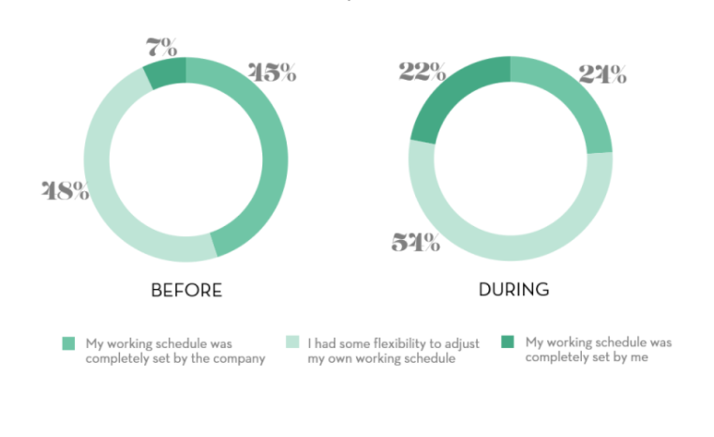
(Source:- The Adecco Group,2020)

Diagram 2-Bar-On EI Competency Model-Scales and Sub-scales

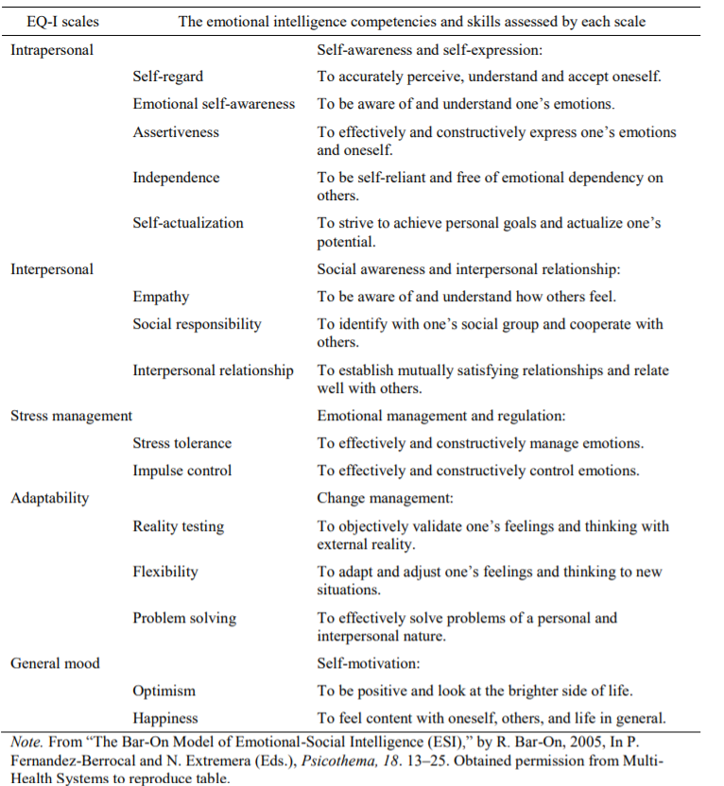
(Source-Barsade, S.G.,2012)
Diagram 3- Goleman’s Emotional Intelligence (EI) Performance Model

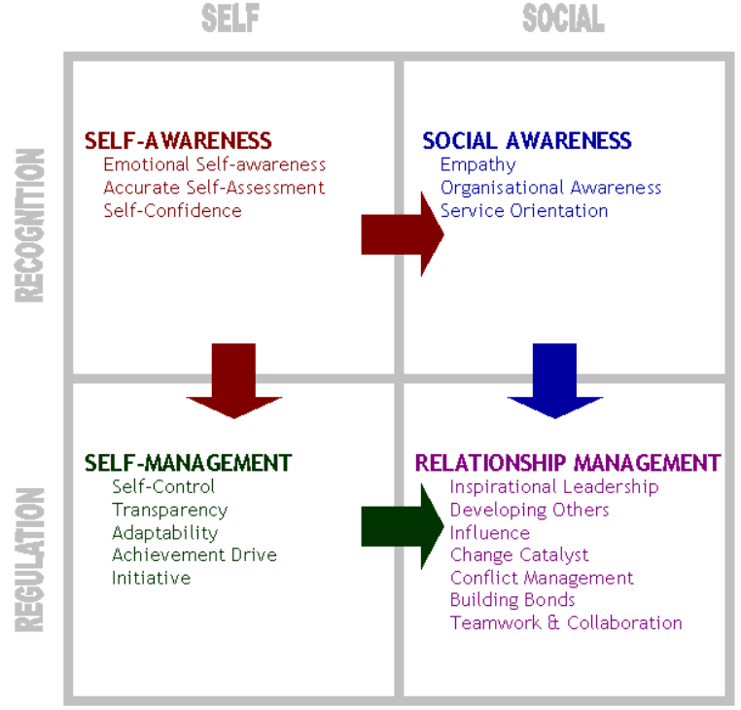
(Source- websonoma.edu,2009)
Diagram 4- Mayer-Salovey-Caruso-Emotional-Intelligence Framework (MSCEIT)

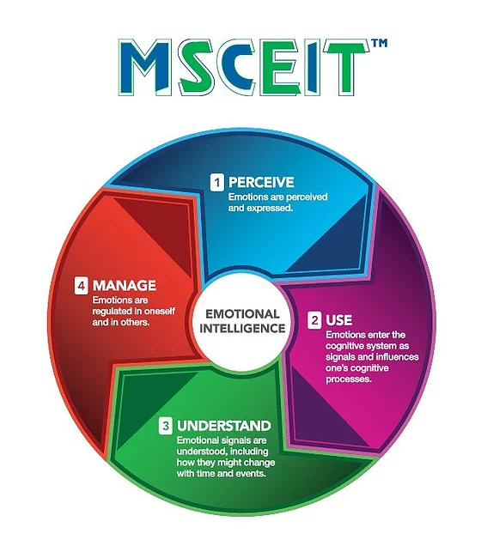

(Source-Dare learning, 2019)

Diagram 5- Genos Emotional Intelligence Model

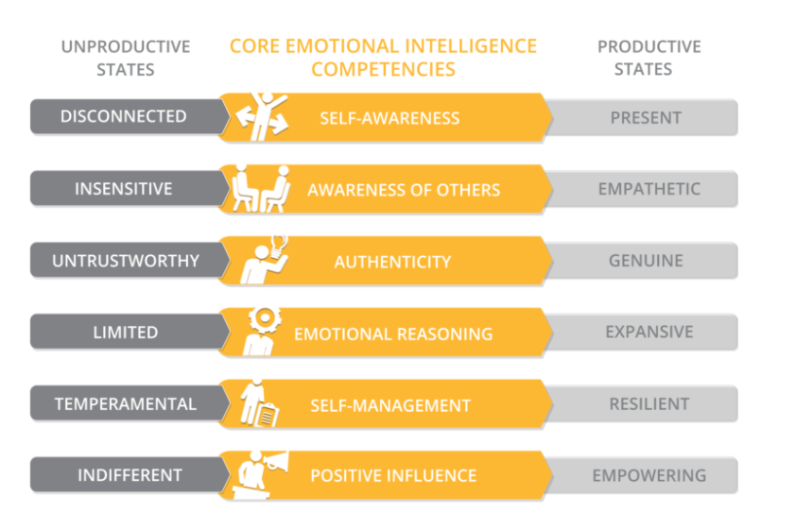
(Source-Genos International, 2021)

