
An investigation on the impact that tv shows/films have on tourism destinations : a case study on wales
Research Proposal

November 18, 2019
University of Wales Trinity Saint David
Courtney James - 1702677
Contents
1. Introduction 2
1.1 Background Information 2
1.2 Aims and Objectives 2
2. Research Methods 3
2.1 Data collection and Analysis 4
2.1.1 Data Collecting Method 4
2.2 Limitations 4
2.3 Ethical Risks 4
3. Resources and Planning 5
3.1 Resources 5
3.2 Gantt Chart 5
4. References 6

1. Introduction

1.1 Background Information
The chosen topic that has been decided to be investigated for this dissertation is film tourism and its impacts on destinations. This was chosen as a personal interest to the researcher and it relates to the degree being studied. Film tourism can be described as a connection to culture tourism and also refers to the increasing interest and demand of destinations of which became popular due to both films and TV series (Tomala, K et al. 2013). Film tourism has become rather popular in recent years, especially as a travel motivation to tourists (ABTA, 2018), therefore there is a substantial amount of information to help towards finding out the required information. The researcher believes that the will be an interesting topic to study for the dissertation and to see what kind of impacts it can cause to tourist destinations. The benefits that will be received at the end of completing this dissertation will be having an exceedingly amount of knowledge on the topic as well as an extremely rewarding sentiment. From recent research, film tourism has created a positive impact in Wales in a variety of different measures. It has helped create the second highest growth in employment since 2016 in the tourism industry, as well as remaining as the biggest sector of growth employment in Wales. Film tourism contributes to a positive driven perception of the country and has seen a high increase in the domestic tourism market (Welsh Government, 2016).

1.2 Aims and Objectives
Aim – to critically research whether films and tv shows have either positive or negative impacts on tourism destinations in Wales.
Objectives
- To critically analyse previous research undertaken to ensure an understanding on the topic.
- To conduct both qualitative and quantitative primary research in the form of surveys and interviews.
- To analyse whether the primary research aligns with the secondary research and make recommendations based on the investigation outcomes.
The investigator believes that these are vital objectives in order to be able to complete the aim. The objectives will lead the researcher in having a successful and beneficial investigation, as well as helping to answer the question that is being researched and studied on whether film tourism is more of a positive or negative impact on tourism destinations in Wales. These objectives are important in being able to come up with a reliable and honest answer to the title of the investigation.

2. Research Methods
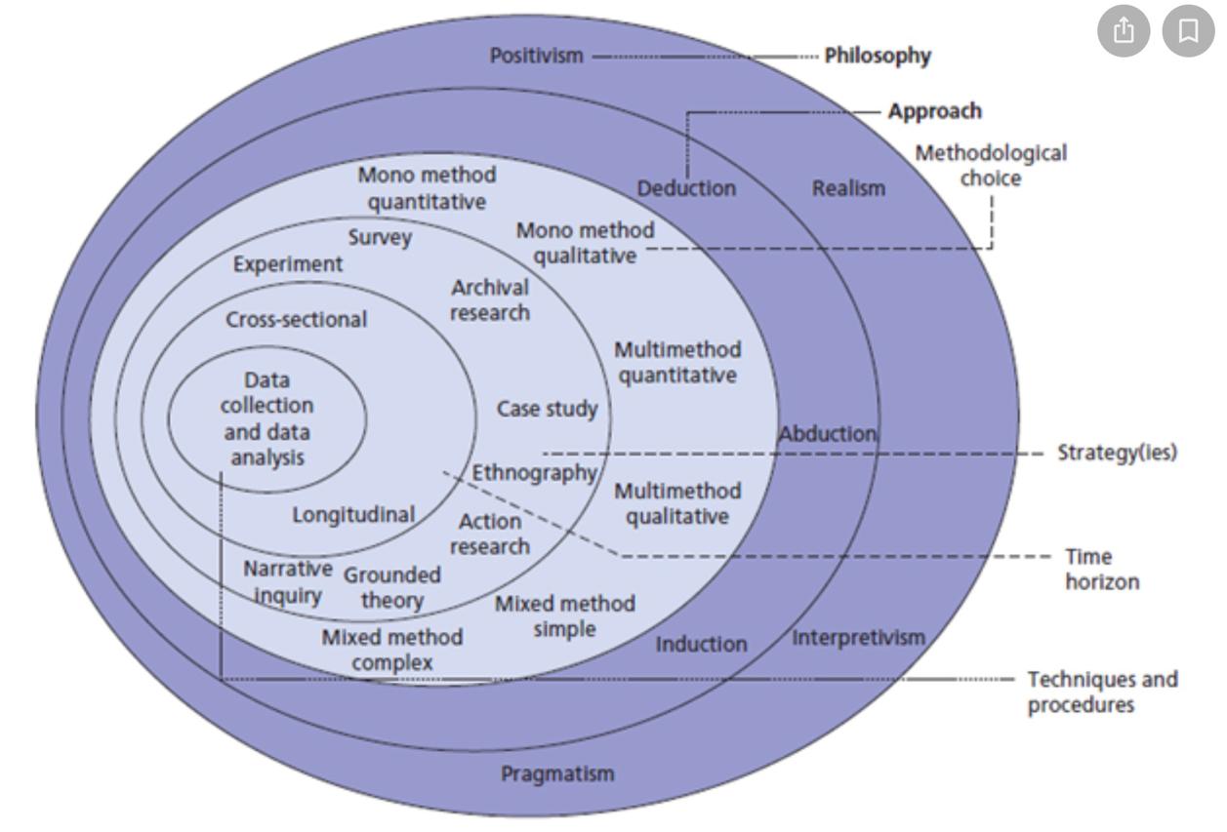
Research can be defined as an individual or group of people who observe and collect data in order to come up with a conclusion (Pathak, R, P. 2008). Research is undertaken in order to find out information in a systematic way to increase knowledge on the subject. The purpose of this being completed it to understand, describe, explain, critique and analyse the topic (Saunders, et al. 2012, p.5). The research onion was firstly introduced by Saunders, et al in 2007 and is used to describe the stages a researcher must go through in order to have and complete a successful research methodology.

Figure 1:The Research Onion (Source: Saunders et al 2007).

The research onion is divided into cross sectional segments to demonstrate the different approaches that can be undertaken whilst completing research methodology. This will be used throughout the investigation to ensure the researcher is using the appropriate methods to collect and analyse their data. The researcher will collect primary data in the form of both quantitative and qualitative, therefore the mono method will be approached.

2.1 Data collection and Analysis
Qualitative research is a technique used to gather information in a systematic way, usually from the media (Flick, U. et al, 2004). This type of research will provide a more descriptive than a numerical based analysis and will help the researcher to complete the investigation in a positivism study. Quantitative research is the opposite, and is a numerical way of collecting data (Brannen, J. 2016). This will guide the researcher in completing the study in a phenomenon approach.

2.1.1 Data Collecting Method
Research will be undertaken in the form of both questionnaires and interviews. The primary research will include conducting an online questionnaire with a minimum of 100 responses. Questionnaires are a beneficial way of collecting information as they are fairly quick and efficient, as well as the responses can be summarised resulting in the statistics being easily compared against each other (CES, 2013). Questionnaires will be useful as part of the primary research as they are an advantageous way of receiving a significant number of respondents, in which will hopefully show whether there are any patterns or trends. Interviews are an useful way of gathering information and provide the researcher with a better understanding on the research topic, as well as a beneficial way of gathering the interviewees feelings, behaviour and opinions (VT, 2018).

2.2 Limitations
The possible limitations that may occur during the investigation is the limited amount of time to undertake the primary research, therefore time management is vital throughout the project. To help overcome this, the researcher has designed a Gantt chart (see figure 2) in order to keep on schedule and meet deadlines.

2.3 Ethical Risks
The ethical risks of this investigation is extremely low as anyone participating in a questionnaire or survey will be over the age of 18, remain anonymous and any participation is voluntary. All information that is collected will be kept confidential where only the researcher will have access too. All data will be secured on password protected software, as well as on a memory stick.

3. Resources and Planning

3.1 Resources
Secondary research will be undertaken to provide the researcher with a better knowledge and understanding on the chosen topic. This will include using reliable online resources from the internet, the universities online library that provides academic resources including books, articles, reports, newspapers and journals. Physical copies of books will be used from the library in the university. An online questionnaire will be used as part of the primary research; IT equipment and software provided by the university will be used in order to analyse the data.

3.2 Gantt Chart
A Gantt chart is often used as a tool to manage and schedule projects of all sizes (APM, 2019). A Gantt chart has been produced specifically by the researcher to help ensure that deadlines and targets will be met throughout year, assuring that all chapters are completed on time. A Gantt chart is essential whilst completing projects as it is a simpler way for individuals to visually check that targets are being met, as well as monitoring work to help stay on schedule.

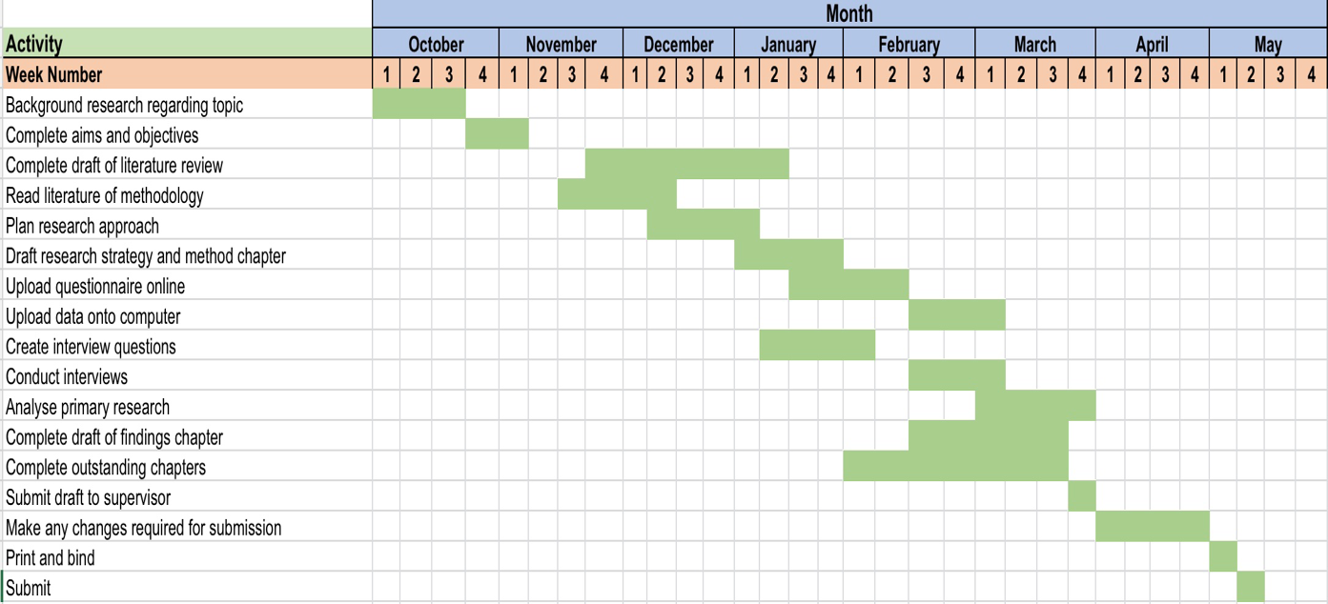
Figure 2: Gantt Chart

4. References

ABTA. (2018) ‘Travel Trends Report 2018’, ABTA. Unpublished.
APM (2019), ‘APM (2019), ‘What is a Gantt Chart’ Available: https://www.apm.org.uk/resources/find-a-resource/gantt-chart/ [Accessed Date – 14th November 2019].
Brannen, J. (2016). ‘Mixing Methods: Qualitative and Quantitative Research’. New York: Routledge.
Charities Evaluation Services (2013). ‘Information Collecting Methods: Choosing Tools for Assessing Impact’. London: CES.
Flick, U. Kardoff, E, Steinke, I. (2004). ‘A Companion to Qualitative Research’. London: Sage.
Pathak, R, P. (2008). ‘Methodology of Educational Research’ . New Dheli: Atlantic Publishers and Dist.
Saunders, M. N. K, Thornhill, Adrian, and Lewis, Philip. (2012).’Research Methods for Business Students’. 6th edn. Pearson.
Silverman, D. ((2016). ‘Qualitative Research’. 4th edn. London: SAGE Publications Ltd.
Tomala K., Faber F. (2011) ‘Film Tourism’. In: Papathanassis A. The Long Tail of Tourism: Gabler.
VT (2018). ‘VT (2018). ‘Research Methods Guide: Interview Research’, Available: https://guides.lib.vt.edu/researchmethods/interviews [Accessed Date - 13th November 2019].
Welsh Government (2016). ‘Partnership for Growth: Strategy for Tourism 2013-2020’, Available: https://uwtsd.ac.uk/media/uwtsd-website/content-assets/documents/library-and-learning-resources/infoskills/Harvard-eng_v.1.2.pdf [Accessed Date - 13th November 2019].

