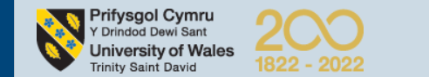

The Complexity of Modern Leadership about Lei Jun.

Student Name: Wang Jiale
Student ID number: 2119809
Module: Strategic Leading and Developing People
Module Code: BMBM6012
Submission deadline: 17th March at 17.00 pm

Submitted to: Laura James
Reported by: Jiale Wang


Content
1.0 Introduction 3
2.0 Main body 5
2.1 What leadership is and its importance. 5
2.2 Leadership model 7
2.3 Transformational Leadership 7
2.4 Adaptive Leadership 10
3.0 Conclusion and Recommendation 11
Reference 13

1.0 Introduction
Lei Jun was born in 1969 in Xiantao, Hubei Province, China and entered the Computer Science Department of Wuhan University in 1987. He completed all his credits and finished his graduation design in just two years. In China, university students in the 1990s were a rare breed of outstanding talent. After entering society, his CV can be divided into three parts.

The first part is about his first business venture. Lei Jun was inspired by the work of Michael Swayne. Influenced by Michael Swaine's work 'The Fires of Silicon Valley', Lei started his first company with his classmates, called Three Colours. But unfortunately Tricolour ran into a much stronger company that could make a similar product better and at a lower price. So Lei Jun's first venture was a failure.

Soon Lei Jun encountered an important turning point in his life when he joined Kingsoft Corporation in early 1992(Çolak, 2022). At the end of 2000, after the restructuring of Kingsoft, he became the President of Beijing Kingsoft Co. On 11 July 2011, Lei Jun was nominated by the Board of Directors of Kingsoft to become Chairman of the Board and received a unanimous vote, Lei Jun officially took over the reins of Kingsoft until 20 June 2022.

In April 2010, Lei joined Lin Bin, Vice President of Google China Engineering Research Institute, Zhou Guangping, former Senior Director of Motorola's Beijing R&D Centre (who designed the "Ming" series of mobile phones), Liu De, former Director of the Industrial Design Department at the University of Science and Technology Beijing, Li Wanqiang, former General Manager of Kingsoft, Huang Jiangji, former Director of Development at Microsoft China Engineering Research Institute and Huang Jiangyi, former Senior Director of Google China Engineering Research Institute. Huang Jiangji and Hong Feng, former senior product manager at Google China, co-founded Xiaomi Technologies and announced the launch of their own brand of mobile phones in August 2011. According to Forbes, Lei Jun is worth US$9.3B as of 16 March 2023 and is ranked 37th on the list of China's billionaires and 163rd on the list of billionaires（Forbes，2023）.
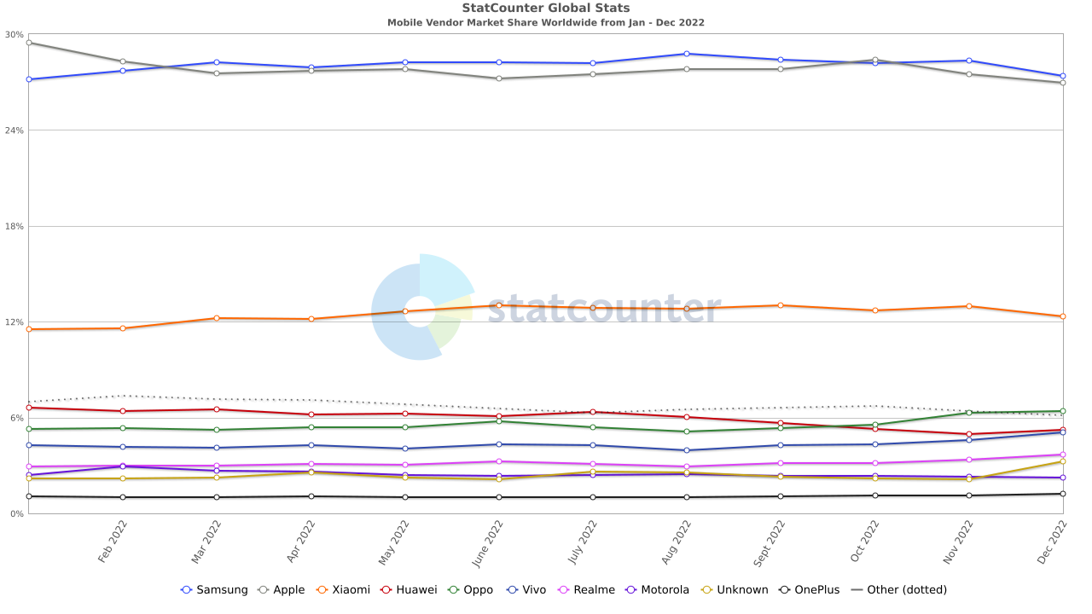
The figures in the chart show that Xiaomi has now reached a 13% market share, second only to Samsung and Apple. Lei Jun's approach to leadership is innovative and restless with the status quo.

2.0 Main body
The previous section has introduced Lei Jun's entrepreneurial experience, and from the three periods, Lei Jun is a man who very much does not like to rest on his laurels. This is evident from the fact that he became the manager of Kingsoff's development department at the age of 22, and became the president of Kingsoff at the age of 31, until he led Kingsoff to complete its IPO at the age of 39. There is a Chinese saying, "thirty years of age when a man should stand on his own feet," which means that people should be able to rely on their own skills to take on their own responsibilities and establish their own goals and directions in life at the age of 30. Lei Jun was already an industry leader at the age of 30, but still chose to found Xiaomi at the age of 40. The 21st century requires a different type of leadership because the world has become more complex and connected and therefore the old styles of leadership have become less effective（Rizvi，2022）. On March 30th 2021, at a launch event held by Xiaomi, Lei Jun announced that Xiaomi was officially entering the smart electric car industry, which he described as his last venture. After reflecting on Lei Jun's leadership environment, this article will attempt to critically analyse Lei Jun's leadership approach.

2.1 What leadership is and its importance.
Leadership is a process of social influence who maximises the efforts of others to achieve goals (Kruse, 2013). The influence group of leadership is a group of people who share a common goal, this can be a group in a company for a project or the entire company's employees, it has no particular requirement for numbers. John Maxwell believes that Leadership is the ability to obtain followers (Maxwell, 1993).

Leadership can actually be briefly described in five behaviours. The first is leading by example. The leader himself is a person of quality in some way, and the leader can set an example and lead by example for his followers through his words and actions on a daily basis. The second point is to share the vision. A common vision and goal is a beacon of light and direction for the group. With the same long-term goal in mind, the group may not dwell on short-term conflicts and may have a sense of moving forward together. The third point is to challenge the status quo. Not being satisfied with the status quo, always seeking excellence, this is the power of human beings to evolve. The fourth point is to make the many walk. Aristotle said that the whole is greater than the sum of the individuals. Whether it is a formal or informal organisation, to have an emergent effect, to make the multitude run in one direction, it is necessary for the leader to inspire cohesion. Finally, it is inspiring. Churchill's speech in The Darkest Hour is a good illustration of how important it is to inspire people, and how important it is for followers.

2.2 Leadership model
Leadership models are really theories about how to manage employees. These models sometimes include organisational theories that present ideas about how employees respond to orders, but they all present at least one style of response that is most useful for leading a business. They are models because they present a particular scenario in which certain types of leadership practice are most useful (Lacoma,2017).

2.3 Transformational Leadership
Transformational leadership is a leadership style that inspires positive change in followers (Cherry, 2023). Leaders can make employees aware of the importance of their responsibilities and tasks through their leadership charisma, their leadership inspiration, their intellectual stimulation of employees and their personal attention to employees, and stimulate their higher needs so that they can maximise their potential to achieve higher levels of performance. Overall, transformational leadership theory interconnects the roles of leaders and subordinates and attempts to create a process between them that enhances the motivation and moral character of both.

Bass sees four distinct components of transformational leadership. They are IDEALISED INFLUENCE, INSPIRATIONAL MOTIVATION, INTELLECTUAL STIMULATION and INDIVIDUALISED CONSIDERATION. IDEALISED INFLUENCE refers to the leader's ability to get employees to trust, admiration and followership. These leaders are generally recognized for their high ethical and moral standards and strong personal charisma. Lei Jun possesses these qualities. Lei Jun established the 'Tengfei Scholarship' in 1999 and later went on to establish the 'Lei Jun Computer Scholarship' at Wuhan University as a way to encourage students of good character and merit in the Wuhan University School of Computer Science. Lei Jun also possesses high ethical standards and Lei Jun attended the 14th National People's Congress for Beijing in 2023. in 2016, Lei Jun donated RMB 9,999.9999 to Wuhan University for the construction of the Science and Technology Building. This shows that Lei Jun has a high idealistic influence.

Inspirational motivation refers to leaders having high expectations of their subordinates and motivating them to join the team and become part of the team that shares their dreams. In practice, leaders often use team spirit and emotional appeal to rally the efforts of their subordinates to achieve team goals. As a result, the performance achieved is much higher than what would have been achieved if the employee had fought for his or her own interests. With Lei Jun's motivation of his employees, Xiaomi was able to achieve better growth. The most important feature of Xiaomi is that the company is fully staffed and motivated by shares, which are held by all employees above the engineer level. It is in the best interest of a company to grow its business and increase the shares of its employees, so the "major shareholders" (the first 100 employees of Xiaomi), who had a vested interest in the company in the early days, must be dedicated to the company.

Intellectual stimulation means encouraging subordinates to innovate and challenge themselves, including instilling new ideas in them, inspiring them to express new opinions and encouraging them to use new methods and approaches to solve problems at work. Through intellectual stimulation leaders can inspire and change the consciousness, beliefs and values of their subordinates. Xiaomi has introduced an equity incentive scheme to motivate its employees to challenge themselves, with more than 4,000 employees being awarded shares in the company in 2020. Lei Jun has always believed that any incentive is future-oriented, and that only when Xiaomi employees see the future can they continue to challenge themselves and give of themselves. Lei Jun will send experienced veteran employees to participate in the development of industry chain companies that are highly relevant to Xiaomi, allowing them to use their strengths to become leaders themselves rather than staying in the original company.

Individualized consideration means caring for each subordinate, valuing individual needs, abilities and aspirations, listening patiently and carefully, and developing and coaching each subordinate differently according to his or her situation and needs. This is where the transformational leader acts as a coach and advisor, helping people to grow as they cope with challenges. In addition to share dividends, Lei Jun also cares highly about Xiaomi's employees. Xiaomi's employee benefits include down jackets in winter and work clothes for the rest of the year; its own canteen, where employees can enjoy very low prices and afternoon tea; and regular employee gifts and internal discounts on electronic products, allowing employees to buy electronic products at very low prices, and this is discounted for employees to choose from, thus meeting their needs. Xiaomi also uses flat management, employees can be promoted step by step from 12-13 levels of fresh graduates to the highest 22 levels, the position of vice president. This allows for targeted training of employees.

2.4 Adaptive Leadership
Adaptive leadership is often used to address long-term and complex issues and challenges. It can help organisations to adapt to change (Herrity, 2023). Adaptive leadership is based on the four principles of Organizational justice, Emotional intelligence, Development and Character (Srivastava, 2022). Firstly, it is important for adaptive leaders to create an environment and company culture where all voices and perspectives can be heard. Secondly, emotional intelligence can be an uncomfortable process as it requires leaders to have the ability to be aware of complex problems and use a mature approach to solve them. Development means that leaders need to be learning new things, which can be a time-consuming and futile process. Finally, character requires that the adaptive leader has a strong personality and needs to stick to his or her principles and ethics. This tends to create an atmosphere of respect.

Lei Jun is not really suited to being an adaptive leader. Adaptive leaders often make bold and unexpected, albeit well-thought-out, moves, but Xiaomi, as one of China's largest mobile device providers, is actually not well placed to make large-scale changes. As Xiaomi already has the highest share of any Chinese company in the world, what Lei Jun needs to do is to stabilise its current market share before choosing to challenge the status quo.

3.0 Conclusion and Recommendation
Overall, the management theory that best suits Lei Jun is transformational leadership. In all four parts of transformational leadership Lei Jun has behaviours to support. Under the idealised influence, Lei Jun has established a large number of scholarships and made donations to his alma mater to create the ability for Xiaomi and Lei Jun himself to be followed by his employees, who therefore consider Lei Jun to be worth following. Lei Jun also regularly motivates his employees. Lei Jun rewards outstanding employees with shares in the company as a way of motivating them and uniting them to create a stronger force. Lei Jun will also encourage his employees to challenge themselves. Lei Jun will send experienced veteran employees to participate in the development of industry chain companies that are highly relevant to Xiaomi, allowing them to use their strengths to become leaders themselves rather than staying in the original company. Lei Jun also values the welfare of Xiaomi's employees. In addition to the usual benefits of food, clothing, housing and transport, Xiaomi employees also receive discounted rolls on electronic products, and those with the ability can choose to be promoted to achieve self-worth.

Beyond that, Lei Jun could try to move towards being an adaptive leader. Although Xiaomi's first task at the moment is to consolidate its market share, it is not appropriate to rely on one product alone, the mobile device. Xiaomi still needs some other products to make up the product chain, so that customers can see the company's products in their lives from time to time. Huawei has recently announced its entry into the new energy car industry and has already built a new energy car called the Huawei Ask. The main feature is the ability to link with smartphones, and in the mobile device industry Xiaomi is highly similar to Huawei's product market, so Xiaomi has been a step behind in new industries. It is hoped that Lei Jun will take some adaptive leadership actions to broaden Xiaomi's product breadth and thus make the company even stronger.

Reference
Stat counter, (2023). Mobile Vendor Market Share Worldwide Jan - Dec 2022. [Online] Available at:< https://gs.statcounter.com/vendor-market-share/mobile/worldwide/2022> [Accessed 8 March, 2023].

Forbes， （2023）. About Lei Jun. [Online] Available at:< https://www.forbes.com/profile/lei-jun/?sh=29ce47e6e64c> [Accessed 16 March, 2023].

Çolak, F., (2022). Xiaomi’s Founder Lei Jun’s Life and His Story. [Online] Available at:< https://xiaomiui.net/lei-juns-life-and-his-story-7875/#:~:text=Xiaomi%E2%80%99s%20Founder%20Lei%20Jun%E2%80%99s%20Life%20and%20His%20Story,Xiaomi%20entered%20the%20Guinness%20Book%20of%20Records%20> [Accessed 16 March, 2023].

Rizvi， H., (2022). 20th Century Leadership Vs 21st Century Leadership. [Online] Available at:< https://xiaomiui.net/lei-juns-life-and-his-story-7875/#:~:text=Xiaomi%E2%80%99s%20Founder%20Lei%20Jun%E2%80%99s%20Life%20and%20His%20Story,Xiaomi%20entered%20the%20Guinness%20Book%20of%20Records%20> [Accessed 16 March, 2023].

John C. Maxwell, (1993) Developing the Leader Within You. Nashville Tennessee: Thomas Nelson, Inc.

Kruse, C., (2013). What is leadership? [Online] Available at:< https://www.forbes.com/sites/kevinkruse/2013/04/09/what-is leadership/?sh=3aeb19c45b90> [Accessed 16 March, 2023].

Lacoma, T., (2017). What Is a Business Leadership Model? [Online] Available at:< https://bizfluent.com/info-10074476-advantages-fiedlers-contingency-theory.html > [Accessed 16 March, 2023].

University of St. Augustine for Health Sciences. (2023). 12 Leadership Models That Can Define Your Style. [Online] Available at:< https://www.usa.edu/blog/leadership-models/> [Accessed 16 March, 2023].

Cherry, K., (2023). What Is Transformational Leadership? [Online] Available at:< https://www.verywellmind.com/what-is-transformational-leadership-2795313> [Accessed 16 March, 2023].

Bass, B. M. & Riggio, R. E. Transformational Leadership. Mahwah, New Jersey: Lawrence Erlbaum Associates, Inc; 2008.

Allen GP, Moore WM, Moser LR, Neill KK, Sambamoorthi U, Bell HS. The role of servant leadership and transformational leadership in academic pharmacy. Am J Pharm Educ. 2016;80(7):113. doi:10.5688/ajpe807113

Choi SL, Goh CF, Adam MB, Tan OK. Transformational leadership, empowerment, and job satisfaction: the mediating role of employee empowerment. Hum Resour Health. 2016;14(1):73. doi:10.1186/s12960-016-0171-2

Jacobs C; Pfaff H; Lehner B, et al. The influence of transformational leadership on employee well-being: Results rrom a survey of companies in the information and communication technology sector in Germany. J Occup Environ Med. 2013;55(7):772-8.​ doi:10.1097/JOM.0b013e3182972ee5

Srivastava， Y., (2022). Principles and examples of adaptive leadership. [Online] Available at:< https://www.betterup.com/blog/adaptive-leadership#:~:text=4%20Principles%20of%20the%20adaptive%20leadership%20model%201,3%203.%20Development%20...%204%204.%20Character%20 > [Accessed 16 March, 2023].

Herrity, J., (2023). What Is Adaptive Leadership? (Plus Pros and Cons). [Online] Available at:< https://www.indeed.com/career-advice/career-development/adaptive-leadership#:~:text=Here%20are%20a%20few%20key%20elements%20of%20the,different%20industries%20and%20within%20organizations%20of%20all%20sizes.> [Accessed 16 March, 2023].

Word count: 2615

