Name: Nia Lloyd-Jones
Student Number: 1909499
Module
Title

Trending consumerism and increase of conscious sustainability
has impacted design in the textile industry

I am exploring how consumerism and the increase in conscious sustainability when investing in textiles has affected design and making in the fashion and interior design industry. This is of keen interest to me as this is my intended career path and I have lived through the decades of change. Absorbing the experiences but also as a mature student I am now piecing together and realising the impact of changing consumer behaviours who will eventually be my customer base and the design constraints imposed on me as I look to develop my own small creative design business. My ambition following my study will be to gain industry work experience with established design companies with the view to owning my own design business and developing a series of collections that I will retail direct to the customer. I have chosen to look at both industry designers, small business designers and how they have navigated and broken through the introduction of sustainable conscious measures since the increase og global pollution has been recognised.
In order to look at today’s design market, I think it is important to review and understand the history of the textile industry. Looking back at behaviours instilled in consumers by our governments during the second world war by applying constraints through to change of habits and the presentation of multiple choice to a development of conscious purchasing in the present day. For this I will be looking at online reference to artifacts from historical archives of the time and present day news and published articles that explain the influences that instigated change and the approach to considerate design. My personal learned experiences and behaviours having lived through this time of change in modern design and designers.
I will be looking at the meaning of value and design and how this relationship is affected by the economy fluctuations that can create exponential wealth. This research will come from a number of published books by well established academic authors of the design industry.
I will study design artists in the fashion industry who explored sustainable measures and how this affected their business and the consumer response in separate documented films. This is relevant to the exploration as one fashion company is retailing to the industry and the other designer is following a passion as a personal project. I will continue my research into industry practice with evaluating colouring fabrics and methods used that are both natural and synthetic and the impact of this on pollution all over the world.
I will conclude how my research has shaped my practice and how I intend to move forward in a design career along with other current design businesses that have adopted drasic sustainable measures as part of their everyday normal practice.
The impact on the textile industry in the UK during the second world war
My first introduction to fabrics, sewing and fashion was made by my grandmother who was a seamstress in the 1980’s. Personal values and ethics were instilled by my grandmother who taught me to sew as a child on a traditional hand levered mechanical sewing machine and who was from the “Make Do and Mend” era during the second world war. “The ‘Make do and Mend’ campaign was introduced by the government to encourage people to get as much wear as possible out of the clothes they already had”, (The National Archives, 2024). This campaign set out to teach people to sew and fix reparable clothes rather than discarding by offering evening classes to attend and learn. The war caused a shortage in clothing availability from abroad, consequently causing pricing to increase over affordability. The National Archives state that British manufacturers were consumed by making military uniforms and parachutes with no capacity for apparel. This enabled sewers and beginners to recreate garments using printed paper drawings (Tilly and the Buttons, 2013).
The growth of the paper pattern industry in the second half of the 19th century mirrored the development of the domestic sewing machine and the increase of fashion print media. It was a time of great development, and the fashion industry - always at the forefront of technological and industrial changes - was growing in size and reaching more people than ever before. (Tilly and the Buttons, 2013 )
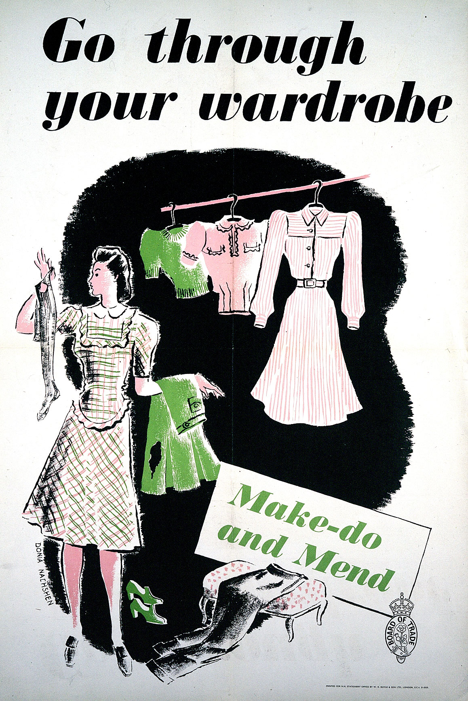
Figure 1. ‘Go through your Wardrobe’, The National Archives

This practice of mending, embellishing and making a garment more unique became my favourite technique. Through my teenage years I would redesign garments for example cutting up jeans to make a long skirt embellished with zips, buttons, studs and badges. Having the freedom of being unique was joyous and would often gain attention. I believe this contributed to building sentimental value attached to fabrics. (include denim skirt)
During “Make Do and Mend” period, rationing and the shortage of new materials and clothing encouraged sewers to make garments last and where quality and durability was important. During the second world war, in particular uniforms were made from woollen fabric for it is naturally flame resistance, failure to melt, breathable and ability to keep soldiers comfortable and warm. “Another reason wool was used for uniforms for the British Army, Royal Navy and Royal Air Force, is that wool is durable and hardwearing” (Simon Lucas Bridge Supplies Ltd. 2021). You will discover later in my writing that a fashion designer I have researched returns to these natural fibres for the same reasons, longevity and fitness for purpose as an introduction to a sustainable strategy and practice. Whereas the multitude of complex and mixed synthetics may not have been as readily available in the Second World War it is those teachings that the natural fabrics have all the premium qualities whilst being the least harmful to the environment. But I can see how overwearing rehashed garments for a period of time when new became available again, it is easy to understand what happened next.

My grandmother taught me to value fabric and a finished presentable garment. When shopping for clothes in the 1990’s she would teach me to find the item label and to search for the quoted fabric mix and understand it, to touch and feel the materiality as to how it folded, creased and stretched, and to check how to maintain the garment through washing and drying and to inspect how the garment was finished. Checking inside seams, hems and top stitching to see if the garment completed without shortcuts and was worth its price. She taught me to double knot and trim cottons strings on the inside of the garment. A technique that has been automated in today’s new electronic sewing machines. My grandmother had so much pride in her work she would ultimately be disappointed to see apparel for sale at a lesser quality than what consumers deserved. She made my comprehensive school uniform that was a woollen pinafore dress and my mother’s wedding dress amongst other event-based clothing which have now become heirlooms. These pieces have great sentimental value to our family, “Each stitch becomes a marker of lived time and embodiment of thought and patience and record of human presence”, (Threads, 2023).
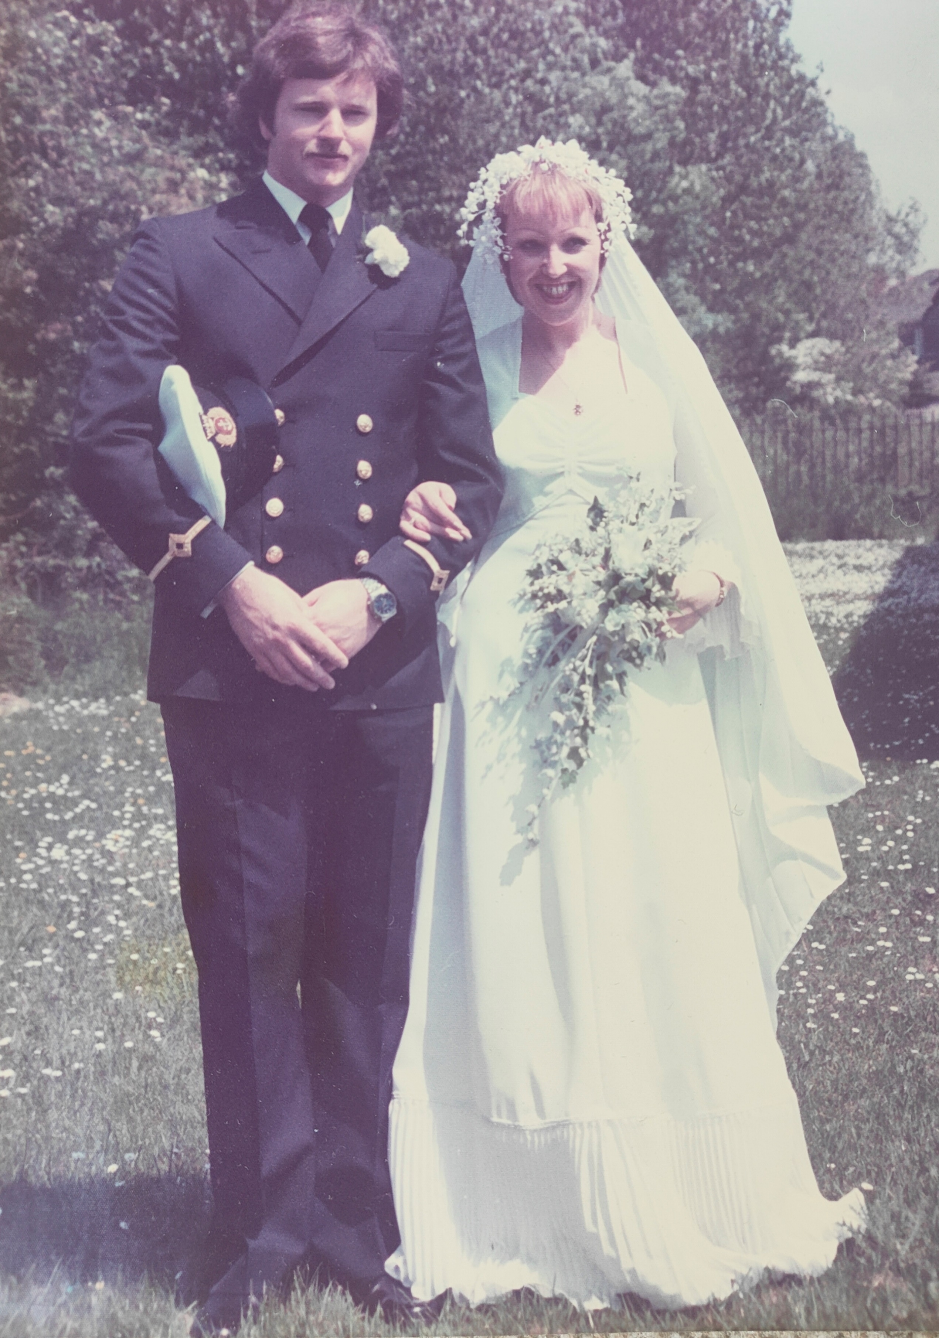
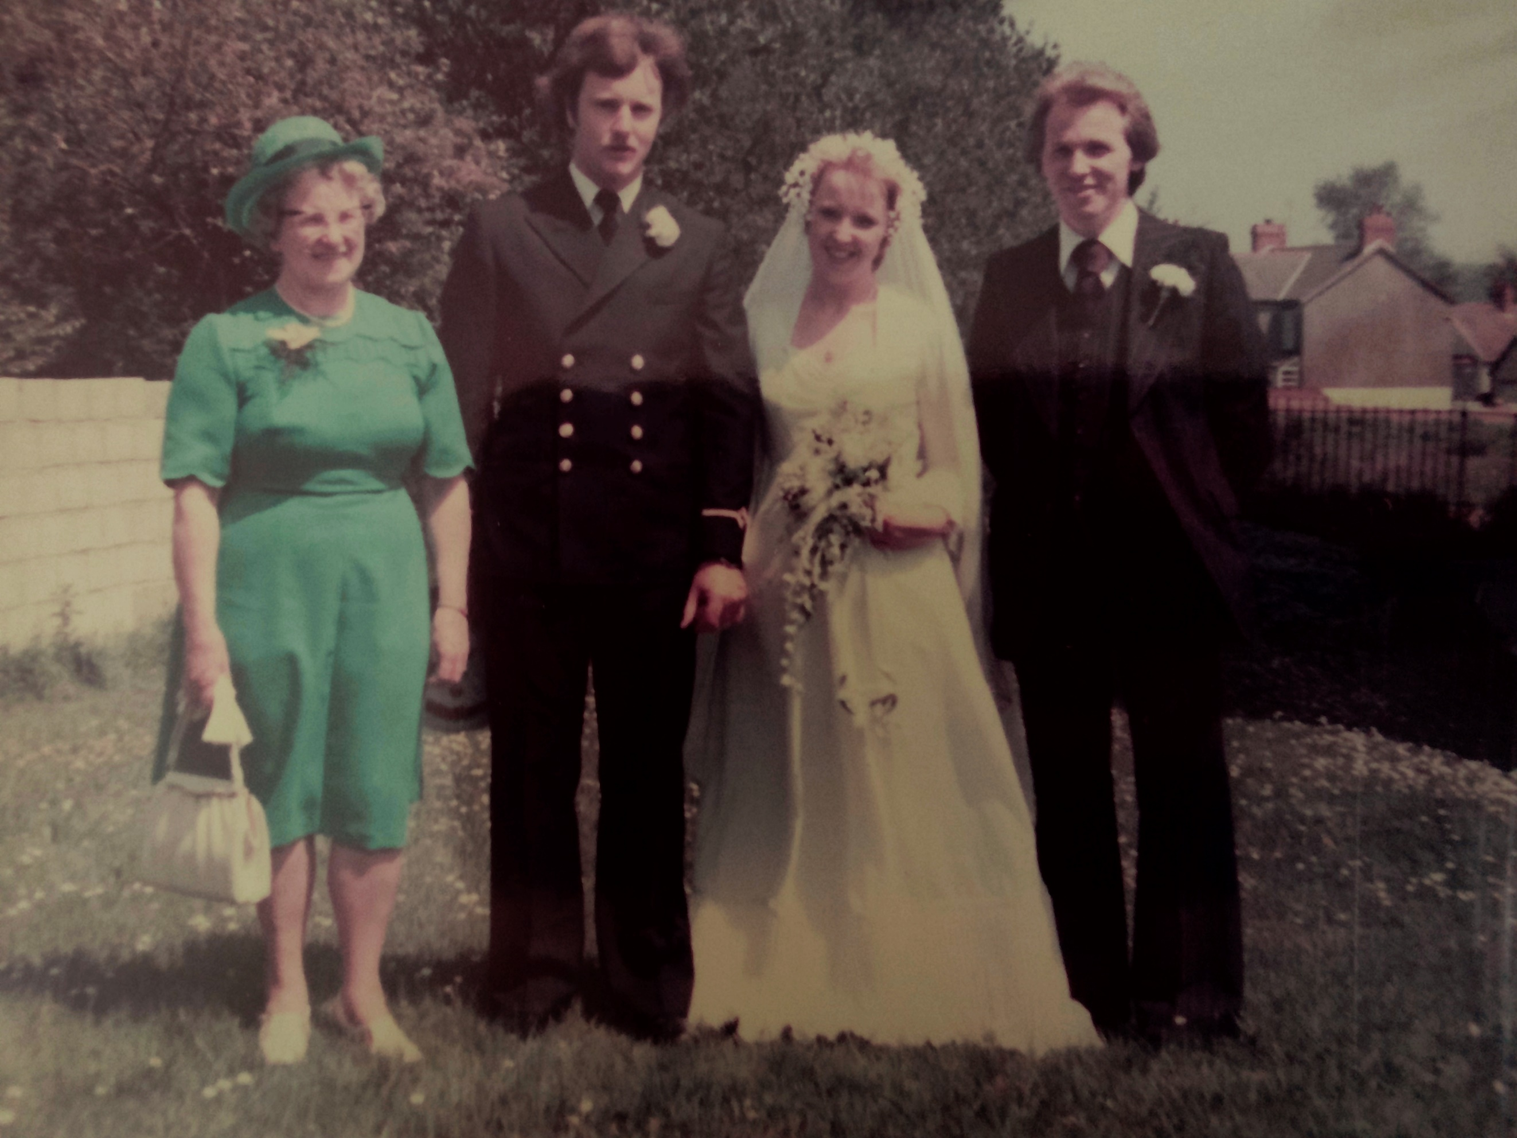

These photographs (figures X and Y) date 1978 and therefore quite difficult to see the detail in the wedding dress. My grandmother “Mamgu” as known in Welsh is wearing the green outfit and again the detail not easy to see but you can be sure that the greens matched perfectly in the hat and the dress. You can also be sure that no other person attending the wedding would be wearing the same. “A thread is a line that links the past with the present, knotting personal and shared experiences together….” (Threads, 2023). Although I was not present at my mother’s wedding, and now that I have lost both my mother and grandmother, these heirlooms bring me close to them again and the pride that would have been felt that day.
Understanding design and a period of change
Julier (2008, p25 ) discusses how the different economic era’s from the 1980’s to more present times and the associated timely trends impacted and influenced design components of budget, audience and creativity. To understand the value of the designed item before it is made when taking into consideration the three elements of the process of value which is designers, production and consumption. He explains its not the commercial value but also the “social, cultural, environmental, political and symbolic values” (Julier, 2008 p14). This branding aspect has a big impact on corporate representation which then fuelled growth in these industries. In the 1980’s there was a keenness to measure the size and impact design of the creative and design professions on the wider economy.
Julier (2008, p26) continues with the importance of creating value in design and that it’s the main duty of the Designer. He refences a quote from an article written by Margaret Thatcher (quoted in Whitley 1991 ; 196) for “Design” which stated “The profit potential for product design and development is considerable. Designers themselves should be more aggressive in selling themselves to industry and wealth creators” (Julier, 2008, p26). Thus, meaning clothing can truly represent a society and the power of branding can get consumers to become part of that cult of clothing.
The definition of design is “a plan or drawing produced to show the look and function or workings of a building, garment, or other object before it is made” (Stevenson, 2010 page no?). The value can be seen in its potential to become a product or object that is creative and communicates a visual message on behalf of the designer or the contract. Clearly the economic fluctuations have impacted the production and consumption but the value on design is consistent, or is it?

The 1990s saw the development and accessibility to the internet which drove industries to develop and deliver at a much faster pace with much more availability to the global markets through better communication. “By the late 1990’s, design was increasingly imbricated into the pressures of the New Economy, becoming instrumental in delivering “fast, better, cheaper”” (Julier, 2008 p37). With the likes of the leading retail websites such as Amazon and Ebay, the digital age has brought the market and consumer closer, “consumer culture is founded on the constant expansion of demand” (Julier 2008 p57). With growing intelligence around consumer behaviour, branding and advertising keeps feeding the consumer more of the same and developing a culture of wanting and needing more “that gives the rise to advertising promoting “false needs”” (Julier, 2008 p59). Creating products in this way has “limited life designed into them, either through their lack of physical durability or their quickly becoming unfashionable” (Julier, 2008 p59). I too have fallen foul of this unconscious buying, purchasing cheap single use items because coming home with shopping bags has been cathartic but with total ignorance to the associated landfill implications and waste of money.
I experienced the change and accessibility to global design and manufacture. In the 1980’s most shops would close on a Sunday and big outdoor markets on a Saturday were prevalent amongst the working class. This was exposure to global products although I would question some the integrity of some stalls selling counterfeit brands and products without British standards approval. These were my memories. In the 1990’s the rise in power of the supermarkets became evident expanding their offering beyond groceries to now clothing and homeware. The supermarkets became the one shop for all and in the 2000’s they capitalised on this strategy by inviting guest designers to offer an affordable range such as Coleen Rooney for Asda George and Matthew Williamson for John Lewis. The once high street prestigious boutiques and shops were now developing ranges for multipurpose stores at affordable prices. In hindsight we were now on the rising trajectory of creating volume sales at cheaper prices. In contrary to this, London based fashion designer Bethany Williams teamed up with the supermarket group Tesco and Vauxhall Foodbank in 2016 to produce her collection Breadline. “She devised a program that allowed foodbank visitors to exchange household waste items for fresh fruit and vegetables” (Solanki, 2018, p74). According to Solanki (2008) the Designer challenged the existing material processes and sources to create a more conscious and responsible framework for fashion designing taking into consideration influential social and environmental issues from today and tomorrow. Breadline, a collection of woven, knitted, printed and embroidered recycled carboard and donated prints collection of streetwear was made with the assistance and collaboration of the local craftspeople. “30 percent of Williams’ profits from the project went to the foodbank” (Solanki, 2018, p74) supporting and giving back to the local community.
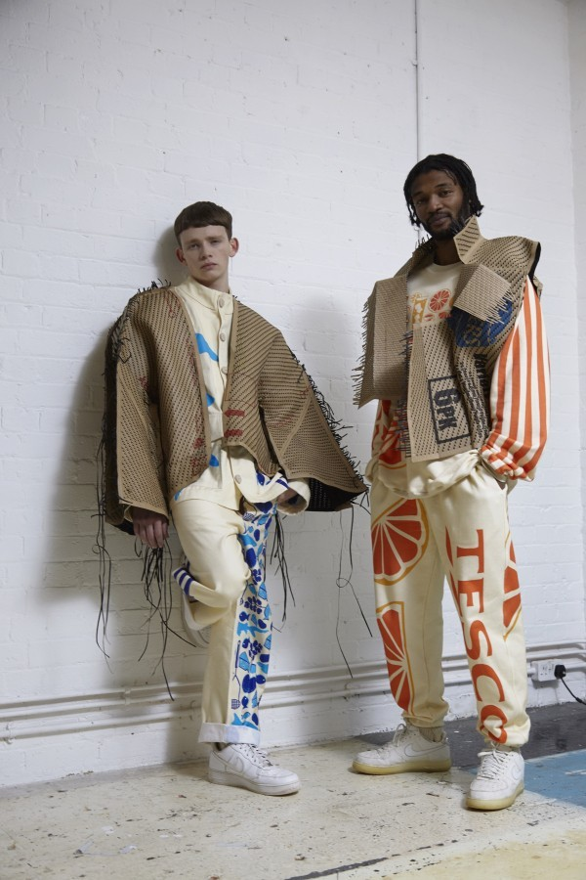
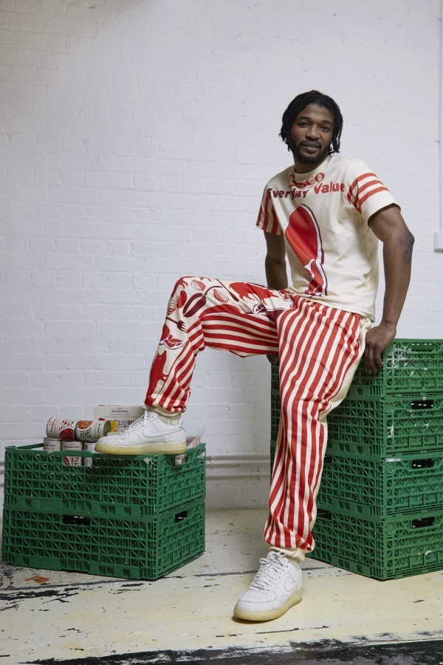

As much as this is refreshing, to be reusing and utilising fabrics and sources normally discarded by supermarkets, how saleable is this streetwear? Is it just a concept or a real solution? How many of us would choose to invest on sustainable measures alone and be branded with the Tesco logo whilst doing so.

There was a global financial crisis in 2009/2010 and since then the high street shops are dying being overcome by numbers of charity shops, takeaways and discount stores or fully replaced by out of town shopping destinations which are now prevalent. Consumers with less disposable income finding they could still purchase in volume for items that were made cheaply, without integrity at very low prices. Consumer habits and attitudes were changing to devalue expensive bespoke products opting for bargain replicas. I believe this developed a consumer attitude that disregarded the value placed on design and making such as my unconscious purchasing previously stated. Being reminded is key.
It was Amy Powney, Creative Director of Mother of Pearl who really tried to challenge the fashion industry for sustainable practice as the Fashion Reimagined documentary explored. Amy Powney, Mother of Pearl won a £100k prize for emerging Designer, awarded by Vogue and the British Fashion Council (Fashion Reimagined, 2013). “This is what I was always supposed to do” Powney claims although facing this challenge would be something else (Fashion Reimagined, 2013). It was this budget that helped her create a sustainable collections that transformed her brand. Powney’s ambition was “to create a sustainable collection from field to finished garment and transform the way we engage with fashion” (Fashionreimaginedfilm.com, 2023). The documentary covers the many challenges the Designer must overcome to produce a sustainably conscious collection and to then convince the fashion industry buyers to invest in her brand and take it to consumers. The documentary explains that at that time a typical garment travels 5 countries before reaching the customer and that 62% of all clothing is made from synthetic fibres. This lead to the Designer wanting to track a garment’s journey as with the current industry that was described as a rat race by a Dior Designer during the film to understand the supply chain (Fashion Reimagined, 2023). I did question throughout the documentary the cost of the research and actual carbon calculation of flying to different destinations to find the right animal wool and leather and if indeed it did offset the cost of producing this particular collection. The documentary focussed on the real search for sourcing the right materials which lead to a number of farm visits across numerous countries. However, I suppose once the learning and supply contacts have been established they are in place for future collections providing this one be successful and this might be where the carbon saving is further developed. The documentary eluded to address this.

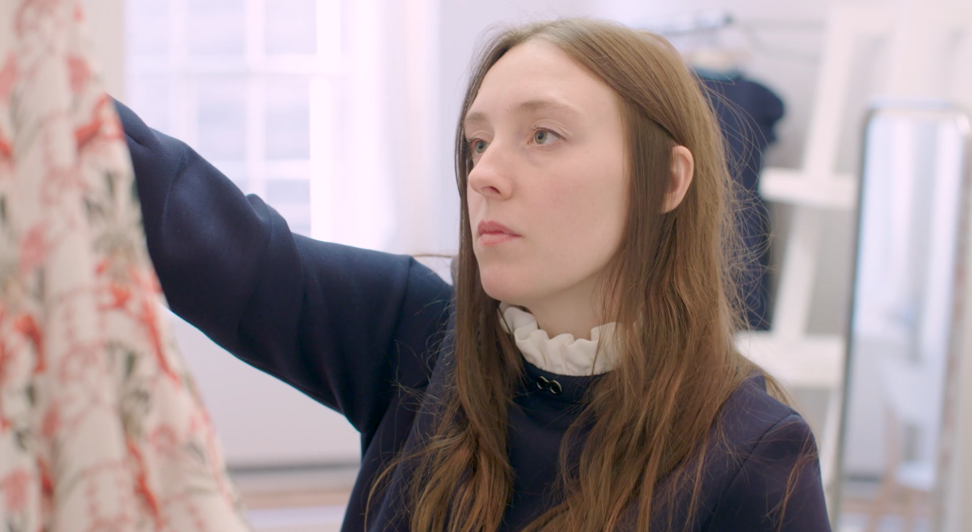
Powney (Fashion Reimagined, 2023) has a family history within the Textile industry with her mother having worked in a fabric mill and used cast off fabrics to cut into triangles for quilting. This inspired her childhood dream to become a Fashion Designer which she describes as a “complete privilege”. Powney began her own research into the impact of fashion on the environment, chemical treatment methods, quantities and how are animals are treated. Realising that we “ buy three times as many clothes than in 1980” reflecting the consumerism and fast fashion influence of volume sales at cheaper prices. “Fashion is one of the most destructive industries on our planet” she continues (Fashion Reimagined, 2023). This is confirmed by Gwilt et al, 2019 “Fashion is also one of the most polluting and socially exploitative industries in the world; we are producing over 100 billion garments per year”. This mass production is unsustainable with a large percentage of clothing being unworn.
Every year across the world we produce 92 million tonnes of textile waste. Unless big changes happen and improve how we make, use, and dispose of clothes, it’s estimated that by 2030 we’ll create 134 million tonnes of textile waste globally. And the global fashion industry is responsible for 10% of all greenhouse gas emissions (Fashion Waste Facts and Statistics).
It was a real challenge at the time of presentation of Powney’s new collection for buyers who at this early on set time of change were unconvinced that the higher price, better quality, natural fabrics was not worth the risk of investment. Could they convince their customer base to buy into this ethos? “It hurts a bit, when you design, it’s a bit of you” they are rejecting (Fashion Reimagined 2023). Powney had changed consciously to the use of leather, cotton and wool concentrating on being able to define the source of the garment, having confidence and integrity with this and also knowing the durability and strength of the fabrics. Choosing these materials doesn’t come without its challenges. Widely recognised for supplying the “most basic of human needs, providing clothing, footwear and shelter and even serving as protective clothing during battles” (Solanki, 2018, p13) as we have established also from the National Archives, we now face a more commercial problem. Solanki states a steady increase since 2012 of the sales of leather shoes, fashion accessories and cars with leather seats, the main repercussion is the amount of waste generated due to increased production. “Between 35 and 40 per cent of leather is discarded during manufacturing because of naturally occurring imperfections” (Solanki, 2018, p13). Therefore is this really a solution to the avoidance of using synthetic fabrics? The level of waste and current level of pollution is “threatening the life of your child” (Fashion Reimagined, 2013).
Grappi et al (2017) introduces us to the NGO movement in 2011 that began the change of attitudes. An NGO is a “non-profit organisation that operates independently of any government” (Stevenson A. 2010) and in this case to put pressure on the fashion industry to reduce its use of chemicals and “take responsibility for their actions” (Grappi et al, 2017). The campaign was called Greenpeace 2011 Detox campaign with a clear aim of “reducing toxic chemicals in the manufacturing processes and final products of fashion brands, (Grappi et al, 2017). “Recent research shows that an increasing number of consumers take the “politics behind the products” (Micheletti, 2003) into account when they make purchase decisions” Grappi et al, 2017) recognising the adaptation in consumer response and attitude before investing in purchases. The article continues to address celebrity engagement and endorsement in awareness campaigns and highlights customers choosing to boycott certain brands for not paying tax in the UK and deemed unfair practices. There have since been a number of campaigns such as “Cleaning up the Fashion Industry and “Dirty Laundry”which exposed a number of brands for their use of textile manufacturing facilities in China which discharged hazardous chemicals in to the water, (Grappi et al, 2017).
InsertDenim was also considered for the collection by Powney. (history of denim and indigo dying).
Insert the Nettle Dress
In my practice I have explored natural dye colouring using mainly vegetables and fruits with some herbs and spices. I have achieved strong bright yellows from turmeric but on the whole I would say the natural non toxic dyes produce a mild and subtle colour palette. Where this can be appropriate for many design considerations the constraints are that they cannot deliver a full spectrum. I have also found that the dyeing process could often leave uneven results across the fabric where a synthetic dye would penetrate a whole fabric piece unapologetically. Synthetic colouring could also achieve subtle and vibrant results and be controlled a lot better when it came to mass producing the same design.
Sustainability goals and targets placed on business
The Welsh government are encouraging businesses to have strong sustainable values and actions if they want to access grant funding to support their growth. Not only do they have a dedicated department that now advise on carbon footprint calculation and sustainable methods they are now introducing financial support to those small businesses that sign up to their sustainable and equality pledges. There are different levels of funding to cater for size and start up stage. Small start up businesses are being asked to commit up to 3 actions to support their sustainable methods to achieve a marketing logo they can then demonstrate on their business promotions to showcase good ethical values. Larger businesses who employ staff are encouraged to get involved to improve their suitability when applying for tenders for contracts (Business Wales, 2024). Local Authorities who have grant funding available as well as sports funding also demand a sustainable practice be in place before committing to investment. These are important considerations for a Designer looking to freelance or start up their own business.

Reflective practice
With my values instilled at a young age, I have chosen through my study to reuse and repurpose a lot of materials where possible. Whereas I have enjoyed and explored digital processed and used synthetic dyes I am still drawn to reusing than creating new fabrics. Influenced by my grandmothers teachings of storing fabrics (hoarding) I developed the same habit preferring to reuse than purchase new. I am particularly drawn to embroidered pieces where so much work has gone into this that landfill would be such a waste. There is a fair argument that these hoarded fabrics and garments might be better donated to families who could make use of them than sit in storage for the right time to be utilised. One thing following experiencing loss of family members is knowing that materialistic things cannot be taken with you into the next life. However it is these materialistic objects that hold such sentimental value and meaning. Maybe it is experiencing that loss that has led to me developing habits of saving objects that I build a sentimental value with. Therefore, the value of the object is not just commercial cost or price but unscalable worth of attached feelings. I suppose these feelings provide part of my identity, of what is important to me and my design consideration. I don’t have a preference of fabrics I collect but layering is a technique I enjoy which usually means there will be some form of transparency through the layering.
A live brief that I was tasked with as part of this degree was in collaboration with HACER Developments and the Urban Foundary to design and create a textile product that was appropriate for one of many spaces the new residential development offered. The development was heavily designed to focus on sustainable living encompassing vegetable patches, greenhouse and an aquaponics system. Deciding to use the indoor walkthrough where it was exposed to natural light, I chose to use natural fabrics where I could disrupt the surface through a devoree technique that would create a transparency. My design, to draw attention to the beautiful flowers that grow from vegetable plants which I named “The Unsung Heroes”.
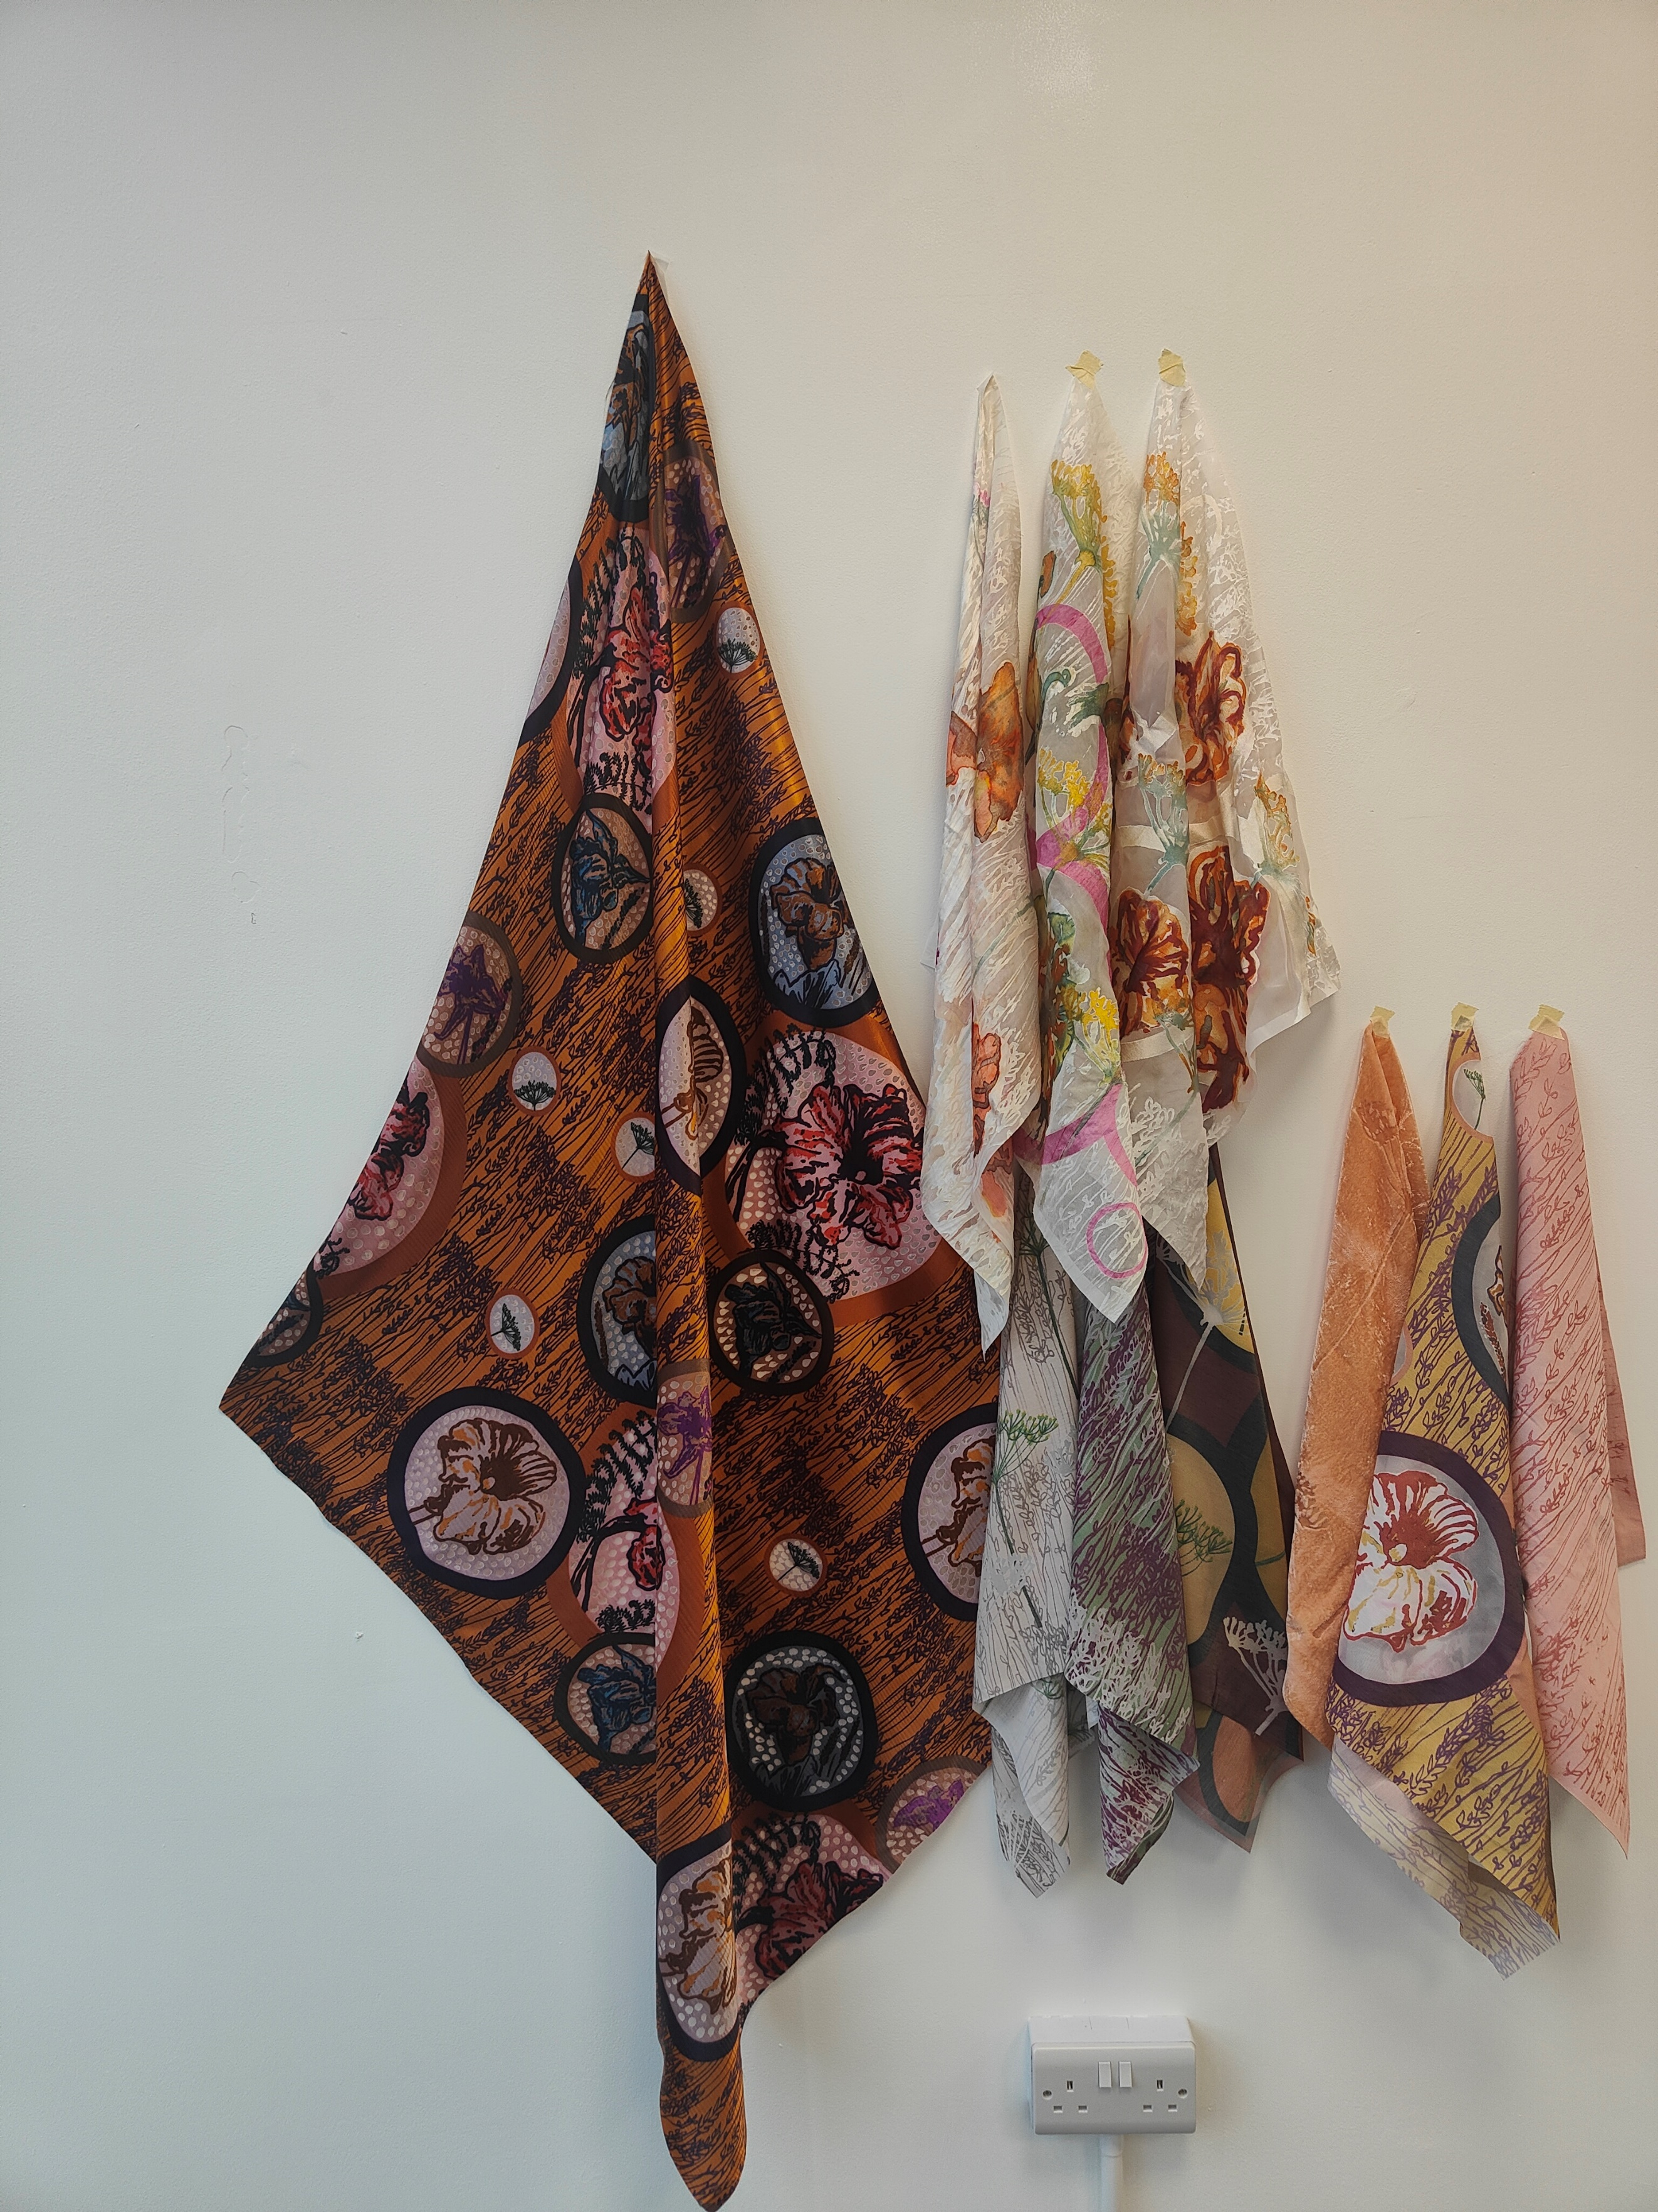
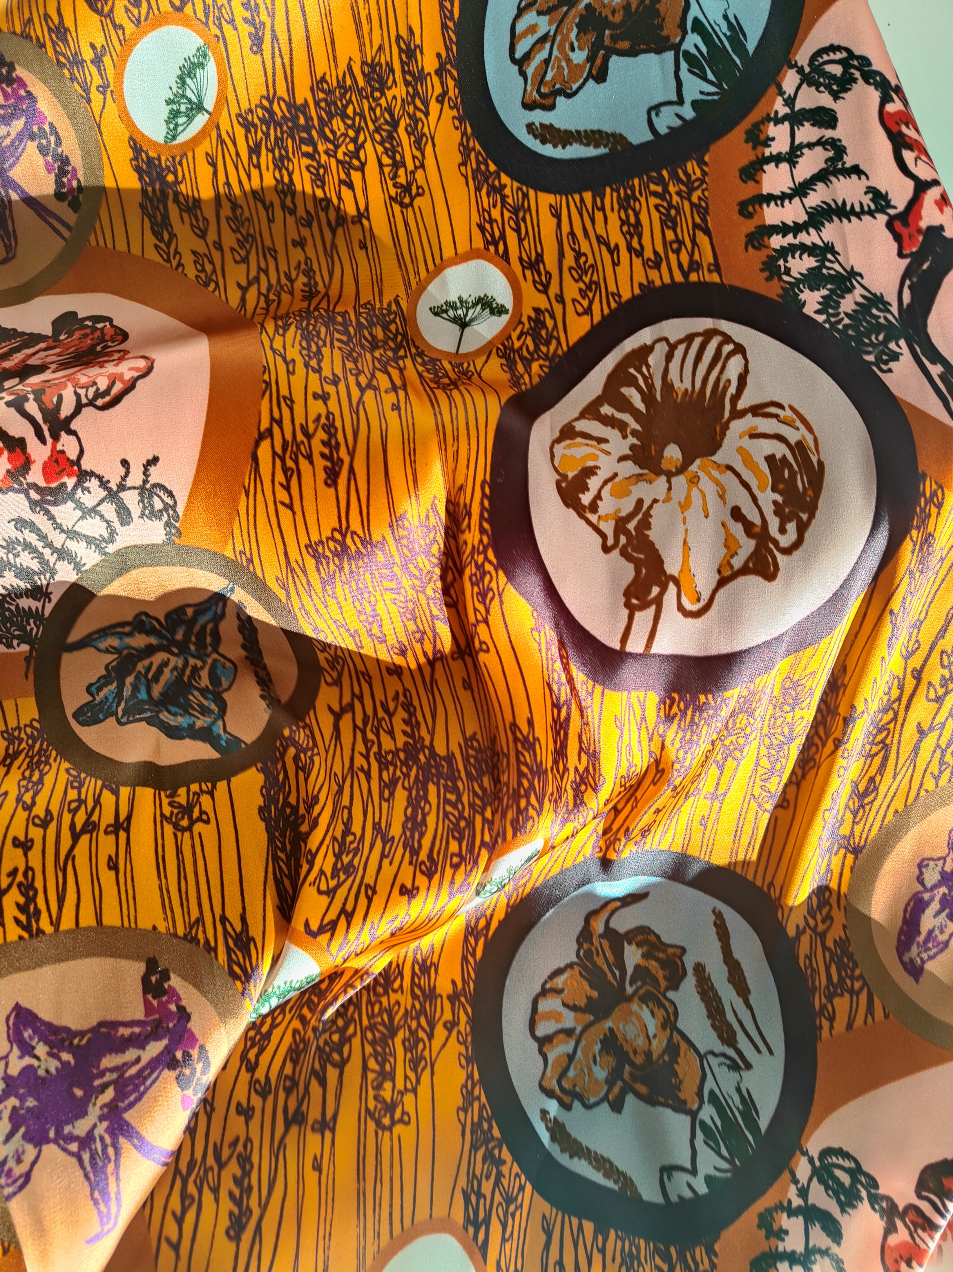

I have made new lampshades from old bedsheets, bridesmaid dresses and empty glass bottles where I have screen printed my design on the fabric. Understanding the journey of this fabric has created sentimental value but also a new life for the item. I love that it has a history as well as a future. It has been a challenge to completely use sustainable methods as sometimes the results can be limiting. Fabric dying with natural ingredients has been a recent exploration and provided subtle results.
I agree with Powney in the approach to her craft and design and the “enjoyment of fashion but thinking of the planet at the same time” (Powney 2023). Focussing more on homewares and interiors, just as I did as a teenager I enjoy adapting and reusing items and repurposing. It might be that it is my taught habit to keep “as it might become handy” is what my grandmother would say avoids me from contributing to landfill unnecessarily. It is important to me look after the planet and enjoy what nature so freely gives to us. I cannot understand some of the logic of why we dump waste in our seas and sewage in our rivers but those are actions beyond my control. I actively recycle as part of my ethical values but beyond this I want my design business to reuse and repurpose so that I don’t add to the current overwhelming problem of pollution. I don’t want my children to be detrimentally affected by my decisions and to do things properly and do them once as taught by my grandmother. The Well-being of future generations Act (Wales) 2015 has made it law to prepare and protect our future generations. “For people, for our planet. For now, and for our future” (Gov.Wales, 2024) concentrates on seven goals to ensure our future generations have the same quality of life as we do now. Being more responsible is one of the key goals to “improve our environment, our economy, our society and our culture” (Gov.Wales 2024).

CRADLE TO CRADLE – ORANGE BOX – NOTHING TO WASTE, CIRCULAR MATERIALITY
THE CRAFTSMAN - RICHARD SENET – LAWRLWYTHO PDF

Bibliography
Business Wales (2024) The Green Growth Pledge. Available at: https://businesswales.gov.wales/topics-and-guidance/sustainability-and-social-responsibility/green-growth-pledge (Accessed: 16 April 2024)
Business Waste (2024) Fashion Waste Facts and Statistics. Available at https://www.businesswaste.co.uk/your-waste/textile-recycling/fashion-waste-facts-and-statistics/#:~:text=Every%20year%20across%20the%20world,tonnes%20of%20textile%20waste%20globally. (Accessed: 19 April 2024)
Fashionreimaginedfilm.com, (2023) Available at: https://www.fashionreimaginedfilm.com/ (Accessed: 16 April 2024)
Gov.Wales (2024) The Well-being of Future Generations Available at: https://www.gov.wales/well-being-of-future-generations-wales (Accessed: 21 April 2024)
Grappi S., Romani S., Barborossa C., (2017) ‘Fashion without pollution: How consumers evaluate brands after an NGO campaign aimed at reducing toxic chemicals in the fashion industry’, Journal of Cleaner Production 149 (April) Available at: https://doi.org/10.1016/j.jclepro.2017.02.183.

Gwilt, A., Payne, A., Ruthschilling, E.A., (2019) Global Perspectives on Sustainable Fashion London: Bloomsbury Publishing USA

Julier, G. The Culture of Design. 2nd edn. London : Sage Publications, p26.
Powney, A. (2023) Fashion Reimagined (2023) Available at: https://www.sky.com/watch/title/programme/86d0a414-df2a-3658-95ef-914cce234d64 (Accessed: 04 October 2023)
Simon Lucas Bridge Supplies Ltd. (2021) About Historical British Military Uniform Fabrics Available at: https://www.baizewoolfabrics.co.uk/product-insights/authentic-historical-british-military-fabrics/#:~:text=British%20military%20uniforms%20during%20World,as%20well%20as%20being%20warm. (Accessed: 18 March 2024)
Solanki, S (2018) Why materials matter. Prestel Verlag.
Stevenson, A. Oxford Dictionary of English (2010) Oxford Reference Available at: https://www-oxfordreference-com.ezproxy.uwtsd.ac.uk/display/10.1093/acref/9780199571123.001.0001/m_en_gb0219420?rskey=d60pzg&result=1 (Accessed: 18 March 2024)
Stevenson, A. Oxford Dictionary of English (2010) Oxford Reference Available at: https://www-oxfordreference-com.ezproxy.uwtsd.ac.uk/search?source=%2F10.1093%2Facref%2F9780199571123.001.0001%2Facref-9780199571123&q=NGO (Accessed: 16 April 2024)
The National Archives Make-do and Mend. Available at: https://www.nationalarchives.gov.uk/education/resources/home-front-1939-1945-part-two/make-do-and-mend/#:~:text=The%20'Make%20do%20and%20Mend'%20campaign%20was%20introduced%20by%20the,about%20how%20to%20do%20this. (Accessed: 14 March 2024)
Threads (2023) Arnolfini
Tilly and the Buttons (2013) A BRIEF HISTORY OF PAPER PATTERNS AND HOME DRESSMAKING IN THE 1930S Available at: https://www.tillyandthebuttons.com/2013/10/a-brief-history-of-paper-patterns-and.html (Accessed: 18 March 2013)

Figures
Figure 1; A Ministry of Information poster entitled ‘Go through your Wardrobe’ and part of the ‘Make do and Mend’ campaign, 1929-1945, Catalogue ref: INF 13/144/1. Accessed https://www.nationalarchives.gov.uk/education/resources/home-front-1939-1945-part-two/make-do-and-mend/#:~:text=The%20'Make%20do%20and%20Mend'%20campaign%20was%20introduced%20by%20the,about%20how%20to%20do%20this.

