Nathan Jones (P151484)

Engineering Design
Drill Press Redesign and Reflective Report

Executive Summary

This report is going to outline the aspects which are in involved in the modification and redesign of an original product. It will look into the design, materials and manufacturing aspect of creating a new product and the design choices which need to be carried out in order to obtain the final outcome.
It will look at different processes which can be used to manufacture the new product and the required quantity of 500 units per week will then have a process chosen for it.

Table of Contents
1. Executive Summary 1
2. Introduction 3
3. Findings 4
3.1.1 Research into Drill Presses 4
3.1.2 The Original DPMSU 4
3.1.3 Improved Drill Press Main Sliding Unit 5
3.1.4 Material Selection and Manufacturing Process 6
4. Conclusion 10
5. Reference List 11

Introduction

During this report the ‘concept’ design of the drill press main sliding unit is going to be critically appraised, outlining all aspects of the component and the functions which it is used for.
Once appraised an improved drill press main sliding unit will be modelled up and analysed and the need to identify the materials and manufacturing processes which will be required in order to create the new model will be outlined.
The new drill press main sliding unit will need to be run in a batch and main production run where a quantity of 500 units per week will need to be produced.

Findings

Research into Drill Presses

What is a drill press?
“Drilling machines, also known as drill presses, are used to cut holes in metal with a twist drill” (Britannica, 2016)
Drill presses can do more than just cut holes they can be used for ‘reaming, counter boring and tapping holes’ Webster (2017), meaning that one machine is able to replace the need for multiple machines.
These machines offer a wide variety of improvements over using a standard hand drill, these improvements can be, ‘drilling wider holes, adjustable/accurate hole depth and better control over drill speed’ Drill Press Guides (2017)

The Original DPMSU
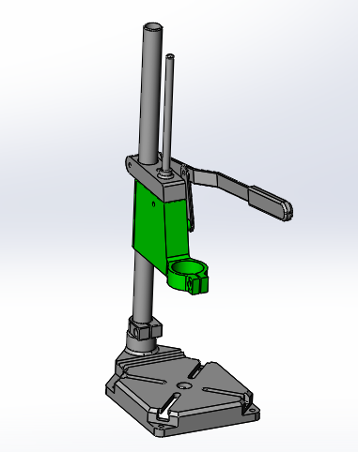
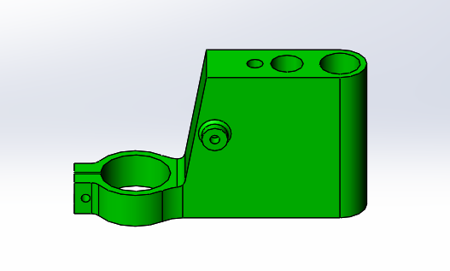

The above figures show the original drill press main sliding unit in component view but also in assembly view.
The function of the component is very simple with what it is initially designed to do, the main objective of the unit is to the hold a drill at 90° to the base plate allowing for vertical drilling.
So how does that component work in the full assembly?
The large hole at the rear of the unit is machined to fit onto the main shaft of the assembly, this shaft is at 90° to the base.
Once the component is on the shaft the 2nd smaller hole is used as a guide hole in which the guide shaft follows in order to keep the component central.
The guide shaft also goes through the lever block which is connect to the main shaft, this block is fixed onto the shaft in a set but moveable position to allow for depth drilling of the hole. The lever block is also used for other functions, which include having a lever arm attached to the block which with the help of linkages also attaches to the main sliding unit. This lever arm is used to transmit a force of pulling the lever into a vertical movement of the sliding unit. The lever arm is on a spring return in order to retract the drill once the lever is released.
The large hole at the front of the unit is the hole in which the neck of the drill sits is used to clamp the drill into the sliding unit and hold it in place.
The improved drill press main sliding unit must be able to have the same functionality.

Improved Drill Press Main Sliding Unit
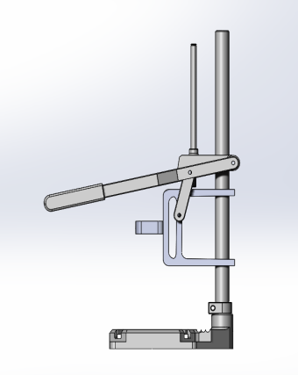
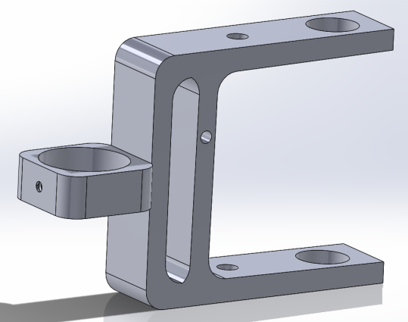
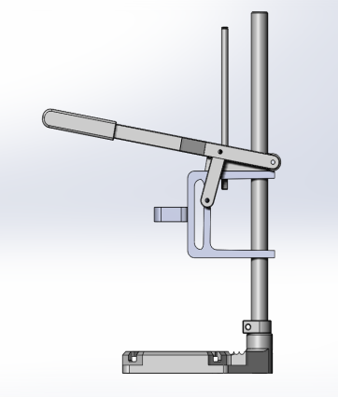

The figures above show the improved drill press main sliding unit in assembly and component view.
As you can see there is a variety of different characteristics between the original and the improved unit, but the functionality of the product remains the same due to the main mounting points of the new unit still having the same positioning holes for the main shaft, guide shaft and lever arm, meaning that the part would be a straight swap as using all the original parts as shown in the above assembly is doable.
In the new unit a different style of clamp is used to hold the drill in position, the hole in the front of the clamping hole is threaded allowing for a grub screw to hold the drill in position in the clamp.
The new drill press unit, clearly has a lot less material making it more environmentally friendly when it is manufactured, but also still is capable of doing the intended function. Due to the less material required to manufacture the component the cost also decreases.

3.1.4 Material Selection and Manufacturing Process

In order to manufacture a batch and main production run of the new and modified drill press main sliding unit a manufacturing process will need to be decided upon and a polymer material will need to be selected to get the best final outcome of the product. A series of prior knowledge and in depth research and analysis will be used to come out with the best technique to create this product.
There will need to be a variety of different aspects which will need to be considered when selecting the material, this will be due to how each material reacts and how easy it is to manufacture with. The cost and availability aspects will also need to be taken into consideration, in order to obtain enough raw material to create 500 units per week.

Material Selection
Material Name | Nylon | Polypropylene | Teflon
Cost | 1 | 1 | 2
Density | 2 | 1 | 3
Tensile strength | 1 | 2 | 3
Impact strength | 1 | 2 | 3
Total | 5 | 6 | 11

All technical data and prices was taken from Alibaba (2017), where the ‘Technical Data Sheets’ for each material where used to complete the scoring in the above matrix analysis.
Using the results obtained from the matrix table nylon is going to be the material of choice in order to create the new DPMSU, the grade of nylon which is going to be used in PA66-GF30.
“PA66 GF30 is a 30 % glass fibre reinforced PA66. It demonstrates outstanding mechanical properties such as higher strength, rigidity, creep strength and dimensional stability.” Ensinger (2017) Using a reinforced version of PA66 means that it has ‘good wear properties’, is ‘very stiff’ and is ‘resistant to many oils, greases and fuels’ making it ideal for workshop use. Ensinger (2017)
PA66 is a grade of nylon.
After looking back through Alibaba the average availability for PA66-GF30 is 200tonnes per month, meaning that raw stock needed to create 500 units per week is easily accessible.

Manufacturing Process:
In order to create a batch run of the new drill press main sliding unit a prototype would need to be made up, the quickest and most effective way to do this would be to have the batch prototypes 3D printed, even though it could take up to ‘several hours’ to 3D print the DPMSU it has a much cheaper overall cost than to tool up an injection moulding machine, and takes hours as oppose to weeks. Ultimaker (2017)
Once a batch run has been completed an injection mould tool could be made up, the lead time to manufacture an injection moulding tool out of tool steel can take up to 26weeks, but one tool can manufacture up to ‘1,000,000 units’, meaning that creating 500 units a week the tool would last for over 38years, the tool would need refurbishment but that would be done every 250,000 units. ToolCraft (2017)
The benefits of using 3D printing:
- ‘Zero or close to zero waste.’ Plastic Scribbler (2017)
- Improved geometric capabilities. Dragon Innovation (2017)
- Allows for designs to be designed and manufactured within a couple of hours. Dragon Innovation (2017)
“Prototyping injection mold tools and production runs are expensive investments. The 3D printing process allows the creation of parts and/or tools through additive manufacturing at rates much lower than traditional machining.” (Dragon Innovation, 2017)

The benefits of Injection Moulding:
- Detailed features. NanoPlas (2015)
- Very strong. NanoPlas (2015)
- Fast process, generally only ’15 to 30 seconds pass between cycles’. Craftech (2017)
- Low labour cost due to being an automated process ‘requiring minimal supervision.’ Craftech (2017)
“The initial creation of a mold can be expensive, with the cost being a few thousand dollars. But once the mold is created you can create a very large volume of plastic components at a minimal cost. For this reason, large production runs using plastic machining can cost up to 25 times more than plastic injection molding.” (Craftech, 2017)
Using injection moulding to create the component also makes it very cheap, this is due to the labour costs but also the fact that there is very little waste material.

Even though injection moulding is a good manufacturing process there are also disadvantages of using this style of manufacturing, due to the ‘high thermal expansion coefficient of polymers, significant shrinkage can occur during cooling,’ to help control shrinkage, ‘the dimensions of the mold cavity must be made larger than the specified part dimensions.’ Other than shrinkage the other problems with injection moulding are ‘flashing’, ‘short shots’, ‘weld lines’ and ‘sink marks and voids’ these features all come down to the characteristics of injection moulding but can be controlled using various methods of ‘increasing temperature and/or pressure’, ‘alternative gating locations’ and carrying out mould flow analysis of the part before going into manufacturing. (Groover 2010)

Conclusion

Based on the findings of this report the original drill press main sliding unit provided a good starting point and provided good use of features to allow the assembly to do the intended job, which is to ‘cut holes, ream, counter bore and tap’ Webster (2017).
Using the features and functionality of the original drill press, the new modified unit was created, the new unit needed to be able to do all the functions the original unit could, but have minor improvements.
The improvements of the modified unit include the less material and the lack of waste when being manufactured.
The material choice for the new unit has ‘good wear properties, and is ‘resistant to many oils, greases and fuels’ making it ideal for repetitive use in an engineering workshop. Ensinger (2017)
The manufacturing process of creating the new unit is to be 3D printed for the batch prototypes and injection moulded for the main production run of 500 parts per week this is due to the characteristics of injection moulding making the part ‘very strong’ (NanoPlas, 2015) for repetitive use and the ‘low labour costs’ involved. Craftech (2017)

Reference List

Alibaba (2017), ‘Raw Materials’, [Online]. Available: https://www.alibaba.com/?spm=a2700.details.scGlobalHomeHeader.6.1a672033rLO2pD 2017, December, 23rd
Britannica (2016), ‘Basic Machine Tools’, [Online]. Available: https://www.britannica.com/technology/machine-tool/Basic-machine-tools#ref424305 2017, December, 20th
Craftech (2017), ‘The Top 10 Benefits of Plastic Injection Molding’, [Online]. Available: http://www.craftechind.com/the-top-10-benefits-of-plastic-injection-molding/ 2017, December, 31st
Dragon Innovation (2014), ‘Top 10 Benefits of 3D Printing’, [Online]. Available: https://blog.dragoninnovation.com/2014/12/30/top-10-benefits-3d-printing-salient-technologies/ 2017, December, 30th
Drill Press Guides (2017), ‘What kind of things can a drill press do?’, [Online]. Available: https://bestdrillpressguide.com/what-kinds-of-things-can-a-drill-press-do/ 2017, December, 20th
Ensinger (2017), ‘PA66 GF30’, [Online]. Available: https://www.ensingerplastics.com/en-gb/shapes/products/pa66-tecamid-66-gf30-black 2017, December, 27th
Groover, MP 2010, Fundamentals Of Modern Manufacturing, 4th edn, John Wiley & Sons Inc, USA
Merriam Webster (2017), ‘Drilling Machine’, [Online]. Available: https://www.merriam-webster.com/dictionary/drilling%20machine 2017, December, 20th
NanoPlas (2015), ‘5 Major Advantages to Using Plastic Injection Molding for the Manufacturing of Parts’, [Online]. Available: http://nanomoldcoating.com/5-major-advantages-to-using-plastic-injection-molding-for-the-manufacturing-of-parts/ 2017, December, 30th

Plastic Scribbler (2017), ‘Benefits of 3D Printing’, [Online]. Available: http://www.plasticscribbler.com/item/8-real-world-benefits-of-3d-printing 2017, December, 30th
ToolCraft (2017), ‘Injection Mould Tool Life’, [Online]. Available: https://www.toolcraft.co.uk/injection-mould-tools/advice/injection-mould-tool-life.htm 2017, December, 28th
Ultimaker (2017), ‘General Questions’, [Online]. Available: https://ultimaker.com/en/resources/11721-general-questions 2017, December, 28th

