

Data Handling and Business Intelligence

Name & Student ID: Ala Uzun
Module: Data Handling and Business Intelligence
Module Code: LCBB5014
Lecturer: Xavier Matieni

Contents
1. Introduction 4
2. Data Cleaning and Preparation 5
Figure 1: Duplicate film records identified and removed in Excel 5
3. Descriptive Statistics and Summary 6
Figure 2: Descriptive statistics for key numerical variables 7
Figure 3: Average film ratings by language group 8
4. Trend Analysis and Visualisation 8
Figure 4: Average engagement metrics by language group 9
5. Inferential Statistical Analysis (SPSS) 10
Figure 5: Independent samples t-test comparing average ratings by language group 11
Figure 6: Correlation matrix for ratings and engagement metrics 12
Figure 7: Multiple regression model predicting average film ratings 13
6. Insights, Implications, and Recommendations 14
8. Conclusion 15
9. Reference List 17
10. Appendix 18
10.1 Appendix A: Data Cleaning and Preparation (Excel) 18
Figure A1: Initial Letterboxd dataset before cleaning 18
Figure A2: Identification and removal of duplicate film records 19
Figure A3: Verification of missing values across key numerical variables 19
Figure A4: Identification of extreme runtime values 20
Figure A5: Creation of English and Non-English language classification 21
10.2 Appendix B: Descriptive Statistics and Summary Analysis 21
Figure B1: Descriptive statistics for key numerical variables 21
Figure B2: Average film ratings by language group 22
10.3 Appendix C: Trend Analysis and Visualisation (Excel) 23
Figure C1: PivotTable configuration for engagement analysis by language group 24
Figure C2: Average engagement metrics by language group 24
10.4 Appendix D: SPSS Outputs and Diagnostic Tests 25
Appendix D1: Collinearity Diagnostics 25
Appendix D2: Normality of Residuals 26
Appendix D3: Homoscedasticity Assessment 27

1. Introduction
Data-driven decision-making has become vital to organisational strategy across multiple sectors. The increasing availability of large digital datasets has profoundly transformed the way businesses uncover insights and support evidence-based decisions. Advances in digital platforms and user-generated content have generated enormous amounts of behavioural data, enabling researchers to identify patterns that were previously difficult to detect. Platforms such as Letterboxd and others in the film and media industries provide extensive engagement data that track how consumers interact with, review, and respond to content on a large scale (Frequent questions, n.d.). These data present valuable opportunities for business intelligence, particularly for understanding the relationship between audience engagement and perceived content quality.
Academic research consistently stresses that the analytical usefulness of large datasets depends not only on their size but also on the accuracy of data preparation, the appropriateness of statistical methodologies, and the critical interpretation of results (Alotaibi et al., 2023; Niu et al., 2021). Extensive datasets often contain duplication, skewed distributions, and correlated variables, all of which can undermine findings if not carefully managed. Hence, data-driven decision-making requires both technical expertise and methodological insight, along with a good understanding of the context.
This report critically evaluates a film dataset comprising 9,664 unique data points to investigate the correlation between user engagement metrics (views, likes, and fans) and average film ratings. The analysis assesses whether statistically significant differences in average ratings exist between English-language and non-English-language films, providing insights into implications for audience segmentation. The dataset was collected and processed using Microsoft Excel before analysis in IBM SPSS. The analytical approach includes data cleaning and validation, descriptive statistical analysis, trend exploration via correlation analysis, and inferential statistical testing, which involves independent samples t-tests and multiple linear regression modelling, following standard statistical guidelines (Field, 2018; Pallant, 2020).
The analysis aims to achieve four objectives. The first step is to use systematic data preparation to ensure data consistency and quality. The second step involves applying descriptive statistics to summarise and understand the dataset's key features. Third, correlation analysis will be employed to examine patterns and relationships between ratings and engagement metrics. Finally, the study will evaluate the explanatory capacity, assumptions, and limitations of statistical models within the context of business intelligence, emphasising the implications for data-driven organisational decision-making (Hair et al., 2019; Niu et al., 2021).

2. Data Cleaning and Preparation
Data cleaning and preparation have been performed to ensure the reliability and validity of subsequent analyses, acknowledging that user-generated datasets frequently exhibit structural issues such as duplication, uneven distributions, and inconsistent formatting. From a business intelligence standpoint, data preparation was viewed as a risk-management process, as errors at this stage could bias qualitative information and compromise the validity of inferential statistical analysis.
Microsoft Excel was used for preliminary data examination and preparation, attributed to its clarity and adaptability for exploratory validation. Duplicate film records were identified and removed using Excel's built-in duplicate detection feature. As shown in Figure 1, this method produced a final dataset comprising 9,664 unique film observations, ensuring that each entry represented a distinct film while preserving the independence assumptions necessary for subsequent analysis.

Figure 1: Duplicate film records identified and removed in Excel.
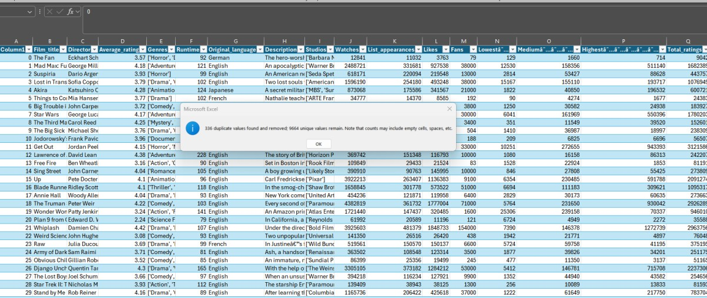
After removing duplicates, missing values were examined for all key numerical variables, including runtime, watches, list appearances, likes, fans, and total ratings. No missing data were found, thus eliminating the need for imputation and reducing the risk of biased parameter estimates. High values were assessed using filtering methods, particularly for runtime and engagement metrics. Although several observations showed abnormally high values, they were retained after consistency checks, as this irregularity reflects the highly uneven distribution of attention typical of digital media platforms.
A categorical variable was generated to classify films as English or non-English based on their original language. This change enabled comparative analysis across language groups and allowed further assessment of hypotheses regarding disparities in audience ratings and engagement patterns.
Further data preparation steps are documented in Appendix A.

3. Descriptive Statistics and Summary
Descriptive statistics were used to gain an initial understanding of the dataset's structure, distribution, and variability before conducting the inferential analysis. In business intelligence, descriptive analysis acts as both a summarisation tool and a diagnostic instrument for identifying statistical features that influence the choice of analysis and interpretation (Field, 2018; Pallant, 2020).
Average movie ratings across the sample showed slight variation around the mean, indicating some consensus among users' assessments. Similar trends have been observed in extensive online rating systems, in which central tendency bias limits the occurrence of extreme evaluations (George and Mallery, 2024). Analytically, limited variance in ratings suggests that, rather than focusing solely on magnitude, statistically significant differences should also be interpreted in relation to effect sizes and contextual factors.

Figure 2: Descriptive statistics for key numerical variables
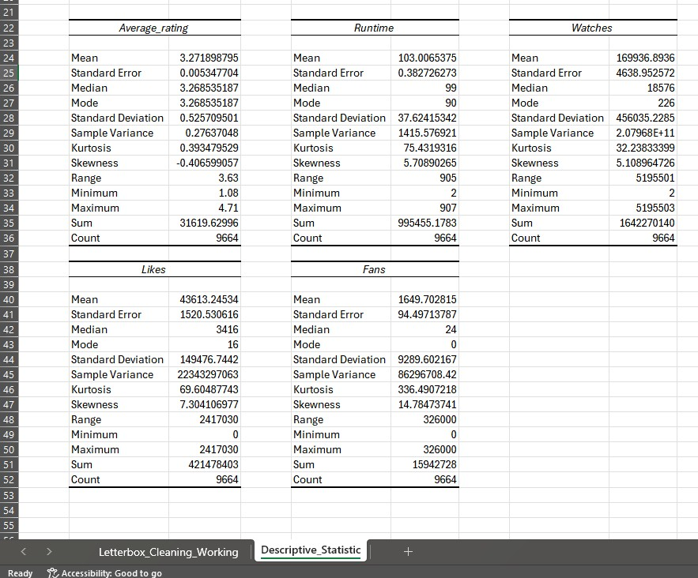
Unlike ratings, engagement metrics such as views, likes, and follower counts showed significant positive deviations from the mean, as illustrated in Figure 2. The average engagement values were considerably higher than the medians, indicating that a small number of films elicited varying levels of user participation. This "long-tail" distribution is typical in digital media platforms and reflects uneven visibility rather than consistent audience preference (Niu et al., 2021; Charles et al., 2023). This highlights the risk of interpreting engagement figures as straightforward indicators of perceived content quality from a business intelligence perspective.
A group-level descriptive analysis revealed consistent disparities across language groups. Figure 3 shows that English-language films received significantly more engagement across all metrics, indicating greater exposure and dominance on platforms. However, non-English films achieved higher average scores, suggesting that assessment outcomes may be affected by audience self-selection rather than mere popularity. Similar findings have been observed in media analytics studies, where culturally specific or unique content tends to attract more engaged and positively receptive viewers (Behrens et al., 2021).

Figure 3: Average film ratings by language group
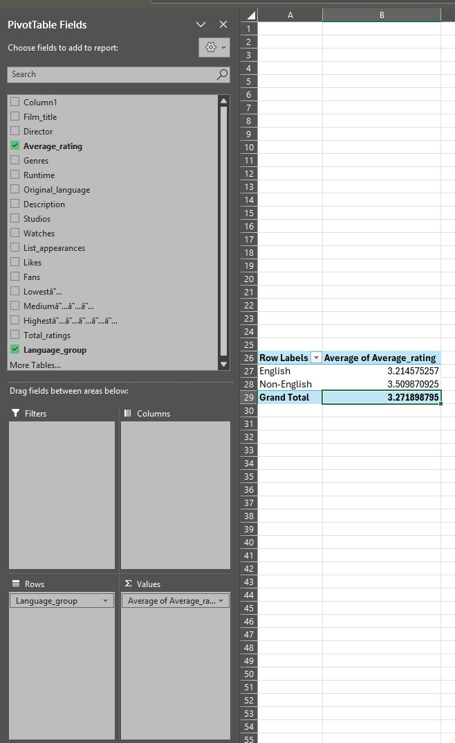
Additional descriptive statistics outputs are provided in Appendix B.

4. Trend Analysis and Visualisation
A trend analysis was conducted to examine correlations between audience engagement indicators and film ratings, to identify systematic patterns before detailed statistical testing. In business intelligence, visual trend exploration aids understanding by revealing direct relationships and structural differences that may not be immediately obvious from summary data alone (Niu et al., 2021; Charles et al., 2023).
Preliminary visualisation revealed significant disparities in levels of involvement across linguistic groups. Figure 4 shows that English-language films consistently achieved substantially higher average metrics for views, likes, and fan counts than non-English films. This trend highlights the dominance of English-language content on international digital platforms and aligns with other studies emphasising the impact of platform visibility and cultural reach on user engagement (Behrens et al., 2021; Niu et al., 2021).

Figure 4: Average engagement metrics by language group
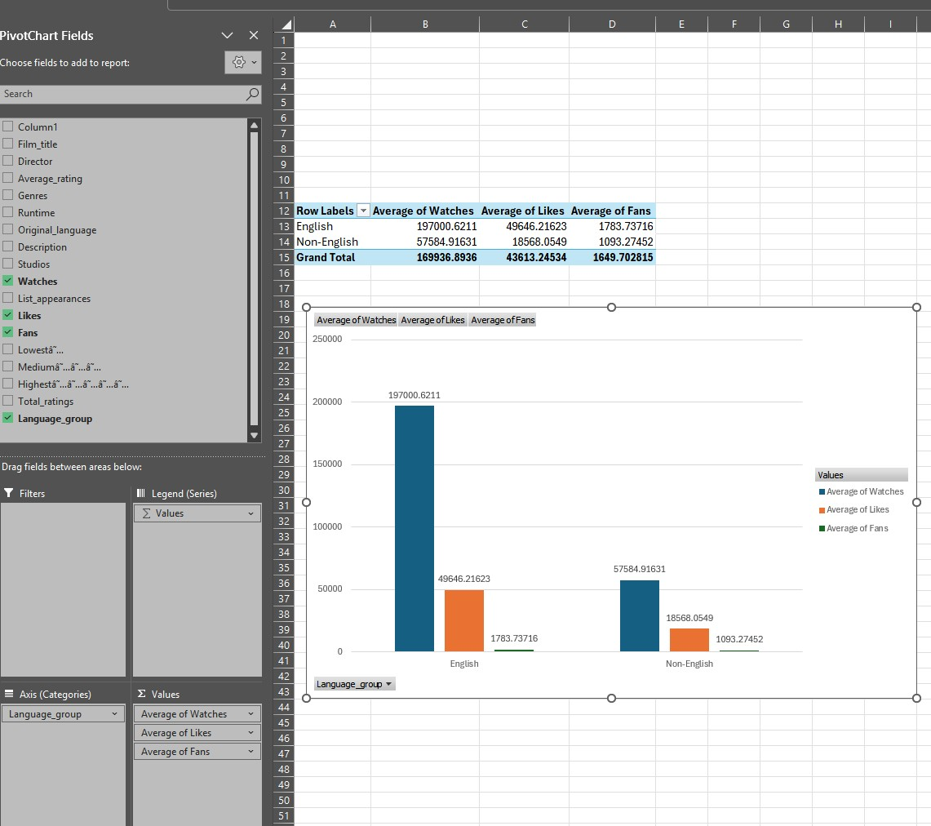
Although the above advantage was evident, the trend examination also revealed a discrepancy between popularity and perceived quality. Figure 4 indicates that, when compared with the elevated average ratings of non-English films in Section 3, engagement levels do not immediately correlate with higher evaluative results. This trend supports current criticisms of engagement-based performance measures by showing that engagement measurements capture exposure and participation rather than audience evaluation of quality (Michael et al., 2024).
Correlation analysis was performed in SPSS in the following section to explore the relationship between engagement and ratings further. However, even during the exploratory phase, the visual patterns suggest that audience involvement and evaluative ratings function as linked but distinct phenomena. This distinction is crucial from a business intelligence perspective, as a strategy focused solely on engagement volume may overlook content that performs well in terms of perceived value but attracts fewer, more targeted audiences (Behrens et al., 2021).
Supporting trend analysis outputs are provided in Appendix C.

5. Inferential Statistical Analysis (SPSS)
Inferential statistical analysis was conducted using IBM SPSS Statistics to explore further the connections identified in the descriptive and trend analyses and to assess whether the observed patterns were statistically significant. In business intelligence, inferential methods assist in determining both systematic relationships and random variation (Field, 2018; Pallant, 2020).
An independent-samples t-test was used to assess whether there was a statistically significant difference in average film ratings between English-language and non-English-language films. Figure 5 indicates a statistically significant difference in mean ratings between the two groups (p < .001), with non-English films receiving higher average scores. The effect size was moderate, suggesting that the observed difference was not solely due to the large sample size but also had practical significance (Field, 2018).

Figure 5: Independent samples t-test comparing average ratings by language group.
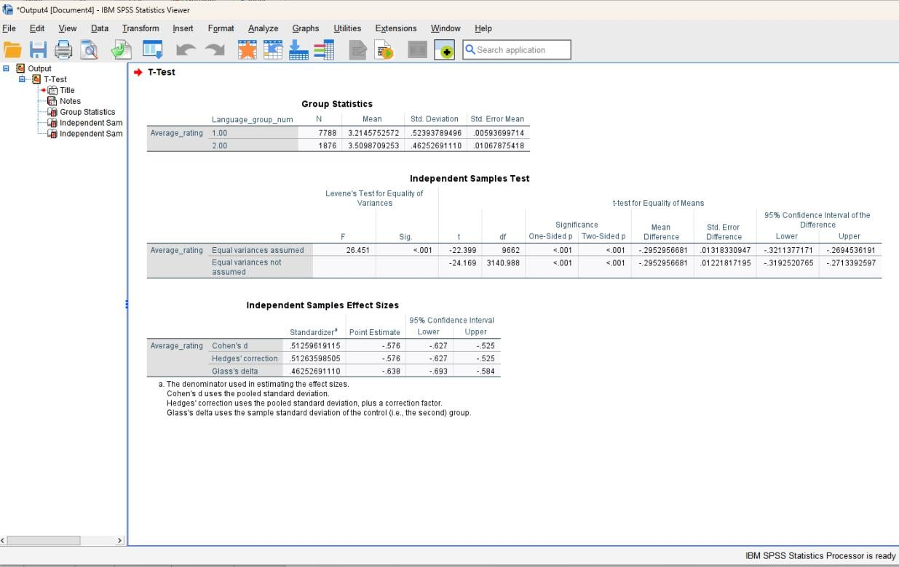
Correlation analysis was then used to examine the relationships between average film ratings and engagement indicators, including views, likes, and fan counts. Figure 6 shows weak-to-moderate positive correlations between ratings and engagement measures. However, engagement metrics were found to be highly interconnected, indicating considerable overlap. This suggests that these variables reflect overlapping aspects of visibility rather than distinct indicators of evaluative outcomes (Hair et al. 2019).

Figure 6: Correlation matrix for ratings and engagement metrics
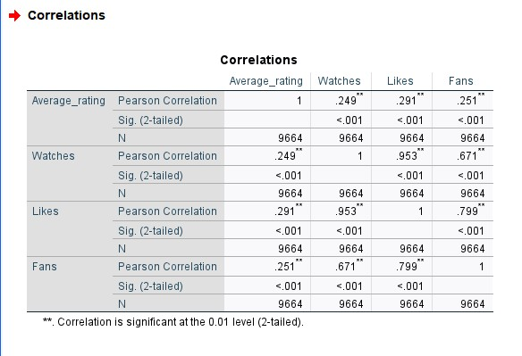
A multiple linear regression analysis was conducted to evaluate the combined interpretive power of engagement indicators, with average film rating as the dependent variable and watches, likes, and fans as independent variables. Figure 7 demonstrates that the entire model is statistically significant, although it explains only a modest portion of the variation in ratings (R² = 0.09). Likes emerged as a positive predictor of ratings, whereas watches had a negative coefficient when accounting for other factors. This trend highlights the effect of crossovers and suggests that increased exposure may attract more diverse audiences, resulting in more critical reviews (Hair et al., 2019; Roustaei, 2024).
Diagnostic assessments showed residuals to be adequately normal but indicated heteroscedasticity, particularly at higher predicted values. The large sample size alleviates some concerns about robustness; however, these results highlight the limitations of linear modelling with heavily skewed media datasets and emphasise the importance of careful interpretation of predictions (Pallant, 2020).

Figure 7: Multiple regression model predicting average film ratings.
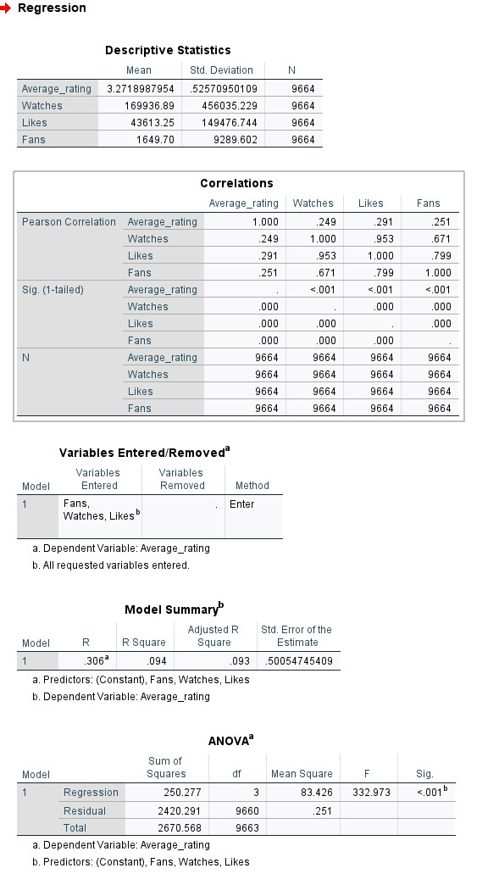
Detailed SPSS outputs and diagnostic plots are provided in Appendix D.

6. Insights, Implications, and Recommendations
The study provides essential insight into the relationship between viewer engagement and perceived film quality, with clear implications for data-driven decisions in the film and media industry. Although engagement metrics such as views, likes, and follower counts are commonly used as indicators of popularity and success, the findings suggest that their connection with average film ratings is complex and not strongly predictive.
The inferential findings suggest that although engagement indicators are strongly correlated with average ratings, they explain only a small portion of the variance (R² = 0.09). This shows that audience engagement alone is insufficient for predicting perceived content quality. In practice, this implies that companies that rely heavily on exposure measures may overestimate their value as indicators of audience satisfaction. Qualitative factors, such as narrative depth, originality, genre conventions, and cultural context, are likely to play a significant role in shaping evaluative outcomes (Hair et al., 2019; Roustaei, 2024).
Secondly, the study revealed a statistically significant difference in average ratings between English and non-English language films, with non-English films achieving higher mean ratings. Although the effect size was small, this research highlights potential audience segmentation effects within user-generated platforms. A likely reason is that non-English films attract more selective, niche audiences, leading to higher ratings. In contrast, English-language films appeal to larger, more diverse audiences that employ different evaluative criteria. This finding suggests that industry stakeholders should consider tailored marketing strategies for foreign and non-English content that focus on favourable reviews rather than widespread visibility (Field, 2018; Pallant, 2020).
Thirdly, strong correlations across engagement metrics indicate substantial multicollinearity, confirming that views, likes, and fan counts are interconnected aspects of visibility rather than distinct factors affecting ratings. The regression diagnostics showed the presence of heteroscedasticity, especially in films with high interest. This phenomenon is common in large digital datasets and highlights the limitations of linear modelling techniques when applied to highly skewed behavioural data (Pallant, 2020).
From a business intelligence perspective, these data suggest many practical recommendations. Organisations should avoid relying solely on single engagement measures as standalone indicators of quality and instead adopt comprehensive evaluation systems that combine quantitative engagement data with qualitative review analysis. Furthermore, employing additional analytical methods, such as segmentation-based models, log-transformed data, or machine learning techniques suited to nonlinear relationships, could enhance predictive modelling. Subsequently, further research might incorporate additional explanatory factors, such as genre, release timing, and production characteristics, to improve model effectiveness and strategic usefulness.
This research emphasises the importance of combining detailed statistical analysis with critical interpretation to gain insights from large digital datasets. By recognising the benefits and limitations of engagement-driven analytics, companies can make more informed, context-aware decisions that extend beyond superficial popularity metrics.

8. Conclusion
The present investigation aims to analyse a large movie dataset to examine the relationship between audience engagement indicators and average film ratings, using data preparation, descriptive analysis, and inferential statistical methods. The research demonstrated the use of Microsoft Excel and IBM SPSS to apply quantitative techniques to generate evidence-based insights within a business intelligence framework.
The results show that although engagement metrics such as views, likes, and follower counts are associated with average ratings, their ability to explain variation is limited. Multiple regression analysis revealed that these factors account for only a small portion of the variation in perceived film quality, underscoring the risks of relying on visibility metrics as substitutes for audience satisfaction. Strong correlations among engagement measures suggest they reflect overlapping aspects of popularity rather than separate indicators of evaluative outcomes.
The independent-samples t-test revealed a statistically significant difference in average ratings between English and non-English language films, with non-English films receiving higher mean ratings. This outcome suggests the need for audience segmentation and underscores the importance of contextual interpretation in the analysis of user-generated data. Diagnostic testing revealed multicollinearity and heteroscedasticity, emphasising the need for caution when applying linear models to highly skewed digital datasets.
The research highlights the importance of integrating robust statistical methods with critical interpretation to guide data-driven decision-making. By recognising the discoveries and limitations of engagement-based analytics, businesses can develop more sophisticated evaluation systems that accurately reflect perceived quality and support strategic decision-making in the film and media industry.

9. Reference List
Alotaibi, Y., Alsolami, F. and Alghamdi, A. (2023) ‘Cleaning big data streams’, Journal of Big Data, 10(1), pp. 1–18.
Behrens, J.T., Yu, C., and McKenzie, J. (2021) ‘Leveraging analytics to produce compelling and profitable film content’, Journal of Business Research, 134, pp. 1–12.
Charles, V., Gherman, T. and Torres, R. (2023). Data Analytics and Business Intelligence. Cham: Springer.
Field, A. (2018) Discovering Statistics Using IBM SPSS Statistics. 5th edn. London: SAGE Publications.
Frequent questions (no date) Letterboxd. Available at: https://letterboxd.com/about/faq/ (Accessed: December 16, 2025).
George, D. and Mallery, P. (2024) IBM SPSS Statistics 29 Step by Step: A Simple Guide and Reference. 18th edn. New York: Routledge.
Hair, J.F., Black, W.C., Babin, B.J. and Anderson, R.E. (2019) Multivariate Data Analysis. 8th edn. Andover: Cengage Learning.
Janse, R.J., Hoekstra, T., Jager, K.J., Zoccali, C., and Dekker, F.W. (2021) ‘Correlation analysis: pitfalls and interpretation’, Journal of Clinical Epidemiology, 134, pp. 1–6.
Michael, C.I., Chukwudi, O. and Eze, S.C. (2024) ‘Data-driven decision-making in information systems’, World Journal of Advanced Research and Reviews, 23(1), pp. 472–480.
Niu, Y., Lu, Y., and Liu, J. (2021) ‘Organisational business intelligence and decision-making using big data analytics’, Information Processing & Management, 58(5), 102725.
Pallant, J. (2020) SPSS Survival Manual. 7th edn. Maidenhead: Open University Press.
Roustaei, N. (2024) ‘Application and interpretation of linear regression analysis’, Medical Hypotheses, Discovery and Innovation in Medicine, 13(3), pp. 151–159.
Somandepalli, K., Presutti, M., Hager, G.D. and Yeung, S. (2021) ‘Computational media intelligence’, Proceedings of the IEEE, 109(5), pp. 891–913.

10. Appendix

10.1 Appendix A: Data Cleaning and Preparation (Excel)
This appendix offers additional proof for the data cleansing and preparation methodologies outlined in Section 2 of the study. The figures below demonstrate the essential validation and transformation processes performed in Microsoft Excel to ensure data accuracy, consistency, and applicability for subsequent descriptive and inferential analyses.

Figure A1: Initial Letterboxd dataset before cleaning
This figure shows the original dataset structure before any cleaning or validation steps were applied.
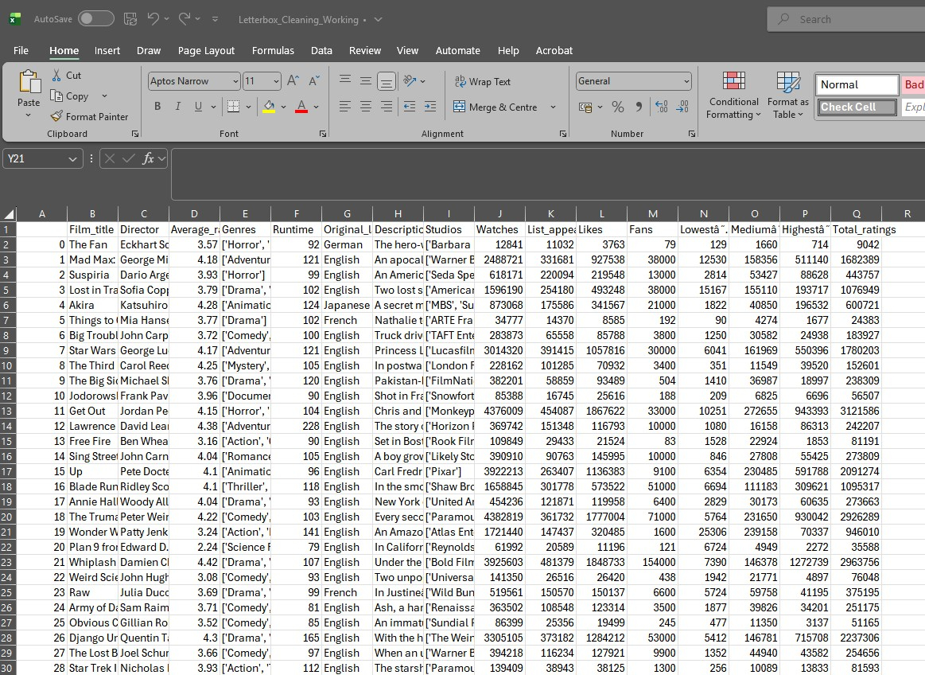

Figure A2: Identification and removal of duplicate film records
This figure confirms the detection and removal of duplicate film records, resulting in a final dataset of 9,664 unique observations.

Figure A3: Verification of missing values across key numerical variables
This figure proves that no missing values were present across the key numerical variables used in the analysis, including runtime, watches, likes, fans, and ratings.


Figure A4: Identification of extreme runtime values
This figure illustrates the identification of unusually high runtime values. These observations were retained following plausibility checks, as extreme values are a known characteristic of media datasets.
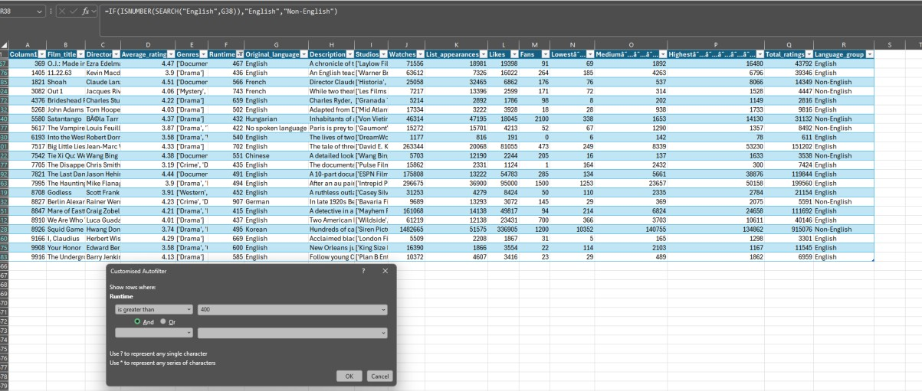

Figure A5: Creation of English and Non-English language classification
This figure illustrates the derivation of a binary categorical variable used to classify films as English or non-English based on original-language metadata.
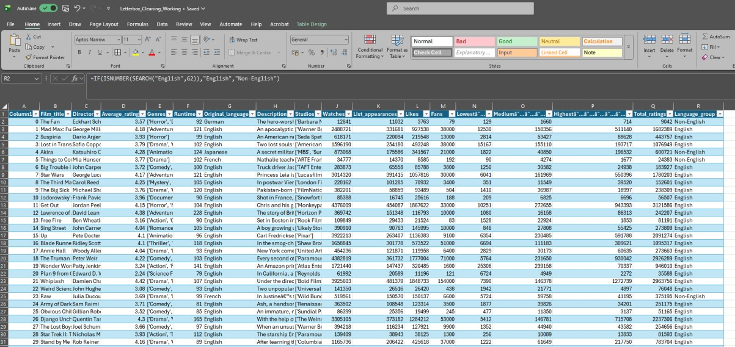

10.2 Appendix B: Descriptive Statistics and Summary Analysis
This appendix features supporting outputs for the descriptive analysis discussed in Section 3 of the report. The figures presented here document the calculation of summary statistics and group-level comparisons conducted in Microsoft Excel to explore the distributional characteristics of ratings and engagement metrics before trend and inferential analyses.

Figure B1: Descriptive statistics for key numerical variables
This figure presents summary statistics for average film ratings and engagement metrics, including mean, median, standard deviation, skewness, and kurtosis. The results highlight substantial positive skewness and kurtosis in engagement variables, indicating highly unequal distributions of audience interaction across films.
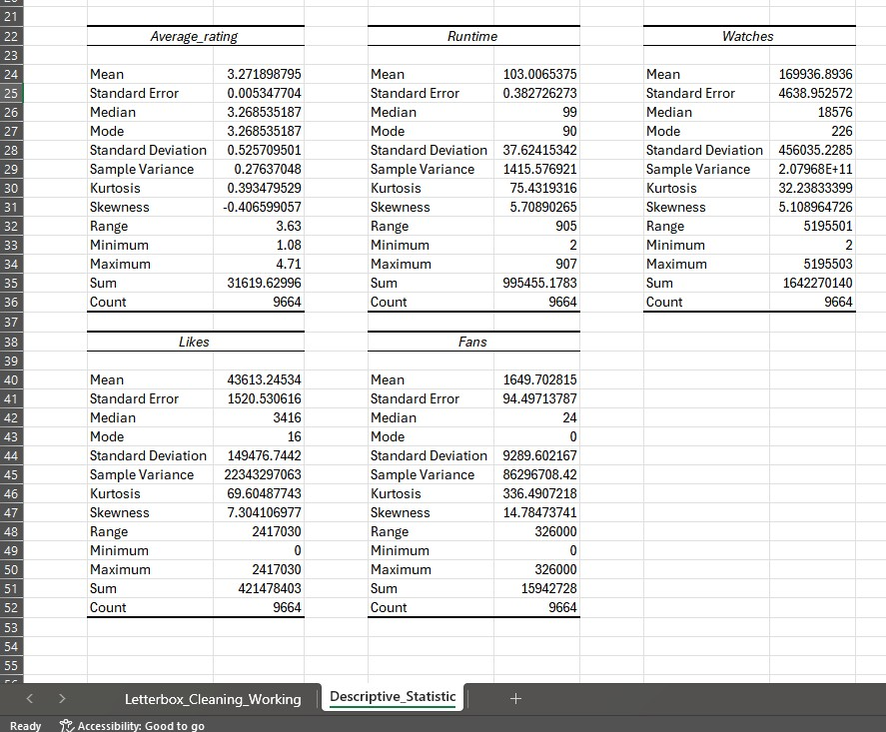

Figure B2: Average film ratings by language group
This figure shows the average film ratings for English-language and non-English-language films. The comparison indicates that, despite lower overall engagement, non-English films receive higher average ratings, motivating further comparative and inferential analyses in subsequent sections of the report.

10.3 Appendix C: Trend Analysis and Visualisation (Excel)
This appendix presents supporting visualisations for the trend analysis discussed in Section 4 of the report. The figures document the use of Microsoft Excel PivotTables and charts to explore differences in audience engagement metrics across language groups before inferential statistical testing.

Figure C1: PivotTable configuration for engagement analysis by language group
This figure illustrates the PivotTable structure used to calculate the average number of watches, likes, and fans for English and non-English films. The configuration enables direct comparison of engagement intensity across language categories.

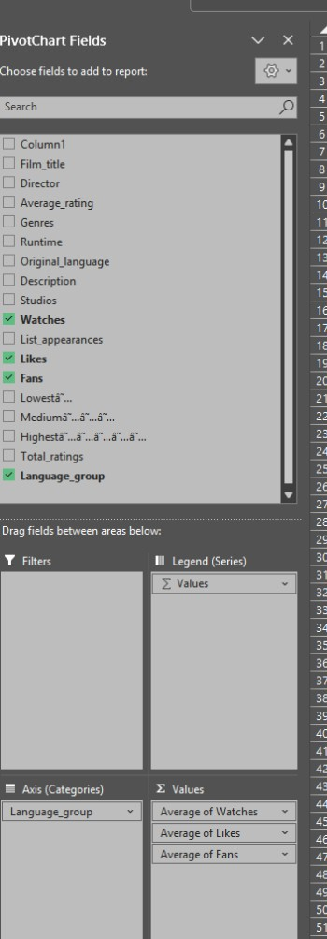

Figure C2: Average engagement metrics by language group
This figure presents a visual comparison of audience engagement metrics across language groups. English-language films demonstrate higher engagement across all metrics, highlighting the influence of platform visibility and audience reach.
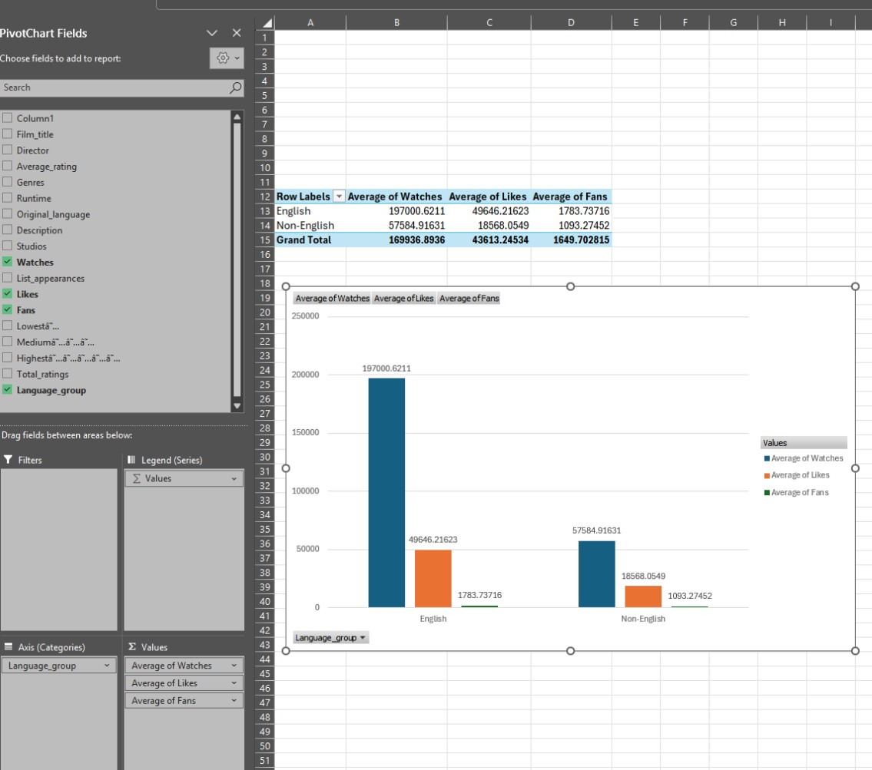

10.4 Appendix D: SPSS Outputs and Diagnostic Tests
Appendix D displays the statistical results and diagnostic tests outlined in Section 5. These findings aim to demonstrate the validity of the inferential analysis and ensure transparency regarding model assumptions, all while maintaining clarity and conciseness in the main report.

Appendix D1: Collinearity Diagnostics
Collinearity diagnostics were assessed using the tolerance and Variance Inflation Factor (VIF) metrics. Elevated VIF values were observed for the engagement measures, indicating strong intercorrelations among predictors. This confirms the presence of multicollinearity, consistent with the correlation matrix shown in Section 5, and calls for careful interpretation of individual regression outcomes.

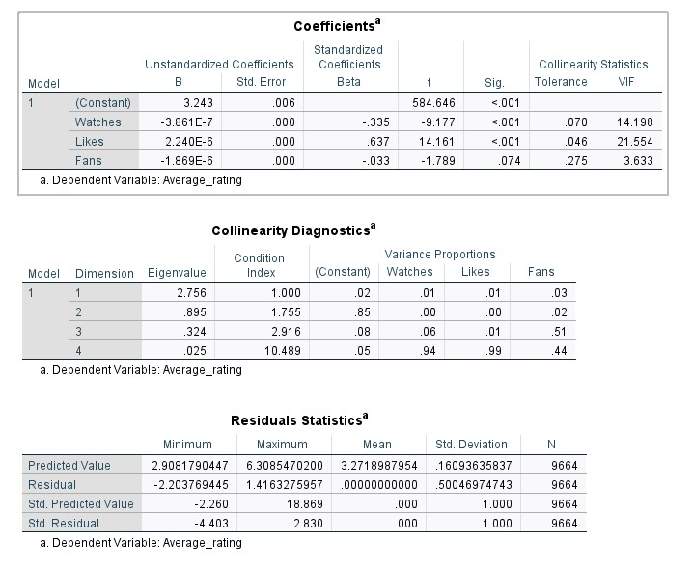

Appendix D2: Normality of Residuals
A Normal P evaluated the normality of residuals–P plot and a histogram of standardised residuals. The plots indicate that the residuals are approximately normal, supporting the normality assumption.
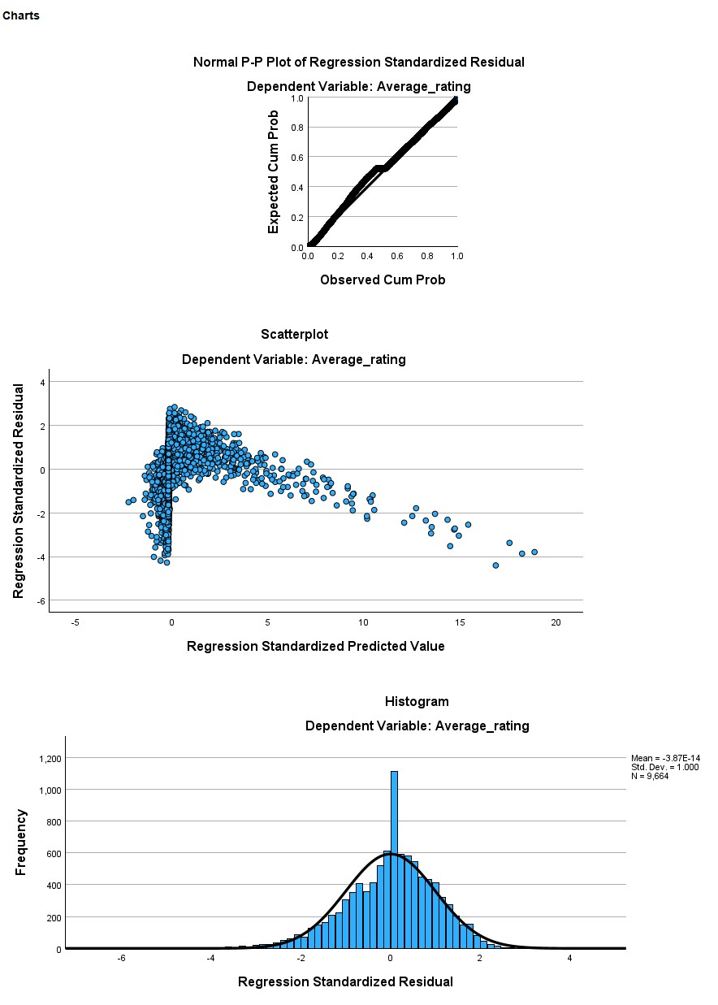

Appendix D3: Homoscedasticity Assessment
Homoscedasticity was assessed using a scatter plot of standardised residuals versus standardised expected values. The increasing variability of the residuals at higher predicted levels indicates heteroscedasticity, consistent with the limitations outlined in Section 5.

