BMSW5010
PEOPLE MANAGEMENT
Name: Mariana Neda
Student ID: 2312753

Table of Contents
Presentation 3
1. Introduction 3
2. Various types of company culture 3
3. Importance of company culture 5
4. Current company culture of TechInnovate 6
5. Challenges associated with the current culture 6
6. Analysing various factors of Shein’s culture model to TechInnovate 8
7. Suggesting a culture for the business 10
8. Recommendation 10
9. Conclusion 11
References 12

Presentation link: https://youtu.be/jTS5i5bCFg4?si=ebZjpkF8r27DqPp1

Presentation

1. Introduction
- TechInnovate is a fast paced company established in South Wales that has experienced remarkable growth.
- As per the case study, the company is hiring skilled and qualified engineers for the growth of the performances of the company.
The presentation has demonstrated the management strategies existing in the business and has also identified the significant culture followed by the company. Further the study has also evaluated the challenges that have been identified within the business princess and have also evaluated the relevant strategies that are highly required to be developed in the business for the growth and profitability of the business in the global market.

2. Various types of company culture
- Hierarchical culture structures clear constructions and formal events
- Emphasises instructions and rules for constancy and dependability (Saiti and Stefou, 2020)
- Endorses operational competence but can delay originality and suppleness

Company culture can yield numerous forms, each manipulating employee performance and organisational efficiency. One mutual type is hierarchical culture, considered by strong structures, official procedures, and an emphasis on constancy. Organisations with this culture highlight guidelines and strategies, endorsing constancy and dependability in operations. This can lead to competence but may smother creativity and suppleness.
- Innovative culture endorses originality, risk-taking, and partnership
- Inspires employees to reflect outside the box and research
- Nurtures a lively setting that drives novelty and flexibility (Naveed et al., 2022).
- Vital for positioning organisational culture with commercial goals in technical field
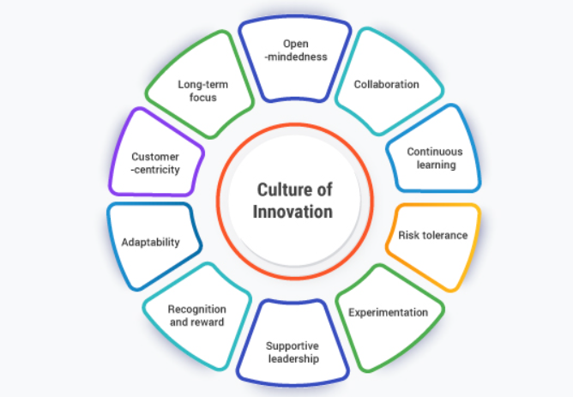
In difference, innovative culture nurtures creativity, risk-taking, and teamwork. Companies with this philosophy inspire staffs to reason outside the box, trial with new thoughts, and hold change. This lively environment can drive novelty and flexibility, vital for companies like TechInnovate in the fast-developing tech scenery. Considering these social types can help leaders deliberately shape their administration’s culture to line up with business goals.

3. Importance of company culture
- Positive company culture helps to increase the motivation and job satisfaction of the employees (Liu et al., 2021).
- The process of adapting various innovations and creativity within the business is also a significant factor of the culture of a company.
In the process of interacting with the employees or providing them some significant training and arranging skill development programmes for them is also a part of the features of a significant culture adopted by the business.
- Reward management, performance management, and training are all significant parts of a positive company culture (Bhuiyan et al., 2020).
- The management can also set an effective feedback system or can project feedback mechanisms within their business.
A strong and positive culture of the business can help to identify the issues and challenges existing within the business process and also helps in fostering long term success of the business. Therefore from the overall analysis it has been identified that a strong and sustainable company culture helps in increasing the resilience of the business by fostering the growth and innovation within the business system.

4. Current company culture of TechInnovate
- Startup culture is a significant culture within the organisational aspect that mainly focuses on the psychological dimensions of the employees (Asatiani et al., 2021).
- The behaviour, action, thoughts and perspectives of the employees are considered in this aspect.
In the case of the fast growing companies like TechInnovate the determination of the Startup culture within their system has helped to increase agility of the workforce and have fostered innovation in the workplace management process. In the case of increasing collaboration and teamwork within the system the adaptation of the Strategies of Startup culture is highly relevant. HoweverTechInnovate has external challenges and issues in the process of fostering their performance by adopting this culture.

5. Challenges associated with the current culture
- Rapid development is corroding TechInnovate's close-knit, cooperative culture
- Reduced employee fulfilment and moods of interruption are developing (Shaikh et al., 2022)
- Relaxed culture is being substituted by disintegration, delaying communication and cooperation
- Invention and amity are suffering as a consequence

The present culture at TechInnovate faces important challenges due to its fast development. As the company enlarges, the when close-knit, cooperative environment is corroding, foremost to reduced employee gratification and a wisdom of disconnection amongst operate. The casual culture that once nurtured invention and camaraderie is being substituted by a more disjointed atmosphere, which can delay communication and collaboration.
- Absence of recognised performance management procedures leads to assessment discrepancies (Awan et al., 2020)
- High executors may feel underrated without clear outlines
- Staffs needing provision might not obtain it, delaying development
- This misalignment can upsurge income and team battle
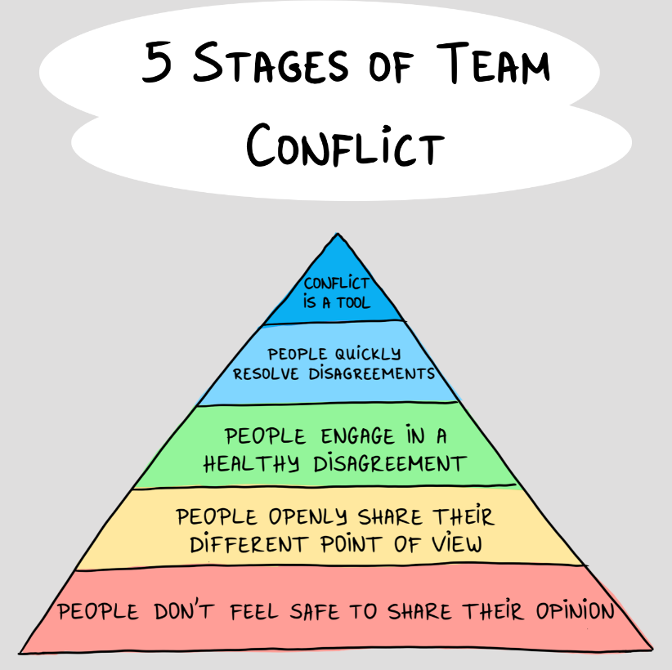
Moreover, the absence of well-known procedures and rules in performance management donates to inconsistencies in how staffs are assessed and satisfied. Without a pure framework, high performers may sense underrated, while others may not obtain the support they want to recover. This misalignment can lead to augmented income and battle within teams, further confusing efforts to uphold a positive business ethos.

6. Analysing various factors of Shein’s culture model to TechInnovate
- Schein’s culture model classifies three levels: artifacts, espoused values, and basic expectations (Mamatha. and Geetanjali, 2020)
- TechInnovate's artifacts comprise exposed office plans and cooperative places endorsing communication
- Fast development may reduce these physical rudiments unsuccessful, leading to misperception and disintegration in company culture
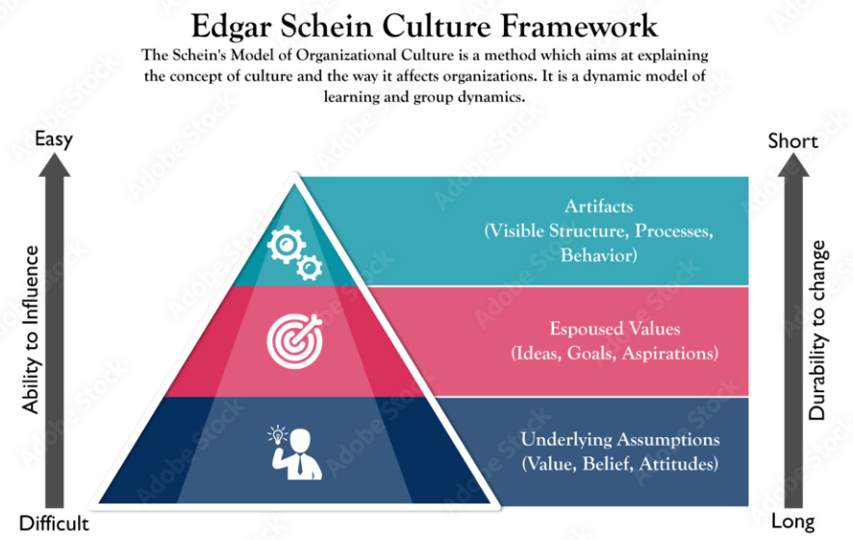
Schein’s culture model highlights three levels of culture: artifacts, espoused values, and basic underlying assumptions. At TechInnovate, artifacts comprise the exposed office plan and collective workstations that originally endorsed communication and collaboration. However, as the company produces, these physical rudiments may no lengthier efficiently support the anticipated culture, leading to misperception and disintegration.

- Espoused values at TechInnovate comprise innovation and teamwork, engrained in founding values
- Fast development may deteriorate strengthening of these standards, leading to worker interruption from the assignment (Cardona and Rey, 2022)
- Basic fundamental assumptions can change with variation to challenges, stressing the requirement for rearrangement with essential values
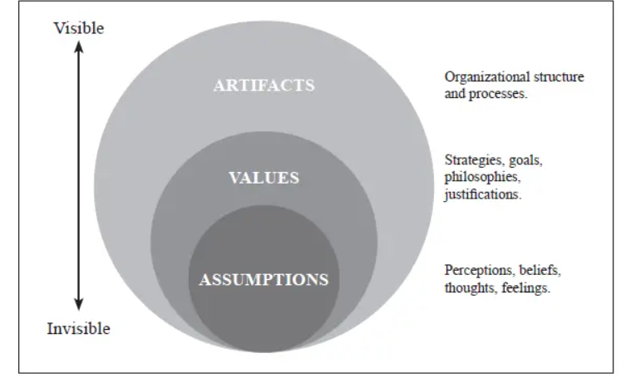
Espoused values at TechInnovate, such as novelty and partnership, reproduce the company’s establishment principles. Yet, with fast growth, these values may not be reliably strengthened, producing staffs to feel disengaged from the organisation's assignment. Elementary underlying expectations, which are frequently understood politics, may also change as the business adapts to new challenges. Considering and addressing these stages of culture can help TechInnovate readjust its performs with its essential values.

7. Suggesting a culture for the business
- Clan culture has some significant types of advantages as it is highly related to the trust, thoughts and beliefs of the employees (Huang et al., 2022).
- Clan culture makes the employees feel valued and it helps in building a close-knit community (Xie et al., 2020).
The company is required to adapt the clan culture in their business model to adapt the trust, change and flexibility. Identifying the needs and preferences of the employees TechInnovate is highly required to advance their recruitment process. Further, the company can also plan for some training and skill development programmes for their employees planning for the efficiency and growth of the performance of the business.
- Clan culture makes the employees cohesive; they feel like they are a part of the business (Fakhri et al., 2021).
- The group activity and the team activities are encouraged in the clan culture model of an organisation.
One of the most significant factors that the management of TechInnovate is required to focus on is the flexibility, adaptability and diversity of the workforce. The management can recruit the employees based on their qualifications and talent and their religion, culture or background are not the factors to be prioritised. Creating a positive and sustainable culture model can help the business to ensure and determine its growth and productivity in the business market.

8. Recommendation
- Training and skill development programmes can help them improve the efficiency and performance of the employees (Laing, 2021).
- Feedback systems can help to increase the interaction between the employees and thus the problems can be solved (Golchevskiy and Yermolenko, 2021).
The management of TechInnovate has to incorporate effective communication tools and collaboration software in their business for skill development. The management of TechInnovate can advance their recruitment recruitment system to hire and select the most eligible and qualified candidates for their workforce. The management can also plan some training and online training programmes for their skill development.
- The management also focuses on the mental well-being of the employees working in the company (Nguyen, 2020).
- The management of TechInnovate can set clear goals for aligning the efficiency of the employees with the organisational objectives.
- Providing reward and recognition programmes for the employees can help to increase the acknowledgement and the morale of the employees.
The leaders are required to prioritise the demands of the employees to encourage the autonomy of the workforce. Further developing a feedback mechanism for the workforce helps in identifying the factors that require innovation for meeting the needs of the employee

9. Conclusion
- The overall study has analysed the current culture existing in TechInnovate.
- Further, the study has explored various challenges existing within the business of the company.
- The challenges of recruitment, training, diversity and feedback mechanisms can help to mitigate the risks existing in the business.
Moreover, the clan culture has been suggested to be adopted within the business system of TechInnovate. The management has to focus on the recruitment, selection and training process to motivate and satisfy the employees.

References

Asatiani, A., Hämäläinen, J., Penttinen, E. and Rossi, M., 2021. Constructing continuity across the organisational culture boundary in a highly virtual work environment. Information systems journal, 31(1), pp.62-93.
Awan, S.H., Habib, N., Shoaib Akhtar, C. and Naveed, S., 2020. Effectiveness of performance management system for employee performance through engagement. SAGE open, 10(4), p.2158244020969383.
Cardona, P. and Rey, C., 2022. Management by missions: Connecting people to strategy through purpose (p. 156). Springer Nature.
Liu, G., Tsui, E. and Kianto, A., 2021. Knowledge-friendly organisational culture and performance: A meta-analysis. Journal of Business Research, 134, pp.738-753.
Mamatha, S.V. and Geetanjali, P., 2020. Founder leaders and organization culture: A comparative study on Indian and American founder leaders based on Schein’s model of organizational culture. IIM Kozhikode Society & Management Review, 9(1), pp.23-33.
Naveed, R.T., Alhaidan, H., Al Halbusi, H. and Al-Swidi, A.K., 2022. Do organizations really evolve? The critical link between organizational culture and organizational innovation toward organizational effectiveness: Pivotal role of organizational resistance. Journal of Innovation & Knowledge, 7(2), p.100178.
Saiti, A. and Stefou, T., 2020. Hierarchical organizational structure and leadership. In Oxford Research Encyclopedia of Education.
Shaikh, S., Chhabra, S. and Somayaji, A., 2022. Leading a team virtually: A manager’s perspective. Medical Writing, 31, pp.50-53.

