Business Report – Comparison of Corinthia Hotels and Ibis Hotels
Programme: BA International Hotel Management
Module: Financial Management for the Hotel Industry
Module code: BMIH5007
Student name: Mirela Mihaela Motohoi
Lecturer: Tristan Hawkins

Table of Contents
1 Introduction 3
2 Overview of Hotels 3
3 Total Revenue 4
4 Market Position 8
5 Growth Potential 9
6 Financial Commitment to CSR 10
7 Conclusion 12
8 References 13

Introduction
This assessment aims to compare Corinthia Hotels and Ibis Hotels wherein both belong to the hospitality industry; however, the subsequent sections of this assessment will focus on their financial management. Some of the areas for assessment include total revenue, market share, growth prospects, and commitment to total Corporate Social Responsibility (CSR). Hence, by assessing these critical components, the report seeks to identify the forces that affect their financial outcomes and viability to understand their efficiency as well as sustainability in a competitive environment.

Overview of Hotels
Corinthia Hotels, originally established in Malta sixty years ago by the Pisani family, Corinthia Hotels has grown into a worldwide luxury hotel company with hotels in some of the most desirable locations across the world. Each hotel is a prototype of grand boutique luxury where guests can get individual attention, a treatment that a small boutique hotel provides, and the magnificence of a grande dame. An increased expansion can be seen in the chain of Corinthia Hotels. Today, it is a vast family of hotels that maintains its focus on the Mediterranean spirit, despite having its hotels in such states as the United Kingdom, the United States of America, Italy, Belgium, Romania, Qatar, Saudi Arabia, and others (Corinthia, 2024).
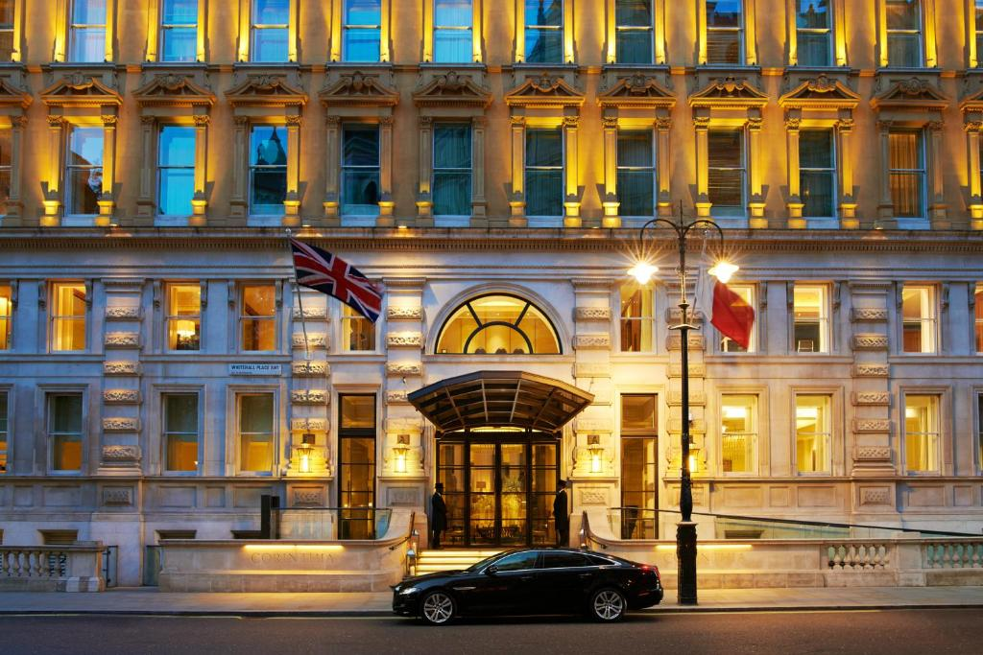
On the other hand, Ibis is a French brand of budget accommodations hotel chain belonging to the Accor Group. The hotel was established in 1974, Ibis turned into the “economy megabrand” of Accor in 2011 when Ibis Styles and Ibis Budget originated from All Seasons and Etap Hôtel correspondingly. By the end of 2019, Accor had 1,218 Ibis brand hotels (not counting Styles and Budget hotels) with a total of 159,180 rooms in 70 countries (Accor, 2024).
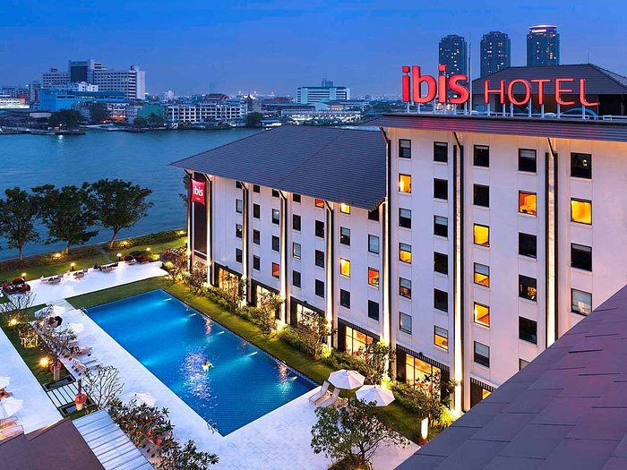

Total Revenue
Corinthia Hotel Budapest indicated stable revenue growth from FY2017 to FY2019, rising from €25.8 million to €28.1 million. This growth was facilitated by a focus on high-revenue drivers and refurbishment initiatives. Though a slightly negative year in terms of RevPAR in FY2018, overall revenue had a consistent upward growth year after year due to better room rates and smart management (Corinthia Hotel, 2020).
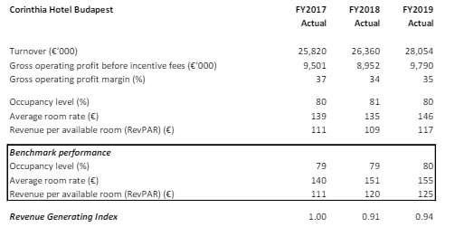
Figure 1: Corinthia Hotel Budapest 2017-2019
(Corinthia Hotel, 2020)
Total revenue can also be characterized by certain fluctuations during the period from 2019 to 2022, mainly due to the COVID-19 impact and other economic crises. It is noted that the company attained a strong revenue of €268.3 million, showing robust operational performance all over its owned hotels, third-party fees, rental income, and catering services in 2019. However, the covid-19 caused a severe revenue decrease in 2020 to €91.9 million, which is a 66% reduction, as lockdowns and travel restrictions highly influenced the hospitality sector (Corinthia Group, 2023). Recovery was observed starting in 2021 where the generated revenue amounted to €129.3, an increase of 41% compared to 2020, due to relaxation of measures and gradual restoration of travelling. By 2022, repeated revenue was recorded to be €238.2 million, about repetition from the previous year, as the industry recovered despite constant encounters such as labour shortages and inflation. This recovery was supported by the better control of costs in particular retained costs and improvement in occupancy levels although some properties particularly those in Tripoli and St. Petersburg remained constrained on demand (Corinthia Group, 2023).

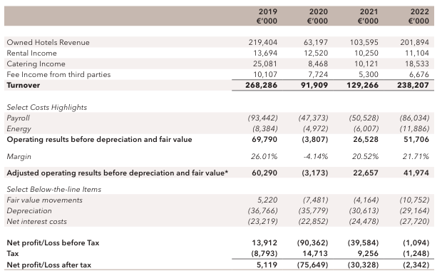
Figure 2: Revenue of Corinthia Hotel from 2019-2022
(Corinthia Group, 2023)
On the other hand, the revenue of Accor Group worldwide has increased over the last three years as depicted below. However, in 2023, the amount of Revenue of Hotel Company Accor Group was nearly 5.06 billion euros, up from 4.22 billion euros the previous year.

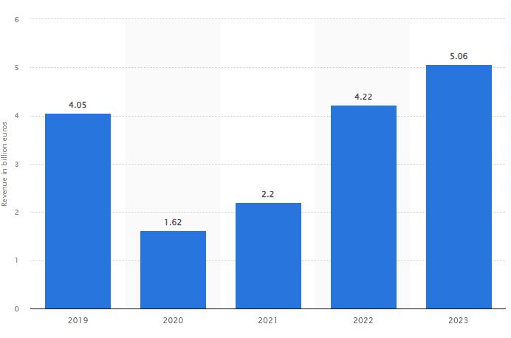
Figure 3: Revenue of Accor Group 2019-2023
(Statista, 2024)
Moreover, Ibis Hotels under the group “Economy, Midscale & Premium Division of Accor” has displayed a strong rebound in 2022. The third quarter of 2022 saw further improvement where Accor’s RevPAR was above the pre-pandemic level for the second consecutive quarter. Accor's overall Q3 2022 revenue surged to €1,149 million, an 83% increase from Q3 2021. On a more general note, Accor's total consolidated revenue in Q3 2022 was €1,149 million, 83 per cent higher than what was reported in Q3 2021. Consequently, the Hotel Services segment, which contains the Ibis brand, revealed €874 million in revenues, which is 84% like for like greater in the third quarter of 2021 than the total same quarter in 2020 and 9% larger than it was in the same time frame in 2019. This growth is attributed to the increased number of bookings by leisure travellers within the domestic and international markets, especially during the summer period, and the increased number of business travellers for trade shows/fairs in September. This growth was supported by the opening of 93 hotels, among which were Ibis, in the third quarter of 2022. There is a continuous upward trend of revenue as shown by Accor; this is cemented by its market and strategic developments in the economy hotel segment (Accor, 2022).
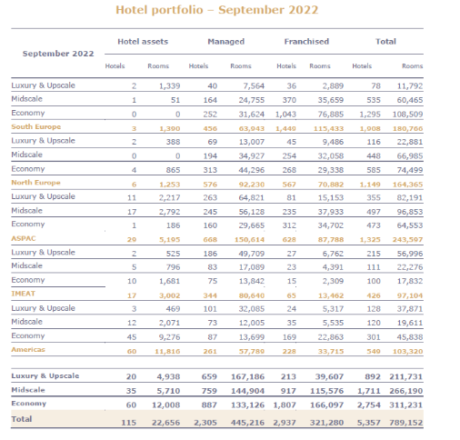
Figure 4: Hotel Portfolio- 2022
(Accor, 2022)

Market Position
Corinthia Hotels are located in the upper echelon of the hotel and resort industry since they offer exclusive services, and sophisticated accommodations, and are situated in the most popular destinations across the globe. As a luxury hotel, Corinthia aims at clients with higher purchasing power who may need accommodation for business, tourism or events. This clientele comprises mainly the wealthy and large corporations who can afford high-end products and expect only the best (Zámborský and Kruesi, 2018).
The brand personality of Corinthia Hotels is perceived to be elegant, luxurious and classy. Its market coverage is not very vast compared to well-established hotels but holds a significant position in the luxury segment. Some of the other strengths supporting Corinthia’s brand include its location, such that many hotels are located in listed buildings and its special guest relations emphasis. Although the pandemic presents some threats, Corinthia Hotels remains relevant by enhancing property improvements and digital media, thus strengthening its competitive niche (Corinthia, 2024d).
Whereas, Ibis Hotels which is a subsidiary of the Accor Group is located in the economy category of the accommodation sector. Ibis is popular for offering affordable accommodation to clients who are usually business people, tourists and even families who are looking for cheap hotels. Ibis Group established a policy that delivers service quality and price options which are perceived to be affordable for short-term accommodation and budget-conscious customers (Accor, 2023). Presenting over 1,200 hotels in the total number of chains, Ibis is one of the market leaders in the spheres of economy hotels (Ibis, 2024). The brand image of Ibis convenience, comfort and affordability are its key values. Their market positioning relates to high occupancy rates and affordable pricing that targets the wider population. The marked increase in Ibis's revenue over the last year by focusing on strategic developments and an increasing trend of travel both nationally and cross-border substantiate its strong market standing (Ren et al. 2018).

Growth Potential
Another business that is under IHI includes Corinthia Developments International (CDI). It aims to identify and implement hotel & real estate acquisition prospects, and to advance projects on IHI's account or for clients globally. Everything about such acquisitions is handled from negotiations with the vendors, sourcing for the required funds, legal, financial, and environmental due diligence, and recruitment of professional consultants to the overall management of the project onsite to deliver another classic Corinthia product (Corinthia, 2024b). Further, these fields of experiential travel and wellness tourism are compatible with Corinthia’s existing services, offering further potential for growth. However, the potential challenges to growth include high costs that accompany the development of luxury properties and also the fluctuations in the economy. On the other hand, Ibis Hotels possesses enormous potential for growth within the economic stratum of the hospitality industry. Therefore, their growth plan is to extend their operations around the globe, especially in the fast-growing economies in the Asian, African, and Latin American regions. This can be attributed to the brand's earlier opening recent 93 hotels in Q3 2022 showing its ramp-up strategy. This policy affirms the brand’s ability to sustain reasonable charges that support quality and standardization of services, which in turn attracts many customers hence the high occupancy (Kádár, 2018). Market opportunities for Ibis include the growth of the budget segment and the trend of domestic tourism that has emerged due to the COVID-19 outbreak (Free and Hecimovic, 2021; Lutskyi and Chepurda, 2023). The patterns and trends of the Ibis’s business travellers also hold a great prospect in the growth of emerging markets since they are cost-conscious. Some threats to the further development of Ibis might be the unfavourable circumstances on the economy that have an impact on the propensity to purchase travel-related services, and the stiffened competition within the category of budget hotels (Chanyasak, 2022).

Financial Commitment to CSR
Ibis Hotels which are part of the Accor group have embraced CSR by participating in the Accor's Planet 21 program. This approach relates to sustainability, stewardship, and responsibility to the community and the larger society. Key CSR activities include:
- Sustainability Practices: Ibis Hotels help Accor in its plan to cut food wastage by a third and to make all new buildings and renovations low-carbon. They are within the framework of introducing one thousand urban gardens by 2020 to support local producers and minimize the adverse effects on the environment (Accor, 2016).
- Community Engagement: Some of the Ibis Hotels support the WATCH program that seeks to fight the sexual exploitation of children, thus showing the company’s interest in the welfare of such vulnerable groups (Accor, 2024b). They also comprise corporate social responsibility programs and charitable initiatives for the locals.
- Ethical Business Practices: Ibis stays on focused the issues of negativizing its impact on the environment through energy and water conservation. Almost all of the Ibis hotels engage in childcare protection and more than 90% of Ibis hotels engage in improvement programs having a good ethical and responsible business proposition (Accor, 2024a).

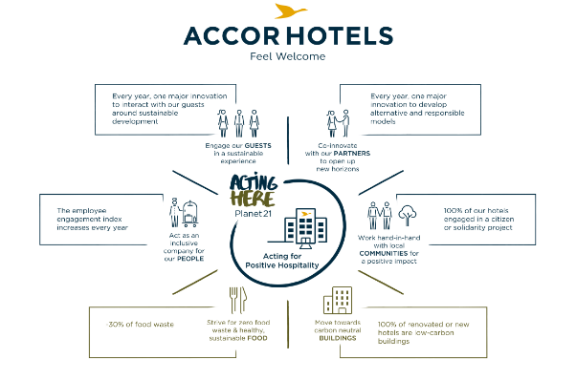
Figure 5: Accor Hotel
(Accor, 2016)
Furthermore, Corinthia Hotels has a strong policy on CSR, where the hotel chain has invested its efforts worldwide through several socially responsible acts across its properties. Some notable CSR activities include:
- Supporting Just a Drop: Corinthia remains backing up Just a Drop and helping to decrease the number of child fatalities linked to unsafe water and sanitation. Initiatives in Cambodia, Tanzania, and Zambia have impacted the lives of tens of thousands of children and their communities by offering them clean water.
- Community Engagement: There are also some activities that Corinthia implements to support local communities, for example, delivering food and sweet hampers to kids at St Patrick’s in Sliema, Malta, and donating N95 masks to residences of elderly people and disabled individuals during COVID-19.
- Environmental Sustainability: Such activities as donating to the Food Bank Foundation, supplying hand-cut local fries from locally grown potatoes, and offering cultural tours to museums for employees contribute to environmental conservation and the general welfare of the community (Corinthia, 2024c).
- Employee Welfare: Maintaining the wellbeing of its staff is another key aspect that Corinthia focuses on collecting money for colleagues, donating to charitable organizations, and conducting online events for employees to express care and concern (Kim et al. 2018; Bibi et al. 2022).
Furthermore, Corinthia Hotels presented the company's commitment to Corporate Social Responsibility (CSR) policy and numerous projects. They include contributing to global charitable organizations such as Just A Drop, providing essential services during the COVID-19 outbreak with contributions of N95 masks and food supplies, contributing to local communities whereby the company donates to schools and residential homes and lastly holding charitable events and campaigns in various places. As such, Corinthia Hotels plays its part in the welfare of communities, society, and even the elevation of the environment demonstrating true commitment towards the well-being of the community (Corinthia Hotels, 2021). Altogether, the CSR initiatives undertaken by Corinthia Hotels are genuine and proactively contributing to a better society, the environment, and their employees, which is a commendable approach to running a sustainable ethical business (Debattista, 2022; Ratner and Iosifov, 2017).

Conclusion
Therefore, the relative analysis of Corinthia Hotels and Ibis Hotels demonstrates the differences in the two companies ‘financial strategies and their expenditure on CSR in the context of the hospitality business. Corinthia Hotels, which specialises in the luxury segment, has been effective in its approach to managing economic risks while adhering to CSR of providing support to affected communities, and protection of the environment and their employees. On the other hand, Ibis Hotels, which operates in the economy segment, has very good growth prospects due to successfully introducing strategic acquisitions and joining Accor's Planet 21 program. Both brands are focused on CSR to some extent, although this indicates that their approach differs and this is related to changes in consumer demands, as well as the company's attempts to address global issues.

References
Accor, 2016. AccorHotels takes its corporate responsibility to the next level with bold new CSR commitments looking. Available at https://press.accor.com/accorhotels-takes-its-corporate-responsibility-to-the-next-level-with-bold-new-csr-commitments-looking/?lang=en. [Accessed on 31st May 2024]
Accor, 2022. Third-quarter 2022 revenue of €1,149 million. Available at https://press.accor.com/third-quarter-2022-revenue-of-e1149-millionup-83-like-for-like/?lang=en. [Accessed on 31st May 2024]
Accor, 2024. Ibis. Available at https://group.accor.com/en/brands/economy/ibis. [Accessed on 31st May 2024]
Accor, 2024a. Environment & CSR. Available at https://group.accor.com/en/hotel-development/Optimise-your-costs/Environment-and-CSR. [Accessed on 31st May 2024]
Accor, 2023. Our History. Available at https://group.accor.com/en/group/who-we-are/our-history. [Accessed on 31st May 2024]
Accor, 2024b. Key Milestone. Available at https://group.accor.com/en/commitment/approach/milestones. [Accessed on 31st May 2024]
Bibi, S., Khan, A., Hayat, H., Panniello, U., Alam, M. and Farid, T., 2022. Do hotel employees really care for corporate social responsibility (CSR): a happiness approach to employee innovativeness. Current Issues in Tourism, 25(4), pp.541-558.
Chanyasak, T., Koseoglu, M.A., King, B. and Aladag, O.F., 2022. Business model adaptation as a strategic response to crises: navigating the COVID-19 pandemic. International Journal of Tourism Cities, 8(3), pp.616-635.
Corinthia Group, 2023. ANNUAL REPORT 2022. Available at https://www.corinthiagroup.com/wp-content/uploads/2023/06/37547-CORINTHIA-ANNUAL-REPORT-2022_WEB-min.pdf. https://www.corinthiagroup.com/wp-content/uploads/2023/06/37547-CORINTHIA-ANNUAL-REPORT-2022_WEB-min.pdf
Corinthia Hotel, 2020. Financial Analysis Summary. Available at https://www.corinthiagroup.com/wp-content/uploads/2020/08/IHI-Financial-Analysis-Summary-2020.pdf. [Accessed on 31st May 2024]
Corinthia, 2021. OVERVIEW OF OUR RECENT CSR ACTIVITIES. Available at https://corinthiagroup.com/insider/overview-of-our-recent-csr-activities/. [Accessed on 31st May 2024]
Corinthia, 2024a. About Corinthia. Available at https://www.corinthia.com/en-gb/our-story/. c
Corinthia, 2024b. We Develop. Available at https://www.corinthia.com/en-gb/development/we-develop/. [Accessed on 31st May 2024]
Corinthia, 2024c. Sustainability Policy. Available at https://www.corinthia.com/globalassets/corinthia-global/documents/sustainability/ch_booklet-sustainabilitypolicy-a5p-28324.pdf. [Accessed on 31st May 2024]
Corinthia, 2024d. UPLIFTING LIVES. Available at https://www.corinthia.com/globalassets/corinthia-global/documents/development/corinthia-development-presentation-may-2023-compressed.pdf. [Accessed on 31st May 2024]
Debattista, D., 2022. MALTA, THE POSSIBILITIES OF SUSTAINABLE LUXURY TOURISM ON A MEDITERRANEAN ISLAND MEGALOPOLIS. The Online Open Access Repository of the Institute of Tourism Studies (Malta).
Free, C. and Hecimovic, A., 2021. Global supply chains after COVID-19: the end of the road for neoliberal globalisation?. Accounting, Auditing & Accountability Journal, 34(1), pp.58-84.
Ibis, 2024. We Are Open. Available at http://www.ibis_Factsheet_EN_0820.pdf. [Accessed on 31st May 2024]
Kádár, B., 2018. Hotel development through centralized to liberalized planning procedures: Prague lost in transition. Tourism Geographies, 20(3), pp.461-480.
Kim, H., Woo, E., Uysal, M. and Kwon, N., 2018. The effects of corporate social responsibility (CSR) on employee well-being in the hospitality industry. International Journal of Contemporary Hospitality Management, 30(3), pp.1584-1600.
Lutskyi, I. and Chepurda, L., 2023. Assessment of hotel business operators in the international and domestic markets. Збірник наукових праць Черкаського державного технологічного університету. Серія: Економічні науки, (71), pp.89-98.
Ren, L., Qiu, H., Ma, C. and Lin, P.M., 2018. Investigating accommodation experience in budget hotels. International Journal of Contemporary Hospitality Management, 30(7), pp.2662-2679.
Ratner, S. and Iosifov, V., 2017. Eco-management and eco-standardization in Russia: The perspectives and barriers for development. Journal of Environmental Management & Tourism, 8(1 (17)), p.247.
Statista, 2024. Revenue of Accor Group worldwide from 2019 to 2023. Available at https://www.statista.com/statistics/266261/revenue-of-the-accor-group/. [Accessed on 31st May 2024]
Zámborský, P. and Kruesi, M.A., 2018. Global Hotel Alliance: Strategy Discovery Moving East. SAGE Publications: SAGE Business Cases Originals.

