NAME: - SHIVANI PATEL
I’D: 2412070
COURSE NAME: POPULATION HEALTH AND DIGITAL PROMOTION
LECTURER NAME: DR PING WU

BLOG-1
WHAT A REVOLUTIONIZING MOBILE HEALTH APP CAN CHANGE DIABETES IMPACT

Now A Days Diabetes is a big problem
Diabetes is increasing day by day all over worldwide. According to World Health Organization (WHO) research of 2021 shows about 530 million adults with diabetes could be increase to 643 million (IDF) 2021. And can be create several health problems like heart disease and kidney failure. With increasingly more people diagnosed with the disease, we have to find new and effective ways of dealing with it. It is here that digital health technologies, including mobile health applications, are able to help.
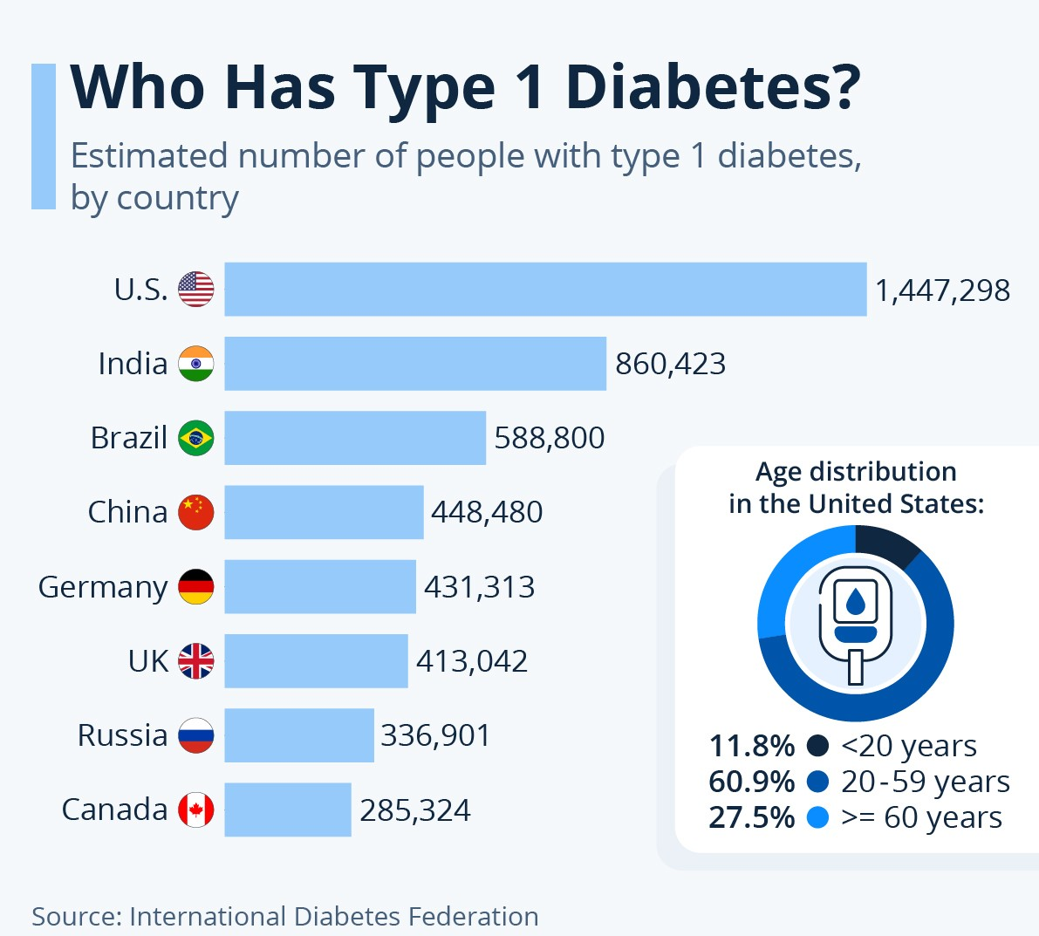

How Mobile Health Apps Support People Living with Diabetes
MySugr and BlueLoop are a couple of applications designed to make life easier for those who live with diabetes. They help patients track blood sugar, remind them to take medication, provide nutrition data, and encourage exercise. These apps use real-time data and artificial intelligence to offer personalized health data. Some also integrate with wearable devices and electronic health records to enable physicians and patients to get to know each other sooner.
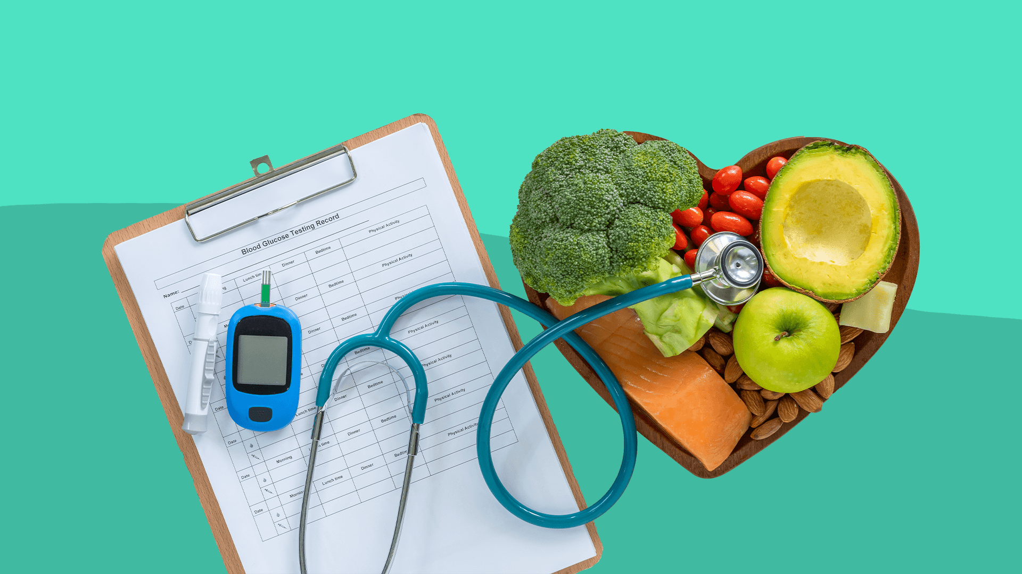

Do mHealth Apps Actually Work? The Evidence Suggests So
There is evidence to back up the fact that mHealth apps are efficient. In a study, patients who utilized diabetes apps were discovered to have better blood glucose control through an average reduction of 0.57% in their HbA1c level (Hou et al., 2018). In another review, Cui et al. (2016) determined that the apps allow patients to stay connected with their health, stick to their medication regimens, and embrace healthier lifestyles. This is allowing digital health technologies to enable people to take control of their diabetes.
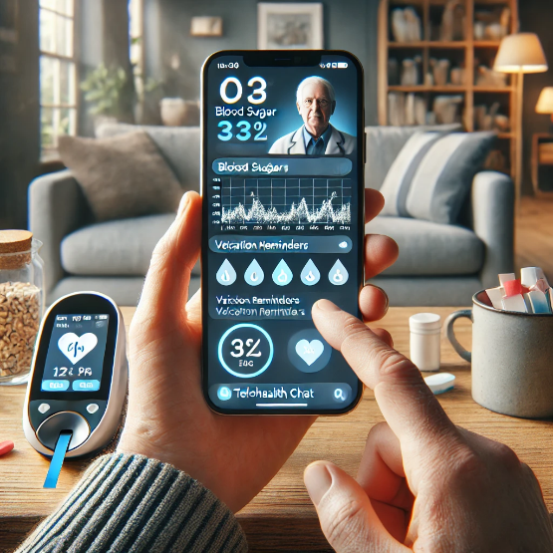
The Benefits and Drawbacks of mHealth Apps
1. Encourage Self-Care: These apps help individuals track their progress, staying motivated.
2. Remote Medical Attention: People are able to send real-time updates to their doctors, preventing unnecessary hospital visits.
3. Personalized Advice: Advice based on AI enables personalized treatment and lifestyle programs for each person.
DRAWBACKS
1. Not Available to All: Smartphones need quality of network, and they is not available at every place; also, not everyone has smartphones.
2. Threat to Privacy: They can collect and share the data and can be dangerous to customers.
3. Need More Long-Term Studies: Studies to be need to understand if it can be a long run or not.

CONCLUSION
mHealth applications have transformed diabetes care by enabling people to be in charge of their well-being Users can directly communicate with the doctor individual to consult and have some advice. Despite the existence of issues like accessibility, privacy concerns, and the need for long-term research that must be addressed, Technology can be helpful to improve health related issues. Diabetes can be cure if everyone has the access to the technology and fight against it for a bright treatment.

REFRENCES
International Diabetes Federation. (2021). Facts & figures.
According to the IDF, approximately 537 million adults (20-79 years) were living with diabetes in 2021, with projections rising to 643 million by 2030.
Hou, C., Carter, B., Hewitt, J., Francisa, T., & Mayor, S. (2018). Mobile phone applications and self-management of diabetes: A systematic review with meta-analysis, meta-regression of 21 randomized trials, and GRADE. Diabetes Care, 39(11), 2089-2095.
This systematic review and meta-analysis found that diabetes apps improve glycemic control in type 1 diabetes patients, with a reduction of 0.57% in HbA1c for type 2 diabetes patients.
Journal of Clinical Epidemiology, 145, 1-10.
This clinical trial demonstrated that mHealth applications significantly decrease HbA1c levels in patients with type 2 diabetes
JMIR mHealth and uHealth, 9(2), e23687.
This systematic review found that diabetes-specific mHealth apps improved glycemic control by significantly reducing HbA1c values in patients with type 1 and type 2 diabetes.

BLOG-2

INTRODUCING DIATRACK: A SMARTER WAY TO MANAGE DIABETES

WHY DIABETES IS A MAJOR CONCERN
According to the Blog-1 World Health Organization (WHO), 537 million individuals with diabetes can rise up to 643 million by 2030 (IDF). If it is uncontrolled, it can cause heart disease and kidney failure. That is why I created DiaTrack, an innovative diabetes management app that can be useful to control and help to get a cure.
WHAT IS DIATRACK?
DiaTrack is a mobile health app that enhances diabetes management through artificial intelligence (AI), real-time monitoring, and
personalized support. Compared to existing apps, DiaTrack offers:
• AI-Driven Predictions: The application identifies patterns and alerts users beforehand of a potential spike or drop in glucose.
•Voice-Activated Logging: Users can log meals, glucose levels, and symptoms hands-free.
• Offline Mode: The information is stored locally and syncs whenever the internet is available.
• Community & Telehealth Features: It allows users to interact with health professionals and peer support groups.


HOW DIATRACK IMPROVES DIABETES CARE
1.Better Tracking for Better Health: Simple logging of blood sugar levels, meals, and medication adherence.
2. Smart Alerts: Ominous alerts avert dangerous glucose swings.
3. Accessibility for All: Voice logging and offline access make it easy to use for visually impaired users and low-network areas.
4. Emotional and Medical Support: A built-in chat feature unites the users with medical experts and other patients.

STRENGTHS AND WEAKNESSES OF DIATRACK
Advantages:
1.Improved User Experience: AI and voice commands simplify tracking.
2.Greater Accessibility: Offline mode ensures usability in remote areas.
3.Proactive Health Monitoring: Smart alerts help users take preventive action.
Challenges:
1.Cost & Affordability: AI-powered features may make the app costly for some users.
2.Privacy Risks: Storing sensitive health data requires strong security measures.
3.User Adoption: Older adults may find it difficult to use advanced digital tools.

ADDRESSING THESE CHALLENGES
To ensure accessibility, DiaTrack will offer a free basic version with premium features for a subscription. 24/7 customer support will be available for user-friendly tutorials to help the customers.

FINAL THOUGHTS
Strong community support and smart tracking has the potential to transform diabetes offering by Diatrack. Improvements are ongoing and challenges will be fixed as per requirements. Diatrack will be powerful tool in diabetes management, helping and taking off control to the health more easily and effectively.

REFRENCES
Nayak, L. M., Vakili, S., & Schulman, K. (2023). 'Smart speaker' shows potential for better self-management of Type 2 diabetes.
Stanford Medicine News.
This study, led by Dr. Kevin Schulman at Stanford Medicine, indicates that an AI-powered smart speaker can assist Type 2 diabetic patients in managing their blood glucose levels.
Vakili, S., Nayak, L. M., & Schulman, K. (2023). Use of Voice-Based Conversational Artificial Intelligence for Basal Insulin
Titration in Patients With Type 2 Diabetes: A Randomized Clinical Trial. JAMA Network Open.
This randomized clinical trial found that participants using a voice-based conversational AI application achieved optimal insulin dosing more rapidly and adhered better to insulin therapy compared to standard care.
Nigam, A., & Sun, J. (2022). Need help managing diabetes? These students made an app for that. Harvard T.H. Chan School of Public Health News.
Harvard students Amber Nigam and Jie Sun co-founded basys.ai, developing an app that aids diabetes patients in tracking blood glucose levels, activities, and diet, utilizing a digital avatar to promote healthy habits.
Abbasian, M., Yang, Z., Khatibi, E., Zhang, P., Nagesh, N., Azimi, I., Jain, R., & Rahmani, A. M. (2024). Knowledge-Infused LLM-
Powered Conversational Health Agent: A Case Study for Diabetes Patients. arXiv preprint.
This paper introduces a knowledge-infused large language model-powered conversational health agent designed to assist diabetic patients in managing their condition effectively.

POSTER


