
1/1/2018
Your name: Ashleigh Steel
Company Name: | Williams Web Design & Hosting Company

Table of Contents
1. Heading 1 1
1.1 Sub Heading 1
1.1.1 Sub, Sub heading 1
Heading one 2
Sub heading of One 2
Sub, Sub heading of One 2
Heading Two 2
Sub heading of Two 2
Sub, Sub heading of 2

Williams Web Design & Hosting company
Spacing 1.5
//Please use spacing to ensure best reading capability.


Justify Block
// Use this for all document to align and make document look professional


PID
This will be defining all major aspects of a project and it forms the basis for its management and assessment of overall Success, this will be provided to Williams web design and hosting to show how this project will be executed.

Project Roles
Date | Meeting | Chairperson | Recorder
30/01/18 | First Meeting | Steff | Ricky J
16/02/18 | Second Meeting | Ashley Steel | Ricky J
02/03/18 | Third Meeting | Ricky Jenkins | Steff L
16/03/18 | Forth Meeting | Steff L | Paul W
30/03/18 | Fifth Meeting | Paul W | Harry H
13/04/18 | Sixth Meeting | Harry H | Ashley S

Role names | Names | Tasks for roles
Project Manager | Ashleigh Steel | PID
Risk Manger | Paul Weaver | Risk assessment, benefits
Quality Manager | Harry Herions | Version control/Quality Control, Presentation prep.
Time Manager | Ricky Jenkins | Project Plan, Project Team Manager
Cost Manager | Steffan Lewis | Cost hard/software & employees

Time Management
Time is a key factor to any task, so we have gathered information and spoke to one another to create a Gannt chart (tasked to Ricky) to effectively plan time, so we can see how long certain things will take, any extra time needed, and be as efficient with time as much as possible.

Gantt Chart
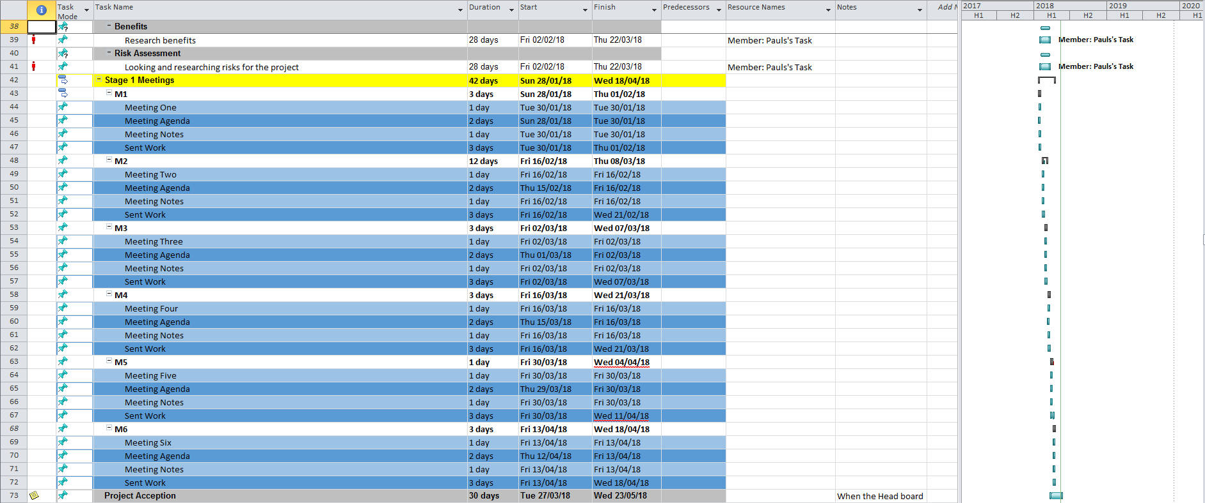
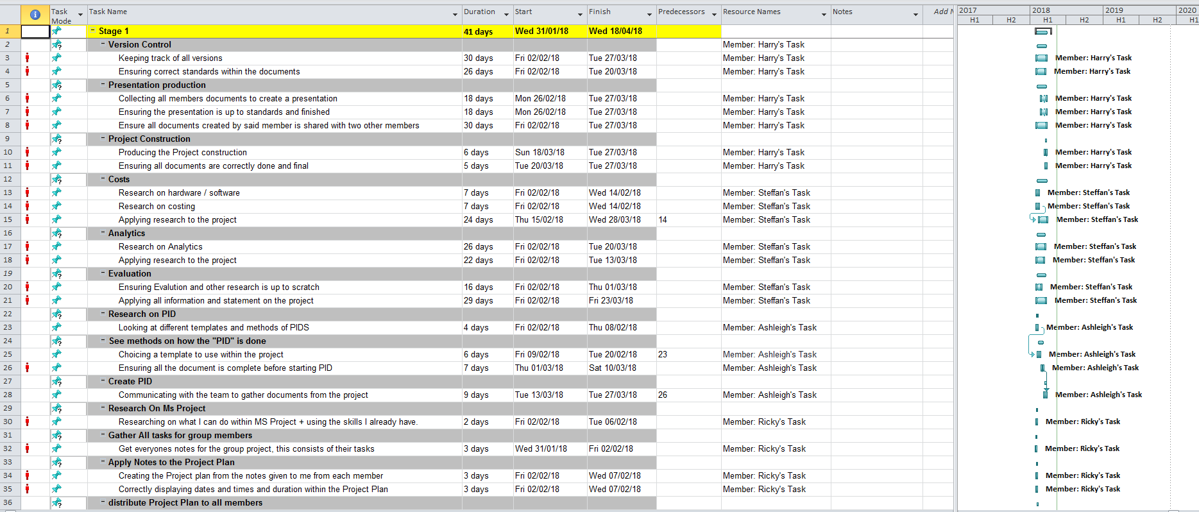
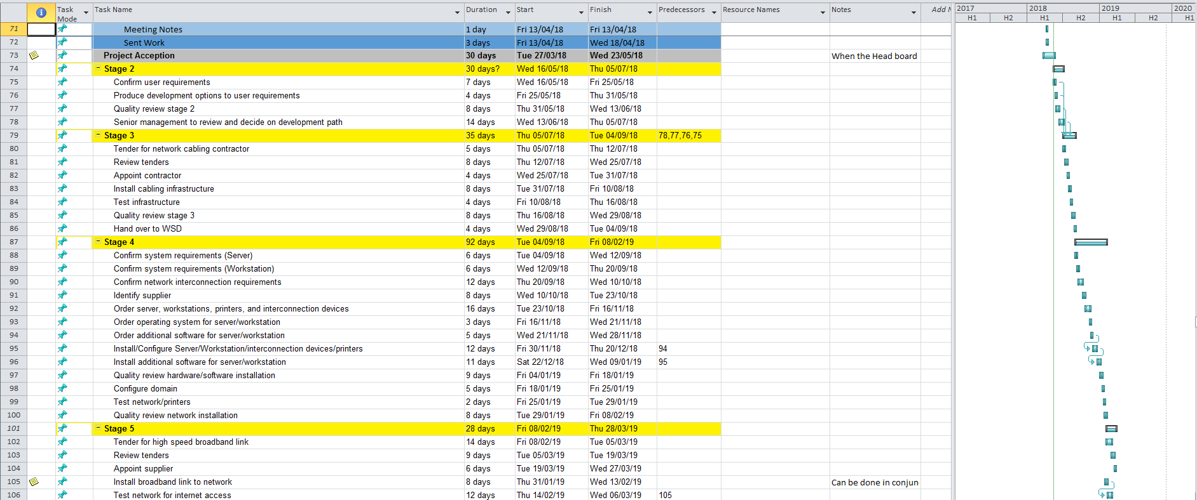
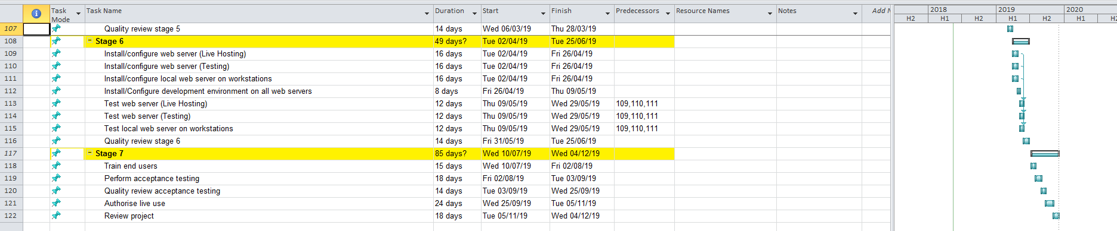

Cost Management
Managing the spending of this project is another key tasked required in planning any project, an effective gathering of information on cost will allow us to analysis and make certain decision based on that knowledge (tasked to Steff). With this we are able to see where we could spend more or less, and plan for other expenses just encase.

Costs of project
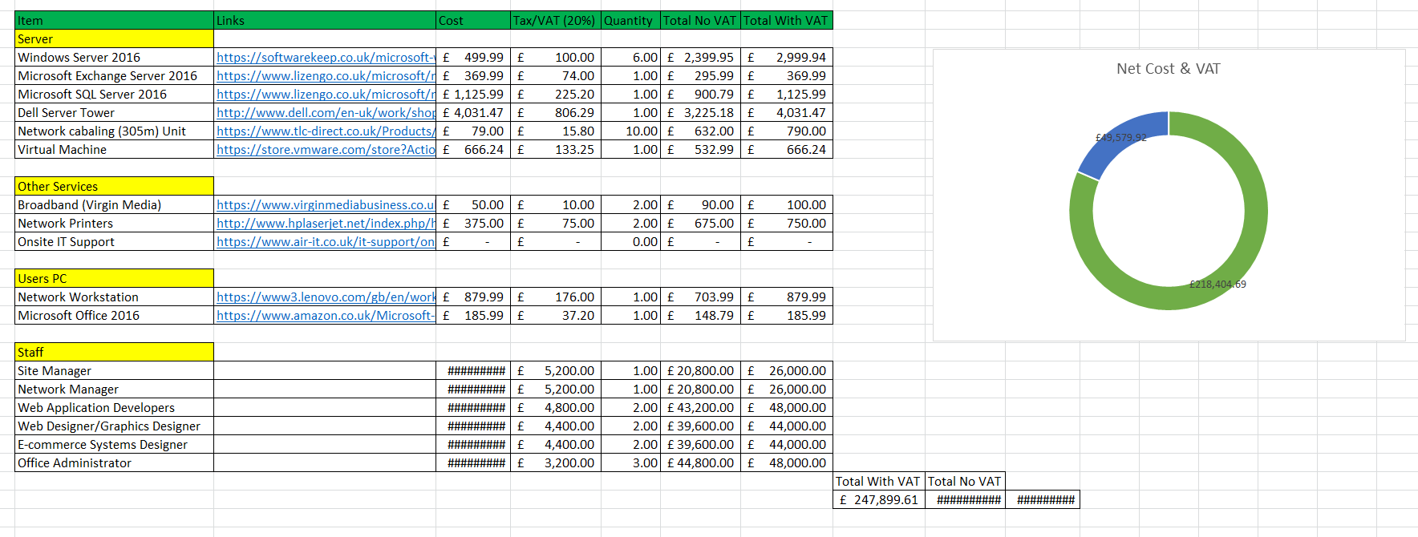

Risks
Analysing the Risks of any project is very important, without knowing the possible risks to certain tasks people could get hurt, project could be ruined and someone could be in danger without knowing and cost the project/company (task to Paul). Overall being able to know the risks and work around them is key to a successful project.
IMAHE HRER DASD

Documentation / Quality control
When working in a team, it’s very important that we all can understand each other, otherwise there would be no way of getting each other’s point across (task by Harry). Which document and quality control comes in, With each document correctly labelled and the quality maintained, being able to look at each other’s work and know the document, version (is it latest and up to date), done by who and so on. The Overall importin’s of this is big when trying to communicate as a team.
Here is an example of how we have structured all documentation, also this PID is an example of this and quality controlled.
“Name of Document”-“Date”_”name of creator”_”version”
PID-18-05-2018_Ashleigh_V1

Meeting Notes
Here are all the notes created in all are meetings. During these meetings we made sure to document anything relevant, and related to the tasks at hand, discussed any problems that anyone was having and resolved them, and ensured we all would keep each other posted on their current tasks.

First Meeting

MEMORANDUM

To: Ashleigh Steel, Harry Hierons, Paul Weaver, Ricky Jenkins, Steffan Lewis

CC: Paul John

From: Steffan Lewis

Date: 29/01/2018

Re: Project Team Meeting -

The agenda is as follows:

- Project overview and evaluation of scenario
- Defining the project tasks
- Task allocation
- Quality control issues
- Define timescales
- Define project plan
- Chair for next meeting
- Date/Time of next meeting
- Team members Health and Safety
- AOB

Meeting Notes

Committee: Williams Web Design Hosting company Meeting |  |  | Chair: Steffan | Date of meeting: 30/01/2018
Present: Steff L, Ricky J, Harry H, Ash S, Paul W
Apologies/Not present: Paul J
Minutes of  Last meeting: | Y  Accepted | Minutes sent to: Steff L, Ricky J, Ash S, Harry H, Paul J, Paul W
Minutes of  Last meeting: | Y  Revised | Copies to: Paul J

 | Agenda Item | Decision | Action by | Target Date
1 | Project overview with dates / work | After speaking with the members of the team, the group has decided all the work given out within the meetings fit everyone’s skills and mind set. | Steff L. | 30/01/2018
2 | Defining the project task | After speaking with everyone, we have all decided that everyone’s roles will be as follows;  Ricky – Project Plan, project manager  Paul – Risk Assessment, Benefits  Steff – Cost  Harrys – PowerPoint, Version Control / Quality Control  Ash – PID | All | 30/01/2018
3 | Task Allocation | We have requested all members to send their work off at the correct times and dates to ensure no issues or problems within the allocated time. | All | 16/02/2018
4 | Quality control issues | While speaking with the group, it has been deemed important to ensure quality control is maintained and therefore Harry and others will ensure the standards are up to scratch. | Harry | 16/02/2018
5 | Define timescales | Each team member is to keep track and make updates on their work for quality control to ensure requirements are met within the requested times. | All | 30/01/2018
6 | Define project plan | The recorder (Ricky) Will wait for everyone’s information on tasks and times before completion of the project plan. | Ricky | 02/02/2018
7 | Chair member for next meeting | We have all agreed that the next chairperson will be Ashleigh. | All | 16/02/2018
8 | Date and Time of next meeting | All the members have agreed that the next meeting will be held at 16/02/2018 using discord as our head of communication.  (Discord is a free service that allows user to create calls, cams and allow users to share their screen and documents live.) | All | 16/02/2018
9 | File naming and paths | We have all agreed on using standardisation for file naming, this is done using the following syntax;  (NameOfFile_MemberName_V-1.Doc)  (NameOfFile-_MemberName_V-2.1.Doc) | All | 30/01/2018
10 | Health and safety | Discussing with the team we have all deemed it is important to ensure everyone’s safety while doing the Project, this includes taking breaks to relieve eye strain and back issues. We also take into consideration members sanity and stress to ensure the right amount of workload. | Ricky, Steff | 30/01/2018
11 | AOB | The member Paul commented that he will not be present for the meeting on the 16/02/2018 | Paul | 16/02/2018

Second Meeting

MEMORANDUM

To: Ash S, Harry H, Ricky J, Steff L, Paul W

CC: Paul J, Caroline B

From: Ashleigh Steel

Date: 15/02/2018

Re: Williams Web Design & Hosting company Meeting

The agenda is as follows:

- Project overview and evaluation of scenario
- Ensuring all members are happy with their project task
- First meeting Refection
- Project Timescale
- Chair for next meeting
- Date/Time of next meeting
- Team members Health and Safety
- AOB

Meeting Notes

Committee: Williams Web Design & Hosting Company Meeting |  |  | Chair: Ashleigh Steel | Date of meeting: 16/02/18
Present: Steff L, Ricky J, Harry H, Ash S
Apologies/Not present: Paul J, Paul W
Minutes of  Last meeting: | X  Accepted | Minutes sent to: Steff L, Ricky J, Ash S, Harry H, Paul J, Paul W
Minutes of  Last meeting: | X  Revised | Copies to: Paul J

 | Agenda Item | Decision | Action by | Target Date
1 | Project overview with dates / work | While within the meeting, all members present spoke about their progress and how their work is going. | All. | 16/02/18
2 | Ensuring all members are happy with their project task | Ash brought up to ensure everyone was happy and focusing on their part of the tasks they were assigned too. | Ash | 16/02/18
3 | First Meeting reflection | Harry brought up points about the first meeting to ensure everyone is doing correct version control and making sure everyone is active on sending their work for verification. | Harry | 16/02/18
5 | Project Timescale. | Ricky asked everyone to ensure all members are happy with the project plan that was distributed and everyone is on time with their tasks. | Ricky | 16/02/18
6 | Cost & Benefits | Discussing with all the team, Steffan brought up that he was in communication with Paul Weaver for cost as it immigrates with Paul’s Weavers tasks of benefits. This allowed him to merge work productively. | Steff | 16/02/18
7 | Syntax for files. | Steffan brought up that it would be a good idea to add the date within the name of the file. Everyone agreed and therefore we changed the syntax for all documents to fit the requirements requested.  FileName-Date_MemberName_Version | Steff | 16/02/18
8 | Chair member for next meeting | We have all agreed that the next chairperson will be Ricky | All | 16/02/18
9 | Date and Time of next meeting | All the members have agreed that the next meeting will be held at 02/03/18 using discord as our head of communication.  (Discord is a free service that allows user to create calls, cams and allow users to share their screen and documents live.) | All | 16/02/18
10 | Health and safety | Discussing with the team we have all deemed it is important to ensure everyone’s safety while doing the Project, this includes taking breaks to relieve eye strain and back issues. We also take into consideration members sanity and stress to ensure the right amount of workload. | All | 16/02/18
11 | AOB | Everyone has agreed that the response time isn’t up to the standard that we predicted and therefore everyone has agreed to improve their response times. | All | 16/02/2018

Third Meeting

MEMORANDUM

To: Ash S, Harry H, Ricky J, Steff L, Paul W

CC: Paul J, Caroline B

From: Ricky Jenkins

Date: 01/03/2018

Re: Williams Web Design & Hosting company Meeting

The agenda is as follows:

- Project overview and evaluation of scenario
- Ensure all users are track.
- Second meeting Refection
- Project Timescale to ensure everyone is competing documents within the project plan dates.
- Chair for next meeting
- Date/Time of next meeting
- Team members Health and Safety
- AOB

Meeting Notes

Committee: Williams Web Design & Hosting Company Meeting |  |  | Chair: Ricky Jenkins | Date of meeting: 02/03/18
Present: Steff L, Ricky J, Ash S, Paul W
Apologies/Not present: Paul J, Harry H
Minutes of  Last meeting: | X  Accepted | Minutes sent to: Paul J, Steff L, Ricky J, Ash S, Harry H, Paul W
Minutes of  Last meeting: | X  Revised | Copies to: Paul J

 | Agenda Item | Decision | Action by | Target Date
1 | Project overview with dates / work | While within the meeting, all members present spoke about their progress and how their work is going and if it will be on time. | All. | 02/03/18
2 | Ensuring all members are happy with their project task | Ash brought up to ensure everyone was happy and focusing on their part of the tasks they were assigned too. | Ash | 02/03/18
3 | Second Meeting reflection | Steffan spoke to all the group to ensure that all documents was changed to the correct syntax. | Steffan | 02/03/18
5 | Project Timescale. | Ricky brought to ensure everyone is on time with their tasks. | Ricky | 02/03/18
6 | Cost & Benefits | Steffan sent out the first version of the Costs & benefits, this was checked by the team and spoke to Paul specifically about the benefits in the document to expand the efficiency. | Steffan | 02/03/18
7 | Chair member for next meeting | We have all agreed that the next chairperson will be Steffan | All | 02/03/18
8 | Date and Time of next meeting | All the members have agreed that the next meeting will be held at 16/03/18 using discord as our head of communication.  (Discord is a free service that allows user to create calls, cams and allow users to share their screen and documents live.) | All | 02/03/18
9 | Health and safety | Discussing with the team we have all deemed it is important to ensure everyone’s safety while doing the Project, this includes taking breaks to relieve eye strain and back issues. We also take into consideration members sanity and stress to ensure the right amount of workload. | All | 02/03/18
10 | AOB | Paul has told us in this meeting that he is unable to attend the next meeting on the 16/03/18. | All | 02/03/18

Forth Meeting

MEMORANDUM

To: Ash S, Harry H, Ricky J, Steff L, Paul W

CC: Paul J, Caroline B

From: Steff L

Date: 15/03/2018

Re: Williams Web Design & Hosting company Meeting

The agenda is as follows:

- Project overview and evaluation of scenario
- Ensure all users are track.
- Third meeting Refection
- Ricky Request: Project Timescale to ensure everyone is competing documents within the project plan dates.
- Chair for next meeting
- Date/Time of next meeting
- Team members Health and Safety
- AOB

Meeting Notes

Committee: Williams Web Design & Hosting Company Meeting |  |  | Chair: Steff Lewis | Date of meeting: 16/03/18
Present: Steff L, Ricky J, Ash S, Harry W, Paul W
Apologies/Not present: Paul J
Minutes of  Last meeting: | X  Accepted | Minutes sent to: Paul J, Steff L, Ricky J, Ash S, Harry H, Paul W
Minutes of  Last meeting: | X  Revised | Copies to: Paul J

 | Agenda Item | Decision | Action by | Target Date
1 | Project overview with dates / work | While within the meeting, all members present spoke about their progress and how their work is going and if it will be on time. | All. | 16/03/18
3 | Third Meeting reflection | All members spoke up to ensure that all documents were changed to the correct syntax. | All | 16/03/18
4 | Project Timescale. | Ricky brought to ensure everyone is on time with their tasks and also discussed getting more time to help each other to insure we all finish on are given deadlines. | Ricky | 16/03/18
5 | Risk management | Paul spoke to Ricky about time management with the risks it has and how can this affect the deadline of the project. Ricky agreed with Paul and asked all members to ensure they keep to the deadline and if not to report it back to Ricky. | Paul | 16/03/18
6 | Cost | Steff received feedback for the first version of cost, due to there only being minor changes. Steff will be sending the next version to ensure no spelling errors. | Steff | 16/03/18
7 | Apologies/Not present | Ash Spoke about the importance of the next two meetings, making sure we are all in to discussed are final versions of are tasks and making sure we can all present it efficiently when it comes to completion. | Ash | 16/03/18
8 | Chair member for next meeting | We have all agreed that the next chairperson will be Paul W. | All | 16/03/18
9 | Date and Time of next meeting | All the members have agreed that the next meeting will be held at 30/03/18 using discord as our head of communication.  (Discord is a free service that allows user to create calls, cams and allow users to share their screen and documents live.) | All | 16/03/18
10 | Health and safety | Discussing with the team we have all deemed it is important to ensure everyone’s safety while doing the Project, this includes taking breaks to relieve eye strain and back issues. We also take into consideration members sanity and stress to ensure the right amount of workload. | All | 16/03/18
11 | AOB | All members have communicated to ensure we all attend the next data, and made to message all by email soon as if attending next meeting isn’t possible. | All | 16/03/18

Fifth Meeting

MEMORANDUM

To: Ash S, Harry H, Ricky J, Steff L, Paul W

CC: Paul J, Caroline B

From: Paul W

Date: 29/03/2018

Re: Williams Web Design & Hosting company Meeting

The agenda is as follows:

- Project overview and evaluation of scenario
- Ensure all users are track.
- Fourth meeting Refection
- Speak about PID
- Final due dates
- Version Control
- PowerPoint Idea’s
- Chair for next meeting
- Date/Time of next meeting
- Team members Health and Safety
- AOB

Meeting Notes

Committee: Williams Web Design & Hosting Company Meeting |  |  | Chair: Paul Weaver | Date of meeting: 30/03/2018
Present: Steff L, Ricky J, Ash S, Harry W, Paul W
Apologies/Not present: Paul J
Minutes of  Last meeting: | X  Accepted | Minutes sent to: Paul J, Steff L, Ricky J, Ash S, Harry H, Paul W
Minutes of  Last meeting: | X  Revised | Copies to: Paul J

 | Agenda Item | Decision | Action by | Target Date
1 | Project overview with dates / work | While within the meeting, all members present spoke about their progress and how their work is going and if it will be on time. | All. | 30/03/2018
2 | Ensuring all are close or finished their tasks | Harry brought up to ensure everyone was close or finished their tasks. If completed tasks please get it verified to ensure document quality is controlled and after that please contact Harry. | Harry | 30/03/2018
3 | PID | Ash brought up that is it very important for everyone to be finalizing their work as Ashleigh will need a certain timeframe to complete the PID. Ash asked for everyone to email their work that’s verified within 48 hours of this meeting. | Ash | 30/03/2018
4 | Final due dates | Everyone discussed and agreed to ensure all tasks and quality control is complete before the next meeting, except PID / PowerPoint. | All | 13/04/2018
5 | Power Point | Harry requested for everyone to make a small personal Power Point Via the template that was provided. This will ensure everyone’s follow the same format/theme format. | Harry | 13/04/2018
6 | Fourth Meeting reflection | Everyone wanted to know where everyone is at with their tasks and finalizing their documents. This was to ensure no one was falling behind as stated in the last meeting. | All | 30/03/2018
7 | Project Timescale. | Ricky brought to ensure everyone is on time with their tasks and also discussed getting more time to help each other to insure we all finish on are given deadlines. | Ricky | 30/03/2018
8 | Project Justification | In this meeting Ricky and Steffan brought up that we need to make a project justification document and Ricky volunteered to do this as Ricky as more time on his hands than other members at the moment. | Ricky & Steffan | 30/03/2018
9 | Apologies/Not present/Importance | Ash Spoke about the importance of the next two meetings. Making sure we are all in to discuss the final versions of are tasks and making sure we can all present it efficiently when it comes to completion. | Ash | 30/03/2018
10 | Chair member for next meeting | We have all agreed that the next chairperson will be Harry H. | All | 30/03/2018
11 | Date and Time of next meeting | All the members have agreed that the next meeting will be held at 30/03/18 using discord as our head of communication.  (Discord is a free service that allows user to create calls, cams and allow users to share their screen and documents live.) | All | 30/03/2018
12 | Health and safety | Discussing with the team we have all deemed it is important to ensure everyone’s safety while doing the Project, this includes taking breaks to relieve eye strain and back issues. We also take into consideration members sanity and stress to ensure the right amount of workload. | All | 30/03/2018
13 | AOB | All members have communicated to ensure we all attend the next data, and made to message all by email soon as if attending next meeting isn’t possible. | All | 30/03/2018

Final Meeting

MEMORANDUM

To: Ash S, Harry H, Ricky J, Steff L, Paul W

CC: Paul J, Caroline B

From: Harry H

Date: 12/04/2018

Re: Williams Web Design & Hosting company Meeting

The agenda is as follows:

- Project overview and evaluation of scenario
- Ensure all users are track.
- Fifth meeting Refection
- Personal PowerPoint
- PowerPoint dates
- PID Development
- Task Agreements
- Quality Control
- Final Submission
- Team members Health and Safety
- AOB

Meeting Notes

Committee: Williams Web Design & Hosting Company Meeting |  |  | Chair: Harry H | Date of meeting: 13/04/2018
Present: Steff L, Ricky J, Ash S, Harry W, Paul W
Apologies/Not present: Paul J
Minutes of  Last meeting: | X  Accepted | Minutes sent to: Paul J, Steff L, Ricky J, Ash S, Harry H, Paul W
Minutes of  Last meeting: | X  Revised | Copies to: Paul J

 | Agenda Item | Decision | Action by | Target Date
1 | Project overview with dates / work | While within the meeting, all members present spoke about their progress and how their work is going and if it will be on time. | All. | 13/04/2018
2 | Ensuring all members are happy with their project task | Ricky brought up to ensure everyone was happy and focusing on their part of the tasks they were assigned too and ensured we all will meet the deadlines. | Ricky | 13/04/2018
3 | Fifth Meeting reflection | Everyone agreed that all tasks should have been finished after the fifth meeting and that we all agree that everyone was happy with their completed tasks. | All | 13/04/2018
4 | Personal Power Point | Harry has spoken with all the team to display and clarify that the final PowerPoint is getting worked on from all the personal PowerPoints and tasks. | Harry
5 | Power Point Dates | Harry also wanted to ensure everyone knew that the presentation is due on the 24/05/2018, 6PM at Ward 4 | Harry | 24/05/2018
6 | PID Development | Ash spoke to everyone to explain the process of the PID and said the document is finished and is requesting everyone to look over the document in the next 24 hours. | Ash | 14/04/2018
7 | Task Agreement | Paul brought attention to everyone to ensure all tasks and completed and no one is left behind. Paul also wanted to ensure that everyone’s documents were correctly validated. | Paul | 13/04/2018
8 | Quality Control | Harry wanted to expand on Pauls comment within the meeting, Harry wanted to also check everyone’s final documents with the files that he has to ensure he has the most up to date version of every file and best quality. | Harry | 15/04/2018
9 | Final Submission | Everyone has agreed to the knowledge of knowing the submission date for the all project is due on the 18/05/2018, any later will cause the following member to fail. | All | 18/05/2018
10 | Health and safety | Discussing with the team we have all deemed it is important to ensure everyone’s safety while doing the Project, this includes taking breaks to relieve eye strain and back issues. We also take into consideration members sanity and stress to ensure the right amount of workload. | All | 13/04/2018
10 | AOB | All members have communicated to ensure we all attend the next data, and made to message all by email soon as if attending next meeting isn’t possible | All | 13/04/2018

