Student Name: [enter]  Student ID: [enter]  Module Title: Foreign Languages and Cultural Awareness  Module Code: BMIH5003  Lecturer: Lisa Bassler  Date: [enter] | 
ASSIGNMENT 1: PORTFOLIO
(4 Components)

Component 1: Professional Reflection (500 words +/- 10%)

Weighting: 25%
I recently had a problem at the hotel I work at where we didn't understand each other's culture because of language barriers. When a guest who didn't speak English asked for a room with a "view," I thought they meant a hotel with a good internet connection because the word for "view" in their language sounded like the word for "connectivity." But they were not very good at using English. The guest was let down when they got to their room and saw that it didn't have a nice view. If you only know a little about how language works, you might get the wrong idea about national tastes or standards. I made a mistake in understanding what the guest wanted because I don't speak their language very well. It's clear to me that I need to work on my language skills and cultural knowledge to avoid future misunderstandings like these (Arasaratnam-Smith, 2017). To read better and understand what people mean when they use certain words and sentences, you need to do more than just learn the basics of language (Deardorff, 2015). I want to change this by taking lessons in the languages of our hotel's most popular guests. I will also try to attend workshops on cultural awareness to learn more about our foreign clients' different tastes and ways of life. If someone asks me to explain something, I will try to do so instead of making assumptions based on simple language comparisons. By taking care of these problems, I hope to make everyone's experience better, lower the risk of cultural misunderstandings, and make the area friendlier and more open to all tourists. I want to add readings and papers that give me information about the manners, conversation styles, and habits of different types of visitors to my language study. This wider view will help me see problems more clearly ahead of time and change how I approach them as needed. I also want to improve my cultural intelligence by having conversations with people from other cultures in internet sites and local groups, where I can learn about their points of view firsthand.
One of the most important things you can do to avoid confusion between cultures is to actively listen (Griffith et al., 2016). I could handle any problems before they happen by talking to guests and asking questions to make sure I understand their needs. It is just as important to pay attention to silent cues that show opinions or worries as it is to talk about them. I also plan to have regular team talks and training classes on cultural awareness, and I will ask my coworkers to share their thoughts and experiences. Together, we can make the front desk a place where workers are always learning and paying attention to what guests need. This will lead to better service that is welcoming to people from all cultures.
References:
Arasaratnam-Smith, L.A., 2017. Intercultural competence: An overview. Intercultural competence in higher education, pp.7-18.
Deardorff, D.K., 2015. How to assess intercultural competence. Research methods in intercultural communication: A practical guide, pp.120-134.
Griffith, R.L., Wolfeld, L., Armon, B.K., Rios, J. and Liu, O.L., 2016. Assessing intercultural competence in higher education: Existing research and future directions. ETS research report series, 2016(2).
Component 2: Presentation

Weighting: 25%

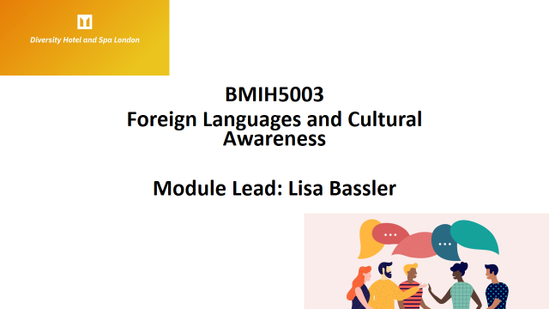
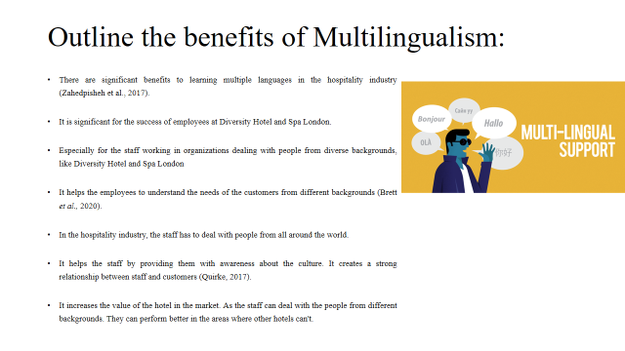
Being able to communicate in more than one language helps individuals overcome barriers of language and culture. Being fluent in more than one language opens doors to new experiences and strengthens bonds in today's increasingly interconnected world. People who are fluent in more than one language have more opportunities to meet new people and broaden their social horizons. As a result of these linkages, we are all able to live in a more accepting and peaceful world where different viewpoints are valued and respected. The ability to speak more than one language fluently opens up a world of financial and career possibilities. Companies in today's increasingly globalised economy place a premium on workers who are fluent in many languages and can adapt to different cultural contexts. Markets, diplomatic circles, and companies that rely on cross-border cooperation tend to seek out persons who are fluent in more than one language. Improving professional connections and securing promotion opportunities may be as simple as learning the language of customers, partners, and coworkers.
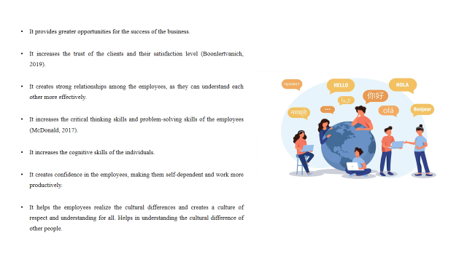
Being able to speak more than one language opens doors to learning about and valuing other cultures. Speaking more than one language allows one to better understand the culture, history, and worldview of the people who speak it. Tolerance, respect, and a better grasp of the subtleties that form cultures are fostered by this cultural enrichment. Being able to communicate in more than one language helps people understand and appreciate one another's cultures. There are several benefits to being bilingual in an educational setting. People who are able to speak more than one language tend to do better in school, have more creative problem-solving abilities, and have better critical thinking skills overall. Learning a second language at a young age has a multiplicative effect on a child's brain development and scholastic performance.
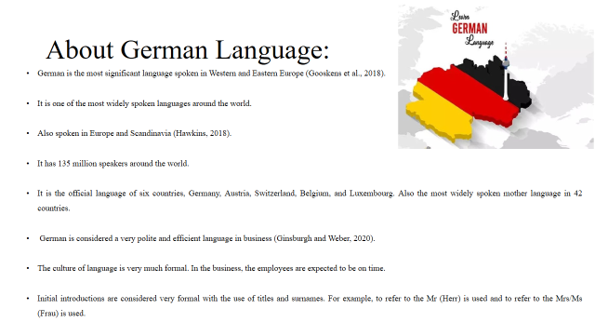
More than 90 million people throughout the globe speak German, a West Germanic language. German is culturally and economically significant since it is the official language of two nations (Austria and Germany) and because it is also a minority language in other countries. Many professionals and academics see German as an important language due to its complex terminology and well-developed grammar. Famed philosophers and scientists like Nietzsche and Goethe added to its language heritage, which has an impact on literature, philosophy, and science. In the very centre of Europe, learning German provides doors to academic opportunities, cultural discovery, and collaboration.
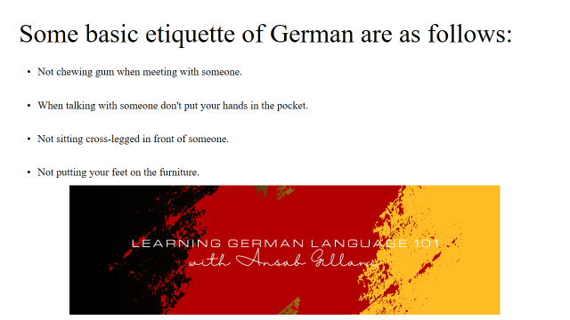
Germans are known for their usage of formal titles and surnames in business and other formal contexts. It is customary to prefix someone's last name with "Herr" (Mr.) or "Frau" (Mrs.) upon first meeting. Ask permission before using the casual "Du" pronoun. A handshake is the most common way to welcome someone. Be careful to make direct eye contact and shake hands firmly. This demonstrates a high level of regard and trust. Being on time is highly esteemed in Germany. Punctuality is key when it comes to social events, appointments, and meetings. Being tardy might be seen as rude. Germans respect each other's personal space and keep their distance while speaking. Always leave plenty of room between yourself and the person you are interacting with, whether in a social or business context.
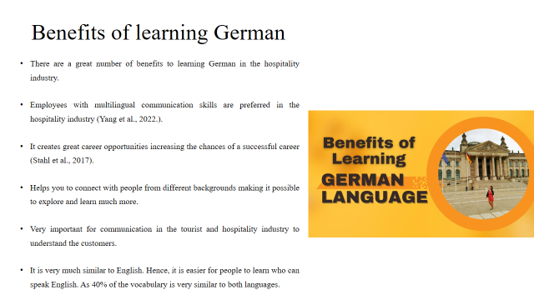
If people speak German well, they will have a lot of job options since Germany is the biggest economy in Europe. Candidates with proficiency in German are often sought after for positions in business, engineering, science, and technology by multinational corporations with operations in German-speaking countries. Germany's world-class institutions provide degrees in a broad variety of fields, making the country an educational powerhouse. If you want to study or do research in Germany or another German-speaking country, learning German is a great first step.
References (no screenshots):
Boonlertvanich, K., 2019. Service quality, satisfaction, trust, and loyalty: the moderating role of main-bank and wealth status. International Journal of Bank Marketing, 37(1), pp.278-302.
Brett, J., Behfar, K. and Kern, M., 2020. Managing multicultural teams. In Organizational Collaboration (pp. 155-164). Routledge.
Ginsburgh, V. and Weber, S., 2020. The economics of language. Journal of Economic Literature, 58(2), pp.348-404.
Gooskens, C., van Heuven, V.J., Golubović, J., Schüppert, A., Swarte, F. and Voigt, S., 2018. Mutual intelligibility between closely related languages in Europe. International Journal of Multilingualism, 15(2), pp.169-193.
Hawkins, J.A., 2018. Germanic languages. In The world's major languages (pp. 51-59). Routledge.
McDonald, S.D., 2017. Enhanced critical thinking skills through problem-solving games in secondary schools. Interdisciplinary Journal of e-Skills and Lifelong Learning, 13, pp.79-96.
Quirke, B., 2017. Making the connections: Using internal communication to turn strategy into action. Routledge.
Stahl, G.K., Miller, E.L. and Tung, R.L., 2017. Toward the boundaryless career: A closer look at the expatriate career concept and the perceived implications of an international assignment. In International Human Resource Management (pp. 485-496). Routledge.
Yang, H., Cheung, C. and Li, W., 2022. Intercultural communication competency practices in the hotel industry. Journal of China Tourism Research, 18(1), pp.162-184.
Zahedpisheh, N., Abu Bakar, Z.B. and Saffari, N., 2017. English for Tourism and Hospitality Purposes (ETP). English Language Teaching, 10(9), pp.86-94.
Component 3:

LIVE PRESENTATION (no links need to be submitted here)
Component 4: Student Self-Reflection (500 words +/- 10%)

Weighting: 25%
Gibbs Reflective Model
As I was getting ready to give my presentation, I used the Gibbs Reflective Cycle to reflect on my own growth and the lessons I had learned. Description, emotion, assessment, analysis, conclusion, and plan of action are the phases that make up the cycle.
- Description
At the start of my study and planning for this talk, I thought I had a good grasp of the subject, so everything seemed to be going well. As I learned more about each setup, it became clear to me that putting all of these different and complicated ideas, points of view, and facts together would be harder and harder. Next, I need to put my thoughts in order so they make sense and the viewer knows what to think about next. This phase involves getting into the specifics of the territory, telling the difference between different points of view on the subject, and trying to cram a lot of information into a short amount of time (Schön, 2017).
- Feeling
Even though I slowly became aware of these new facts, my first feelings were anger and unhappiness. People in China say that it seems like every problem you solve brings up a new one. My original fear of failing quickly went away. As a team, we solved more and more problems, and I became more and more sure that what we were doing was important. Managing complicated ideas and understanding how well they fit together led to deep findings in an interesting learning process that had some setbacks but eventually paid off. This wavy flow of information, like a wave between the novel's high and low points, led to either vague or clear conclusions.
- Evaluation
I looked very closely at my methods and results because the review step asked me to. What started out as an easy task turned into an exciting trip. Making sense of what I knew helped me understand it better and showed me how important it is to handle things carefully (Donati, 2016). I am getting a better sense of how complicated and multilayered the topic is thanks in large part to this stage.More talk about how thoughts are put together led to new discoveries through direct connections. What interested me about this subject was a deeper understanding and thought about it.
- Analysis
When I thought about everything that happened last month, I could see both my strengths and weaknesses. It is required to break up work into smaller, easier-to-handle pieces, but managing time is just as important. During the iterative process of this project, I learned how important feedback loops are for helping me improve myself quickly and systematically. In later classes, we looked at the form and methods of research, as well as how learning happens in cycles, in more depth.
- Conclusion
After giving it some thought, I realised that this event had caused a big change in how I understood things. It is important to keep going because what happened taught us that future projects like this need to be carefully planned and based on science. I can not make a plan that will work for you until you know what you're good at and what you need to work on. Some things I can do are take lessons to get better at speaking and writing English, encourage my coworkers to look for helpful comments so they can get better, and read out loud while paying close attention. Also, this can only be done by looking at a problem from different angles and carefully thinking about all of the choices before making a decision. If I do this, I will find many more ways to make yourself better.It's always possible to get better at organising and giving presentations through education, even if the trip never ends.
References:
Donati, M., 2016. Becoming a reflective practitioner. The handbook of counselling psychology, 4.
Henderson, P., Islam, R., Bachman, P., Pineau, J., Precup, D. and Meger, D., 2018, April. Deep reinforcement learning that matters. In Proceedings of the AAAI conference on artificial intelligence (Vol. 32, No. 1).
Schön, D.A., 2017. The reflective practitioner: How professionals think in action. Routledge.

