

Management &OrganisationalBehaviour
Module code: BMIH5004
Student name and id: Iulia Maria Luca 2239007

Executive summary
Hilton Hotels and Resorts operates more than 7,000 properties in 123 countries and maintains a strong global presence through franchised, managed, and company-owned hotels. Success is attributed to Hilton's customer-oriented culture, strategic leadership, and innovation in digital transformation, sustainability, and employee engagement. Stand-out projects are the Digital Key system, the Travel with Purpose sustainability program, and Hilton Thrive to support employees' welfare issues. The long-term strategies of Hilton focus on global expansion, technological improvement, and providing wonderful experiences for guests. In order to retain leadership, Hilton must focus on enhancing the personalization of its Services using AI, increasing its trailblazing efforts in sustainability, boosting its loyalty programs, and investing in the development of its people as a driver of growth.

Table of Contents
Introduction 3
Discussion 4
Organisation Structure, Culture, and Goals 4
Recent Change Initiatives 5
Strategic Direction 7
Recommendation 10
Conclusion 11
References 12

Introduction
Hilton Hotels & Resorts runs more than 7,000 properties throughout 123 different nations and it has become a worldwide leader in the hospitality industry. Hilton succeeds through its combination of hotels that it owns and manages as well as franchised properties because of its focus on luxury and service management and innovation (Hilton, 2024). The hospitality market success of Hilton depends on its dedication to satisfied customers and developed employees along with sustainable business practice execution. The objective of this analysis focuses on assessing the essential role of Hilton’s organisational structure, culture, personnel and performance dynamics in determining business achievement. The discussion includes evaluation of leadership and management functions as well as the variables which impact their effectiveness. The report finishes with an assessment of personal conduct at work through study of staff motivation and operational effectiveness elements.
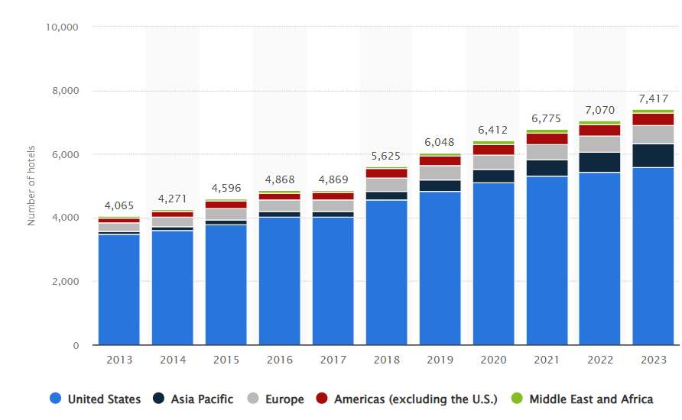
Figure 1: Hilton Hotels in worldwide
(Source: Statista, 2024)

Discussion

OrganisationStructure, Culture, and Goals
Organisational Structure
Hilton Hotels & Resorts works with a divisional structure that allows its properties to exist as franchises or managed hotels or company-owned facilities. Regional managers within this structure enjoy access to decentralised decision-making capabilities that let them adjust to market conditions locally while keeping Hilton Hotels & Resorts standards intact (Hinson et al., 224). Strategic oversight and financial management and brand standard compliance enable the corporate headquarters to ensure Hilton achieves its global vision while hotels maintain their operations. The executive structure of the business produces efficient outcomes yet enables distinct service methods through local leadership.
Corporate Culture and Its Influence on Operations
The corporate values hospitality, integrity, leadership, teamwork, ownership along with now form the foundation of Hilton's organisational culture (Rockett, 2024). Such principles become operational through staff training as well as staff engagement programs combined with performance-based incentive systems. The company maintains both customer-focused procedures and team-oriented policies that improve employee satisfaction and quality of service delivery. Applied culture at Hilton shapes operational standards and generates uniform guest satisfaction at all properties under its management. The employee well-being initiative Hilton Thrive leads to better business results and outstanding service quality.

Corporate and Individual Unit Goals
The corporate strategy for Hilton includes creating wider global presence and strengthening brand loyalty with simultaneous implementation of environmentally-friendly business practices (Fathy et al., 2025). Hilton prioritises three essential objectives that involve digital advancement alongside market penetration together with sustainable environmental practices. Hotels operating at the individual unit maintain three primary objectives which include improving guest satisfaction as well as operational efficiency while adapting to local markets. These business objectives maintain harmony with company priorities but let each location adjust their services to serve unique customer groups along with local interests. The alignment of priorities from both corporate headquarters and hotel units provides Hilton with continuous expansion and financial success and industry dominance (Prentice et al., 224).

Recent Change Initiatives
The competitive position and operational effectiveness of Hilton Hotels & Resorts rests on multiple strategic changes that the company implements. Hilton Hotels & Resorts has launched several important change initiatives since recent times.

- The Digital Key through Hilton Honors App enabled Hilton guests to conduct contactless checks by using their phones for access and hotel facility use (Sanli, 2024).
- Hilton established its Travel with Purpose initiative to advance sustainability through two key aims: environmental impact reduction alongside carbon emission decrease and hospitality practices standardisation toward sustainability.
- The Hilton thrive program in oder to established by the company serves as the initiative to prioritise employee menctal wellness by flexible work options and career progression alongside a diversity focus (Hughes and Christensen, 2021).
- During the pandemic Hilton launched the CleanStay program which implements enhanced safety protocols among all their properties.
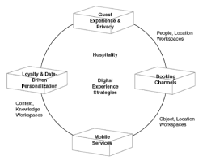
Figure 2: Effectiveness of Hilton Hotels
(Source: Hughes and Christensen, 2021).

Impact of These Initiatives on the Organisation
The significant results of these initiatives affected Hilton’s operational efficiency together with client experience and brand reputation.

- Customer experience has also improved through Digital transformation initiatives that are include the Digital Key system which brings to enhanced convenience to customers and boosts satisfaction and loyalty toward Hilton brands (Bardukova, 2023). Research alignment occurs with the Technology Acceptance Model since it demonstrates that system usability and perceived usefulness both influence technology adoption behavior.
- Travel with Purpose has enabled Hilton to decrease its carbon emissions and achieve better ESG results. The company follows Stakeholder Theory principles by taking into account customer needs and employee demands as well as environmental stakeholder requirements.
- Through the Hilton Thrive initiative employees now feel more engaged because their morale has risen and turnover numbers have declined and productivity levels have grown. According to Maslow’s Hierarchy of Needs satisfied psychological demands and self-actualisation needs within employees result in performance enhancement (Rojas et al., 2023).
- Through its CleanStay program Hilton restored customer faith which sustained business activities throughout the pandemic. Hilton achieved Model-level implementation by successfully thawing previous hygiene procedures before introducing new protocols thus completing the cycle of Lewin’s Change Management Model.

Evaluation of Change Management Strategies
The implementation of change at Hilton follows the 8-step model proposed by Kotter.

- Hilton responded to changing market demands by establishing urgency because customers started embracing digital solutions and sustainability practices.
- Leadership established a powerful collaboration through their partnership with AI-driven technology specialists from Google along with environmental specialists who worked together for change initiatives (Laig and Abocejo, 2021).
- Hilton established transparent objectives to minimise environmental impact by 50% through the year 2030.
- Hilton used employee training sessions to get with stakeholder reports and customer engagement activities in order to regularly communicate about the initiatives (Wang et al., 2024).
- Employing the strategy of obstacle removal Hilton provided educational programs together with financial rewards that made employees adopt new technologies without difficulties.
- The company progressed its sustainable practices by establishing new digital features for growing portions of its properties.
- Hilton solidified its corporate strategy by making sustainability and digital innovation essential components that would last through time (Santos and Lima, 2024).
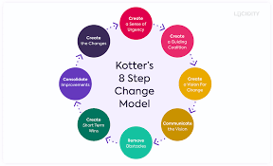
Figure 3: Kotters 8 step model
(Source: Laig and Abocejo, 2021).

Strategic Direction

Strategic direction of the organisation
Through an organised strategic framework Hilton Hotels & Resorts has gained world leadership in the hospitality market. The company exists to expand its business while ensuring sustainability along with digital advancements and superior customer service.

1. Global Expansion
Hilton maintains worldwide expansion by facilitating franchising operations and conducting strategic partnerships and acquisitions. Hilton desires to expand its business operations throughout developing markets across India China and the Middle East. The establishment of 99,000 new hotel units across the world led Hilton to reach its highest unit expansion milestone in 2024 (Hilton, 2024). This forceful market expansion strategy enhances both the recognition of Hilton's brand as well as its business control in the industry.

2. Sustainability and ESG Commitment
Travel with Purpose serves Hilton's sustainability initiative a features three goals for year 2030 that also support carbon emission reduction and water management alongside in waste control. Hilton dedicates its resources toward sustainable power systems and green hotel blueprint development to demonstrate environmental dedication (Aslantamer andIlgın., 2024).

3. Digital Transformation
Hilton uses modern technology systems in order to improve guest satisfaction along with operational performance.
Key innovations include:

- The Digital Key Technology provides guests with mobile check-in possibilities.
- AI-driven personalisation, offering tailored experiences.
- Smart hotel automation, improving efficiency.
- The company makes itself stand out through technical innovation in its mission to serve the modern hospitality industry (Ratna et al., 2024).

4. Customer-Centric Strategies
Guest loyalty increases at Hilton because the Hilton Honors program delivers customised rewards to its users. The Curio Collection of Hilton Hotels features hospitality options which draw their inspiration from local communities.
Analyse the strategies implemented to achieve their long-term objectives
Hilton Hotels & Resorts uses specific business strategies which serve to advance global growth as well as environmental sustainability and digital innovation and customer relationship development (Rawashdeh et al., 2024). These competitive measures work toward improving Hilton's dominant market position as well as leading to sustained profitability.

1. Expansion Through Franchising and Partnerships
The company concentrates on managing franchises together with contracts to manage properties as its primary growth method which enables quick market penetration without large capital outlays. Hilton's expansion plan has enabled the company to spread across hot global regions such as India and China as well as the Middle East through franchised hotel development (Hudson, 2025). The hotel chain pursues a partnership with Embassy Group in India to build 150 Spark brand hotels that enhance its South Asian market reach.

2. Sustainability and ESG Initiatives
The "Travel with Purpose" program of Hilton operates under global environmental goals that include:

- Managed hotels operated by Hilton must decrease their carbon emissions to 75% below current levels before 2030 (Menegaki,, 2024).
- The hotel should utilise energy-efficient detection technologies which include LED lighting systems along with smart thermostatic control devices.
- The company utilises renewable energy resources for two main reasons: it both reduces operational expenses and enhances sustainability attributes.

3. Digital Transformation and Innovation
Hilton uses technology in order to optimise guest satisfaction together with operational effectiveness through:

- The hotel employs AI to process data analytics for creating customised recommendations for their guests.
- The implementation of Digital Key technology provides both mobile check-in and room entry capabilities to hotel guests (Çeltek, 2024).
- Hotel system automation helps businesses lower expenses while creating more efficient services.
- The technological advancements establish Hilton as a frontier-leading hospitality organisation focused on software development.

4. Customer Loyalty and Differentiation
Through Hilton Honors loyalty program the company also develops better long-term relationships with a guests by providing custom rewards and memorable experiences (Gonçalves, 2024). Through its Curio Collection the brand operates unique stays with locally inspired themes that distinguish its brand from competitors.

Recommendation
1. Strengthening Digital Transformation
The company should extend its AI and automation initiatives to deliver superior guest satisfaction combined with better operational excellence. The deployment of AI concierge services in to conjunction with predictive analytics as well as smart room automation enables personalised experiences and operational optimisation (Yadav and Raju, 2025). The IT and digital transformation teams at Hilton should implement these initiatives starting in 12-18 months with special attention towards flagship locations across North America, Europe and Asia since this approach will boost customer satisfaction and brand differentiation.

2. Expanding Sustainable Initiatives
Hilton must enhance its carbon reduction and eco-friendly practices so it becomes in accordance with international ESG targets. The company plans to develop sustainable practices by using renewable power resources while removing disposable plastics and running waste minimisation plans. Sustainability and operations teams should distribute these operational changes to all Hilton properties with initial emphasis on urban properties having high energy consumption during the upcoming 2-3 years.

3. Enhancing Customer Loyalty Programs
The Hilton Honors program should receive improvements through implementing customised reward options with digital benefits and artificial intelligence systems for guest identification (Juthiet al., 2025). The marketing and customer engagement teams need to deploy their changes over a 6-12 month period to maintain current clients and appeal to new consumer groups.

4. Workforce Development and Employee Well-being
Building employee training for wellness initiatives remains fundamental to achieving lasting company success. Hilton needs to deploy AI-training tools together with leadership development systems and mental health welfare programs to improve their service quality standards (Hughes. and Christensen, 2021). The HR together with training departments need to enforce this strategy across Hilton properties in the time span of 6 to 12 months.

Conclusion
This document conducts a comprehensive investigation of Hilton Hotels & Resorts' structural design along with their corporate values and strategic initiatives and managerial systems. Through its strong brand legacy are commitment to customer needs as well as continual innovation Hilton maintains its own leadership position as global hospitality leader. Hilton needs to continue evolving its business approach to sustain future market leadership and continued business success. The assessment emphasised four key areas that would help Hilton expand its market position: digital transformation, sustainability initiatives, workforce enhancement and loyalty programs. Through their implemented recommendations Hilton will achieve operational excellence as well as improved customer service and workforce satisfaction which will drive business expansion and preserve their industry leadership.

References
Aslantamer, Ö.N. and Ilgın, H.E., 2024. Space Efficiency in Tall Hotel Towers. Buildings, 14(7), p.2051.
Bardukova, L., 2023. Navigating the Hospitality Horizon: Current Trends and Strategies for Customer Attraction and Retention in the Hotel Industry. Economics and computer science, 2, pp.88-103.
Çeltek, E., 2024. Unmanned smart hotel: applications and examples. Worldwide Hospitality and Tourism Themes, 16(5), pp.611-626.
Fathy, E.A., Fouad, A.M. and Kahly, A.M., 2025. Navigating The Path to Sustainability and Overcoming Environmental Barriers in the Egyptian Hotel Industry. In Sustainable Waste Management in the Tourism and Hospitality Sectors (pp. 245-272). IGI Global Scientific Publishing.
Gonçalves, M.N., 2024. Developing Loyalty Programs in the Hospitality Industry: The Determinants of Customer Loyalty and the Key to Optimizing the Guest Experience of Hospitality Loyalty Program Members (Master's thesis, Universidade NOVA de Lisboa (Portugal)).
Hilton, 2024, about company Avaiable at:https://www.hilton.com/en/locations/united-kingdom/ [Accessed on 20.02.2025]
Hilton, 2024, global-footprint-expanded-2024Available at:https://stories.hilton.com/growth-development/global-footprint-expanded-2024[Accessed on 20.02.2025]
Hinson, R.E., Mensah, I., Amoako, G.K., Mensah, E.A., Coffie, I. and Khosa, E., 2024. Hospitality and Tourism Marketing: Building Customer Driven Hospitality and Tourism Organisations. CRC Press.
Hudson, S., 2025. Hospitality Management: International Introduction. Taylor & Francis.
Hughes, J.C. and Christensen, J.D., 2021. Talent management innovation in a time of unprecedented disruption: implications for practice and research. In Talent Management Innovations in the International Hospitality Industry (pp. 153-179). Emerald Publishing Limited.
Juthi, J., Islam, Q.T., Zabir, F. and Akif, A., 2025. Navigating a Sustainable Voyage: Hilton’s Strategic Blueprint in Global Tourism and Achieving Sustainable Development Goals.
Laig, R.B.D. and Abocejo, F.T., 2021. Change management process in a mining company: Kotter’s 8-step change model. Journal of Management, Economics, and Industrial Organisation, 5(3), pp.31-50.
Menegaki, A., 2024. Energy Consumption in Hotels Through a Policy-Driven, Case-Based and Scenario Approach. Case-Based and Scenario Approach (November 27, 2024).
Prentice, C., Tracogna, A. and Akbar, Y.H., 2024. The Paths to an Enhanced Ecosystem for International Hotel Chains. Journal of the Knowledge Economy, pp.1-25.
Ratna, S., Saide, S., Putri, A.M., Indrajit, R.E. and Muwardi, D., 2024. Digital transformation in tourism and hospitality industry: a literature review of blockchain, financial technology, and knowledge management. EuroMed Journal of Business, 19(1), pp.84-112.
Rawashdeh, A., Abdallah, A.B., Alfawaeer, M., Al Dweiri, M. and Al-Jaghbeer, F., 2024. The impact of strategic agility on environmental sustainability: the mediating role of digital transformation. Sustainability, 16(3), p.1338.
Rockett, G., 2024. Hilton's approach to diversity, equity and inclusion management. In The Routledge Handbook of Diversity, Equity, and Inclusion Management in the Hospitality Industry (pp. 321-331). Routledge.
Rojas, M., Méndez, A. and Watkins-Fassler, K., 2023. The hierarchy of needs empirical examination of Maslow’s theory and lessons for development. World Development, 165, p.106185.
Sanli, M., 2024. Digital Transformations in the Hotel Industry (Doctoral dissertation, Long Island University, CW Post Center).
Santos, F. and Lima, S., 2024. Hilton´ s Path to Post-Pandemic Prosperity (Master's thesis, Universidade NOVA de Lisboa (Portugal)).
Statista, 2024,hilton-worldwide-hotels-by-geographical-Avaiable at: regionhttps://www.statista.com/statistics/297754/number-of-hilton-worldwide-hotels-by-geographical-region/ [Accessed on 20.02.2025]
Wang, D., Yang, M. and Deng, Z., 2024. Pathway to Environment Management in Hotel Industry: A Stakeholder Engagement Framework. Journal of China Tourism Research, pp.1-21.
Yadav, N. and Raju, S.S., 2025. Smart Hotel Technologies Redefining Guest Convenience and Operational Efficiency. In Marketing Technology-Infused Hospitality: Upskilling Frontline Employees for Competitiveness (pp. 25-56). IGI Global Scientific Publishing.

