Assessment 2: Individual Report

Student name: Victor Toni Tirpan
Table of content
1.0 Introduction 3
2.0 Literature Review 3
2.1 Blended learning environment in Moodle 3
2.2 Gamified Virtual Learning Environment 4
2.3 Lifelong opportunities and Flexible learning 4
3.0 Aim and Objectives 5
Aim 5
Objectives 5
Gantt chart 5
4.0 Method 6
5.0 RESULTS 6
6.0 DISCUSSION 11
6.1 Virtual learning environment makes learning easy and gives lifelong opportunity 11
6.2 Virtual learning environment helps disable students equally 11
7.0 CONCLUSION 12
8.0 References 13

1.0 Introduction
The purpose of this report is to provide a detailed discussion on the importance of Virtual Learning Environment in the Universities. In school, colleges and universities also technology plays an important role and helps students to make their education more effective and interesting. During the Covid 19 pandemic it helps students to continue their education from their home so they might not be completely detached from their institutions. Virtual Learning Environment or Moodle has been adopted in many universities and University of Wales Trinity Saint David London Campus is one of them (Uwtsdlondon, 2022). This study will help in understanding the positive and negative influence of Moodle on the students at University of Wales Trinity Saint David London Campus. It will be done through a research methodology that involves both the Primary as well as Secondary research technique. This study sheds light on the impact of Virtual Learning Environment or Moodle on the education of the students in the UK.

2.0 Literature Review

2.1 Blended learning environment in Moodle
In the opinion of Lyndon and Hale (2014) the Universities of the UK has adopted the blended learning technique where the universities continue their education system in both regular form and VLE form. There are many benefits that have been displayed in this article and one of the benefits can be seen during the Covid 19 pandemic. As in the critical situation of covid 19 students were unable to attend their universities and continue their courses VLE provides them an opportunity to keep their study continue. It has been observed that even after Covid 19 there is a huge demand for learning in Moodle within females. The demand is observed more in females than male. Females can continue their study even after their marriage and children through Moodle and it will provide them a chance to grow their knowledge.
Similarly, it is an opportunity for those students who face difficulties with the complex concepts of their subjects. Efiloğlu Kurt and Tingöy, (2017) suggests that mathematics is a complex and abstract subject as a result of which students are afraid of it and most of the students cannot understand the math clearly, but VLE makes it easy to understand the concept through a proper visual explanation. It has been observed that students' interest is increasing slowly on their complex subject as they gain interest in it through enjoying their study. Thus it helps students in enhancing their critical thinking skills and writing skills also.

2.2 Gamified Virtual Learning Environment
In the opinion of Tsay et al., (2020) Students who engage with computer-based gamified learning systems in higher education contexts often experience a novelty effect: a pattern of high activity during the introduction of the gamified system and a decline in activity after a few weeks, once its novelty wears off. It has been observed that gamification in education enables students to involve themselves more in their study than before. Sometimes studying is very boring and the least interesting thing as a result of which students lose their interest from their education and it has a negative impact on their study. Virtual Learning Environments enables students to enjoy their study through gamification. Starting from kids to adults everyone likes games more or less and Virtual Learning Environment takes this opportunity. Students learn their subjects in a manner of game that does not make them feel bored or frustrated. They can easily understand their subjects, their interest level grows at a huge rate, and they hardly feel tired of it.
Virtual Learning Environment includes games which make learning fun and encourage students to involve themselves more in their study. In this process some gaming elements are put into VLE learning. According to Shaban and Pearson, (2019) Disbale children can also learn from it as they need a better and different process of education. It not only makes it fun and encouraging for the students and disable children, but they are also able to memorize their subjects quickly. At present there are so many educational applications that are available in the market for the fun education of children and adults. Even parents also prefer gamification learning as they find it effective for their child. Children can even choose this learning as their playing objects and while they are playing, they have already learned many things included in their educational subjects.

2.3 Lifelong opportunities and Flexible learning
According to Blin and Munro (2008), VLE provides a lifelong opportunity to the students for their career also. For example, it can be said that VLE helps in enhancing digital skills of students. Students can understand the use of technology and about various aspects of technology that helps them to enhance their digital skills. As the world is proceeding towards digitalization it is necessary that students must be aware of the usage of technology in every field. According to Ornellas et al., (2018) the e-learning process helps strategy in enhancing their Employability skills to a huge extent. These skills will help them further in their professional career at this age of digitalization. Flexible learning encourages every type of male and female to continue their study without any worry. Those who are engaged in any job can also think for their further education or any short course as they get a flexible learning opportunity, and they even need not to worry about their notes if they miss any of their classes as their teachers provide notes in PDF and other formats in Moodle.

3.0 Aim and Objectives

Aim
Aim of this research study is to highlight the impact of Virtual Learning Environment or VLE in the education of the students in the University of Wales Trinity Saint David London Campus.

Objectives
- To collect primary data in order to understand the impact of Virtual Learning Environment on students at Universities.
- To design a questionnaire that will help in collecting the primary data related to the impact of virtual Learning Environment on students at University of Wales Trinity Saint David London Campus.
- To send the questionnaire to the students at University of Wales Trinity Saint David London Campus by arranging a survey.

Gantt chart
Tasks | Wk1 | Wk2 | Wk3 | W4 | W5 | W6 | W7 | W8 | W9
Design Questionnaire
Send Questionnaire
Collect Primary Data
Data Analysis
Findings
Literature Review

4.0 Method
In the entire research study various information has been collected using the research methodology. There are mainly two types of research methods and techniques observed: Primary Research and Secondary Research. These two research methods have been adopted in this research. The reason for taking Primary Research is that it helps in getting firsthand and reliable information related to the topic (Pandey and Pandey, 2021). In this research study some of the students at the University of Wales Trinity Saint David London Campus are chosen for a survey. The aim of this research is to identify the impact of Moodle learning on the students at this university, so the participants are chosen among the students at this university for this survey. They can better explain their experience and knowledge on the VLE classes. In the survey some questions regarding the VLE or Moodle classes have been prepared by the researchers that involve as many important questions as possible (Allan, 2020). Students share their own experience and view, so researchers get fresh information, and this information are trustworthy also. Though Primary Research helps in getting qualitative data but because of the timing issue all the questions cannot be solved and for this reason Secondary Research method has also been adopted here. In secondary research various websites and articles have been used for remaining information and it helps in getting additional information that make the topic far clearer.

5.0 RESULTS
a. For how long have you been studying in this University?

Options | Percentage | Received response | Total number of respondents
3 years | 41.66666667 | 50 | 120
5years | 33.33333333 | 40 | 120
1 years | 4.166666667 | 5 | 120
2 years | 12.5 | 15 | 120
4 years | 8.333333333 | 10 | 120
Table 1: Response 1

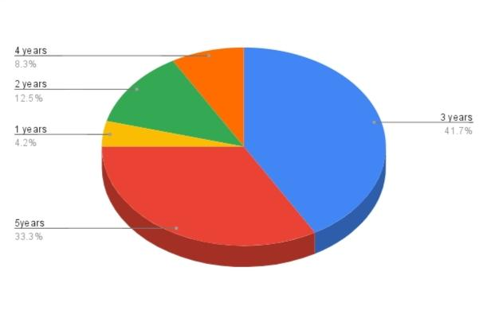
Figure 1: Response 1

From the survey it has been observed that most of the participants are studying there for 5 years.
b. Do you feel excited to join your class in Moodle?

Options | Percentage | Received response | Total number of respondents
strongly agree | 50 | 60 | 120
agree | 33.33333333 | 40 | 120
neutral | 4.166666667 | 5 | 120
disagree | 4.166666667 | 5 | 120
strongly disagree | 8.333333333 | 10 | 120
Table 2: Response 2

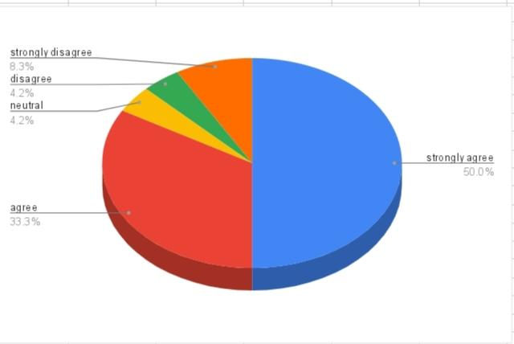
Figure 2: Response 2

There 33.3% of the students of the university among the participants strongly agree on the fact that they feel excited for their online classes while 8.3% strongly disagree on the question.
c. Do you agree Moodle is equally helpful for disabled students also?

Options | Percentage | Received response | Total number of respondents
strongly agree | 16.66666667 | 20 | 120
agree | 41.66666667 | 50 | 120
neutral | 4.166666667 | 5 | 120
disagree | 12.5 | 15 | 120
strongly disagree | 25 | 30 | 120
Table 3: Response 3

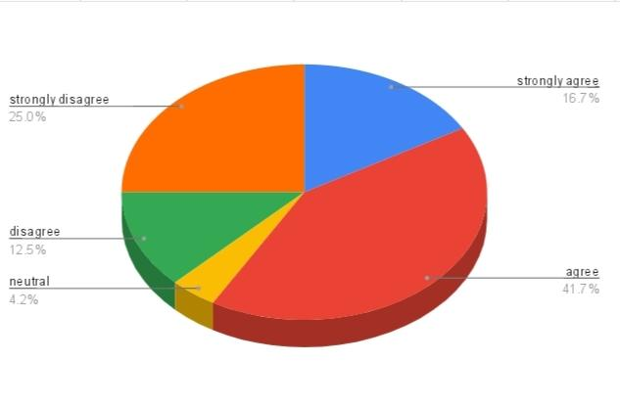
Figure 3: Response 3

Almost 41.6% of the participants agreed that Moodle is equally helpful for both normal and disabled students while 25% strongly disagreed on this fact.
d. Do you think Moodle helps in making complex concepts of math easier for students?

Options | Percentage | Received response | Total number of respondents
strongly agree | 41.66666667 | 50 | 120
agree | 33.33333333 | 40 | 120
neutral | 8.333333333 | 10 | 120
disagree | 8.333333333 | 10 | 120
strongly disagree | 8.333333333 | 10 | 120

Table 4: Response 4

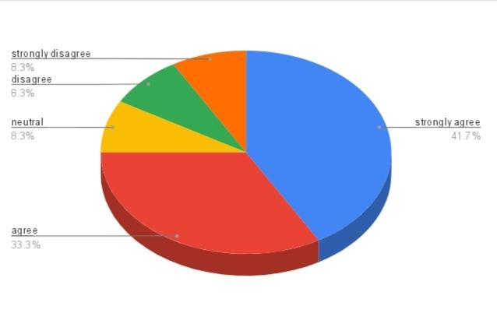
Figure 4 : Response 4

On its importance for making complex concepts of mathematics easier almost 41.6% students strongly agreed on it and 33.3% agreed on it.
e. Does Virtual Learning Environment provide a great opportunity to improve the efficiency and employability within a student?

Options | Percentage | Received response | Total number of respondents
strongly agree | 16.66666667 | 20 | 120
agree | 25 | 30 | 120
neutral | 12.5 | 15 | 120
disagree | 20.83333333 | 25 | 120
strongly disagree | 16.66666667 | 20 | 120
Table 5: Response 5

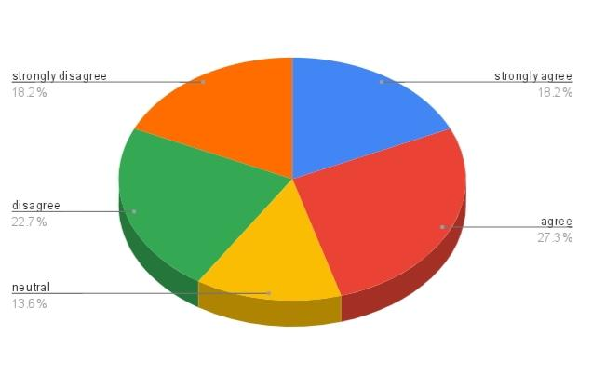
Figure 5: Response 5

An interesting result observed here as an equal number of students (16.6%) agreed and disagreed on this matter.
f. Do you find VLE an easy process for note taking?

Options | Percentage | Received response | Total number of respondents
strongly agree | 33.33333333 | 40 | 120
agree | 29.16666667 | 35 | 120
neutral | 8.333333333 | 10 | 120
disagree | 25 | 30 | 120
strongly disagree | 4.166666667 | 5 | 120
Table 6 : Response 6

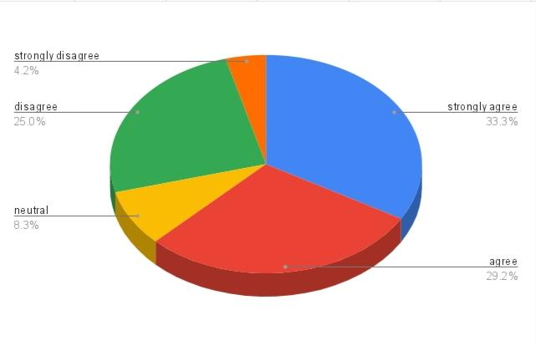
Figure 6 : Response 6

Maximum number of participants (33.3%) strongly agreed that VLE is an easy process of note taking.
g. Do you agree that gamification in learning is a great opportunity for students?

Options | Percentage | Received response | Total number of respondents
strongly agree | 33.33333333 | 40 | 120
agree | 33.33333333 | 40 | 120
neutral | 12.5 | 15 | 120
disagree | 12.5 | 15 | 120
strongly disagree | 8.333333333 | 10 | 120

Table 7: Response 7

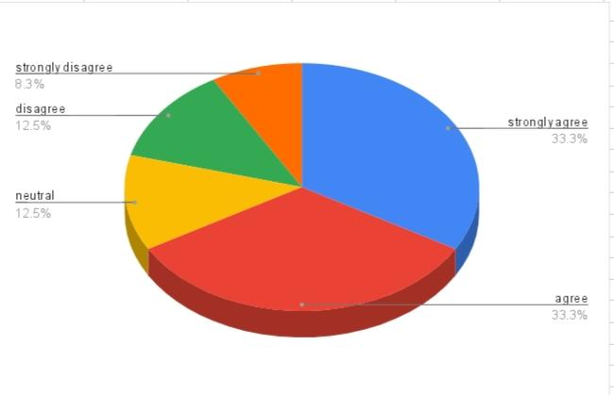
Figure 7: Response 7

From the survey it has been realized that the maximum number of students prefer for gamification learning which is almost 33.3% of all periods 12.5% disagree on it and an equal number of students are neutral.
h. Do you think blended learning in universities will provide lifelong opportunity and flexible learning to students?

Options | Percentage | Received response | Total number of respondents
strongly agree | 25 | 30 | 120
agree | 29.16666667 | 35 | 120
neutral | 20.83333333 | 25 | 120
disagree | 16.66666667 | 20 | 120
strongly disagree | 8.333333333 | 10 | 120
Table 8: Response 8

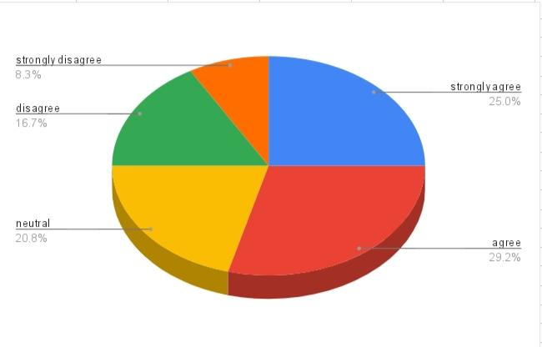
Figure 8: Response 1

In the survey 25% students strongly agreed that blended learning provides lifelong opportunity while 20% of total participants show neutral opinion of it.

6.0 DISCUSSION

6.1 Virtual learning environment makes learning easy and gives lifelong opportunity
It has been observed that VLE or Moodle helps students in various disciplines and one of the ways is by explaining the complex concepts in an easier way. In the opinion of Dhakal, (2022) a complex subject like mathematics can also become helpful when students understand the actual concept and find it interesting. Most of the cases subjects with complex ideas and concepts make students bored and lose interest but when they learn the same concept through VLE they get a virtual picture of everything, and it helps them to understand each and every detail. Even because of this virtual learning, students enjoy their study, and they can remember it for a long period of time. With the help of Virtual learning environment video-based classes are done, Conceptual videos and pictures help in making the complex math easier.

6.2 Virtual learning environment helps disable students equally
As it is a digital era, and the entire world is in the run of transforming itself into a digital platform along with all other organizations educational institutions are also adopting technology at a huge rate. From this research it has been observed that VLE is not only helpful for the university students, but it is equally helpful for disabled students also (Ouherrou et al., 2019). It provides an opportunity to those students and their parents to educate their children in a flexible way. Sometimes parents do not feel safe and comfortable to send their disabled children to a school for many reasons and some disable students are also there who cannot cope with the situation or environment of traditional schools. Though there are many reasons not to send students in a brick-and-mortar school and university but education is necessary and in this situation VLE plays significant role in the education of disable child. It shows how it helps in mitigating the gaps that create issues and challenges in the learning of all types of students

7.0 CONCLUSION
From the above discussion it has been realized that different students have different opinions. As students are habituated to the traditional offline classes, they sometimes face problems in online classes. Still as the adoption of online classes are increasing day by day in universities and it provides lots of benefits and lots of positive impact on the students' education, they slowly become habituated to the Virtual Learning Environment also. Students at the University of Wales get various benefits from Moodle and their teachers are quite helpful to make them feel comfortable and engaged in their classes. They are served with all the important notes in Pdf format, virtual charts and also get help from their teachers in need.

8.0 References
Allan, G., 2020. Qualitative research. In Handbook for research students in the social sciences (pp. 177-189). Routledge.
Blin, F. and Munro, M., 2008. Why hasn’t technology disrupted academics’ teaching practices? Understanding resistance to change through the lens of activity theory. Computers & Education, 50(2), pp.475-490.
Dhakal, P.K., 2022. Learning Mathematics through virtual mode: A review of literature. Siddhajyoti Interdisciplinary Journal, 3(1), pp.115-125.
Efiloğlu Kurt, Ö. and Tingöy, Ö., 2017. The acceptance and use of a virtual learning environment in higher education: an empirical study in Turkey, and the UK. International Journal of Educational Technology in Higher Education, 14(1), pp.1-15.
Lyndon, S. and Hale, B., 2014. Evaluation of how the blended use of a virtual learning environment (VLE) can impact on learning and teaching in a specific module. Enhancing Learning in the Social Sciences, 6(1), pp.56-65.
Ornellas, A., Falkner, K. and Stålbrandt, E.E., 2018. Enhancing graduates’ employability skills through authentic learning approaches. Higher education, skills and work-based learning.
Ouherrou, N., Elhammoumi, O., Benmarrakchi, F. and El Kafi, J., 2019. Comparative study on emotions analysis from facial expressions in children with and without learning disabilities in a virtual learning environment. Education and Information Technologies, 24(2), pp.1777-1792.
Pandey, P. and Pandey, M.M., 2021. Research methodology tools and techniques. Bridge Center.
Shaban, A. and Pearson, E., 2019, May. A learning design framework to support children with learning disabilities incorporating gamification techniques. In Extended Abstracts of the 2019 CHI Conference on Human Factors in Computing Systems (pp. 1-6).
Tsay, C.H.H., Kofinas, A.K., Trivedi, S.K. and Yang, Y., 2020. Overcoming the novelty effect in online gamified learning systems: An empirical evaluation of student engagement and performance. Journal of Computer Assisted Learning, 36(2), pp.128-146.
Uwtsdlondon. (2022). UWTSD. Available at. https://www.uwtsdlondon.ac.uk/ (Accessed 20 January 2022)

